**Cucumber**

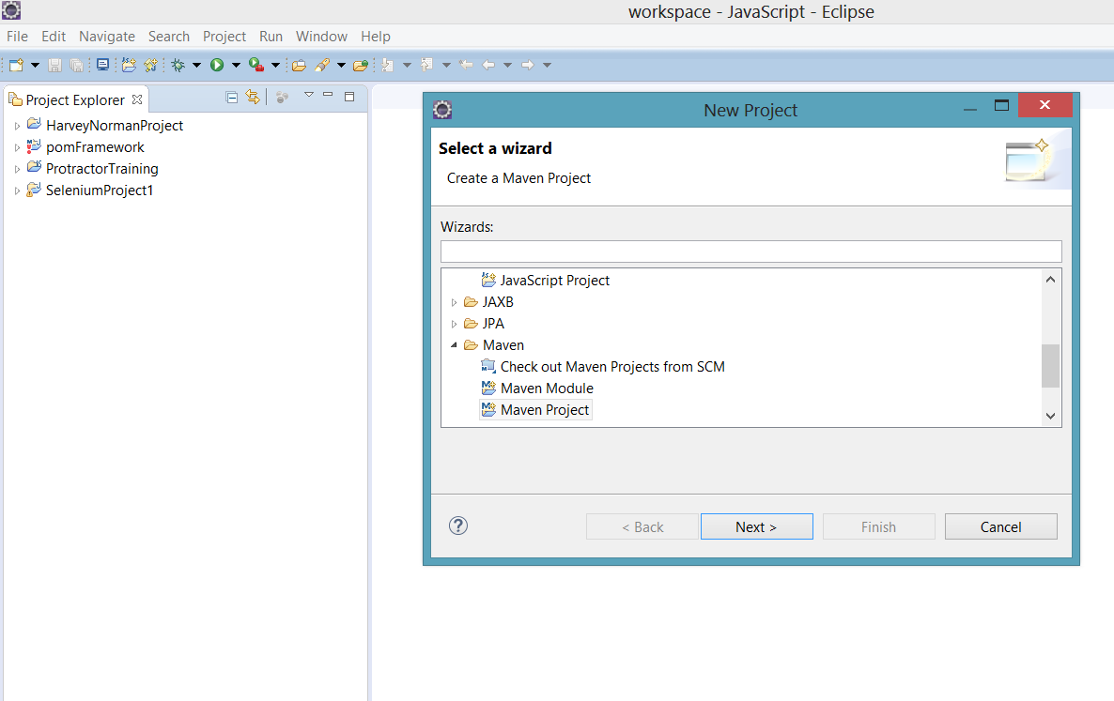

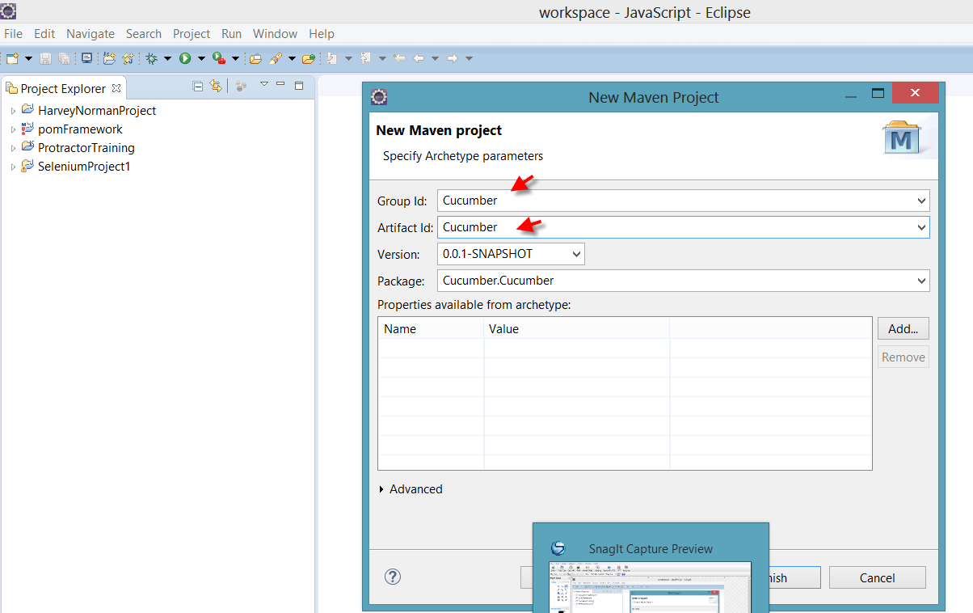

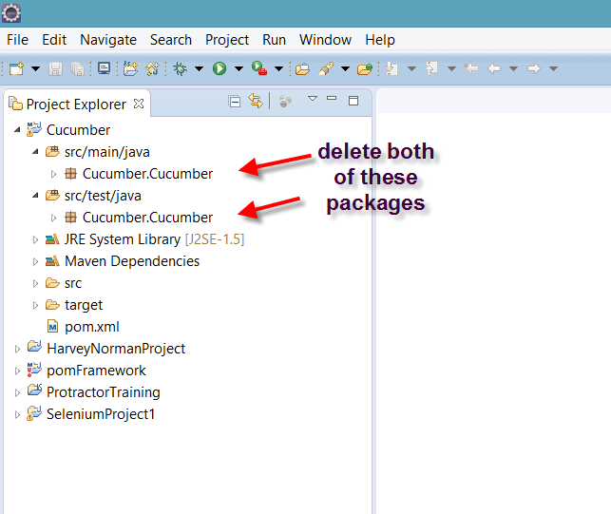

Paste below code in pom.xml file

|  |
| --- |
| <project xmlns="http://maven.apache.org/POM/4.0.0" xmlns:xsi="http://www.w3.org/2001/XMLSchema-instance" |
|  | xsi:schemaLocation="http://maven.apache.org/POM/4.0.0 http://maven.apache.org/xsd/maven-4.0.0.xsd"> |
|  | <modelVersion>4.0.0</modelVersion> |
|  |  |
|  | <groupId>FreeCrmBDDFramework</groupId> |
|  | <artifactId>FreeCrmBDDFramework</artifactId> |
|  | <version>0.0.1-SNAPSHOT</version> |
|  | <packaging>jar</packaging> |
|  |  |
|  | <name>FreeCrmBDDFramework</name> |
|  | <url>http://maven.apache.org</url> |
|  |  |
|  | <properties> |
|  | <project.build.sourceEncoding>UTF-8</project.build.sourceEncoding> |
|  | </properties> |
|  |  |
|  | <dependencies> |
|  |  |
|  |  |
|  | <dependency> |
|  | <groupId>info.cukes</groupId> |
|  | <artifactId>cucumber-java</artifactId> |
|  | <version>1.2.5</version> |
|  | <scope>test</scope> |
|  | </dependency> |
|  |  |
|  | <dependency> |
|  | <groupId>info.cukes</groupId> |
|  | <artifactId>cucumber-jvm</artifactId> |
|  | <version>1.2.5</version> |
|  | <type>pom</type> |
|  | </dependency> |
|  |  |
|  | <dependency> |
|  | <groupId>info.cukes</groupId> |
|  | <artifactId>cucumber-junit</artifactId> |
|  | <version>1.2.5</version> |
|  | <scope>test</scope> |
|  | </dependency> |
|  |  |
|  | <dependency> |
|  | <groupId>info.cukes</groupId> |
|  | <artifactId>cucumber-jvm-deps</artifactId> |
|  | <version>1.0.5</version> |
|  | </dependency> |
|  |  |
|  | <dependency> |
|  | <groupId>net.masterthought</groupId> |
|  | <artifactId>cucumber-reporting</artifactId> |
|  | <version>1.0.0</version> |
|  | </dependency> |
|  |  |
|  | <dependency> |
|  | <groupId>info.cukes</groupId> |
|  | <artifactId>gherkin</artifactId> |
|  | <version>2.12.2</version> |
|  | </dependency> |
|  |  |
|  | <dependency> |
|  | <groupId>junit</groupId> |
|  | <artifactId>junit</artifactId> |
|  | <version>3.8.1</version> |
|  | <scope>test</scope> |
|  | </dependency> |
|  |  |
|  |  |
|  |  |
|  | <dependency> |
|  | <groupId>org.seleniumhq.selenium</groupId> |
|  | <artifactId>selenium-java</artifactId> |
|  | <version>3.5.3</version> |
|  | </dependency> |
|  |  |
|  | <!-- https://mvnrepository.com/artifact/info.cukes/cucumber-picocontainer --> |
|  | <dependency> |
|  | <groupId>info.cukes</groupId> |
|  | <artifactId>cucumber-picocontainer</artifactId> |
|  | <version>1.2.5</version> |
|  | <scope>test</scope> |
|  | </dependency> |
|  |  |
|  |  |
|  |  |
|  |  |
|  | </dependencies> |
|  | </project> |

Create a package as Features under Project ‘Cucumber’

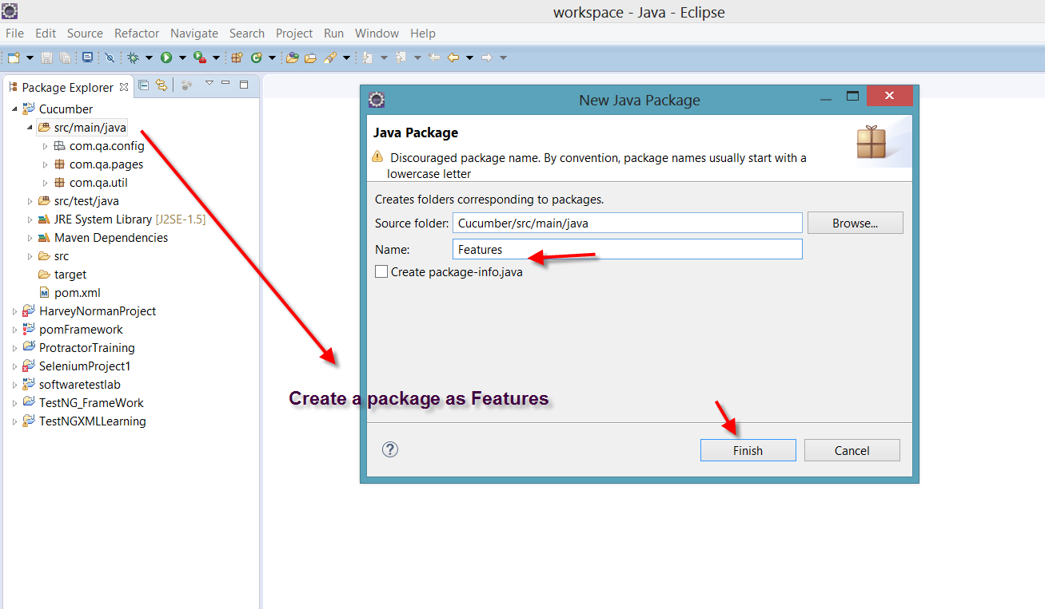

Download natural plugin

Help>eclipse market place> search for natural

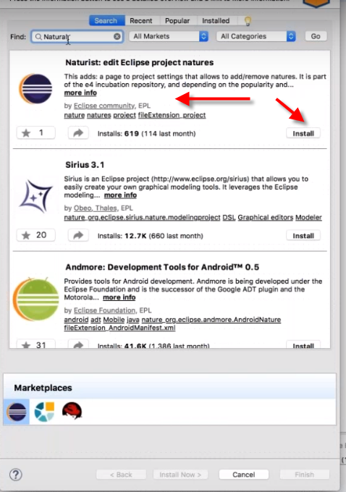

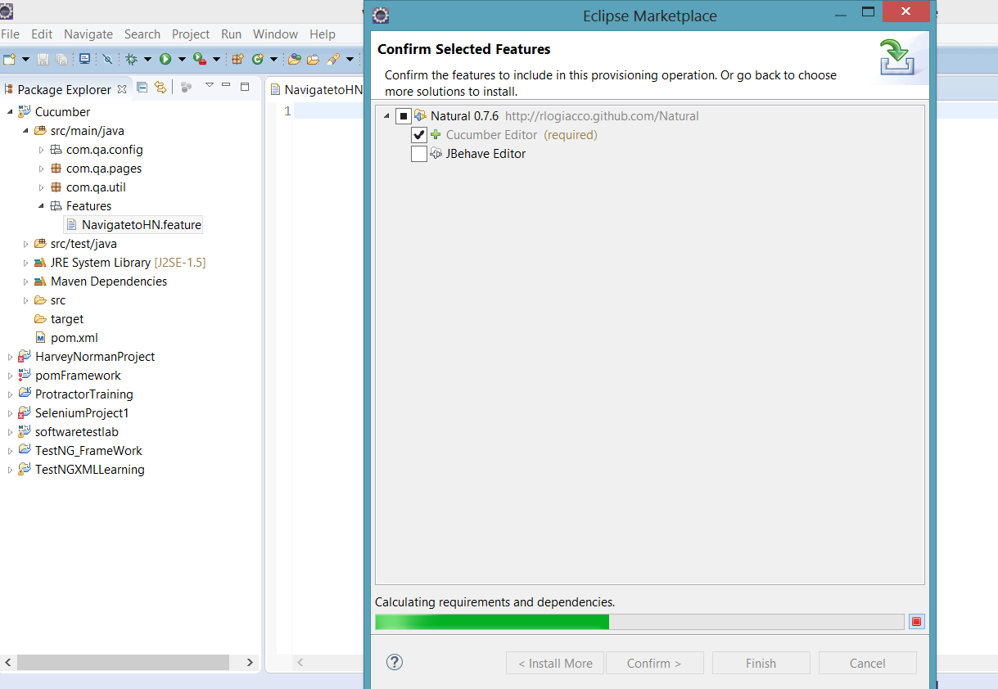

If not able to add natural from eclipse market place do below step

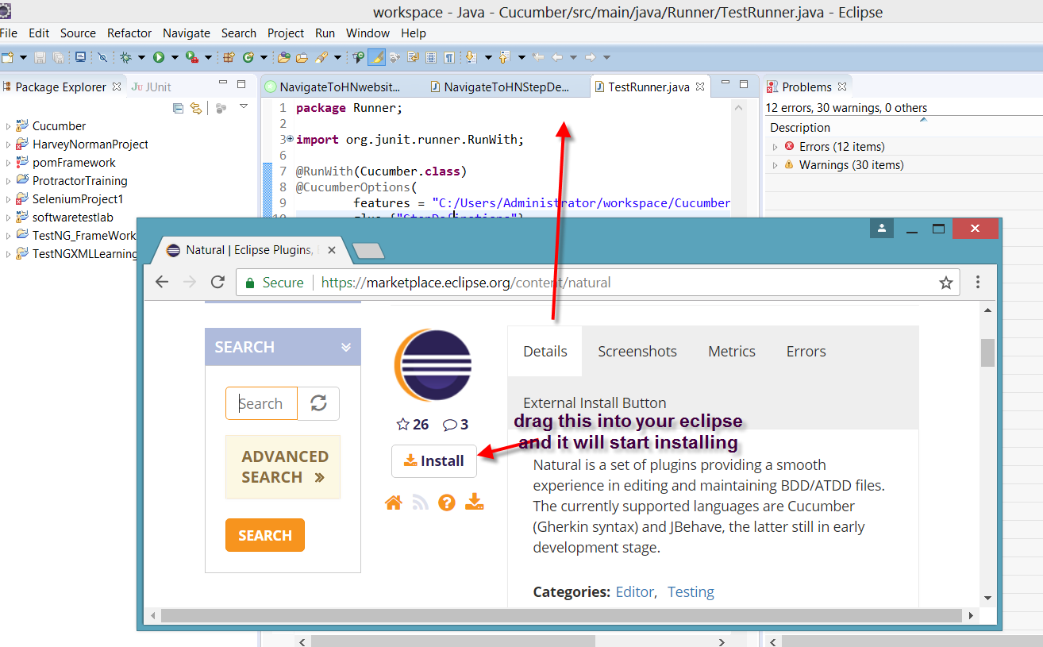

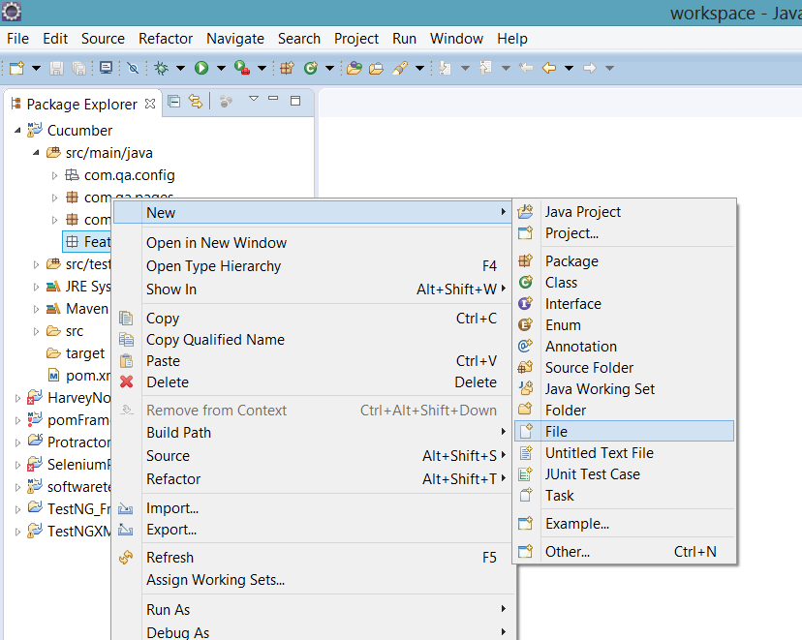

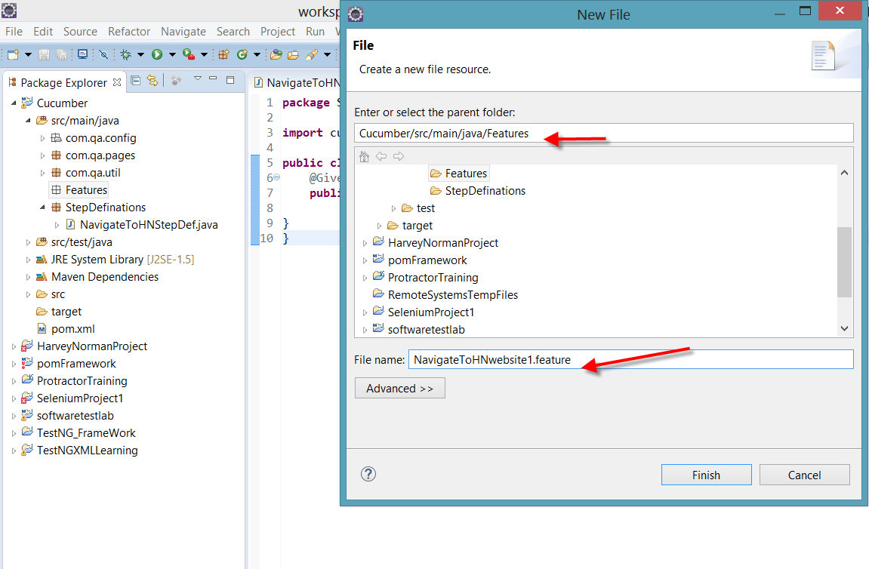

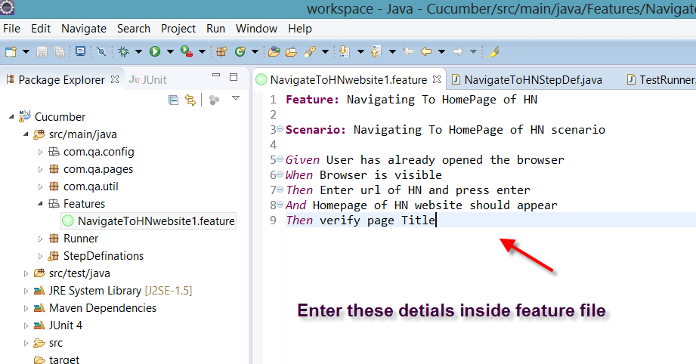

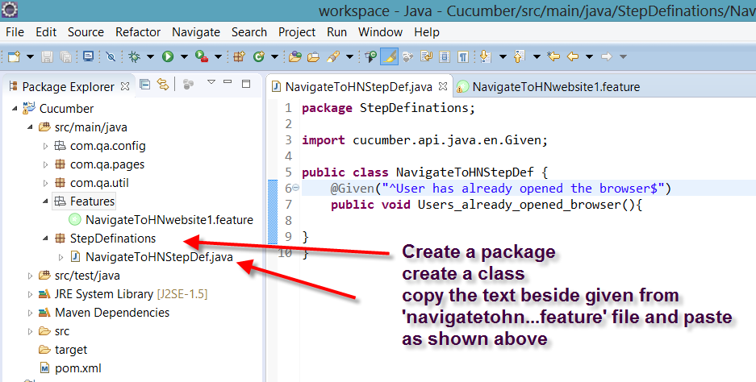

Create another package as shown below

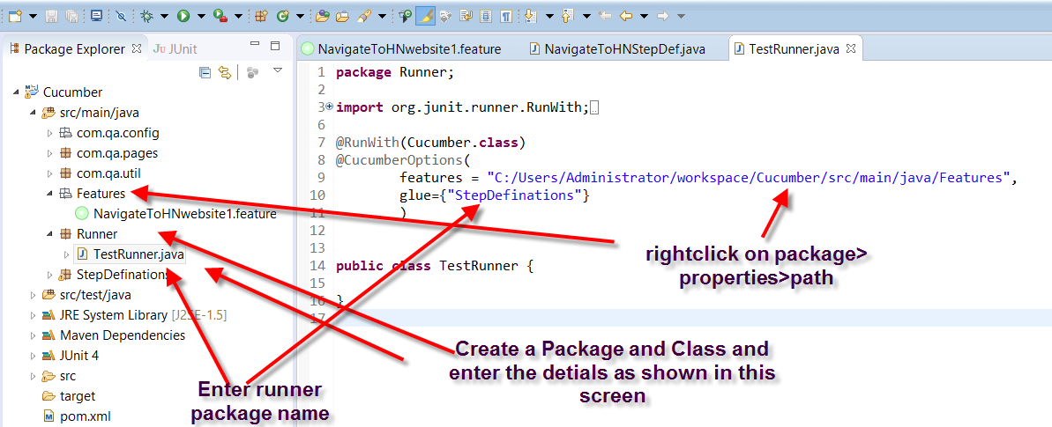

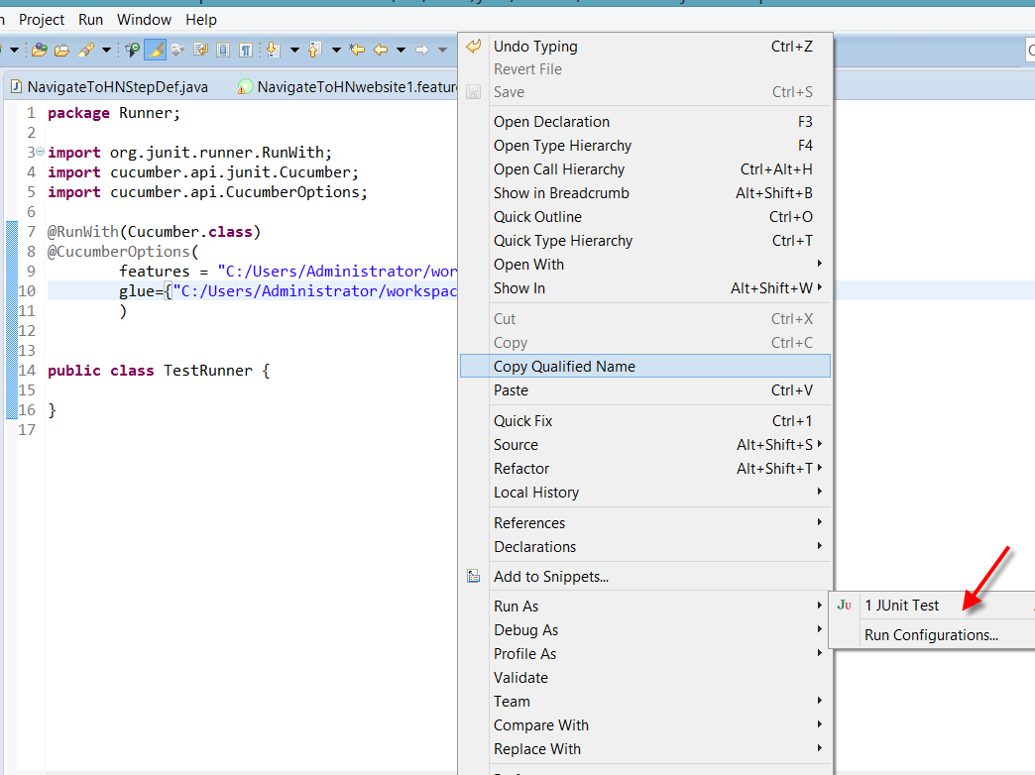

Run as >junit

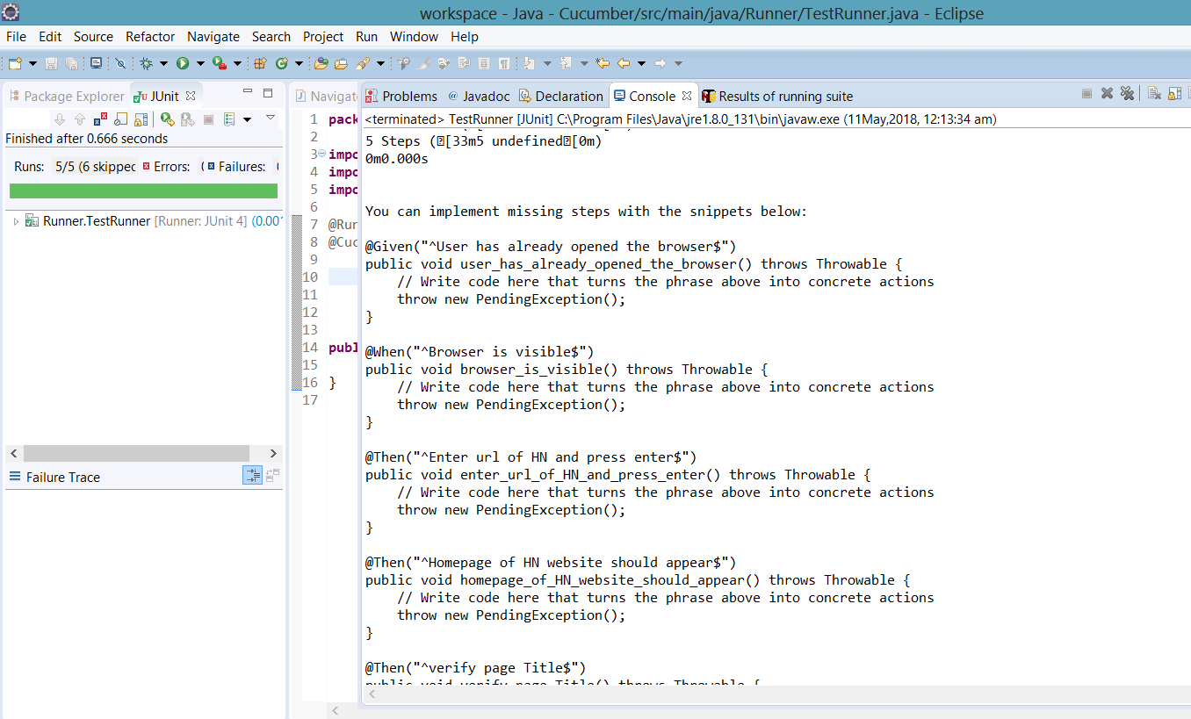

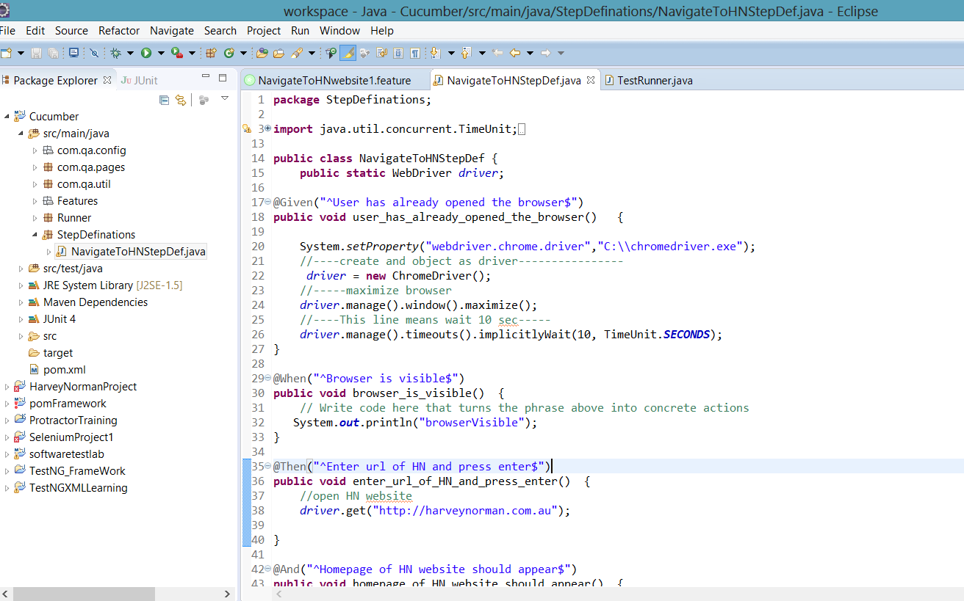

package StepDefinations;

import java.util.concurrent.TimeUnit;

import org.openqa.selenium.By;

import org.openqa.selenium.WebDriver;

import org.openqa.selenium.chrome.ChromeDriver;

import cucumber.api.java.en.And;

import cucumber.api.java.en.Given;

import cucumber.api.java.en.Then;

import cucumber.api.java.en.When;

public class NavigateToHNStepDef {

public static WebDriver driver;

@Given("^User has already opened the browser$")

public void user_has_already_opened_the_browser() {

System.setProperty("webdriver.chrome.driver","C:\\chromedriver.exe");

//----create and object as driver----------------

driver = new ChromeDriver();

//-----maximize browser

driver.manage().window().maximize();

//----This line means wait 10 sec-----

driver.manage().timeouts().implicitlyWait(10, TimeUnit.SECONDS);

}

@When("^Browser is visible$")

public void browser_is_visible() {

// Write code here that turns the phrase above into concrete actions

System.out.println("browserVisible");

}

@Then("^Enter url of HN and press enter$")

public void enter_url_of_HN_and_press_enter() {

//open HN website

driver.get("http://harveynorman.com.au");

}

@And("^Homepage of HN website should appear$")

public void homepage_of_HN_website_should_appear() {

System.out.println("HomePageAppeared");

}

@Then("^verify page Title$")

public void verify_page_Title() {

System.out.println("TitleVerified");

}

}

**Please ignore below steps for now**

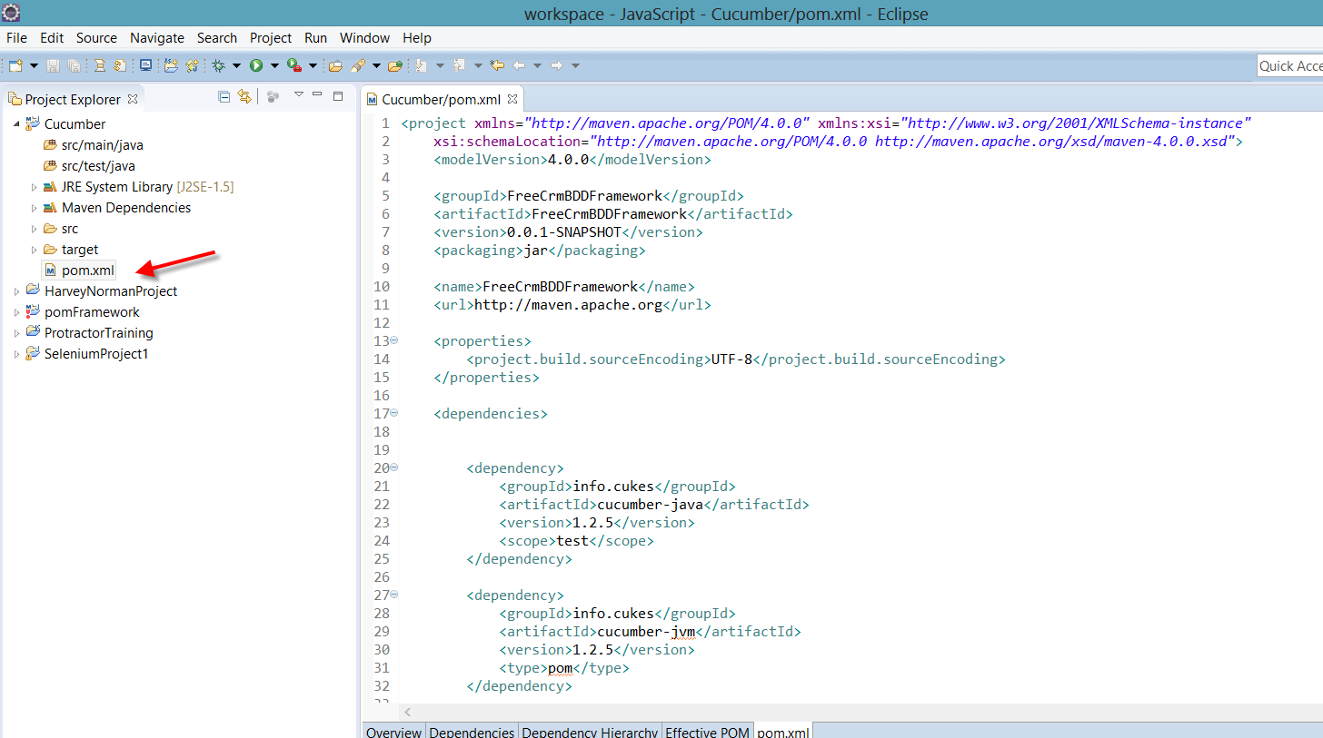

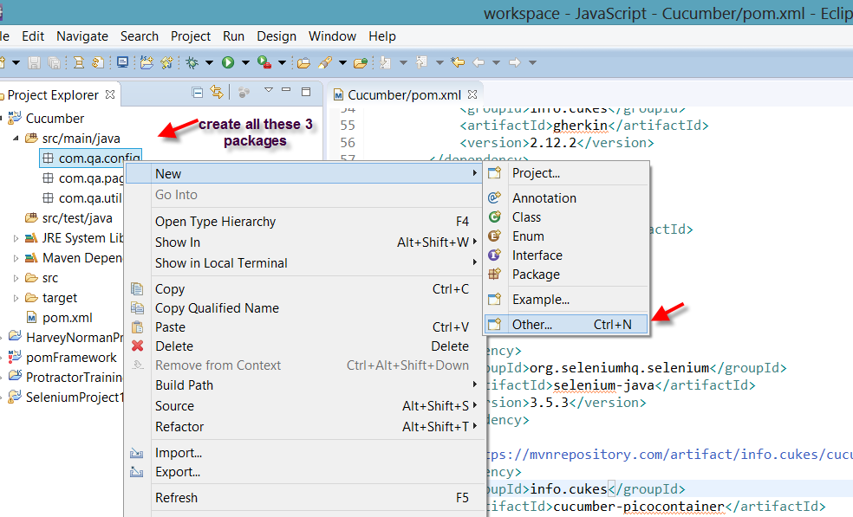

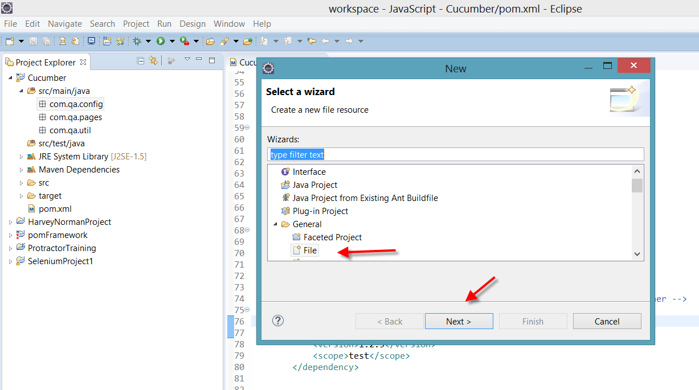

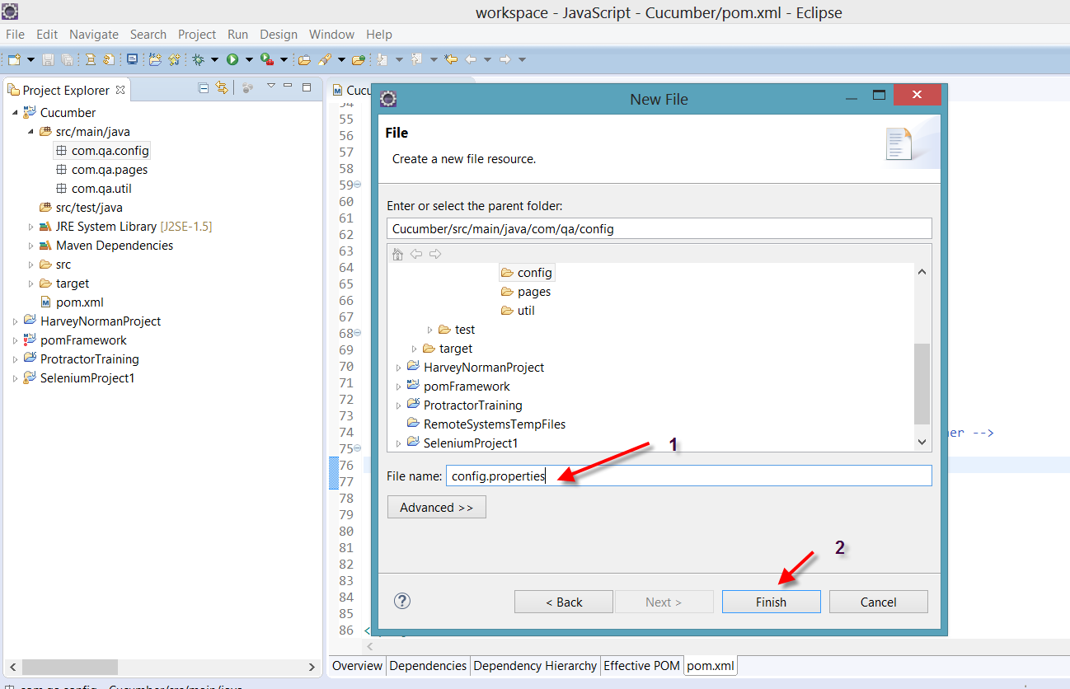

Add this code under TestBase class

**package** com.qa.util;

**import** java.io.FileInputStream;

**import** java.io.FileNotFoundException;

**import** java.io.IOException;

**import** java.util.Properties;

**import** java.util.concurrent.TimeUnit;

**import** org.openqa.selenium.WebDriver;

**import** org.openqa.selenium.chrome.ChromeDriver;

**import** org.openqa.selenium.chrome.ChromeOptions;

**import** org.openqa.selenium.firefox.FirefoxDriver;

**import** org.openqa.selenium.support.events.EventFiringWebDriver;

**public** **class** TestBase {

**public** **static** WebDriver *driver*;

**public** **static** Properties *prop*;

**public** TestBase(){

**try** {

*prop* = **new** Properties();

FileInputStream fis = **new** FileInputStream("C:\\Users\\Administrator\\workspace\\Cucumber\\src\\main\\java\\com\\qa\\config\\config.properties");

*prop*.load(fis);

} **catch** (FileNotFoundException e) {

e.printStackTrace();

} **catch** (IOException e) {

e.printStackTrace();

}

}

**public** **static** **void** initialization(){

String browserName = *prop*.getProperty("browser");

**if**(browserName.equals("chrome")){

System.*setProperty*("webdriver.chrome.driver", "C:\\chromedriver");

*driver* = **new** ChromeDriver();

}

**else** **if**(browserName.equals("FF")){

System.*setProperty*("webdriver.gecko.driver", "/Users/naveenkhunteta/Documents/SeleniumServer/geckodriver");

*driver* = **new** FirefoxDriver();

}

*driver*.manage().window().maximize();

*driver*.manage().deleteAllCookies();

*driver*.manage().timeouts().pageLoadTimeout(TestUtil.PAGE_LOAD_TIMEOUT, TimeUnit.***SECONDS***);

*driver*.manage().timeouts().implicitlyWait(TestUtil.IMPLICIT_WAIT, TimeUnit.***SECONDS***);

*driver*.get(*prop*.getProperty("url"));

}

}

