**Extent Reporting**

1. In Maven project
2. In pom.xml, add below code to activate extent reports .

<!-- https://mvnrepository.com/artifact/com.relevantcodes/extentreports -->

<dependency>

<groupId>com.relevantcodes</groupId>

<artifactId>extentreports</artifactId>

<version>2.40.2</version>

</dependency>

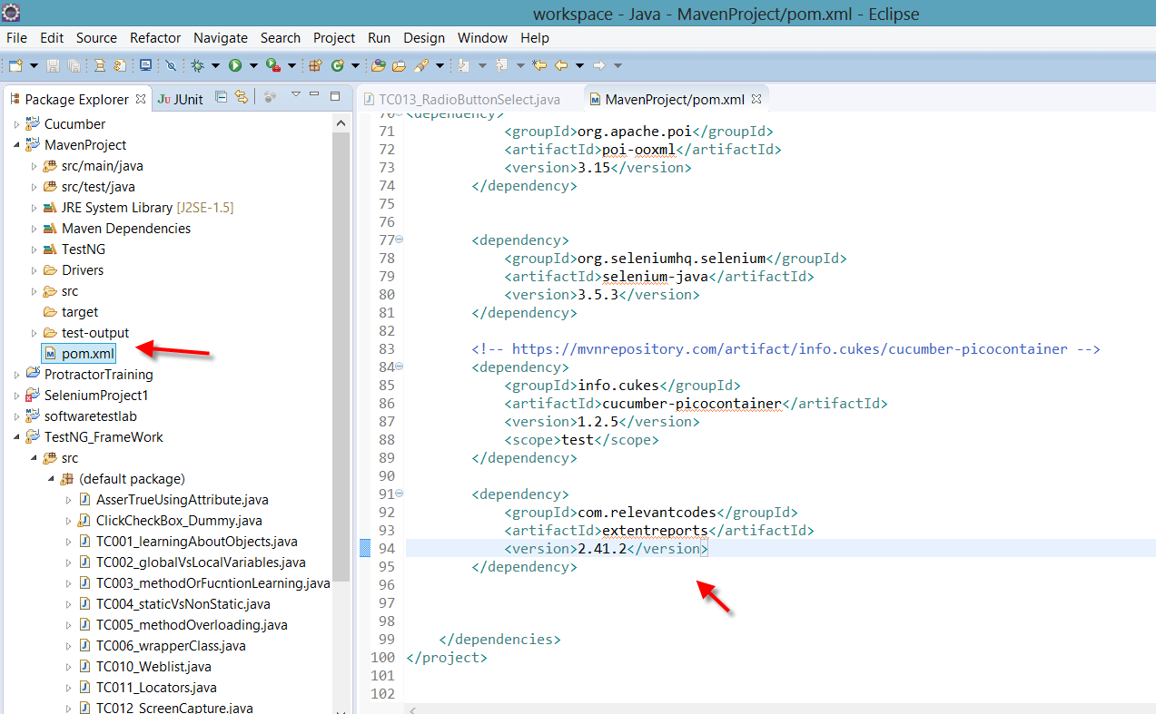

3.

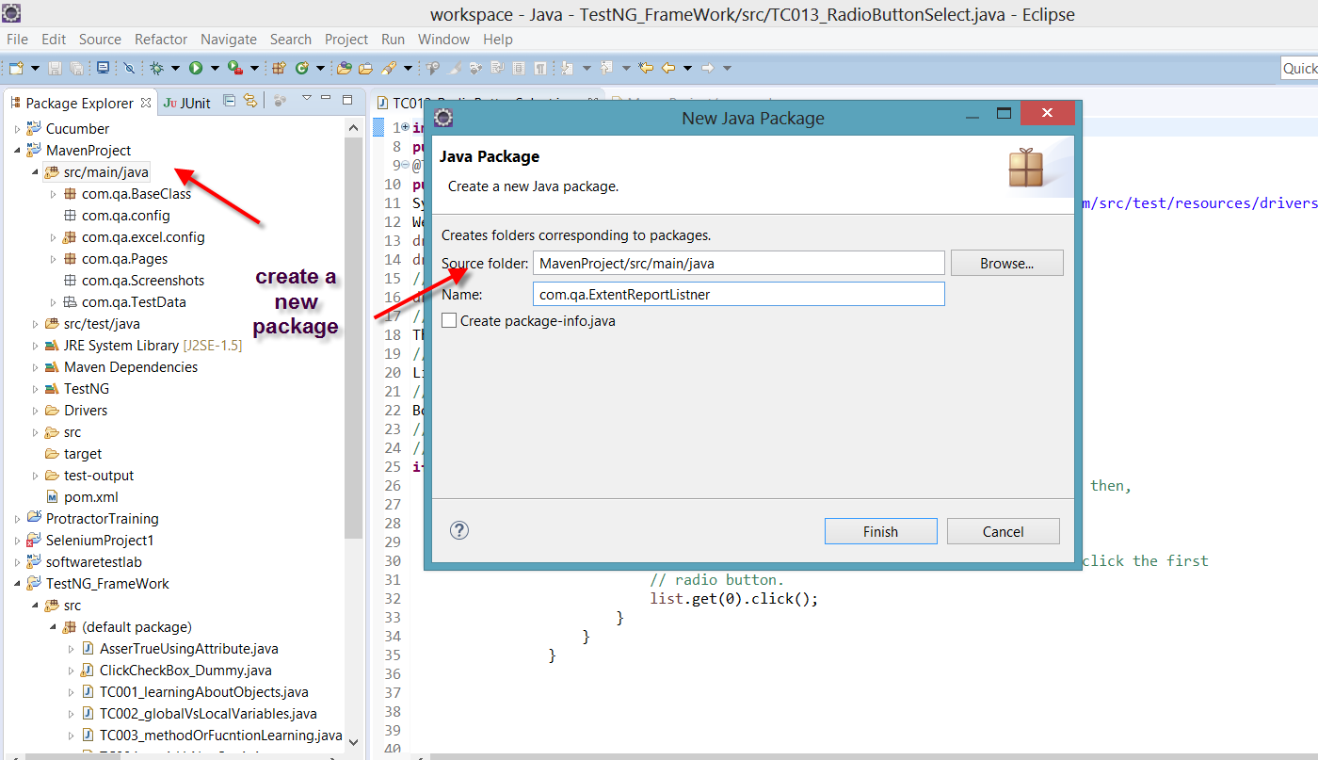

4.

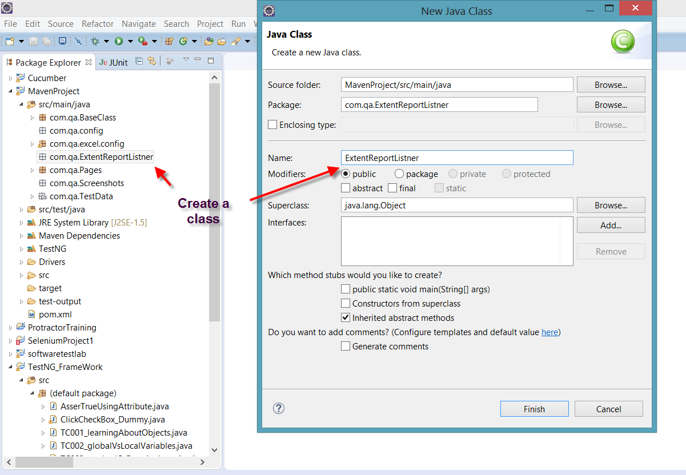

5.

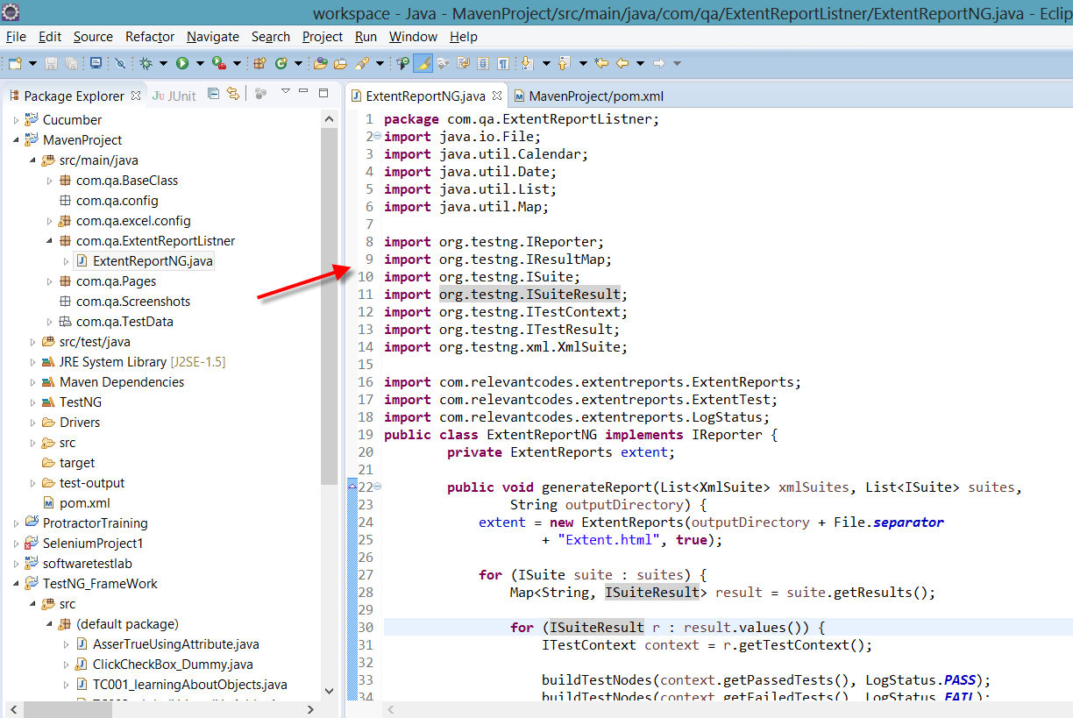

**Add this below code in the above created class**

**package** com.qa.ExtentReportListner;

**import** java.io.File;

**import** java.util.Calendar;

**import** java.util.Date;

**import** java.util.List;

**import** java.util.Map;

**import** org.testng.IReporter;

**import** org.testng.IResultMap;

**import** org.testng.ISuite;

**import** org.testng.ISuiteResult;

**import** org.testng.ITestContext;

**import** org.testng.ITestResult;

**import** org.testng.xml.XmlSuite;

**import** com.relevantcodes.extentreports.ExtentReports;

**import** com.relevantcodes.extentreports.ExtentTest;

**import** com.relevantcodes.extentreports.LogStatus;

**public** **class** ExtentReportNG **implements** IReporter {

**private** ExtentReports extent;

**public** **void** generateReport(List<XmlSuite> xmlSuites, List<ISuite> suites,

String outputDirectory) {

extent = **new** ExtentReports(outputDirectory + File.***separator***

+ "Extent.html", **true**);

**for** (ISuite suite : suites) {

Map<String, ISuiteResult> result = suite.getResults();

**for** (ISuiteResult r : result.values()) {

ITestContext context = r.getTestContext();

buildTestNodes(context.getPassedTests(), LogStatus.***PASS***);

buildTestNodes(context.getFailedTests(), LogStatus.***FAIL***);

buildTestNodes(context.getSkippedTests(), LogStatus.***SKIP***);

}

}

extent.flush();

extent.close();

}

**private** **void** buildTestNodes(IResultMap tests, LogStatus status) {

ExtentTest test;

**if** (tests.size() > 0) {

**for** (ITestResult result : tests.getAllResults()) {

test = extent.startTest(result.getMethod().getMethodName());

test.setStartedTime(getTime(result.getStartMillis()));

test.setEndedTime(getTime(result.getEndMillis()));

**for** (String group : result.getMethod().getGroups())

test.assignCategory(group);

**if** (result.getThrowable() != **null**) {

test.log(status, result.getThrowable());

} **else** {

test.log(status, "Test " + status.toString().toLowerCase()

+ "ed");

}

extent.endTest(test);

}

}

}

**private** Date getTime(**long** millis) {

Calendar calendar = Calendar.*getInstance*();

calendar.setTimeInMillis(millis);

**return** calendar.getTime();

}

}

6. Open your testing.xml and below code

<listeners>

<listener class-name=*"com.qa.ExtentReprotListner.ExtentReportNG"*></listener>

</listeners>

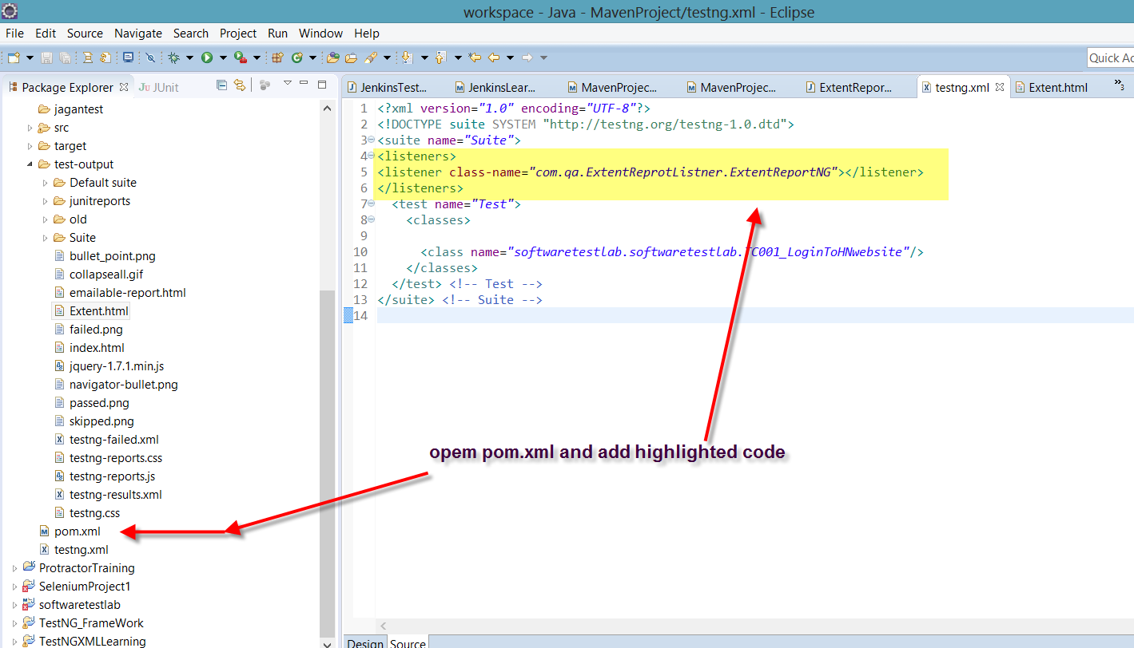

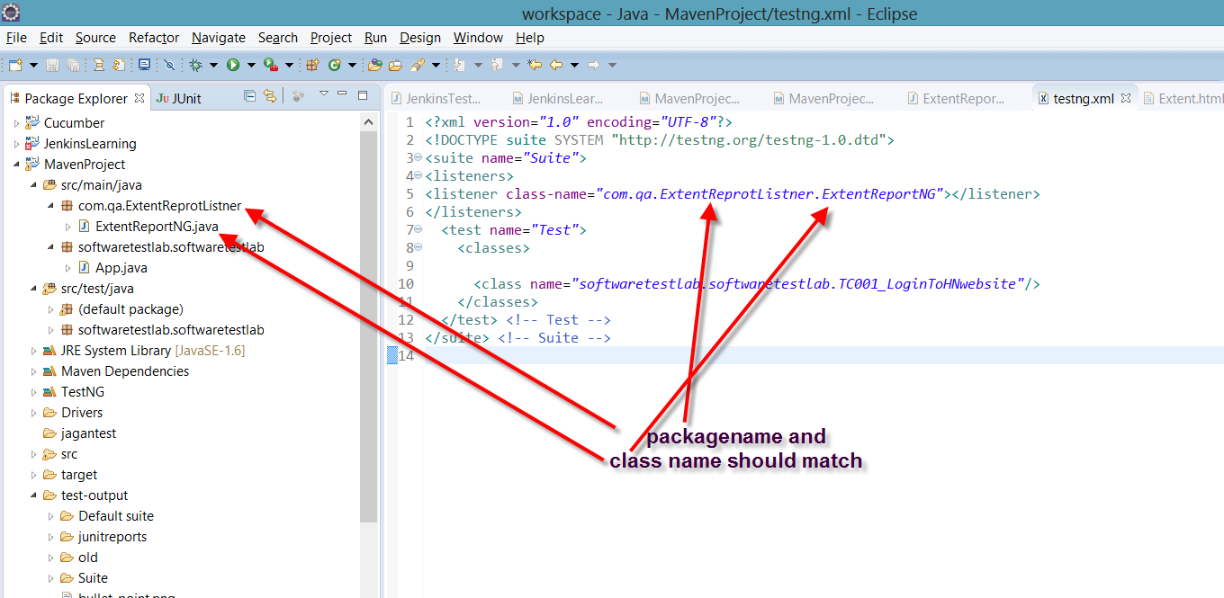

7. Run testing.xml file

Rightclick testing.xml > run as > TestNG Suite

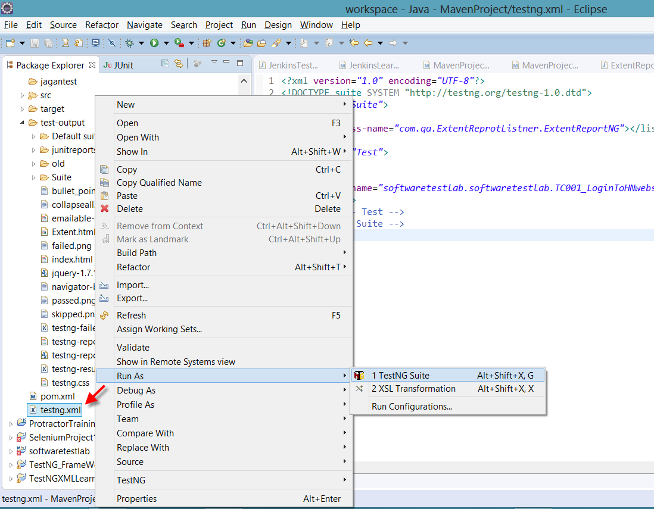

Once finished running copy path of Extent.html

Extent.html>RightClick>copy path and paste it in browser

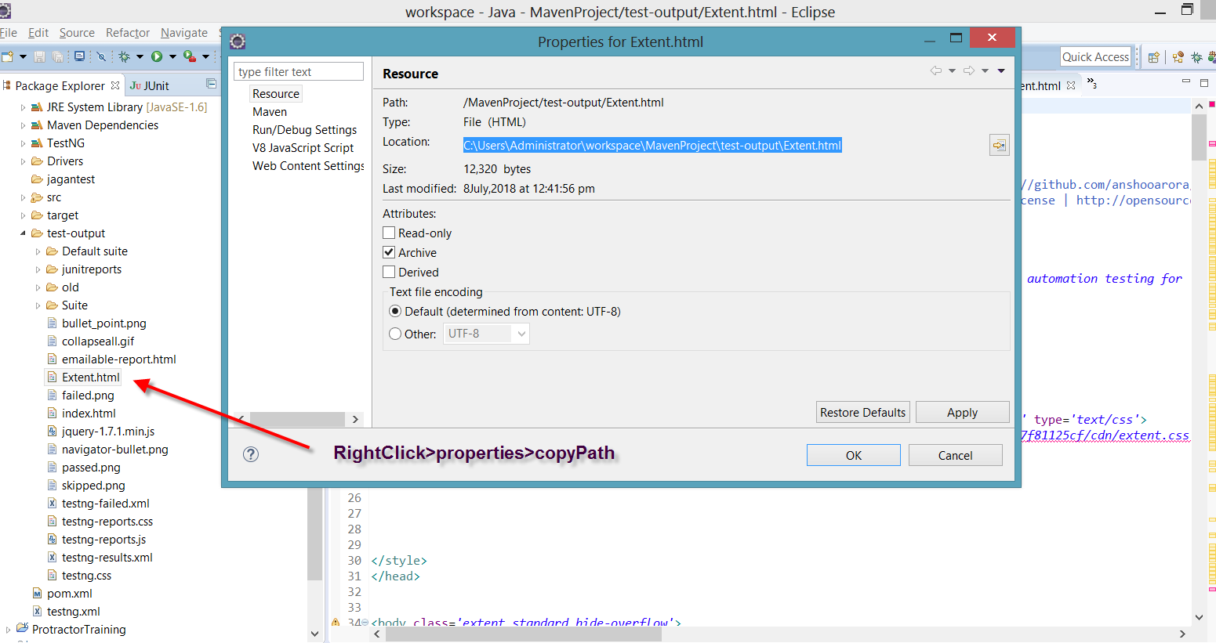

8. Test Results

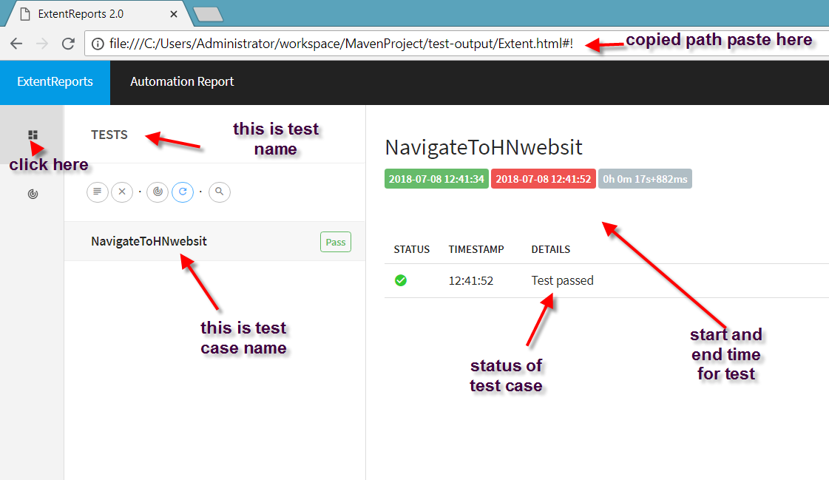

9. Defects

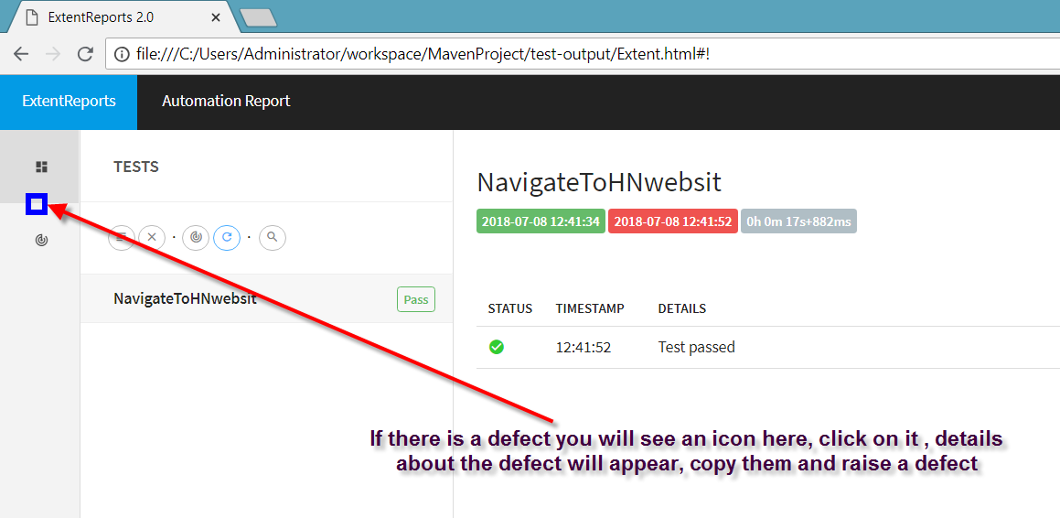

10. Graphical Representation of test results

