JenkinsSetUpandProjectCreation

Pre-condition..this has to be checked before creating a project on Jenkins

Run below test case from testng.xml and it should pass

Testng.xml>rightclick>runsas>testngSuite

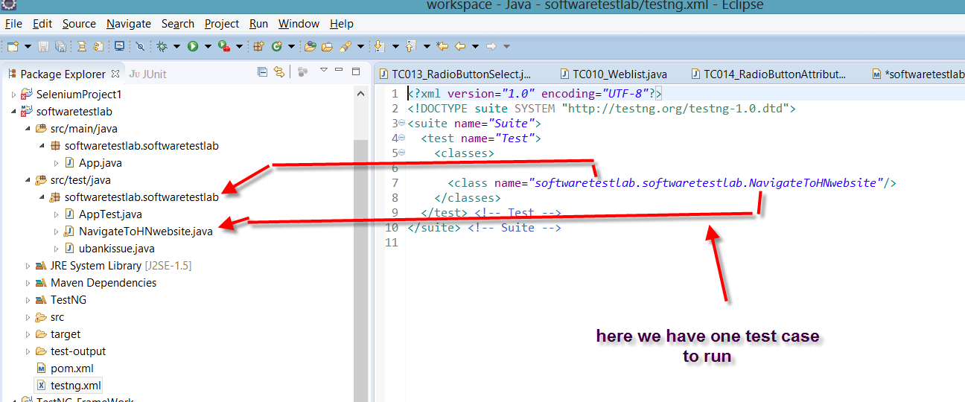

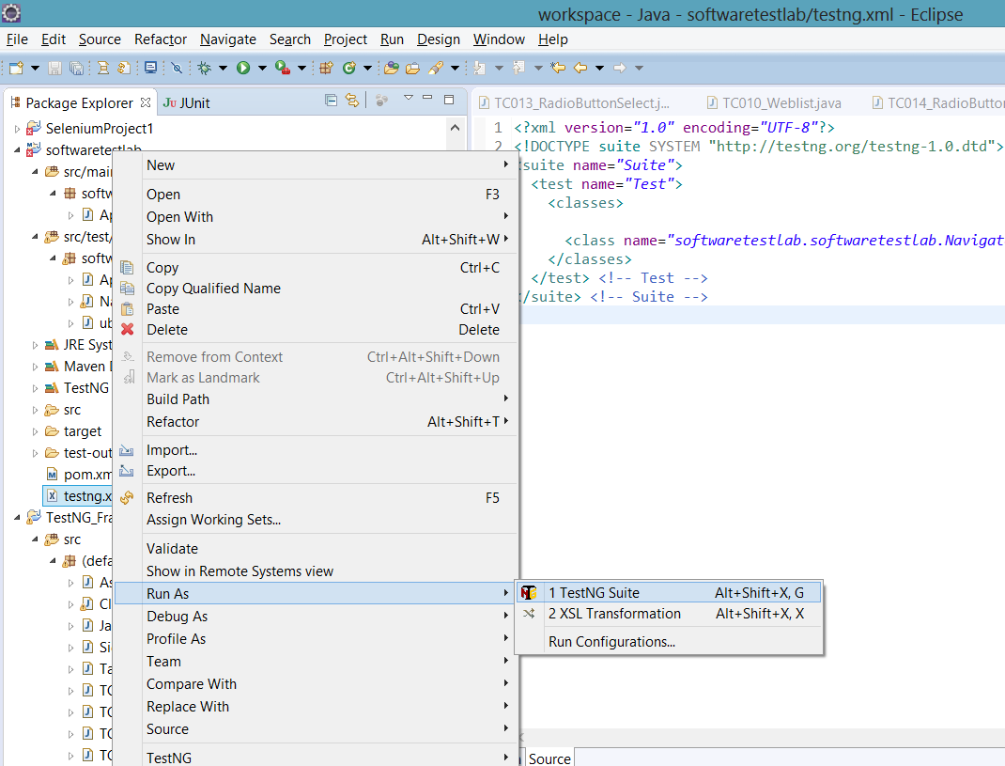

Pom.xml

Run

Maven clean

Maven test

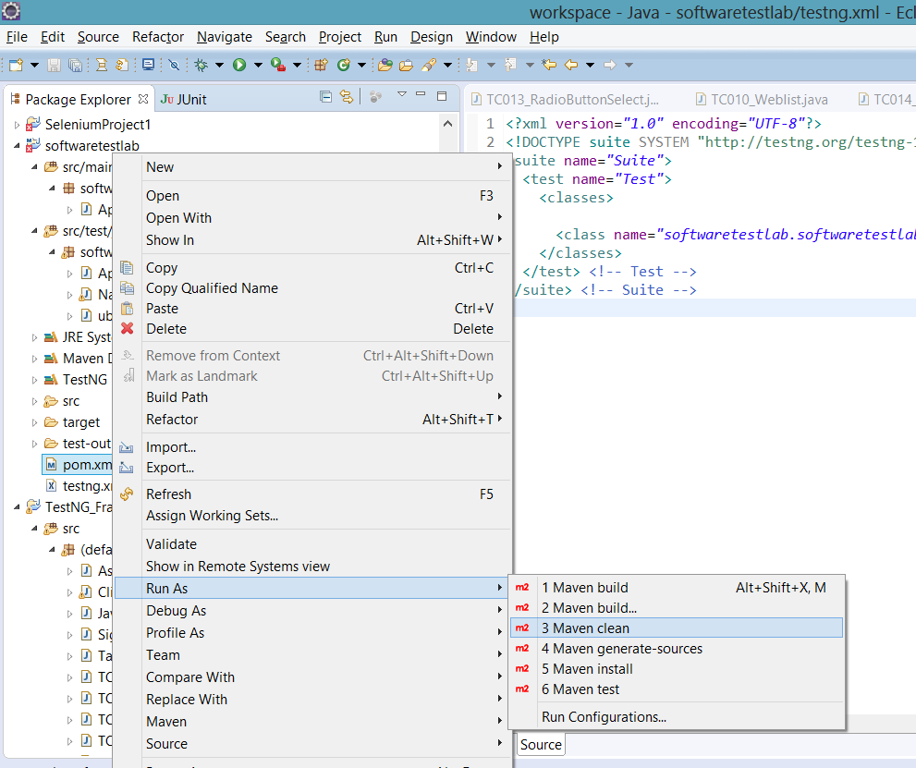

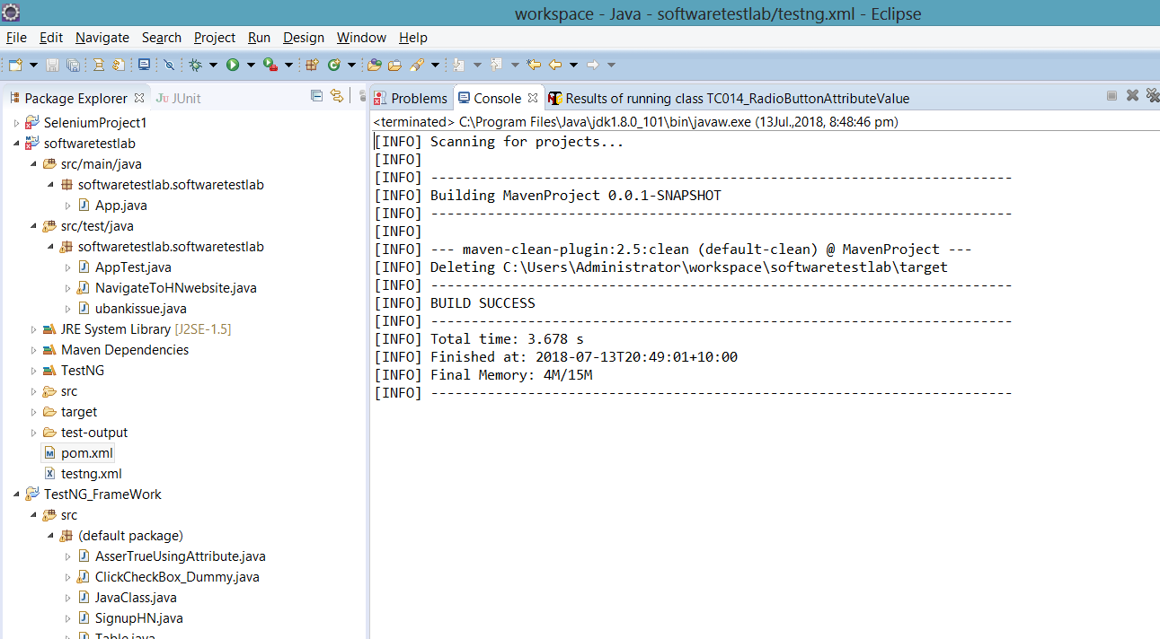

Maven test

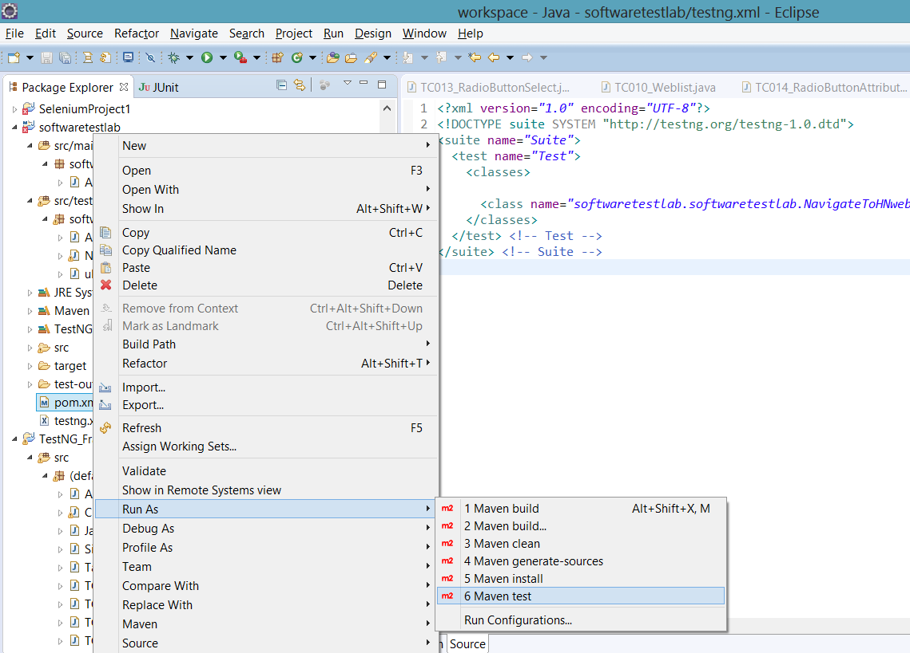

Its should execute all the test cases in testng.xml

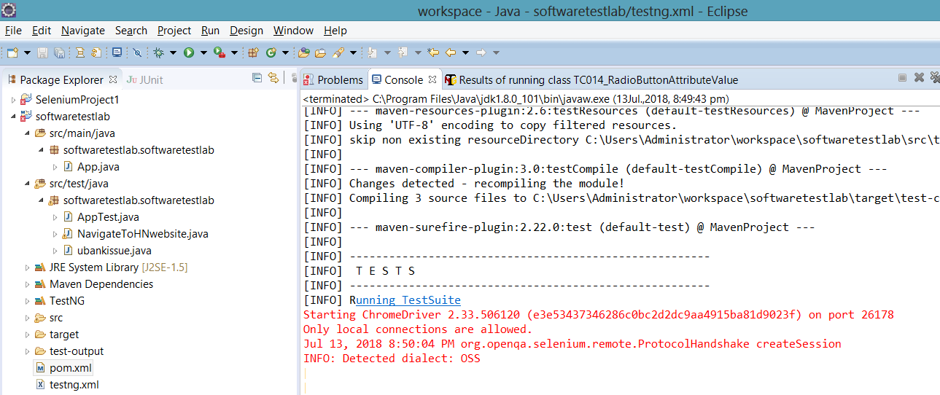

Jenkins setup

Windows>preferences>java>installedJREs>search>navigate to the path were ‘java’ is located in your machine and select ‘java’ then both jre and jdk will appear under ‘installed JREs’ window and from here select JDK only

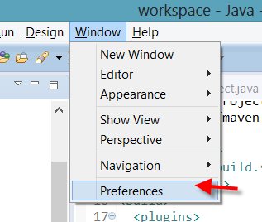

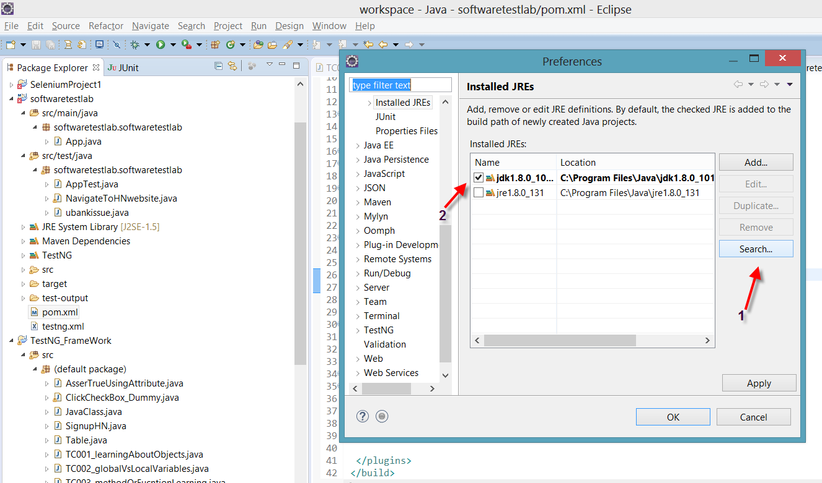

Make sure below steps shows jdk selected

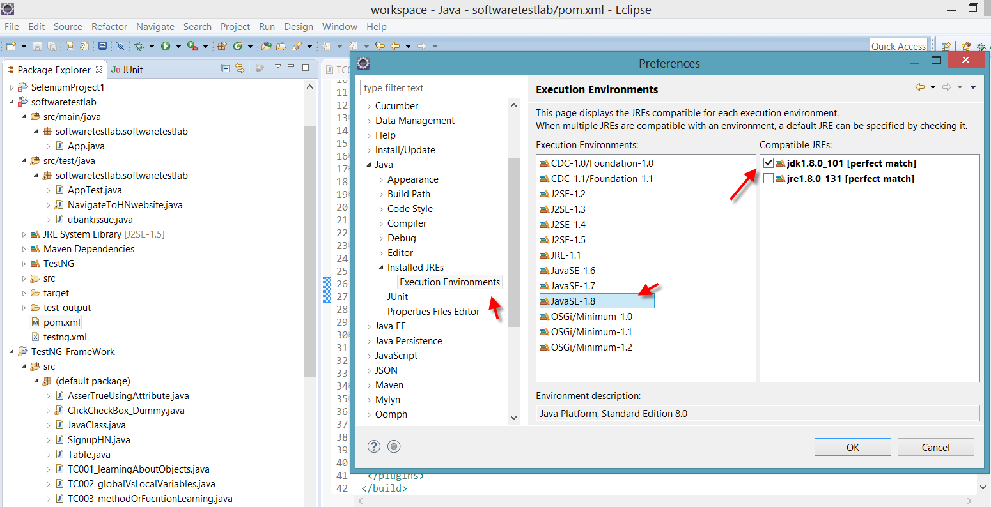

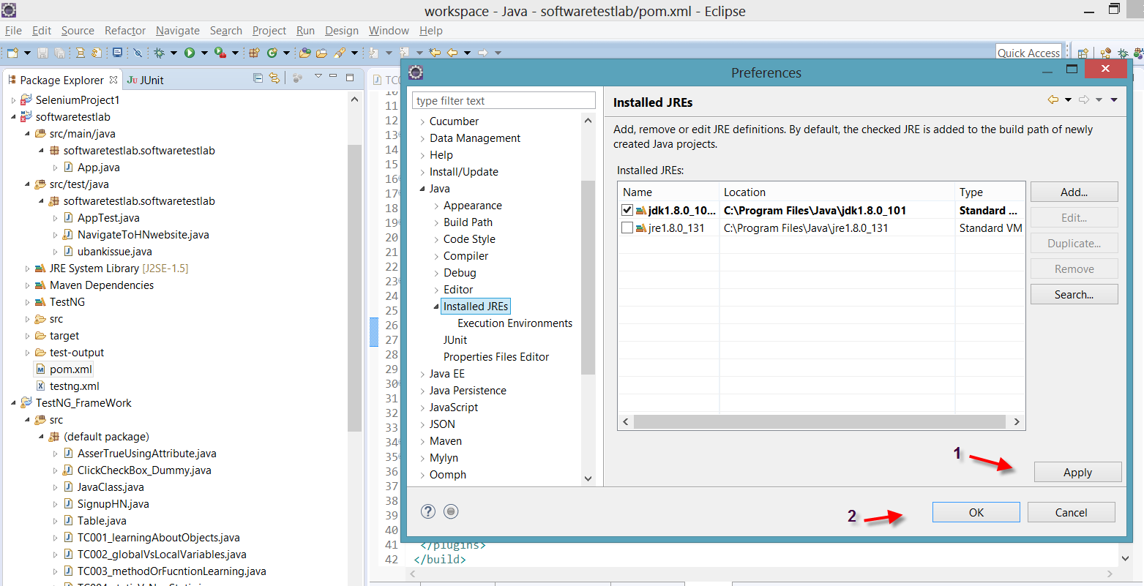

POM.xml paste below code

<build>

<plugins>

<plugin>

<groupId>org.apache.maven.plugins</groupId>

<artifactId>maven-compiler-plugin</artifactId>

<version>3.0</version>

<configuration>

<complierVersion>1.8</complierVersion>

<source>1.6</source>

<target>1.6</target>

</configuration>

</plugin>

<plugin>

<groupId>org.apache.maven.plugins</groupId>

<artifactId>maven-surefire-plugin</artifactId>

<version>2.22.0</version>

<configuration>

<suiteXmlFiles>

<suiteXmlFile>testng.xml</suiteXmlFile>

</suiteXmlFiles>

</configuration>

</plugin>

</plugins>

</build>

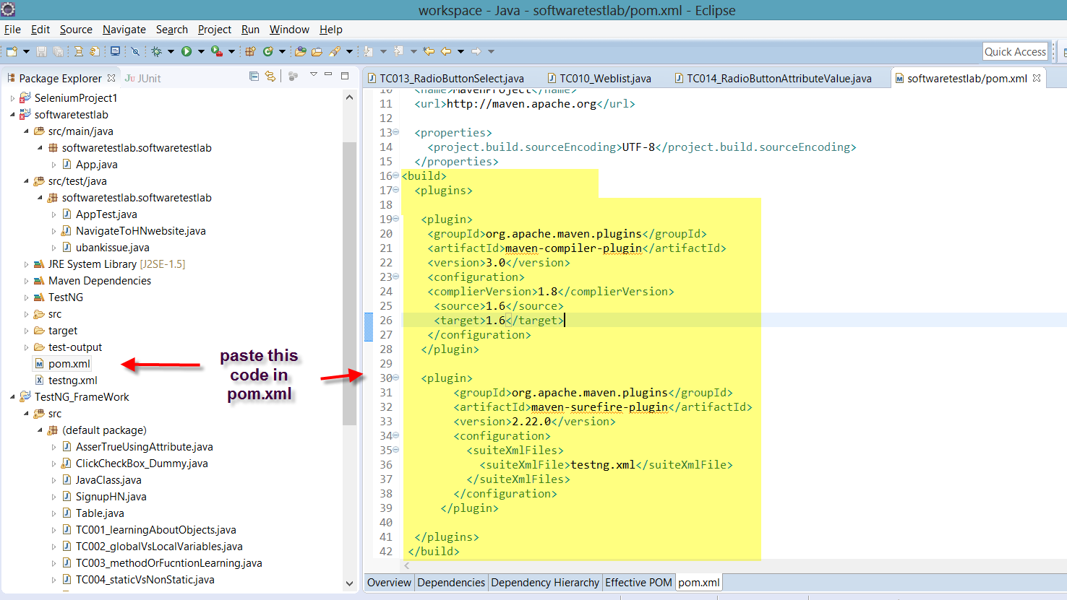

Search for Jenkins on google and download

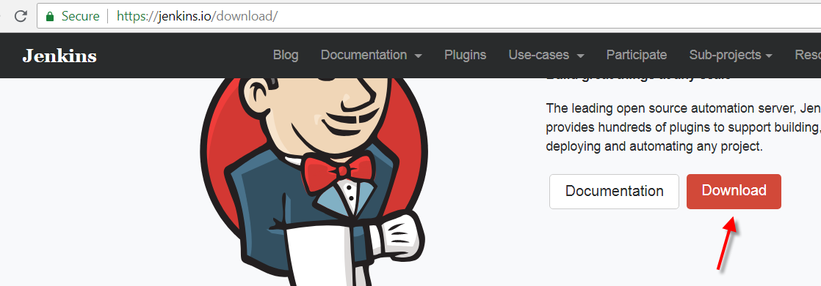

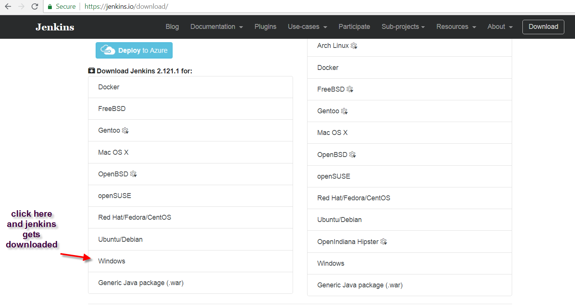

Once downloaded>unzip

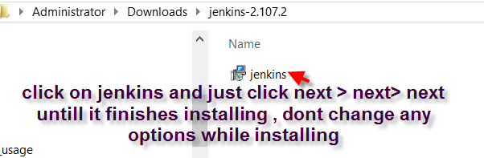

In browser type <http://localhost:8080/>

You should see Jenkins, don’t create any logins at this point

In windows search for run, once run window opens enter **services.msc**

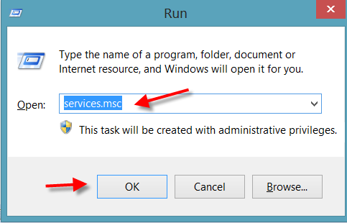

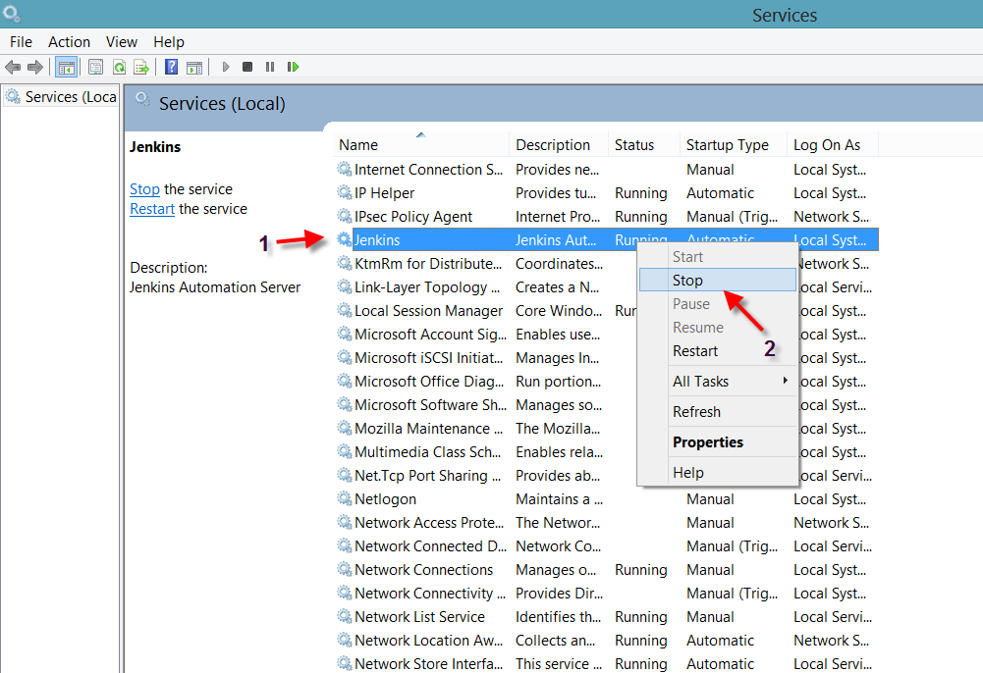

Open cmd and navigate to the path were Jenkins is located

In my case its located at

cd C:\Program Files\Jenkins

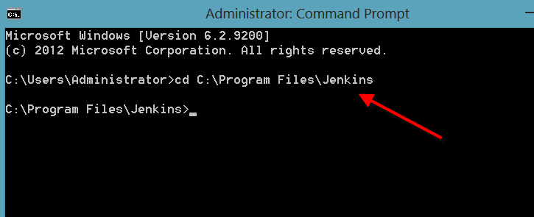

Stop Jenkins from here

In cmd type

Jenkins.exe stop

And press enter key

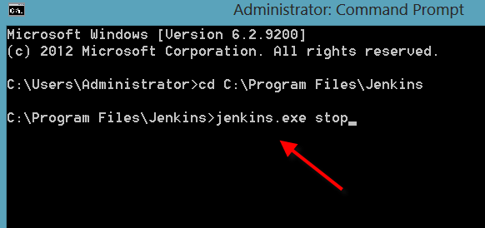

Start Jenkins

Enter below command in cmd

Java –jar Jenkins.war

And press enter key

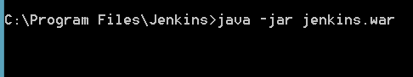

Wait till you see a message is cmd as Jenkins is fully up and running, once you see this message opens Jenkins from browser by typing **localhost:8080**

Don’t close cmd

Copy password from cmd and paste in the Jenkins

Now select install default plugins (wait for it to install)

Now create username and password

Jenkins will restart after installing

Enter username and password and login

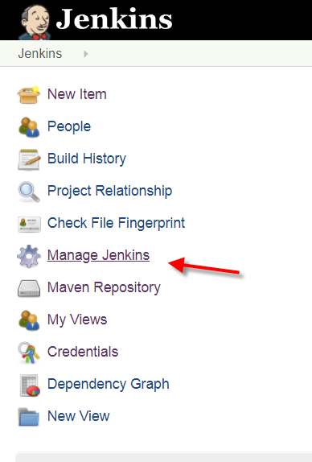

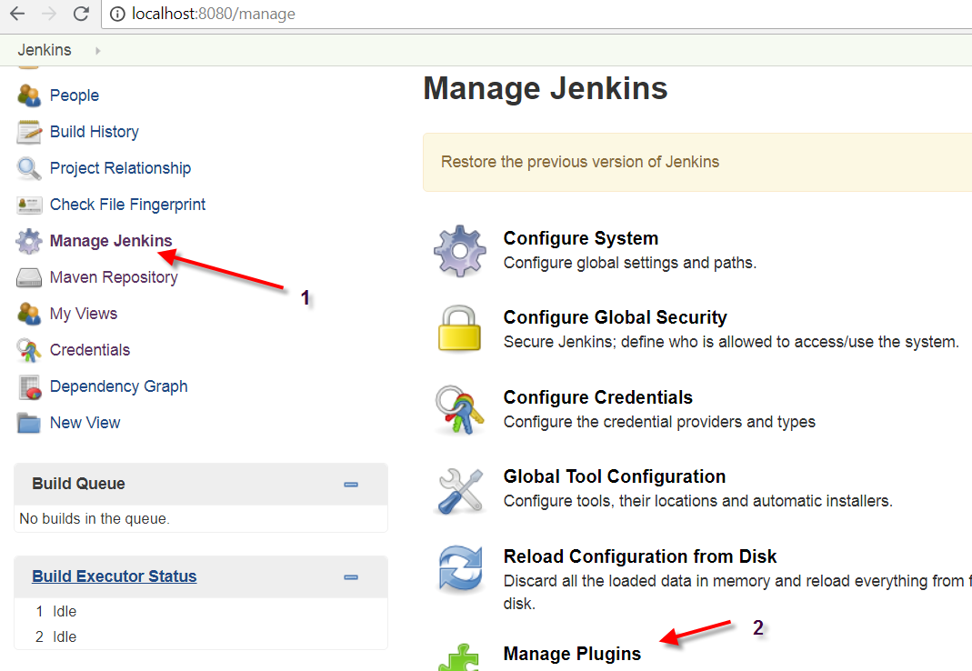

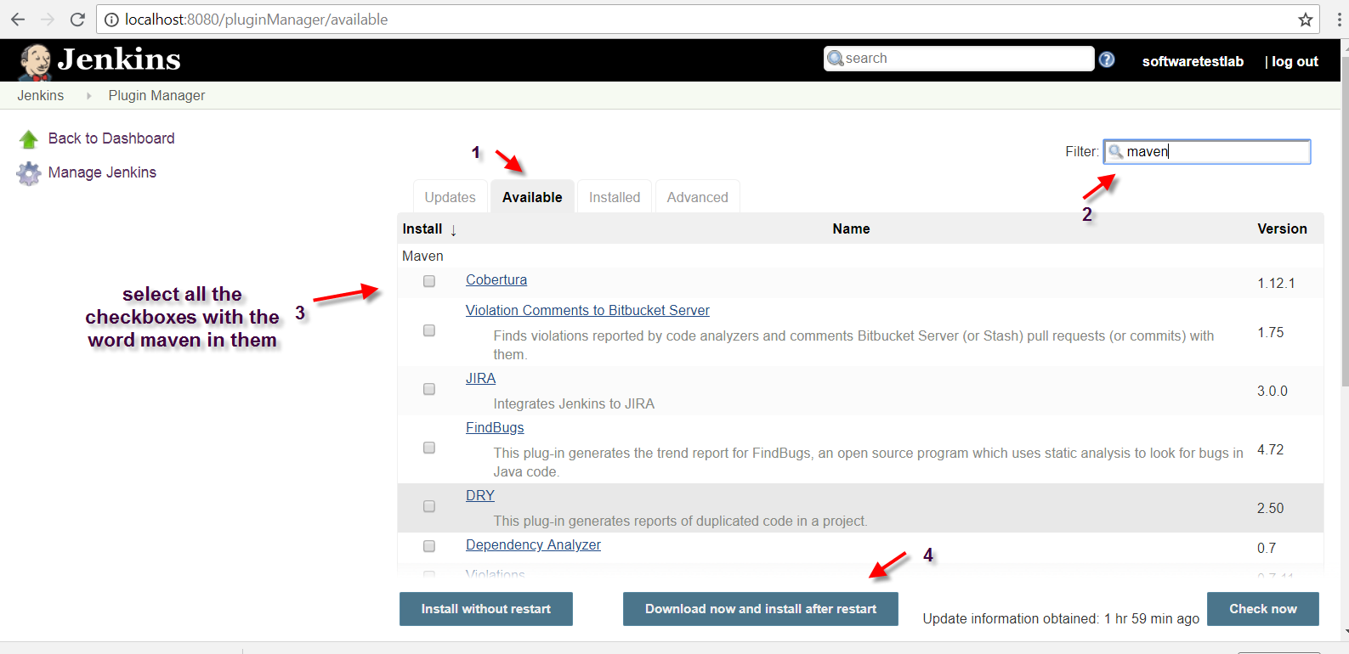

Wait for installation to be complete

Now once installation is done from cmd type java –jar Jenkins.war

Once Jenkins is up enter username and password

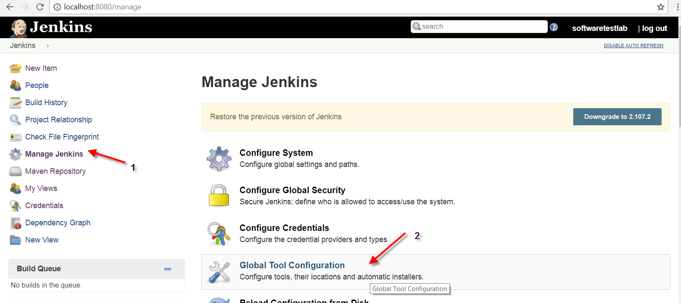

Enter location were jdk is installed

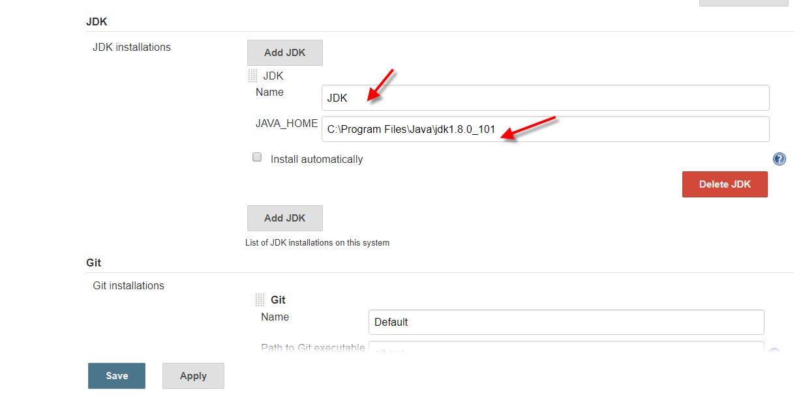

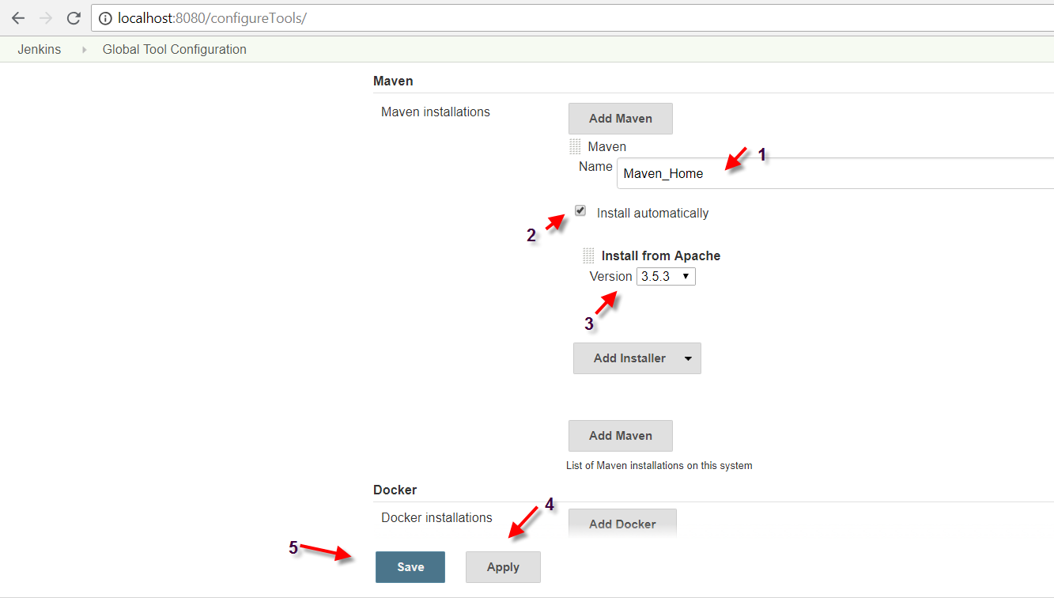

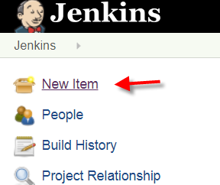

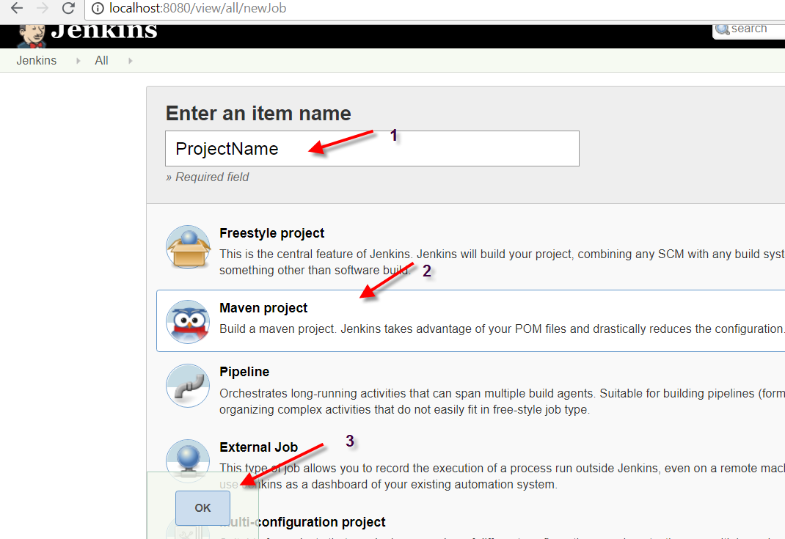

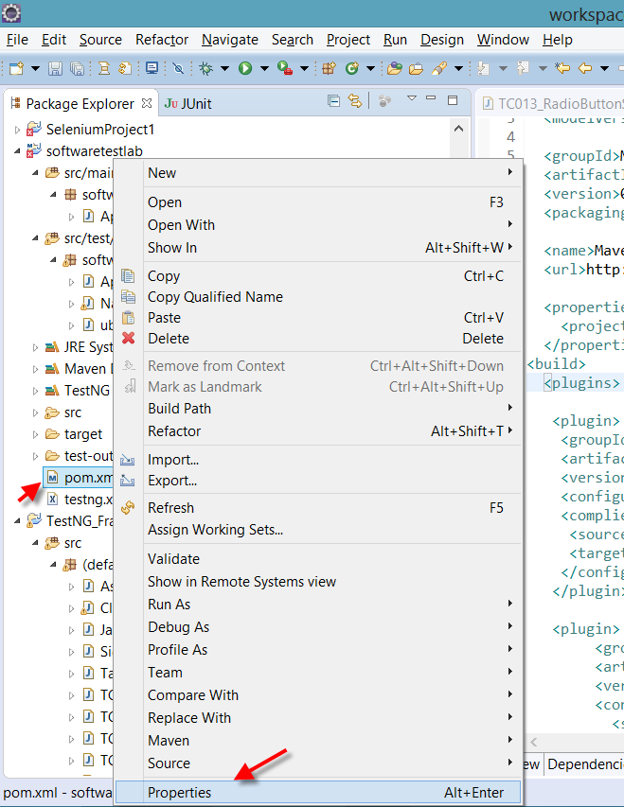

Copy path

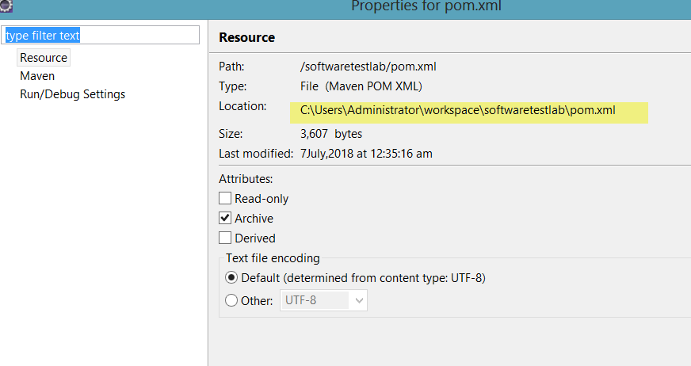

Paste below

