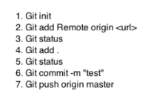
Create a new repository on git
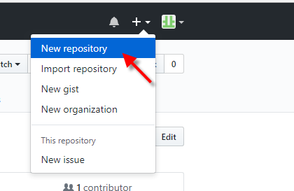
Copy url
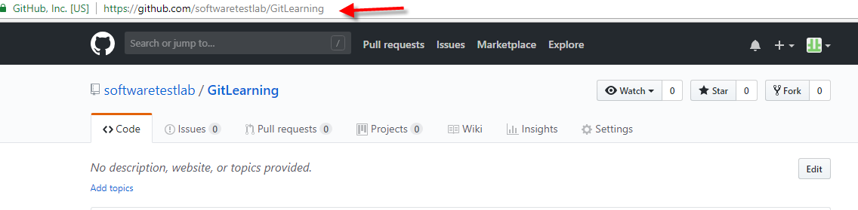

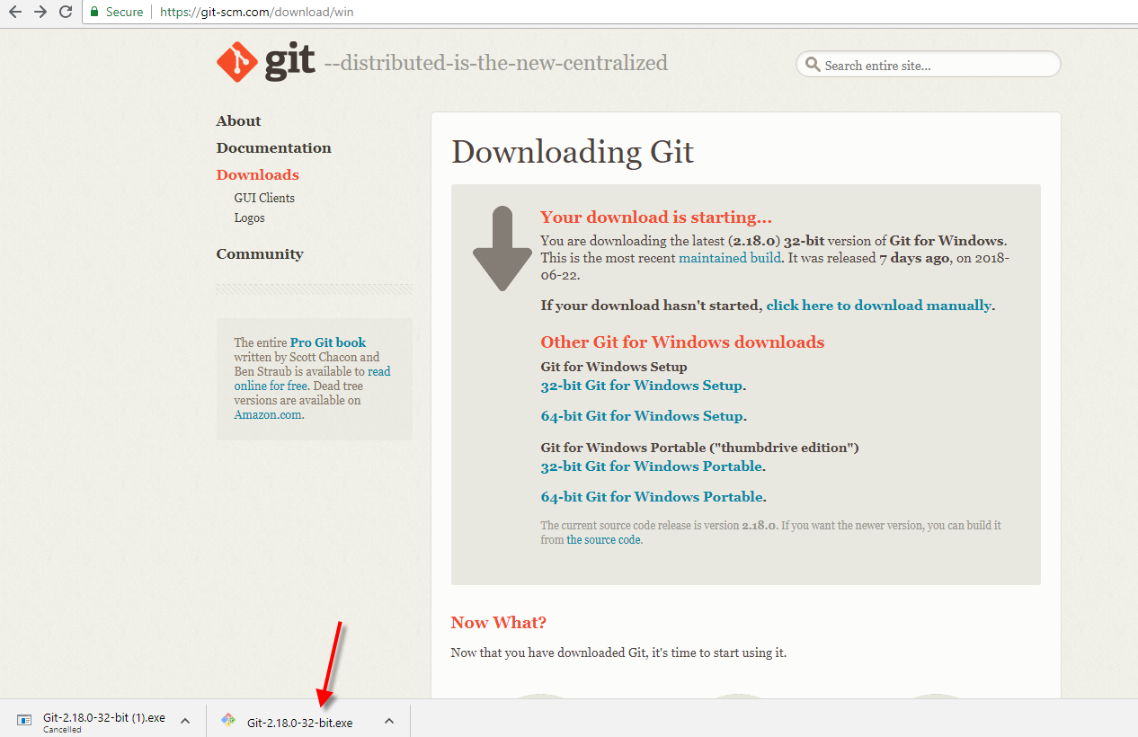

Click next..next until it comes to installation screen..dont edit anything
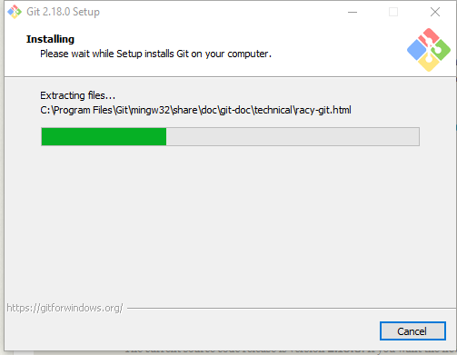

C:\Users\Softwaretestlab>cd C:\Users\Softwaretestlab\eclipse-workspace\softwaretestlab
C:\Users\Softwaretestlab>cd C:\Users\Softwaretestlab\eclipse-workspace\softwaretestlab> dir

Directory of C:\Users\Softwaretestlab\eclipse-workspace\softwaretestlab

29-Jun-18 10:48 PM <DIR> .
29-Jun-18 10:48 PM <DIR> ..
09-Apr-18 07:55 PM 1,022 .classpath
09-Apr-18 07:55 PM 567 .project
09-Apr-18 07:55 PM <DIR> .settings
06-Jun-18 10:14 PM 2,809 pom.xml
09-Apr-18 07:54 PM <DIR> src
09-Apr-18 07:55 PM <DIR> target
17-Jun-18 12:22 AM <DIR> test-output
3 File(s) 4,398 bytes
6 Dir(s) 74,611,519,488 bytes free

C:\Users\Softwaretestlab\eclipse-workspace\softwaretestlab>git init
Initialized empty Git repository in C:/Users/Softwaretestlab/eclipse-workspace/softwaretestlab/.git/

C:\Users\Softwaretestlab\eclipse-workspace\softwaretestlab>git status
On branch master

No commits yet

Untracked files:
(use "git add <file>..." to include in what will be committed)

.classpath
.project
.settings/
pom.xml
src/
target/
test-output/

nothing added to commit but untracked files present (use "git add" to track)

C:\Users\Softwaretestlab\eclipse-workspace\softwaretestlab>git add .

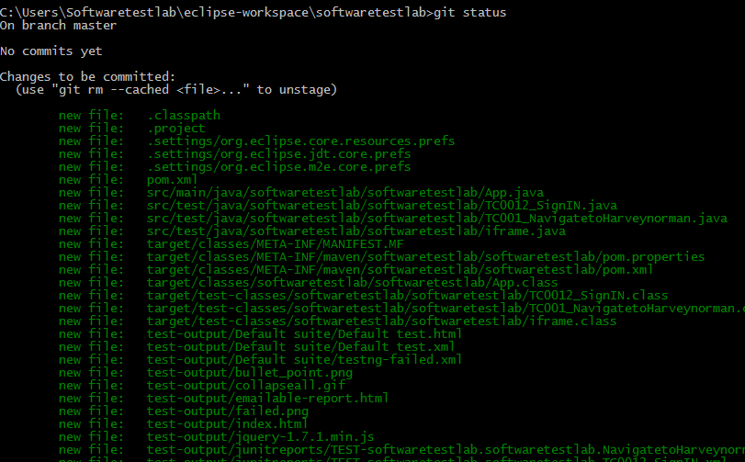

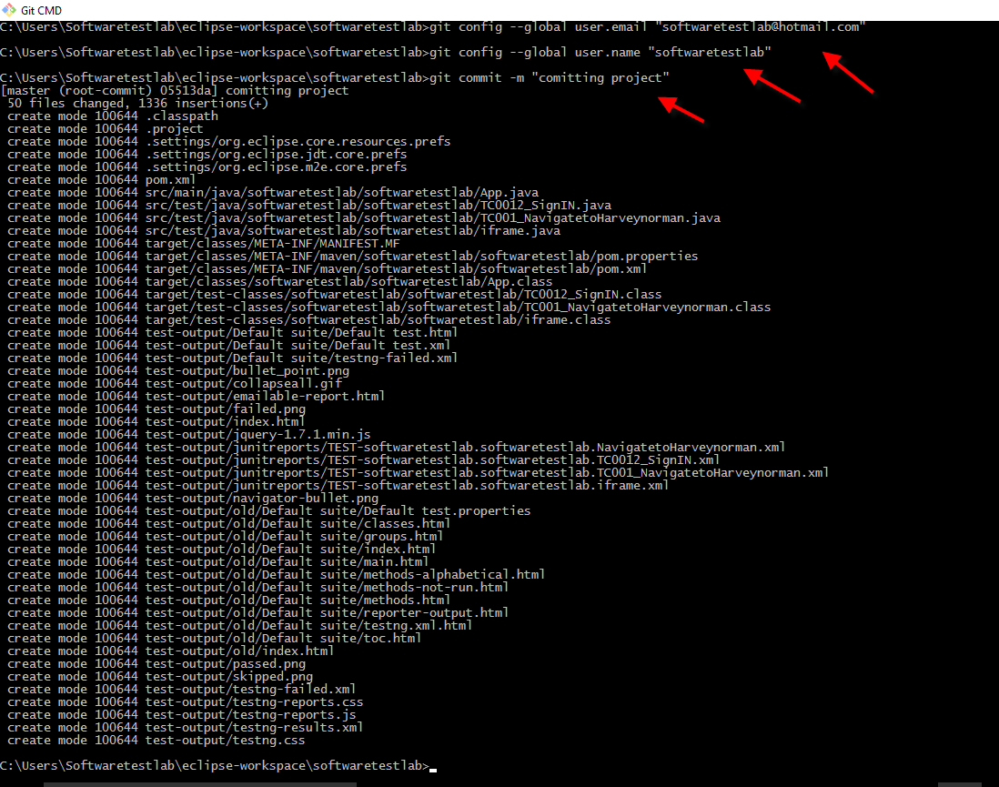

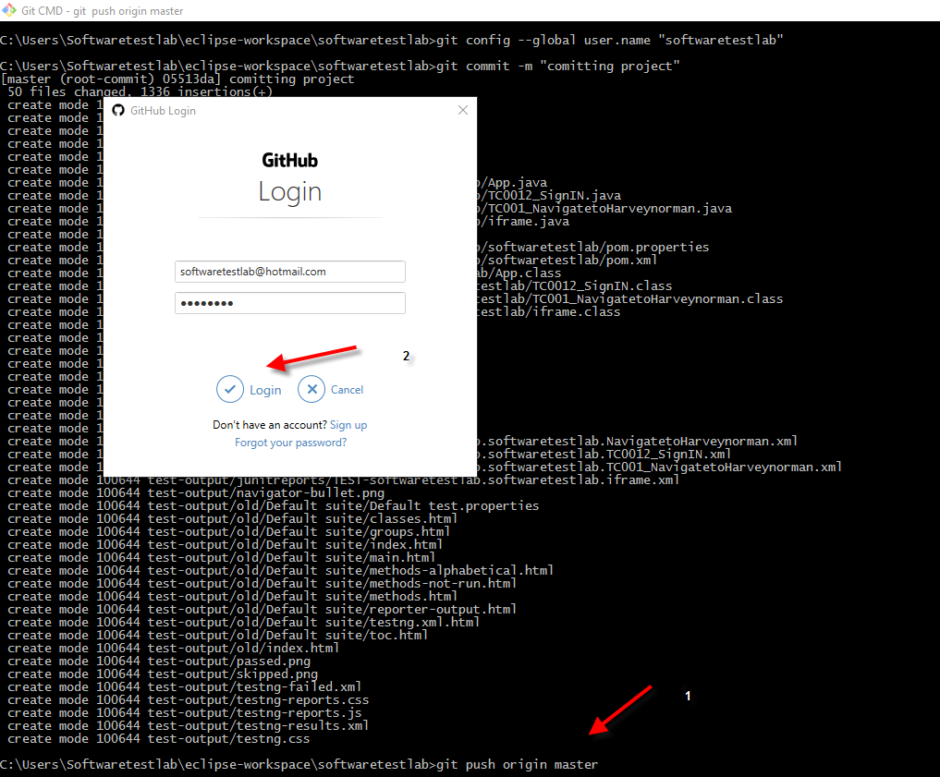

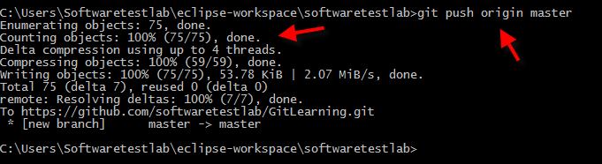

If permission denied..due to public key missing then generate ssh key on your local machine and paste in git

Ignore these red lines
Pull concept
To get a project which is not present on your local machine from Git
Select a directory on your locan and perform clone
Note: clone is done only once
>Git clone “url of the project from git”
Now open the project in eclipse
Any new changes you want to pull into local from now on you have to use below command
>Git pull origin master

Create a new branch
Create a new class in the project
Get the path of the project

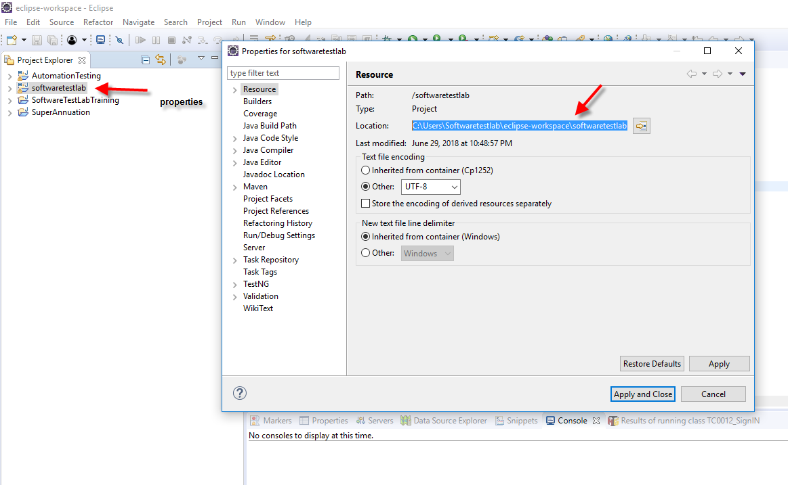

Got to git CMD and enter the path
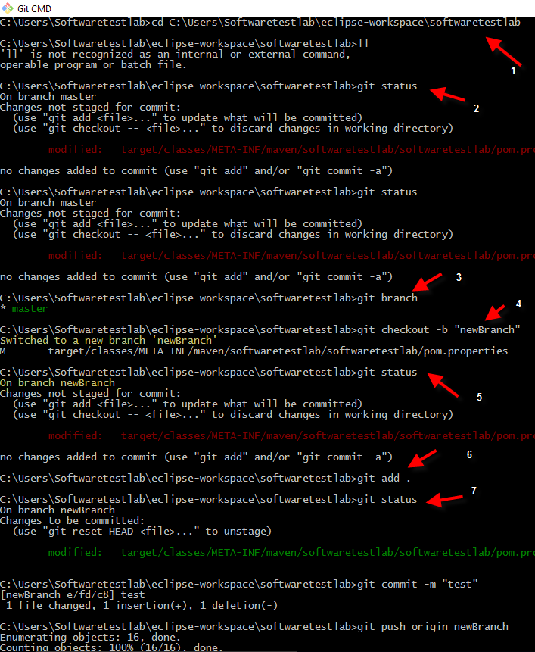

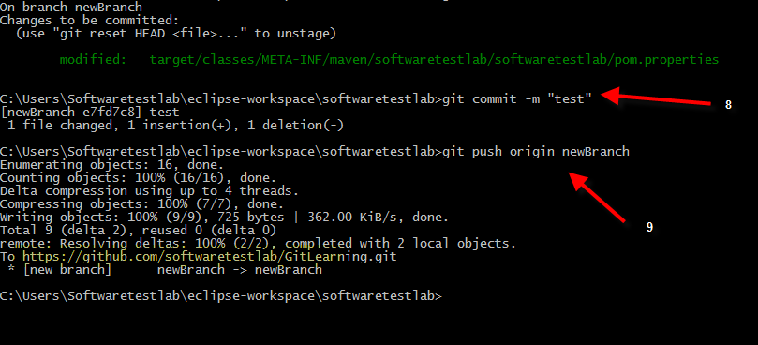

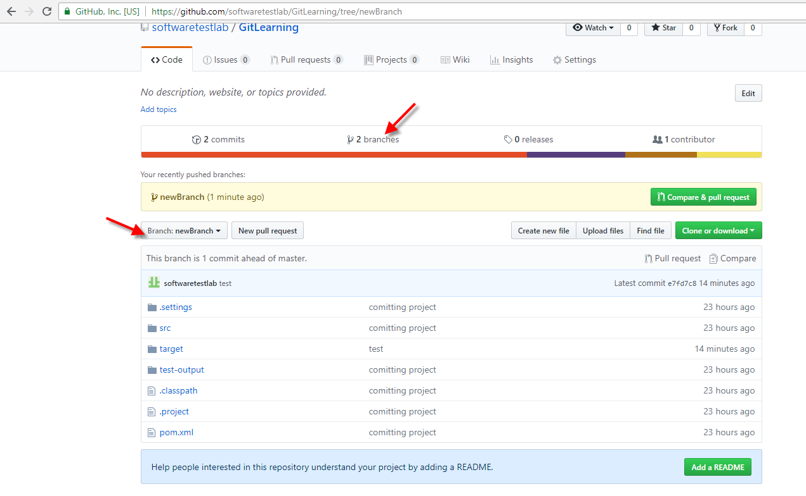

Process to merge code from branch to Master
Click ‘compare & pull request’ from above screen
Below screen—click on ‘create pull request’

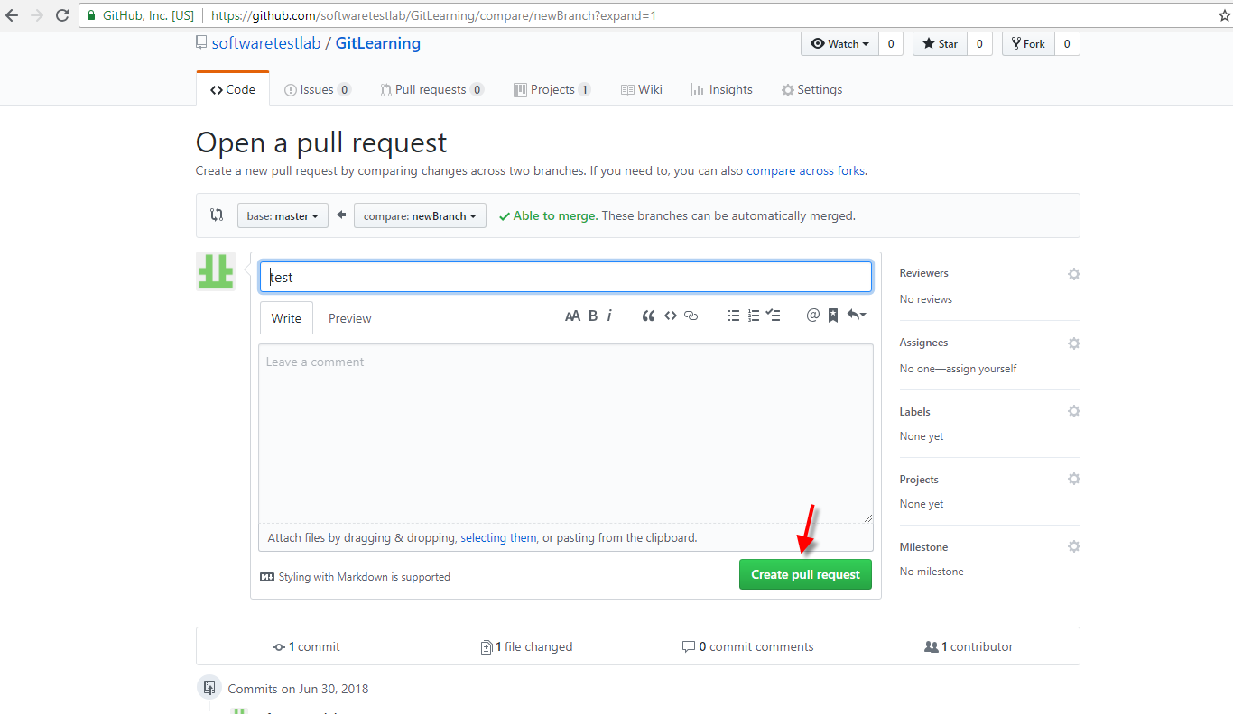

Files changed’ will be reviewed by your Test lead (so provide url )

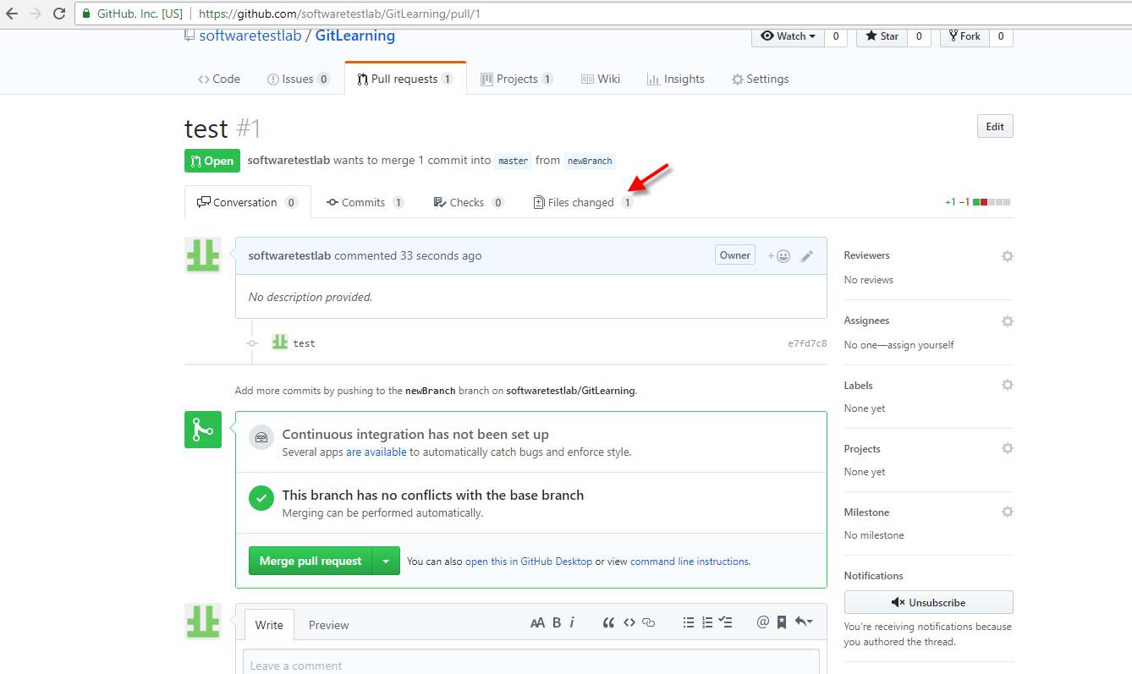

Your lead clicks on ‘review changes’ and drop down appears
Based on your code standard your lead will write a review and select one of the 3options
And click on ‘submit review’ button
Lets assume ‘Approve’ is selected and clicked on ‘submit review’
Note: as I cant approve my code its not allowing me select approve radio button
Lets write a comment and click on submit review button

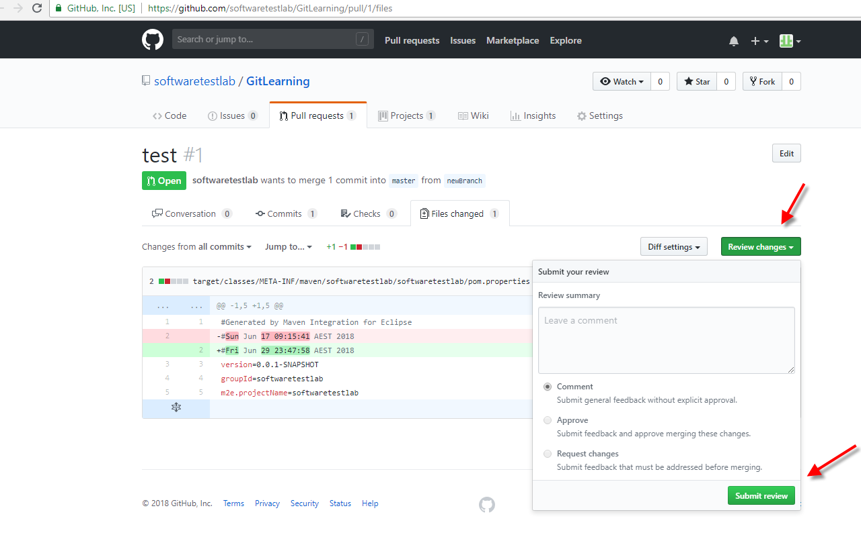

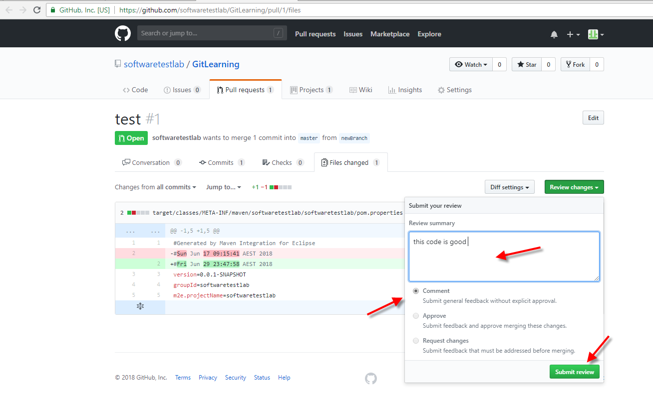

Either you have the permission to merge or your team lead ---click on ‘submit review’

Click on ‘merge pull request’
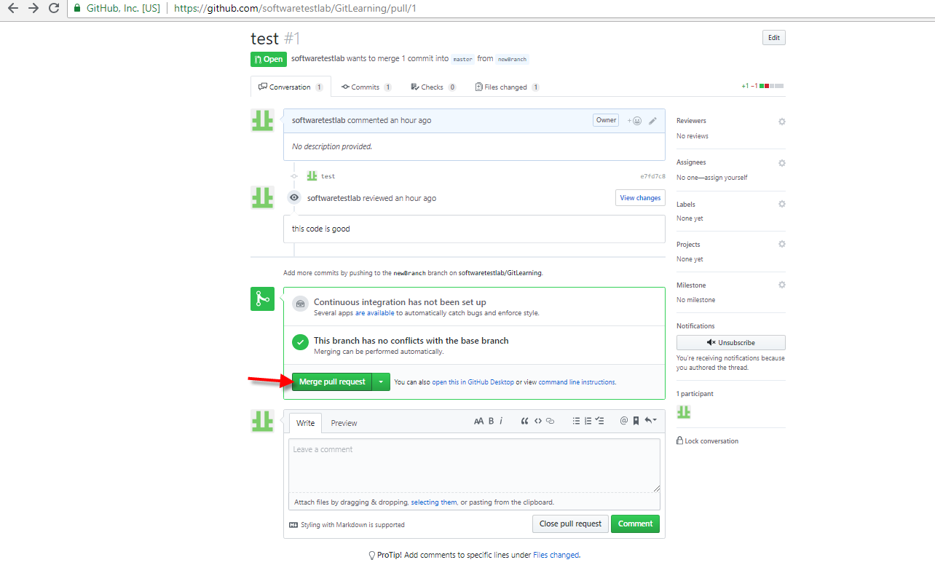

Confirm merge’ –click
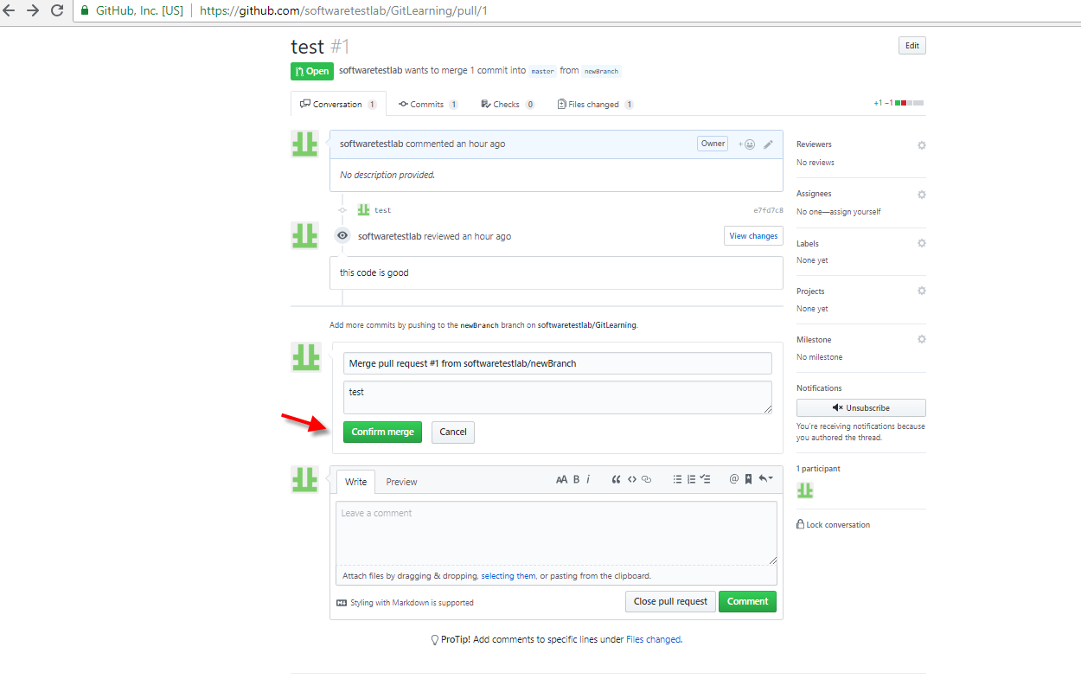
This below screen tells us we have merged from branch to master
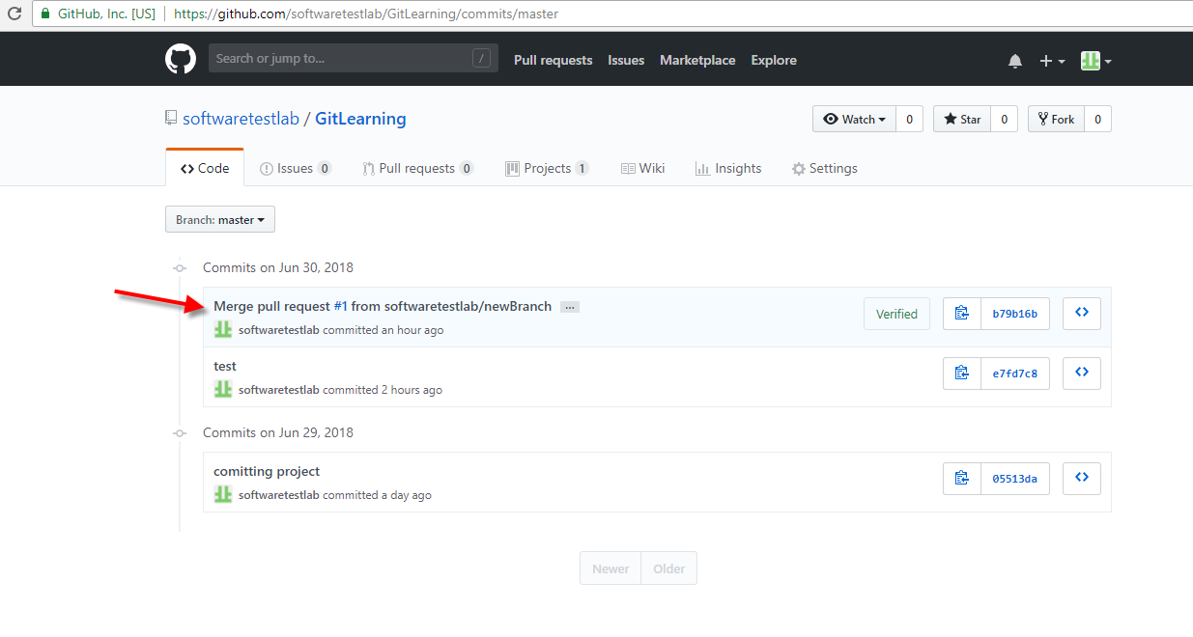
Pull code
Lets suppose other automation testers code is also added to master then …
Next day morning …Now pull these new changed from master to local

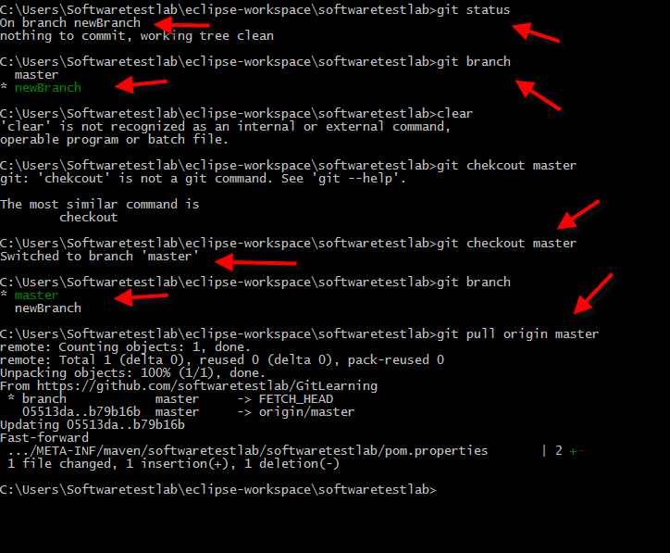

Now got to the project in eclipse and you can see these new changes added to your project

Java –jar Jenkins.jar

