Weblist
Code:
package Login;

import java.util.concurrent.TimeUnit;

import org.openqa.selenium.By;
import org.openqa.selenium.WebDriver;
import org.openqa.selenium.chrome.ChromeDriver;
import org.openqa.selenium.support.ui.Select;

public class DropDownSelection {

public static void main(String[] args) {
System.setProperty("webdriver.chrome.driver", "C:\\Users\\Softwaretestlab\\chromedriver.exe");
WebDriver driver = new ChromeDriver();
//driver.manage().window().maximize();
driver.get("http://www.harveynorman.com.au");
//Select first product from the homepage
driver.findElement(By.xpath("//*[@id=\"category-grid\"]/div[1]/div[1]/div/div/div[3]/a")).click();
//Wait few seconds for the page to load
driver.manage().timeouts().implicitlyWait(10, TimeUnit.SECONDS);

/*-------------------------To select dropdown using visible text-----------------------------------------------------------------

Select Warranty = new Select(driver.findElement(By.id("select_999999900")));
//To Select Warrant through visible text opiton
Warranty.selectByVisibleText("1 year Product Care");
---------------------------------------------------------------------------------------------
*/
/*---------------To select all dropdown elements-----------------------------------------------------------------------
Select Warranty = new Select(driver.findElement(By.id("select_999999900")));

//Get all the elements in from dropdown
for(int j=0;j<=3;j++)
System.out.println(Warranty.getOptions().get(j).getText());

-----------------------End of Select dropdown------------------------------------------------------------
*/

/*---------------To select dropdwon elements by index-----------------------------------------------------------------------
Select Warranty = new Select(driver.findElement(By.id("select_999999900")));
// To select it by index
Warranty.selectByIndex(3);
----------------------End of index method-------------------------------------------------------------------
*/

}

}

1. To select a particular element from weblist
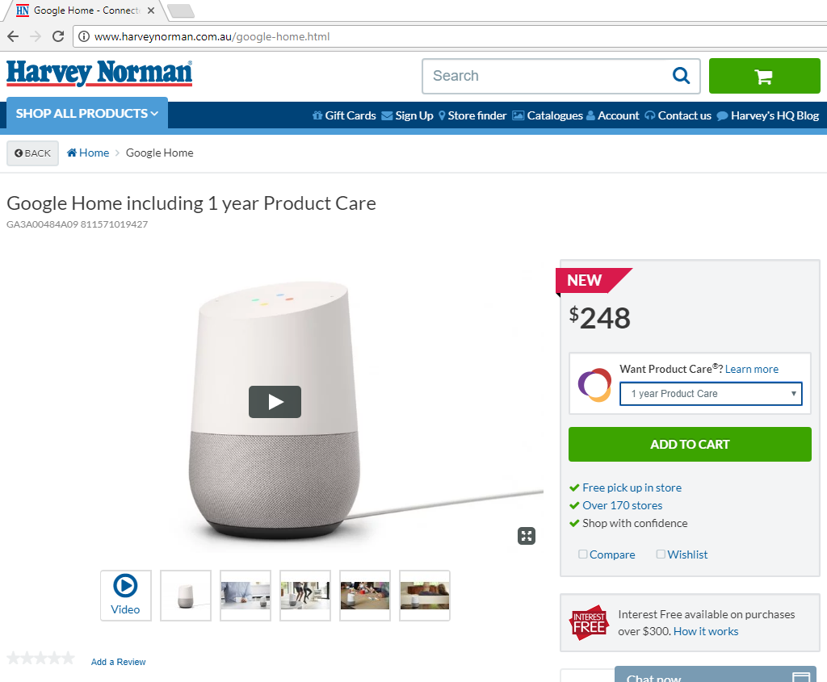

2. Here is the list of elements in dropdown and lets fetch all them through code

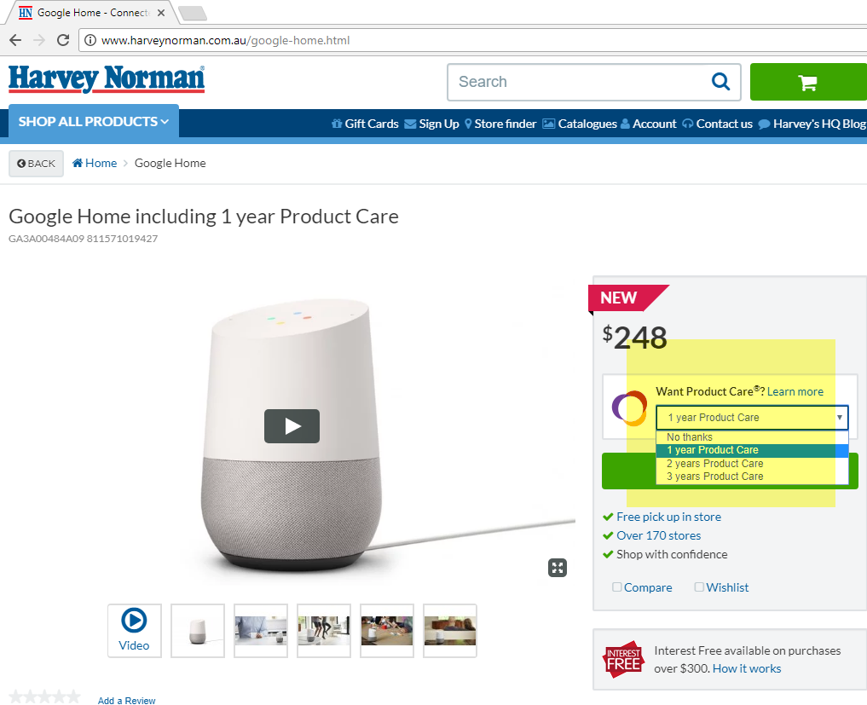

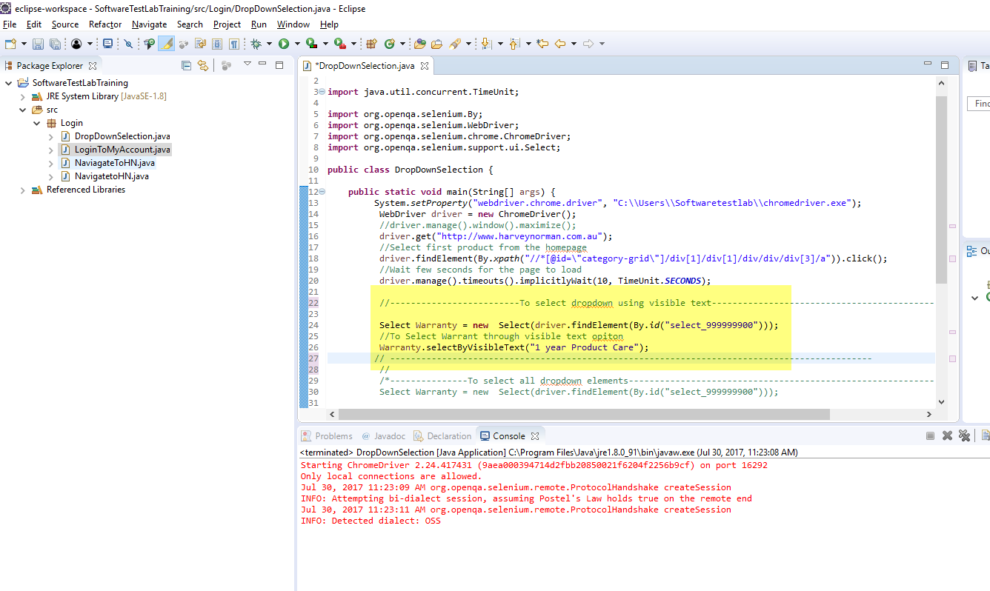
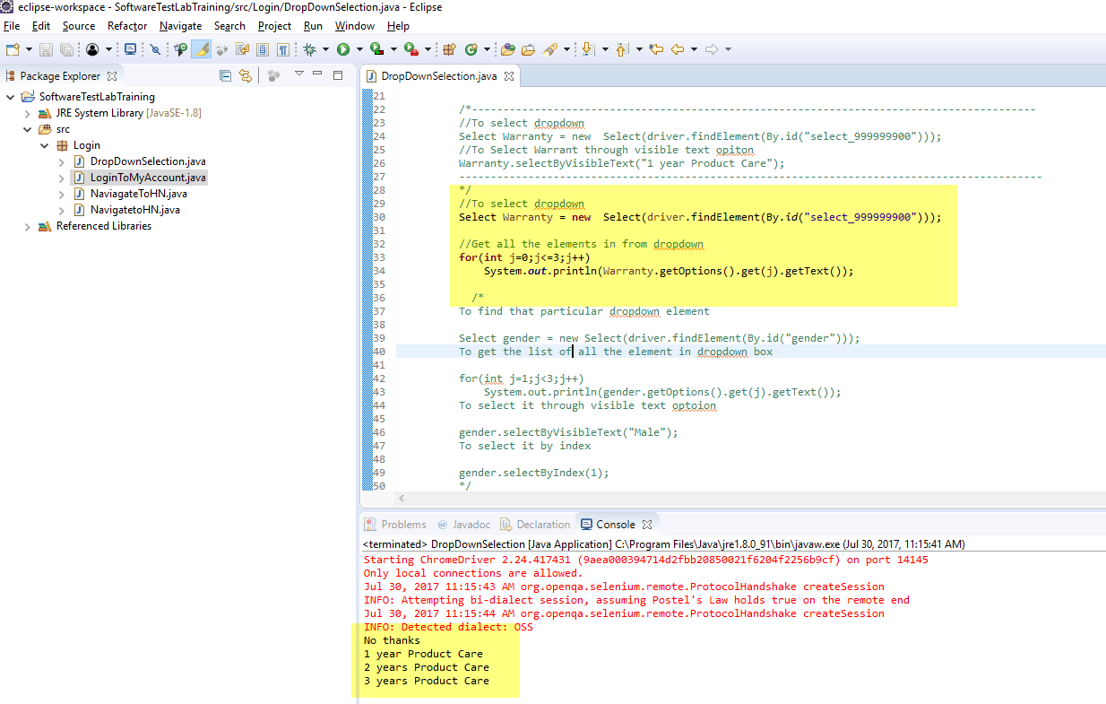

3. Select by index
