Atlassian JIRA

Introduction to JIRA Issue and Project Tracking

Software Tutorial 1

Tutorial #1: Introduction to JIRA Issue and Project Tracking Tool
Tutorial #2: How Are Issues Handled in JIRA?
Tutorial #3: Creating and Working with Sub-tasks in JIRA
Tutorial #4: Managing Issues, Workflow Progress & Reporting Feature
Tutorial #5: Admin Aspects of JIRA Test Management Tool
Tutorial #6: Using JIRA for Managing Agile Projects
*********************
Before we get into what this tool is, how it can be used and who it is used by, I want to lay out some ground rules that will help us learn any tool easily and effectively in a short period of time.


I personally think that learning any tool has 2 phases to it:
- Understanding the underlying process
- Learning the tool itself- features/capabilities/shortcomings etc.
Take the case of JIRA. Think that you are a newbie and know nothing about it. You have heard about it from various friends, online references etc. You want to try your hand at it. How can you do that?

Ask yourself these questions: What kind of tool is it? Who uses it?
Tip: When you are learning a tool (or any other software) and you want to get a non-technical description, Wikipedia is the best place to start. Since wiki is aimed at a general audience, the information will be easy for you to understand without being overwhelming.
JIRA is an Incident Management tool; what is Incident management? This is the stage when you forget all about the tool and work on the process.
Before we see more details about this tool, let’s get familiar to the incident management process.

Incident Management Process overview:
Any task that is to be completed can be considered an incident.
The top 10 Incident Management requirements are:
- An incident has to be created
- Additional information needs to be added to the incident to make the description comprehensive
- Each stage of its progress should be marked and moved along the steps until completion
- The stages or steps that the incident needs to go through should be defined
- It might be linked to other incidents or have some child incidents
- Incidents might have to be grouped according to some common rules
- Concerned people should be aware of the incident creation/change in the state
- Others should be able to provide their feedback on a certain defects
- Incident should be searchable
- Reports have to available, if we need to see any trends
Whether it is JIRA or any other incident management tool, they should be able to support these core 10 requirements and enhance them if possible, right? In this series, we will look into how JIRA fares with respect to our list.

What is JIRA?
It is a defect tracking/project management tool by Atlassian, Inc., the current version is 6. It is platform independent.
You can download JIRA and try it free for 30 days at this page: Download JIRA

Who uses JIRA?
Software project development teams, help desk systems, leave request systems etc.
Coming to its applicability to QA teams, it is widely used for bug tracking, tracking project level issues- like documentation completion and for tracking environmental issues. A working knowledge of this tool is highly desirable across the industry.
Basics about JIRA:
JIRA in its entirety is based on 3 concepts.
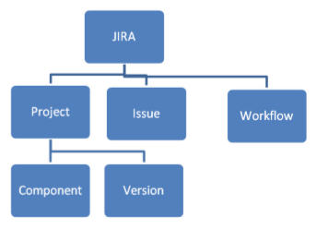
- Issue: Every task, bug, enhancement request; basically anything to be created and tracked via JIRA is considered an Issue.
- Project: a collection of issues
- Workflow: A workflow is simply the series of steps an issue goes through starting from creation to completion.
Say the issue first gets created, goes to being worked on and when complete gets closed. The work flow in this case is:
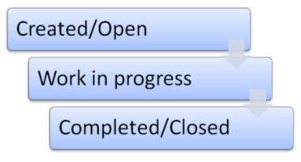

Let us get hands on:
Once you create a trial, an OnDemand account gets created for you and you will be able to login to it.
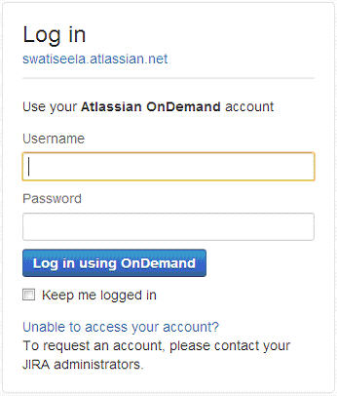

Once logged in, the dashboard page is displayed (unless otherwise chosen) to the user. The dashboard page gives a snap shot about the description of the project you belong to; issue summary and the activity stream (the issues that are assigned to you, the issues that you created etc).
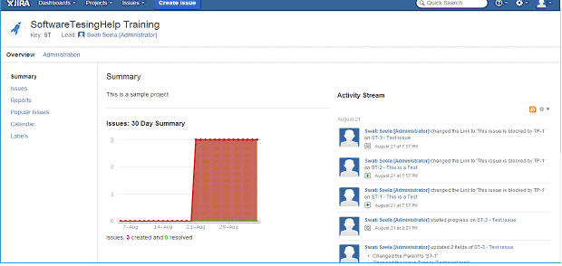

Tip: When you are trying to create/modify a certain issue under a project for the first time, it really helps to know about the project itself.
You can do that by going to the main menu and choosing the Project name from the “Projects” drop down.

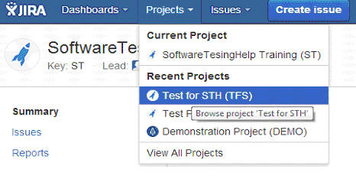
We defined earlier that a project is a collection of issues. Item number 6 in our list – the feature that enables the grouping of the issues is fulfilled with this concept. Projects have components and versions under it. . Components are nothing but subgroups within a project based on common grounds . Also, for the same project, different versions can be tracked.

Every project has the following main attributes:
- Name – as selected by the administrator.
- Key- It is an identifier that all the issue names under the project are going to start with. This value is set during the creation of a project and cannot be modified later even by an administrator.
- Components
- Versions
For instance, take a web based application; there are 10 requirements that need to be developed. There will be 5 more features added to it later on. You can choose to create the project as “Test for STH” version 1 and Version 2. Version1 with 10 requirements, version 2 with 5 new ones.
For version 1 if 5 of the requirements belong to Module 1 and the rest of them belong to module 2. The module 1 and module 2 can be created as separate units

Note: Project creation and management in JIRA is an admin task. So we are not going cover project creation and will continue the discussion using an already created project.
Taking the details in the above example, I have created a project in JIRA called “Test for STH”, the key is “TFS”. So, if I create a new issue, the issue identifier will start with TFS and will be “TSH-01”. We will see this aspect in the next session when we create issues.

The following is how the Project details are displayed in JIRA: (click to enlarge images)
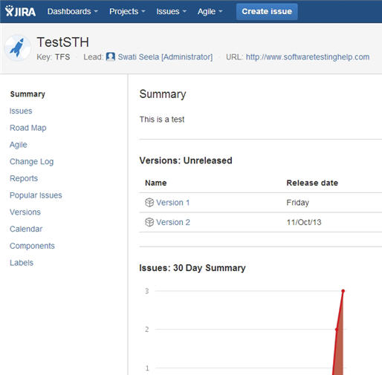
Please note the left hand side navigation.
When I choose the “Components” option, it displays the two components within the project:
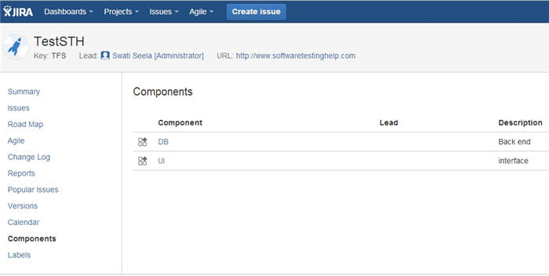

When I choose the versions option, the versions within the project are displayed
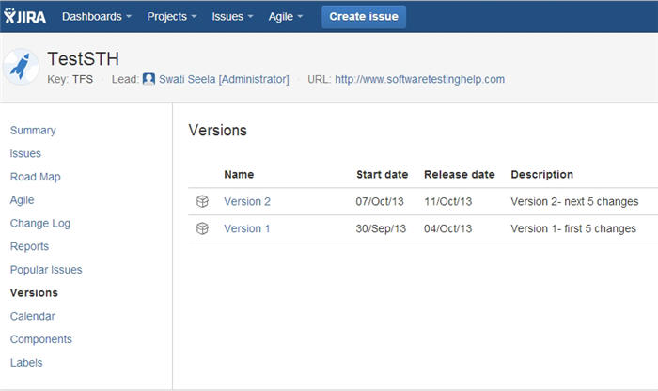
Choose Roadmap option, the version information is displayed along with dates giving a general idea about the important milestones in the project.
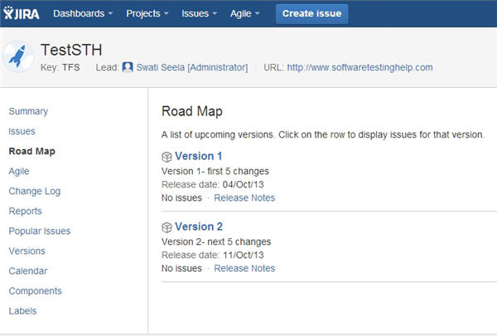
Choose the calendar option to view the milestones date wise:
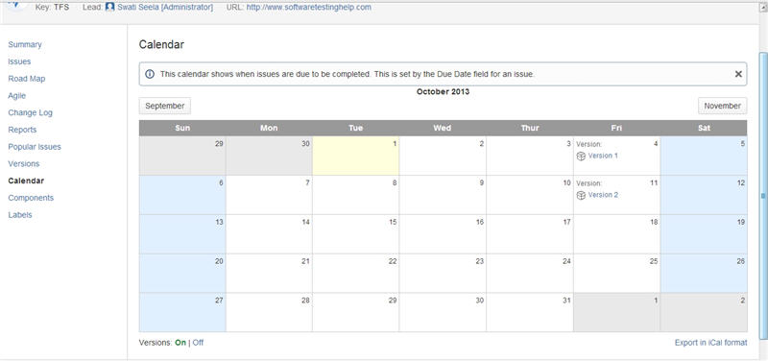
At this point, there are no issues created for this project. If there were, you will be able to see all of them by choosing “Issues” from the left navigation menu.
We will learn all about working with issues in JIRA in the next session.

