Creating and Working with Sub-tasks (Divisions of a Parent Issue) in JIRA – Tutorial #3

Having created an issue successfully in the last JIRA tutorial we are on our way to master yet another important topic today – Creating and working with sub-tasks in JIRA.

A sub-task is nothing but a division of a parent issue (task) into chunks of work that can be assigned and tracked individually.

Example 1: A QA related example could be of the task of Test documentation. Test documentation by itself is an activity that might take a week to finish. Say, it involves the following aspects: Test plan documentation which takes 2 days. Test case documentation – 2 days, Test plan review – ½ day and Test case review – 1 day. Also assume that there are 2 resources.

In this case we can create a JIRA issue of the type task for “Test documentation” and have the following four sub tasks under it:
- Test plan documentation – assigned to resource 1
- Test case documentation – assigned to resource 2
- Test plan review- assigned to resource 2
- Test case review- assigned to resource 1

By doing so, it is easier to have a better insight into the progress task wise and resource wise by breaking a sizeable parent task into sub-tasks.

Note: It should not be confused that an issue type of “Task” only contains “sub-tasks”. An issue of any type can have sub-tasks.

Example 2: An example related to bug could be – if a bug is encountered and needs a code change to fix it, the developer can use a sub-task to track this code-fix that needs to take place. Here, the code-fix (of type sub-task) becomes a sub-task under the bug found (of type Bug).
You can create sub-tasks by following one of the two methods:
- Create a sub-task to an issue, or
- Convert an issue to a sub-task and choose a parent
We will see both the ways below.

Method 1: Creating a sub-task under a parent issue
When a parent issue is already created the following steps can be followed to create a sub-task under it:
1) Open the issue. Go to “More” drop down in option on the top. Choose the “Create sub-task” option from the list.
(click on any image to enlarge)
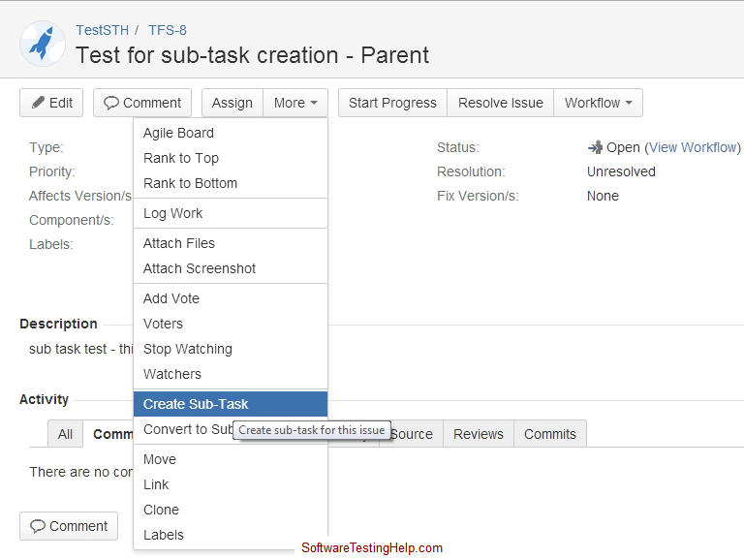
2) The “Create Subtask” dialog with the parent issue number will come up. This is similar to the “create issue” dialog, except that:
- Project: this field does not exist, because the sub-task will have to under the project that the parent is created.
- Issue type- auto populated as sub task. The drop down also has a “Technical Task” as an alternative. In case of our example 2, marking it is a Technical task will be more appropriate.
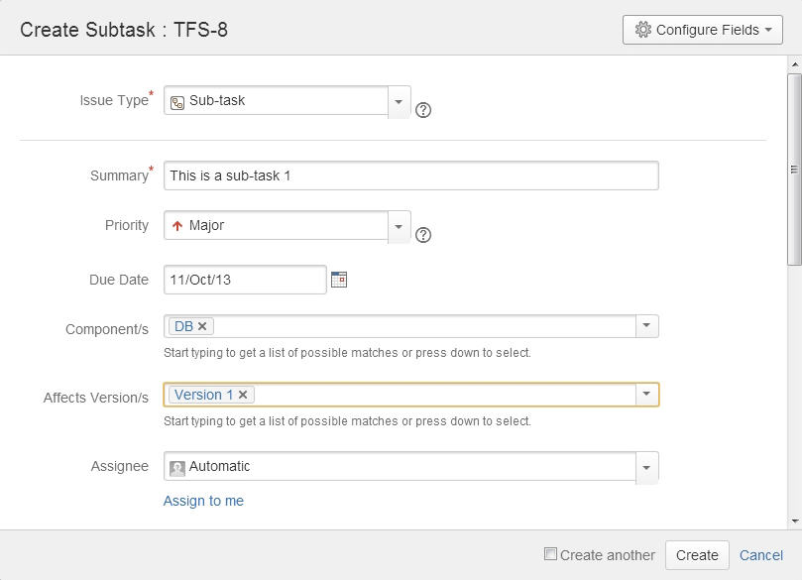
3) Enter the information as desired and click on “Create” to create the sub-task. Once created, the link to the sub-task will appear in the “Sub-tasks” section of the parent issue as shown below:
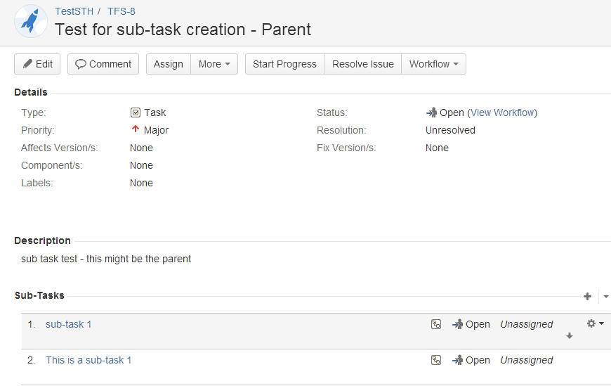
Note: You can choose to add a new sub-task by clicking on the “+” sign in the sub-tasks section shown above.

4) Click on the link of the sub-task that you want to created. The details will be displayed as below.
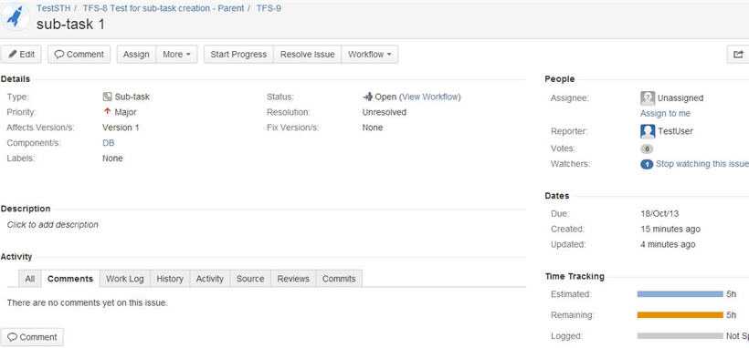

Method 2: Converting an issue into a sub-task
1) Open a created issue. Go to “More” drop down list and choose “Convert to Sub-task” option. The following screen gets displayed.
– Type in the issue ID or you can search it by using the link provided.
– As the message on the screen specifies: only non-sub-task type issues already existing under the same project can be chosen.
– Choose the sub-task type as either Sub-task or technical task.
– Click Next.
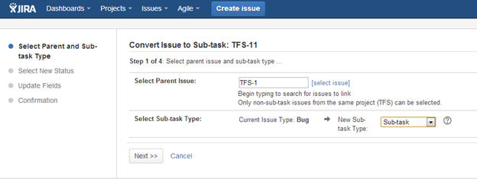
2) Continue with steps 2 and 3 by choosing “Next”

3) Step 4 will show you the conversion summary. Choose Finish to convert an issue to a sub-task.
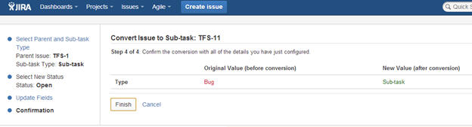
4) This issue will now be displayed under the “Sub-tasks” section of the parent section.

Some important points to note:
1) You can have as many sub-tasks as needed under an issue.
2) You cannot have sub-tasks to a sub-task.
3) Once you create a sub-task under a parent, the parent can no longer be converted into a sub-task.

4) A sub- task can however be converted into a parent issue. To do so, go to “More->Convert to Issue” option. The following screen comes up. This process is similar to the method 2 of issue creation. Choose the new issue type and follow through all the steps to convert the sub-task into an issue.
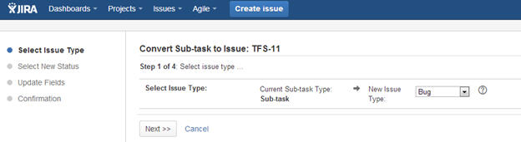

5) For an issue with sub-tasks the “Time tracking” portion will display the consolidated time of the parent + the sub-tasks.
For example, if the Parent issue’s Original Estimate field was chosen as 5 hours and the sub-task’s was set to 3 hours during the creation. The time tracking section of the Parent issue will display the ‘Estimated time’ as a sum of both parent and sub-task. For our example, it will display 8 hours (5+3).The same is true with the “Remaining Time” field too. There is an option to just display the parent’s time tracking information not considering the sub-tasks. You can do so by un-checking the “Include sub-tasks” checkbox in this section.
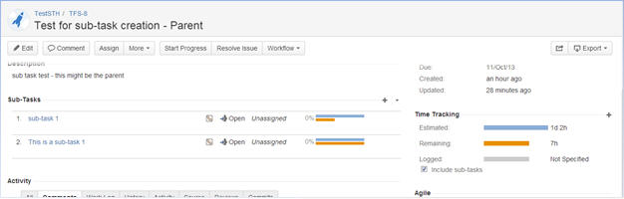

6) In the sub-tasks section you can choose to display all the sub-tasks or just the ones that are open by clicking on the down-arrow next to “+” sign.
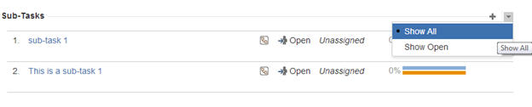

7) You can work on your sub-task without having to navigate away from the parent issue. The activities you can perform are listed when the “Actions” option corresponding to each sub-task is clicked on. You can directly choose what you would like to do from the list that comes up.
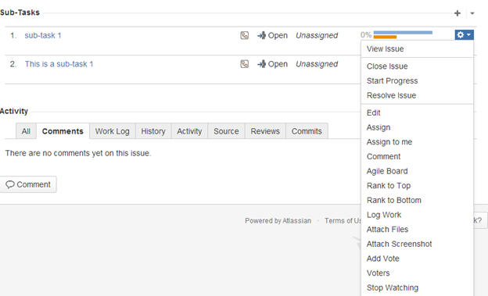
This sums up all there is to know about sub-tasks in JIRA. In the next article we will see cloning, editing, emailing issue etc.

