Atlassian JIRA Tutorial #4 – Managing Issues, Using Workflow Progress and the Reporting Feature
JIRA User Module – Conclusion
We have seen the different kinds of issues and how to create them in our previous JIRA Tutorials. This is a next JIRA tutorial in this series where we will learn how to use them, the workflow progress and the reporting feature of JIRA.
The issue once created can be accessed by searching the ID, browsing the “Issues” menu item or going to the project details and checking the issues tab.
When you access an issue and click on its link, the details will be displayed. All the actions that can be performed on the particular issue are available on the header of an issue details screen:
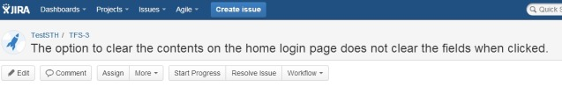
We will go in a sequential order from Right to left and discuss all the options.

Manage Issues in JIRA:
1) Edit: As the name suggests, this option lets you modify an issue created. Click on it and modify the information as desired. Choose ‘Update’ when done. This is similar to “Create Issue” dialog.
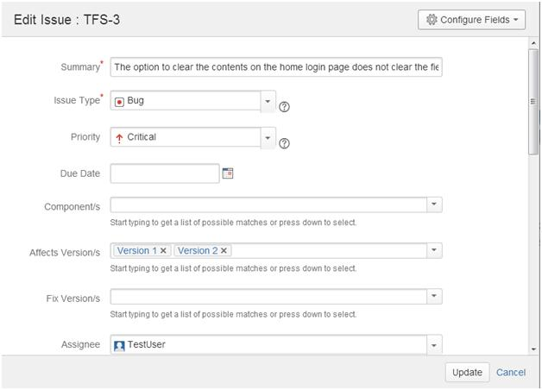
2) Comment: This is a useful way to record the proceedings on an issue and to communicate with the concerned members. Enter your comments and choose the option to restrict viewership:
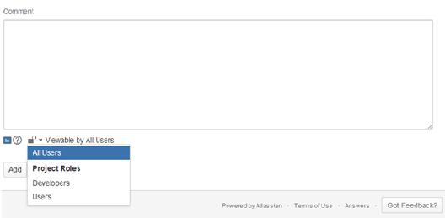
3) Assign: This is the option you would need when you want to shift the ownership of an issue. Enter the Assignee information, comments (anything that you would want to communicate) and choose the viewership of the comment. Once an issue is assigned to the user, an automatic email is sent (if this option is chosen by the admin) and the issue appears on the assignee’s dashboard on login.
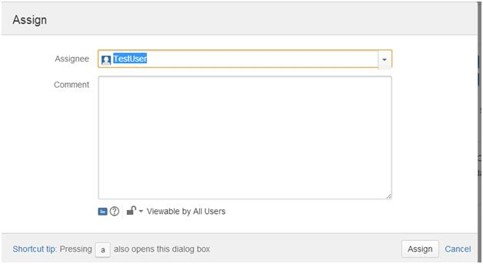
4) More: The following options are available under the “More” menu item:
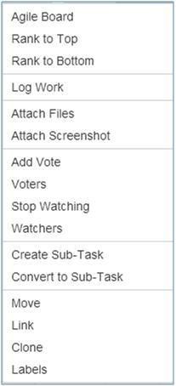
Agile Board, Rank to Top, Rank to Bottom -> Related to Agile Projects – the details of which are going to be coming up in a later article.
Attach Files, Attach Screenshots -> Lets you attach files to an issue. The screenshot option will auto capture a screenshot. All you need to do is print screen on your machine and you can directly copy it here into JIRA.
Add Vote, Voters, Stop watching, Watchers -> Voting is a process that JIRA users can perform to support the resolution of an issue favorably or unfavorably. The options in this section facilitate the same. You can also choose to watch an issue – when you do so, all the changes to it will be notified to you.
Create Sub-Task, Convert to Sub-task -> These are the options that help create and work with sub-tasks. The details are available in tutorial #3 of the JIRA series.
Labels -> This concept is similar to the “Labels” that we find on various blog and web pages. You can categorize issues based on Version and Component formally, but when in need of something more informal, this option can be used. For example, all the issues raised to track peer review comments can be labeled “peer review” to view and track them easily.
5) Log work: This is a way to track the progress on your issue in terms of time. When this option is used, the following dialog opens up. As you can see, the detailed information about how much time is spent on an issue, how much is remaining, etc can be logged here.
(Click on images to enlarge)
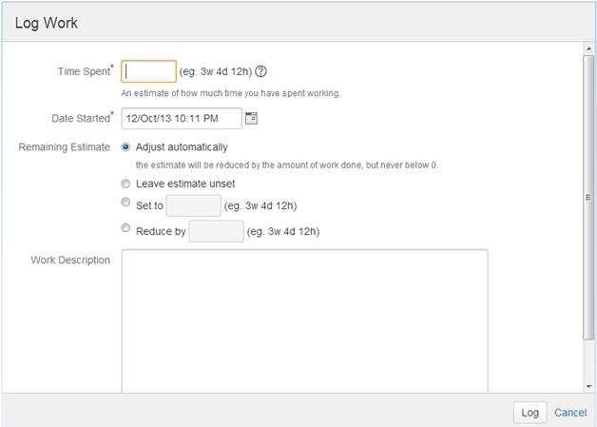
6) Move: JIRA issues can be moved across projects. However, the move from one project to another might mean a different target workflow, a different issue type, a new status etc. It is therefore advisable to analyze thoroughly how the move is going to affect the issue before going ahead with this.
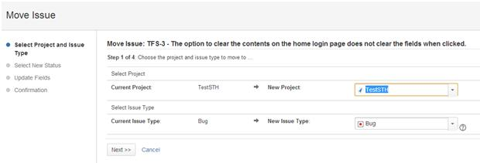
7) Link: This is a very versatile feature of JIRA that allows you can logically link issues with one another and establish relationships/dependencies.
An example situation where this can be used in QA projects is when a certain defect prevents you from working a certain requirement. You can use this option to show the dependency.
When this link is accessed, the following dialog opens up. Using this dialog is very simple:
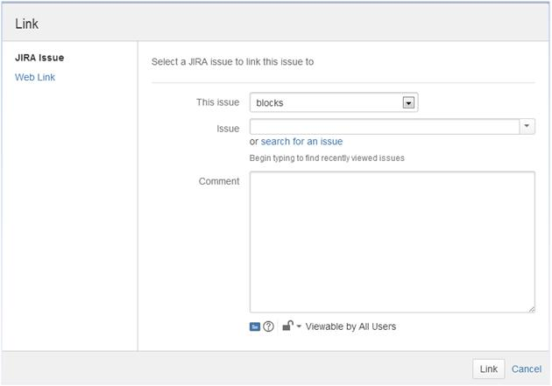
The different kind of associations can be chosen from the “This issue” list box. The list contains:
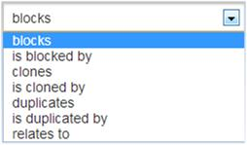
Alternately, you can choose to include a web-link as a reference.
8) Clone: As the name implies you can create a duplicate for an issue.
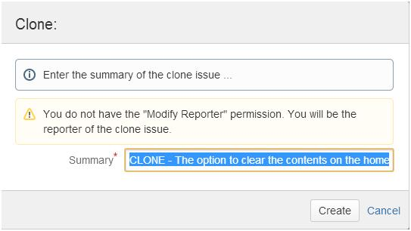
When an issue is cloned:
- The cloned issue’s summary begins with “CLONE” prefixed.
- There will be a link established between the parent issue and the cloned issue.
9) Email issue: Click on the icon . Enter the information for the recipient of the issue information in the below dialog that opens up. An email with the JIRA issue details will be sent.
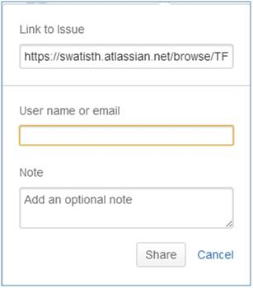
10) Export: JIRA also provides a way to write the issue information to external files. To do so, click on the “Export” button at the right most corner and you will see the formats to which you can download a JIRA issue:
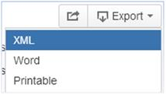

How to move a JIRA issue through the different stages of Workflow?
1) An issue created in JIRA is always in the status “Open” upon creation.
2) The workflow stages that it goes depends on the project type and the workflow assigned to the project while creation.
3) Only Admin will be able to choose this and once chosen, it cannot be changed and all the issues under the project will go through the same workflow.
4) When “Start Progress” button is clicked the issue status changes to “In Progress “and button label changes to “Stop Progress” which when clicked will revert the status back to “Open”.
5) Clicking on “Workflow” button will display you a list box of the next stages that an issue can go to.
6) If the issue needs to be set to “Resolved” directly, there is a “Resolve issue” button available. On clicking it you will be able to choose the reason for saying the issue is fixed.
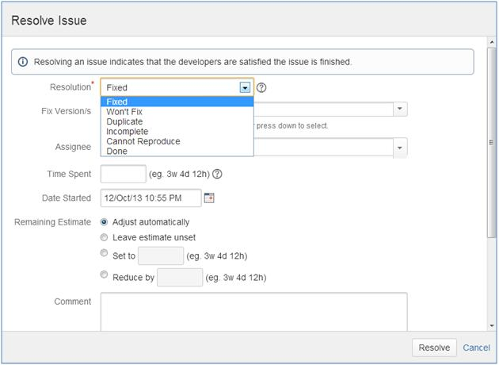
7) To view the workflow that the certain issue goes through, click on the “View workflow” link that is next to the status field of an issue in the issue details page. For example, for my issue the workflow displayed is:
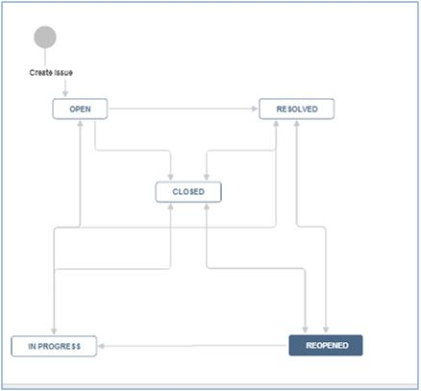

JIRA Reports:
JIRA also comes with a robust reporting feature. There are many kinds of reports that it facilitates. Browse through a project whose details you would want to get a report of and go to the “Reports” tab. Here you will see a list of all the reports that can present for you. Choose the report and set the data criteria and you will have a custom made report in hand within no time.
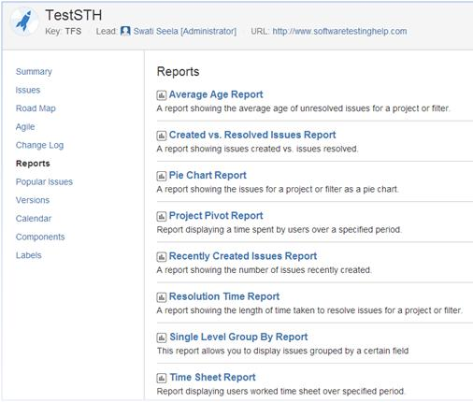
Also, for an incident management tool, a user would expect strong search features and JIRA fits the bill in this area too. So, be sure to leverage that to your benefit.

Conclusion:
This brings us to an end the ‘JIRA- User’ part of the series. As always, we hope these 4 JIRA tutorials in the series will not only helps you use Atlassian JIRA issue tracking software successfully but also aids you in achieving best results for your Project/Incident/Test/Defect management activities.
The next tutorial is going to deal with JIRA’s administration activities – Project Management, User Management, Access permissions etc.

