Learn the Admin Aspects of JIRA Test Management Tool – Tutorial #5

JIRA Administration:
We are going to learn all about JIRA administration today. This is a unique opportunity to learn the admin aspects of a Project/Incident/Test Management tool.

Not all of them are as effective (and simple) and as accessible from the UI as it is for JIRA. So, as always, concepts are more important than the tool specific details – look out for the operations and their importance- that will help you to estimate what you can expect from the “Admin” module of any tool.

Note: When you create a trial, new JIRA URL will be created for you and the first user who registers will be the admin by default. Use that initial ID to learn the features that are going to be discussed in this article.

JIRA- Project Management:
Project management is one of the first and most important concepts in administration. A JIRA admin can:
- Create a project
- Configure an already created Project.

Create Project:

1) Once you login, in the dashboard itself you will have a few options to get started:
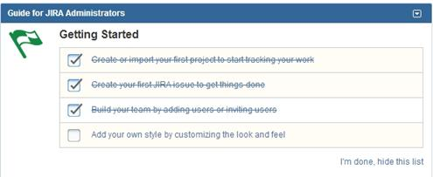

2) You can either click on the item in the list or you can choose:
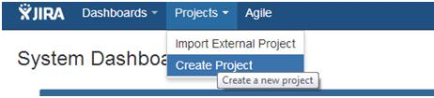

Or go to the Administration->Projects menu option:
And then in this page, you will have an option to “Add Project”

3) Choose any of the above 3 methods to add a project. In the below window, choose the type of the project.

Tip: The Project type will determine the type of workflow your issues will go through.
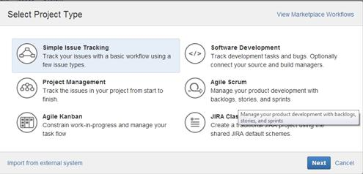

Note: Please note the “Import from external systems” link at the bottom of the page. If you have been using a different bug/issue tracking system and would like to migrate to JIRA. This is the option you could use. Also, if all you had earlier is an excel sheet for all your issues, you can create a project by importing all the issues in the CSV file into JIRA.

4) Enter the project Name, Key (once chosen cannot be changed) and assign a Project Lead (the person who is responsible for the overall project). Click Submit when done.
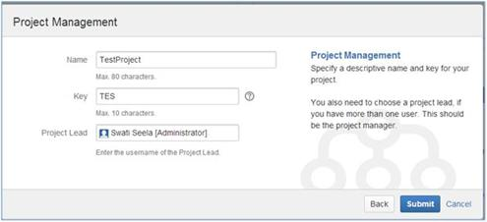

5) The project gets created and the following details are displayed. By going to the “Administration” link you will be able to configure the project.(in case of an already configured project, you can edit the configurations)
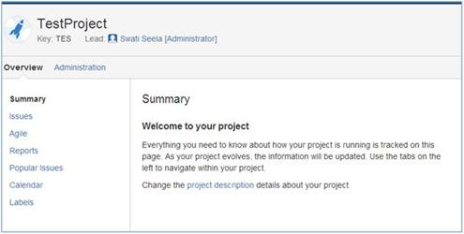

Configuring a Project:
As you can see below, you can choose the issue types that need to show up, the workflow that the project follows, versions and components, people involved and the level of access permissions they have etc. (Click to enlarge image)
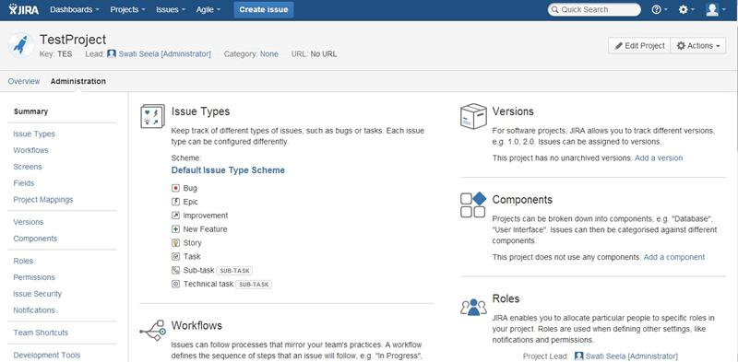

User Management
User creation being the most important part of the User Management process, it is not limited to just that. The other important user related activities performed by a JIRA admin are:
- Edit a particular user information
- Delete a user
- Creating users groups
- Creating Roles
- Permissions
- Setting Preferences
We will see the creations, deleting and editing of an issue in details below. For the rest of the operations, we would encourage you to try them on the site with your trial ID.
Note: With the trial you can add up to 10 users to your account i.e., 9 additional users and 1 admin, yourself.

Firstly, Go to Administration->User Management:

There are two ways in which you can add users to JIRA.
- Create them manually.
- Send an invite to join JIRA to a user’s email ID

Let us look at create manually in detail:

1) Click on Create User button in the below page: (Click to enlarge image)
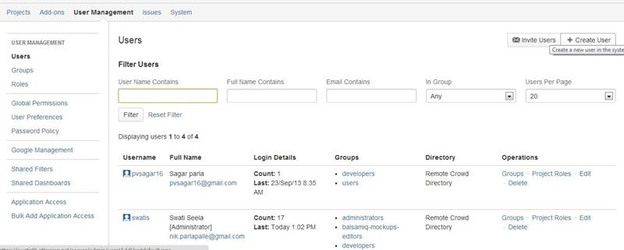

2) Enter the user details in the “Create new user” dialog that opens up. In the below example I have entered only mandatory fields. The others are self-explanatory and can be set as required.
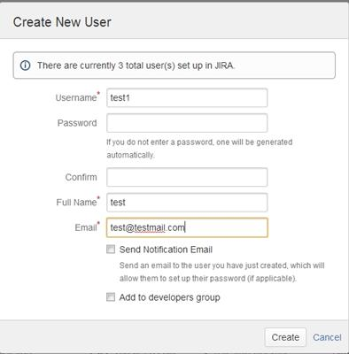
3) On Clicking create, the user gets added and the following confirmation page comes up for the user. (Click to enlarge image)
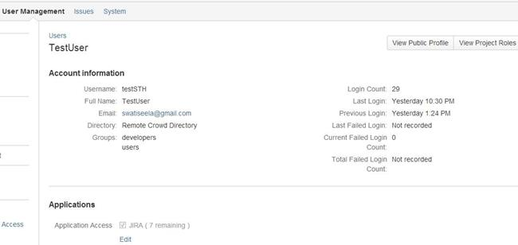

An email is sent to the ID provided to the user with the information on to how to set up a password that would enable the user to login and use JIRA.

Method 2 of user creation, via email invites:
1) Click on the “Invite users” button in the User Management->Users screen and enter one or more email ID’s in the below dialog that opens up. When done, click Send.
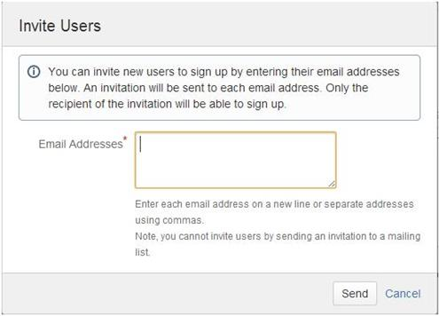

2) The invitation sent message comes up when the message is successfully sent.

3) In case of an email invite, the user is not added until the recipient of the email invite acts on the received invitation.

Editing a user:

1) Go to the User Management -> Users page. All the users available will be displayed. The top portion of this page contains a “Filter” section. This can be used to manipulate how/what user information needs to be displayed. You can choose to keep it empty, in which case it displays all the users available.

2) Below the filter is a list of users organized in a tabular form is displayed. (Click to enlarge image)
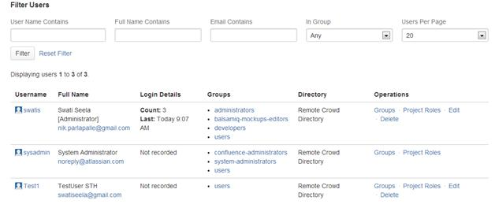

3) Note the “Edit” link in the “Operations” column. Click on the corresponding “Edit” link for the user whose information is to be modified.
You will be able to change the following profile information.
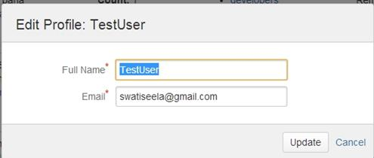

Delete a user:
Choose the “Delete” link corresponding to the user you would like deleted from JIRA. The following confirmation message is displayed and you can choose to delete a user or cancel the operation.
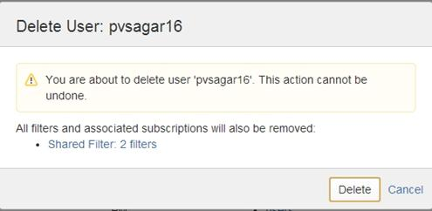

A JIRA admin can additionally:
- Configure the look and feel
- Configure workflows
- Set Project/issue level security details.
- Can add custom fields/screens
- Integrate a JIRA project with development tools to make sure that the commit, revert , changes etc. can reflect immediately in JIRA.
- Configure Dashboard settings
- Set time/time zone information.
- Configure and set email preferences

Please note that all the admin aspects of any tool should more or less support the activities we have detailed above.

Also, admin access to a tool is very powerful and, “with great power comes great responsibility”.

Typically, admin access is limited to just one person in an organization to make sure that accidental inconsistencies do not happen. All the requests for changes, new projects or new users are directed through the admin.
In our last JIRA tutorial we will see how to use JIRA for the projects following Agile methodology.

