How to Use JIRA Effectively for Managing Agile Projects – JIRA Tutorial #6

This is the last tutorial in our JIRA self-learning tutorials series. We hope you find this series useful. We welcome your feedback and suggestions. Let us know if you want us to cover such series of detailed tutorials on other Software Testing or Automation testing topics.

JIRA – Agile Project
Agile methodology for software development has gained immense popularity in the recent years.
Agile Projects follow an incremental approach to development of the requirements.

The highlights of an Agile/Scrum Project are:
- The requirements are created/agreed upon and the grouped together into a Product Backlog
- The requirements (User stories) are ranked in the order of priority and business importance
- Once ranked, the stories are assigned developmental cycles (Sprints) that last for approx. 4-6 weeks.
- The detailed documentation is avoided. Instead, a scrum board is maintained that will show the status and progress.

JIRA successfully supports all the activities listed above for projects following an Agile Methodology. In this article, we will see how.

Note – Firstly, you will need JIRA Agile add-on if you have not gotten it already.

User stories in JIRA are created using JIRA issues:
- You can have a product backlog by creating a main User story and having various sub-tasks under it.
- Or you can create an Issue type -Epic and Issue type – Story linked to it. To do so, in the ‘Create Issue’ page you can go to “Configure Fields” and choose “Epic link” field to be included in the issue creation screen. – This is the most commonly used method.
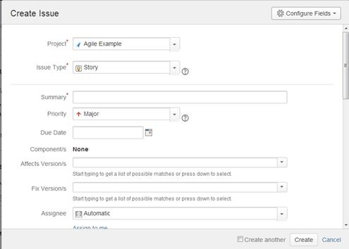

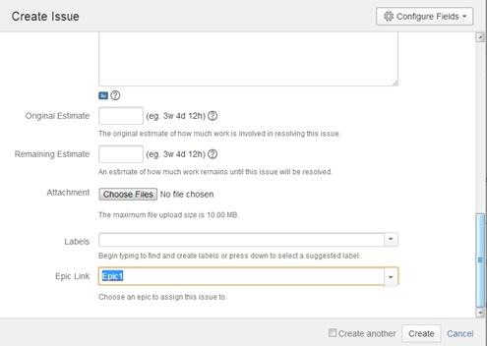

Note: You will not be able to link Epic to another Epic.
The next important feature of an Agile Project is the Scrum board. JIRA provides a solid basis to facilitate it. The feature is called a “Board”, and it is right there under the “Agile” menu item. (This menu option will be available only if you have the JIRA Agile add-in; this was previously called ‘GreenHopper’)

JIRA features that help achieve the Agile process:

Feature #1) A user can create and manage boards in Agile. – It will display the issues from the same project or multiple projects so the progress can be monitored from one place

Feature #2) There are two kinds of boards in JIRA agile. What are they and what they do is explained in the below window. Choose the appropriate board and continue through the steps to create a board. You will have to choose the projects from which issues are to be considered. In this article we are going to discuss a Scrum board.
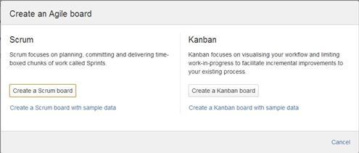

Feature #3) After a board is created you will be able to configure it as you see fit. Basically, there are two modes to a board – Plan and work. As the name implies, plan is the part where you can categorize your requirements (stories) into Sprints. Work mode is when you can track the time spent and the overall progress. Apart from these two you can generate several reports.

Feature #4) Plan mode:
The following is how the plan mode looks like: (Click to enlarge image)
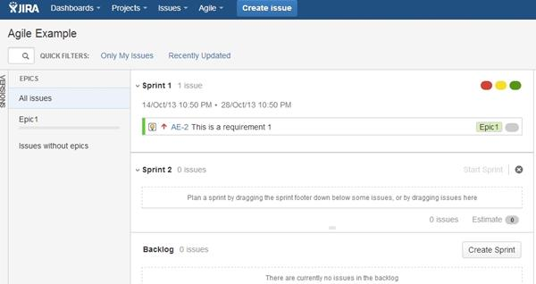
- The plan mode displays all the user stories created for the project.
- You can use the LHS menu to decide the basis on which the issues need to be displayed. You can choose to view all the issues or only the ones related to a certain Epic.
- Change the order in which issues need to be considered simply by dragging them up or down in the backlog.
- From the RHS side menu upon clicking on an issue, you can create links, subtasks, logwork and perform any other activity like you would on a normal issue.
- You can use this screen to create a sprint too, if you have the right permissions.

Feature #5) Work mode:
This will display the Active sprint information. All the user stories are going to be categorized into To do, In progress and Done to show the progress clearly.

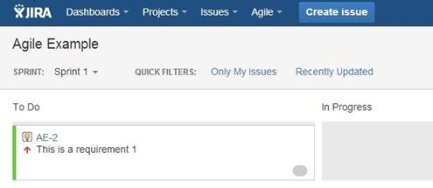

Feature #6) Agile Reports:
Go to Agile Board->Reports. As you can see, there are lots of custom Agile reports that can be generated using JIRA. All you have to do is, choose the report that you would like and decide the data based on which this report should be generated. (Click to enlarge image)

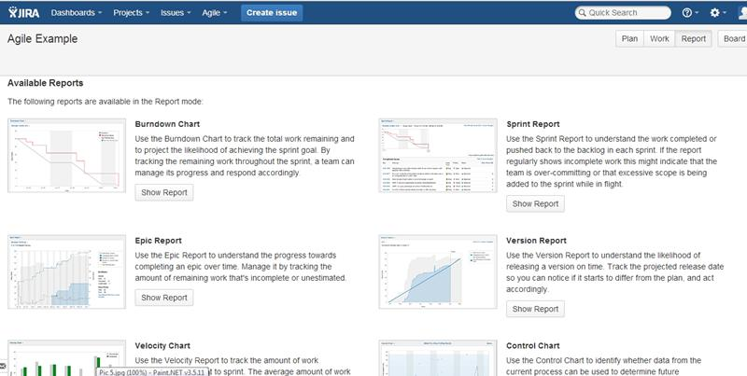

Feature #7) Managing boards:
With the right permissions or if you are an admin, you will be able to configure a board after its creation. To do so, go to “Agile->Manage Boards”. In the following screen, select the “Configure” option next to the board that you want to edit from the list of the all boards available. (Click on image to enlarge)
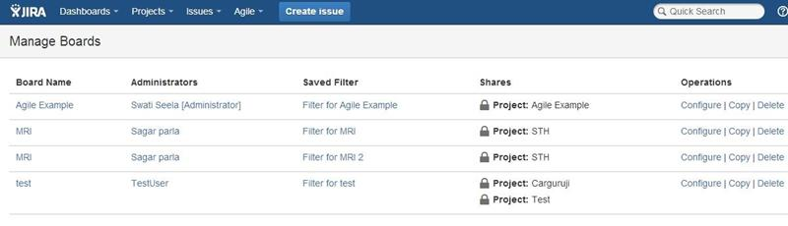

From the following page that comes up you will be able to define/edit the details as needed:
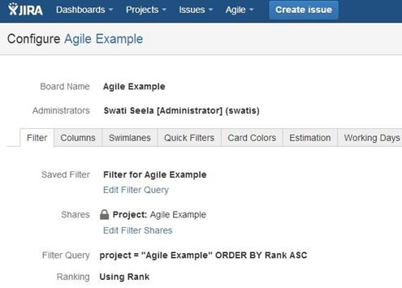

Conclusion:
That completes the basic introduction into how JIRA can be used for Agile Projects. In my opinion, the tool when used right can provide solid support for this methodology. Since the focus on documentation is low in Agile, JIRA can be your one stop-shop to have everything in one place.
Now, the obvious question: How is JIRA agile helpful for testers? Frankly, for the QA fraternity the scope of JIRA is either for bug tracking or task tracking – these do not change whether they are Agile Projects or regular ones. But having a good knowledge of this methodology by itself and the tool provided support is important because the IT world is shifting its focus to Agile – and we want to know all there is to know about it to make the best of it.

This finishes our Atlassian JIRA tutorial series.

