Login Screen Creation

**Created by – Pramod Gopisetty**

**Version No - 1.0**

**Date – 14th October, 2016**

**Approval:**

|  |  |  |  |
| --- | --- | --- | --- |
| **Position** | **Name** | **Comment** | **Signoff** |
| Project Manager |  |  |  |
| Developer |  |  |  |
| Client |  |  |  |
| DBA |  |  |  |

**Index**

1.0 Introduction 4

2.0 Business Objective 4

3.0 Business Process 4

4.0 Login Screen explained in detail 5

4.1 Username 5

Rules 5

4.2 Rules for Password 6

4.3 Rules for Login button 6

4.4 Rules for Register button 7

5.0 Field Level Validation Rules 7

5.1 Username 7

5.2 Password 7

6.0 Process Flowchart 7

7.0 References 8

8.0 Figure Index 8

# 1.0 Introduction

Create an online shopping website for ABC Pty Ltd, with 4 major screens. This site allows the customers to Register and login into their website, shop and add products to their cart, able to process payment and send billing information to the customers. After the Payment confirmation, this site provides an approximate ETA of the Product delivery. We predominantly focus on creating the initial Register/Login screen.

# 2.0 Business Objective

ABC Pty Ltd is a furniture store that operates in Australia. They are now looking forward to market their products online and allow their customers to buy their products online. In order for customers to shop online, they need to register if they are the first time users of this site or login to their account if the customer is already having an active existing account. This site gives the customer access to the site, if they only have valid credentials.

Username and Password does have specific conditions to meet. The site will direct its customers to the next screen if both the username and password matches. For new customers, the site will direct to the Account creation page when they click on the Register button on the home screen.

# 3.0 Business Process

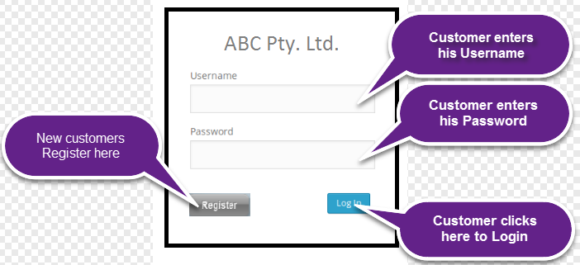

Figure – Login Screen

# 4.0 Login Screen explained in detail

## 4.1 Username

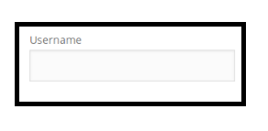

Figure - Username

### Rules

* Username should only accept alphabets.
* Error Message should come up if the customer enters any other character other than alphabets
* The system shouldn’t allow the customer to enter the Password if they enter incorrect username.
* If username is left blank. System should show an error message under ‘username’ field as ‘please enter a valid data in username field’
* If customer tries to enter other than alphabets…..error message
* If the username entered doesn’t exist, the system should request the user to Register first.
* Size—8character min
* Valid scenario

**Error Messages:**

## 4.2 Rules for Password

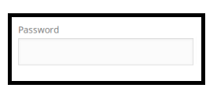

Figure - Password

* The system should allow the customer to go to the Login tab only if they enter the correct password.
* Error message to come up if they enter incorrect password.
* Password cannot be blank.

## 4.3 Rules for Login button



Figure – Login Tab

* This tab is only highlighted if a user enters the correct Username and Password.
* By clicking on the Login screen, the system should direct the user to the next screen.

## 4.4 Rules for Register button



Figure – Register Tab

* When a user clicks on this button, it should just direct them to the Account Creation Page.

# 5.0 Field Level Validation Rules

## 5.1 Username

* Username can only be alphanumeric.
* Cannot be special characters.
* Size cannot be more than 6 characters.
* Field cannot be Blank.

## 5.2 Password

* Should have a minimum of 1 uppercase letter and 1 lowercase letter.
* Should have alteast one number.
* Size cannot be more than 6 characters.
* Field cannot be Blank.

# 6.0 Process Flowchart

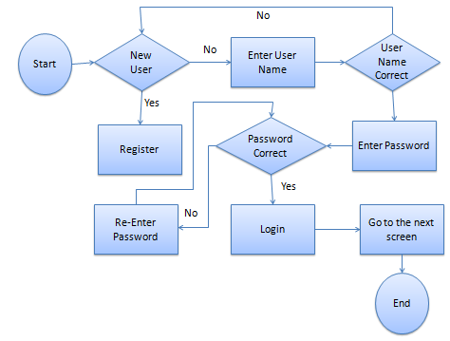

Figure – Process Flowchart

# 7.0 References

# 8.0 Figure Index

Figure 1 – Login Screen 4

Figure 2 - Username 4

Figure 3 - Password 5

Figure 4 – Login Tab 5

Figure 5 – Register Tab 5

Figure 6 – Process Flowchart 6