Contents

StartsWith-EndsWith 1

ToLoweCase-ToUpperCase 3

Extends 5

Assigning SubClass reference to SuperClass object and accessing members 5

# StartsWith-EndsWith

startsWith( ) method determines whether a given string starts with a specified string. (example- determines whether *Sunny* string starts with *Sun* string)  
endsWith( ) method determines whether a given string ends with a specified string. (example- determines whether *Starfish* string ends with *fish* string)  
  
**Lets implement this on Eclipse IDE:**  
  
1. Create *startsWithendsWithDemo* class under any project as shown below:

[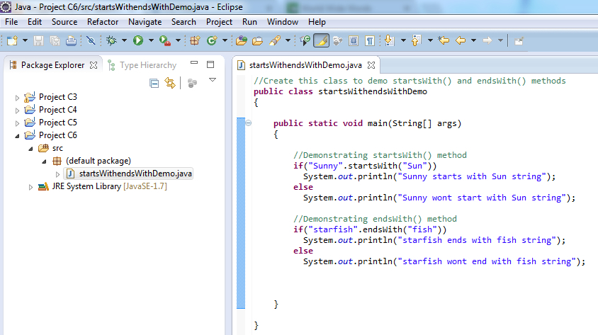](https://4.bp.blogspot.com/-2BVphyPFDyo/UVGJRkMdchI/AAAAAAAAQJ4/1Md65SFjv_M/s1600/1.jpg)

2. Save and Run the 'startsWithendsWithDemo' class  
3. Observe that the output is displayed in the console as shown below:

[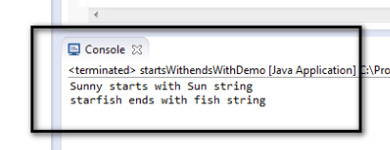](https://3.bp.blogspot.com/-73GwWYfUNjw/UVGJV3VQDNI/AAAAAAAAQKA/DIg3PzBo95Q/s1600/3.jpg)

Trim

trim( ) method removes the white space before and after the specified string.  
trim( ) method wont remove the white space between the words in the specified string.  
  
**Example:**  
  
**"         One  Two       ".trim( );**  -> This method will remove the white space before and after the specified string and will output the resulting string as "One Two"  (Observe that the white space between the words is not removed by this method)  
  
**Lets implement this on Eclipse IDE:**  
  
1. Create 'trimDemo' class under any project as shown below:

[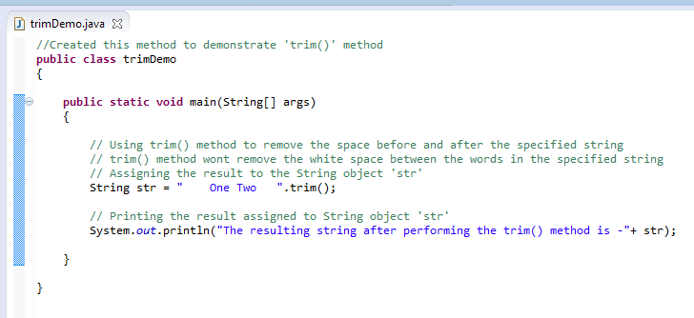](https://4.bp.blogspot.com/-6v1eqpMr6IA/UVGMrn6xpMI/AAAAAAAAQL4/70kilsbOIWk/s1600/1.jpg)

2. Save and Run the 'trimDemo' class file  
3. Observe that the output is displayed in the console as shown below:

[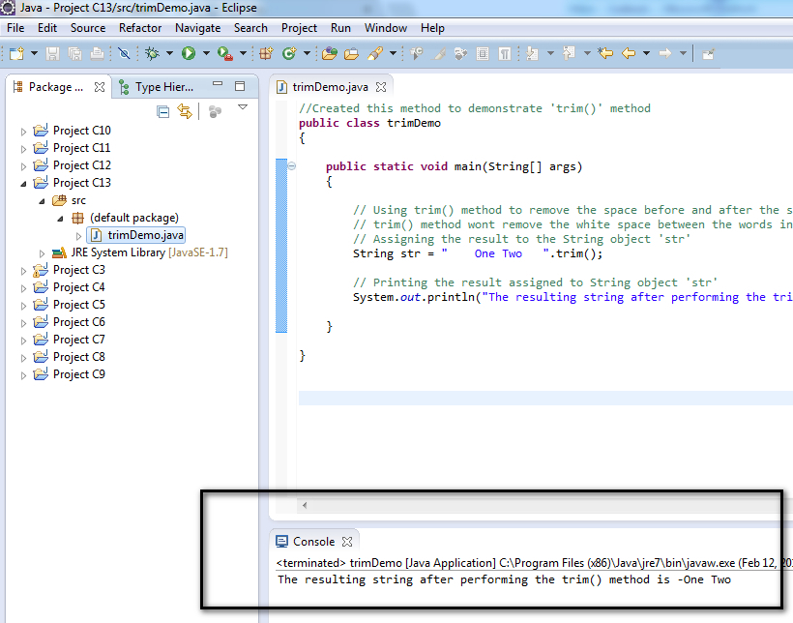](https://2.bp.blogspot.com/-sCOXy7UhVCk/UVGMwnZkCtI/AAAAAAAAQMA/zMhu0WlpVqc/s1600/3.jpg)

# ToLoweCase-ToUpperCase

toLowerCase( ) method is used to convert all the characters in the specified string from Upper case to Lower case.  
toUpperCase( ) method is used to convert all the character in the specified string from Lower case to Upper case.  
  
**Examples:**  
  
"This is a Test Statement".toLowerCase( );  -> This will convert all the upper case letters in the specified string to lower case -> The resulting string after conversion will be "this is a test statement"  
  
"This is a Test Statement".toUpperCase( );  -> This will convert all the lower case letters in the specified string to upper case -> The resulting string after conversion will be "THIS IS A TEST STATEMENT"  
 **Lets implement this on Eclipse IDE:**  
  
1. Create 'toLowerCasetoUpperCaseDemo' class under any project as shown below:

[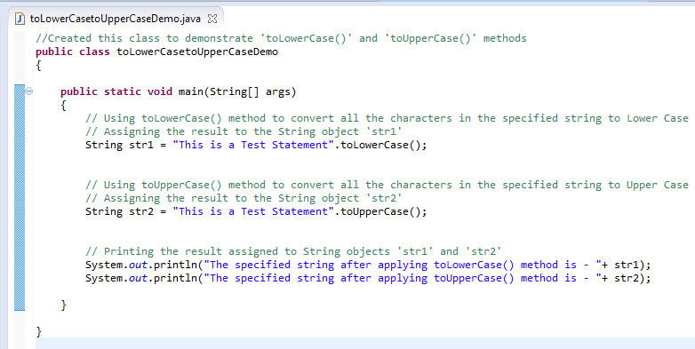](https://3.bp.blogspot.com/-bzW8HV-uI24/UVGNQZB6w3I/AAAAAAAAQMI/wEGjdB0WW6s/s1600/1.jpg)

2. Save and Run the 'toLowerCasetoUpperCaseDemo' class file  
3. Observe that the output is displayed in the console as shown below:

[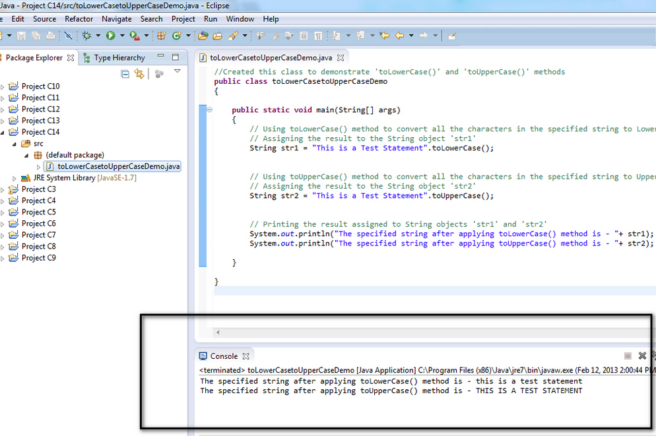](https://3.bp.blogspot.com/-_y379JttP-s/UVGNVcKKR9I/AAAAAAAAQMQ/spnnK-1mWqY/s1600/3.jpg)

# Extends

Assigning SubClass reference to SuperClass object and accessing members

On assigning the object of SubClass to its SuperClass object, the SuperClass object can only access the members of the SuperClass. Though we have assigned the object of SubClass to SuperClass, the SuperClass object cant access the members of the SubClass.

Example -

SubClass **subobject** = new SubClass( );

SuperClass **superobject** = **subobject**;

After assigning the SubClass object to the SuperClass object, using SuperClass object '**superobject**' -

* We can access the members of the SuperClass
* We can access the members inherited by the SubClass from the SuperClass
* We cannot access the members of the SubClass

Lets implement this on Eclipse IDE -

1. Launch Eclipse IDE, create a new Java Project 'Project 24' as shown below -

[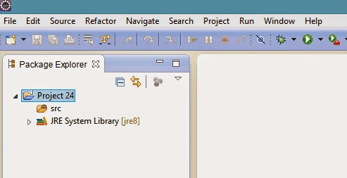](https://2.bp.blogspot.com/-7zYYET5GOE8/U7PRljJXcEI/AAAAAAAAatc/UJ2jwNXj4a4/s1600/1.jpg)

2. Create a .java Class 'SuperClass' , define an instance variable 'a' and assign a value to it as shown below -

[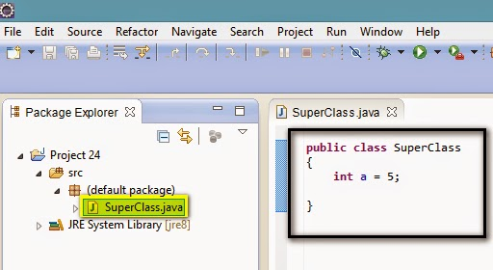](https://2.bp.blogspot.com/-Oo_YREUTJoc/U7PSZMloECI/AAAAAAAAatk/hr8gezqqIjY/s1600/2.jpg)

3. Create a .java Class 'SubClass', define an instance variable 'b' and assign a value to it as shown below -

[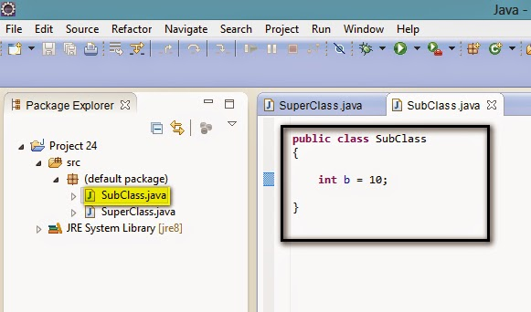](https://2.bp.blogspot.com/-Wjc--jIV6kw/U7PVBk-fqII/AAAAAAAAats/q8vj9_9ZKfw/s1600/3.jpg)

4. Let the 'SubClass' inherit the 'SuperClass' by writing the following statement -

[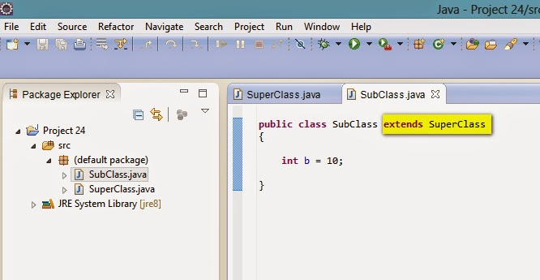](https://2.bp.blogspot.com/-hUzBQ1xR-JU/U7PVTVsg1wI/AAAAAAAAat0/-tTfhUHRJ9w/s1600/4.jpg)

5. Create another .java Class 'ClassOne' with main( ) method as shown below  to create objects and access the members of SuperClass and SubClass Classes -

[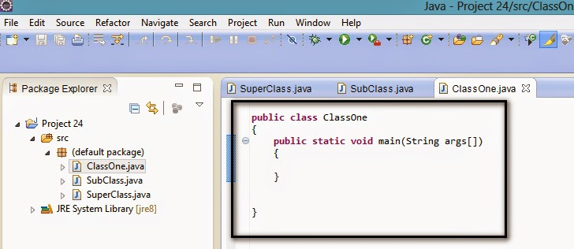](https://2.bp.blogspot.com/-KIDiNonxMFk/U7PZLMbi5pI/AAAAAAAAat8/cV_pOWTUeQY/s1600/5.jpg)

6. Create an object for the SubClass as shown below -

[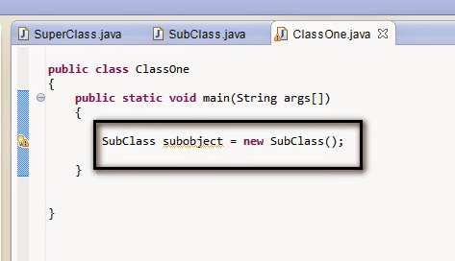](https://2.bp.blogspot.com/-9_fNUsjDxKc/U7PaDTDZbXI/AAAAAAAAauE/-IDivVw72AU/s1600/6.jpg)

7. Define an object for the SuperClass (Just define don't create) as shown below -

[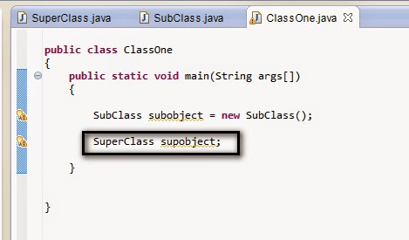](https://4.bp.blogspot.com/-yWi7lPV5btQ/U7Pasxa7GaI/AAAAAAAAauQ/JDuHY3eRxTI/s1600/7.jpg)

8. Now assign the subclass object to the SuperClass object as shown below -

[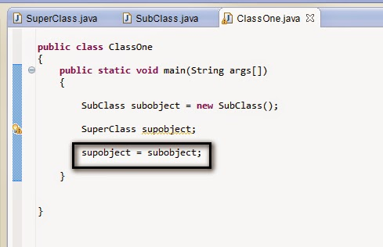](https://3.bp.blogspot.com/-vu80UJJ0H18/U7PbBTSYMHI/AAAAAAAAauY/ljIZ4Lf1odw/s1600/8.jpg)

Now SuperClass object 'supobject' has the reference of the SubClass object 'subobject'. Now lets see what we can access using the SuperClass object 'supobject' by following the below steps.  
  
9. Access the instance variable 'a' of the SuperClass using the SuperClass object 'supobject' as shown below and print the value -

[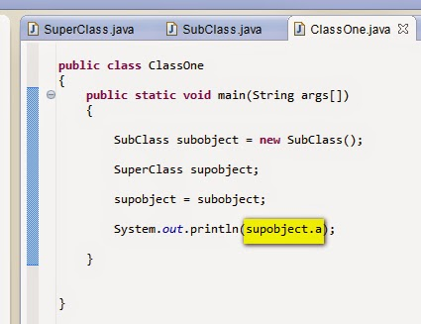](https://1.bp.blogspot.com/-uw2T0X6MmiQ/U7Pb4bvq3-I/AAAAAAAAaug/7QzwBX6YIxc/s1600/9.jpg)

10. You may think that, on assigning the subclass object to the superclass object, we can access the members of the subclass also using the superclass object. But it is not possible to access the members of the subclass using the superclass object even though the object of subclass is assigned to the superclass object. Now lets try to access the members of the subclass using the superclass object 'supobject' as shown below -

[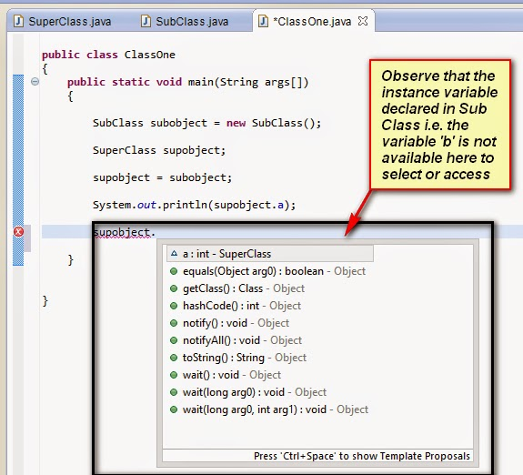](https://1.bp.blogspot.com/-hxp4PHpPu4E/U7PcuN5LyhI/AAAAAAAAauo/zCjQCdVsYWg/s1600/10.jpg)

11. Comment the above statement as shown below -

[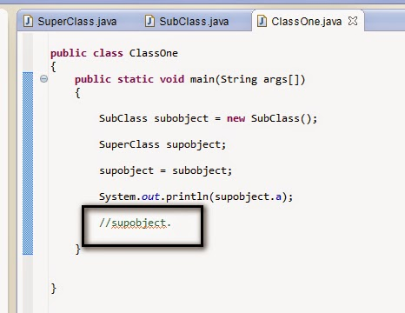](https://3.bp.blogspot.com/-EY9G4xrgy5U/U7PdFoLk13I/AAAAAAAAauw/fEGBuzF0xUc/s1600/11.jpg)

12. Run the 'ClassOne' Class as it is containing the main( ) methods and the objects to access the members of the other Class.  
  
13. Observe that the output is displayed in the console as shown below -

[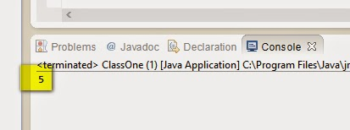](https://4.bp.blogspot.com/-rluXvtiCAbE/U7PdfkasrNI/AAAAAAAAau4/pdJVpEeK1ek/s1600/12.jpg)

When you assign a subclass object reference to superclass object reference, using superclass object -

1. You can access the members of the SuperClass
2. You cannot access the member of the SubClass
3. You can access the members inherited by the SubClass from the SuperClass.