Using findElements( )

Till now we have worked with  **findElement( )** command to locate Web Elements. But now we are going to work with **findElements( )** command.  
  
What is the difference between **findElement( ) and findElements( )** commands ?  
  
**findElement( )** is for locating a single WebElement, where as **findElements( ) can be used for locating**multiple WebElements.  
  
Example:  
  
Using **findElement( )** you can only locate a single link on a page. But if we have to locate all the links on the page, we have to use **findElements( )** for locating instead of **findElement( ).**  
 **Example Code:**  
 **//Locate all the links on the page using findElements(By.tagName("a"))**  
**//Assing the located elements to the List<WebElement> type variable** List<WebElement**>**homepage_links**=**_driver.**findElements(By.tagName("a"));**  
 **Test Description:**  
[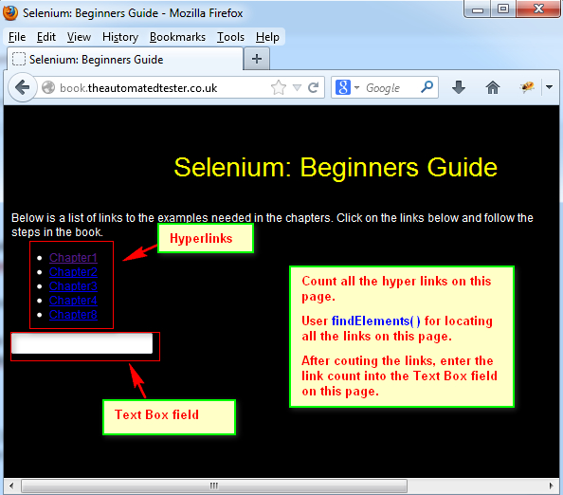](https://3.bp.blogspot.com/-7EVv-QwGfWM/UdVXAkM1iwI/AAAAAAAAWiM/tbHRf-KaSnM/s594/1.jpg)

**Lets Implement the Test on Eclipse IDE:**  
  
**Pre-requisites:**  
1. Create a new Java Project say 'WebDriver-Project74' in Eclipse IDE  
2. Configure the Project to work with Selenium WebDriver  
3. Create a package say 'package74' under the newly created project.  
4. Create a Java Class file say 'Class74' under the newly created package as shown below:

[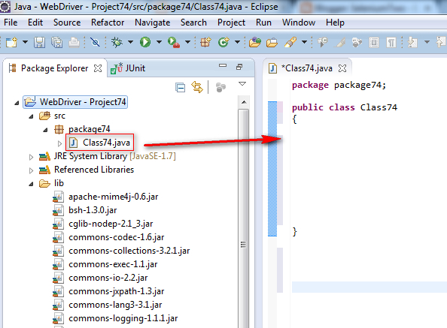](https://4.bp.blogspot.com/-Cj4svmLJoC8/UdVYF6HSgeI/AAAAAAAAWiY/55LY9mk6M8M/s594/2.jpg)

**Actual Steps:**  
  
1. Write the following code into the newly created Java Class file as shown below and make sure that you resolve all the errors before going to next step:

[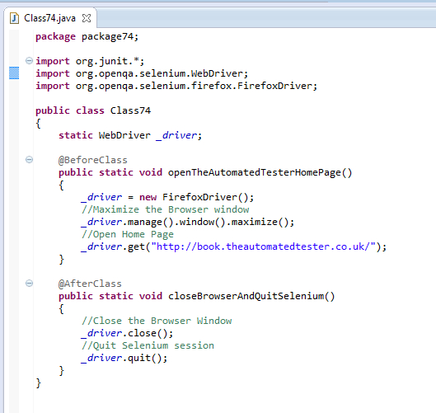](https://2.bp.blogspot.com/-dLzjNUD6p_s/UdVZis17UAI/AAAAAAAAWio/jN4hs1JxL_4/s529/3.jpg)

2. Create a test method 'countLinksOnHomePage( )'  as shown below:

[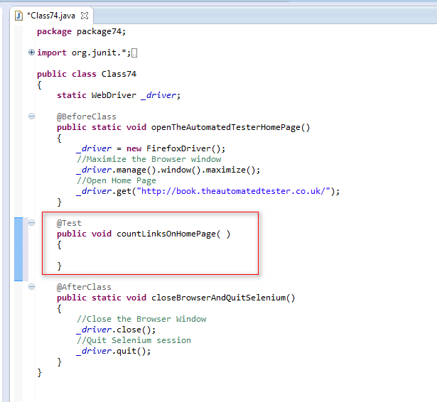](https://3.bp.blogspot.com/-ydGvxo7uimM/UdVa0pZ3FAI/AAAAAAAAWi0/N6ugCZ-_DFs/s615/4.jpg)

3.  Locate all the link elements on the page using **findElements(By.tagName("a"))** and assign the located elements to **List<WebElement>** type variable as shown below:

[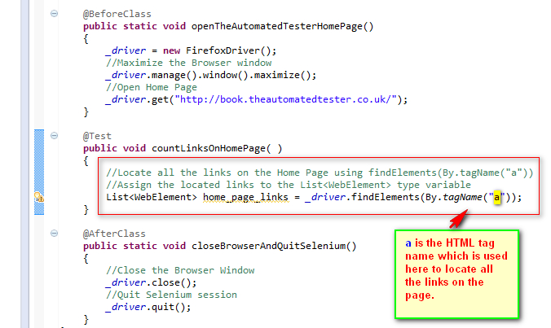](https://2.bp.blogspot.com/-4uTUZwyDjwc/UdWpK6L5XdI/AAAAAAAAWk4/rnPyqDje_gs/s676/5.jpg)

4. Count the number of links available on the Home page by writing a for loop as shown below:

[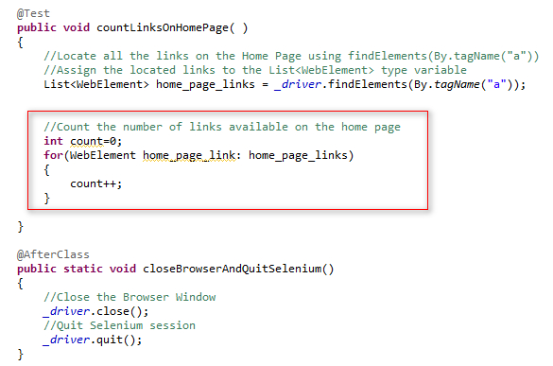](https://1.bp.blogspot.com/-NqcWVjvZmiU/UdWub4pPAJI/AAAAAAAAWlI/sfabYkH7bV0/s585/6.jpg)

5. Enter the number of links count into the text area field as shown below:

[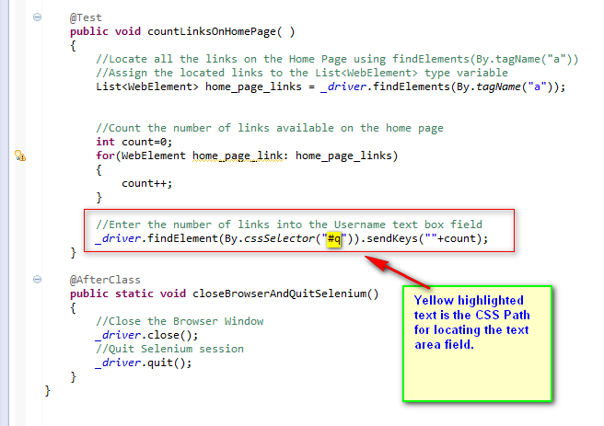](https://2.bp.blogspot.com/-e9-DBm4AkEw/UdWu6efAmUI/AAAAAAAAWlQ/ICHI6sjlcw0/s656/7.jpg)

6. Save and Run the 'Class74.java' file by selecting the 'JUnit Test' option and ensure that our Automation Test has located all the links on the page, counted all the located links and entered the links count into a text area field as shown below:

[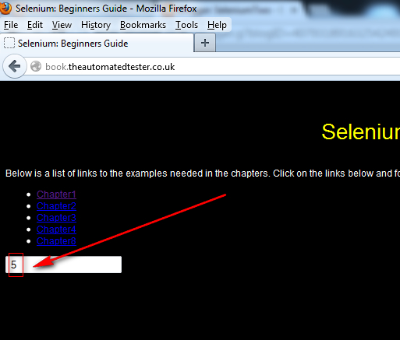](https://1.bp.blogspot.com/-RraJe8hKMoc/UdWvZsFRfAI/AAAAAAAAWlY/sVaKspkNMdA/s513/8.jpg)