isEnabled

Using isEnabled( ) to find out whether the button is enabled

**isEnabled( )** is the predefined method of Selenium WebDriver, which is used to verify whether the specified form element is either enabled or not.  
  
**isEnabled( )** method will return true if the specified form element is enabled else it will return false.  
  
  
**Test Description:**  
Please go through the comments on the below screenshot to understand the Test Description

[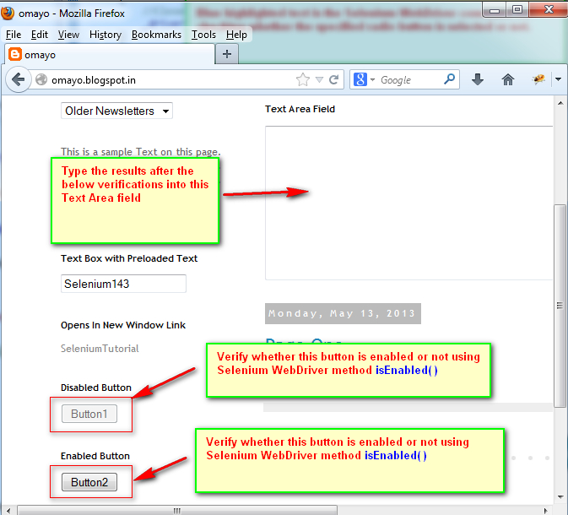](https://2.bp.blogspot.com/-2kp2941NEYk/UcLcldA7dVI/AAAAAAAAViI/rJV47qUZakY/s1600/1.jpg)

**Lets Implement the Test on Eclipse IDE:**  
  
**Pre-requisites:**  
  
1. Create a new Project say 'WebDriver-Project40' in Eclipse IDE  
2. Configure the Project to work with Selenium WebDriver  
3. Create a package say 'package40' under the newly created project.  
4. Create a Java Class file say 'Class40' under the newly created package as shown below:

[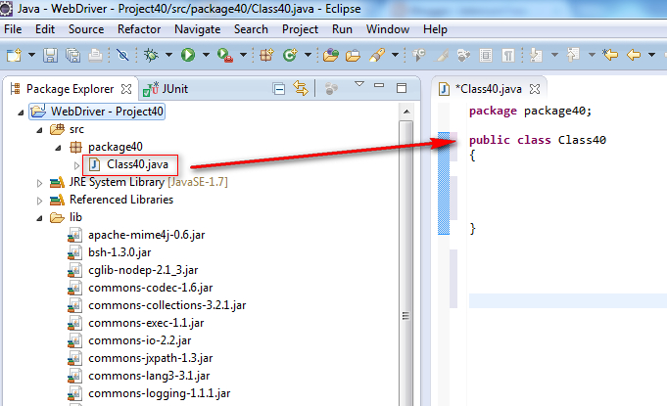](https://4.bp.blogspot.com/-oHG72j_s9GU/UcLdLp6MvbI/AAAAAAAAViQ/EQpjgFESx-s/s1600/2.jpg)

**Actual Steps:**  
  
1. Write the following code into the newly created Java Class file as shown below and make sure that you resolve all the errors before going to next step:

[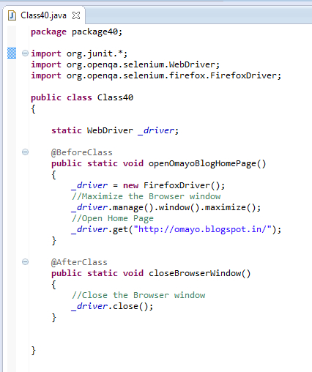](https://2.bp.blogspot.com/-oaxg0KaBFjM/UcLd03EJRoI/AAAAAAAAViY/wQPDdB0lXaw/s1600/3.jpg)

2. Write the test method 'isEnabledMethodDemo()' which uses CSS Path Statements for locating the  buttons and Text Area field as shown below:

[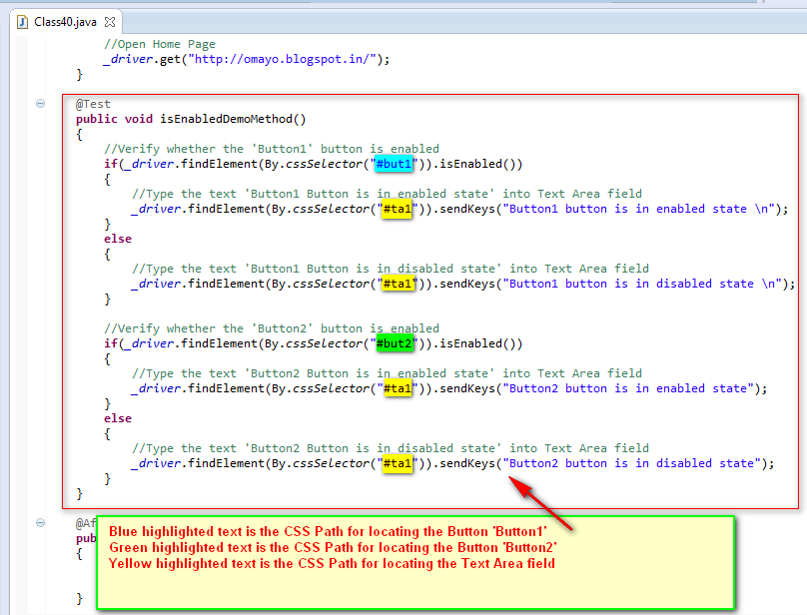](https://1.bp.blogspot.com/-phsdNaZN0_4/UcLjEclCcvI/AAAAAAAAVio/__FTw6St9wU/s1600/4.jpg)

3. Save and Run the 'Class40.java' file by selecting the 'JUnit Test' option and ensure that our Automation Test has verified whether the specified buttons Button1 and Button2 are in enabled or disabled state