selectByVisibleText

Using selectByVisibleText( ) command to select more than one list options from the Multi Select Box field

**selectByVisibleText( )**command is used to select the list option using the specified List Option label from the multi-selection Box field.  
  
In order to use the **selectByVisibleText( )** command, we have to create an object for **Select** class of selenium as shown below:  
  
**Select** select = new **Select**(_driver.findElement(By.cssPath("CSS Path of Multi-Select Box field")));

* Here **Select** is the Class name
* select is the object of Select Class

After creating an object for **Select** Class, you can get the **selectByVisibleText( )** predefined method of **Select** Class by using its object select as shown below:  
  
select.**selectByVisibleText("Selection Item 1")**;  
select.**selectByVisibleText("Selection Item 3")**;  
  
Note - Before using the above statements for selecting the more than one List options in the Multi-Selection Box field, first lets deselect all the list options as explained in our previous post # 124 using **deselectAll( )** command.

**Test Description:**  
  
Understand the test description by reading the comments mentioned on the below screenshot:

[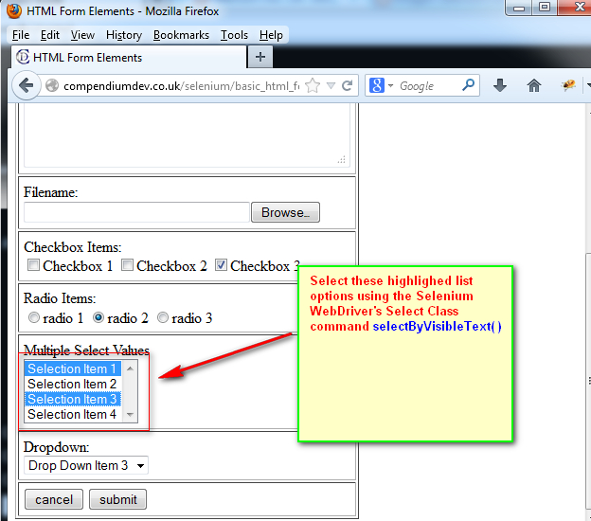](https://1.bp.blogspot.com/-lcVsUqbrRbc/Ucg_EtZKp-I/AAAAAAAAVpY/5dDgktAG5Ng/s1600/1.jpg)

**Lets Implement This:**  
  
**Pre-requisites:**  
  
1. Create a new Java Project say 'WebDriver-Project44' in Eclipse IDE  
2. Configure the Project to work with Selenium WebDriver  
3. Create a package say 'package44' under the newly created project.  
4. Create a Java Class file say 'Class44' under the newly created package as shown below:

[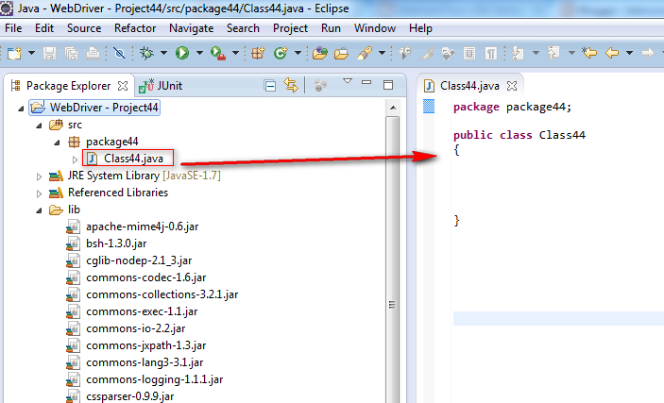](https://2.bp.blogspot.com/-3w8htyObJ3s/UchE6BM34rI/AAAAAAAAVpo/CcueLWCWOVQ/s1600/2.jpg)

**Actual Steps:**  
  
1. Write the following code into the newly created Java Class file as shown below and make sure that you resolve all the errors before going to next step:

[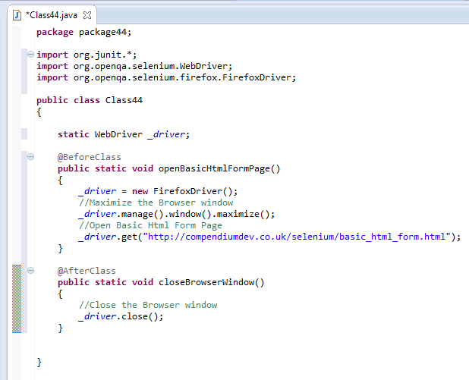](https://4.bp.blogspot.com/-48d4wumf2qo/UchF7hXEBGI/AAAAAAAAVp0/D25HI4DvBFI/s1600/3.jpg)

2. Write the test method 'selectByVisibleTextDemo( )' which uses CSS Path Statement for locating the  Multi-Selection Box field as shown below:

[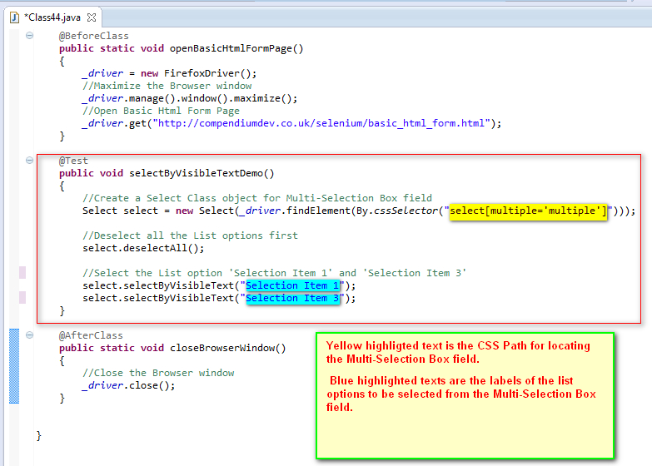](https://2.bp.blogspot.com/-EWXsoYVg7x8/UchLR5hinBI/AAAAAAAAVqc/Mq57A8yjv-c/s1600/4.jpg)

3. Save and Run the 'Class44.java' file by selecting the 'JUnit Test' option and ensure that our Automation Test has selected more than one list options from the Multi-select Box field as shown in the below video: