CSCI 331
Group 6 (Evan Burdick, Jordan Knight, Joseph Kuzko, Matthew Xiong)
Group Project 2

Updated: Design Document
Problem:
Create 2 CSV files (just a regular CSV & row randomized). Run those files through our current code. MODIFY buffer class to a length-indicated method.
- Create (in RAM), write (as a file), and read (back into RAM), a primary key index that can be used to display the Zip Code data for all Zip Codes listed on the command line.
  - Design and use a header record for the primary key index file (facilitates reading and writing the primary key index more flexibly)
  - Use a command line flag (e.g. -Z56301) to indicate each Zip Code record to search for.
  - If the Zip Code record is not in the file, display a message to that effect.
  - If the Zip Code record is in the file, display the complete Zip Code record on a line with each field labeled.
- Do test runs with speaficy details on d2l.

Header Record Architecture:
- file structure type
- string: structureType (Length indicated, comma-separated, etc.)
- version of your file structure type (we may add features in subsequent versions)
- double: version (# of the file.)
- header record size
- int: headerSize (basic declaration of size of header.)
- number of bytes for each record size integer
- int recordSizeByte =2 ( size of each record)
- size format type {ASCII or binary}
- index file name
- string indexFileName (name of file)
- index file schema information {how to read the index file format}
- string indexSchema (order of index file)
- record count
- int recordCount (# of records in file)
- count of fields per record
- int fieldCount =6 (six for the six variables we are counting for)
- indicate (ordinally) which field serves as the primary key
- int fieldOrder[] (tracker for the fields)
buffer.h : Similar structure as project 1 just added:
void createLengthIndicatedFile(string); //creates the length indicated file with the header at the top
void EvaluateArguments(string arr[], int count);
int searchForPrimaryKey(primaryKey);
void createPrimaryKeyIndexFile();
void PrintKeyData();

primaryKey.h:
Declare:
- int key;
- int byteLocation;

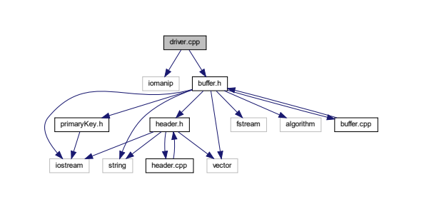
Figure 1: The general data structure of Project 2. (For specific details of each class look at Doxygen file.)

