**Undefined** **{?} Parameter**

By Melynda Lindhorst, Blake Bartlett, Joseph Lee, Braeden Bodily

**Senior Capstone Project:**

**Design Document**

**Use Cases and UI Sketches**

Appendix

Section 1: Use Case Diagrams

1. Register for the Website

**Description:** A new user to QuizZing will need to register for the website, allowing access to the full range of features (see diagram below).

1. Through the home page, the user will select the option to register.
2. They will fill out the necessary information on the registration form, including name, user name, password, email address, and more.
3. Once the registration form is filled out, the user clicks on submit. If any errors are found they will be highlighted in red, and an error message appears notifying the user to correct them.
4. Once all information is entered correctly, the user will be authenticated and directed to their profile page.

**Related UI:** Section 2.0 Home Page and Section 2.2 Registration Page

Figure 1A: Registration

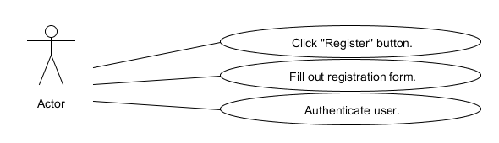

1.1 Create a Quiz

**Description:** Through their registered group or class the user will create a quiz by using tags and ratings, or use the feature to auto generate a quiz (see diagram below).

1. Through the home page, the user will log into their account.
2. The user will select a class or group from his list of registered courses.
3. From the group page, the user will select the option to create a quiz.
4. The user will customize the type of quiz they wish to create by adding tags, which can function as categories of questions, ratings, or difficulty.
5. They can either click on generate to allow the system to generate a quiz, or select the questions from a list, which is sorted according to selected tags.
6. If they select to generate a quiz, the user will indicate the number of questions to create.
7. The quiz can now be saved for later use by selecting the option to save.

**Related UI:** Section 2.5 Quiz/Question Generation Page

Figure 1B: Quiz creation

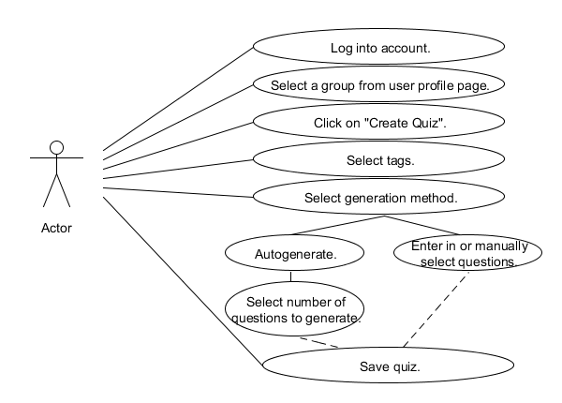

1.2 Add a Quiz Question

**Description:** The user can create their own custom questions by accessing the create a question section through the corresponding group or class (see diagram below).

1. Through the home page, the user will log into their account.
2. The user will select a class or group from his list of registered courses.
3. By clicking on the “create a question” link the user will be directed to a page to create a question.
4. The type of question is selected, for example: multiple choice, fill in the blank, or matching.
5. Tags are selected to add categories, difficulty, or specify a specific purpose of the question, such as midterm prep.
6. The user fills in the question and then enters the answer or answers depending on the question type.
7. The question is submitted by clicking on the submit button.

Related UI: Section 2.5 Quiz/Question Generation Page

Figure 1C: Question creation

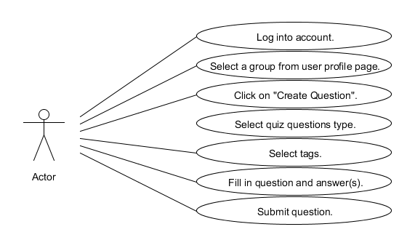

1.3 Take a Quiz

**Description:** The user can take a quiz or answer single questions at any time by performing a general or detailed search on subject matter (see diagram below).

1. Through the home page, the user will log into their account.
2. At any point, the user will be able to use the ubiquitous search bar at the top of the page to search through quizzes or questions.
3. The search may also be refined using our tag system to increase search granularity.
4. The user selects a question or quiz from the search results.
5. The user answers the question or questions and performs any other necessary actions (ie., flagging a question for review (see

Related UI: Section 2.6 Search Page and Section 2.4 Quiz Page

Figure 1D: Taking a quiz use case

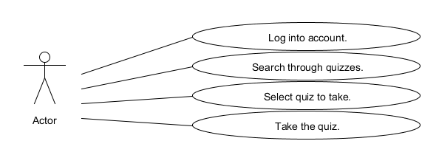

1.4 Challenge a User

**Description:** Users can access the gameplay aspect of QuizZing by challenging other users compete on a quiz. Winner is determined by time and accuracy. (see diagram below).

1. Through the home page, the user will log into their account.
2. On his profile page a user can select the option to challenge another player.
3. The user will find a competitor by searching among groups, user names, region, etc.
4. The user will find a quiz to challenge his friend to. It is also possible to challenge a player directly from a chosen quiz.
5. The user will be able to immediately take the quiz, even if his friend is offline.
6. Once the friend logs in, they will receive a notification on their profile page of the challenge.
7. If the user accepts the challenge, they will immediately be able to take the quiz, even if the challenger is offline.
8. Once both parties have completed the quiz the results will be displayed to both parties, in the form of a notification. They will see this immediately or next time they log in.

Related UI: Section 2.1 Profile Page and Section 2.4 Quiz Page

Figure 1E: Challenge a user

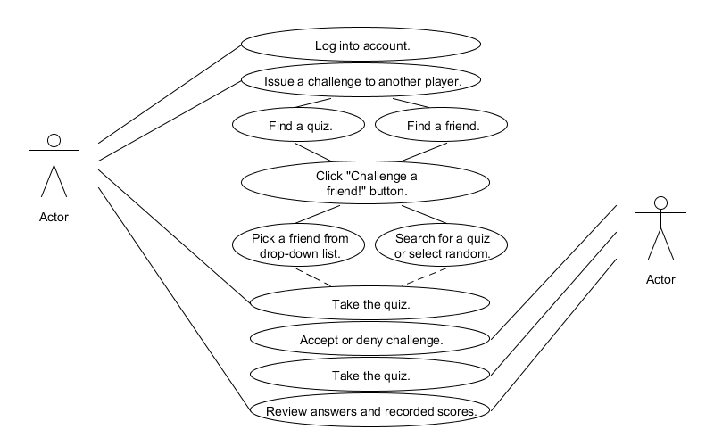

1.5 Challenge a Group

**Description:** Entire groups can participate in the gameplay aspects of QuizZing by using the challenge a group option. (see diagram below).

1. Through the home page, the user will log into their account.
2. The user creates a quiz for the group challenge (see Section 1.2).
3. User groups can be issued a challenge to take the quiz by selecting challenge a group through that group’s page.
4. The challenger immediately takes the quiz, even if all other challengers are offline.
5. If the time limit is reached, the quiz is ended and the user sees their score.
6. When other users log into their profile page, they receive a notification of the challenge.
7. If the user accepts, they immediately take the quiz, until time limit is reached, and view their score.
8. Once a user has taken the quiz, they can view their rankings.
9. Each time a new user takes the quiz all previous users are sent notifications of the change in the rankings.

Related UI: Section 2.3 Group/Class Page

Figure 1F: Challenge a group

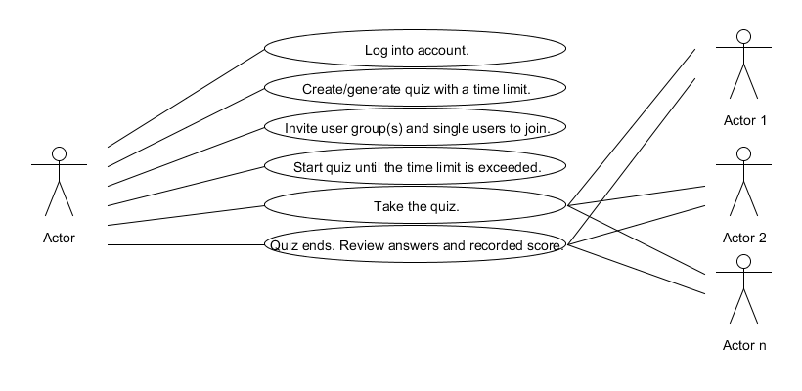

1.6 Create a Group

**Description:** Users can create groups for school or extracurricular purposes. They can invite other users to join or receive requests from other users to join. (see diagram below).

1. Through the home page, the user will log into their account.
2. The user will navigate to the “Create Group” button, located under the ubiquitous drop-down navigation menu.
3. The user will be prompted to fill out information for that group that includes the name, description/purpose of group, and subjects the group will cover.
4. The user will also have to add tags for that group so that quizzes and questions can be linked back to that group.
5. The user who is now the group owner will send out invitations to individual users to join the group.
6. Alternatively, users can ask to join the group by clicking the “Ask to Join” button on the group’s profile page.

Related UI: Section 2.3 Group/Class Page

Figure 1G: Create a group

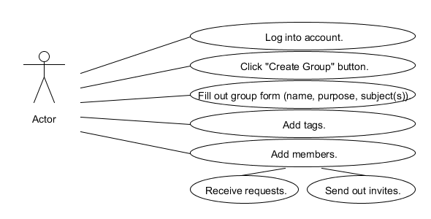1.7 Rate or Challenge a Question

**Description:** Entire groups can participate in the gameplay aspects of QuizZing by using the challenge a group option. (see diagram below).

1. Through the home page, the user will log into their account.
2. Users will find a question either by searching or casually encountering questions during quizzes.
3. The user may want to rate the question or challenge the question for displaying incorrect information.
4. Users can choose to flag the question to rate or challenge at another time or provide feedback right then.
5. If the user chooses to flag the question, a notification will appear in their inbox and the question will be added to their flagged queue.

Related UI: Section 2.1 Profile Page and Section 2.4 Quiz Page

Figure 1H: Rate/challenge a question

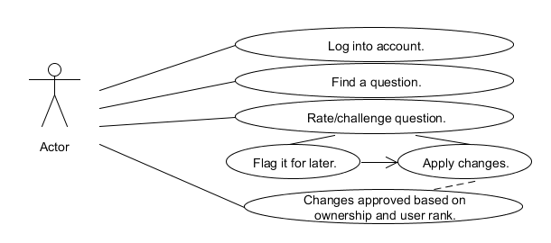

Section 2: UI Sketches

2.0 Home

*This is a sketch of the main page that every user will see when they first reach our website. It will provide a news feed, a link to register or login, and other side bars to be determined in the future.*

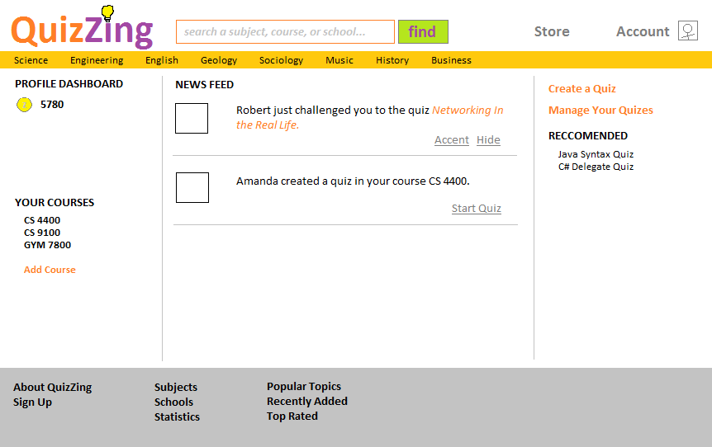

2.1 Profile

*The profile page is what a user will see after they successfully register or log into their account. They can use it to view or modify their personal information, or class and registration.*

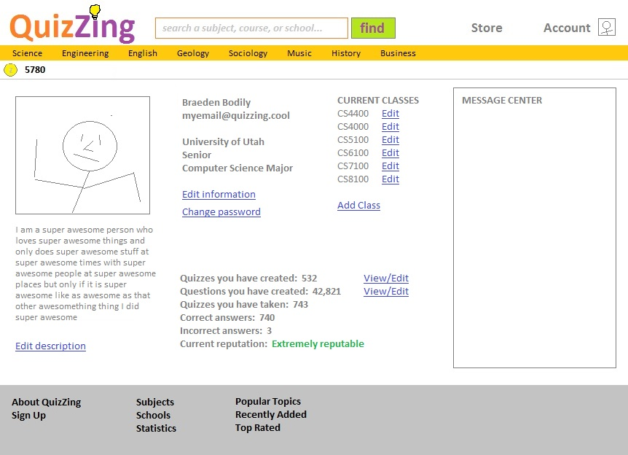

2.2 Registration

*The Registration page shows what the user will see when they are registering for the webpage.*

2.3 Group/Class Page

*The Group or Class page shows details and data about a particular group. It provides links to register for the class, view members, generate a quiz, or even try a quiz as a guest.*

2.4 Quiz

*The Quiz page is what the user will see while they are taking a quiz. It will provide the ability for a user to go forwards and backwards through the quiz, rate a question, flag a question, or even a link to challenge the question immediately.*

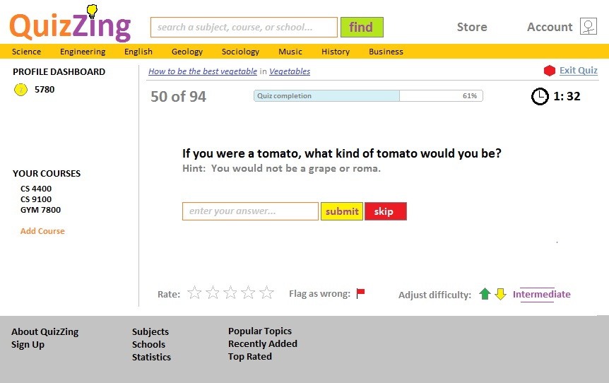

2.5 Quiz Generation

*The Quiz Generation page is the page a user will access to create a quiz. It will be accessed through a Class or Group page. It provides the ability to toggle categories, difficulty, and ratings. Also, it provides a link for a user to auto-generate the quiz (based on their selections) or hand pick the questions themselves.*

2.6 Search

*A search bar will be at the top of most pages to allow the user to search for quizzes or questions. More detailed searches can also be performed. This will allow the user to get to what they need quicker.*

