OP SILENT PERIMETER

Submitted By:
Maj Gaurav Verma
ACO-03

PHASE 1 — Routing Crisis (Cisco Packet Tracer)

1.1 Network Topology & IP Addressing. The following topology in Cisco Packet Tracer with three routers (R1, R2, R3) and their respective LANs was designed:

Router | LAN Network | Transit Link | Protocol
R1 (HQ) | 10.10.10.0/24 | R1↔R2: 192.168.12.0/30 R1↔R3: 192.168.13.0/30 | OSPF Area 0
R2 (Operations) | 20.20.20.0/24 | R2↔R3: 192.168.23.0/30 | OSPF Area 0
R3 (Logistics) | 30.30.30.0/24 | Connected to R1 & R2 | EIGRP AS 100

1.2 Interface IP Configuration Commands

Router R1:
  - R1(config)# interface fastethernet0/0
  - R1(config-if)# ip address 10.10.10.1 255.255.255.0
  - R1(config-if)# no shutdown
  - R1(config)# interface Serial0/0/0 ! Link to R2
  - R1(config-if)# ip address 192.168.12.1 255.255.255.252
  - R1(config-if)# no shutdown
  - R1(config)# interface Serial0/0/1 ! Link to R3
  - R1(config-if)# ip address 192.168.13.1 255.255.255.252
  - R1(config-if)# no shutdown

Router R2:
  - R2(config)# interface fastEthernet0/0
  - R2(config-if)# ip address 20.20.20.1 255.255.255.0
  - R2(config-if)# no shutdown
  - R2(config)# interface Serial0/0/0 ! Link to R1
  - R2(config-if)# ip address 192.168.12.2 255.255.255.252
  - R2(config-if)# no shutdown
  - R2(config)# interface Serial0/0/1 ! Link to R3
  - R2(config-if)# ip address 192.168.23.1 255.255.255.252
  - R2(config-if)# no shutdown

Router R3:
  - R3(config)# interface fastEthernet0/0
  - R3(config-if)# ip address 30.30.30.1 255.255.255.0
  - R3(config-if)# no shutdown
  - R3(config)# interface Serial0/0/0 ! Link to R1
  - R3(config-if)# ip address 192.168.13.2 255.255.255.252
  - R3(config-if)# no shutdown
  - R3(config)# interface Serial0/0/1 ! Link to R2
  - R3(config-if)# ip address 192.168.23.2 255.255.255.252
  - R3(config-if)# no shutdown

1.3 OSPF Configuration (R1 and R2)

R1 OSPF:
  - R1(config)# router ospf 1
  - R1(config-router)# network 10.10.10.0 0.0.0.255 area 0
  - R1(config-router)# network 192.168.12.0 0.0.0.3 area 0
  - R1(config-router)# network 192.168.13.0 0.0.0.3 area 0

R2 OSPF:
  - R2(config)# router ospf 1
  - R2(config-router)# network 20.20.20.0 0.0.0.255 area 0
  - R2(config-router)# network 192.168.12.0 0.0.0.3 area 0
  - R2(config-router)# network 192.168.23.0 0.0.0.3 area 0

1.4 EIGRP Configuration (R3)

  - R3(config)# router eigrp 100
  - R3(config-router)# network 30.30.30.0 0.0.0.255
  - R3(config-router)# network 192.168.13.0 0.0.0.3
  - R3(config-router)# network 192.168.23.0 0.0.0.3
  - R3(config-router)# no auto-summary

1.5 Route Redistribution
On R1 — Redistribute EIGRP into OSPF:
  - R1(config)# router ospf 1
  - R1(config-router)# redistribute eigrp 100 subnets
  - On R1 — Redistribute OSPF into EIGRP:
  - R1(config)# router eigrp 100
  - R1(config-router)# network 192.168.13.0 0.0.0.3
  - R1(config-router)# redistribute ospf 1 metric 10000 100 255 1 1500

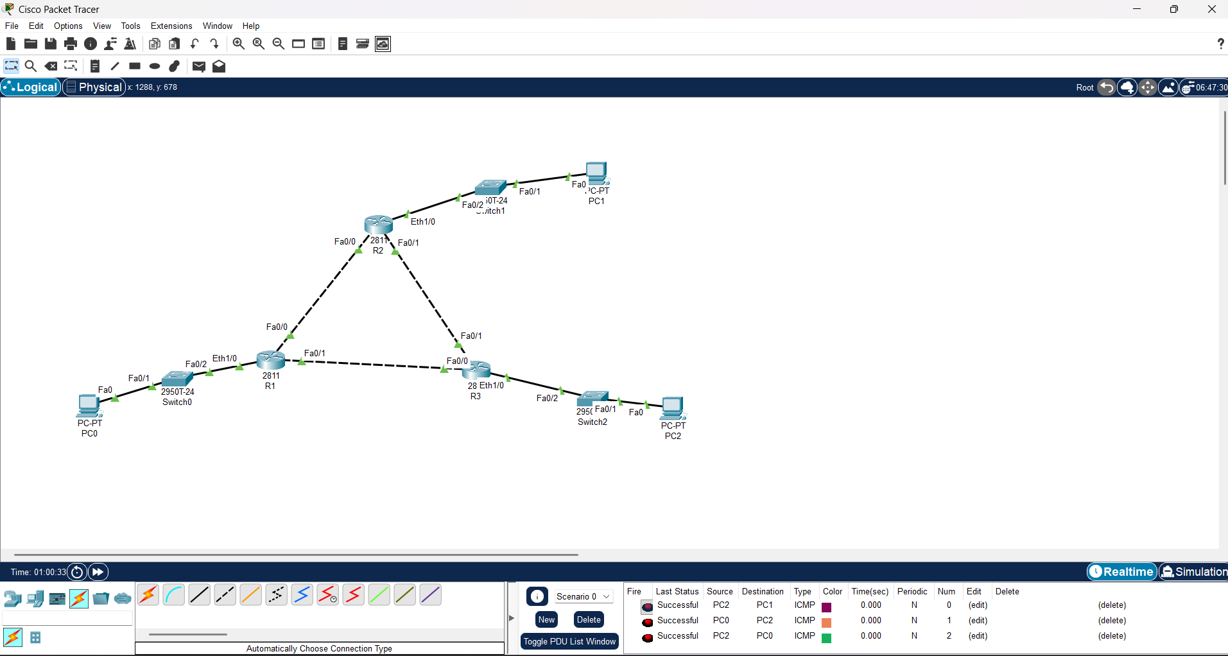

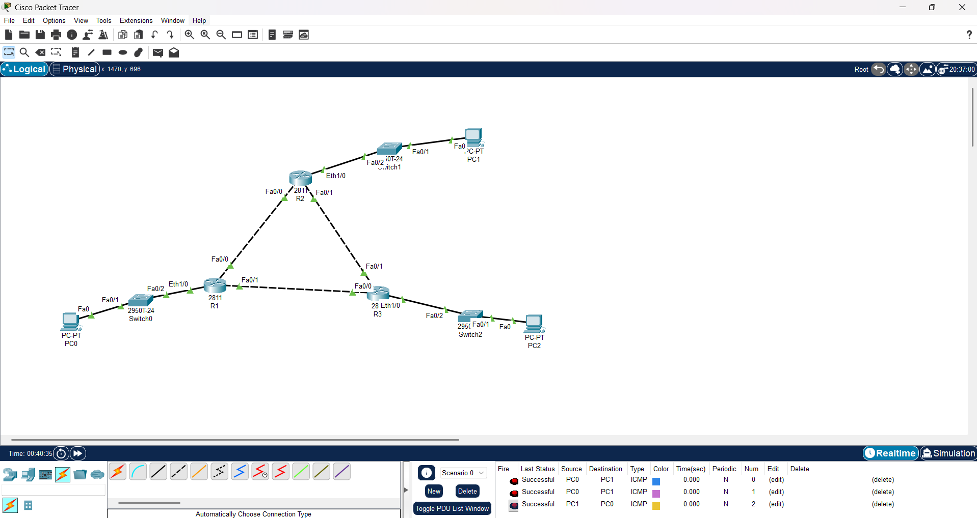

PHASE 2 — Intercepted Credentials (Wireshark)

2.1 FTP Credential Capture

Field | FTP | Telnet | HTTP (DVWA)
Username | ftpuser1 | root | admin
Password | Pass123 | root | password
Source IP | 10.10.10.50 | 10.10.10.60 | 10.10.10.70
Destination IP | 10.10.10.10 (Server) | 30.30.30.10 | 20.20.20.10 (DVWA)

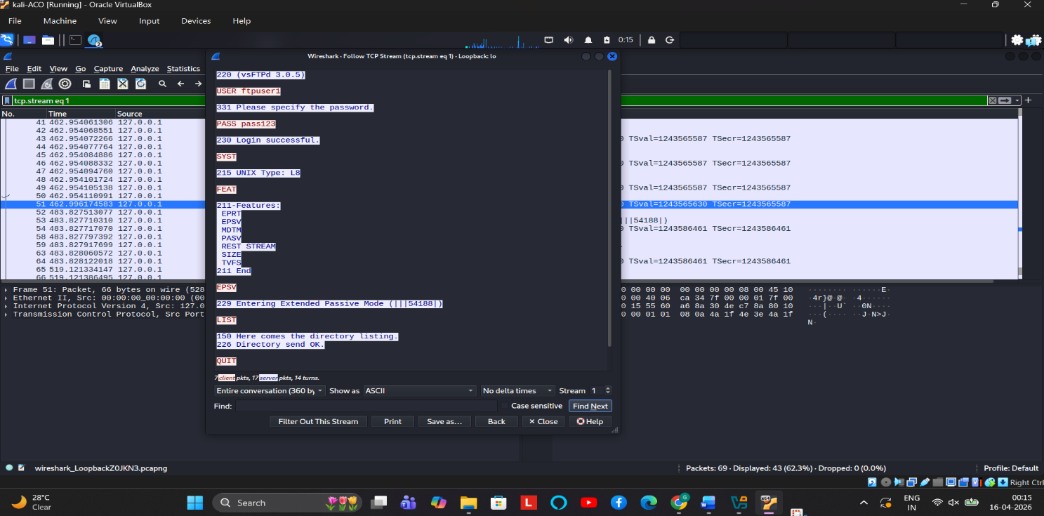
PH2- FTP- SUCCESSFUL CAPTURE OF FTPUSER AND PASSWORD

2.2 Telnet Credential Capture
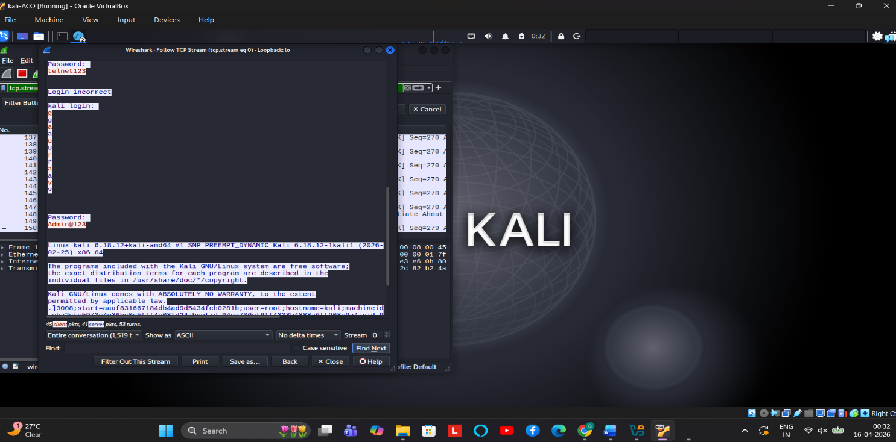
PH2- TELNET - CAPTURE OF TELNET USER AND PASSWORD

2.3 DVWA HTTP POST Capture
HTTP POST requests send form data unencrypted. Apply filter:
  - http.request.method == POST
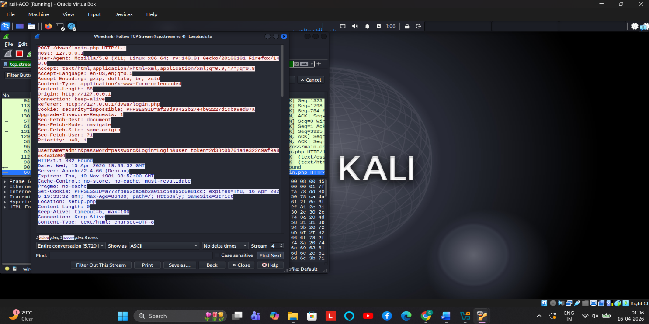

PH2- DVWA - CAPTURE OF USERID AND PASSWORD

PHASE 3 — Intrusion Detection (Suricata)

3.1 Suricata Installation
sudo apt update && sudo apt install suricata -y
sudo suricata-update # Update rule signatures
sudo systemctl enable suricata

3.2 Custom Rules File
Edit: /etc/suricata/rules/local.rules

Rule 1 — ICMP Recon (Ping Detection):
alert icmp any any -> any any (msg:"RECON: ICMP Ping Detected"; itype:8; sid:1000001; rev:1;)
Rule 2 — Nmap SYN Scan Detection:
alert tcp any any -> any any (msg:"SCAN: Nmap SYN Scan Detected"; flags:S,12; threshold: type both, track by_src, count 20, seconds 3; sid:1000002; rev:1;)
Rule 3 — Telnet Usage Alert:
alert tcp any any -> any 23 (msg:"POLICY: Telnet Usage Detected - Insecure Protocol"; sid:1000003; rev:1;)
Rule 4 — FTP Credential Exposure:
alert tcp any any -> any 21 (msg:"CREDS: FTP USER Command Detected"; content:"USER"; nocase; sid:1000004; rev:1;)
alert tcp any any -> any 21 (msg:"CREDS: FTP PASS Command Detected"; content:"PASS"; nocase; sid:1000005; rev:1;)
Rule 5 — Port Scan Detection (Multiple Ports):
alert tcp any any -> any any (msg:"SCAN: Multiple Port Scan from Same Source"; flags:S; threshold: type threshold, track by_src, count 5, seconds 10; sid:1000006; rev:1;)

3.3 Enable Local Rules in suricata.yaml
sudo nano /etc/suricata/suricata.yaml
Locate the rule-files section and add:
- /etc/suricata/rules/local.rules

3.4 Testing Commands
Test ICMP Rule:
ping -c 5 192.168.12.1

Test Nmap SYN Scan Rule:
nmap -sS 192.168.12.1

Test Telnet Rule:
telnet 30.30.30.10 23
Test FTP Rule:
ftp 10.10.10.10
Run Suricata in test mode:
sudo suricata -c /etc/suricata/suricata.yaml -i eth0
Watch alerts live:
sudo tail -f /var/log/suricata/fast.log

3.5 Highest Priority Alert. Rule 5 (Port Scan / Multiple Port Hits)
    - Port scanning is reconnaissance — it precedes every intrusion.
    - It has the broadest implication: attacker is mapping the entire network.
    - Should trigger immediate defensive lockdown of the source IP.
    - ICMP pings alone may be benign; a methodical port scan is clearly hostile in a military network.

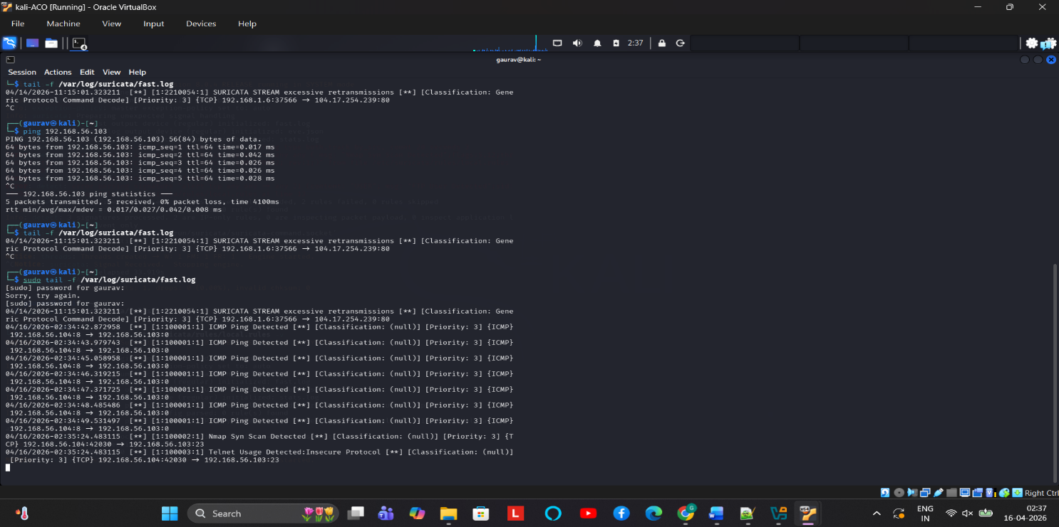

PHASE 4 — Host Forensics (Netstat)

4.1 Commands and Their Purpose
Command | Purpose | Key Info
netstat -an | All connections, no DNS resolution | Shows numeric IPs and ports
netstat -ano | All connections + PID | Links connection to process ID
netstat -rn | Routing table (numeric) | Default gateway, routes
netstat -tulpn | TCP/UDP listening ports + process name | Linux — reveals which services are open

PHASE 5 — Final War Scenario: Incident Report

Incident Timeline (Reconstructed)
Time | Event | Evidence
2247 | Attacker begins Nmap SYN scan | Suricata Rule 5 — port scan alert in fast.log
2255 | Routing to Logistics disrupted | Phase 1 — OSPF wildcard mask manipulated
2258 | Telnet credentials stolen | Wireshark — plaintext USER/PASS in capture
2301 | FTP data transfer observed | Wireshark — RETR/STOR commands logged
2305 | Laptop connects to port 4444 | Netstat — ESTABLISHED to 203.0.113.99:4444
2310 | C2 beacon confirmed active | Process PID 3421 — Meterpreter payload

1. What Happened First. The Nmap reconnaissance scan was the first event (~2247 hrs). The attacker mapped the network before exploiting any service. This is the standard cyber kill chain: Reconnaissance → Weaponization → Delivery.

2. Which evidence proves credential theft. Wireshark captures are the primary evidence. The FTP stream clearly shows USER and PASS commands in plaintext. The Telnet stream shows keystroke-by-keystroke login. The HTTP POST from DVWA shows form fields including username and password in the packet payload.

3. How to contain the incident in 10 minutes?
  - 00:00 — Isolate compromised host 10.10.10.1 (remove from network).
  - 00:02 — Block 203.0.113.99 at all perimeter ACLs and firewall rules.
  - 00:04 — Kill malicious process PID 3421, preserve forensic image.
  - 00:05 — Reset all credentials for FTP, Telnet, and DVWA immediately.
  - 00:07 — Restore correct OSPF routing configuration on R1.
  - 00:09 — Activate enhanced Suricata monitoring on all segments.

4. Long-Term Remediation Plan
  - Replace FTP with SFTP (SSH File Transfer Protocol) — encrypts both commands and data.
  - Replace Telnet with SSH — encrypted remote management.
  - Enforce HTTPS on DVWA — prevent credential sniffing from web logins.
  - Deploy OSPF MD5 or SHA authentication on all routers.
  - Implement network segmentation using VLANs — servers in dedicated DMZ.
  - Deploy EDR (Endpoint Detection and Response) on all hosts.
  - Configure egress ACLs to block outbound connections on non-standard ports.
  - Regular penetration testing and vulnerability assessments.

5. Which protocols should be replaced?
Insecure Protocol | Replacement | Reason
FTP (Port 21) | SFTP (Port 22) | FTP sends credentials and data in plaintext
Telnet (Port 23) | SSH (Port 22) | Telnet sends every character unencrypted
HTTP (Port 80) | HTTPS (Port 443) | HTTP POST credentials visible in traffic
OSPF (no auth) | OSPF + MD5 Auth | Unauthenticated routing enables injection

6. How to Improve Monitoring Posture
  - Deploy centralized SIEM (e.g., Wazuh, ELK Stack) to aggregate Suricata, system logs, and router logs.
  - Enable NetFlow/sFlow on all routers — detect anomalous traffic volumes.
  - Configure Suricata in IPS mode (inline) instead of passive IDS to actively block threats.
  - Create alerting thresholds: >50 connections/minute from a single host = automatic ACL drop.
  - Implement honeypots on legacy Telnet/FTP ports to detect future probing.

