PHASE 4 – HOST FORENSICS (NETSTAT)

1. Output Screenshots.
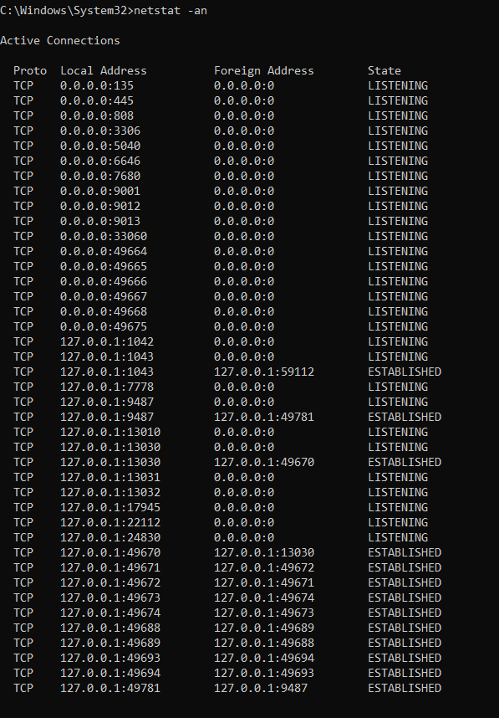
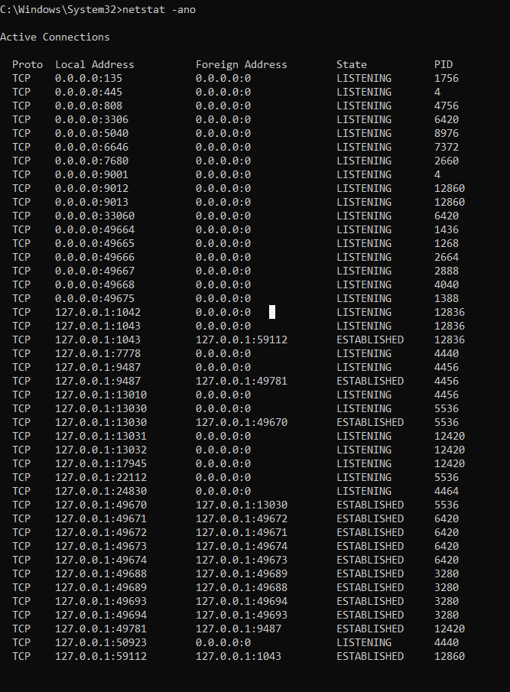
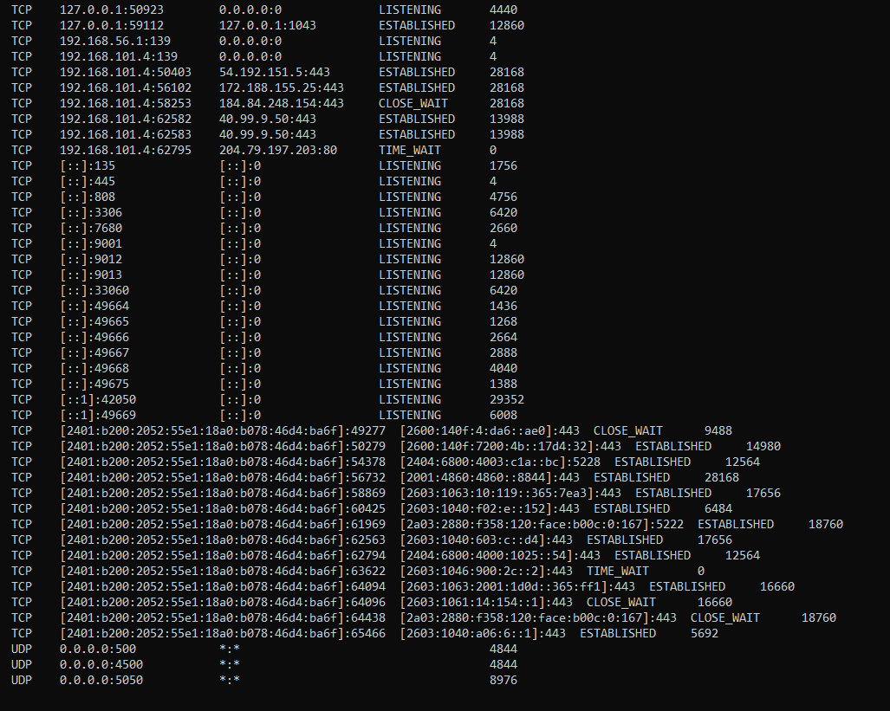

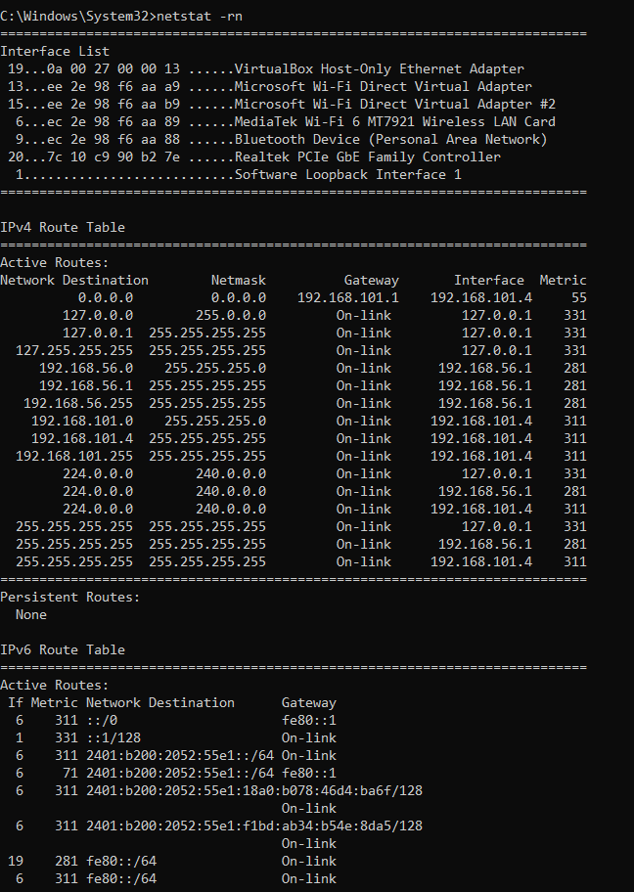
2. Identify any suspicious connection.
2.1. Too many unknown IPs
2.2. No suspicious activity found
3. Containment steps.
3.1. Active firewall.
3.2. No open ports.
3.3. Thorough monitoring of logs.
3.4. Continuous scanning across the server.

