PHASE 1 – ROUTING CRISIS (CISCO PACKET TRACER)

1. Screenshot of routing tables
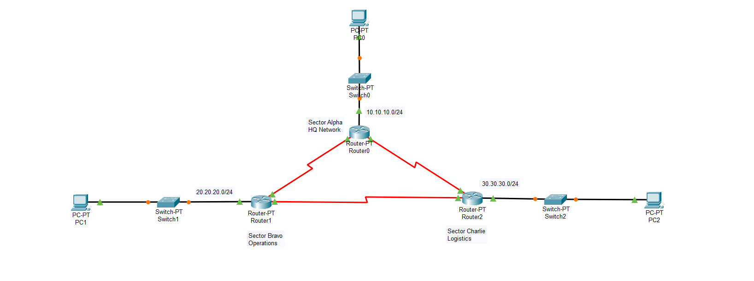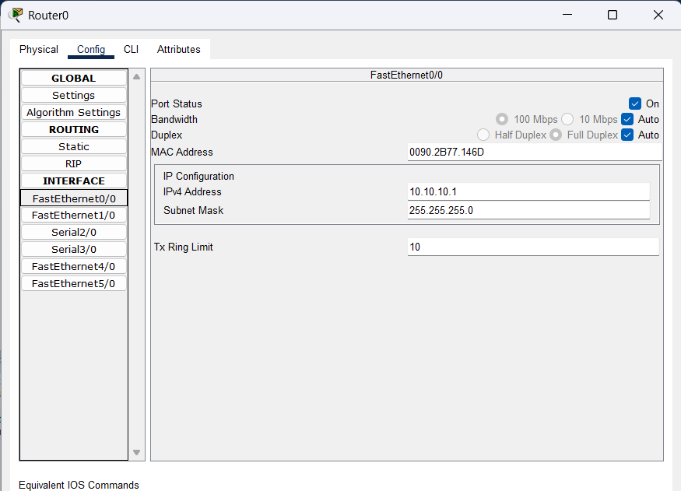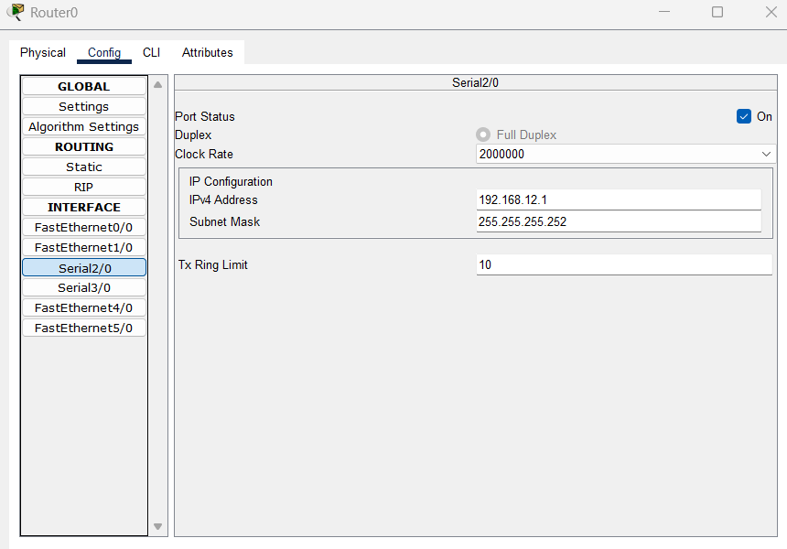
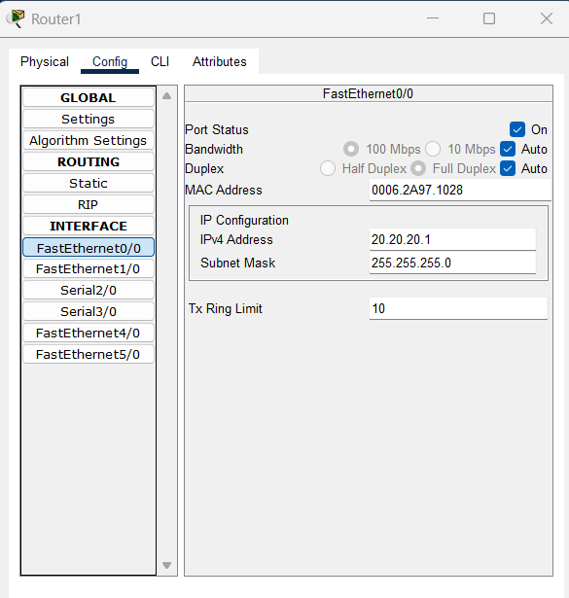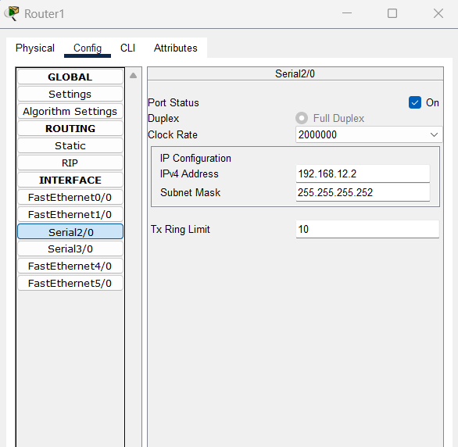

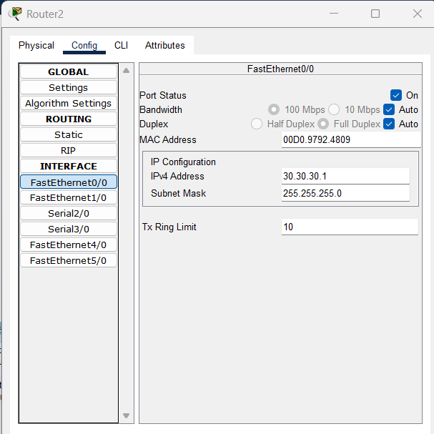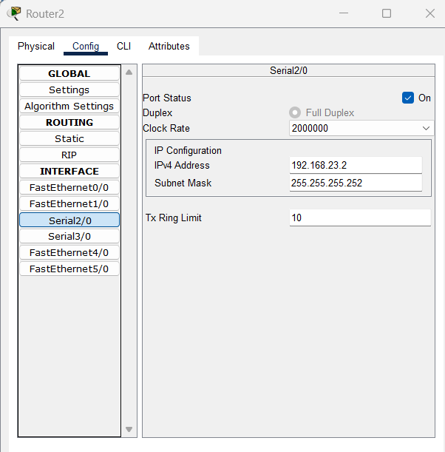
R1
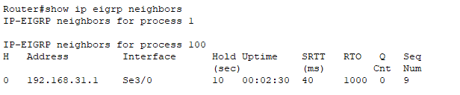
R2
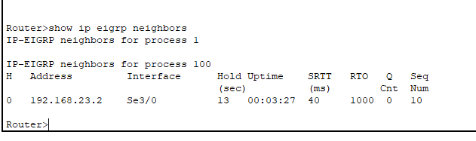
R3
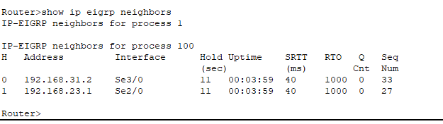
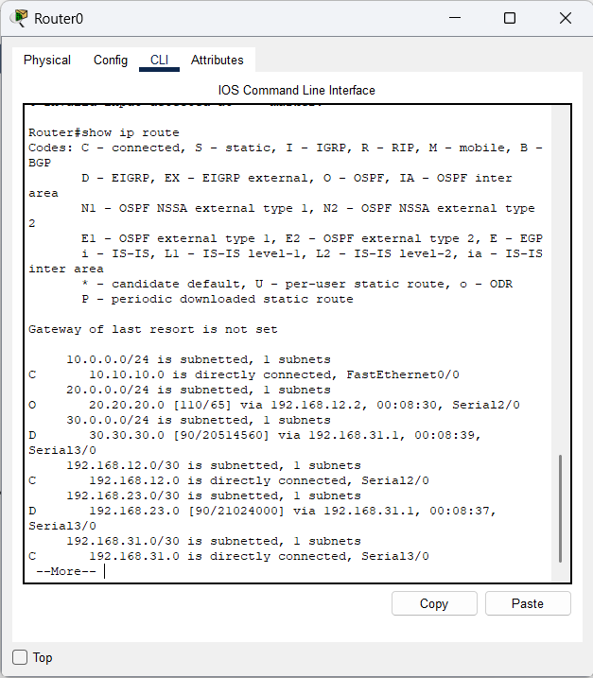

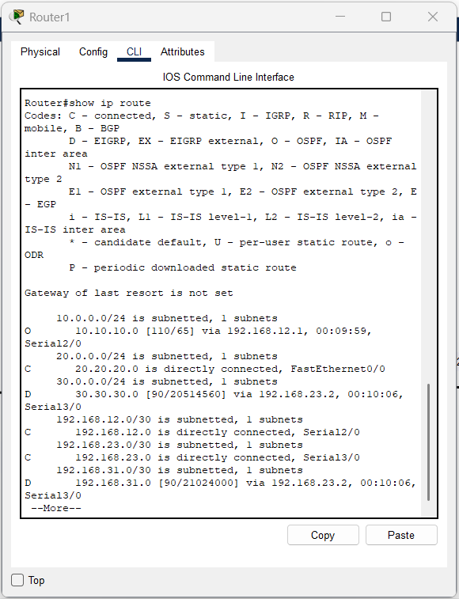
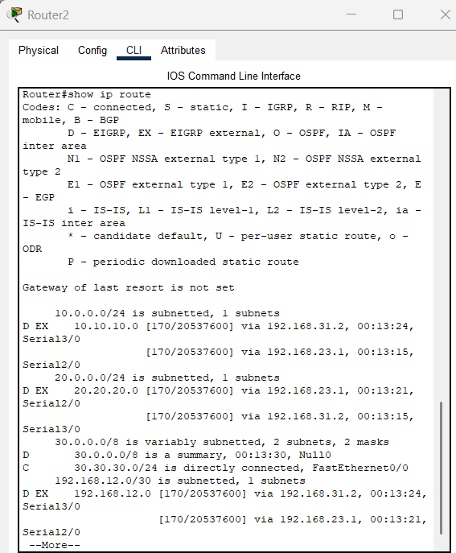

2. Successful ping from HQ to Charlie
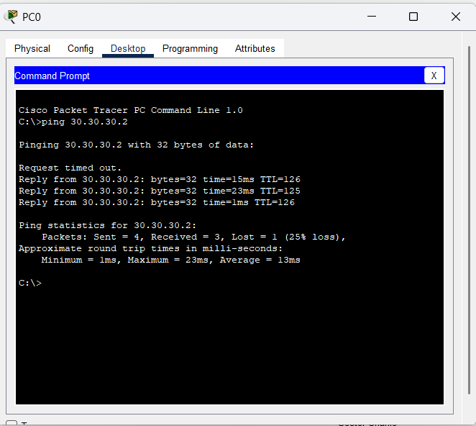

3. Fault introduction
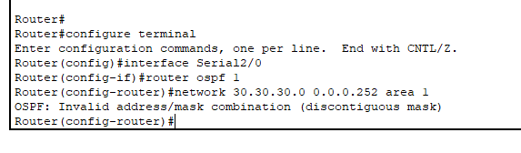
It was also kept in area 1. Network was also incorrect for ospf.

4. Explanation of why failure occurred
4.1. Non adherence to wildcard rules of keeping all network bits as 0 and host bits as 1
4.2. Keeping network in other area. Here area was incorrectly given as 1

