PHASE 3 – INTRUSION DETECTION BATTLE (SURICATA)

1. Rules File.
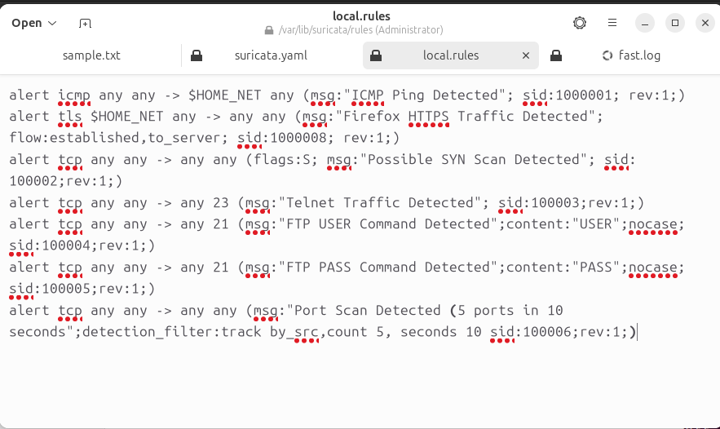
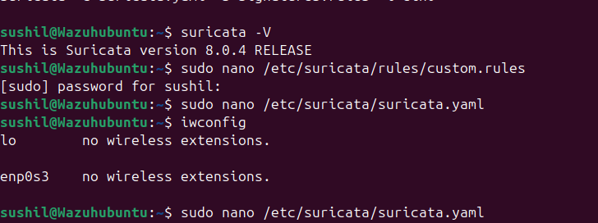

2. Commands used for testing

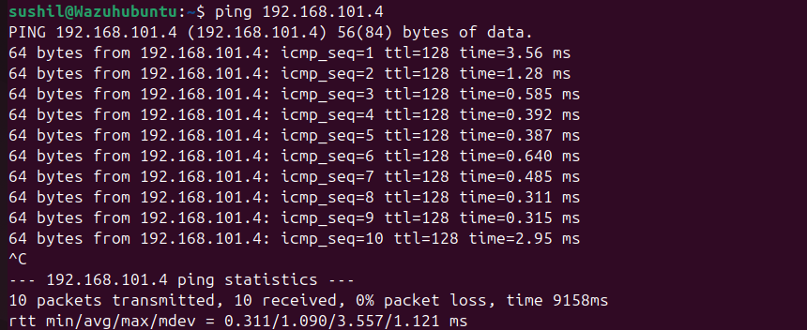

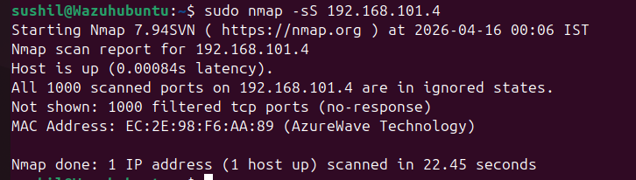

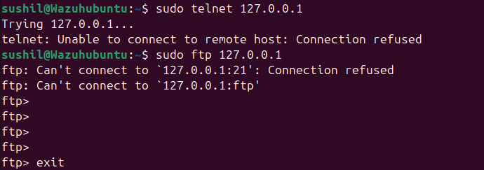

3. Fast.log and eve.json for alert

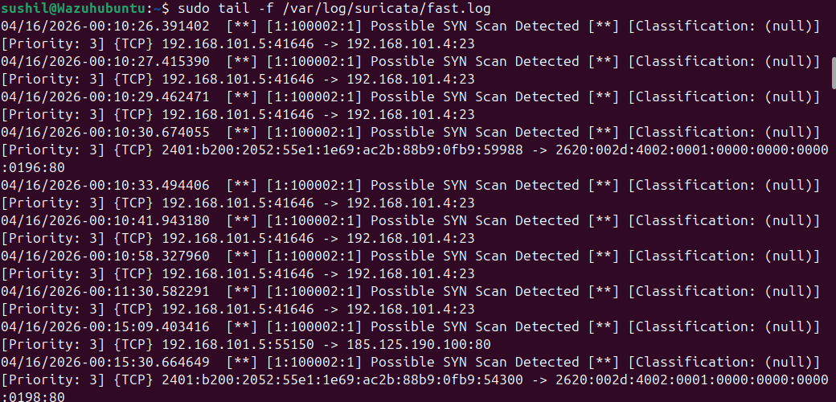

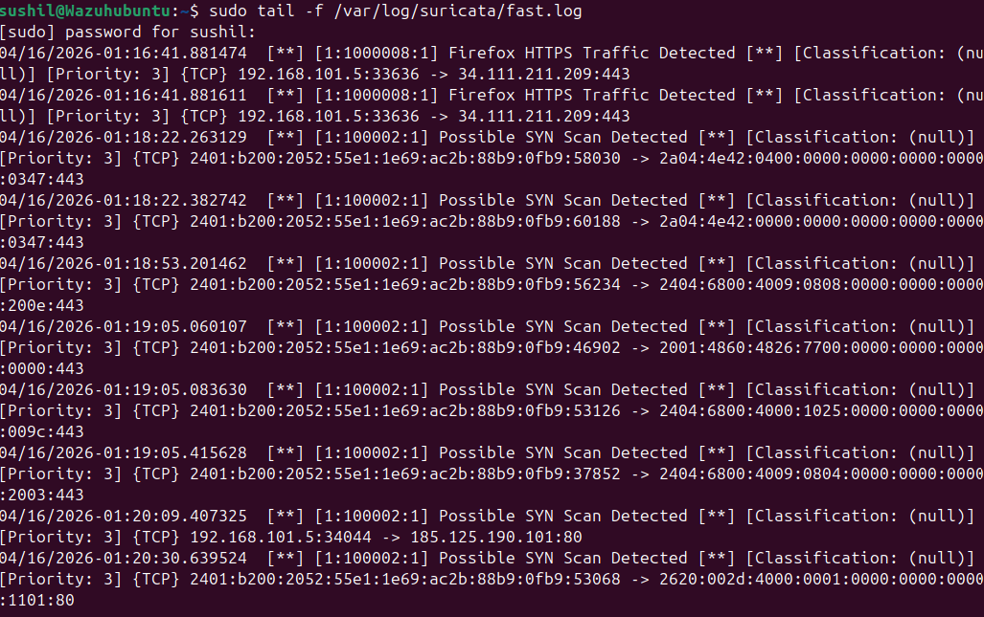

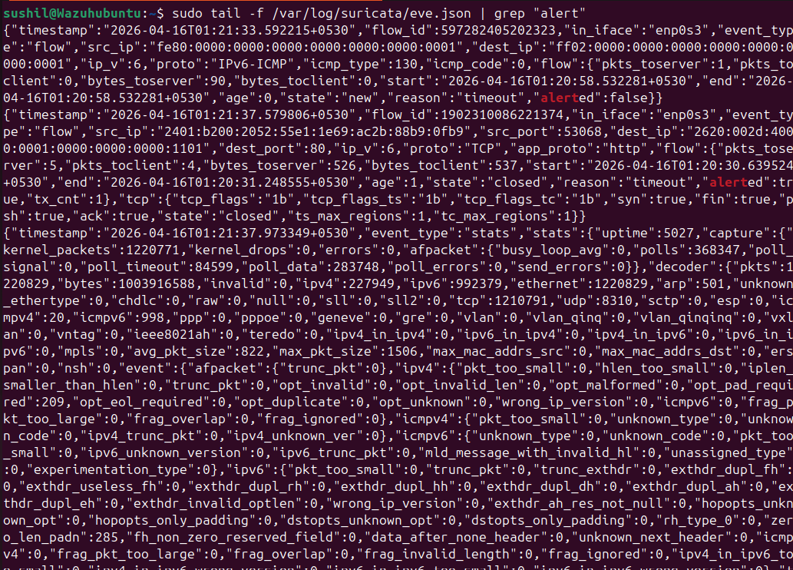

4. Highest priority alert. Multiple Port Scan Detection. Reasons are as follows:-
  - Indicates active reconnaissance phase
  - Often precursor to:
    - Exploitation
    - Brute force attacks
  - Shows attacker intent (not just normal traffic)

