PHASE 2 – INTERCEPTED CREDENTIALS (WIRESHARK)
1. FTP.
1.1. Screenshots.
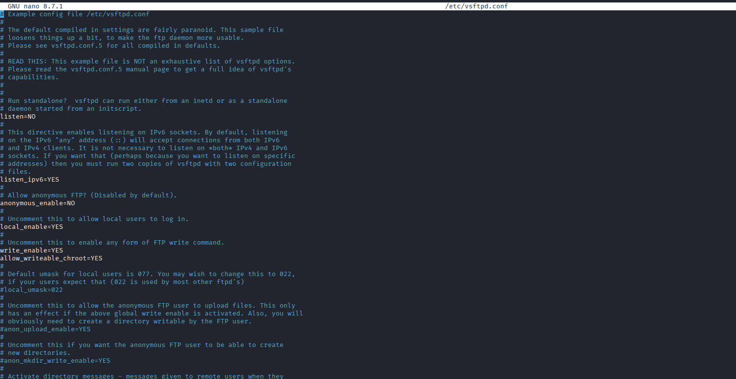
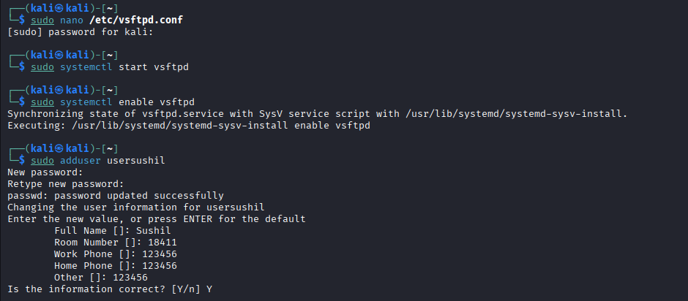
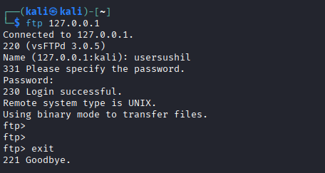
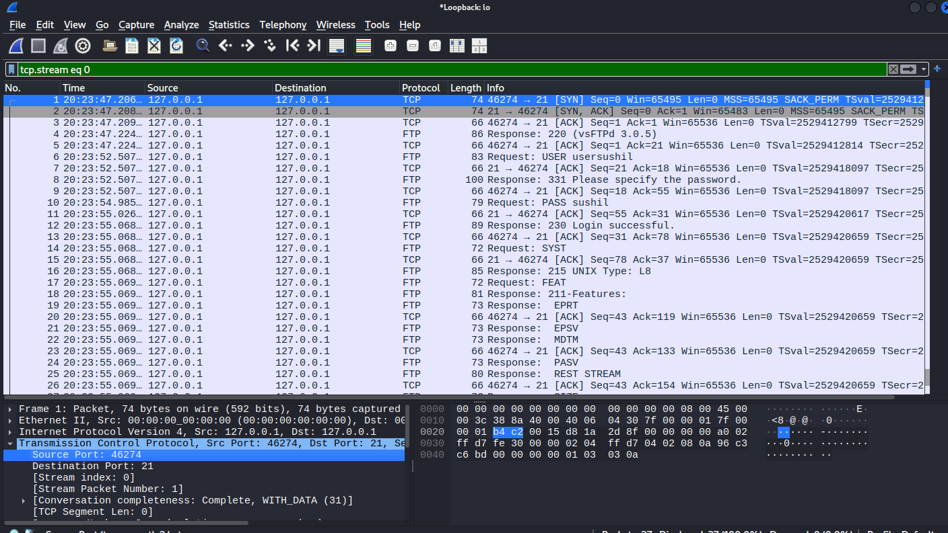
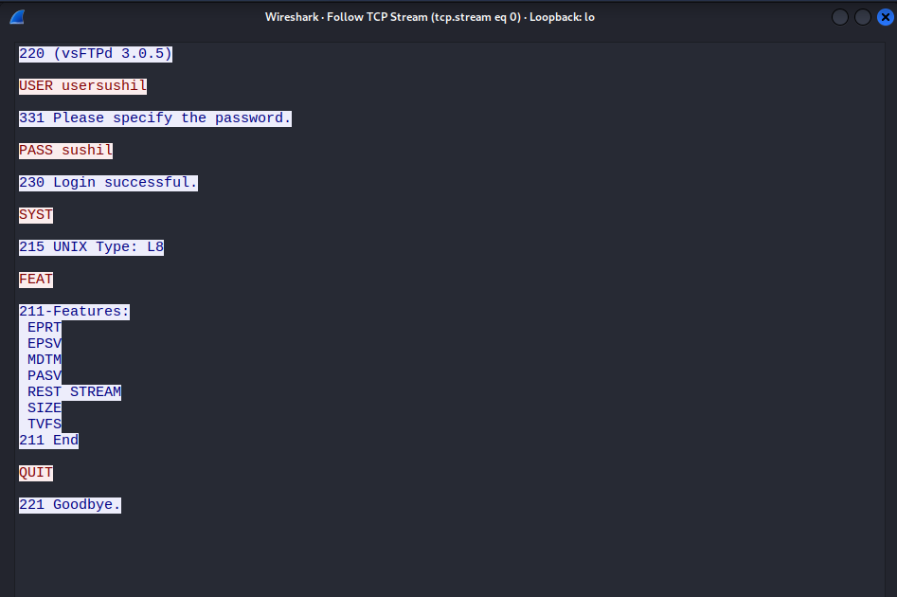

1.2. FTP Login Analysis
    - Username: usersushil
    - Password: sushil
    - Source IP: 127.0.0.1
    - Destination IP: 127.0.0.1
    - FTP sends credentials in plaintext. Any attacker using packet sniffing can: -
      - Steal login credentials
      - Gain unauthorized access

2. Telnet
2.1. Screenshots.
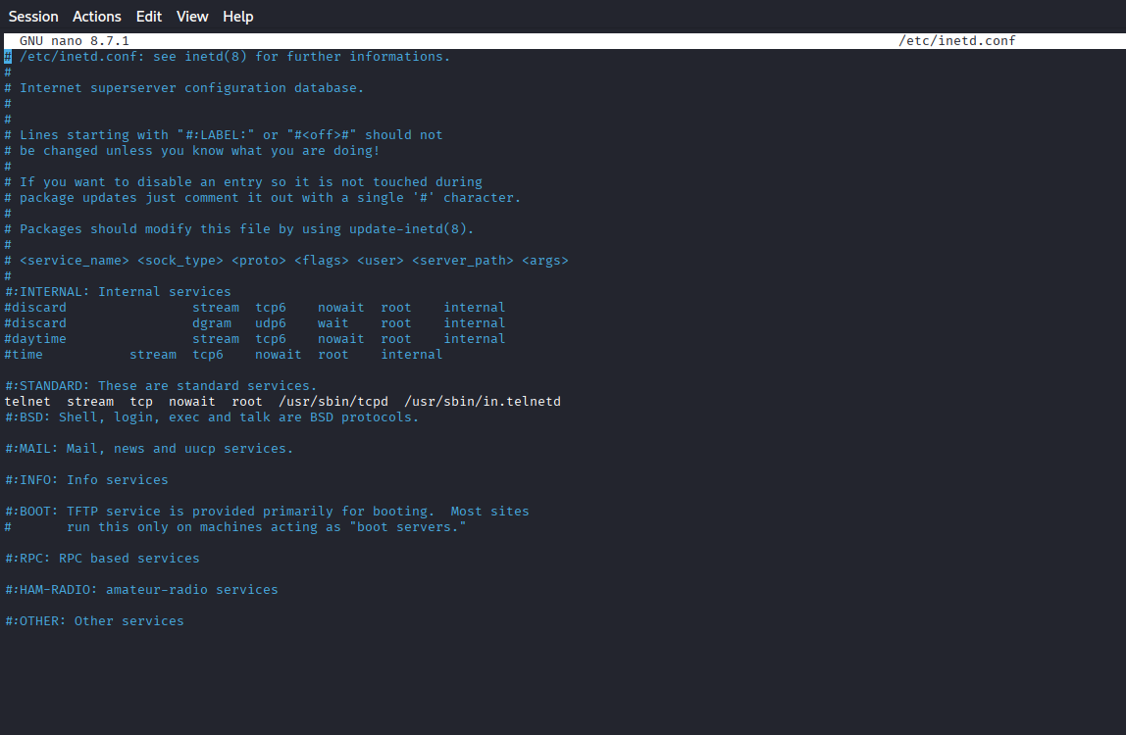
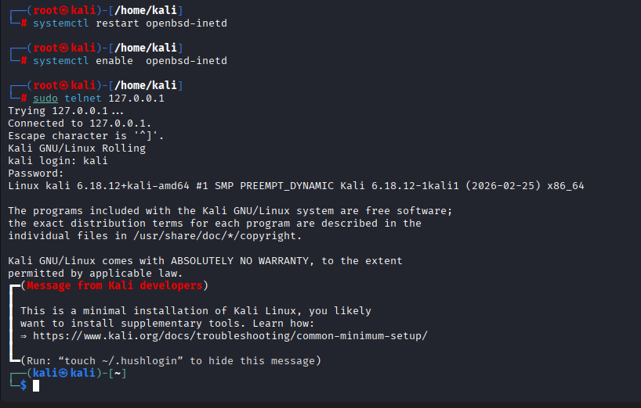
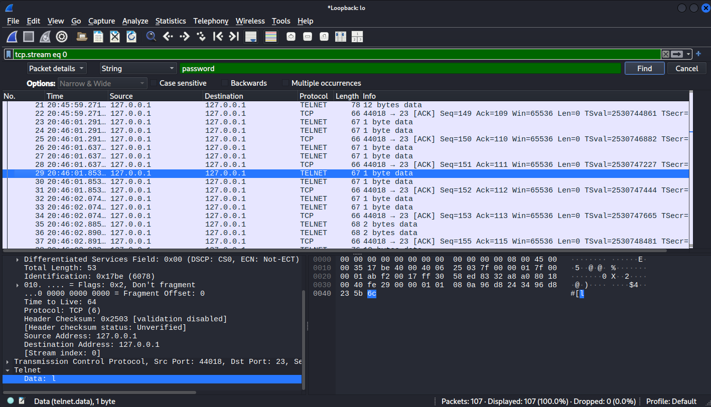
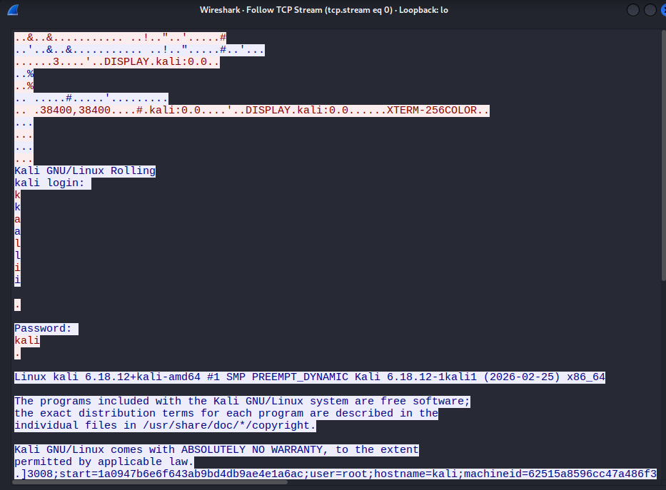

2.2. FTP Login Analysis
    - Username: kali
    - Password: kali
    - Source IP: 127.0.0.1
    - Destination IP: 127.0.0.1
    - Telnet transmits everything in clear text. Attackers can: -
      - Capture credentials
      - Hijack Sessions

3. DVWA
3.1. Screenshots.
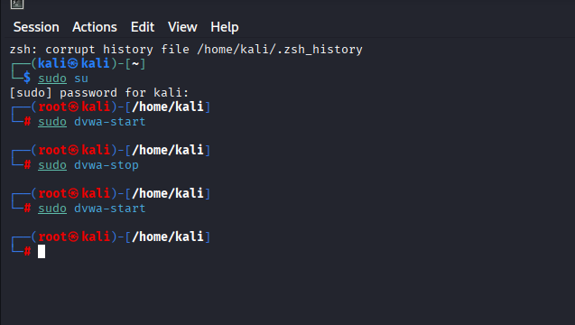

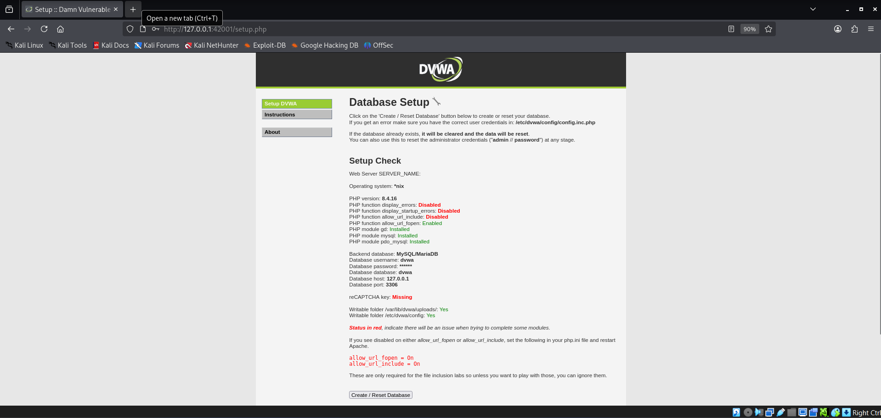

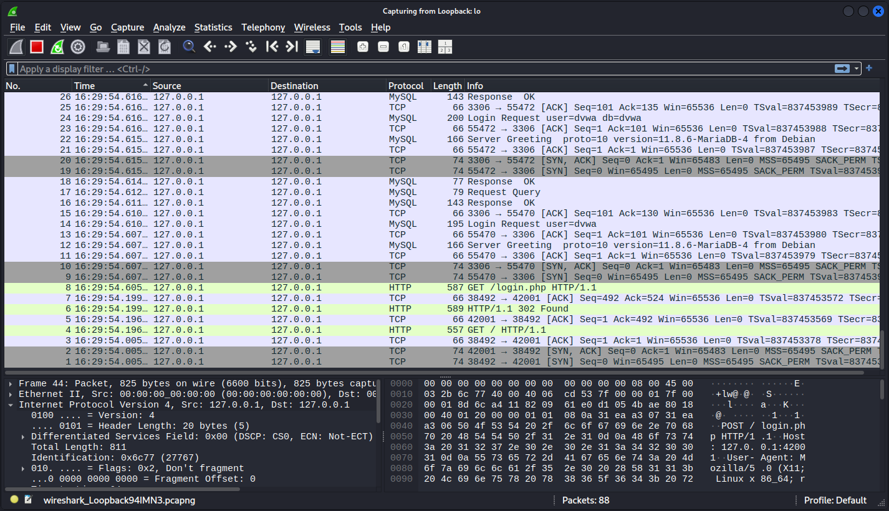

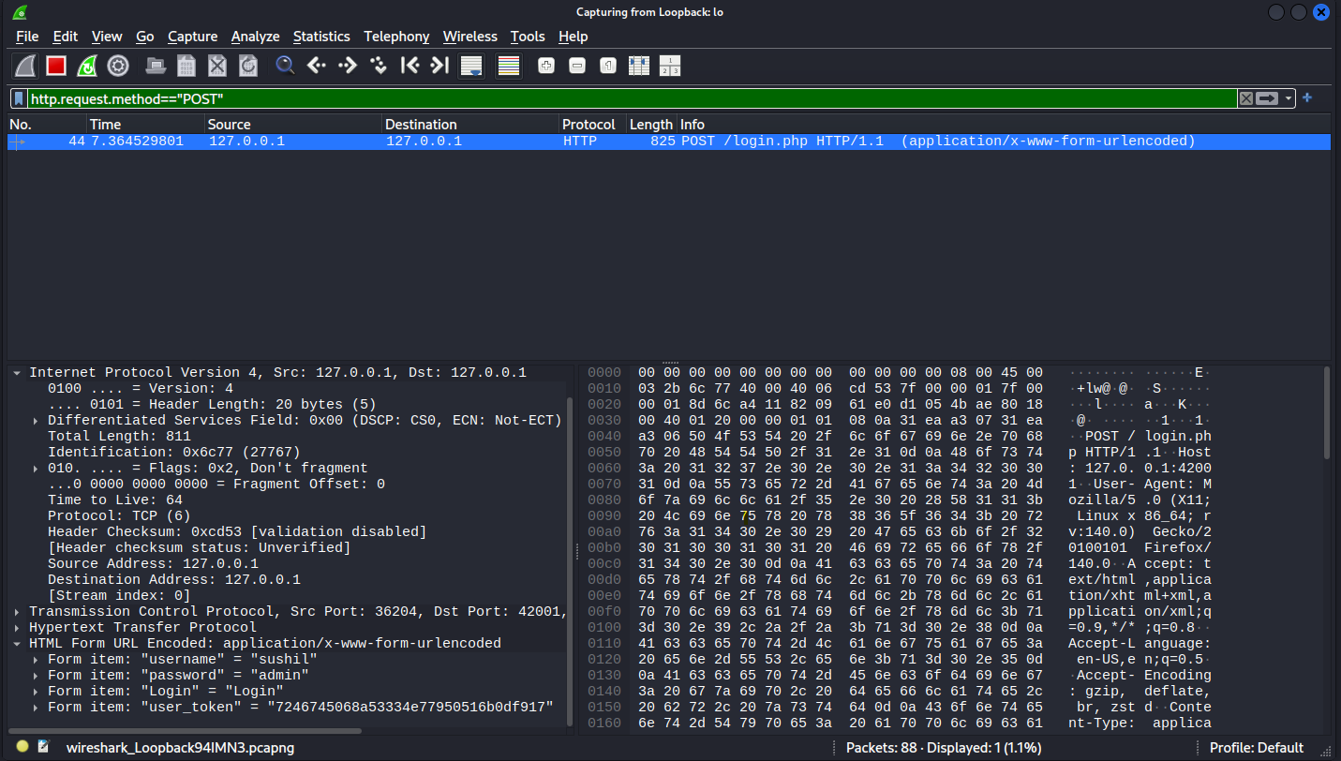

3.2. DVWA Login Analysis
    - Username: sushil
    - Password: admin
    - Source IP: 127.0.0.1
    - Destination IP: 127.0.0.1
    - HTTP POST requests transmit credentials in plaintext, exposing them to interception

