JoeM BMC
Battery Management Controller
V3.2

1 Introduction 2

2 Pin Configuration 2

3 Absolute maximum Ratings 2

4 Wiring 3
4.1 Precautions 3
4.2 Tesla Model S / X 3
4.3 VW MEB 4
4.4 BMW i3 4

5 Configuration over USB 4
5.1 Connecting via Terminal 4
5.2 Default Screen 5
5.3 Configuration Menu 5
5.4 Firmware Update 5

Introduction
This BMC (Battery Management Controller) is not a BMS on it’s own. It is designed to control OEM Battery Management Boards, Cell Monitoring Units or Battery Management Systems.
⚠ Although the BMC has been thoroughly tested, this is not a finished product. Some prior knowledge is required for commissioning. Use at your own risk!

Pin Configuration
 | A | B | C | D | E | F | G | H | J | K | L | M
1 | Out8 (PWM) | Out7 (PWM) | Out5 (PWM) | Out6 (PWM) | Out1 (12V) | Out2 (12V) | Out4 (12V) | Out3 (12V) |  |  | 12V | 12V
2 | BMB RX | BMB TX | Disp. RX | Disp. TX | ASen1 | ASen2 | In4 | In3 | In1 | In2
3 | GND | 5V | GND | 5V | GND | 5V
4 | CAN1-L | CAN1-H | CAN2-L | CAN2-H | 5V | USB D- | USB D+ | GND |  |  | GND | GND

All pins with the same symbol are internally connected.
All PWM-Outputs are tied to GND.

Absolute maximum Ratings

Parameter | Symbol | Values |  |  | Unit
Parameter | Symbol | Min. | Typ. | Max. | Unit
Supply
Supply Voltage | 12V | 6 | 12 | 28* | V
Inputs
Voltage at In1 – In4 | V_{IN} | 6 | 12 | 80 | V
ASen1 / Asen2 | VSen | 0 | - | 5 | V
Outputs
Current through OUT1 – Out4 (High) | I_{HOUT} | - | - | 1 | A
Current through OUT5 – Out8 (Low) | I_{LOUT} | - | - | 1 | A
5V | 5V | - | - | 0.5 | A

*Beware that the high side outputs are tied to the input voltage. It is technically possible to power the BMC with more than 12V. But all components controlled by the BMC on Out1 to Out4 should be able to withstand this high voltage.

Wiring

Precautions
- All wires for the power supply (L1,M1,L4,M4) should be 1mm². Add a fuse (10A) to the 12V line.
It is not necessary to use both 12V and GND input pins.
- Do not use any other pin except L4 & M4 as your main GND connection!
- Do not feed any 5V pin with voltage! When intending to wire up and connect USB to your PC or any device that provides 5V over USB, do not connect the 5V pin! It might damage your USB-Port.
- Add 1A fuses to the outputs and use appropriate wire sizes.
- Use shielded wires for signals. Connect shielding to GND.

Tesla Model S / X
Tesla Modules are daisy chained together. You start at the BMC Pin B2 (TX) which connects to the Molex connector of the Tesla board on Pin 2 or 7 (RX). Next you connect Pin 4 or Pin 9 (TX) to the next boards RX and so on. From the last board you connect the TX back to the BMC on Pin A2 (RX).
For power supply of the Tesla board use Pin B3 (5V) and A3 (GND) which connect to Pin 1 or 5 (5V) and Pin 3 or 8 (GND) respectively.
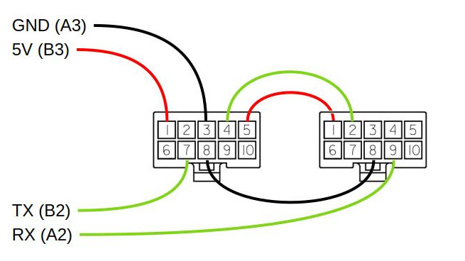

VW MEB
Since the CMU connectors are not available on the free market, it’s important you keep the original connectors!
VW MEB Modules use CAN for communication. Therefor the CMUs must be connected in a kind of chain. One of the CMUs marks the end of the chain where a termination resistor must be activated.
Wire colors:

PIN | Function
1 | GND
2 | GND
3 | --
4 | TermR
5 | --
6 | TermR
7 | CAN High
8 | CAN High
9 | CAN Low
10 | CAN Low
11 | 12V
12 | 12V

Green-White 12V
Brown GND
Orange-Blue CAN High
Orange-Brown CAN Low
To use the termination resistor for example connect Pin 4 to Pin 7 and Pin 6 to Pin 9.

BMW i3

Configuration over USB

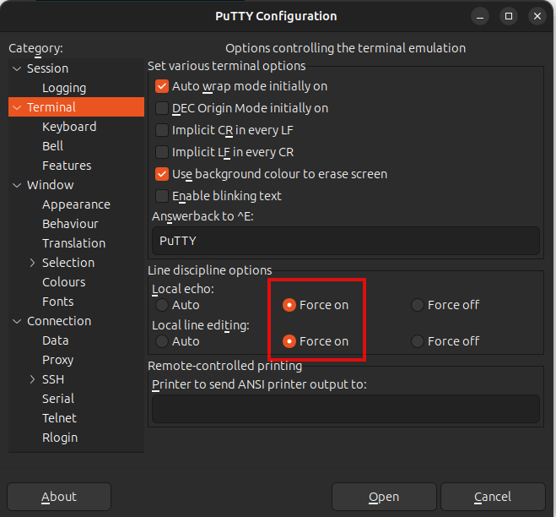
Connecting via Terminal
For a proper connection to the BMC use a terminal software such as putty (https://www.putty.org/). You can also use the Serial Monitor of the Arduino IDE. It’s important that the terminal software is set to use local echo and local line editing! Arduino IDE does this by default. In putty you find these settings under “Terminal”.

Default Screen
Hotkeys:
b – toggle Modules / Cells display
o – toggle Output display
m – open Menu

Configuration Menu

Firmware Update
To update the BMC you need the latest firmware file from https://github.com/JoeMudr/JoeMBMC.
You also need the Teensy loader software from https://www.pjrc.com/teensy/loader.html.
Start the Teensy loader software and chose File → Open HEX File and select the Firmware.hex file.
Connect the BMC via USB. And open a Terminal. Press [M]+[Enter] to enter the main menu. In the main menu press [X]+[Enter]. This will reboot the micro controller to load the new firmware.

