Puzzle Ideas – v.1 – 6/19/09

**Puzzle Constraints**

**Movement**

* Moves
* Spacebar= chomp
* Directional Keys = move
* Push (approach, towards)
* Pull (chomp, away)

**Puzzle Types**

* Environmental
* Minigames

**Puzzle Scenarios**

* Tutorial
* Level 1 – 7?

**Preliminary Map**

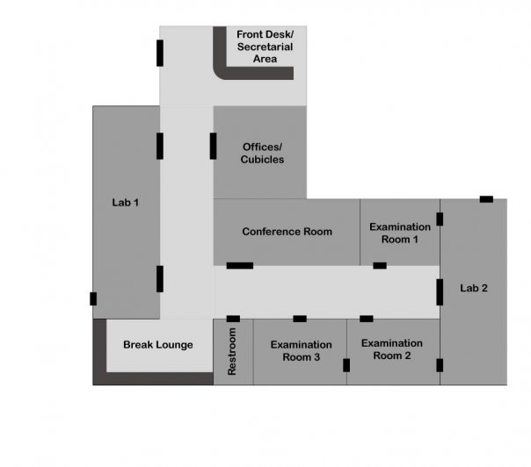

**Puzzle Ideas**

**Environmental Puzzles**

1. A bottle of pills somewhere (lab coat pocket?) and a coffee cup on the counter - putting a pill into the coffee cup causes a scientist to fall asleep
2. To get up to one of the countertops, three drawers must be opened slightly, each in a different way. (The bottom one can be pulled, the highers ones are more difficult.
3. Turning on the chemical shower - flooded lab makes it easier to sense approach of enemies.
4. Water pipe maze (might instead be context puzzle, since we have to switch characters) - Blicka can fit down the drain holes of the chemical shower where the other Salamanders can't. She can swim through the water pipes and, if she makes it out the other side, do... something. I don't know. Flip a switch? Re-route the water?
5. In the conference room (utilizing a Radio and Speaker Phone)  
   -Turn on the Speaker Phone to intercom mode  
   -Turn on the Radio – the radio has 8 channels:  
    Country, Top 40, Classic Rock, Ranchero, Classical, Jazz, Talk, Party  
   -The state of the scientists will be impacted by what music you broadcast over the intercom – (Classic Rock, Top 40, Ranchero, and Party will make the scientists speed up) (Country, Classical, Jazz, and Talk will make the scientists slow down). If these states (sped up and slowed down) don’t make sense for the scientist mechanics, alternate states could be used instead.
6. In a lab or exam room (utilizing a razor, guinea pig , and donut)  
   -Find the razor in a desk drawer  
   -Shave a guinea pig  
   -Bring a donut into the cage (it’s stickiness will pick up the shaved fur)  
   -Bring the furry donut with you (it will be indicated that, when you do, you look sort of like a guinea pig yourself)  
   -Use this as camouflage in entering into “Crazy Chubbycheeks’” cage. Crazy Chubbycheeks is a guinea pig who is on a test that makes him hyper aggressive against anything that is not a fellow guinea pig. Only in disguise can you enter his cage and retrieve an object found in it that is needed for another puzzle.
7. Use an apple to float across water  
   -chomp an apple 3 times to eat half of it. After the third time, the player will be prevented from eating it any further. (maybe some dialogue would same something along the lines of “you’ve already eaten half the apple! That’s a lot of apple for a little salamander like you.”)  
   -push the apple half into nearby water  
   -walk onto the floating apple  
   -the apple then floats to an area you couldn’t otherwise access
8. In a lab or exam room (utilizing a banana found in the Break Room, perhaps)  
   -Bring the banana to a monkey  
   -The monkey eats the banana and throws the peel on the floor.   
   -the Peel can be used for a number of purposes such as – cover (bring the peel with you so that scientists won’t easily notice you), “skateboard” (move more quickly), landmine (place the peel somewhere a scientist might step to temporarily take him out)

**Minigames**

1. 8-Queens (n-queens?) - Creatures that don't like each other (spiders, or something?) must be arranged so none can see any of the others. If they can see the others, they will fight. Otherwise, they will reveal... whatever. I dunno. They'll head to the crack in the wall, or something.
2. Pitcher pouring puzzle
3. Raft crossing the river puzzle
4. Mini-tetris puzzle (too complicated to program?) - lock-picking?
5. Memory-Match – Match the lab animals to their clones

**Objects that can be Used**

**Lab 1, 2 & Examination Room 1, 2, 3**

* Widows
* Lab Tables
* Animal Cages (with mice, guinea pigs, monkeys, etc.)
* Burners
* Sinks
* Chemical Eye Wash
* Chemical Shower
* House Plants
* Fire Extinguisher
* Fire Alarm
* Lab Coats
* Intercom
* Whiteboard
* Surgical instruments
* Chemicals

**Break Lounge**

* Refrigerator
* Table
* Food (donuts, soda, fruit, chips, half eaten sandwich)
* Foosball Table
* Radio
* Television
* Sofa

**Front Desk/Secretarial Area**

* Pens/Pencils
* Paper
* Phone
* Desk
* Plush Chairs
* Paintings

**Offices/Cubicles**

* Paper
* Desks
* Water Dispenser
* Vending Machine
* Phones
* Computers
* Printers
* Photos of Family Members
* Letter Opener
* Mail Cart

**Conference Room**

* Paper
* Radio
* Conference Telephone (speaker phone)
* Bottles of Water
* Computer
* Whiteboard

**Restroom**

* Soap
* Sinks
* Toilets
* Urinals
* Paper Towels
* Toilet Paper