Project Euler Problem 163 – Cross Hatched Triangles
https://projecteuler.net/problem=163
Runtime: approximately 100 seconds

Overall structure of my approach

Build the triangle as a network of nodes by starting with a size 1 triangle, and adding layers one by one to get a size 36 triangle. Process this network of nodes to give a set of all of the straight lines in the triangle.

Node numberings and connection angles

Flat triangle
In Triangle.add_edges you can see the following lines:

self.add_edge(0, 1, 0)
self.add_edge(0, 2, 150)
self.add_edge(0, 3, 120)
self.add_edge(1, 4, 0)
self.add_edge(1, 2, 90)
self.add_edge(2, 4, 30)
self.add_edge(2, 5, 150)
self.add_edge(2, 6, 90)
self.add_edge(2, 3, 30)
self.add_edge(3, 6, 120)
self.add_edge(4, 5, 60)
self.add_edge(5, 6, 60)
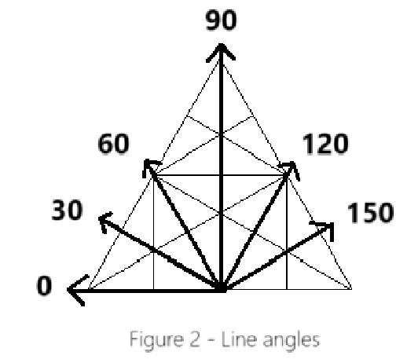
The first two arguments correspond to node numbers in the upper triangle in Figure 1, where the two nodes are directly adjacent. The third is the line angle with which they are connected, as shown in Figure 2. All lines on the hatched triangle correspond to one of these angles.

The node numbers here correspond to the indexes of the nodes within a Triangle objects list of nodes.

Upside down triangle (Lower triangle in Figure 1)
To process an upside down triangle all that needs to be done is to change the angle by which the nodes in a flat triangle connect by. This is done in Triangle.add_edge as such:

if self.type == TriangleType.UPSIDE_DOWN:
angle = (180 - angle) % 180

Zero lines and zero nodes

We will define zero lines as fully extended lines (meaning that they must extend as far as they can, i.e. a fully extended line L cannot be a line segment of a greater line L') that have an angle of 0. See bold lines in Figure 3.

We will then define zero nodes as any node that is on a zero line.

Generating all lines and finding all triangle
To find all of the triangles in the cross hatched triangle, we will first get a list of all of the fully extended lines in the hatched triangle. To do this we will use the following facts.

From inspection one can see the following:
- All triangles must contain at least one zero node. This means that if we find all the triangles that contain zero nodes we will in fact find every triangle.

- Every fully extended line on the triangle must either start of finish on: a node on the bottom zero line; or the start or end node of a higher up zero lines.

- Analysing lines that start with start/end nodes of higher up zero lines we see that:
  - 0 degree lines are already found, they are our zero lines
  - 30 degrees lines coming from a zero line start node have their other end at the end node of a lower zero line.
  - 60, 90 and 120 degree lines have an end node on the base zero line and so are already found.
  - 150 degree lines coming from an end node have their other end at the start node of a lower zero line.

To find all the fully extended lines first the lines that have an end on the bottom zero line are to be found. This is simple enough, one just has to loop through each node on the bottom zero line and traverse all the non zero angle lines coming from those nodes.

To find the zero lines that start/finish at the start or end node of a higher up zero line we will use (3).

(3.1 and 3.3) mean that we need not traverse any of the lines that have an angle of 0, 60, 90, 120 coming from the start and end zero nodes.

If we search for lines starting using the lowest down zero lines and working our way up, then (3.2) means that when examining the an end node of zero line, we need only traverse the 30 degree line, and (3.4) means what when examining the start node of zero line, we need only traverse the 150 degree line.

Doing this means that we will put together all of the lines in hatched triangle.

Layers
To build up the cross hatched triangle we start with one size 1 triangle (which will also be our first layer), then add a layer of 3 triangles to make it a size 2 triangle, then add a layer of 5 to make it a size 3 triangle, etc. until we get a size 36 triangle.

The nth layer will 2n – 1 triangles in it.

When adding triangles to a layer, we need to connect the shared nodes together, and it turns out that there are 3 cases.

Case 1: The first (flat) triangle
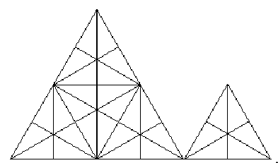
The first triangle in any layer will only have 1 shared node: node 0 of the new triangle will be the same node as node 4 of the first triangle of the previous layer. (See node numberings).

Case 2: Flat triangles
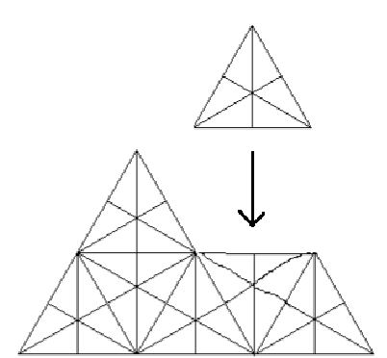
The oddly indexed triangles within a layer are also flat triangles and so have the same numbering and angles between nodes but they share 3 nodes:
Node 0, 1 and 4 of the new triangle are the same nodes as node 0, 1 and 4 of the previous triangle in same layer respectively.

Case 3: Upside down triangles

The evenly indexed triangles in a layer are upside down triangles and they share 5 nodes. For an upside down triangle of index n within a layer the shared nodes are as follows:
- Node 0 of the new triangle is node 6 of the index n – 1 triangle of the previous layer.
- Node 3 of the new triangle is node 5 of the index n – 1 triangle of the previous layer.
- Node 6 of the new triangle is node 4 of the index n – 1 triangle of the previous layer.
- Node 5 of the new triangle is node 3 of the previous triangle in the same layer.
- Node 4 of the new triangle is node 6 of the previous triangle in the same layer.
Previous algorithm
The first algorithm that I implemented was the laziest that I could think of and it turned out that it probably would fit into the category of “Algorithms that won't complete in the estimated life span of the universe” type algorithms and so I came up with the current one.

It can be found in previous versions but it is not well documented.

