Lab 13
1. Your lab document must be uploaded to Canvas in Landscape Mode to get a grade above 1. You must also ensure that all screenshots are visible in the Canvas preview window, after uploading your document.

2. If the NDG Lab is not functioning correctly and you have confirmed that your previous steps are correct and that you are doing the current step correctly, you will need to cancel your current reservation and start a new reservation on a different NDG POD.

3. Incorrect answers are worth 6pts each

Pay attention to tables and questions that require a supporting screenshot to count as correct.
If your screenshot is not the correct screenshot or the correct information is not selected/highlighted/visible in your screenshot (where the Student Template states to select/highlight the correct answer), your answers will be marked as incorrect.
You must type out the answers to questions/table entries. Screenshots are not accepted where you must answer a question or fill in a table. You only provide screenshots where you see a requirement to insert a screenshot.
4. Screenshots

Incorrectly formatting your screenshots (i.e. not following the requirements shown in front of your student template for the first two NDG lab Student Templates) will be a 2-point deduction per screenshot, up to 11 points for the lab. See this for guidance Screenshots Format Demo Video

If your NDG name is missing/not visible in your screenshot, that screenshot is incorrect.

If your screenshots are too small to view/see the information in the screenshot within Canvas’s grading window, your answer / screenshot may be marked incorrect, which is in addition to the 2 points for formatting issues.

This Student Template shows a single page dedicated to each screenshot. Ensure that when you paste your screenshots, that the screenshots take up most (more than 3/4) of the page (Your screenshots will take up most of a page, when captured and pasted correctly (using Win + Shift + S to capture and Ctrl + V to paste for a Windows PC or equivalent MacOS commands).

5. Wireshark, TCP / HTTP Stream Windows, terminal/console windows, Kibana, and Sguil must be full screen inside the NDG VM before taking a screenshot
(DO NOT OMIT capturing the bottom of the screenshots at this point)

Setting up NDG for screenshots.

            - After you log into NDG, select No Lab: Launch Cyber Range Lab, click on the Security Onion tab to log in with username analyst and password cyberops).

            - Now, click on the right dropdown arrow of the Security Onion Tab (red arrow) on the top bar in NDG and select Actual Size (blue arrow). This will make your virtual PC much smaller than your personal browser window size (if you have your personal browser full screen).

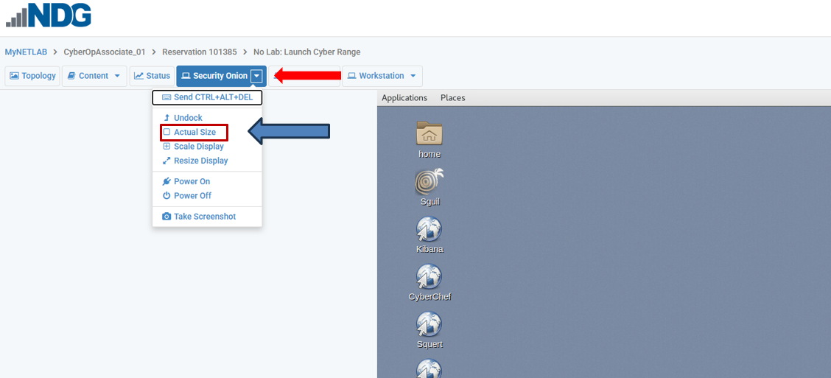

            - If your personal browser is running full screen, you will need to take it out of full screen by clicking on the double squares in the upper right corner of the screen so that you can shrink your browser to match the Security Onion VM desktop width.


            - Be sure that your username in NDG, Time Remaining, and Speaker and Power icons are lined up (the blue field of the browser in the VM will be right up next to the edge of your browser window)

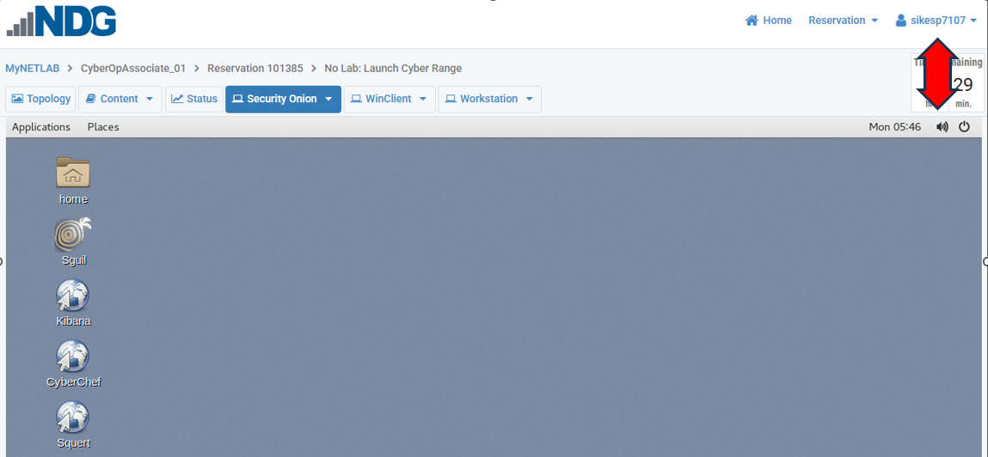

            - With this setup, the Workstation will be set up appropriately . If you do not adjust your personal browser size after this point, your Workstation screenshots will be fine.
Reminder: the following must be full screen inside the NDG VM before taking a screenshot

Wireshark

TCP / HTTP Stream windows

terminal/console windows

Kibana

Sguil

You must capture the bottom of the screens for these types of screenshots

If a field on this document will not allow you to enter your answer or paste your screenshot, the form field was altered during the download from Canvas.
To fix the issue, you will have to download the document from Canvas again, transfer your answers and screenshots from this document to the new document, and continue with the lab.

Remember to follow the screenshot requirements shown in the first NDG lab you performed.

Objectives
Part 1: Use Kibana to Learn About a Malware Exploit
Part 2: Investigate the Exploit with Sguil

Background / Scenario
You have decided to interview for a job in a medium sized company as a Tier 1 cybersecurity analyst. You have been asked to demonstrate your ability to pinpoint the details of an attack in which a computer was compromised. Your goal is to answer a series of questions using Sguil, Kibana, and Wireshark in Security Onion.
You have been given the following details about the event:
- The event happened in October of 2019
- It was discovered by Snort NIDS

Part 1: Use Kibana to Learn About a Malware Exploit
In Part 1, use Kibana to answer the following questions. To help you get started, you are informed that the attack took place at some time during October 2019. You will need to pinpoint the exact time.
Step 1: Narrow the timeframe.
- From NDG’s No Lab: Launch Cyber Range, click on the Security Onion VM and log in with the user analyst and password cyberops.
- Open Kibana (username analyst and password cyberops), set an Absolute time range to narrow the focus to October 4th, 2019. (Ensure Kibana is fullscreen inside the Security Onion Desktop) and under Alert Data select NIDS.

- Only a small line is visible in the NIDS – Alerts Over Time showing that the event took place over a short period.

- Take your mouse and zoom in on the event by left clicking just in front of the first dot in the upper left and dragging your mouse to just the other side of the last dot on the bottom right (as if you were trying to highlight the vertical line). Repeat this process until the event is taking up 75% to 90% of the graph. (If you cut off part of the event, just use the Absolute Tab to narrow it again and start over). Zoom in until your display resembles the one below.
(THIS IS NOT THE ACTUAL EVENT BELOW, BUT A SAMPLE TO SHOW YOU HOW MUCH OF THE CHART YOURS NEEDS TO TAKE UP)
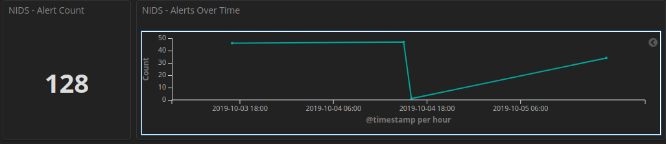

YOUR SCREENSHOT WILL NOT BE LIKE ABOVE
YOU HAVE TO PROVIDE A FULL SCREENSHOT THAT INCLUDES THIS PART OF THE SCREEN

Part 1d Screenshot [On the next page, insert a screenshot showing you narrowed the focus of the Dashboard like above] [Ensure the NIDS – Alert count is in the screenshot along with the chart]
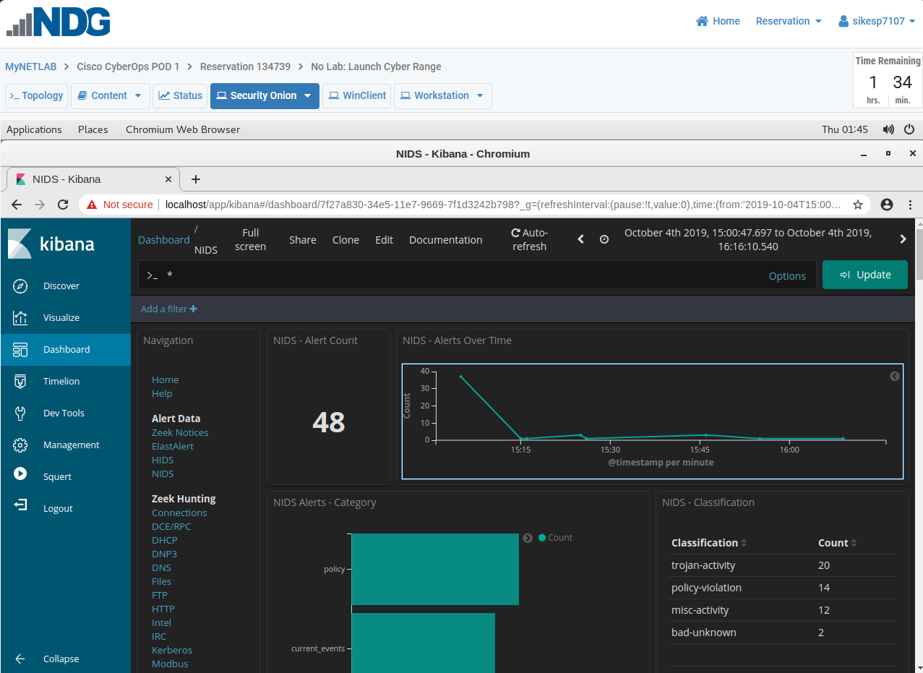
Step 2: Locate the Event Details in Kibana
- Now view details of the events that occurred by scrolling all the way to the bottom of the dashboard until you see the NIDS - Alerts section (not to be confused with the NIDS – Alert Summary section). The alerts are arranged by time, but the last alert may be listed first. Therefore, ensure the arrow next to Time is facing up, indicating that the first alert at the top of the list is the first alert that was received. If it is not, just click on the arrow next to Time to reorder the list.
Expand each event in the list by clicking the pointer arrow that is to the left of the timestamp until you find the first one in chronological order that has the ET POLICY PE EXE or DLL Windows file download HTTP alert.

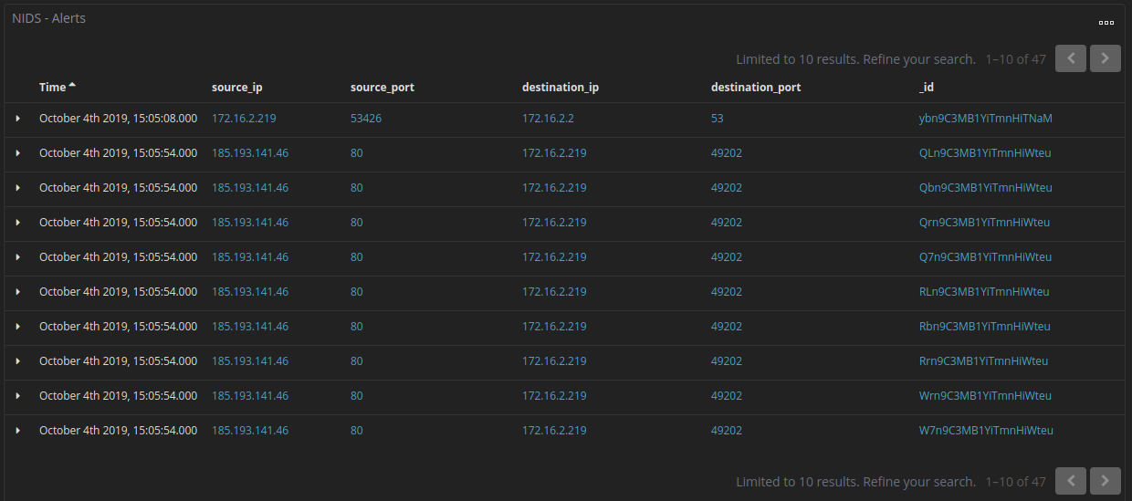

- Look at the expanded alert details and answer the following questions:

1. What is the complete @timestamp of the detected NIDS alert in Kibana that was the first event to record an ET POLICY PE EXE or DLL Windows file download HTTP alert? (the @timestamp is the first timestamp located at the top of table. Be sure not to omit any part of the @timestamp)
[Insert your answer below]
October 4th 2019, 15:05:54.000

2. What is the source IP address of the alert?
[Insert your answer below]
185.193.141.46

3. What is the source port in the alert?
[Insert your answer below]
80

4. What country is listed for the source IP?
[Insert your answer below]
Russia

5 What is the destination IP address in the alert?
[Insert your answer below]
172.163.2.219

6. What is the severity of the alert?
[Insert your answer below]
High

Part 1 Step 2b Screenshot [On the next page, insert a screenshot showing the expanded alert details] [In your screenshot ensure that the columns @timestamp down to # destination port are visible] [If you provide the wrong screenshot, all the answers above will be marked incorrect]
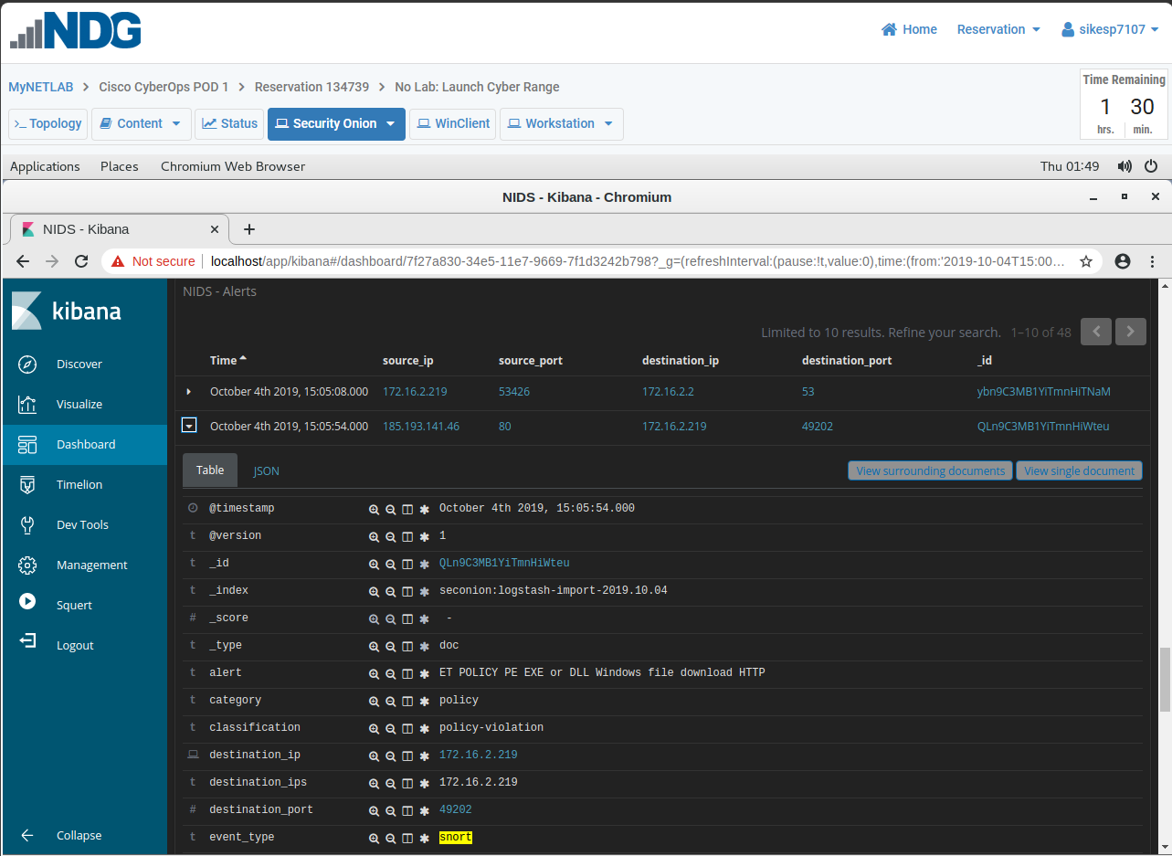
Step 3: View the Transcript capME!
- Click the alert _id value, to pivot to CapME to inspect the transcript of the event. (Sample screenshot, not actual event below)
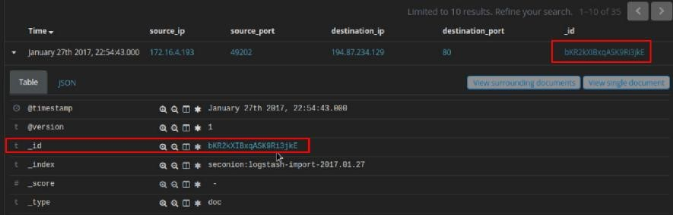
In the CapME! window you can see the transcript from the session. It shows the transactions between the source computer (blue text) and the destinations (red text) that are accessed by the source. A lot of valuable information, including a link to the pcap file that is related to this alert, is available in the transcript. Some information that you might find in a transcript is listed below. (This is a sample, not the actual CapME! for the file in your lab)

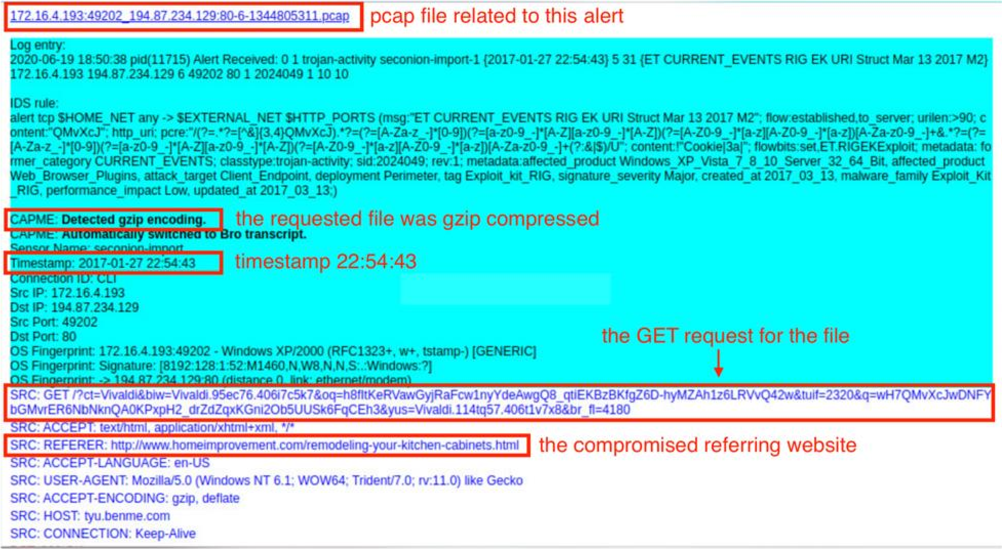
The host server (i.e. website)
- Examine the first block of blue text that starts with SRC (not the blue highlighted section and top that is black text inside a blue field). This is the request from the source (client) to the destination (webserver). Note that a URL is listed in this block, tagged as SRC: HOST. This is the website that the source computer (victim) accesses. In red(the webserver’s replay) you will find that a file was downloaded.
1. What website did the user connect to?
[Insert your answer below]
[Enter the website using the safety switches shown below question 2] [Be sure to use the safety switch while you are typing it, otherwise, many word processors will hyperlink it, causing a dangerous situation. Entering the safety switches after the hyperlink is established will not remove the hyperlink]
xoccolearp[.]com

2. What is the filename of the attachment that was downloaded? [Correct screenshot required on next page]
[Insert your answer below]
bovex5.lz2

If you were to research a site via the Internet, you would type the URL using cybersecurity safety switches to protect yourself from bringing up that domain directly. For instance, if you suspected bing of being a malicious site hosting malware, you would type it on a report and/or research it on the Internet using the following template
www[.]microsoft[.]com or microsoft[.]com
To test if this works, enter www.microsoft.com in your browser address bar. Now retype it using the format above.

Part 1 Step 3b Screenshot [On the next page, insert a screenshot showing the capME! output with the top of the output (pcap name) down to the line that answers number 2 in the screenshot]
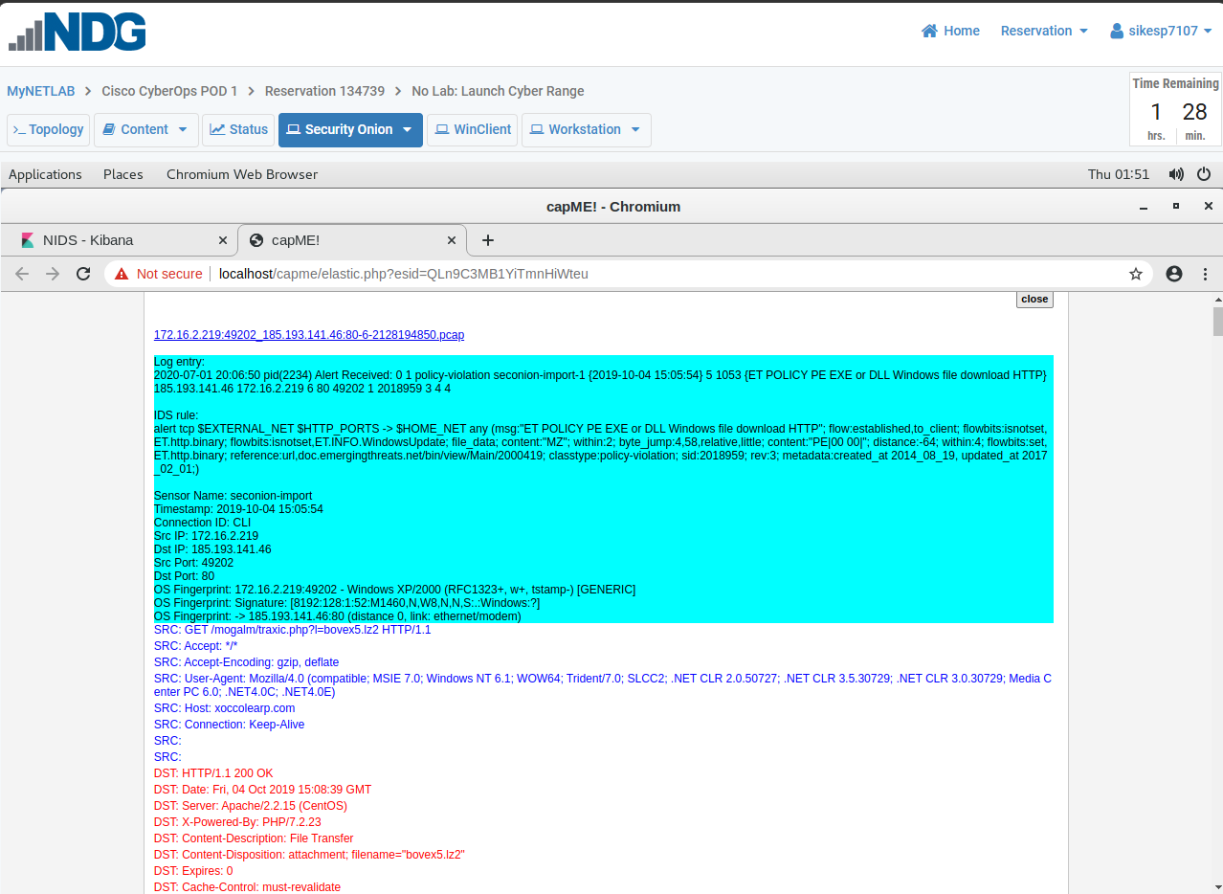

- Close the CapME! browser tab.
- Scroll back to the top of the Dashboard and click HTTP located under Zeek Hunting in the left column.
- In the HTTP dashboard, scroll down to HTTP – Sites Hosting EXEs section of the dashboard. What URL or ULRs contained EXEs?
1. Which URL or URLs are hosting EXEs?
[Insert your answer below]
[For multiple sites, hit ENTER after each entry so they are listed individually and vertically]
[Enter the url(s) using the safety switches you were shown previously]
xoccolearp[.]com

.

Part 2: Investigate the Exploit with Sguil
In Part 2, you will use Sguil to check the IDS alerts and gather more information about the series of events related to this attack.
Note: The alert IDs used in this lab are for example only. The alert IDs on your VM may be different.
Step 1: Open Sguil and locate the alerts.
- Launch Sguil from the desktop. Login with username analyst and password cybercops. Enable all sensors by clicking Select All and then clicking Start SGUIL. Make Sguil fullscreen inside the Security Onion Desktop.
- Locate the group of alerts from October 2019.

How many entries are listed for the events of October 4th 2019?
[Insert your answer below]
7

Step 2: Investigate the alerts in Sguil.
- View the Alert ID 5.1065. Click the Show Rule checkbox to see IDS signature rule related to the alert. Expand the rules box to show the entire rule.
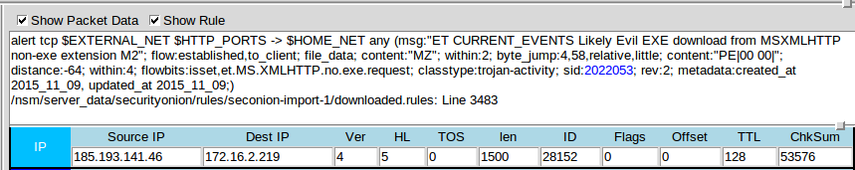
Left click on this square and drag it down to expand the rules box

- According to the IDS signature rule in Alert ID 5.1065, what are the affected products?
[Insert your answer below]
Windows_XP_Vista_7_8_10_Server_32_64

Step 3: View Transcript of Events
- Right-click the associated alert ID 5.1027. Select Transcript from the menu as shown in the figure. Make the transcript fullscreen.

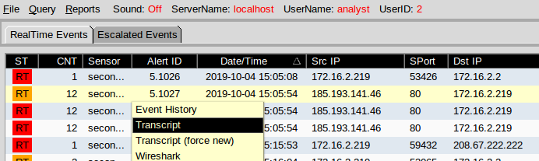

- Refer to the transcript and answer the following questions:

1. The attacker made this file appear to be from a well-known company. What company did the attacker make the file 'appear' to belong to? [Correct screenshot required on next page]
[Insert your answer below]
Trend Micro

2. Based on the transcript, what type of software did the victim think they were downloading?

[Insert your answer below]
Acceptable answers are
Antivirus Software
or
CWShredder

Part 2 Step 3b Screenshot [On the next page, insert a screenshot showing the transcript (FULLSCREEN) scrolled to the location you found the answer you gave for number 1 above]
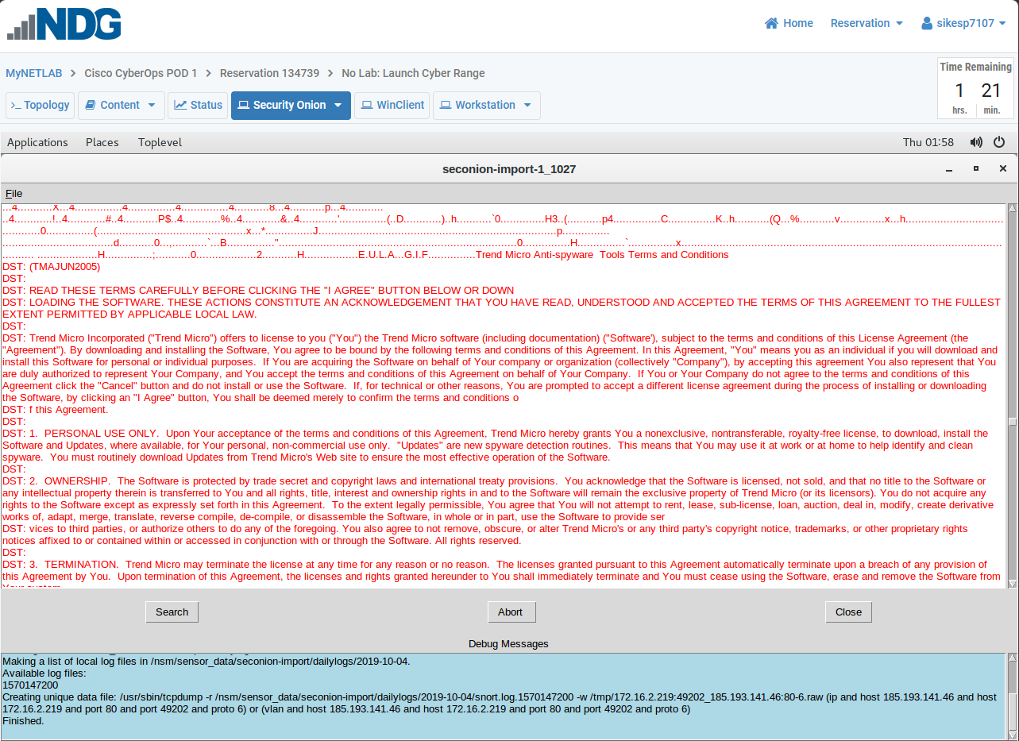

- Close the transcript
- Now that we see what the downloaded file appeared to be, let’s see what the web site they visited is supposed to be or supposed to provide users with. NetworkMiner is a tool that gives us a lot more data and is more useful than what we are using it for here, but this gives you a chance to look at the tool and to look around if you like.
- To open NetworkMiner, right-click on Alert ID 5.1027 and select NetworkMiner. Make NetMiner fullscreen. On the Hosts tab you will see client listed first then the website next to its IP address (the example below is not from this lab). You will also find more details listed on three other tabs (Files, Sessions, & Parameters) that contain information about this alert.

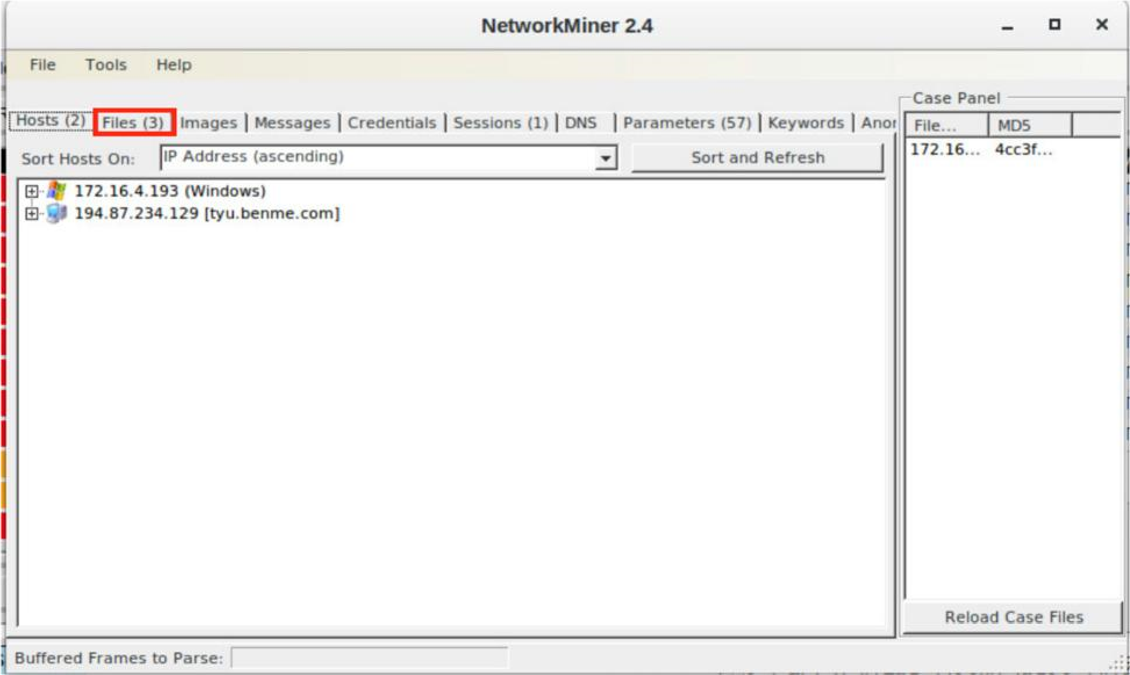

- Expand both + signs next to both IP addresses listed on the Hosts tab. Notice you see details, including layer 2 details of both IP addresses. For instance, the vendor of the NIC of the attacker IP address shows Cisco Systems.

Part 2 Step 3f Screenshot [On the next page, insert a screenshot showing Network Miner Host Tab with both IPs expanded] [Do not expand any other + signs]
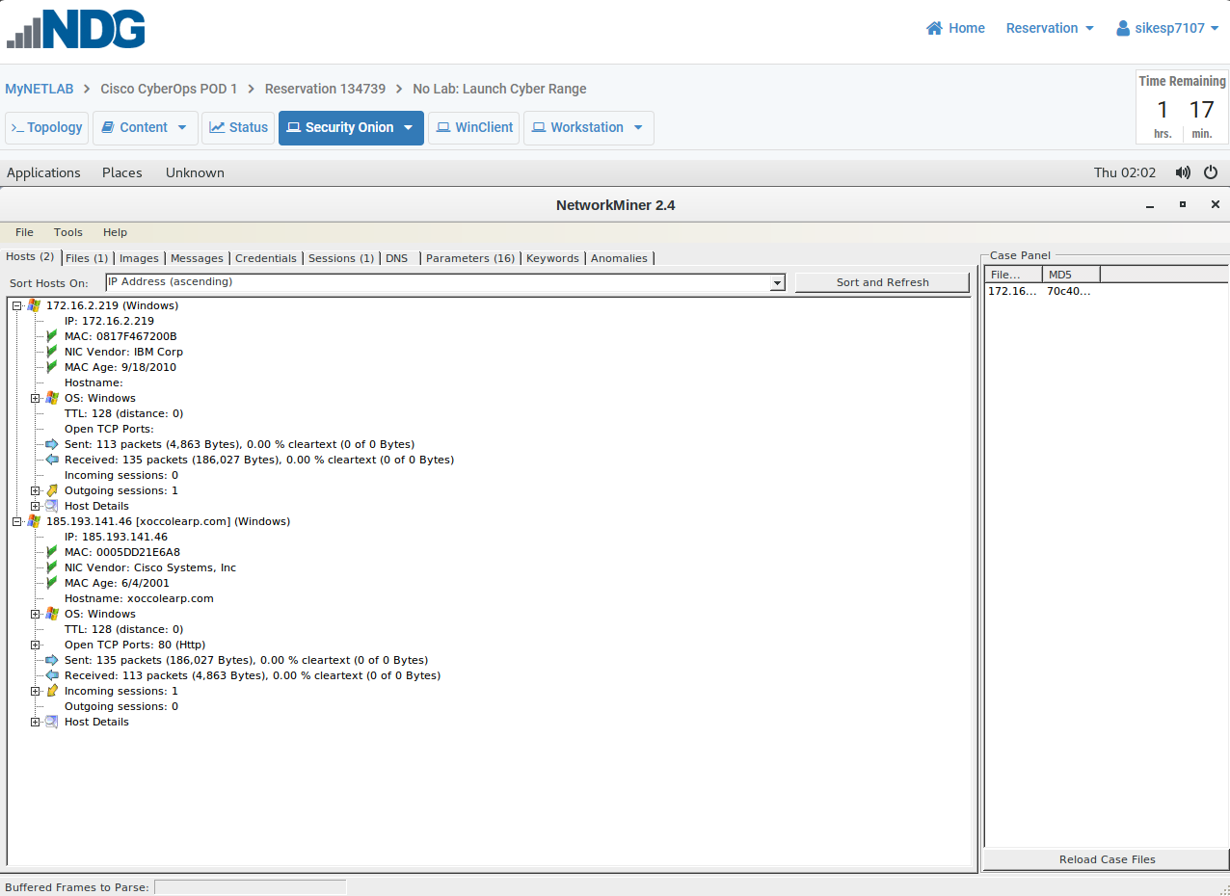

EXTRA CREDIT (WORTH 15 points)
From a networking standpoint, why is the adversary’s NIC (layer 2 data) showing up as Cisco Systems instead of a PC vender like the one on the victim’s device?
[Insert your answer below]
Since layer 2 headers do not cross a layer 3 device, the layer 2 information from the attacker's device never gets to our host. We are only seeing the layer 2 header from our gateway device. In this case it is a Cisco router or multilayer switch.

- Using the URL showing next to the adversary’s IP address, enter it in the URL search bar located at VirusTotal (from your personal web browser) and take a look at the information under the Categories section under the Details Tab. Remember the file that was downloaded? Who supposedly created that file?

1. From the Details tab, what is the category of the website according to Bitdefender [Correct screenshot required]

[Insert your answer below]
porn

Part 2 Step 3g Screenshot [On the next page, insert a screenshot with the Details Tab Categories section visible in the screenshot]
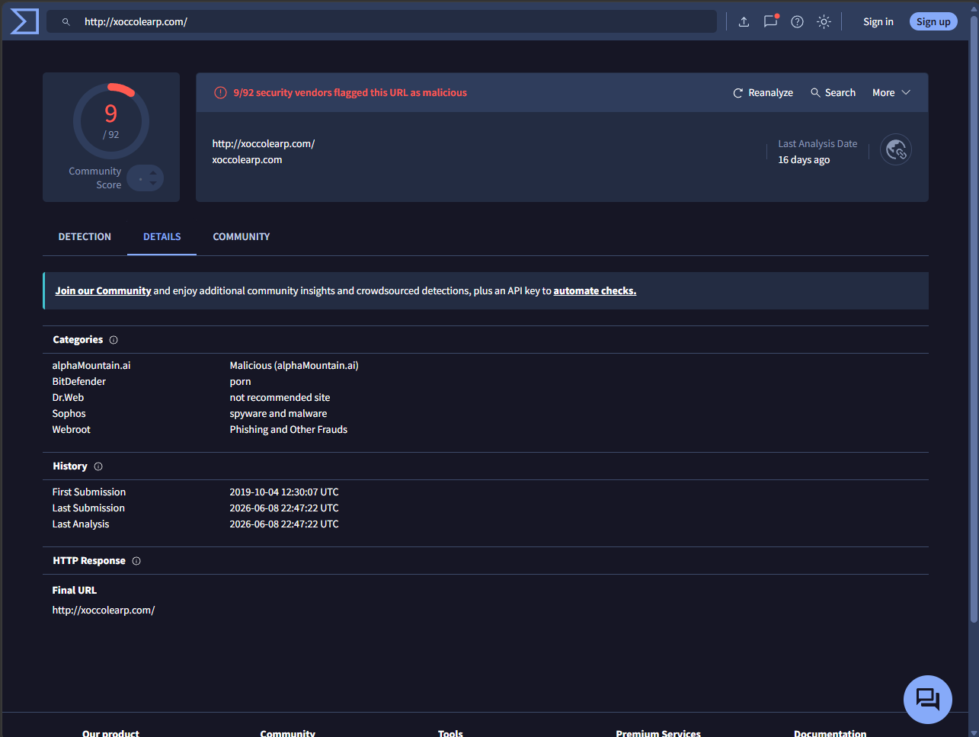
- Close the Network Miner window.

