1. Your lab must be uploaded to Canvas in Landscape Mode to get a grade above a 1. You must also ensure that all your screenshots are visible in the Canvas preview window, after uploading it.
2. If the NDG Lab is not functioning correctly and you have confirmed that all the previous steps are correct and that you are doing the current step correctly, you will need to cancel your current reservation and start a new reservation on a different NDG POD.
3. Incorrect answers are worth 4 pts each
Pay attention to tables and questions that require a supporting screenshot to count as correct.
If your screenshot is not the correct screenshot or the correct information is not selected/highlighted/visible in your screenshot (where the Student Template states to select/highlight the correct answer), your answers will be marked as incorrect.
You must type out the answers to questions/table entries. Screenshots are not accepted where you must answer a question or fill in a table. You only provide screenshots where you see a requirement to insert a screenshot.
4. Screenshots
Incorrectly formatting your screenshots (i.e. not following the requirements shown in front of your student template for the first two NDG lab Student Templates) will be a 2-point deduction per screenshot, up to 11 points for the lab. See this for guidance Screenshots Format Demo Video

If your NDG name is missing/not visible in your screenshot, that screenshot is incorrect.

If your screenshots are too small to view/see the information in the screenshot within Canvas’s grading window, your answer / screenshot may be marked incorrect, which is in addition to the 2 points for formatting issues.

This Student Template shows a single page dedicated to each screenshot. Ensure that when you paste your screenshots, that the screenshots take up most (more than 3/4) of the page (Your screenshots will take up most of a page, when captured and pasted correctly (using Win + Shift + S to capture and Ctrl + V to paste for a Windows PC or equivalent MacOS commands).

5. Wireshark, TCP / HTTP Stream Windows, terminal/console windows, Kibana, and Sguil must be full screen inside the NDG VM before taking a screenshot
(You must capture the bottom of the screenshots for these types of screenshots)

Setting up NDG for screenshots.

            - After you log into NDG, select No Lab: Launch Cyber Range Lab, click on the Security Onion tab to log in with username analyst and password cyberops).

            - Now, click on the right dropdown arrow of the Security Onion Tab (red arrow) on the top bar in NDG and select Actual Size (blue arrow). This will make your virtual PC much smaller than your personal browser window size (if you have your personal browser full screen).

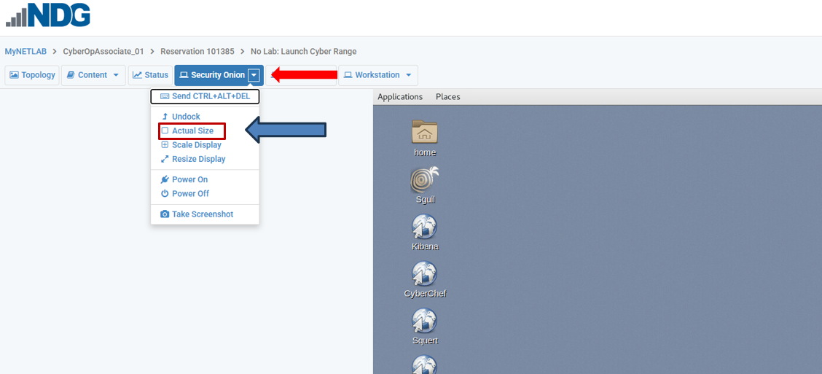

            - If your personal browser is running full screen, you will need to take it out of full screen by clicking on the double squares in the upper right corner of the screen so that you can shrink your browser to match the Security Onion VM desktop width.


            - Be sure that your username in NDG, Time Remaining, and Speaker and Power icons are lined up (the blue field of the browser in the VM will be right up next to the edge of your browser window)

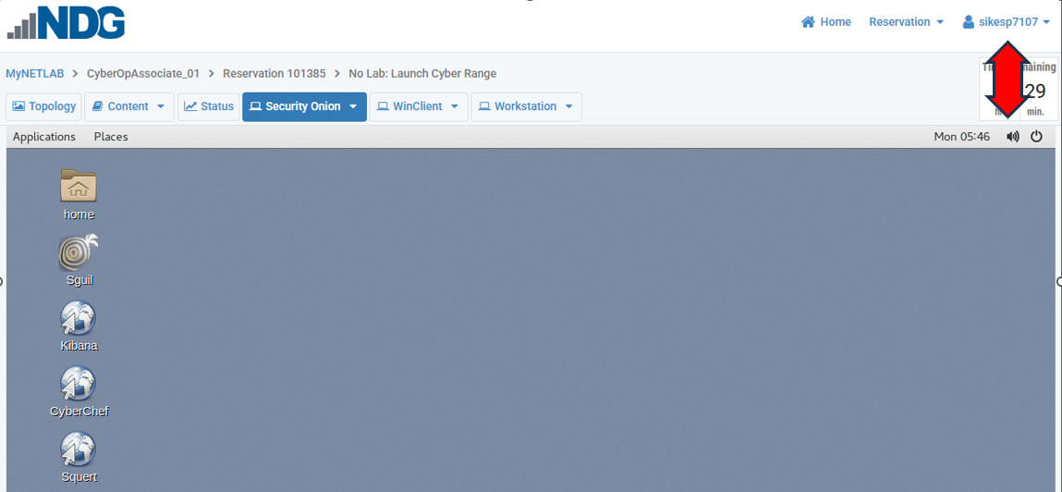

            - With this setup, the Workstation will be set up appropriately . As long as you do not adjust your personal browser size after this point, your Workstation screenshots will be fine.
Since some students are not reading page 1
Reminder: the following must be full screen inside the NDG VM before taking a screenshot

Wireshark

TCP / HTTP Stream windows

terminal/console windows -new - to keep students from being confused as to which can and cannot be fullscreen

Kibana

Sguil

You must capture the bottom of the screens for these types of screenshots

Objectives
Part 1: Explore DNS Query Traffic
Part 2: Explore DNS Response Traffic

Background / Scenario
Wireshark is an open source packet capture and analysis tool. Wireshark gives a detailed breakdown of the network protocol stack. Wireshark allows you to filter traffic for network troubleshooting, investigate security issues, and analyze network protocols. Because Wireshark allows you to view the packet details, it can be used as a reconnaissance tool for an attacker.
In this lab, you use Wireshark to filter for DNS packets and view the details of both DNS query and response packets.

Part 1: Explore DNS Query Traffic
- Log into NDG and use No Lab: Launch Cyber Range at the bottom of NDG for this lab.
  - If you did not already do so, set up your screenshots using the requirements on pages 2 and 3.
  - Log on to the Workstation VM as user analyst using the password cyberops.
- In the upper left, click on Applications > CyberOPS > Wireshark
- Make Wireshark run in fullscreen within your VM.
- In Wireshark, click on File > Open. Select dns-traffic.pcap and open that file in Wireshark.
- The default size of the font in Wireshark is small therefore, for this lab you must click on the magnifying glass (the one with the + sign) on the top bar 2 times to achieve a size that is more viewable and that can be graded.
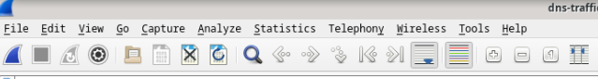
- Now, click on the Resize packet list column to fit contents icon (to the right of the magnifying glass with the – sign to make your columns now fit the upper pane better.
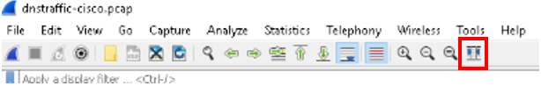

- Observe the traffic captured in the Wireshark Packet List pane.
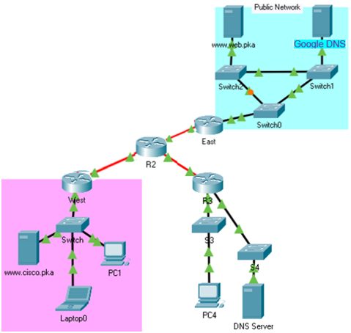
Figure 1 (Topology for the Lab)
For all questions in this lab, PC4’s IP is 192.168.0.10 and Cisco.pka is Cisco.com in the lab material

Just a reminder of some of the parts of Wireshark
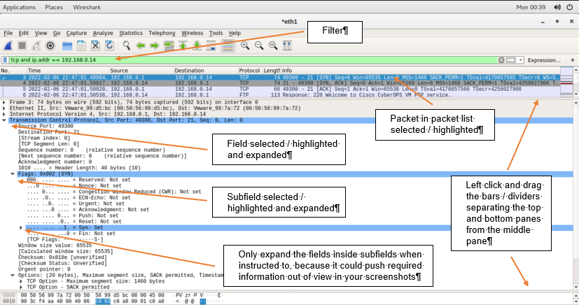

- In Wireshark, shrink the Packets (top) pane to view only 4 packets and completely collapse the Bytes (bottom) pane so that the Details (middle) pane has the maximum amount of viewing space then apply the display filter for DNS, by typing dns into the display filter bar and hitting the arrow to the right of the filter bar.
  - If you see anything other than DNS listed under protocol, you have not properly applied the dns display filter (you need to add dns to the display filter bar or you need to hit the blue arrow to the right of the display filter bar)
  - Be aware that the display filter bar turns green when you type a legitimate filter in the display filter bar, but a green display filter bar does not indicate you applied that display filter to the list (only a green filter bar and a grey arrow to the right of the display filter bar means you have applied an acceptable filter).
  - If the arrow to the right is blue, you have not applied the display filter that you have entered.

- Select the first DNS packet that contains Standard query and A www.google.com in the Info column from the list and expand Ethernet II field and the Destination subfield to show the Address sub-subfield to view the details.
  - What is the destination MAC address (give the all numerical MAC address, not the MAC address that starts with the Vendor name)
[Insert your answer below]
00:50:56:f0:01:58

  - Looking at the Destination IP address, what must the destination MAC address belong to? (Give the network topology name of this item, it is two words and “a router” is not the answer I’m looking for).
[Insert your answer below]
Default Gateway
Partial credit for answering with R3

Part 1i Screenshot - [On the next page, insert a screenshot of Wireshark with the correct display filter applied to limit the displayed packets to just DNS and the required packet selected. Expand the Ethernet II field and ensure the correct subfield and that one of the subfields that contain one of the answers is highlighted selected/highlighted in your screenshot and visible, otherwise the question will be incorrect.]
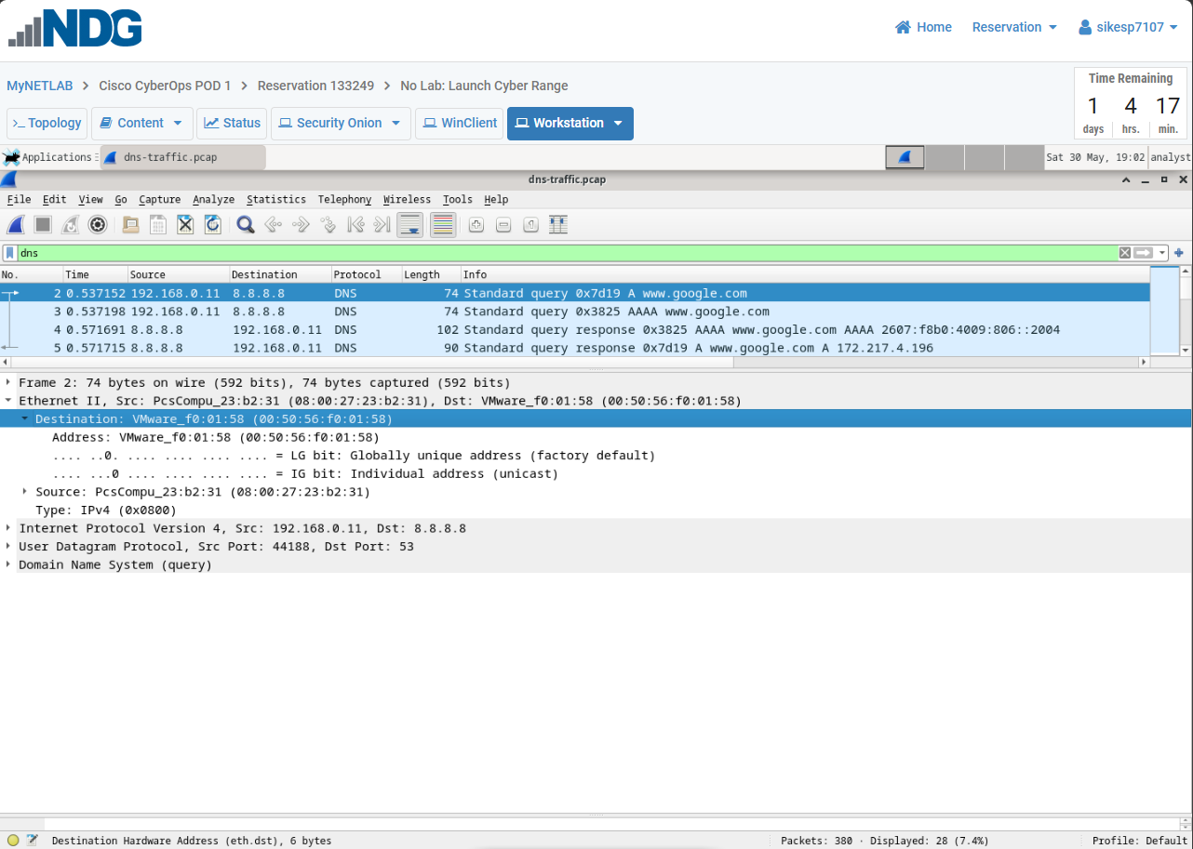

- Collapse the Ethernet II field and expand the Internet Protocol Version 4 field and view the details. (Use your favorite search engine if needed to help with number 3.)
  - What protocol is listed?
[Insert your answer below]
UDP

  - What is the destination IP address?
[Insert your answer below]
8.8.8.8

  - What is that destination IP address for (give the name of the company and what that server is)?
[Insert your answer below]
Google’s Public DNS Server

Part 1j Screenshot - [On the next page, insert a screenshot of Wireshark with the correct display filter applied to limit the displayed packets to just DNS and the required packet selected. Expand the IPv4 field and ensure the correct subfield and that one of the subfields that contain one of the answers is highlighted selected/highlighted in your screenshot and visible, otherwise the question will be incorrect.]
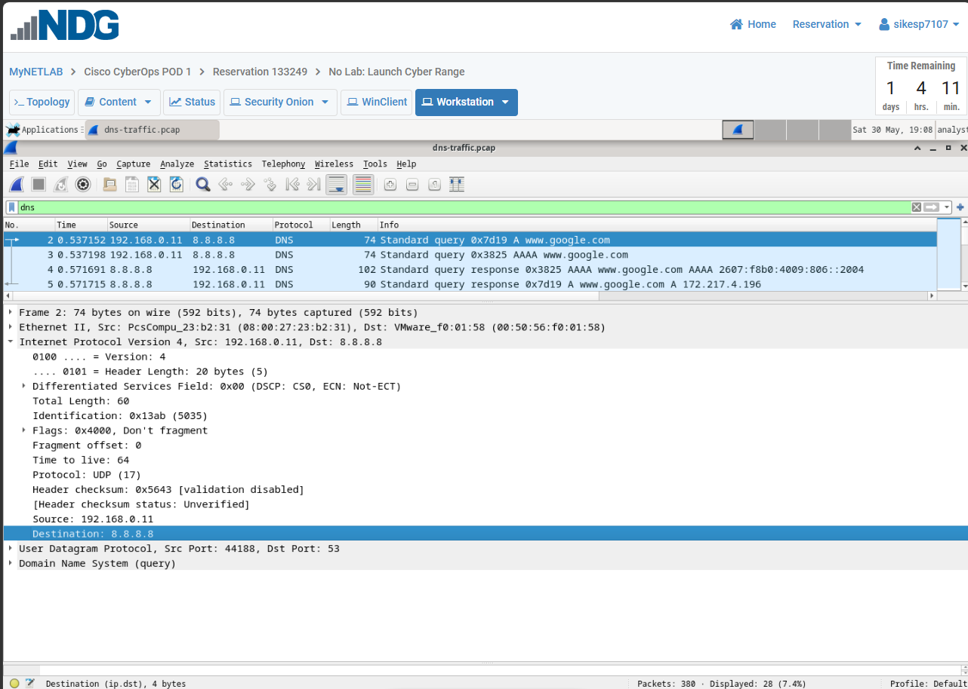

- Collapse the IPv4 field and expand the User Datagram Protocol field to view the details.

  - What is the Source Port
[Insert your answer below]
44188

  - What is the Destination Port
[Insert your answer below]
53

  - What protocol primarily uses the destination port shown?
[Insert your answer below]
DNS

Part 1k Screenshot - [On the next page, insert a screenshot of Wireshark with the correct display filter applied to limit the displayed packets to just DNS and the required packet selected. Expand the UDP field and ensure the correct subfield and that one of the subfields that contain one of the answers is highlighted selected/highlighted in your screenshot and visible, otherwise the question will be incorrect.]
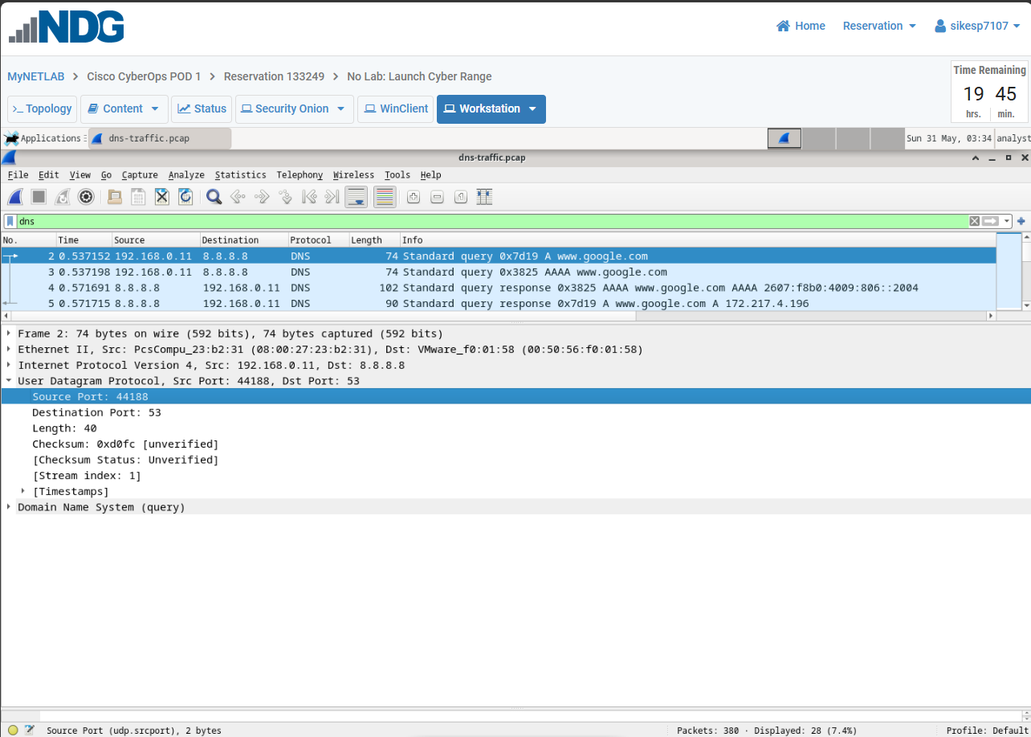

- Enter udp.port == 53 in the display filter and click the arrow (or press enter). You should be filtering for only DNS traffic again.
- Select the first DNS packet that contains Standard query and A www.google.com in the Info column.
- Collapse any fields that are expanded and only expand the Domain Name System field, the Queries subfield, and the sub-subfield of the listed query.

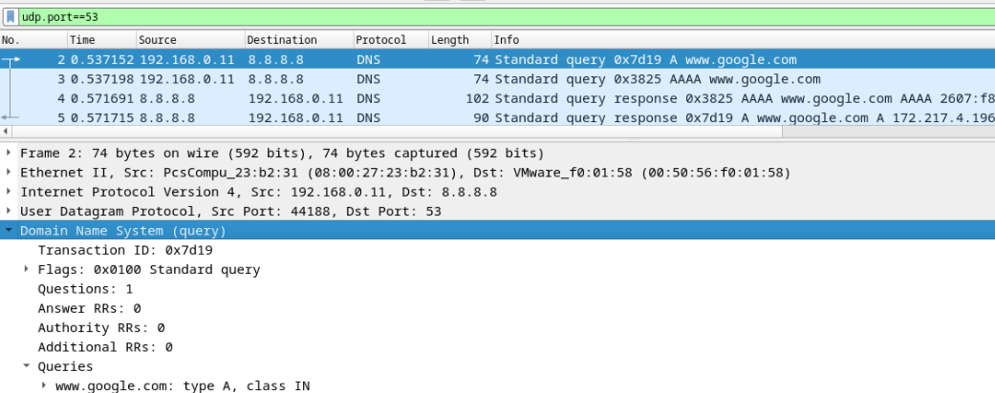

- The first packet that is sent from this device is a dns query (a request for the ip address that is associated with the domain name in the request). That information can be seen in the Queries subfield.
Using the details listed in Wireshark and the Internet, answer the following:
  - What domain name is this request looking for the IP address to?
[Insert your answer below]
www.google.com

  - What is the Transaction ID
[Insert your answer below]
0x7d19

  - What packet is the answer (Response In) to this query (Enter only a number below)?
[Insert your answer below]
5

  - What is the listed Type (not what is show in the parenthesis)?
[Insert your answer below]
A

  - What is the listed Class (Not what is show in the parenthesis)
[Insert your answer below]
IN

Part 1o Screenshot - [On the next page, insert a screenshot of Wireshark with the correct display filter applied and the required packet selected. Expand the Domain Name System field and ensure the correct subfield and that one of the subfields that contain one of the answers is highlighted selected/highlighted in your screenshot and visible, otherwise the question will be incorrect.]
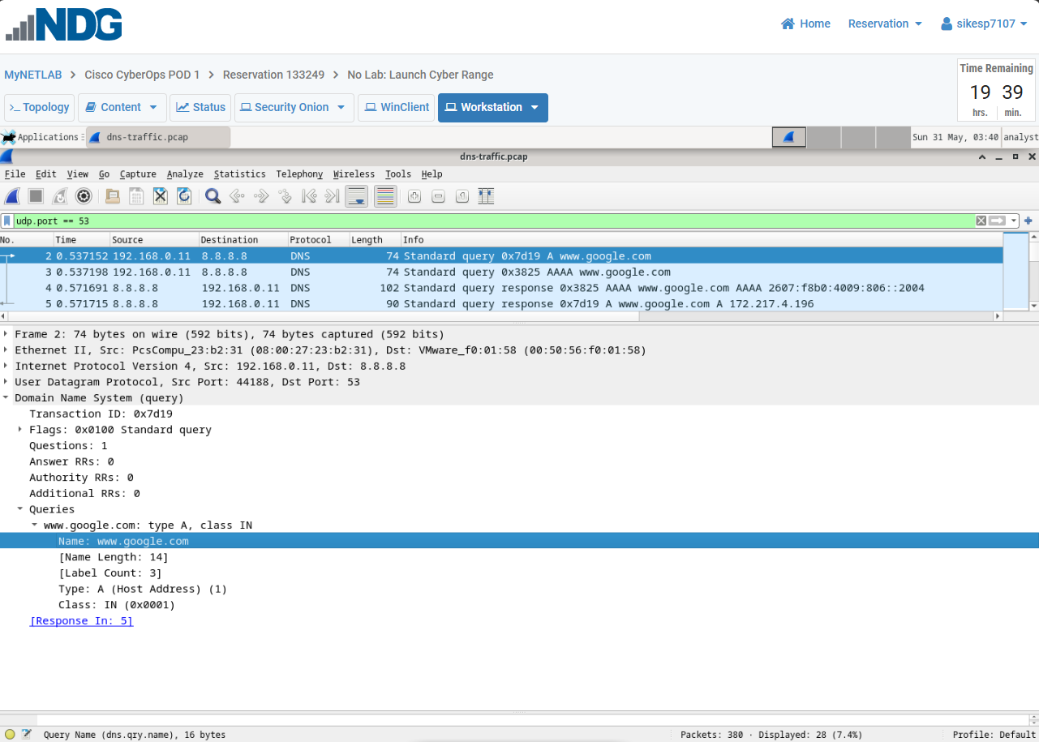

Part 2: Explore DNS Response Traffic
In Wireshark, at the bottom of the Standard Query packet it tells you which packet to find the answer to that query. For instance, in the screenshot below, the standard query is packet 339 and at the bottom it says to find the response to that query in packet 352.
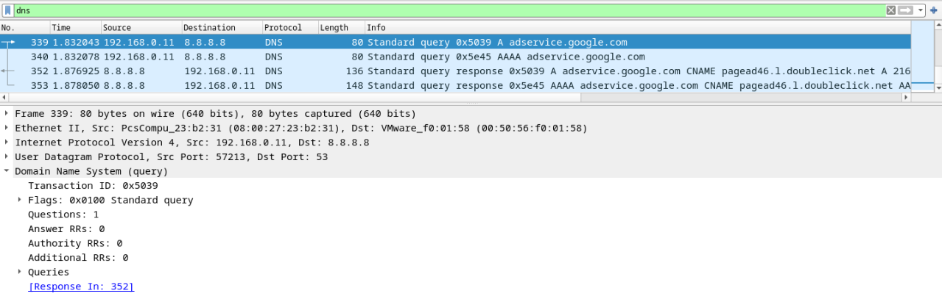
- In Wireshark, shrink the Packets (top) pane to view only 4 packets and completely collapse the Bytes (bottom) pane so that the Details (middle) pane has the maximum amount of viewing space

- Select the correct response DNS packet to our previous request that has Standard query response and A www.google.com in the Info column and expand Internet Protocol Version 4 field to view the details.

  - What is the Source IP address?
[Insert your answer below]
8.8.8.8

  - What is the destination IP address?
[Insert your answer below]
192.168.0.11

Part 2b Screenshot - [On the next page, insert a screenshot of Wireshark with the correct display filter applied to limit the displayed packets to just DNS and the required packet selected. Expand the IPv4 field and ensure the correct subfield and that one of the subfields that contain one of the answers is highlighted selected/highlighted in your screenshot and visible, otherwise the question will be incorrect.]
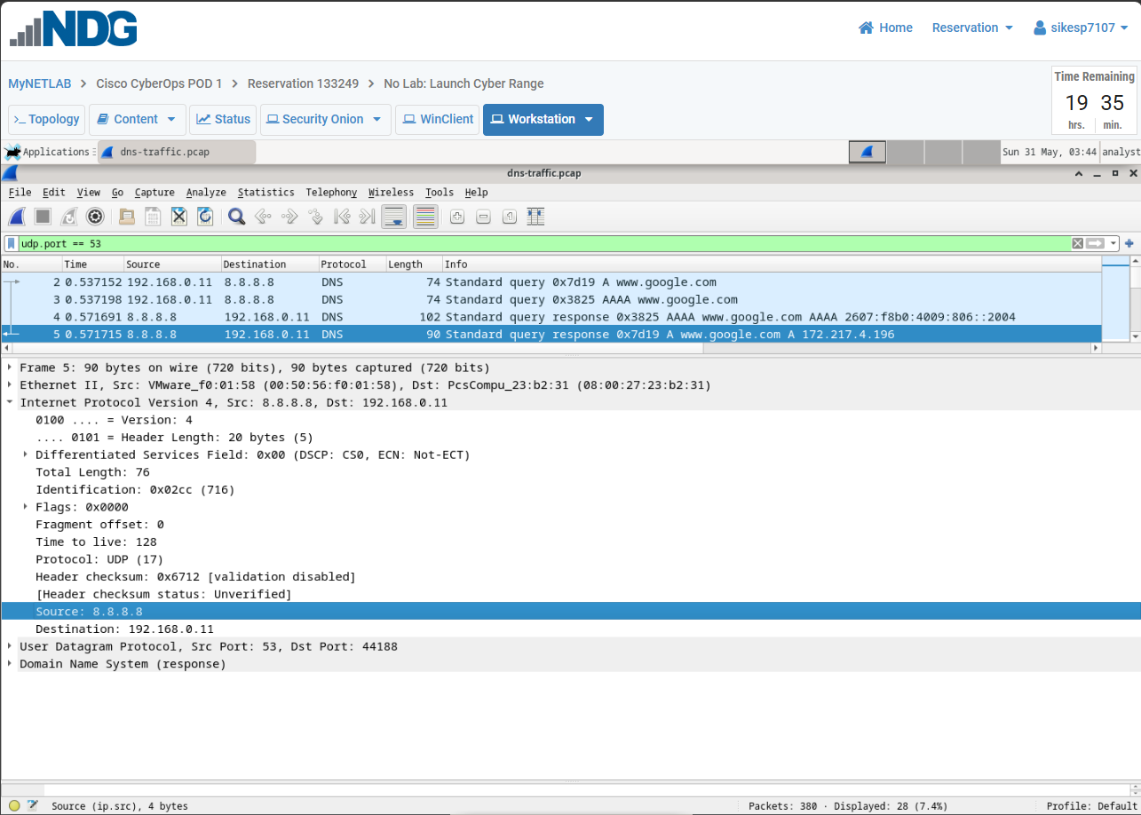

- Collapse the IPv4 field and expand the User Datagram Protocol field to view the details.

  - What is the Source Port
[Insert your answer below]
53

  - What is the Destination Port
[Insert your answer below]
44188

Part 2c Screenshot - [On the next page, insert a screenshot of Wireshark with the correct display filter applied to limit the displayed packets to just DNS and the required packet selected. Expand the UDP field and ensure the correct subfield and that one of the subfields that contain one of the answers is highlighted selected/highlighted in your screenshot and visible, otherwise the question will be incorrect.]
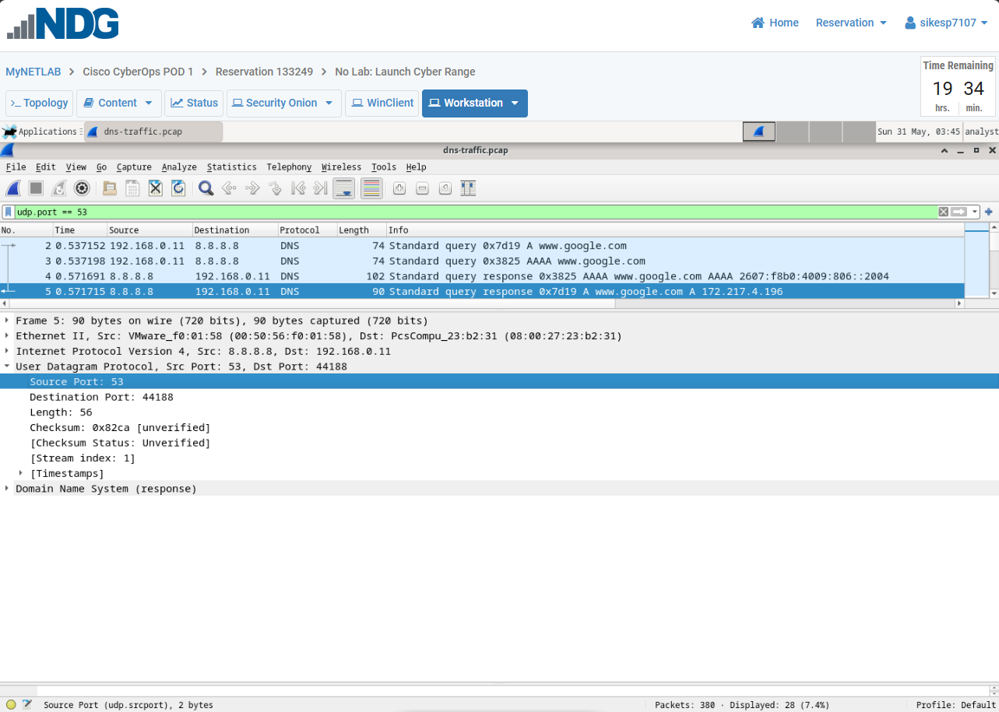

- Collapse the User Datagram Protocol field and expand the Domain Name System field, the Answers subfield, and the sub-subfield of the listed answer.

  - What is the Transaction ID?
[Insert your answer below]
0x7d19

  - What is the IP address listed in the response answer
[Insert your answer below]
172.217.4.196

Part 2d Screenshot - [On the next page, insert a screenshot of Wireshark with the correct display filter applied and the required packet selected. Expand the Domain Name System field and ensure the correct subfield and that one of the subfields that contain one of the answers is highlighted selected/highlighted in your screenshot and visible, otherwise the question will be incorrect.]
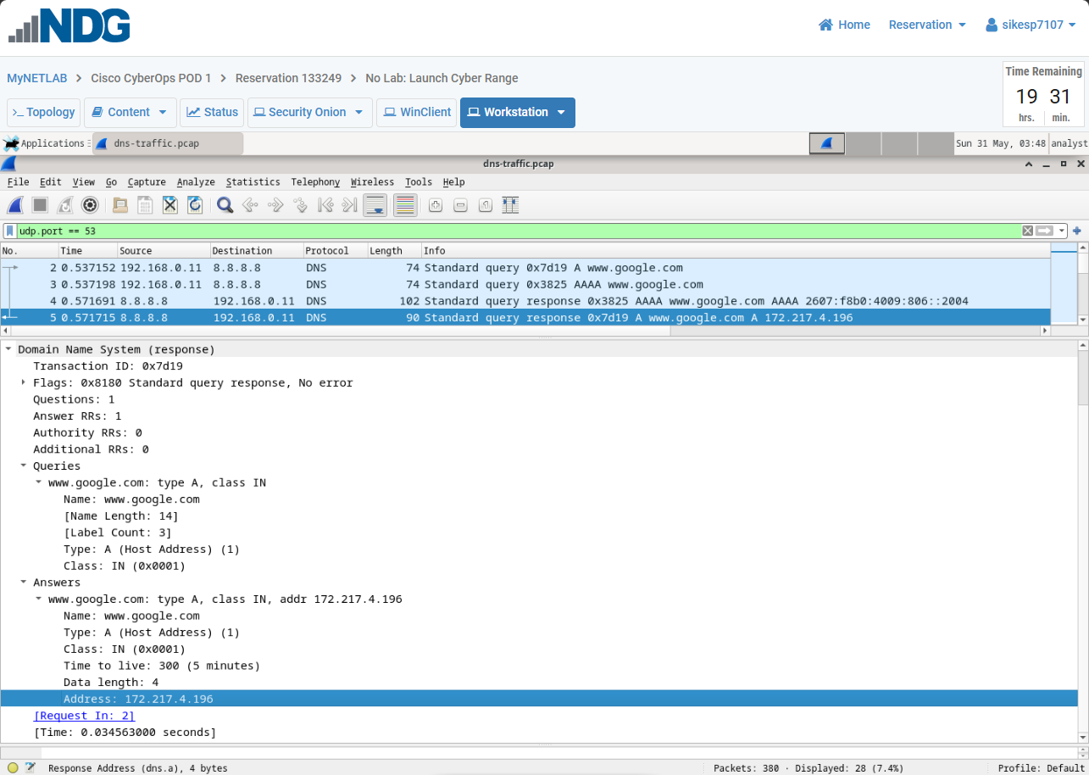

- Go to packet no. 266 and expand the Domain Name System field, the Answers subfield, and the sub-subfields of the listed answers. You will have to scroll down in the packet details pane to show all the information listed under the Answers subfield.

  - How many answers were received in this response?
[Insert your answer below]
2

  - In the first answer listed, what is the Type listed?
[Insert your answer below]
CNAME

  - In the first answer listed, it does not provide an IP address for that domain name. What is the name of the field shown instead of the Address field?
[Insert your answer below]
CNAME

  - In the field you listed above, what is the answer provided in that field
[Insert your answer below]
plus.1.google.com

  - In the second answer received, what is the Type listed?
[Insert your answer below]
A

  - In the second answer received, what is the Address listed?
[Insert your answer below]
172.217.4.206
Part 2e Screenshot - [On the next page, insert a screenshot of Wireshark with the correct display filter applied and the required packet selected. Expand the Domain Name System field and ensure the correct subfield and that one of the subfields that contain one of the answers is highlighted selected/highlighted in your screenshot and visible, otherwise the question will be incorrect.]
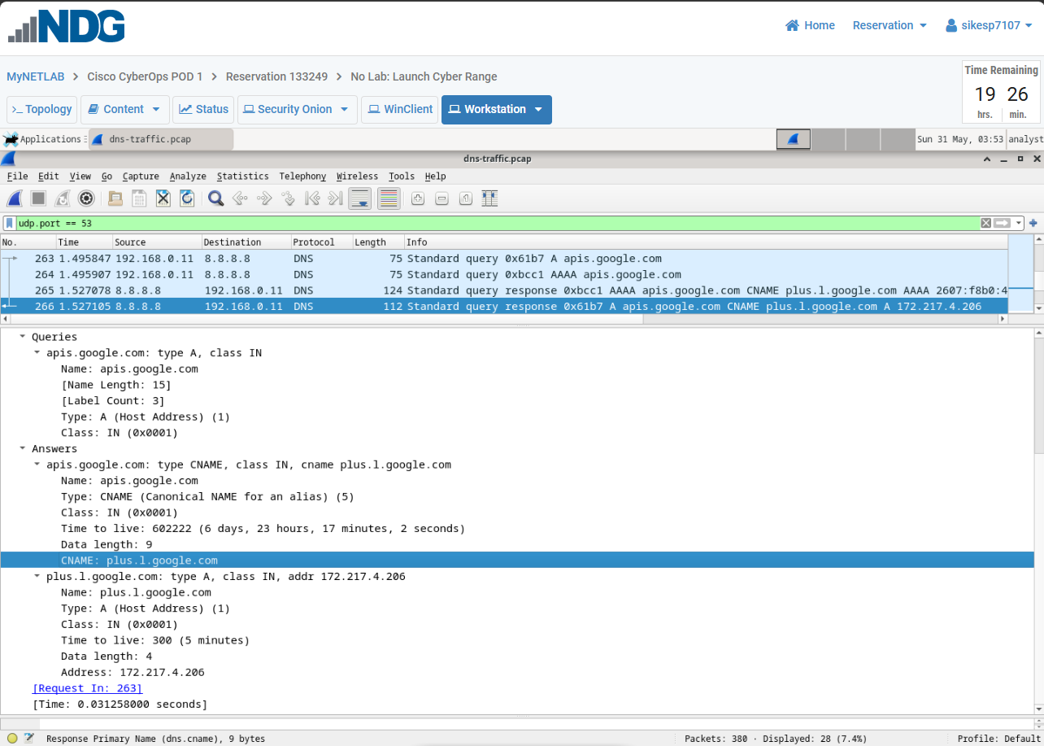

Close all windows and shut down the virtual machine. Save your work as a pdf.

