1. Your lab must be uploaded to Canvas in Landscape Mode to get a grade above 1. You must also ensure that all your screenshots are visible in the Canvas preview window, after you upload them.
2. If the NDG Lab is not functioning correctly and you have confirmed that all the previous steps are correct and that you are doing the current step correctly, you will need to cancel your current reservation and start a new reservation on a different NDG POD.
3. Incorrect answers are worth 9 pts each (except were noted)
Pay attention to tables and questions that require a supporting screenshot to count as correct.
If your screenshot is not the correct screenshot or the correct information is not selected/highlighted/visible in your screenshot (where the Student Template states to select/highlight the correct answer), your answers will be marked as incorrect.
You must type out the answers to questions/table entries. Screenshots are not accepted where you must answer a question or fill in a table. You only provide screenshots where you see a requirement to insert a screenshot.
4. Screenshots
Incorrectly formatting your screenshots (i.e. not following the requirements shown in front of your student template for the first two NDG lab Student Templates) will be a 2-point deduction per screenshot, up to 11 points for the lab. See this for guidance Screenshots Format Demo Video

If your NDG name is missing/not visible in your screenshot, that screenshot is incorrect.

If your screenshots are too small to view/see the information in the screenshot within Canvas’s grading window, your answer / screenshot may be marked incorrect, which is in addition to the 2 points for formatting issues.

This Student Template shows a single page dedicated to each screenshot. Ensure that when you paste your screenshots, that the screenshots take up most (more than 3/4) of the page (Your screenshots will take up most of a page, when captured and pasted correctly (using Win + Shift + S to capture and Ctrl + V to paste for a Windows PC or equivalent MacOS commands).

5. Wireshark, TCP / HTTP Stream Windows, terminal/console windows, Kibana, and Sguil must be full screen inside the NDG VM before taking a screenshot
(DO NOT OMIT capturing the bottom of the screenshots at this point)

Setting up NDG for screenshots.

            - After you log into NDG, select No Lab: Launch Cyber Range Lab, click on the Security Onion tab to log in with username analyst and password cyberops).

            - Now, click on the right dropdown arrow of the Security Onion Tab (red arrow) on the top bar in NDG and select Actual Size (blue arrow). This will make your virtual PC much smaller than your personal browser window size (if you have your personal browser full screen).

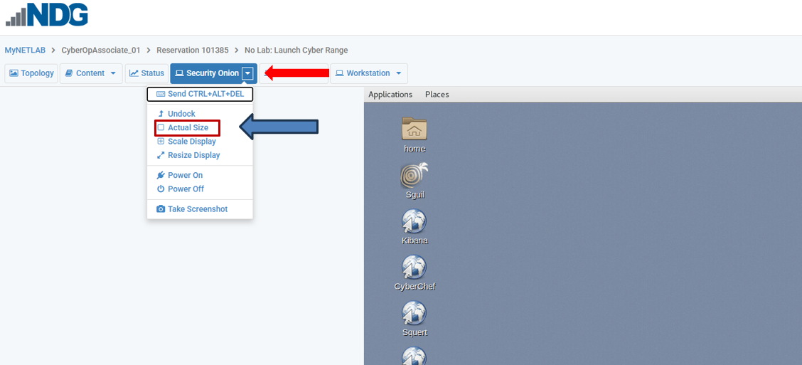

            - If your personal browser is running full screen, you will need to take it out of full screen by clicking on the double squares in the upper right corner of the screen so that you can shrink your browser to match the Security Onion VM desktop width.


            - Be sure that your username in NDG, Time Remaining, and Speaker and Power icons are lined up (the blue field of the browser in the VM will be right up next to the edge of your browser window)

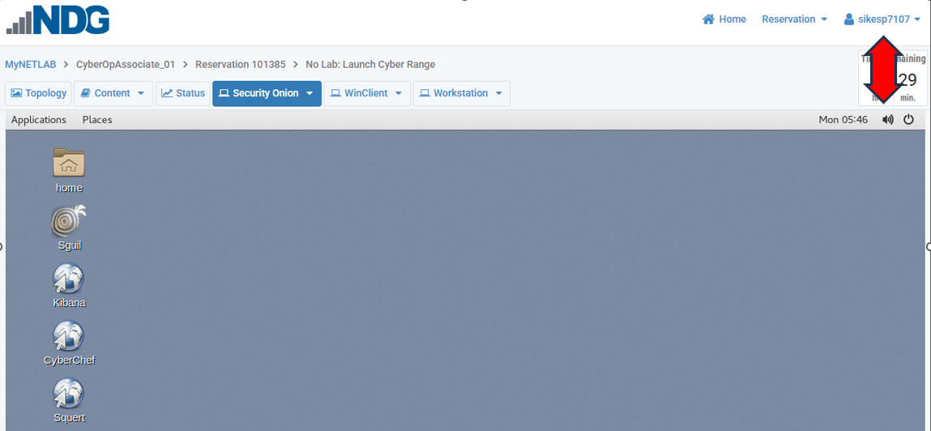

            - With this setup, the Workstation will be set up appropriately . If you do not adjust your personal browser size after this point, your Workstation screenshots will be fine.
Reminder: the following must be full screen inside the NDG VM before taking a screenshot

Wireshark

TCP / HTTP Stream windows

terminal/console windows

Kibana

Sguil

You must capture the bottom of the screens for these types of screenshots

If a field on this document will not allow you to enter your answer or paste your screenshot, the form field was altered during the download from Canvas.
To fix the issue, you will have to download the document from Canvas again, transfer your answers and screenshots from this document to the new document, and continue with the lab.

Remember to follow the screenshot requirements shown in the first NDG lab you performed.
Objectives
In this lab, you will view a PCAP file from a previous attack against a SQL database.

Part 1: Encrypting Messages with OpenSSL
Part 2: Decrypting Messages with OpenSSL
Part 3: Create and Encrypt Files
Part 4: Recover Encrypted Zip File Passwords

Background / Scenario
OpenSSL is an open-source project that provides a robust, commercial-grade, and full-featured toolkit for the Transport Layer Security (TLS) and Secure Sockets Layer (SSL) protocols. It is also a general-purpose cryptography library. In this lab, you will use OpenSSL to encrypt and decrypt text messages.
Note: While OpenSSL is the de facto cryptography library today, the methods presented here should NOT be used to secure truly sensitive data. Below are two security problems with this lab:
1. The method described in this lab uses a weak key derivation function. The ONLY security is introduced by a very strong password.
2. The method described in this lab does not guarantee the integrity of the text file.

Part 1: Encrypting Messages with OpenSSL
OpenSSL can be used as a standalone tool for encryption. While many encryption algorithms can be used, this lab focuses on AES. To use AES to encrypt a text file directly from the command line using OpenSSL, follow the steps below:
- Log into NDG and use the No Lab: Launch Cyber Range at the bottom of the NDG Labs list.
- If you did not already do so, set up your screenshots using the requirements on pages 2 and 3
- Log on to the Workstation VM as user analyst using the password cyberops.
- Open a terminal window in fullscreen.
- Because the text file to be encrypted is in the /home/analyst/lab.support.files/ directory, change to that directory:
[analyst@secOps ~]$ cd /home/analyst/lab.support.files/
[analyst@secOps lab.support.files]$
- Type the command below to list the contents of the encrypted letter_to_grandma.txt text file on the screen:
[analyst@secOps lab.support.files]$ cat letter_to_grandma.txt
Hi Grandma,
I am writing this letter to thank you for the chocolate chip cookies you sent me. I got them this morning and I have already eaten half of the box! They are absolutely delicious!

I wish you all the best. Love,
Your cookie-eater grandchild.

[Insert on the next page a screenshot ensuring you capture the command and the output in your screenshot]
Part 1d Screenshot
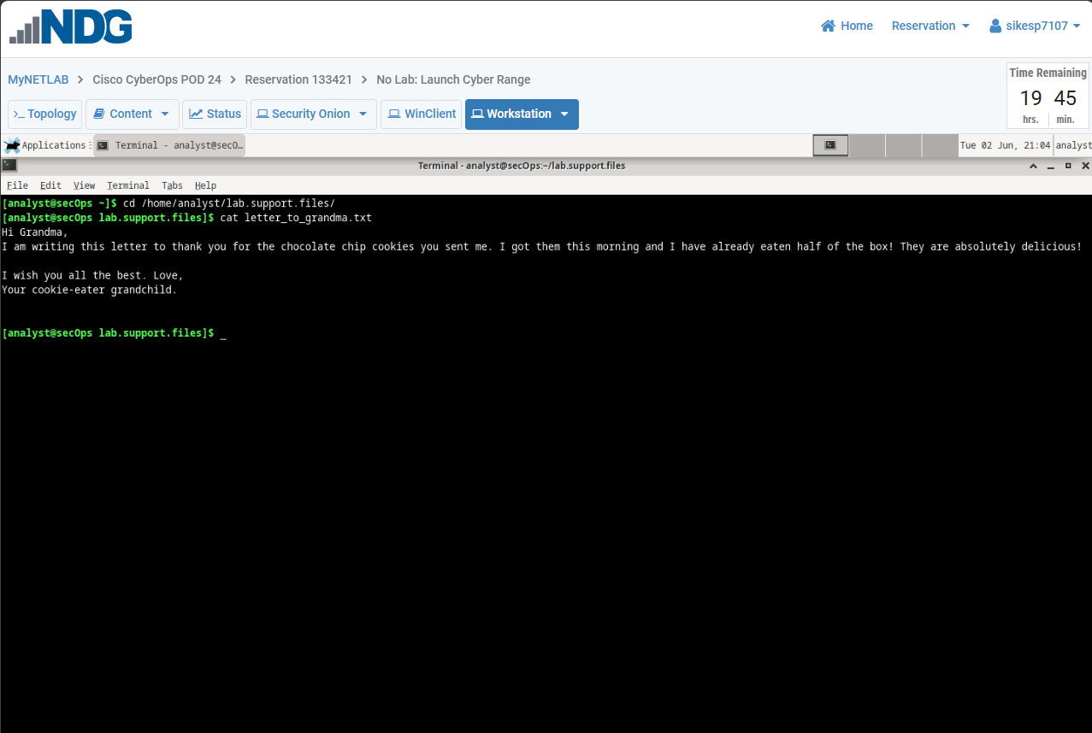

- From the same terminal window, issue the command below to encrypt the text file. The command will use AES-256 to encrypt the text file and save the encrypted version as message.enc. OpenSSL will ask for a password and for password confirmation. Provide the password as requested and be sure to remember the password.
[analyst@secOps lab.support.files]$ openssl aes-256-cbc -in letter_to_grandma.txt -out message.enc
enter aes-256-cbc encryption password:
Verifying - enter aes-256-cbc encryption password:
*** WARNING : deprecated key derivation used.
Using -iter or pbkdf2 would be better.
[analyst@secOps lab.support.files]$
Question:
Remember your password.

- Clear the terminal using the clear command
- When the process is finished, use the cat command again to display the contents of the message.enc file.
[analyst@secOps lab.support.files]$ cat message.enc
Question
Notice that the contents of the message.enc file did not display correctly

[Insert on the next page a screenshot ensuring you capture the command and the output in your screenshot]
Part 1g Screenshot
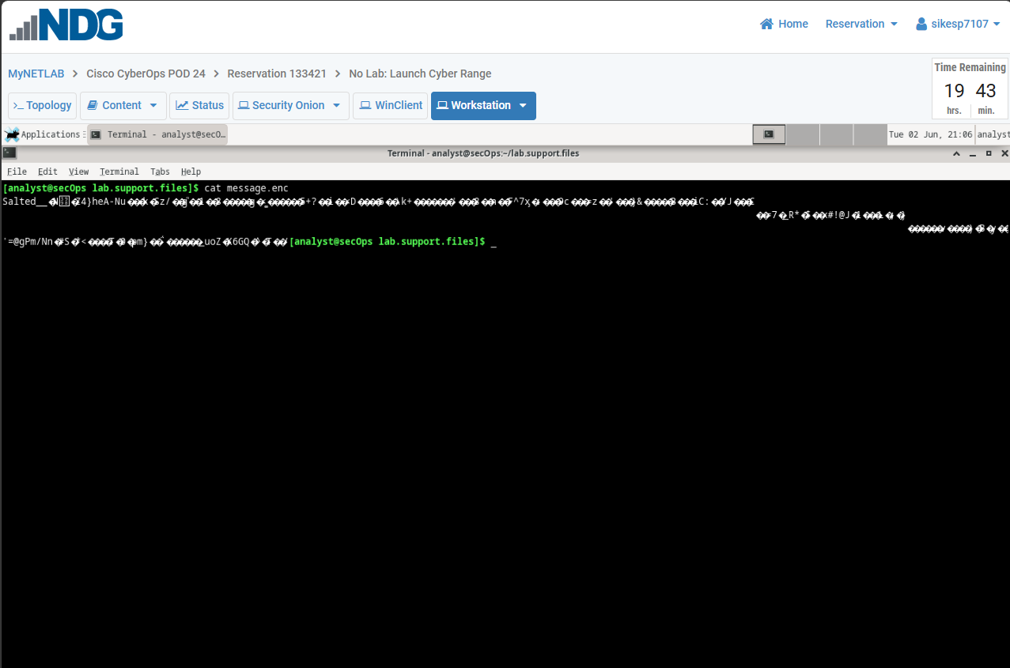
Why are you not able to read the message?

[Insert your answer below] [Both the screenshot above and answer must be correct]
Because the file was encrypted

- Clear the terminal using the clear command.
To make the file readable, run the OpenSSL command again, but this time add the -a option. The -a option tells OpenSSL to encode the encrypted message using a different encoding method of Base64 before storing the results in a file.

Note: Base64 is a group of similar binary-to-text encoding schemes used to represent binary data in an ASCII string format.

Here is a use case for base64 https://www.youtube.com/watch?v=gocwRvLhDf8&feature=emb_logo

- Issue the command below:
[analyst@secOps lab.support.files]$ openssl aes-256-cbc -a -in letter_to_grandma.txt -out message.enc
enter aes-256-cbc encryption password:
Verifying - enter aes-256-cbc encryption password:
*** WARNING : deprecated key derivation used.
Using -iter or pbkdf2 would be better.
Question
- Once again, use the cat command to display the contents of the, now re-generated, message.enc file:
Note: The contents of message.enc will vary.
[analyst@secOps lab.support.files]$ cat message.enc
U2FsdGVkX19ApWyrn8RD5zNp0RPCuMGZ98wDc26u/vmj1zyDXobGQhm/dDRZasG7 rfnth5Q8NHValEw8vipKGM66dNFyyr9/hJUzCoqhFpRHgNn+Xs5+TOtz/QCPN1bi 08LGTSzOpfkg76XDCk8uPy1hl/+Ng92sM5rgMzLXfEXtaYe5UgwOD42U/U6q73pj a1ksQrTWsv5mtN7y6mh02Wobo3A1ooHrM7niOwK1a3YKrSp+ZhYzVTrtksWDl6Ci XMufkv+FOGn+SoEEuh7l4fk0LIPEfGsExVFB4TGdTiZQApRw74rTAZaE/dopaJn0
sJmR3+3C+dmgzZIKEHWsJ2pgLvj2Sme79J/XxwQVNpw=
[analyst@secOps lab.support.files]$

Notice that the contents of the message.enc file displayed differently this time

[Insert on the next page a screenshot ensuring you capture the command and the output in your screenshot]
Part 1j Screenshot
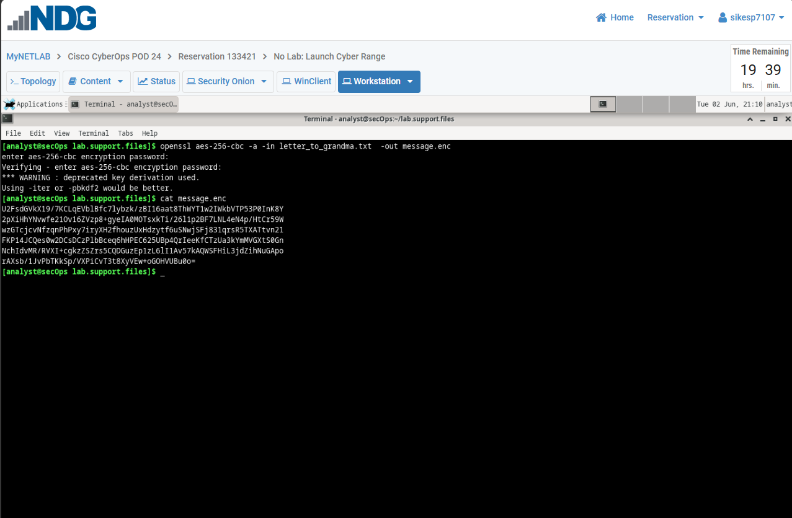:

A benefit of having message.enc Base64-encoded is that you can now copy and paste it an email or other document.

- Clear the terminal using the clear command

Part 2: Decrypting Messages with OpenSSL
With a similar OpenSSL command, it is possible to decrypt message.enc.
- Use the command below to decrypt message.enc:
[analyst@secOps lab.support.files]$ openssl aes-256-cbc –a -d -in message.enc -out decrypted_letter.txt

If you get a bad decrypt error message, you need to perform the command again. If it occurs again, you will need to start over from Part 1e to fix the issue.

- OpenSSL will ask for the password used to encrypt the file. Enter the same password again.
- When OpenSSL finishes decrypting the message.enc file, it saves the decrypted message in a text file called decrypted_letter.txt. Use the cat display the contents of decrypted_letter.txt:
[analyst@secOps lab.support.files]$ cat decrypted_letter.txt
Questions:

The command used to decrypt also has the -a option because you have to use the same option you used to encoded it to decode it.

[Insert on the next page a screenshot ensuring you capture the command and the output in your screenshot]
Part 2c Screenshot
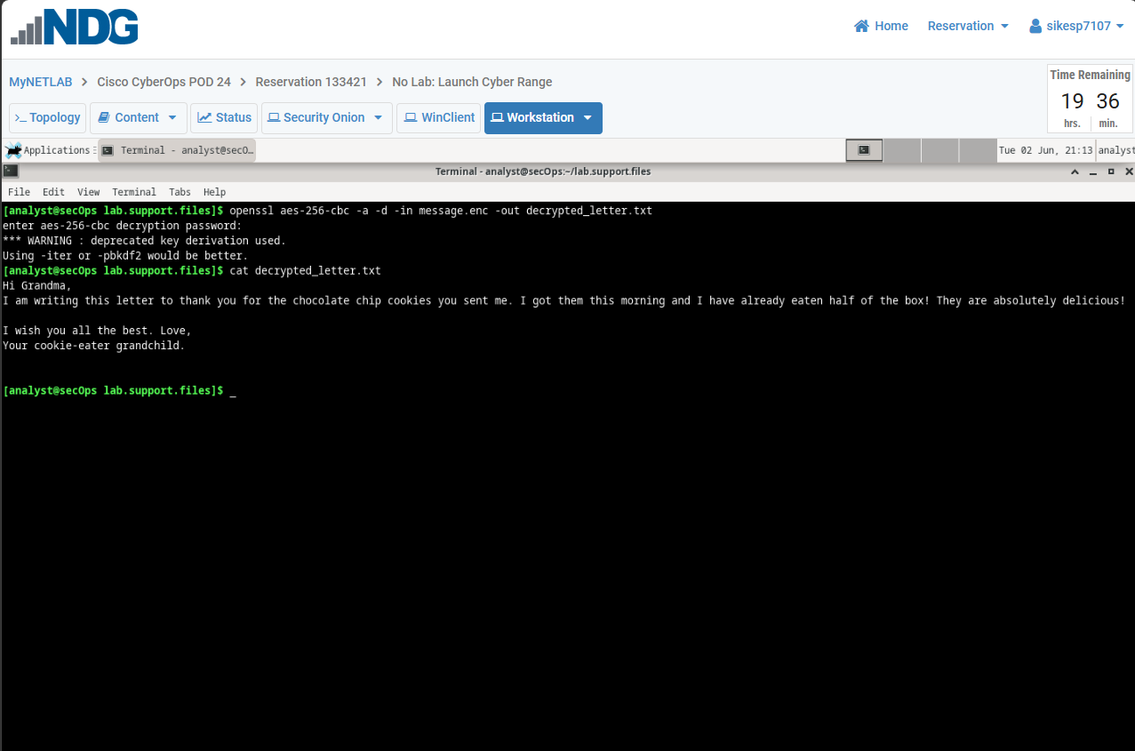:

Background / Scenario
In this scenario, the Chief Financial Officer (CFO) is out-of-town on business and has contacted you in a panic with an emergency request for help. While out-of-town on business, he attempted to unzip important documents from an encrypted zip file on a USB drive. However, the password provided to open the zip file is invalid. The CFO contacted you to see if there was anything you could to do.
There may be some tools available to recover lost passwords. This is especially true in situations such as this where the cybersecurity analyst could acquire pertinent information from the CFO. The pertinent information could be the length of the password and an idea of what it could be. Knowing pertinent information dramatically helps when attempting to recover passwords.
Examples of password recovery utilities and programs include hashcat, John the Ripper, Lophtcrack, and others. In our scenario, we will use fcrackzip which is a simple Linux utility to recover the passwords of encrypted zip files.
Consider that these same tools can be used by cybercriminals to discover unknown passwords. Although they would not have access to some pertinent information, with time, it is possible to discover passwords to open encrypted zip files. The amount of time required depends on the password strength and the password length. Longer and more complex passwords (mix of different types of characters) are more secure.

Part 3: Reading Log Files with Cat, More, Less, and Tail
In this part, you will create a few text files that will be used to created encrypted zip files in the next step
Step 1: Create Text Files
- Clear the terminal using the clear command. With the terminal window in fullscreen, enter cd ~ and verify that you are in the analyst home directory.
- Create a new folder called Zip-Files using the mkdir Zip-Files command.
- Move into that directory using the cd Zip-Files command.
- Enter the following to create three text files.
[analyst@secOps Zip-Files]$ echo This is a sample text file > sample-1.txt
[analyst@secOps Zip-Files]$ echo This is a sample text file > sample-2.txt
[analyst@secOps Zip-Files]$ echo This is a sample text file > sample-3.txt

- Verify that the files have been created, using the ls -l command.

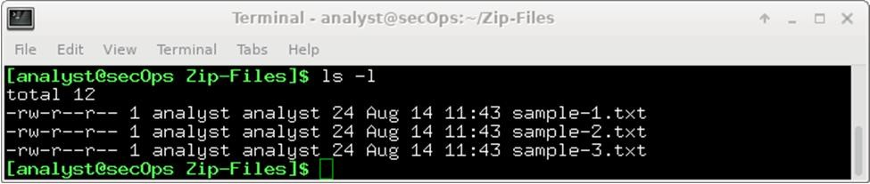

[Insert on the next page a screenshot ensuring you capture the command and the output in your screenshot]
Part 3 Step 1e Screenshot
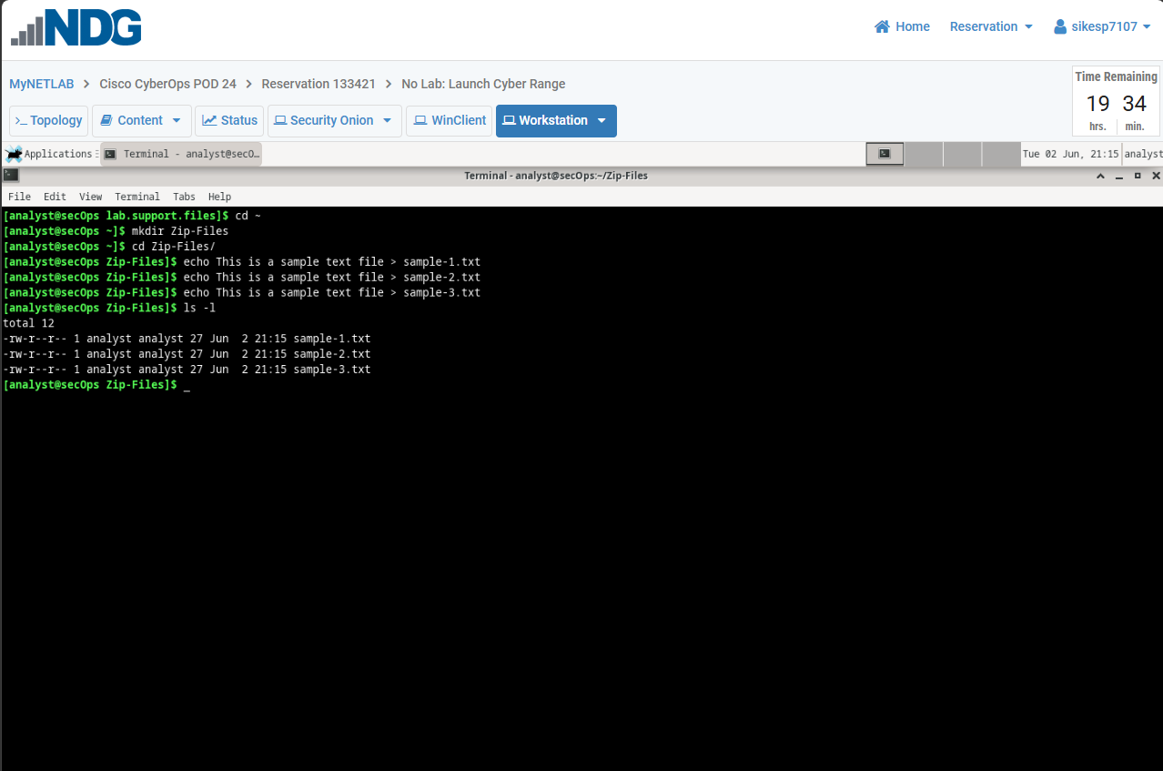:
Step 2: Zip and encrypt the text files.
Next, we will create several encrypted zipped files using varying password lengths. To do so, all three text files will be encrypted using the zip utility.
- Clear the terminal using the clear command
- Create an encrypted zip file called file-1.zip containing the three text files using the following command:
[analyst@secOps Zip-Files]$ zip –e file-1.zip sample*

- When prompted for a password, enter capital letter B as your single letter password. Enter capital letter B again when prompted to verify.

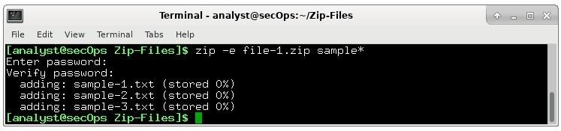
- Repeat steps a and b to create the following 4 files using the following passwords (below are zeros, not the letter O, in the passwords)
  - file-2.zip using the 2-character password R2
  - file-3.zip using the 3-character password 0B1
  - file-4.zip using the 4-character password Y0Da
  - file-5.zip using the 5-character password C-3P0

- Clear the terminal using the clear command
- Verify that all zipped files have been created using the ls -l f* command.
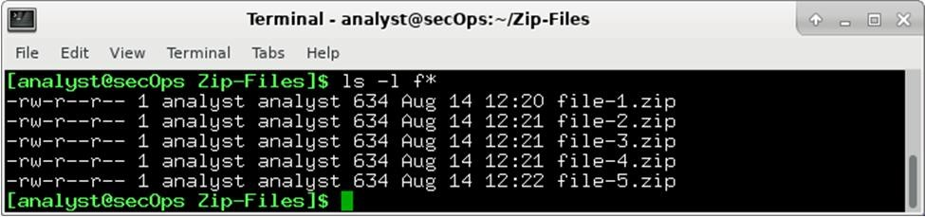

[Insert on the next page a screenshot ensuring you capture the command and the output in your screenshot]
Part 3 Step 2f Screenshot
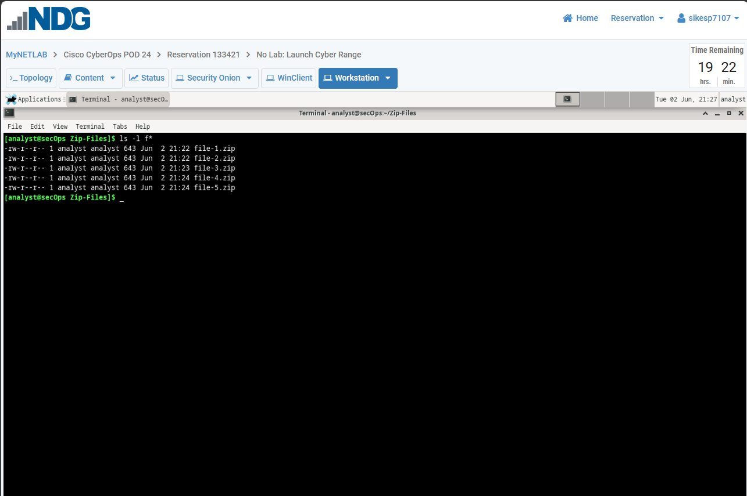:
- Attempt to open a zip entered the wrong password on purpose.
[analyst@secOps Zip-Files]$ unzip file-1.zip

Ensure you enter n for [n]o when it asks if you want to replace the text file at the end

Attempt to open the zip using an incorrect password as shown below. In other words, keep entering the wrong password until the command prompt returns. Ensure it looks like the example below. If you make a mistake, redo the step, starting off by using the clear command followed up with the unzip command.

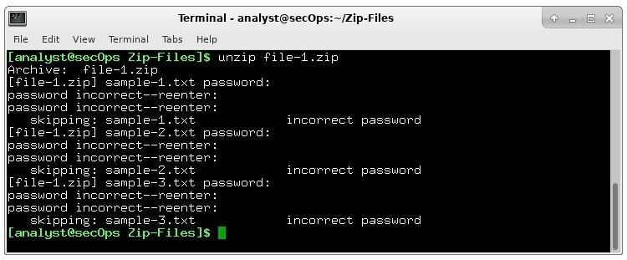

[Insert on the next page a screenshot ensuring you capture the command and the output in your screenshot]
Part 3 Step 2g Screenshot
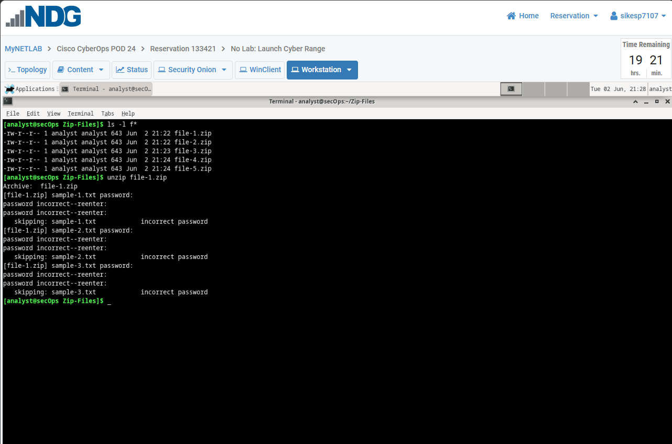:

Part 4: Recover Encrypted Zip File Passwords
In this part, you will use the fcrackzip utility to recover lost passwords from encrypted zipped files. Fcrackzip searches each zip file given for encrypted files and tries to guess the password using brute-force methods. The reason we created zip files with varying password lengths was to see if password length influences the time it takes to discover a password.
Step 1: Introduction to fcrackzip
From the terminal window, enter the fcrackzip –h command to see the associated command options. In our examples, we will be using the –v, -u, and -l command options. The -l option will be listed last because it specifies the possible password length.
[analyst@secOps Zip-Files]$ fcrackzip -h

Step 2: Recovering Passwords using fcrackzip
- Clear the terminal using the clear command
- Now try to recover the password of the file-1.zip file. Since we used a one-character password to encrypt the file, use the following fcrackzip command:
[analyst@secOps Zip-Files]$ fcrackzip -vul 1-4 file-1.zip

Note: The password length could have been set to less than 1 – 4 characters for the first couple since we did not use 4 characters.
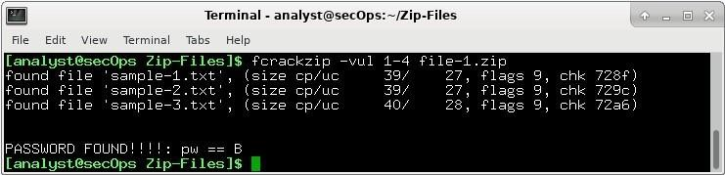

Note how fast it discovered the password

[Insert on the next page a screenshot ensuring you capture the command and the output in your screenshot]
Part 4 Step 2b Screenshot
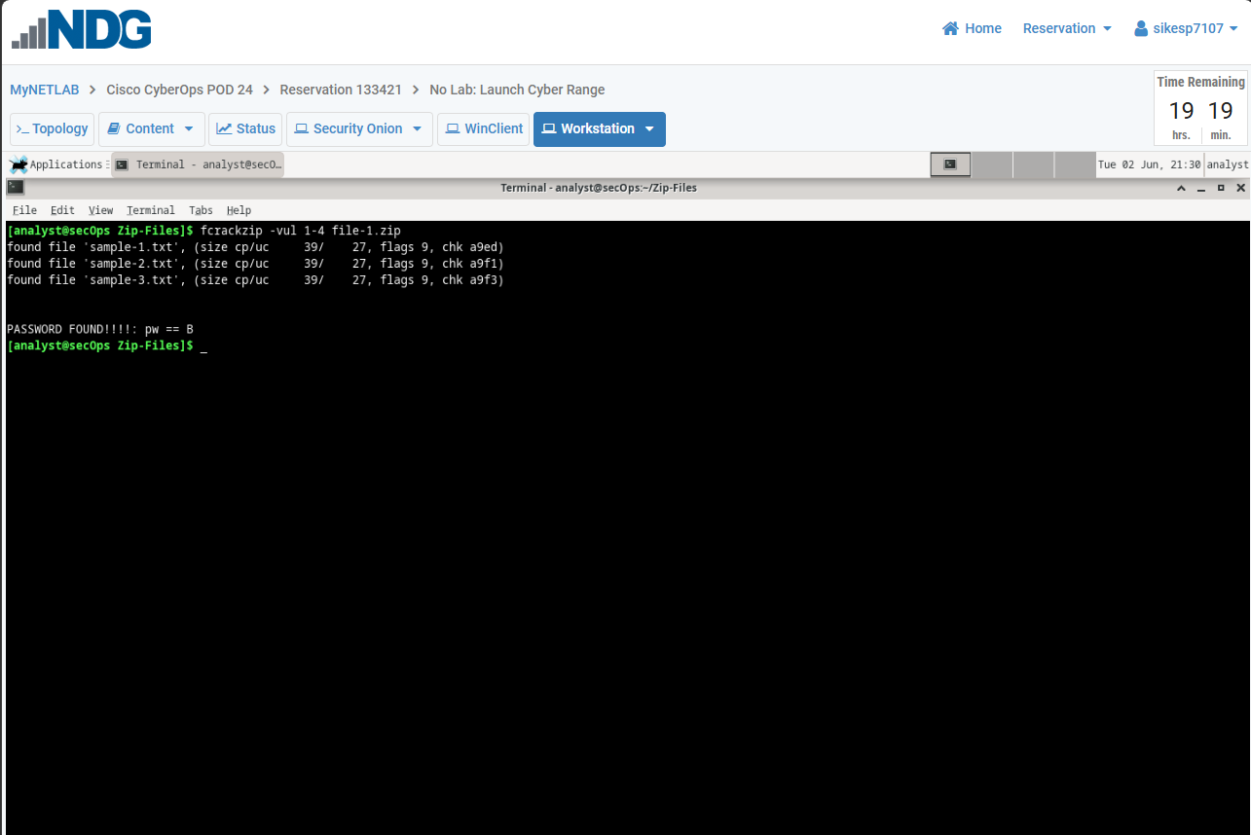:
- Repeat the procedure and recover the password of the file-4.zip file. Recall, that a three-character password was used to encrypt the file. Time to see how long it takes to discover a 4-letter password. Use the following fcrackzip command:
[analyst@secOps Zip-Files]$ fcrackzip –vul 1-4 file-4.zip

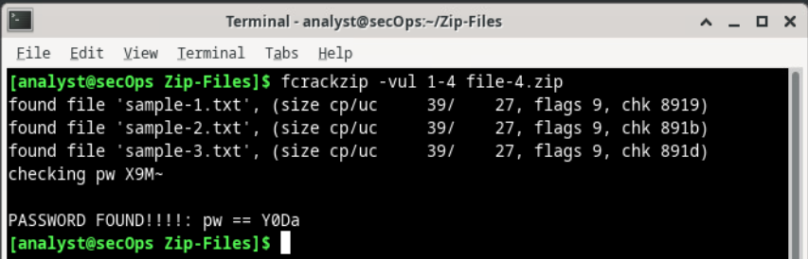
Notice how long it took to discover the password?

- How long does it take to crack a password of five characters? Repeat the procedure and recover the password of the file-5.zip file. The password length is five characters, so we need to set the -vul command option to 1-5. Again, time to see how long it takes to discover the password using the following fcrackzip command
[analyst@secOps Zip-Files]$ fcrackzip –vul 1-5 file-5.zip

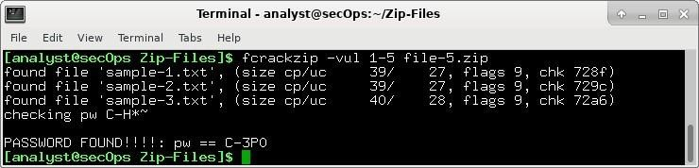

Notice how the time it takes to discover the password is dramatically increasing with each character that is being added to the password.

[Insert on the next page a screenshot ensuring you capture the command and the output in your screenshot]
Part 4 Step 2d Screenshot
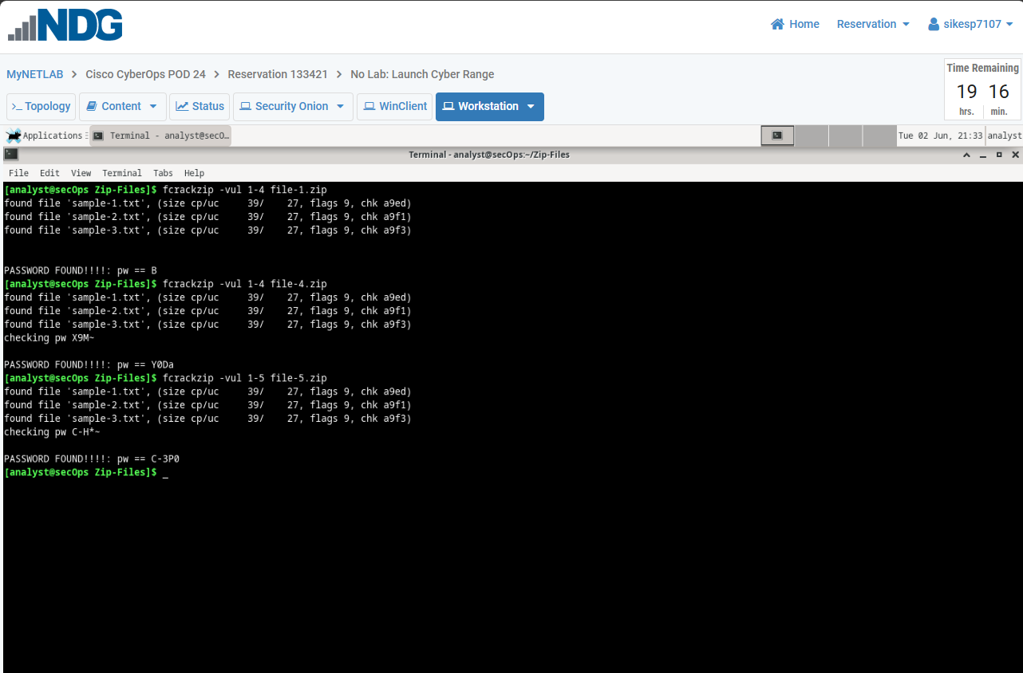:

Reflection Questions 10pts
Since we have covered Threat Intelligence Platforms, use AI and create a prompt to find create a list of the 5 best or top-rated open-source threat intelligence platforms.

On the next page, provide a screenshot of the AI, ensuring that your prompt and output are visible in your screenshot

2 pts - Reflection Screenshot 1 - [Insert screenshot here of the AI with your prompt and list visible.]
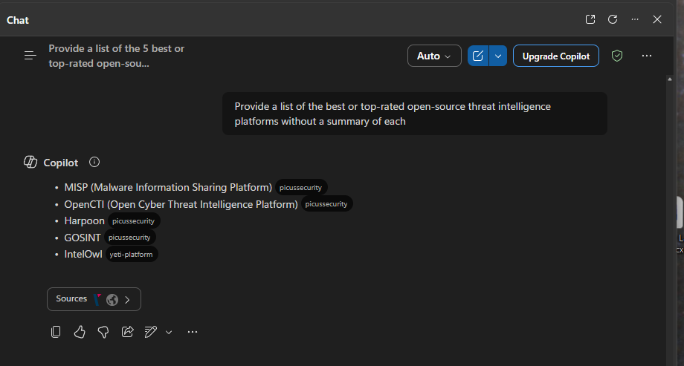

For your second part, look at the list that the AI output provided and select two platforms to find more information about.

Create a prompt that will give you a detailed comparison of those two platforms, ensuring that the output provides a detailed chart (for ease of comparison) and that is has a minimum of 10 categories

Do not taking a screenshot., Copy the output via your AI’s copy feature, see examples below, and pasting that on the next page. Most AI’s have their copy feature at the end of the output.

The icons highlighted below are what you click to copy the output
This is from Microsoft’s Copilot This is from Google’s Gemini
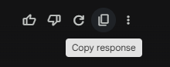

8 pts - Paste your AI output from part 2 below
Here is a detailed comparison chart of OpenCTI vs. IntelOwl across 15 categories, focusing strictly on their capabilities as open-source threat intelligence platforms:

📊 OpenCTI vs. IntelOwl – Detailed Comparison
Category | OpenCTI | IntelOwl
Primary Focus | Strategic & operational threat intelligence management | Tactical intelligence enrichment & automation
Core Architecture | Graph-based (knowledge graph with relationships) | Observable-based (artifact analysis engine)
Data Model | STIX 2.1–native structured intelligence model | Flexible, analyzer-driven data model
Supported Intelligence Types | Threat actors, campaigns, malware, vulnerabilities, IOCs | IPs, domains, URLs, hashes, files, observables
Standards Support | Strong support for STIX/TAXII standards | Limited native standards; integrates with STIX platforms
Data Ingestion | Connector framework for feeds (MISP, MITRE, CVE, etc.) | Aggregates 100+ analyzers/services in parallel
Enrichment Capability | Automated enrichment via connectors and workflows | Core strength: rapid multi-source enrichment via API [deepwiki.com]
Visualization | Advanced graph visualization of relationships | Dashboards and basic visualization of analysis results [intelowlpr....github.io]
Automation | Workflow automation & enrichment pipelines | Strong automation with playbooks and parallel analyzers [en-na.com]
API Type | GraphQL API (complex queries & relationships) | REST API (simple, fast enrichment queries) [deepwiki.com]
Integration Ecosystem | Extensive integrations (300+ connectors possible) [filigran.io] | Integrates external analyzers (VirusTotal, Shodan, OTX, etc.) [en-na.com]
Scalability | Enterprise-grade, horizontally scalable architecture | Scalable via async processing (Celery task queues) [deepwiki.com]
Deployment Complexity | High (multiple services: DB, workers, connectors) | Moderate (Docker-based, easier to deploy) [en-na.com]
Learning Curve | Steep (complex schema and relationships) | Moderate (simpler analyst workflow)
Use Case Fit | Strategic CTI, threat modeling, intelligence lifecycle | SOC triage, threat hunting, IOC enrichment
Collaboration Features | RBAC, case management, shared intelligence | Multi-user support with roles and TLP controls [deepwiki.com]
Data Correlation | Deep correlation across entities (graph relationships) | Correlation via analyzer results and pivots [helpnetsecurity.com]
Customization | Highly customizable via connectors and schema | Plugin framework for custom analyzers [intelowlpr....github.io]
Best Fit | Mature CTI programs and enterprise SOCs | Analysts needing fast, automated enrichment workflows

✅ Key Distinction (concise)
- OpenCTI → “Intelligence brain” (context, relationships, strategy)
- IntelOwl → “Intelligence engine” (enrichment, automation, speed)

If you’d like, I can map how both tools work together in a full CTI stack (very useful for labs or SOC architecture design).

