1. Your lab must be uploaded to Canvas in Landscape Mode to get a grade above 1. You must also ensure that all your screenshots are visible in the Canvas preview window, after you upload them.
2. If the NDG Lab is not functioning correctly and you have confirmed that all the previous steps are correct and that you are doing the current step correctly, you will need to cancel your current reservation and start a new reservation on a different NDG POD.
3. Incorrect answers are worth 7.5 pts each
Pay attention to tables and questions that require a supporting screenshot to count as correct.
If your screenshot is not the correct screenshot or the correct information is not selected/highlighted/visible in your screenshot (where the Student Template states to select/highlight the correct answer), your answers will be marked as incorrect.
You must type out the answers to questions/table entries. Screenshots are not accepted where you must answer a question or fill in a table. You only provide screenshots where you see a requirement to insert a screenshot.
4. Screenshots
Incorrectly formatting your screenshots (i.e. not following the requirements shown in front of your student template for the first two NDG lab Student Templates) will be a 2-point deduction per screenshot, up to 11 points for the lab. See this for guidance Screenshots Format Demo Video

If your NDG name is missing/not visible in your screenshot, that screenshot is incorrect.

If your screenshots are too small to view/see the information in the screenshot within Canvas’s grading window, your answer / screenshot may be marked incorrect, which is in addition to the 2 points for formatting issues.

This Student Template shows a single page dedicated to each screenshot. Ensure that when you paste your screenshots, that the screenshots take up most (more than 3/4) of the page (Your screenshots will take up most of a page, when captured and pasted correctly (using Win + Shift + S to capture and Ctrl + V to paste for a Windows PC or equivalent MacOS commands).

5. Wireshark, TCP / HTTP Stream Windows, terminal/console windows, Kibana, and Sguil must be full screen inside the NDG VM before taking a screenshot
(DO NOT OMIT capturing the bottom of the screenshots at this point)

If an answer or screenshot field in this document will not allow you to enter your answer or paste your screenshot, the form fields in the document got altered during the download process.
To fix the issue, download the document from Canvas again, transfer your answers and screenshots from this document to the new document and continue with the lab.

Since you are not using NDG for this lab, you are only capturing the Windows inside Packet Tracer that have your name at the top, (that is what will prove you have completed the task)

For instance, if you had to show that you enabled the NetFlow Collector Service and show some of the Traffic Contribution information, your screenshot would look like this one below……

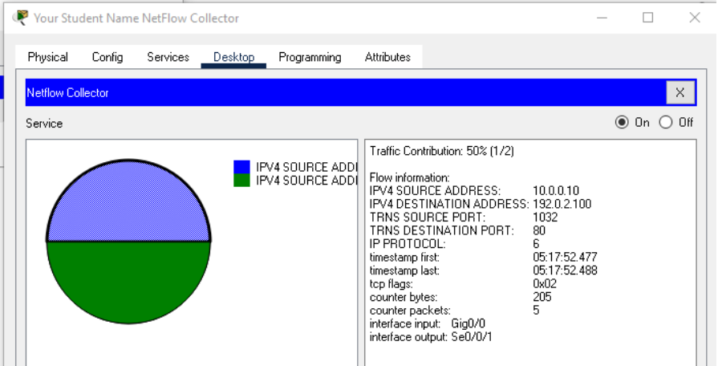

Do not provide full screen screenshots of Packet Tracer
Objectives
Part 1: View Log Entries with Syslog
Part 2: Observe AAA user access logging
Part 3: Observe NetFlow information

Background / Scenario

In this activity, you will use Packet Tracer 8.0 or later to view network data generated by syslog, AAA, and NetFlow.

View Log Entries with Syslog

The syslog Server
Syslog is a messaging system designed to support remote logging. Syslog clients send log entries to a syslog server. The syslog server concentrates and stores log entries. Packet Tracer supports basic syslog operations and can be used for demonstration. The network includes a syslog server and syslog clients. R1, R2, Core Switch, and the Firewall are syslog clients. These devices are configured to send their log entries to the syslog server. The syslog server collects the log entries and allows them to be read.
Log entries are categorized by eight severity levels. Lower levels are more serious events. The levels are
- 0 - emergencies
- 1 - alerts
- 2 - critical
- 3 - errors
- 4 - warnings
- 5 - notifications
- 6 - informational
- 7 - debugging
Syslog clients can be configured to ship log entries to syslog servers based on the severity level.
- Using the 25.3.11 Packet Tracer file, click the Syslog Server to open its window.
- Click the Config Tab, and in the Display Name field, enter your student name, as shown in Canvas, followed by Syslog Server. The top banner of the Syslog Server window will now have your name in front of Syslog Server.
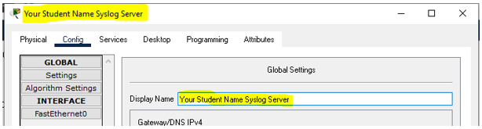

- Click on the Services tab and select SYSLOG from the list of services shown on the left and next to Service click On to turn on the Syslog service.
- Syslog entries coming from syslog clients will be shown in the window below the radio button.
- Keep this window visible by putting a checkmark in the box next to Top on the bottom left side of the Syslog Server Window.
- In the Syslog Services window, you will see messages coming in every minute. You will also see VLAN mismatch messages every minute or so.

Enable syslog
The devices are configured to send log messages to the syslog server, but Packet Tracer only supports the logging for the debugging severity level with syslog. Because of that, we must generate debug level messages (level 7) so they can be sent to the syslog server.
      - Click R1 > CLI tab.
      - Press Enter to get a command prompt and enter the command enable.
      - Enter the command debug eigrp packets to enable EIGRP debugging. The command line console will immediately fill with debug messages.
      - Return to the Syslog Server window. Verify that log entries appear on the syslog server.

Part 2 Step 2d - [Insert a screenshot of the Syslog Server Window showing some of the EIGRP messages (with your name and all required information visible.]

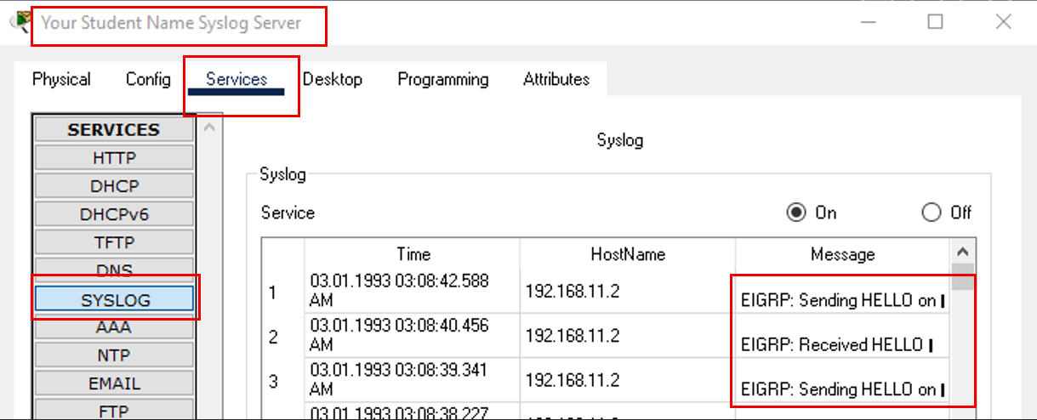

      - After a few messages have been logged, click the radio button to turn the syslog service Off. But leave it open.
      - Close the R1 device window.

Log User Access
Another important type of log relates to user access. Having records of user logins is crucial for troubleshooting and traffic analysis. Cisco IOS supports Authentication, Authorization and Accounting (AAA). With AAA, it is possible not only to delegate the user validation task to an external server but also to log activities.

TACACS+ is a protocol designed to allow remote authentication through a centralized server.
Packet Tracer offers basic AAA and TACACS+ support. R2 is also configured as a TACACS+ server. R2 will ask the server if that user is valid by verifying username and password, and grant or deny access based on the response. The server stores user credentials and is also able to log user login transactions. Follow the steps below to log in to R2 and display the log entries related to that login:
      - If necessary, click the Syslog Server to open its window.
      - Select the Services tab and select AAA from the list of services shown on the left.
      - Click Off the AAA service and then click On to turn back on the AAA service, just to ensure it starts.
      - Select the Desktop tab and select AAA Accounting. Leave the AAA Accounting Records window open.
      - Click R2 > CLI.
      - Press Enter to get a command prompt. R2 will ask for username and password before granting access to its CLI. Enter the following user credentials: analyst and cyberops as the username and password, respectively.
      - Return to the Syslog Server’s AAA Accounting Records window. On the TACACS+ Accounting tab, view the information that is showing.
      - Back on R2, enter the logout command.
      - Return to the Syslog Server’s AAA Accounting Records window. On the TACACS+ Accounting tab, view the information that is showing.
      - Repeat Part 4e thru 4i.
      - Make the window wide enough to accommodate each entry as a single line. Which is the name of the column inside TACACS+ that shows a user has successfully logged in and what term is used in the record to let you know this?
[Insert your answer below]
Flag; Start

Part 2k [Insert a screenshot of the Syslog Server Window showing the AAA Accounting Records TACACS+ Tab with entries generated up to this point (ensure your name is visible)]

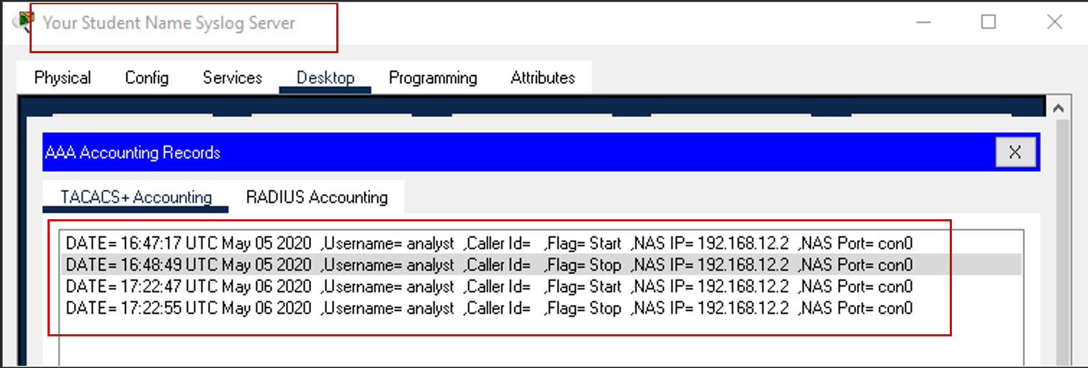

      - Make it so that you can see the R2 > CLI and the AAA Accounting Records at the same time
      - On R2, press Enter to get a command prompt and enter the name USERNAME and use PASSWORD for the credentials.
      - Repeat the previous step until you see an entry show up in the AAA Accounting Records
How many unsuccessful login attempts did it take before an entry showed in the record?
[Insert your answer below]
3

Part 2n - [Insert a screenshot of the Syslog Server Window showing the AAA Accounting Records TACACS+ Tab with entries generated up to this point (ensure your name is visible)]

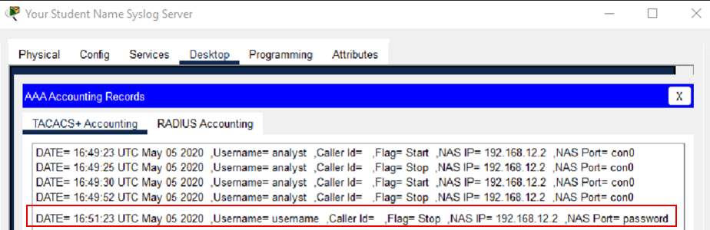:

      - Return to the Syslog Server’s Services Tab. Turn off the AAA Service.
      - Click R2 > CLI.
      - Press Enter to get a command prompt. Enter the correct user credentials.
      - Were you able to log into the router?
[Insert your answer below]
Yes

Before you take your screenshot, wait long enough for AAA to record it!

Part 2r - [Insert a screenshot of the Syslog Server Window showing the AAA Accounting Records showing that the login entry was now captured by AAA (ensure your name is visible)]

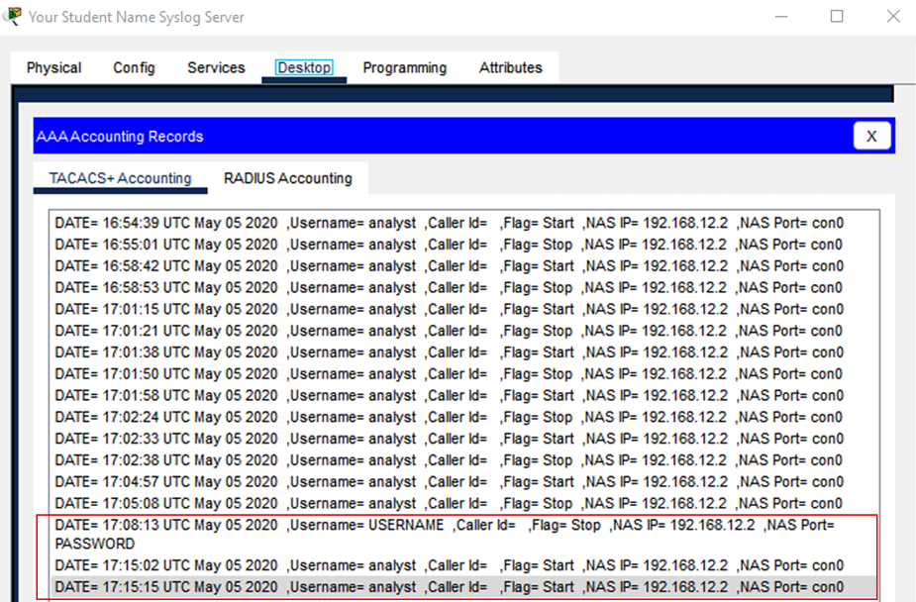:

      - Return to the Syslog Server’s Services Tab. Turn On the AAA Service once again.
      - On the bottom of the AAA Services window is User Setup. Click on the user analyst and then click Remove. There will now be no entry in the User Setup

Part 2t - [Insert a screenshot of the Syslog Server Window showing that the User Setup is now empty (ensure your name is visible)]

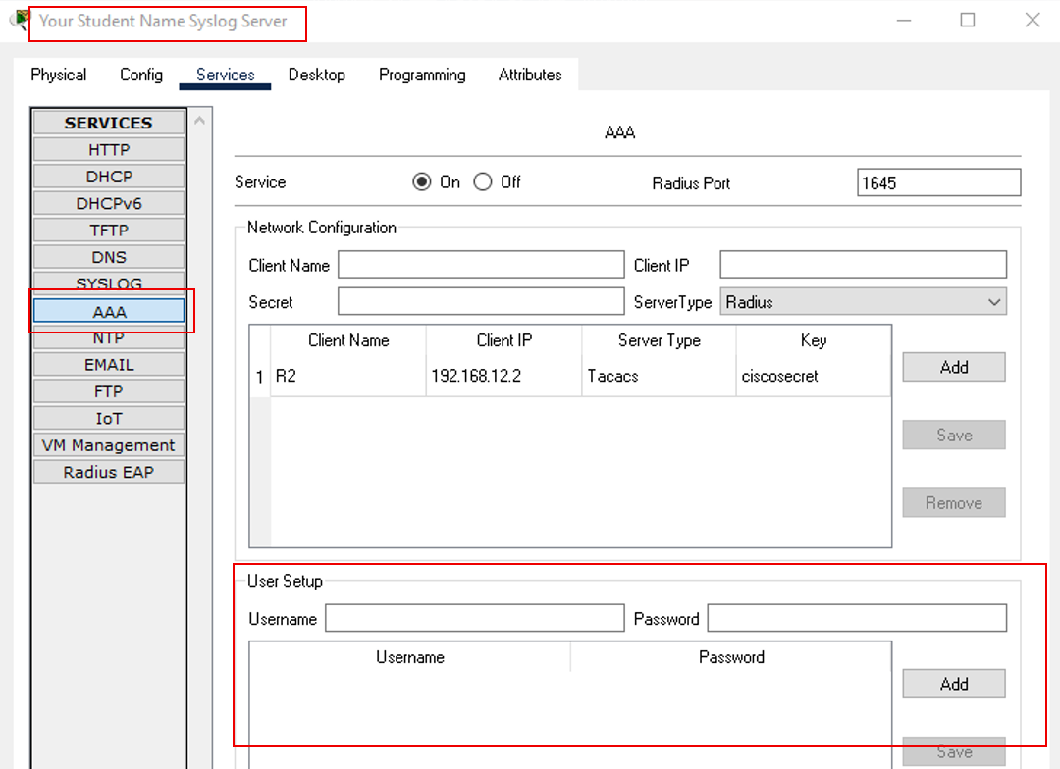:

      - Again, click R2 > CLI.
      - Press Enter to get a command prompt. Enter the correct user credentials.
      - Were you able to log into the router?
[Insert your answer below]
No

Before you take your screenshot, wait long enough for AAA to record it!

Part 2w [Insert a screenshot of the Syslog Server Window showing the AAA Accounting Records TACACS+ Tab with entries generated up to this point (ensure your name is visible)]

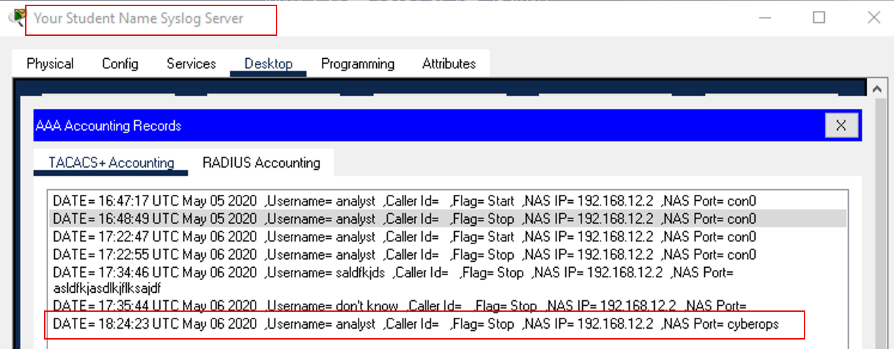

      - Looking at the login entries in the AAA Accounting Records, which column is the password column?
[Insert your answer below]
Port

      - Close the AAA Accounting Records application and R2

  - NetFlow and Visualization
In the topology, the Syslog server is also a NetFlow collector. The firewall is configured as a NetFlow exporter.
- If necessary, click the Syslog Server to bring up its window. Close the AAA Accounting Records window.
- From the Desktop tab, select NetFlow Collector. The NetFlow collector services in on and there should be a pie chart showing.
- From PC2.1, ping the Corp Web Server at 209.165.200.194. After a brief delay, the pie chart will update to show the new traffic flow.
Note: The pie charts displayed will vary based on the traffic on the network. Other packets flows, such as EIGRP-related traffic, are being sent between devices. NetFlow is capturing these packets and exporting statistics to the NetFlow Collector. The longer NetFlow is allowed to run on a network, the more traffic statistics will be captured

Reflection
While the tools presented in this activity are useful, each one has its own service and may need to run on totally different devices. A better way, explored later in the course, is to have all the logging information be concentrated under one tool, allowing for easy cross-reference and powerful search capabilities. Security information and event management (SIEM) platforms can gather log files and other information from diverse sources and integrate the information for access by a single tool.

