Claude AI Prompts
1st Prompt
this project is to get help creating good prompts to work with Claude Code. I want to create the prompts for Claude Code in VS Code. I want to build an AI agent to tutor students on the Cisco Certified Network Associate exam. All the code will be on my github repository. My VS Code studio is connected to the repository and tested using Claude Code in another project just completed. I will host the webpage launcher on Render.com using Anthropic API Keys. I have a working AI agent using them now. The API Keys are on github environmental variable. I will give Claude Code example test bank of questions. I will Claude Code example network protocol subjects. I want Claude Code to build the Python code with flask webpage. I want to build in small steps so I can verify the code starting with a launch webpage then each network protocol on a different webpage. Claude Code will parse the test bank questions to find questions and/or correct answers the protocols. The last step to build a webpage that launches example labs. The labs run on Cisco Packet Tracer so the students need to login on Packet Tracer at Cisco NetAcad and they all have accounts.
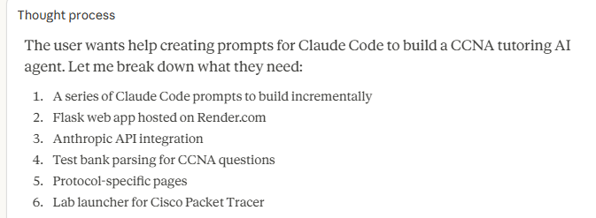
This is a great project! Let me build you a structured set of Claude Code prompts that follow your incremental approach. I'll create a document you can reference as you work through each step.
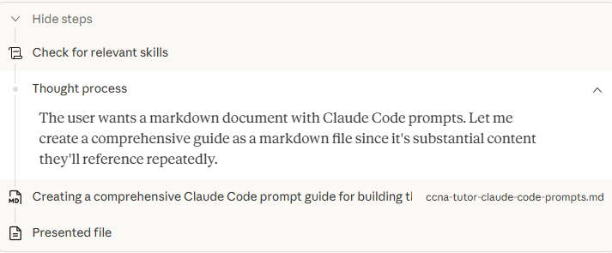
Here's your complete prompt guide with 8 incremental steps. Each prompt is copy-paste ready for Claude Code in VS Code.
How to use it:
- Open the file and start with the "Before You Start" setup prompt — this creates the project skeleton
- Then go through Steps 1–8 one at a time, testing after each step before moving on
- Step 1 gets Flask running with a landing page (quick win to verify everything works)
- Step 2 wires up your Anthropic API
- Steps 3–4 build out all the protocol study pages
- Step 5 is where you drop in your test bank files and Claude Code parses them
- Step 6 builds the interactive quiz with AI-powered explanations for wrong answers
- Step 7 adds the Packet Tracer lab launcher
- Step 8 polishes everything and preps for Render deployment
The Tips section at the bottom has quick prompts for common situations like fixing errors, adding more questions, or tuning the AI responses. Let me know if you want to adjust any of the steps or add features!
2nd Prompt
I like the current plan. I want to add the following. The students have completed three courses in a network administrator degree program so have a basic understanding of terms and configurations. The AI agent will use the Cisco configuration guides provided for a switch and a router to tutor students on network concepts and device configuration. The tutor uses the understanding that a human remembers information to answer questions by being forced to focus on one very small detail that is framed within a later understanding of a network protocol. When the student does not answer the exam question from the example exam guide correctly, the agent gives a combination of broad concepts and configuration guide details. The questions will be given to student in exactly the same way as written on the exam guide. This includes the way question and answer are written. Then the student can try to answer the question again. When the student answers correctly the AI agent explains the reason, the other answers are not correct by referencing the configuration guides. There are many CCNA training references that are not based on the configuration guides that can give student misconceptions. The Cisco CCNA exam training textbook does not cover all the material on the test because the author of the book is not authorized to review the test bank. Some questions use more than one protocol so should be included in more than area.

Here's the updated v2 with all your additions woven throughout. The key changes from v1:
Tutoring methodology is now the core of the AI system prompt (Step 2):
- Wrong answer → broad concept + config guide detail hint → student retries (no answer revealed)
- Correct answer → explains why correct AND why every other option is wrong, all referencing config guides
- Progressive hints get more specific on each retry attempt
Cisco config guides are the single source of truth:
- New config_guide.py module and data/config_guides/router/ and switch/ folders
- Every protocol JSON now has config_guide_refs and common_misconceptions fields
- The AI explicitly calls out where third-party training materials get it wrong
Exam-exact question presentation:
- Questions stored with _original fields that are never modified
- Parser preserves character-for-character wording
- Quiz displays exactly as written in the exam guide

3rd Prompt
The exam question bank has a lot of questions on the same detail about a protocol. The questions are just worded a little different. The designers of the exam question bank did this so students need to understand the protocol not just memorize question answers. But this bores students and they can lose interest. The AI agent needs sort these redundant questions into groups and only give a student one question from the group. Then ask the student if you want more questions from the same group or go to different questions on the same protocol. The student should get a random question from the group each time they restart the AI agent tutor. The AI agent tutor will not trace individual students since they all use the same login ID. This will require Anthropic AI to analyze the question bank beyond protocols to questions on the same fact or concept on the protocol. What is the probability that the Anthropic AI can analyze protocols and find questions on the concept to put in groups. I did this and found them. Some questions have switched the question part of concept to the answer part the the question.
Great question on Claude's capability here. The probability is very high — this is actually one of the things LLMs excel at. Claude is strong at semantic understanding, so it can identify that two questions test the same concept even when the wording is different or the question/answer positions are swapped. For example, it can recognize that "What is the default administrative distance of OSPF?" and "Which routing protocol has a default administrative distance of 110?" are testing the same fact from opposite directions.
The main consideration is doing this analysis at startup (or as a preprocessing step) rather than on every quiz request, since analyzing the full question bank takes API calls and tokens. Let me update the prompt guide with this feature built in.
Created a file, read a file
Here's v3 with the concept grouping system built in. To answer your direct question:
Can Claude reliably group these questions by concept? Yes, with high confidence. This plays to exactly what LLMs are good at — semantic understanding of meaning regardless of surface wording. The question-answer swap pattern you described (where the question becomes the answer and vice versa) is something Claude handles particularly well because it's analyzing the underlying fact, not pattern-matching on keywords. You mentioned you've already done this manually and found the groups — Claude should arrive at very similar groupings.
The key additions in v3:
New Step 5B is the concept grouper. It sends questions to Claude protocol-by-protocol with a prompt specifically designed to catch the three patterns you described: same concept different wording, question-answer swaps, and same fact in different scenarios. Results are cached as JSON so you only pay for the API calls once.
Step 6 quiz flow now works by concept group, not by individual question. Students see one random question per concept, then get the choice to try more from the same group or move on. Since everyone shares a login, randomization ensures each session feels fresh without needing to track individuals.
Manual overrides let you fix any groupings the AI gets wrong — you'll know your question bank better than anyone.
Three new utility prompts at the bottom: one for running the grouper, one for reviewing results, and one for fixing mis-grouped questions. Let me know if you want to adjust anything!

