Cisco

Exam Questions 200-301
Cisco Certified Network Associate



NEW QUESTION 1
- (Topic 3)
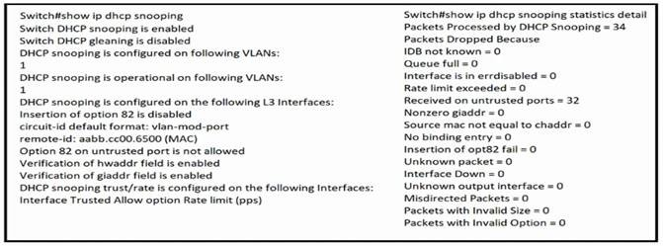
Refer to the exhibit.
The DHCP server and clients are connected to the same switch. What is the next step to complete the DHCP configuration to allow clients on VLAN 1 to receive addresses from the DHCP server?

- Configure the ip dhcp snooping trust command on the interlace that is connected to the DHCP client.
- Configure the ip dhcp relay information option command on the interface that is connected to the DHCP client.
- Configure the ip dhcp snooping trust command on the interface that is connected to the DHCP server.
- Configure the Ip dhcp relay information option command on the interface that is connected to the DHCP server.

Answer: C

NEW QUESTION 2
- (Topic 3)
What causes a port to be placed in the err-disabled state?

- nothing plugged into the port
- link flapping
- shutdown command issued on the port
- latency

Answer: B

NEW QUESTION 3
- (Topic 3)
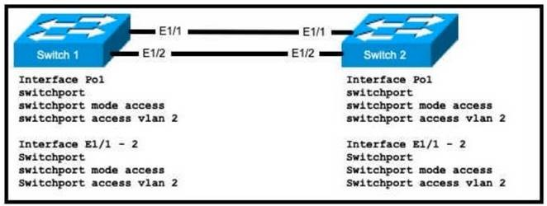
Refer to the exhibit.
An engineer is configuring an EtherChannel using LACP between Switches 1 and 2 Which configuration must be applied so that only Switch 1 sends LACP initiation packets?

- Switch 1 (config-if)#channel-group 1 mode on Swrtch2(config-if)#channel-group 1 mode passive
- Switch1(config-if)#channel-group 1 mode passive Switch2(config-if)#channel-group 1 mode active
- Switch1{config-if)£channel-group 1 mode active Switch2(config-if)#channel-group 1 mode passive
- Switch1(config-if)#channel-group 1 mode on Switch2(config-if)#channel-group 1 mode active

Answer: C

NEW QUESTION 4
- (Topic 3)
R1 as an NTP server must have:
- NTP authentication enabled
- NTP packets sourced from Interface loopback 0
- NTP stratum 2
- NTP packets only permitted to client IP 209.165 200 225 How should R1 be configured?
A)

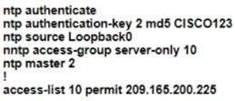
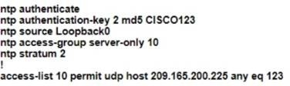
B)
C)
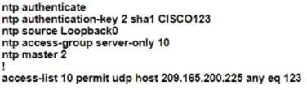
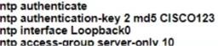
D)

- Option A
- Option B
- Option C
- Option D

Answer: B

NEW QUESTION 5
- (Topic 3)
Which interface mode must be configured to connect the lightweight APs in a centralized architecture?

- WLAN dynamic
- management
- trunk
- access

Answer: D

NEW QUESTION 6
- (Topic 3)
Which value is the unique identifier that an access point uses to establish and maintain wireless connectivity to wireless network devices?

- VLANID
- SSID
- RFID
- WLANID

Answer: B

NEW QUESTION 7
- (Topic 3)
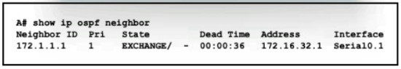
Refer to the exhibit.
An engineer assumes a configuration task from a peer Router A must establish an OSPF neighbor relationship with neighbor 172 1 1 1 The output displays the status of the adjacency after 2 hours. What is the next step in the configuration process for the routers to establish an adjacency?

- Configure router A to use the same MTU size as router B.
- Set the router B OSPF ID to a nonhost address.
- Configure a point-to-point link between router A and router B.
- Set the router B OSPF ID to the same value as its IP address

Answer: B

NEW QUESTION 8

- (Topic 3)
A network engineer must configure two new subnets using the address block 10 70 128 0/19 to meet these requirements:
- The first subnet must support 24 hosts
- The second subnet must support 472 hosts
- Both subnets must use the longest subnet mask possible from the address block Which two configurations must be used to configure the new subnets and meet a
requirement to use the first available address in each subnet for the router interfaces? (Choose two )

- interface vlan 1234ip address 10.70.159.1 255.255.254.0
- interface vlan 1148ip address 10.70.148.1 255.255.254.0
- interface vlan 4722ip address 10.70.133.17 255.255.255.192
- interface vlan 3002ip address 10.70.147.17 255.255.255.224
- interface vlan 155ip address 10.70.155.65 255.255.255.224

Answer: BD

NEW QUESTION 9
- (Topic 3)
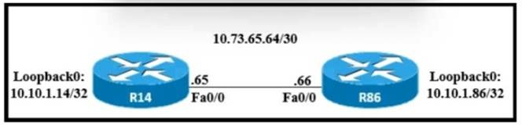
Refer to the exhibit.
A static route must be configured on R14 to forward traffic for the 172 21 34 0/25 network that resides on R86 Which command must be used to fulfill the request?

- ip route 172.21.34.0 255.255.255.192 10.73.65.65
- ip route 172.21.34.0 255.255.255.0 10.73.65.65
- ip route 172.21.34.0 255.255.128.0 10.73.65.64
- ip route 172.21.34.0 255.255.255.128 10.73.65.66

Answer: D

NEW QUESTION 10
DRAG DROP - (Topic 3)
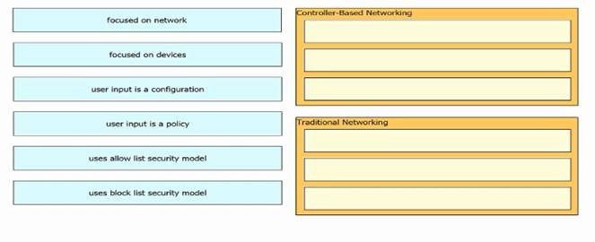
Drag and drop the characteristics of networking from the left onto the networking types on the right.

- Mastered
- Not Mastered Answer: A Explanation:

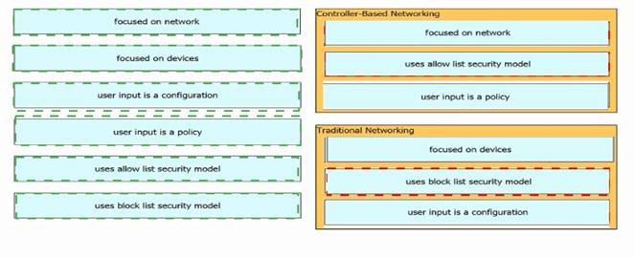

NEW QUESTION 10
- (Topic 3)
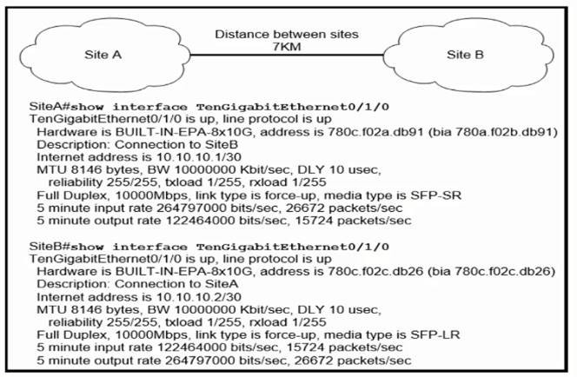
Refer to the exhibit.
Site A was recently connected to site B over a new single-mode fiber path. Users at site A report Intermittent connectivity Issues with applications hosted at site B. What is the reason for the problem?

- Heavy usage is causing high latency.
- An incorrect type of transceiver has been inserted into a device on the link.
- physical network errors are being transmitted between the two sites.
- The wrong cable type was used to make the connection.

Answer: B

NEW QUESTION 11
- (Topic 3)
A Cisco engineer is configuring a factory-default router with these three passwords:
- The user EXEC password for console access is p4ssw0rd1
- The user EXEC password for Telnet access is s3cr3t2
- The password for privileged EXEC mode is pnv4t3p4ss Which command sequence must the engineer configured A)
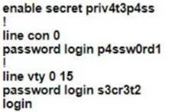
B)

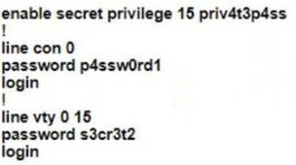
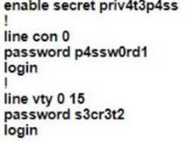
C)
D)
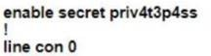

- Option A
- Option B
- Option C
- Option D

Answer: B

NEW QUESTION 14
- (Topic 3)
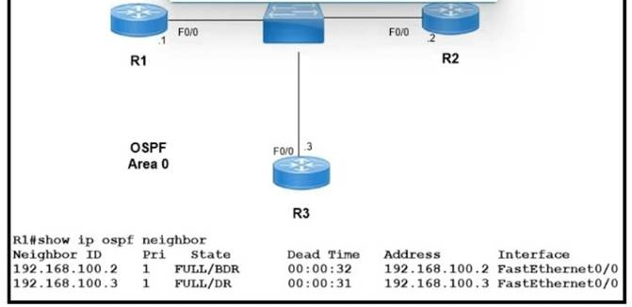
Refer to the exhibit.
Which two configurations must the engineer apply on this network so that R1 becomes the DR? (Choose two.) A)
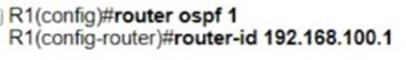
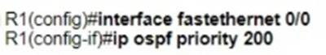
B)
C)
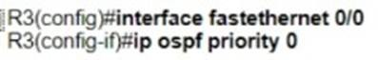
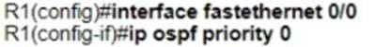
D)
E)

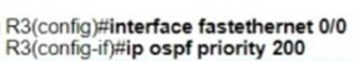

- Option A
- Option B
- Option C
- Option D
- Option E

Answer: BC

NEW QUESTION 18
- (Topic 3)
A network engineer is installing an IPv6-only capable device. The client has requested that the device IP address be reachable only from the internal network. Which type of IPv6 address must the engineer assign?

- unique local address
- link-local address
- aggregatable global address
- IPv4-compatible IPv6 address

Answer: B

NEW QUESTION 20
- (Topic 3)
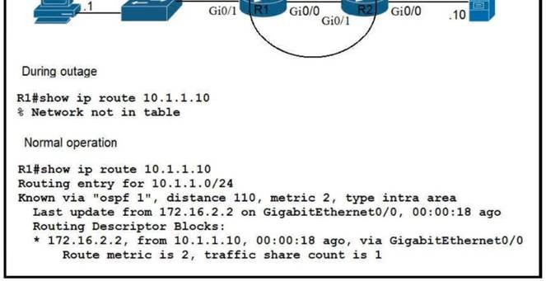
Refer to the exhibit.
Which route must be configured on R1 so that OSPF routing is used when OSPF is up. but the server is still reachable when OSPF goes down?

- ip route 10.1.1.10 255.255.255.255 172.16.2.2 100
- ip route 10.1.1.0 255.255.255.0 gi0/1 125
- ip route 10.1.1.0 255.255.255.0 172.16.2.2 100
- ip route 10.1.1.10 255.255.255.255 gi0/0 125

Answer: D

NEW QUESTION 22
- (Topic 3)
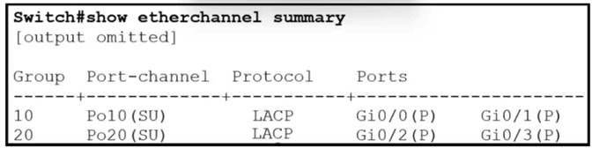
Refer to the exhibit.
Which two commands when used together create port channel 10? (Choose two.)

- int range g0/0-1channel-group 10 mode active
- int range g0/0-1 chanm.l-group 10 mode desirable
- int range g0/0-1channel-group 10 mode passive
- int range g0/0-1 channel-group 10 mode auto
- int range g0/0-1 channel-group 10 mode on

Answer: AC

NEW QUESTION 26
- (Topic 3)
How does Rapid PVST+ create a fast loop-free network topology?

- lt requires multiple links between core switches
- It generates one spanning-tree instance for each VLAN
- It maps multiple VLANs into the same spanning-tree instance
- It uses multiple active paths between end stations.

Answer: A

NEW QUESTION 27
- (Topic 3)
Which two components comprise part of a PKI? (Choose two.)

- preshared key that authenticates connections
- RSA token
- CA that grants certificates
- clear-text password that authenticates connections
- one or more CRLs

Answer: BC

NEW QUESTION 31
- (Topic 3)
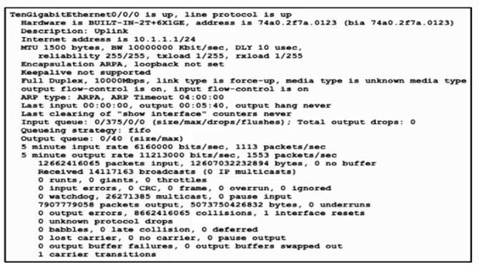
Refer to the exhibit.
Traffic that is flowing over interface TenGigabitEthernet0/0 experiences slow transfer speeds. What is the reason for the issue?

- heavy traffic congestion
- a duplex incompatibility
- a speed conflict
- queuing drops

Answer: C

NEW QUESTION 32
- (Topic 3)
Which characteristic differentiates the concept of authentication from authorization and accounting?

- user-activity logging
- service limitations
- consumption-based billing
- identity verification

Answer: D

NEW QUESTION 37
- (Topic 3)
Which two network actions occur within the data plane? (Choose two.)

- Add or remove an 802.1Q trunking header.
- Make a configuration change from an incoming NETCONF RPC.
- Run routing protocols.

- Match the destination MAC address to the MAC address table.
- Reply to an incoming ICMP echo request.

Answer: BD

NEW QUESTION 41
- (Topic 3)
A network engineer must implement an IPv6 configuration on the vlan 2000 interface to create a routable locally-unique unicast address that is blocked from being advertised to the internet. Which configuration must the engineer apply?

- interface vlan 2000ipv6 address ffc0:0000:aaaa::1234:2343/64
- interface vlan 2000Ipv6 address fc00:0000:aaaa:a15d:1234:2343:8aca/64
- interface vlan 2000ipv6 address fe80;0000:aaaa::1234:2343/64
- interface vlan 2000ipv6 address fd00::1234:2343/64

Answer: B

NEW QUESTION 46
- (Topic 3)
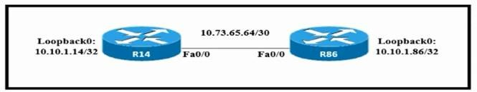
Refer to the exhibit.
Which configuration allows routers R14 and R86 to form an OSPFv2 adjacency while acting as a central point for exchanging OSPF information between routers? A)
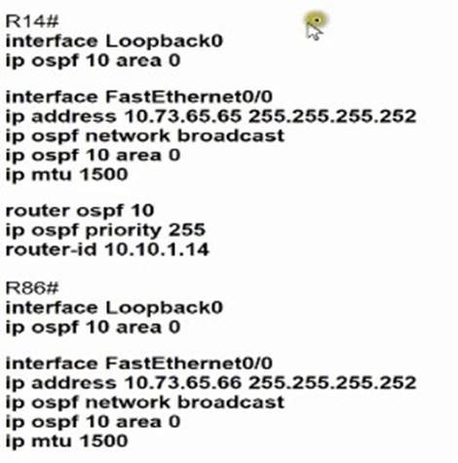
B)

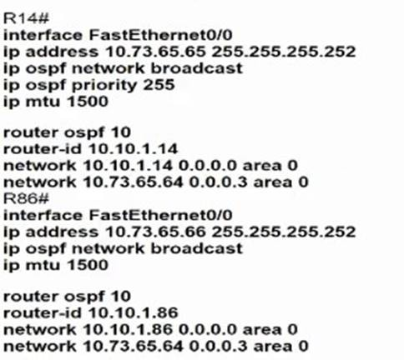
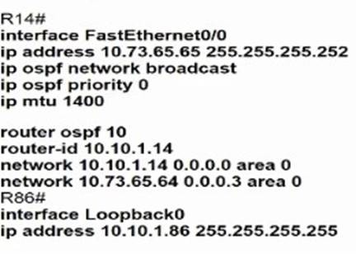
C)
D)
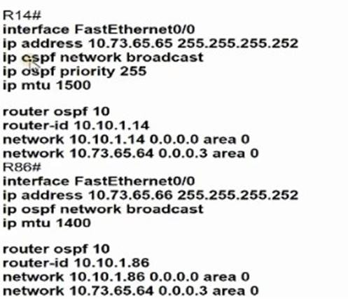

- Option A
- Option B
- Option C
- Option D

Answer: D

NEW QUESTION 48
- (Topic 3)
What is an expected outcome when network management automation is deployed?

- A distributed management plane must be used.
- Software upgrades are performed from a central controller
- Complexity increases when new device configurations are added
- Custom applications are needed to configure network devices

Answer: B

NEW QUESTION 50
- (Topic 3)
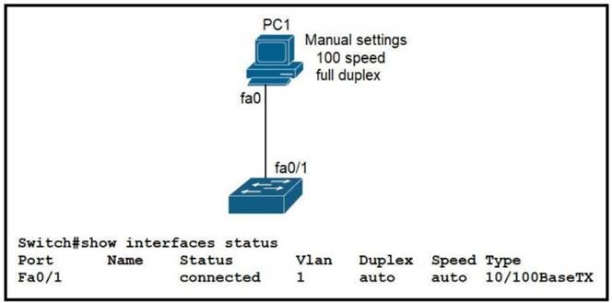
Refer to the exhibit.
The link between PC1 and the switch is up. but it is performing poorly. Which interface condition is causing the performance problem?

- There is a duplex mismatch on the interface
- There is an issue with the fiber on the switch interface.
- There is a speed mismatch on the interface.
- There is an interface type mismatch

Answer: A

NEW QUESTION 51
- (Topic 3)
What is a requirement for nonoverlapping Wi-Fi channels?

- different security settings
- discontinuous frequency ranges
- different transmission speeds
- unique SSIDs

Answer: B

NEW QUESTION 54
- (Topic 3)
A network engineer is configuring a switch so that it is remotely reachable via SSH. The engineer has already configured the host name on the router. Which additional command must the engineer configure before entering the command to generate the RSA key?

- password password
- crypto key generate rsa modulus 1024
- ip domain-name domain
- ip ssh authentication-retries 2

Answer: C

Explanation:
https://www.cisco.com/c/en/us/solutions/small-business/resource-center/networking/how-to-setup-network-switch.html

NEW QUESTION 58
- (Topic 3)
Refer to the exhibit.

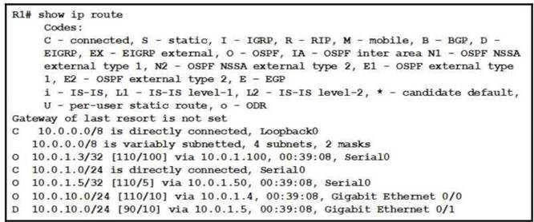
Web traffic is coming in from the WAN interface. Which route takes precedence when the router is processing traffic destined for the LAN network at 10 0.10.0/24?

- via next-hop 10.0.1.5
- via next-hop 10 0 1.4
- via next-hop 10.0 1.50
- via next-hop 10.0 1 100

Answer: A

NEW QUESTION 60
- (Topic 3)
What is a function of a Next-Generation IPS?

- makes forwarding decisions based on learned MAC addresses
- serves as a controller within a controller-based network
- integrates with a RADIUS server to enforce Layer 2 device authentication rules
- correlates user activity with network events

Answer: D

NEW QUESTION 61
DRAG DROP - (Topic 3)
An engineer is tasked to configure a switch with port security to ensure devices that forward unicasts multicasts and broadcasts are unable to flood the port The port must be configured to permit only two random MAC addresses at a time Drag and drop the required configuration commands from the left onto the sequence on the right Not all commands are used.
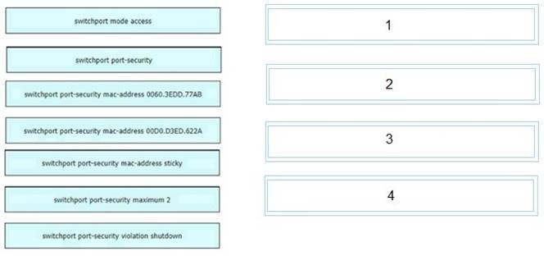

- Mastered
- Not Mastered Answer: A Explanation:

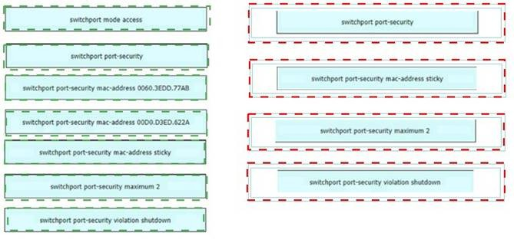

NEW QUESTION 66
- (Topic 3)
What is a function of an endpoint on a network?

- forwards traffic between VLANs on a network
- connects server and client devices to a network
- allows users to record data and transmit to a tile server
- provides wireless services to users in a building

Answer: C

Explanation:
An endpoint is a host that acts as the source or destination of data traffic flowing through a network. When you are at your PC, editing your CV and uploading it to a file server, you are sitting at an endpoint.

NEW QUESTION 68
- (Topic 3)
Which PoE mode enables powered-device detection and guarantees power when the device is detected?

- dynamic
- static
- active
- auto

Answer: B

NEW QUESTION 69
- (Topic 2)
What is the primary different between AAA authentication and authorization?

- Authentication verifies a username and password, and authorization handles the communication between the authentication agent and the user database.
- Authentication identifies a user who is attempting to access a system, and authorization validates the users password
- Authentication identifies and verifies a user who is attempting to access a system, and authorization controls the tasks the user can perform.
- Authentication controls the system processes a user can access and authorization logs the activities the user initiates

Answer: C

Explanation:
AAA stands for Authentication, Authorization and Accounting.+ Authentication: Specify who you are (usually via login username & password)+ Authorization: Specify what actions you can do, what resource you can access+ Accounting: Monitor what you do, how long you do it (can be used for billing and auditing)An example of AAA is shown below:+ Authentication: “I am a normal user. My username/password is user_tom/learnforever”+ Authorization: “user_tom can access LearnCCNA server via HTTP and FTP”+ Accounting: “user_tom accessed LearnCCNA server for 2 hours”. This user only uses “show” commands.

NEW QUESTION 71
- (Topic 2)
Which networking function occurs on the data plane?

- forwarding remote client/server traffic
- facilitates spanning-tree elections
- processing inbound SSH management traffic
- sending and receiving OSPF Hello packets

Answer: A

NEW QUESTION 73
- (Topic 2)

While examining excessive traffic on the network, it is noted that all incoming packets on an interface appear to be allowed even though an IPv4 ACL is applied to the interface.
Which two misconfigurations cause this behavior? (Choose two)

- The packets fail to match any permit statement
- A matching permit statement is too high in the access test
- A matching permit statement is too broadly defined
- The ACL is empty
- A matching deny statement is too high in the access list

Answer: BC

NEW QUESTION 78
- (Topic 2)
What are two differences between optical-fiber cabling and copper cabling? (Choose two)

- Light is transmitted through the core of the fiber
- A BNC connector is used for fiber connections
- The glass core component is encased in a cladding
- Fiber connects to physical interfaces using Rj-45 connections
- The data can pass through the cladding

Answer: AC

NEW QUESTION 79
- (Topic 2)
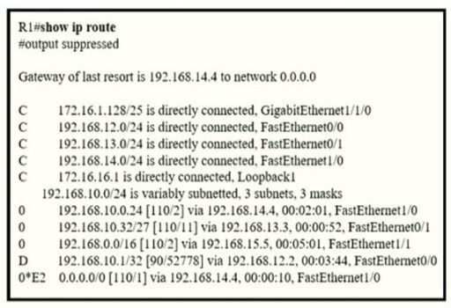
Refer to the exhibit.
If R1 receives a packet destined to 172.161.1, to which IP address does it send the packet?

- 192.168.12.2
- 192.168.13.3
- 192.168.14.4
- 192.168.15.5

Answer: C

NEW QUESTION 81
- (Topic 2)
Which protocol does an access point use to draw power from a connected switch?

- Internet Group Management Protocol
- Adaptive Wireless Path Protocol
- Cisco Discovery Protocol
- Neighbor Discovery Protocol

Answer: C

NEW QUESTION 86
DRAG DROP - (Topic 2)
Drag the descriptions of IP protocol transmissions from the left onto the IP traffic types on the right.

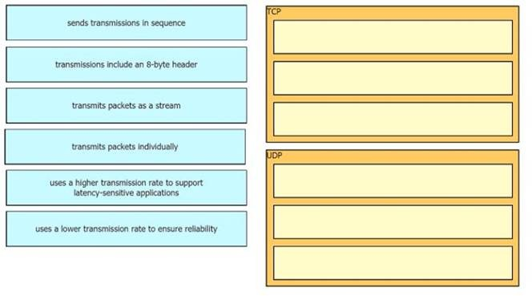

- Mastered
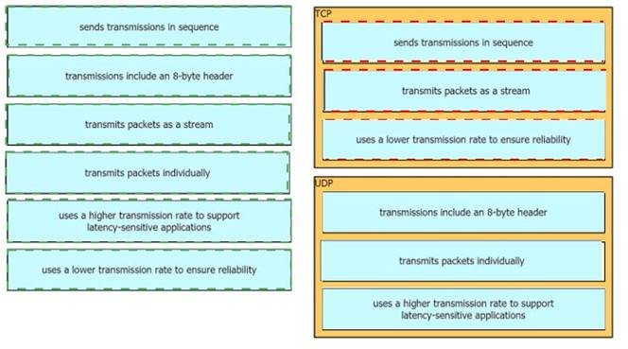
- Not Mastered Answer: A Explanation:

NEW QUESTION 88
- (Topic 2)
Refer to the exhibit.

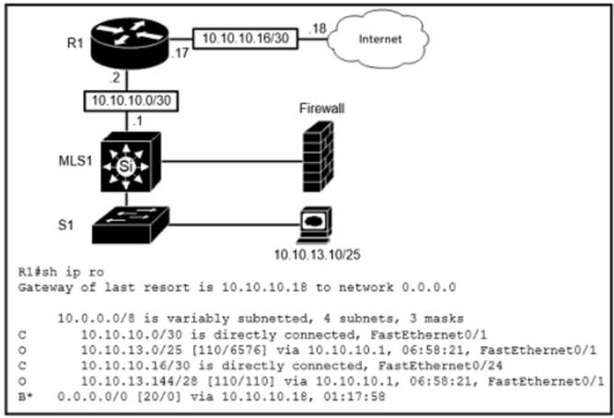
Which route type is configured to reach the internet?

- host route
- default route
- floating static route
- network route

Answer: B

NEW QUESTION 91
- (Topic 2)
An engineer is configuring NAT to translate the source subnet of 10.10.0.0/24 to any of three addresses 192.168.30.1, 192.168.3.2, 192.168.3.3 Which configuration should be used?
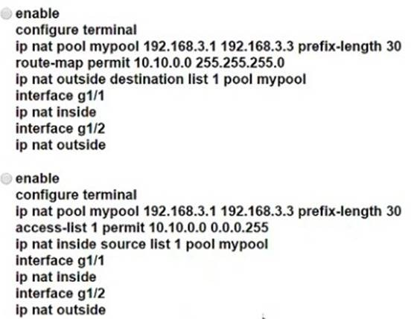

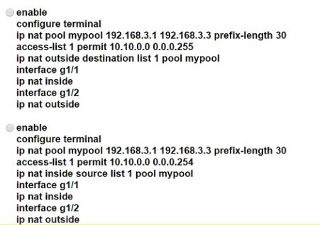

- Option A
- Option B
- Option C
- Option D

Answer: C

NEW QUESTION 93
- (Topic 2)
What is the same for both copper and fiber interfaces when using SFP modules?

- They support an inline optical attenuator to enhance signal strength
- They provide minimal interruption to services by being hot-swappable
- They offer reliable bandwidth up to 100 Mbps in half duplex mode
- They accommodate single-mode and multi-mode in a single module

Answer: B

NEW QUESTION 96
- (Topic 2)
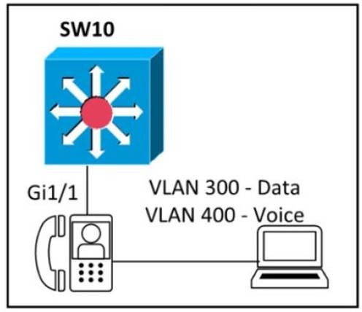
Refer to the exhibit.
An engineer must configure GigabitEthernet1/1 to accommodate voice and data traffic Which configuration accomplishes this task?

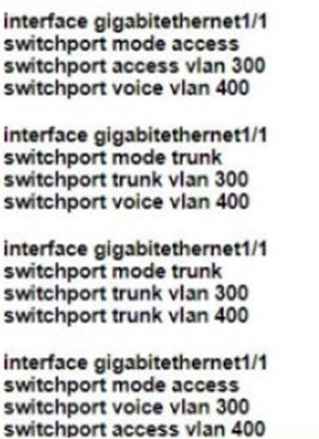

- Option A
- Option B
- Option C
- Option D

Answer: A

NEW QUESTION 100
- (Topic 2)
Which two QoS tools provides congestion management? ( Choose two )

- CAR
- CBWFQ
- PQ
- PBR
- FRTS

Answer: BC

Explanation:
Type of queuing methods are available:• First-In-First-Out (FIFO)• Priority Queuing (PQ)• Custom Queuing (CQ)• Weighted Fair Queuing (WFQ)• Class-Based Weighted Fair Queuing (CBWFQ)• Low-Latency Queuing (LLQ)
https://www.orbit-computer-solutions.com/qos-congestion-management-tools/

NEW QUESTION 104
- (Topic 2)
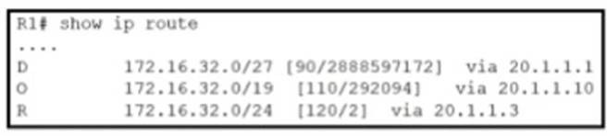
Refer to the exhibit.
Router R1 is running three different routing protocols. Which route characteristic is used by the router to forward the packet that it receives for destination IP 172.16.32.1?

- longest prefix
- metric
- cost
- administrative distance

Answer: A

Explanation:

https://learningnetwork.cisco.com/s/question/0D53i00000KszSlCAJ/administrative- distance-vs-longest-match-rule

NEW QUESTION 108
DRAG DROP - (Topic 2)
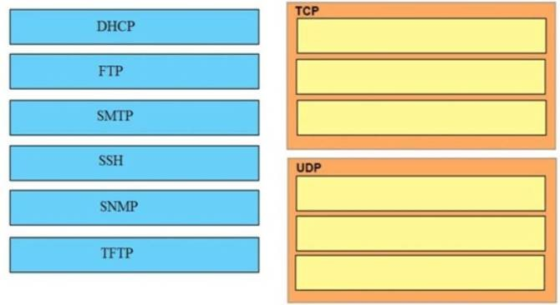
Drag and drop the application protocols from the left onto the transport protocols that it uses on the right

- Mastered
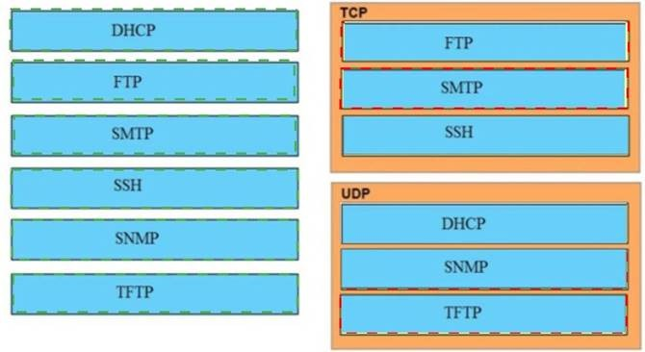
- Not Mastered Answer: A Explanation:

NEW QUESTION 109
- (Topic 2)
When the active router in an HSRP group fails, what router assumes the role and forwards packets?

- backup
- standby
- listening
- forwarding

Answer: B

NEW QUESTION 112
- (Topic 2)
Which action does the router take as rt forwards a packet through the network?

- The router replaces the source and desinaoon labels wth the sending router uterface label as a source and the next hop router label as a desbnabon
- The router encapsulates the source and destination IP addresses with the sending router P address as the source and the neighbor IP address as the destination
- The router replaces the original source and destination MAC addresses with the sending router MAC address as the source and neighbor MAC address as the destination

- The router encapsulates the original packet and then includes a tag that identifies the source router MAC address and transmit transparently to the destination

Answer: C

NEW QUESTION 116
- (Topic 2)
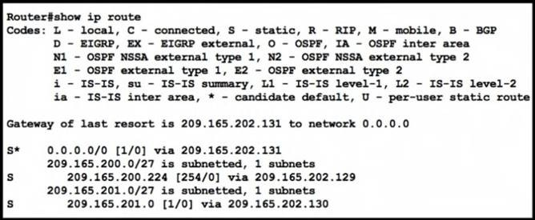
Refer to the exhibit.
Which command configures a floating static route to provide a backup to the primary link?

- ip route 0.0.0.0 0.0.0.0 209.165.202.131
- ip route 209.165.201.0 255.255.255.224 209.165.202.130
- ip route 0.0.0.0 0.0.0.0 209.165.200.224
- ip route 209.165.200.224 255.255.255.224 209.165.202.129 254

Answer: D

NEW QUESTION 120
- (Topic 2)
A corporate office uses four floors in a building
- Floor 1 has 24 users
- Floor 2 has 29 users
- Floor 3 has 28 users
•Floor 4 has 22 users
Which subnet summarizes and gives the most efficient distribution of IP addresses for the router configuration?

- 192.168.0.0/26 as summary and 192.168.0.0/29 for each floor
- 192.168.0.0.24 as summary and 192.168.0.0/28 for each floor
- 192.168.0.0/23 as summary and 192.168.0.0/25 for each floor
- l92.168.0.0/25 as summary and 192.168.0.0/27 for each floor

Answer: D

NEW QUESTION 125
- (Topic 2)
Which function is performed by DHCP snooping?

- propagates VLAN information between switches
- listens to multicast traffic for packet forwarding
- provides DDoS mitigation
- rate-limits certain traffic

Answer: A

NEW QUESTION 128
- (Topic 2)
Refer to the exhibit.

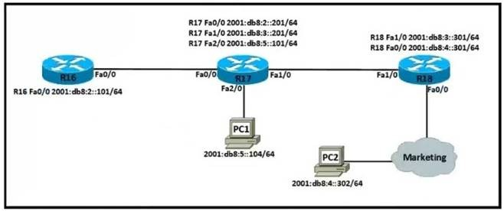
Which IPv6 configuration is required for R17 to successfully ping the WAN interface on R18? A)
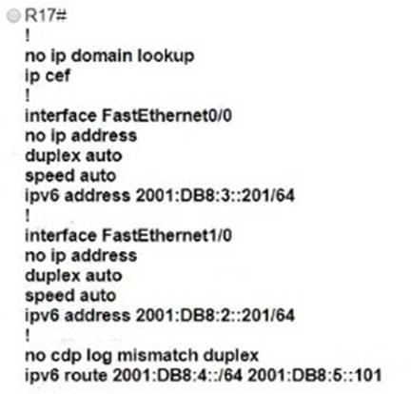
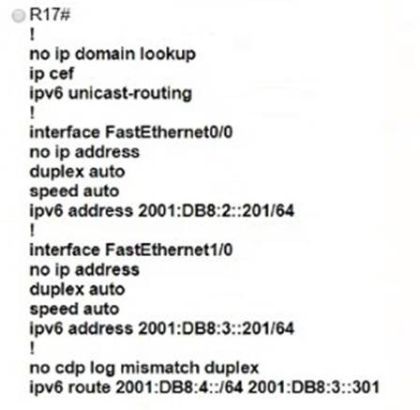
B)
C)

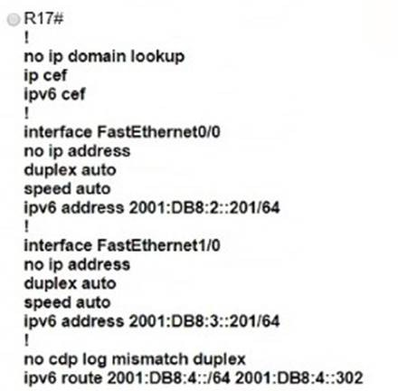
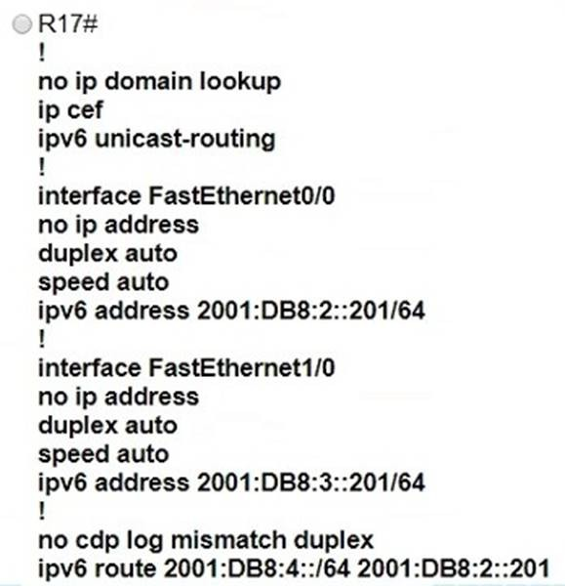
D)

- Option A
- Option B
- Option C
- Option D

Answer: B

Explanation:
ipv6 unicast-routing statement included (IPv6 is enabled on the router).Compared to the exhibit, Fa0/0 and Fa0/1 have correct configurations.The route to subnet 2001:db8:4::/64 points to R18’s Fa1/0 (correct next-hop).

NEW QUESTION 131
DRAG DROP - (Topic 2)
Drag and drop the TCP/IP protocols from the left onto the transmission protocols on the right

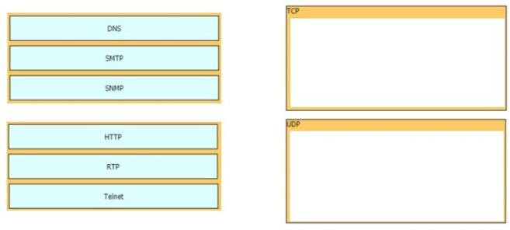

- Mastered
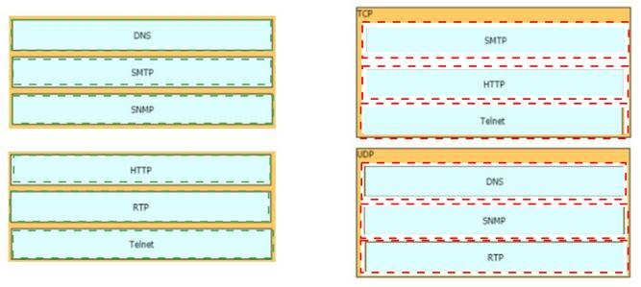
- Not Mastered Answer: A Explanation:

NEW QUESTION 135
- (Topic 2)
A user configured OSPF in a single area between two routers A serial interface connecting R1 and R2 is running encapsulation PPP By default which OSPF network type is seen on this interface when the user types show ip ospf interface on R1 or R2?

- port-to-multipoint
- broadcast
- point-to-point
- nonbroadcast

Answer: C

Explanation:
The default OSPF network type for HDLC and PPP on Serial link is point-to- point (while the default OSPF network type for Ethernet link is Broadcast).

NEW QUESTION 136
- (Topic 2)
Refer to the exhibit.
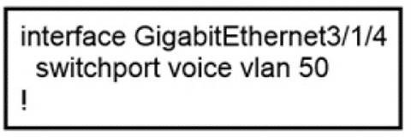
An administrator is tasked with configuring a voice VLAN. What is the expected outcome when a Cisco phone is connected to the GigabitEfriemet3/1/4 port on a switch?

- The phone and a workstation that is connected to the phone do not have VLAN connectivity
- The phone and a workstation that is connected to the phone send and receive data in VLAN 50.

- The phone sends and receives data in VLAN 50, but a workstation connected to the phone has no VLAN connectivity
- The phone sends and receives data in VLAN 50, but a workstation connected to the phone sends and receives data in VLAN 1

Answer: D

NEW QUESTION 139
- (Topic 2)
An engineer must configure an OSPF neighbor relationship between router R1 and R3 The authentication configuration has been configured and the connecting interfaces are in the same 192.168 1.0/30 sublet. What are the next two steps to complete the configuration? (Choose two.)

- configure the hello and dead timers to match on both sides
- configure the same process ID for the router OSPF process
- configure the same router ID on both routing processes
- Configure the interfaces as OSPF active on both sides.
- configure both interfaces with the same area ID

Answer: AE

NEW QUESTION 144
- (Topic 2)
What are two reasons for an engineer to configure a floating state route? (Choose two)

- to automatically route traffic on a secondary path when the primary path goes down
- to route traffic differently based on the source IP of the packet
- to enable fallback static routing when the dynamic routing protocol fails
- to support load balancing via static routing
- to control the return path of traffic that is sent from the router

Answer: AC

NEW QUESTION 148
- (Topic 2)
When OSPF learns multiple paths to a network, how does it select a route?

- It multiple the active K value by 256 to calculate the route with the lowest metric.
- For each existing interface, it adds the metric from the source router to the destination to calculate the route with the lowest bandwidth.
- It divides a reference bandwidth of 100 Mbps by the actual bandwidth of the existing interface to calculate the router with the lowest cost.
- It count the number of hops between the source router and the destination to determine the router with the lowest metric

Answer: C

NEW QUESTION 149
- (Topic 2)
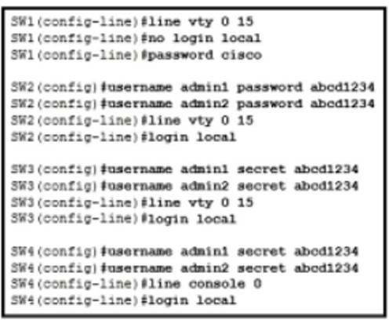
Refer to the exhibit.
An administrator configures four switches for local authentication using passwords that are stored in a cryptographic hash. The four switches must also support SSH access for administrators to manage the network infrastructure. Which switch is configured correctly to meet these requirements?

- SW1
- SW2
- SW3
- SW4

Answer: C

NEW QUESTION 150
- (Topic 2)
When a site-to-site VPN is used, which protocol is responsible for the transport of user data?

- IKEv2
- IKEv1
- IPsec
- MD5

Answer: C

Explanation:
A site-to-site VPN allows offices in multiple fixed locations to establish secure connections with each other over a public network such as the Internet. A site-to-site VPN means that two sites create a VPN tunnel by encrypting and sending data between two devices. One set of rules for creating a siteto-site VPN is defined by IPsec.

NEW QUESTION 152
DRAG DROP - (Topic 2)
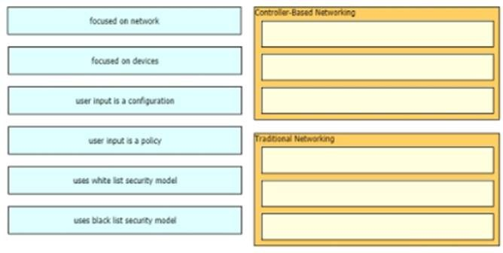
Drag and drop to the characteristics of networking from the left onto the correct networking types on the right.

- Mastered
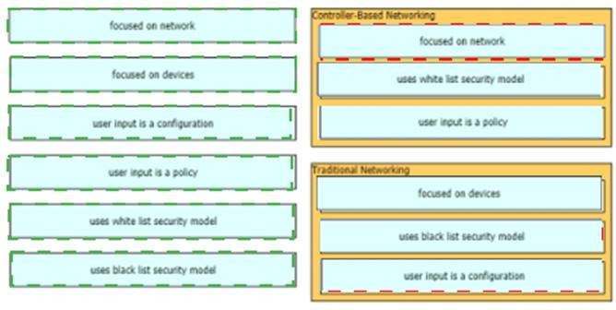
- Not Mastered Answer: A Explanation:

NEW QUESTION 153
- (Topic 2)
Which statement about Link Aggregation when implemented on a Cisco Wireless LAN Controller is true?

- To pass client traffic two or more ports must be configured.
- The EtherChannel must be configured in "mode active"
- When enabled the WLC bandwidth drops to 500 Mbps
- One functional physical port is needed to pass client traffic

Answer: D

Explanation:
Reference: https://www.cisco.com/c/en/us/td/docs/wireless/controller/8-2/config-guide/b_cg82/b_cg82_chapter_010101011.html

NEW QUESTION 157
- (Topic 2)
Which two values or settings must be entered when configuring a new WLAN in the Cisco Wireless LAN Controller GUI? (Choose two)

- management interface settings
- QoS settings
- Ip address of one or more access points
- SSID
- Profile name

Answer: DE

NEW QUESTION 160
- (Topic 2)
What is a function of TFTP in network operations?

- transfers a backup configuration file from a server to a switch using a username and password
- transfers files between file systems on a router
- transfers a configuration files from a server to a router on a congested link
- transfers IOS images from a server to a router for firmware upgrades

Answer: D

Explanation:
TFTP is mostly used (Firmware upgrade) whereby the admin have the IOS image on one device and uses TFTP to load the image to all other devices quickly.

NEW QUESTION 165
- (Topic 2)
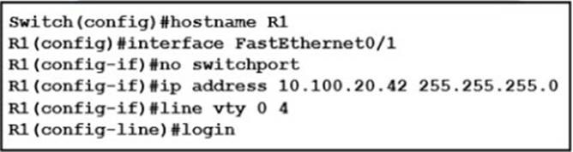
Refer to the exhibit.
An engineer booted a new switch and applied this configuration via the console port. Which additional configuration must be applied to allow administrators to authenticate directly to enable privilege mode via Telnet using a local username and password?
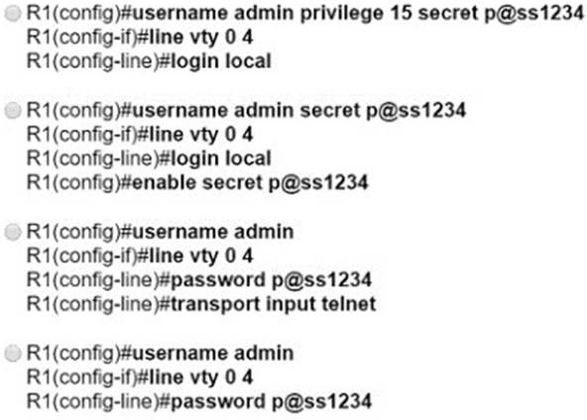

- Option A
- Option B
- Option C
- Option D

Answer: A

NEW QUESTION 170
- (Topic 2)
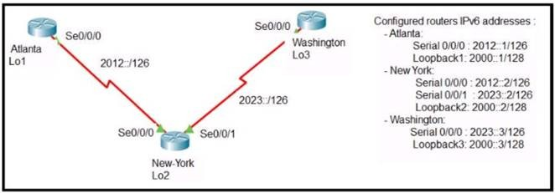
Refer to the exhibit.
The New York router is configured with static routes pointing to the Atlanta and Washington sites. Which two tasks must be performed so that the Serial0/0/0 interfaces on the Atlanta and Washington routers can reach one another?
(Choose two.)

- Configure the ipv6 route 2012::/126 2023::1 command on the Washington router.
- Configure the ipv6 route 2023::/126 2012::1 command on the Atlanta router.
- Configure the Ipv6 route 2012::/126 s0/0/0 command on the Atlanta router.
- Configure the ipv6 route 2023::/126 2012::2 command on the Atlanta router.
- Configure the ipv6 route 2012::/126 2023::2 command on the Washington router.

Answer: DE

Explanation:
The short syntax of static IPv6 route is:ipv6 route <destination-IPv6-address>
{next-hop-IPv6-address | exit-interface}

NEW QUESTION 171
- (Topic 2)
Which action is taken by a switch port enabled for PoE power classification override?

- When a powered device begins drawing power from a PoE switch port a syslog message is generated
- As power usage on a PoE switch port is checked data flow to the connected device is temporarily paused
- If a switch determines that a device is using less than the minimum configured power it assumes the device has failed and disconnects
- Should a monitored port exceeds the maximum administrative value for power, the port is shutdown and err-disabled

Answer: D

Explanation:
Reference: https://www.cisco.com/c/en/us/td/docs/switches/lan/catalyst6500/ios/12-2SX/configuration/guide/book/power_over_ethernet.pdf
PoE monitoring and policing compares the power consumption on ports with the administrative maximum value (either a configured maximum value or the port’s default value). If the power consumption on a monitored port exceeds the administrative maximum value, the following actions occur:– A syslog message is issued.– The monitored port is shut down and error-disabled.– The allocated power is freed.

NEW QUESTION 172
- (Topic 2)
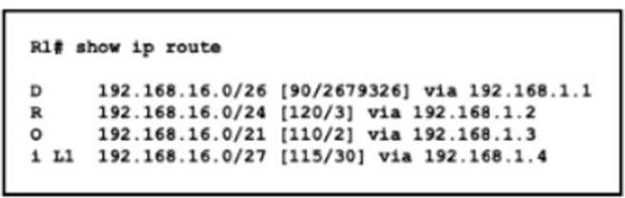
Refer to the exhibit.
Which route does R1 select for traffic that is destined to 192 168.16.2?

- 192.168.16.0/21
- 192.168.16.0/24
- 192.168 26.0/26
- 192.168.16.0/27

Answer: D

Explanation:
The destination IP addresses match all four entries in the routing table but the 192.168.16.0/27 has the longest prefix so it will be chosen. This is called the “longest prefix match” rule.

NEW QUESTION 175
- (Topic 2)
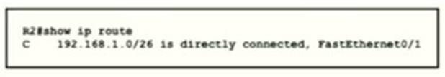
Refer to the exhibit.
Which two prefixes are included in this routing table entry? (Choose two.)

- 192.168.1.17
- 192.168.1.61
- 192.168.1.64
- 192.168.1.127
- 192.168.1.254

Answer: BC

NEW QUESTION 177
- (Topic 2)
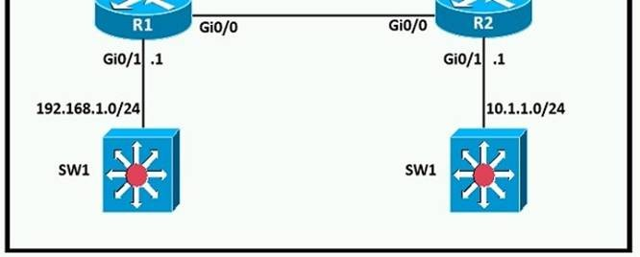
Refer to the exhibit.
A network engineer is in the process of establishing IP connectivity between two sites. Routers R1 and R2 are partially configured with IP addressing. Both routers have the ability to access devices on their respective LANs. Which command set configures the IP connectivity between devices located on both LANs in each site?
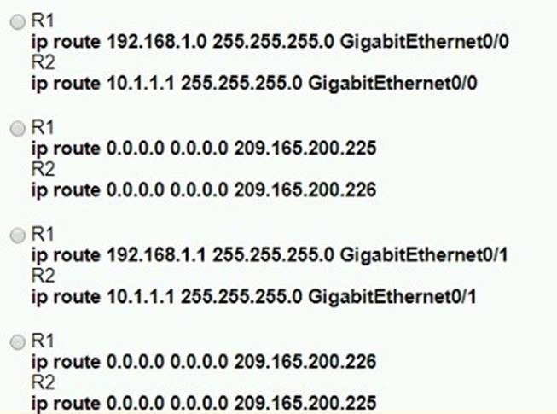

- Option A
- Option B
- Option C
- Option D

Answer: D

NEW QUESTION 181
DRAG DROP - (Topic 2)
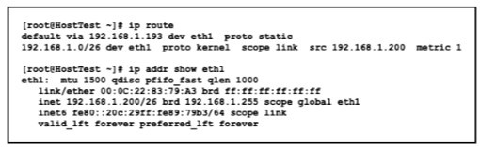
Refer to the exhibit.
Drag and drop the networking parameters from the left onto the correct values on the right.
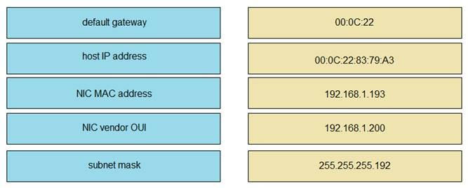

- Mastered
- Not Mastered

Answer: A

Explanation:
NIC vendor OUI –> 00:0C:22NIC MAC address –> 00:0C:22:83:79:A3default gateway –>192.168.1.193host IP address –> 192.168.1.200subnet mask –> 255.255.255.192
The “ip route” and “ip addr show eth1” are Linux commands.+ “ip route”: display the routing table+ “ip addr show eth1”: get depth information (only on eth1 interface) about your network interfaces like IP Address, MAC Address information

NEW QUESTION 182
- (Topic 2)
What are two benefits of FHRPs? (Choose two.)

- They prevent (oops in the Layer 2 network.
- They allow encrypted traffic.
- They are able to bundle muftlple ports to increase bandwidth
- They enable automatic failover of the default gateway.
- They allow multiple devices lo serve as a single virtual gateway for clients in the network

Answer: DE

NEW QUESTION 185
- (Topic 2)
What is a characteristic of private IPv4 addressing?

- traverse the Internet when an outbound ACL is applied
- issued by IANA in conjunction with an autonomous system number
- composed of up to 65.536 available addresses
- used without tracking or registration

Answer: D

NEW QUESTION 190
- (Topic 2)
What are two characteristics of a public cloud Implementation? (Choose two.)

- It is owned and maintained by one party, but it is shared among multiple organizations.
- It enables an organization to fully customize how It deploys network resources.
- It provides services that are accessed over the Internet.
- It Is a data center on the public Internet that maintains cloud services for only one company.
- It supports network resources from a centralized third-party provider and privately- owned virtual resources

Answer: CE

Explanation:

Private cloud is cloud infrastructure operated solely for a single organization, whether managed internally or by a third party, and hosted either internally or externally. Most public-cloud providers offer direct-connection services that allow customers to securely link their legacy data centers to their cloud-resident applications.

NEW QUESTION 192
- (Topic 2)
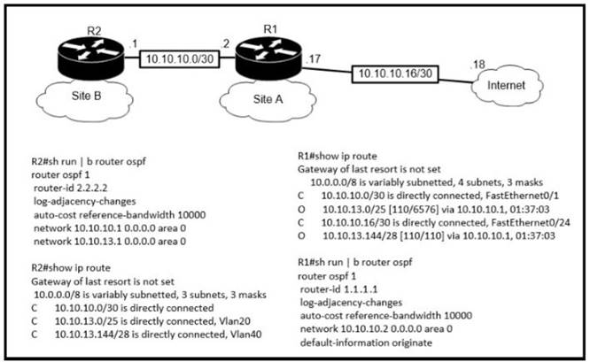
Refer to the exhibit.
The default-information originate command is configured under the R1 OSPF configuration After testing workstations on VLAN 20 at Site B cannot reach a DNS server on the Internet Which action corrects the configuration issue?

- Add the default-information originate command onR2
- Configure the ip route 0.0.0.0 0.0.0.0 10.10.10.18 command on R1
- Configure the ip route 0.0.0.0 0.0.0.0 10.10.10.2 command on R2
- Add the always keyword to the default-information originate command on R1

Answer: B

NEW QUESTION 194
- (Topic 2)
Which configuration is needed to generate an RSA key for SSH on a router?

- Configure the version of SSH
- Configure VTY access.
- Create a user with a password.
- Assign a DNS domain name

Answer: D

NEW QUESTION 197
- (Topic 2)
A user configured OSPF and advertised the Gigabit Ethernet interface in OSPF By default, which type of OSPF network does this interface belong to?

- point-to-multipoint
- point-to-point
- broadcast
- nonbroadcast

Answer: C

Explanation:
https://www.oreilly.com/library/view/cisco-ios- cookbook/0596527225/ch08s15.html
The Broadcast network type is the default for an OSPF enabled ethernet interface (while Point-toPoint is the default OSPF network type for Serial interface with HDLC and PPP encapsulation).

NEW QUESTION 200
- (Topic 2)
What is the effect when loopback interfaces and the configured router ID are absent during the OSPF Process configuration?

- No router ID is set, and the OSPF protocol does not run.
- The highest up/up physical interface IP address is selected as the router ID.
- The lowest IP address is incremented by 1 and selected as the router ID.
- The router ID 0.0.0.0 is selected and placed in the OSPF process.

Answer: B

NEW QUESTION 201
- (Topic 2)
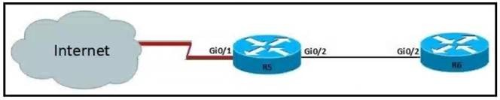
Refer to the exhibit.
For security reasons, automatic neighbor discovery must be disabled on the R5 Gi0/1 interface. These tasks must be completed:
- Disable all neighbor discovery methods on R5 interface GiO/1.
- Permit neighbor discovery on R5 interface GiO/2.
- Verify there are no dynamically learned neighbors on R5 interface Gi0/1.
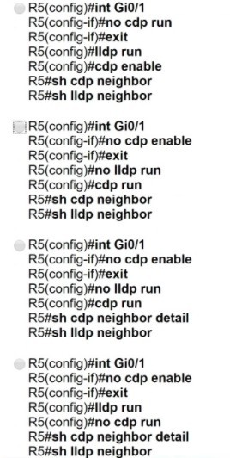
- Display the IP address of R6*s interface Gi0/2. Which configuration must be used?

- Option A
- Option B
- Option C
- Option D

Answer: C

NEW QUESTION 204
- (Topic 2)
Refer to the exhibit.

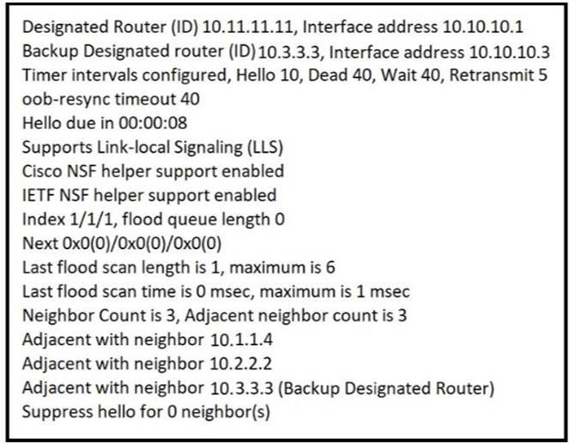
The show ip ospf interface command has been executed on R1 How is OSPF configured?

- The interface is not participating in OSPF
- A point-to-point network type is configured
- The default Hello and Dead timers are in use
- There are six OSPF neighbors on this interface

Answer: C

Explanation:
https://www.cisco.com/c/en/us/support/docs/ip/open-shortest-path-first- ospf/13689-17.html

NEW QUESTION 207
- (Topic 2)
What are two descriptions of three-tier network topologies? (Choose two)

- The core and distribution layers perform the same functions
- The access layer manages routing between devices in different domains
- The network core is designed to maintain continuous connectivity when devices fail.
- The core layer maintains wired connections for each host
- The distribution layer runs Layer 2 and Layer 3 technologies

Answer: CE

NEW QUESTION 208
- (Topic 2)
Which protocol prompts the Wireless LAN Controller to generate its own local web administration SSL certificate for GUI access?

- HTTPS
- RADIUS
- TACACS+
- HTTP

Answer: A

Explanation:
Reference: https://www.cisco.com/c/en/us/td/docs/wireless/controller/8-0/configuration-guide/b_cg80/b_cg80_chapter_011.html

NEW QUESTION 210
- (Topic 2)
Refer to the exhibit.

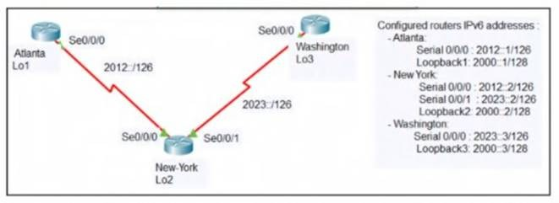
An engineer configured the New York router with state routes that point to the Atlanta and Washington sites. When command must be configured on the Atlanta and Washington routers so that both sites are able to reach the loopback2 interface on the New York router?

- ipv6 route ::/0 Serial 0/0/1
- ipv6 route 0/0 Serial 0/0/0
- ipv6 route ::/0 Serial 0/0/0
- ip route 0.0.0.0.0.0.0.0 Serial 0/0/0
- ipv6 route ::/0 2000::2

Answer: C

NEW QUESTION 211
- (Topic 2)
How do AAA operations compare regarding user identification, user services and access control?

- Authorization provides access control and authentication tracks user services
- Authentication identifies users and accounting tracks user services
- Accounting tracks user services, and authentication provides access control
- Authorization identifies users and authentication provides access control

Answer: B

NEW QUESTION 215
- (Topic 2)
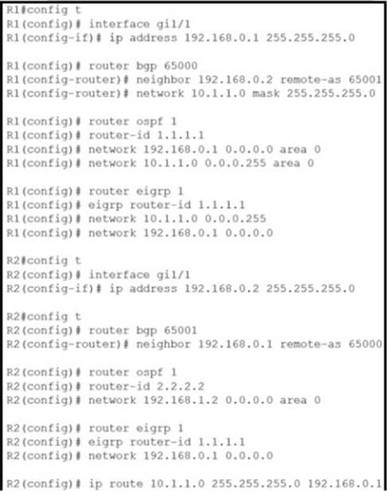
Refer to the exhibit.
Router R2 is configured with multiple routes to reach network 10 1.1 0/24 from router R1. What protocol is chosen by router R2 to reach the destination network
10.1 1 0/24?

- eBGP
- static
- OSPF
- EIGRP

Answer: B

NEW QUESTION 216
- (Topic 2)
Which type of traffic is sent with pure iPsec?

- broadcast packets from a switch that is attempting to locate a MAC address at one of several remote sites
- multicast traffic from a server at one site to hosts at another location
- spanning-tree updates between switches that are at two different sites
- unicast messages from a host at a remote site to a server at headquarters

Answer: D

Explanation:
“The original poster makes a correct observation that EIGRP does not work in a pure IPSEC environment. IPSEC was designed to process unicast traffic.

NEW QUESTION 218
- (Topic 2)
Which condition must be met before an NMS handles an SNMP trap from an agent?

- The NMS software must be loaded with the MIB associated with the trap.
- The NMS must be configured on the same router as the SNMP agent
- The NMS must receive a trap and an inform message from the SNMP agent within a configured interval
- The NMS must receive the same trap from two different SNMP agents to verify that it is reliable.

Answer: A

NEW QUESTION 221
- (Topic 2)
Which mode must be set for APs to communicate to a Wireless LAN Controller using the Control and Provisioning of Wireless Access Points (CAPWAP) protocol?

- bridge
- route
- autonomous
- lightweight

Answer: D

NEW QUESTION 223
- (Topic 2)
The SW1 interface g0/1 is in the down/down state. Which two configurations are valid reasons for the interface conditions?(choose two)

- There is a duplex mismatch
- There is a speed mismatch
- There is a protocol mismatch
- The interface is shut down
- The interface is error-disabled

Answer: BE

NEW QUESTION 226
- (Topic 2)
An engineer must configure a WLAN using the strongest encryption type for WPA2- PSK. Which cipher fulfills the configuration requirement?

- WEP
- RC4
- AES
- TKIP

Answer: C

Explanation:
Many routers provide WPA2-PSK (TKIP), WPA2-PSK (AES), and WPA2- PSK (TKIP/AES) as options. TKIP is actually an older encryption protocol introduced with WPA to replace the very-insecure WEP encryption at the time. TKIP is actually quite similar to WEP encryption. TKIP is no longer considered secure, and is now deprecated. In other words, you shouldn’t be using it.
AES is a more secure encryption protocol introduced with WPA2 and it is currently the strongest encryption type for WPA2-PSK.

NEW QUESTION 231
- (Topic 2)
What Is a syslog facility?

- Host that is configured for the system to send log messages
- password that authenticates a Network Management System to receive log messages
- group of log messages associated with the configured severity level
- set of values that represent the processes that can generate a log message

Answer: C

Explanation:
Cisco Community – Difference between logging level and logging facility Post by ahmednaas
“The logging facility command basically tells the syslog server where to put the log message. You configure the syslog server with something like: local7.debug /var/adm/local7.log
Now, when you use the “logging facility local7” on your device, all messages with severity “debug” or greater should be saved in /var/adm/local7.log.” Example: on a switch, any process (CDP, SNMP, etc.) can generate a log message. On a syslog server, the logging facility is the place where all received messages with the same priority level are stored.

NEW QUESTION 235
- (Topic 2)
Which command must be entered when a device is configured as an NTP server?

- ntp authenticate
- ntp server
- ntp peer
- ntp master

Answer: D

Explanation:
To configure a Cisco device as an Authoritative NTP Server, use the ntp master [stratum] command.To configure a Cisco device as a NTP client, use the command ntp server <IP address>. For example:Router(config)#ntp server 192.168.1.1. This command will instruct the router to query 192.168.1.1 for the time.

NEW QUESTION 238
DRAG DROP - (Topic 2)
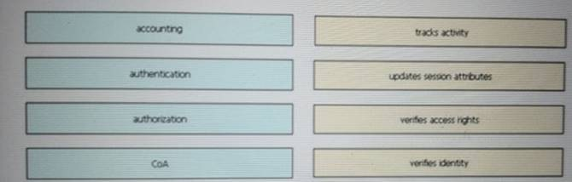
Drag and drop the AAA terms from the left onto the description on the right.

- Mastered
- Not Mastered

Answer: A

Explanation:
1-1, 2-4, 3-3, 4-2

NEW QUESTION 240
- (Topic 2)
When a WPA2-PSK WLAN is configured in the wireless LAN Controller, what is the minimum number of characters that in ASCll format?

- 6
- 8
- 12
- 18

Answer: B

NEW QUESTION 242
- (Topic 2)
Refer to the exhibit.

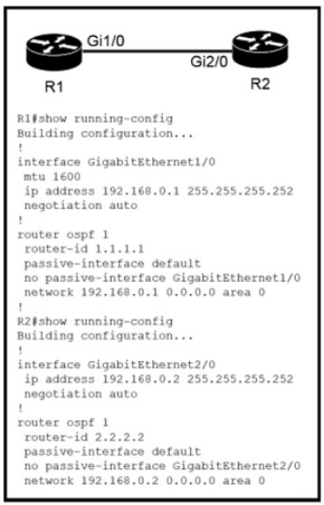
Which configuration issue is preventing the OSPF neighbor relationship from being established between the two routers?

- R2 is using the passive-interface default command
- R1 has an incorrect network command for interface Gi1/0
- R2 should have its network command in area 1
- R1 interface Gil/0 has a larger MTU size

Answer: D

NEW QUESTION 246
- (Topic 2)
What are two characteristics of an SSID? (Choose Two)

- It can be hidden or broadcast in a WLAN
- It uniquely identifies an access point in a WLAN
- It uniquely identifies a client in a WLAN
- It is at most 32 characters long.
- IT provides secured access to a WLAN

Answer: BE

NEW QUESTION 249
- (Topic 2)
An administrator must secure the WLC from receiving spoofed association requests. Which steps must be taken to configure the WLC to restrict the requests and force the user to wait 10 ms to retry an association request?

- Enable Security Association Teardown Protection and set the SA Query timeout to 10
- Enable MAC filtering and set the SA Query timeout to 10
- Enable 802.1x Layer 2 security and set me Comeback timer to 10
- Enable the Protected Management Frame service and set the Comeback timer to 10

Answer: C

NEW QUESTION 252
- (Topic 2)
Refer to the exhibit.

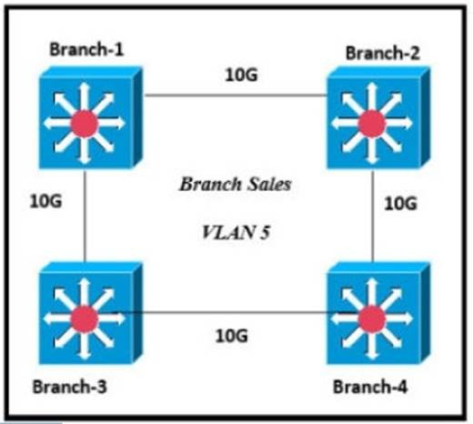
Only four switches are participating in the VLAN spanning-tree process. Branch-1 priority 614440
Branch-2: priority 39082416
Branch-3: priority 0 Branch-4: root primary
Which switch becomes the permanent root bridge for VLAN 5?

- Branch-1
- Branch-2
- Branch-3
- Branch-4

Answer: C

Explanation:
Dynamic ARP inspection is an ingress security feature; it does not perform any egress checking.

NEW QUESTION 254
- (Topic 2)
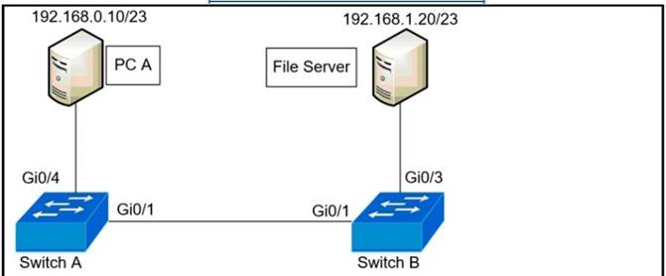
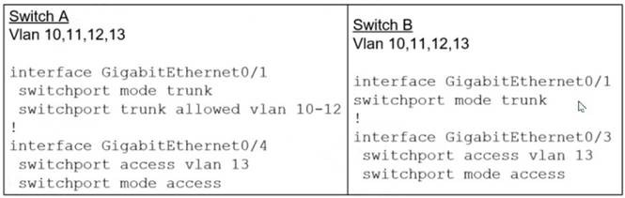
Refer to the exhibit.
A network administrator assumes a task to complete the connectivity between PC A and the File Server. Switch A and Switch B have been partially configured with VLAN 10, 11, 12, and 13. What is the next step in the configuration?

- Add PC A to VLAN 10 and the File Server to VLAN 11 fa VLAN segmentation

- Add VLAN 13 to the trunk links on Switch A and Switch B for VLAN propagation
- Add a router on a stick between Switch A and Switch B allowing for Inter-VLAN routing.
- Add PC A to the same subnet as the Fie Server allowing for intra-VLAN communication.

Answer: B

NEW QUESTION 257
- (Topic 2)
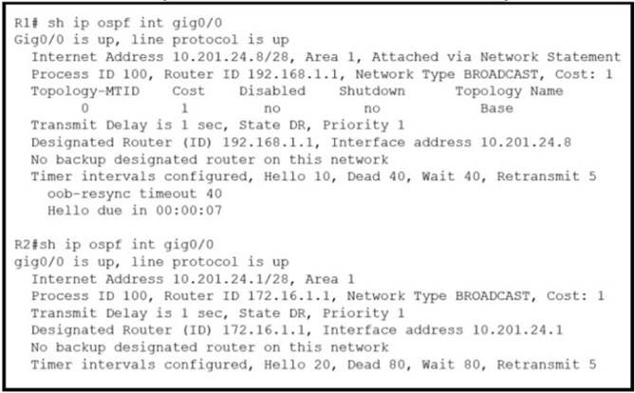
Refer to the exhibit.
What action establishes the OSPF neighbor relationship without forming an adjacency?

- modify hello interval
- modify process ID
- modify priority
- modify network type

Answer: A

NEW QUESTION 258
- (Topic 2)
Which 802.11 frame type is indicated by a probe response after a client sends a probe request?

- action
- management
- control
- data

Answer: B

NEW QUESTION 259
- (Topic 2)
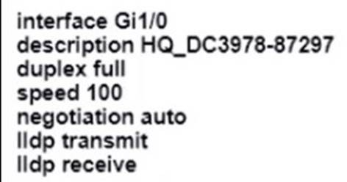
An engineer configures interface Gi1/0 on the company PE router to connect to an ISP Neighbor discovery is disabled
Which action is necessary to complete the configuration if the ISP uses third-party network devices?

- Enable LLDP globally
- Disable autonegotiation
- Disable Cisco Discovery Protocol on the interface
- Enable LLDP-MED on the ISP device

Answer: D

NEW QUESTION 262
- (Topic 2)
What benefit does controller-based networking provide versus traditional networking?

- moves from a two-tier to a three-tier network architecture to provide maximum redundancy
- provides an added layer of security to protect from DDoS attacks
- allows configuration and monitoring of the network from one centralized port
- combines control and data plane functionality on a single device to minimize latency

Answer: C

NEW QUESTION 265
- (Topic 2) Refer to Exhibit.
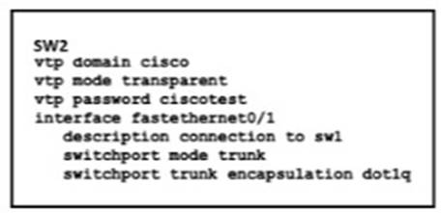
How does SW2 interact with other switches in this VTP domain?

- It processes VTP updates from any VTP clients on the network on its access ports.
- It receives updates from all VTP servers and forwards all locally configured VLANs out all trunk ports
- It forwards only the VTP advertisements that it receives on its trunk ports.
- It transmits and processes VTP updates from any VTP Clients on the network on its trunk ports

Answer: C

Explanation:
Reference: https://www.cisco.com/c/en/us/support/docs/lan-switching/vtp/10558-21.html
The VTP mode of SW2 is transparent so it only forwards the VTP updates it receives to its trunk links without processing them.

NEW QUESTION 270
- (Topic 2)
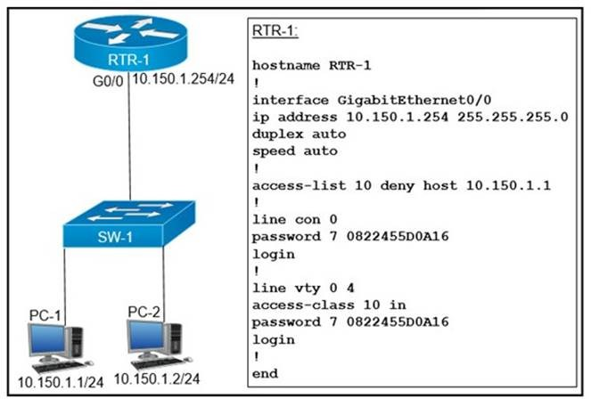
Refer to the exhibit.
An access list is created to deny Telnet access from host PC-1 to RTR-1 and allow access from all other hosts A Telnet attempt from PC-2 gives this message:"% Connection refused by remote host" Without allowing Telnet access from PC-1, which action must be taken to permit the traffic?

- Add the access-list 10 permit any command to the configuration
- Remove the access-class 10 in command from line vty 0.4.
- Add the ip access-group 10 out command to interface g0/0.

- Remove the password command from line vty 0 4.

Answer: A

NEW QUESTION 271
- (Topic 2)
Which two primary drivers support the need for network automation? (Choose two.)

- Eliminating training needs
- Increasing reliance on self-diagnostic and self-healing
- Policy-derived provisioning of resources
- Providing a ship entry point for resource provisioning
- Reducing hardware footprint

Answer: CD

NEW QUESTION 275
- (Topic 2)
What Is the path for traffic sent from one user workstation to another workstation on a separate switch In a Ihree-lter architecture model?

- access - core - distribution - access
- access - distribution - distribution - access
- access - core - access
- access -distribution - core - distribution - access

Answer: D

NEW QUESTION 276
DRAG DROP - (Topic 2)
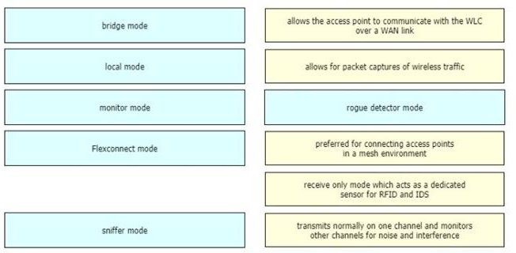
Drag and drop the lightweight access point operation modes from the left onto the descriptions on the right

- Mastered
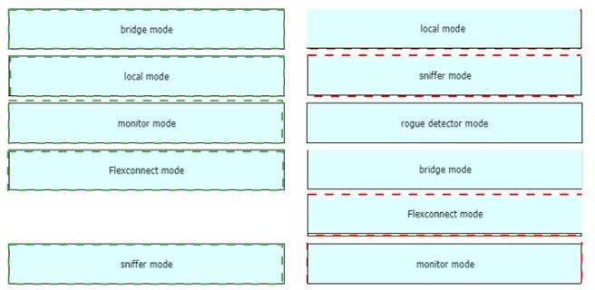
- Not Mastered Answer: A Explanation:

NEW QUESTION 278
- (Topic 2)
Where is the interface between the control plane and data plane within the software- defined architecture?

- control layer and the infrastructure layer
- application layer and the infrastructure layer
- application layer and the management layer
- control layer and the application layer

Answer: A

NEW QUESTION 281
- (Topic 2)
What is the function of a server?

- It transmits packets between hosts in the same broadcast domain.
- It provides shared applications to end users.
- It routes traffic between Layer 3 devices.
- It Creates security zones between trusted and untrusted networks

Answer: B

NEW QUESTION 284
- (Topic 2)
Which JSON data type is an unordered set of attribute- value pairs?

- array
- string
- object
- Boolean

Answer: C

NEW QUESTION 287
- (Topic 2)
What are two characteristics of a controller-based network? (Choose two)

- The administrator can make configuration updates from the CLI
- It uses northbound and southbound APIs to communicate between architectural layers
- It moves the control plane to a central point.
- It decentralizes the control plane, which allows each device to make its own forwarding decisions
- It uses Telnet to report system issues.

Answer: BC

NEW QUESTION 291
- (Topic 2)
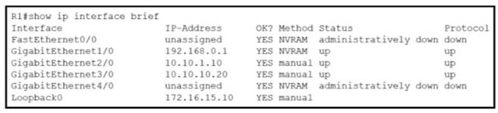
Refer to the exhibit.
What does router R1 use as its OSPF router-ID?

- 10.10.1.10
- 10.10.10.20
- 172.16.15.10
- 192.168.0.1

Answer: C

Explanation:
OSPF uses the following criteria to select the router ID:1. Manual configuration of the router ID (via the “router-id x.x.x.x” command under OSPF router configuration mode).2. Highest IP address on a loopback interface.3. Highest IP address on a non-loopback and active (no shutdown) interface.

NEW QUESTION 293
- (Topic 2)
What is the purpose of an SSID?

- It provides network security
- It differentiates traffic entering access posits
- It identities an individual access point on a WLAN

- It identifies a WLAN

Answer: D

Explanation:
“In IEEE 802.11 wireless local area networking standards (including Wi-Fi), a service set is a group of wireless network devices which share a service set identifier (SSID)… A service set forms a logical network of nodes operating with shared link-layer networking parameters; they form one logical network segment.“

NEW QUESTION 297
- (Topic 2)
Which type of organization should use a collapsed-core architecture?

- large and requires a flexible, scalable network design
- large and must minimize downtime when hardware fails
- small and needs to reduce networking costs currently
- small but is expected to grow dramatically in the near future

Answer: C

Explanation:
A collapsed-core architecture is a limited investment for a small company, and may be efficient and productive for a limited time.

NEW QUESTION 301
- (Topic 2)
An organization secures its network with multi-factor authentication using an authenticator app on employee smartphone. How is the application secured in the case of a user’s smartphone being lost or stolen?

- The application requires an administrator password to reactivate after a configured Interval.
- The application requires the user to enter a PIN before it provides the second factor.
- The application challenges a user by requiring an administrator password to reactivate when the smartphone is rebooted.
- The application verifies that the user is in a specific location before it provides the second factor.

Answer: B

NEW QUESTION 304
- (Topic 2)
What are two recommendations for protecting network ports from being exploited when located in an office space outside of an IT closer? (Choose two.)

- enable the PortFast feature on ports
- implement port-based authentication
- configure static ARP entries
- configure ports to a fixed speed
- shut down unused ports

Answer: BE

NEW QUESTION 307
- (Topic 2)
Which IPv6 address type provides communication between subnets and is unable to route on the Internet?

- global unicast
- unique local
- link-local
- multicast

Answer: B

NEW QUESTION 310
- (Topic 2)
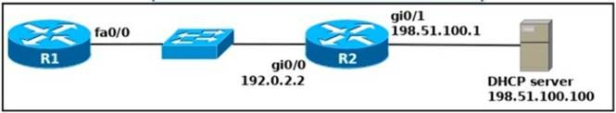
Refer to the exhibit.
An engineer deploys a topology in which R1 obtains its IP configuration from DHCP. If the switch and DHCP server configurations are complete and correct. Which two sets of
commands must be configured on R1 and R2 to complete the task? (Choose two)

- R1(config)# interface fa0/0R1(config-if)# ip helper-address 198.51.100.100
- R2(config)# interface gi0/0R2(config-if)# ip helper-address 198.51.100.100
- R1(config)# interface fa0/0 R1(config-if)# ip address dhcp R1(config-if)# no shutdown
- R2(config)# interface gi0/0 R2(config-if)# ip address dhcp
- R1(config)# interface fa0/0R1(config-if)# ip helper-address 192.0.2.2

Answer: BC

NEW QUESTION 311
- (Topic 2)
An engineer needs to configure LLDP to send the port description time length value (TLV). What command sequence must be implemented?

- switch(config-line)#IIdp port-description
- switch(config)#IIdp port-description
- switch(config-if)#IIdp port-description
- switch#IIdp port-description

Answer: B

NEW QUESTION 315
DRAG DROP - (Topic 2)
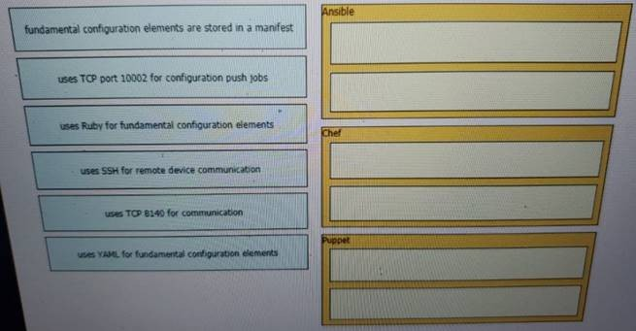
Drag and drop the descriptions from the left onto the configuration-management technologies on the right.

- Mastered
- Not Mastered

Answer: A

Explanation:
Ansible:– uses SSH for remote device communication– uses YAML for fundamental configuration elements Chef:– uses TCP port 10002 for configuration push jobs– uses Ruby for fundamental configuration elements Puppet:– fundamental configuration elements are stored in a manifest– uses TCP 8140 for communication
The focus of Ansible is to be streamlined and fast, and to require no node agent installation.Thus, Ansible performs all functions over SSH. Ansible is built on Python, in contrast to the Ruby foundation of Puppet and Chef.TCP port 10002 is the command port. It may be configured in the Chef Push Jobs configuration file
.This port allows Chef Push Jobs clients to communicate with the Chef Push Jobs server.Puppet is an open-source configuration management solution, which is built with Ruby and offers custom Domain Specific Language (DSL) and Embedded Ruby (ERB) templates to create custom Puppet language files, offering a declarative-paradigm programming approach.A Puppet piece of code is called a manifest, and is a file with .pp extension.

NEW QUESTION 320
- (Topic 1)
When using Rapid PVST+, which command guarantees the switch is always the root bridge for VLAN 200?

- spanning -tree vlan 200 priority 614440
- spanning -tree vlan 200 priority 38572422
- spanning -tree vlan 200 priority 0
- spanning -tree vlan 200 root primary

Answer: C

NEW QUESTION 324
- (Topic 1)

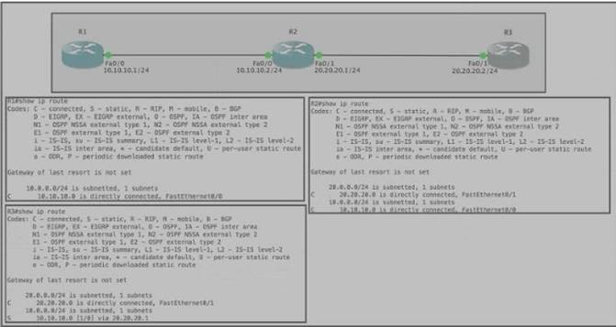
Refer to the exhibit Router R1 Fa0/0 is unable to ping router R3 Fa0'1. Which action must be taken in router R1 to help resolve the configuration issue?

- set the default network as 20.20.20.0/24
- set the default gateway as 20.20.20.2
- configure a static route with Fa0/1 as the egress interface to reach the 20.20.20.0/24 network
- configure a static route with 10.10.10.2 as the next hop to reach the 20.20.20.0/24 network

Answer: D

NEW QUESTION 326
- (Topic 1)
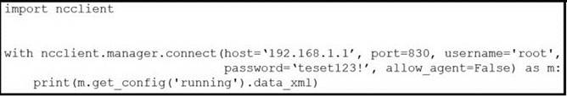
Refer to the exhibit.
After running the code in the exhibit, which step reduces the amount of data that the NETCONF server returns to the NETCONF client, to only the interface's configuration?

- Use the Ixml library to parse the data returned by the NETCONF server for the interface's configuration.
- Create an XML filter as a string and pass it to get_config() method as an argument.
- Create a JSON filter as a string and pass it to the get_config() method as an argument.
- Use the JSON library to parse the data returned by the NETCONF server for the interface's configuration.

Answer: D

NEW QUESTION 328
- (Topic 1)
An engineering team asks an implementer to configure syslog for warning conditions and error conditions. Which command does the implementer configure to achieve the desired result?

- logging trap 5
- logging trap 2
- logging trap 4
- logging trap 3

Answer: C

NEW QUESTION 330
- (Topic 1)
Which type of information resides on a DHCP server?

- a list of the available IP addresses in a pool
- a list of public IP addresses and their corresponding names
- usernames and passwords for the end users in a domain
- a list of statically assigned MAC addresses

Answer: A

NEW QUESTION 333
- (Topic 1)
Two switches are connected and using Cisco Dynamic Trunking Protocol SW1 is set to Dynamic Desirable What is the result of this configuration?

- The link is in a down state.
- The link is in an error disables state
- The link is becomes an access port.
- The link becomes a trunk port.

Answer: D

NEW QUESTION 338
- (Topic 1)
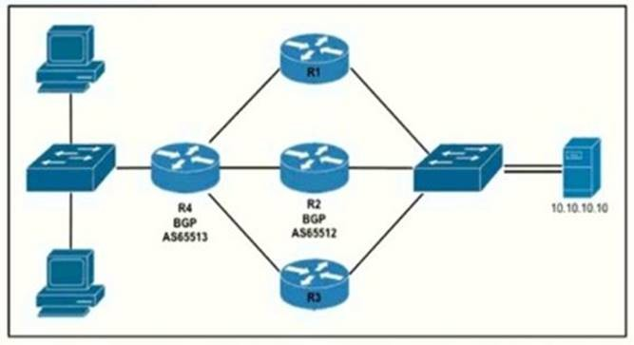
Refer to the exhibit.
Router R4 is dynamically learning the path to the server. If R4 is connected to R1 via OSPF Area 20, to R2 v2ia R2 BGP, and to R3 via EIGRP 777, which path is installed in the routing table of R4?

- the path through R1, because the OSPF administrative distance is 110
- the path through R2. because the IBGP administrative distance is 200
- the path through R2 because the EBGP administrative distance is 20
- the path through R3. because the EIGRP administrative distance is lower than OSPF and BGP

Answer: C

NEW QUESTION 341
- (Topic 1)
Which WAN access technology is preferred for a small office / home office architecture?

- broadband cable access
- frame-relay packet switching
- dedicated point-to-point leased line
- Integrated Services Digital Network switching.

Answer: A

NEW QUESTION 342
- (Topic 1)
Refer to the exhibit.

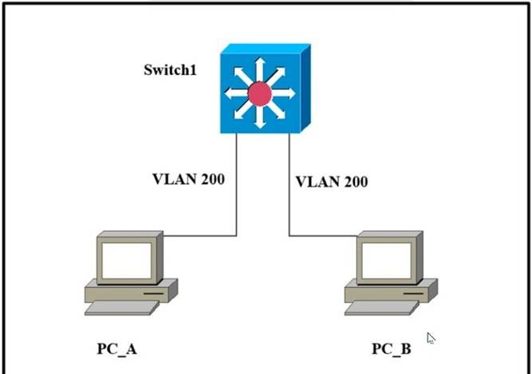
Which outcome is expected when PC_A sends data to PC_B?

- The switch rewrites the source and destination MAC addresses with its own.
- The source MAC address is changed.
- The source and destination MAC addresses remain the same.
- The destination MAC address is replaced with ffff.ffff.ffff.

Answer: C

NEW QUESTION 344
DRAG DROP - (Topic 1)
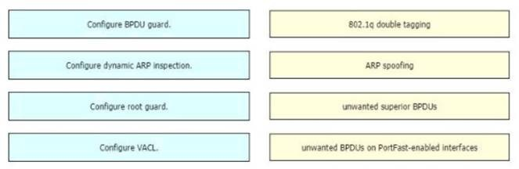
Drag and drop the threat-mitigation techniques from the left onto the types of threat or attack they mitigate on the right.

- Mastered
- Not Mastered

Answer: A

Explanation:
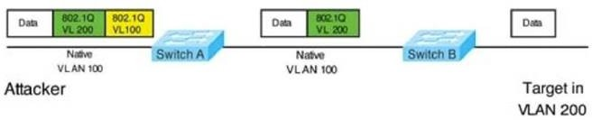
Double-Tagging attack:
In this attack, the attacking computer generates frames with two 802.1Q tags. The first tag matches the native VLAN of the trunk port (VLAN 10 in this case), and the second matches the VLAN of a host it wants to attack (VLAN 20).When the packet from the attacker reaches Switch A, Switch A only sees the first VLAN 10 and it matches with its native VLAN 10 so this VLAN tag is removed. Switch A forwards the frame out all links with the same native VLAN 10. Switch B receives the frame with an tag of VLAN 20 so it removes this tag and forwards out to the Victim computer.Note: This attack only works if the trunk (between two switches) has the same native VLAN as the attacker.To mitigate this type of attack, you can use VLAN access control lists (VACLs, which applies to all traffic within a VLAN. We can use VACL to drop attacker traffic to specific victims/servers) or implement Private VLANs.ARP attack (like ARP poisoning/spoofing) is a type of attack in which a malicious actor sends falsified ARP messages over a local area network as ARP allows a gratuitous reply from a host even if an ARP request was not received. This results in the linking of an attacker’s MAC address with the IP address of a legitimate computer or server on the network. This is an attack based on ARP which is at Layer 2.Dynamic ARP inspection (DAI) is a security feature that validates ARP packets in a network which can be used to mitigate this type of attack.

NEW QUESTION 348
- (Topic 1)
What are two roles of the Dynamic Host Configuration Protocol (DHCP)? (Choose two)

- The DHCP server offers the ability to exclude specific IP addresses from a pool of IP addresses
- The DHCP client can request up to four DNS server addresses
- The DHCP server assigns IP addresses without requiring the client to renew them
- The DHCP server leases client IP addresses dynamically.
- The DHCP client maintains a pool of IP addresses it can assign.

Answer: AD

NEW QUESTION 353
- (Topic 1)
What are network endpoints?

- act as routers to connect a user to the service prowler network
- a threat to the network if they are compromised
- support inter-VLAN connectivity
- enforce policies for campus-wide traffic going to the internet

Answer: B

NEW QUESTION 357
- (Topic 1)
Which statement identifies the functionality of virtual machines?

- Virtualized servers run most efficiently when they are physically connected to a switch that is separate from the hypervisor
- The hypervisor can virtualize physical components including CP
- memory, and storage
- Each hypervisor can support a single virtual machine and a single software switch
- The hypervisor communicates on Layer 3 without the need for additional resources

Answer: B

NEW QUESTION 362
- (Topic 1)
Which implementation provides the strongest encryption combination for the wireless environment?

- WPA2 + AES
- WPA + AES
- WEP
- WPA + TKIP

Answer: A

NEW QUESTION 367
- (Topic 1)
In QoS, which prioritization method is appropriate for interactive voice and video?

- expedited forwarding
- traffic policing
- round-robin scheduling
- low-latency queuing

Answer: D

NEW QUESTION 368
- (Topic 1)
How do TCP and UDP differ in the way they provide reliability for delivery of packets?

- TCP is a connectionless protocol that does not provide reliable delivery of data, UDP is a connection-oriented protocol that uses sequencing to provide reliable delivery.
- TCP does not guarantee delivery or error checking to ensure that there is no corruption of data UDP provides message acknowledgement and retransmits data if lost.
- TCP provides flow control to avoid overwhelming a receiver by sending too many packets at once, UDP sends packets to the receiver in a continuous stream without checking for sequencing
- TCP uses windowing to deliver packets reliably; UDP provides reliable message transfer between hosts by establishing a three-way handshake

Answer: C

NEW QUESTION 370
- (Topic 1)
Which two minimum parameters must be configured on an active interface to enable OSPFv2 to operate? (Choose two)

- OSPF area
- OSPF MD5 authentication key

- iPv6 address
- OSPf process ID
- OSPf stub flag

Answer: AD

NEW QUESTION 372
- (Topic 1)
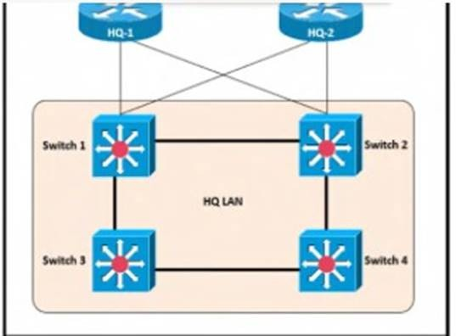
Refer to the exhibit.
After the election process what is the root bridge in the HQ LAN?
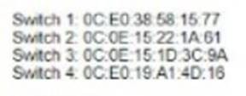

- Switch 1
- Switch 2
- Switch 3
- Switch 4

Answer: C

Explanation:
The root bridge is determined by the lowest bridge ID, which consists of the priority value and the MAC address. Because the priority values of all of the switches are not avalable, the MAC address is used to determine the root bridge. Because S3 has the lowest MAC address, S3 becomes the root bridge.

NEW QUESTION 377
- (Topic 1)
What uses HTTP messages to transfer data to applications residing on different hosts?

- OpenFlow
- OpenStack
- OpFlex
- REST

Answer: D

NEW QUESTION 382
- (Topic 1)
Refer to the exhibit.

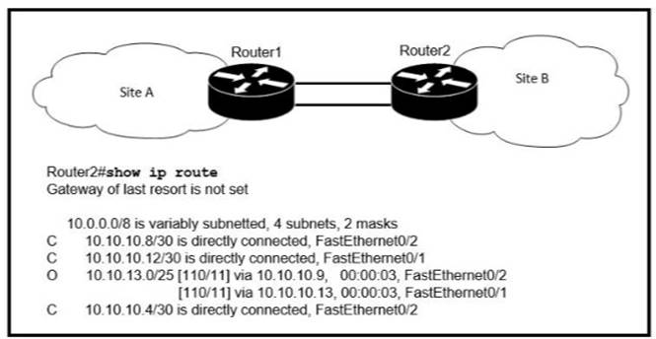
If OSPF is running on this network, how does Router 2 handle traffic from Site B to 10.10.13/25 at Site A?

- It sends packets out of interface Fa0/2 only.
- It sends packets out of interface Fa0/1 only.
- It cannot send packets to 10.10.13 128/25
- It load-balances traffic out of Fa0/1 and Fa0/2

Answer: C

Explanation:
Router2 does not have an entry for the subnet 10.10.13.128/25. It only has an entry for 10.10.13.0/25, which ranges from 10.10.13.0 to 10.10.13.127. https://study-ccna.com/administrative-distance-metric/

NEW QUESTION 383
- (Topic 1)
How does HSRP provide first hop redundancy?

- It load-balances traffic by assigning the same metric value to more than one route to the same destination m the IP routing table.
- It load-balances Layer 2 traffic along the path by flooding traffic out all interfaces configured with the same VLAN.
- It forwards multiple packets to the same destination over different routed links n the data path
- It uses a shared virtual MAC and a virtual IP address to a group of routers that serve as the default gateway for hosts on a LAN

Answer: D

Explanation:
https://www.cisco.com/c/en/us/td/docs/ios-xml/ios/ipapp_fhrp/configuration/xe-16/fhp-xe-16-book/fhp-hsrp-mgo.html

NEW QUESTION 388
- (Topic 1)
in Which way does a spine and-leaf architecture allow for scalability in a network when additional access ports are required?

- A spine switch and a leaf switch can be added with redundant connections between them
- A spine switch can be added with at least 40 GB uplinks
- A leaf switch can be added with a single connection to a core spine switch.
- A leaf switch can be added with connections to every spine switch

Answer: D

Explanation:
Spine-leaf architecture is typically deployed as two layers: spines (such as an aggregation layer), and leaves (such as an access layer). Spine-leaf topologies provide high-bandwidth, low-latency, nonblocking server-to-server connectivity.
Leaf (aggregation) switches are what provide devices access to the fabric (the network of spine and leaf switches) and are typically deployed at the top of the rack. Generally, devices connect to the leaf switches.
Devices can include servers, Layer 4-7 services (firewalls and load balancers), and WAN or Internet routers. Leaf switches do not connect to other leaf switches. In spine-and-leaf architecture, every leaf should connect to every spine in a full mesh.
Spine (aggregation) switches are used to connect to all leaf switches and are typically deployed at the end or middle of the row. Spine switches do not connect to other spine switches.

NEW QUESTION 392
- (Topic 1)
Which command on a port enters the forwarding state immediately when a PC is connected to it?

- switch(config)#spanning-tree portfast default
- switch(config)#spanning-tree portfast bpduguard default
- switch(config-if)#spanning-tree portfast trunk
- switch(config-if)#no spanning-tree portfast

Answer: C

NEW QUESTION 393
DRAG DROP - (Topic 1)
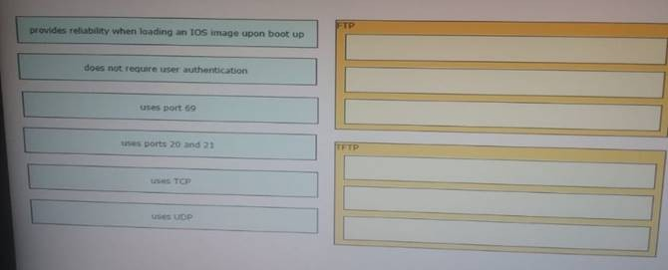
Drag and drop the descriptions of file-transfer protocols from the left onto the correct protocols on the right.

- Mastered
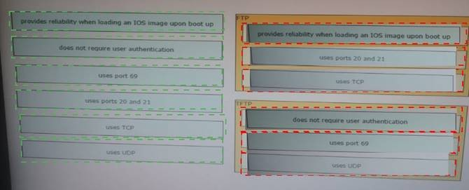
- Not Mastered Answer: A Explanation:

NEW QUESTION 396
- (Topic 1)
What is a network appliance that checks the state of a packet to determine whether the packet is legitimate?

- Layer 2 switch
- load balancer
- firewall
- LAN controller

Answer: C

NEW QUESTION 398
- (Topic 1)
What is an advantage of Cisco DNA Center versus traditional campus device management?

- It supports numerous extensibility options including cross-domain adapters and third- party SDKs.
- It supports high availability for management functions when operating in cluster mode.
- It enables easy autodiscovery of network elements m a brownfield deployment.
- It is designed primarily to provide network assurance.

Answer: A

NEW QUESTION 401
- (Topic 1)
which purpose does a northbound API serve in a controller-based networking architecture?

- communicates between the controller and the physical network hardware
- reports device errors to a controller
- generates statistics for network hardware and traffic
- facilitates communication between the controller and the applications

Answer: D

NEW QUESTION 403
- (Topic 1)
Which type of attack can be mitigated by dynamic ARP inspection?

- worm
- malware
- DDoS
- man-in-the-middle

Answer: D

NEW QUESTION 406
- (Topic 1)
Which mode must be used to configure EtherChannel between two switches without using a negotiation protocol?

- on
- auto
- active
- desirable

Answer: A

Explanation:
The Static Persistence (or “on” mode) bundles the links unconditionally and no negotiation protocol is used. In this mode, neither PAgP nor LACP packets are sent or received.

NEW QUESTION 411
- (Topic 1)
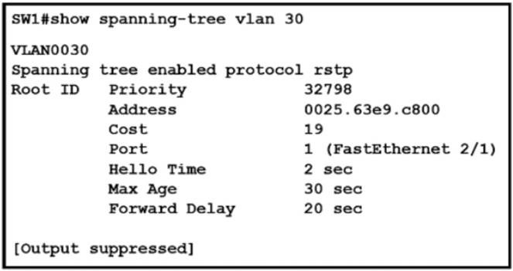
Refer to the exhibit.
What two conclusions should be made about this configuration? (Choose two )

- The designated port is FastEthernet 2/1
- This is a root bridge
- The spanning-tree mode is Rapid PVST+
- The spanning-tree mode is PVST+
- The root port is FastEthernet 2/1

Answer: CE

Explanation:
An engineer is configuring data and voice services to pass through the same port. The designated switch interface fastethernet0/1 must transmit packets using the same priority for data when they are received from the access port of the IP phone. Which configuration must be used?
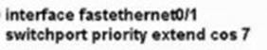
A)
B)
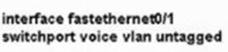
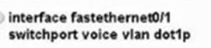
C)
D)

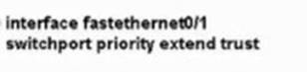
- Option A
- Option B
- Option C
- Option D Answer: A

NEW QUESTION 415
- (Topic 1)
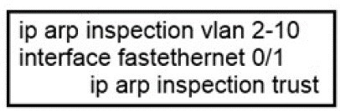
Refer to the exhibit.
If the network environment is operating normally, which type of device must be connected to interface FastEthernet 0/1?

- DHCP client
- access point
- router
- PC

Answer: C

NEW QUESTION 420
- (Topic 1)
Which command prevents passwords from being stored in the configuration as plain text on a router or switch?

- enable secret
- service password-encryption
- username Cisco password encrypt
- enable password

Answer: B

NEW QUESTION 421
- (Topic 1)
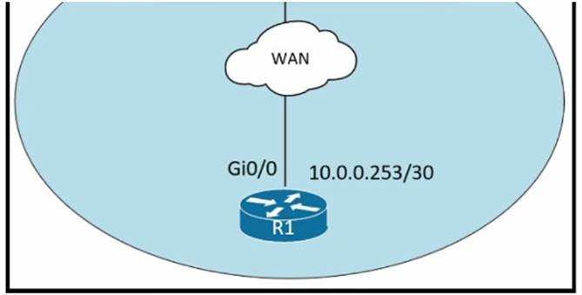
Refer to the exhibit.
An administrator must turn off the Cisco Discovery Protocol on the port configured with address last usable address in the 10.0.0.0/30 subnet. Which command set meets the requirement?

- interface gi0/1 no cdp enable
- interface gi0/1 clear cdp table
- interface gi0/0no cdp advertise-v2
- interface gi0/0 no cdp run

Answer: D

NEW QUESTION 425
- (Topic 1)
Which two encoding methods are supported by REST APIs? (Choose two)

- YAML
- JSON
- EBCDIC
- SGML
- XML

Answer: BE

Explanation:
https://www.cisco.com/c/en/us/td/docs/switches/datacenter/aci/apic/sw/2-x/rest_cfg/2_1_x/b_Cisco_APIC_REST_API_Configuration_Guide/b_Cisco_APIC_REST
_ API_Configuration_Guide_chapter_01.html Reference:
https://www.cisco.com/c/en/us/td/docs/switches/datacenter/nexus1000/sw/5_x/rest_api_co nfig/b_Cisco_N1KV_VMware_REST_API_Config_5x/b_Cisco_N1KV_VMware_REST_API
_Config_5x_chapter_010.pdf
The Application Policy Infrastructure Controller (APIC) REST API is a programmatic interface that uses REST architecture. The API accepts and returns HTTP (not enabled by default) or HTTPS messages that contain JavaScript Object Notation (JSON) or Extensible Markup Language (XML) documents.

NEW QUESTION 429
DRAG DROP - (Topic 1)
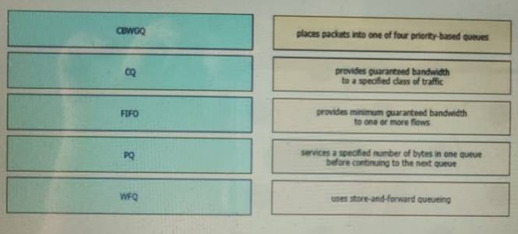
Drag and drop the QoS congestion management terms from the left onto the description on the right.

- Mastered
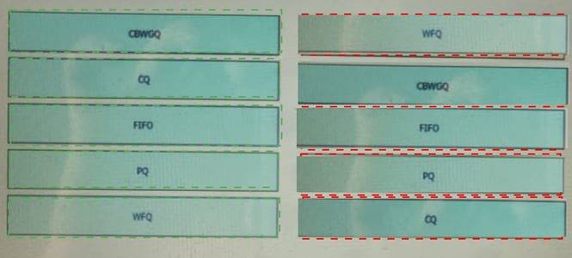
- Not Mastered Answer: A Explanation:

NEW QUESTION 433
- (Topic 1)
What are two southbound APIs? (Choose two )

- OpenFlow
- NETCONF
- Thrift
- CORBA
- DSC

Answer: AB

Explanation:

OpenFlow is a well-known southbound API. OpenFlow defines the way the SDN Controller should interact with the forwarding plane to make adjustments to the network, so it can better adapt to changing business requirements.
The Network Configuration Protocol (NetConf) uses Extensible Markup Language (XML) to install, manipulate and delete configuration to network devices.

NEW QUESTION 436
- (Topic 1)
Which WAN topology provides a combination of simplicity quality, and availability?

- partial mesh
- full mesh
- point-to-point
- hub-and-spoke

Answer: C

NEW QUESTION 441
- (Topic 1)
A network engineer must back up 20 network router configurations globally within a customer environment. Which protocol allows the engineer to perform this function using the Cisco IOS MIB?

- CDP
- SNMP
- SMTP
- ARP

Answer: B

Explanation:
SNMP is an application-layer protocol that provides a message format for communication between SNMP managers and agents. SNMP provides a standardized framework and a common language used for the monitoring and management of devices in a network.The SNMP framework has three parts:+ An SNMP manager+ An SNMP agent+ A Management Information Base (MIB)The Management Information Base (MIB) is a virtual information storage area for network management information, which consists of collections of managed objects.With SNMP, the network administrator can send commands to multiple routers to do the backup

NEW QUESTION 444
- (Topic 1)
Which function is performed by the collapsed core layer in a two-tier architecture?

- enforcing routing policies
- marking interesting traffic for data polices
- attaching users to the edge of the network
- applying security policies

Answer: A

NEW QUESTION 445
- (Topic 1)
When a floating static route is configured, which action ensures that the backup route is used when the primary route fails?

- The floating static route must have a higher administrative distance than the primary route so it is used as a backup
- The administrative distance must be higher on the primary route so that the backup route becomes secondary.
- The floating static route must have a lower administrative distance than the primary route so it is used as a backup
- The default-information originate command must be configured for the route to be installed into the routing table

Answer: A

NEW QUESTION 448
- (Topic 1)
What is the function of a controller in controller-based networking?

- It serves as the centralized management point of an SDN architecture.
- It centralizes the data plane for the network.
- It is the card on a core router that maintains all routing decisions for a campus.
- It is a pair of core routers that maintain all routing decisions for a campus

Answer: A

NEW QUESTION 453
- (Topic 1)
Refer to the exhibit.

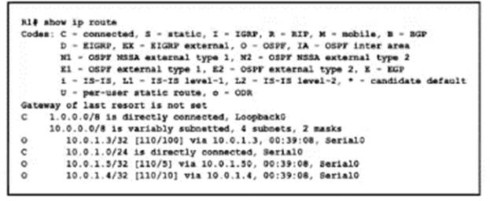
What is the next hop address for traffic that is destined to host 10.0.1.5?

- 10.0.1.3
- 10.0.1.50
- 10.0.1.4
- Loopback D

Answer: B

NEW QUESTION 456
- (Topic 1)
An engineer is asked to protect unused ports that are configured in the default VLAN on a switch. Which two steps will fulfill the request? (Choose two)

- Configure the ports in an EtherChannel.
- Administratively shut down the ports
- Configure the port type as access and place in VLAN 99
- Configure the ports as trunk ports
- Enable the Cisco Discovery Protocol

Answer: BC

NEW QUESTION 461
- (Topic 1)
Which device performs stateful inspection of traffic?

- firewall
- switch
- access point
- wireless controller

Answer: A

NEW QUESTION 465
- (Topic 1)
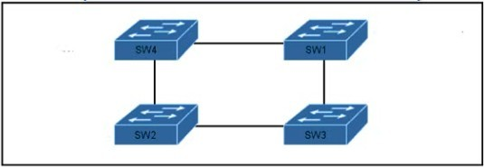
Refer to the exhibit.
Which switch in this configuration will be elected as the root bridge?
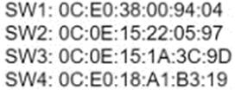

- SW1
- SW2
- SW3
- SW4

Answer: C

NEW QUESTION 469
- (Topic 1)
What are two characteristics of the distribution layer in a three-tier network architecture? (Choose two.)

- serves as the network aggregation point
- provides a boundary between Layer 2 and Layer 3 communications
- designed to meet continuous, redundant uptime requirements
- is the backbone for the network topology
- physical connection point for a LAN printer

Answer: BC

NEW QUESTION 471
- (Topic 1)
Which two events occur automatically when a device is added to Cisco DNA Center? (Choose two. )

- The device Is assigned to the Global site.
- The device Is placed into the Unmanaged state.
- The device is placed into the Provisioned state.
- The device is placed into the Managed state.
- The device is assigned to the Local site.

Answer: AB

NEW QUESTION 472
- (Topic 1)
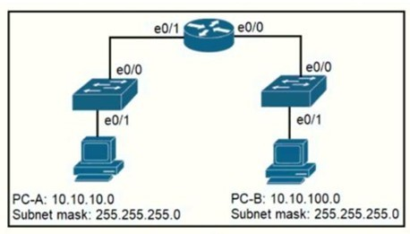
Refer to the exhibit.
When PC-A sends traffic to PC-B, which network component is in charge of receiving the packet from PC-A verifying the IP addresses, and forwarding the packet to PC-B?

- Layer 2 switch
- Router
- Load balancer
- firewall

Answer: B

Explanation:
PC--A and PC-B are not in the same network. Switches send traffic in layer 2 and within the same VLA while routers route traffic to different subnet and at layer 3.

NEW QUESTION 474
- (Topic 1)
Which level of severity must be set to get informational syslogs?

- alert
- critical
- notice
- debug

Answer: C

NEW QUESTION 476
- (Topic 1)
How do TCP and UDP differ in the way that they establish a connection between two endpoints?

- TCP uses synchronization packets, and UDP uses acknowledgment packets.
- UDP uses SYN, SYN ACK and FIN bits in the frame header while TCP uses SYN, SYN ACK and ACK bits
- UDP provides reliable message transfer and TCP is a connectionless protocol
- TCP uses the three-way handshake and UDP does not guarantee message delivery

Answer: D

NEW QUESTION 477
- (Topic 1)
What is the benefit of using FHRP?

- reduced management overhead on network routers
- balancing traffic across multiple gateways in proportion to their loads
- higher degree of availability
- reduced ARP traffic on the network

Answer: C

NEW QUESTION 481
- (Topic 1)
Which global command encrypt all passwords in the running configuration?

- password-encrypt
- enable password-encryption
- enable secret
- service password-encryption

Answer: B

NEW QUESTION 483
- (Topic 1)
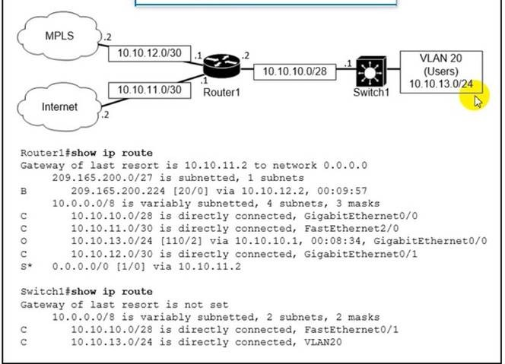
Refer to the exhibit.
which path is used by the router for internet traffic ?

- 209.165.200.0/27
- 10.10.10.0/28
- 0.0.0.0/0
- 10.10.13.0/24

Answer: C

NEW QUESTION 484
- (Topic 1)
Which command enables a router to become a DHCP client?

- ip address dhcp
- ip helper-address
- ip dhcp pool
- ip dhcp client

Answer: A

Explanation:
Reference: https://www.cisco.com/c/en/us/td/docs/ios-xml/ios/ipaddr_dhcp/configuration/12-4/dhcp-12-4-book/config-dhcp-client.html

If we want to get an IP address from the DHCP server on a Cisco device, we can use the command “ip address dhcp”. Note: The command “ip helper-address” enables a router to become a DHCP Relay Agent.

NEW QUESTION 489
- (Topic 1)
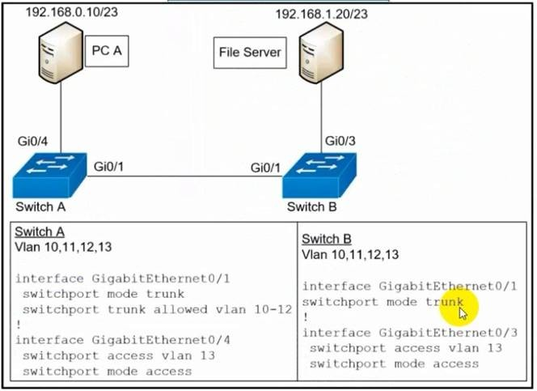
Refer to the exhibit.
A network engineer must configured communication between PC A and the File Server. To prevent interruption for any other communications, which command must be configured?

- Switch trunk allowed vlan 12
- Switchport trunk allowed vlan none
- Switchport trunk allowed vlan add 13
- Switchport trunk allowed vlan remove 10-11

Answer: C

NEW QUESTION 494
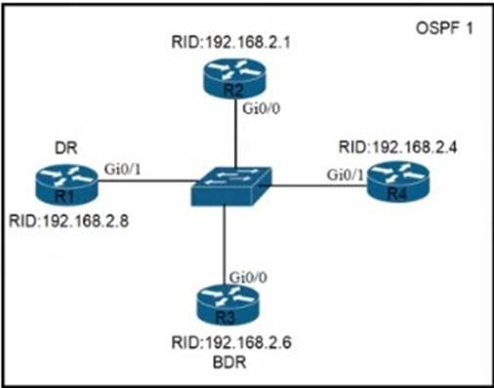
- (Topic 1)
Refer to the exhibit. All routers in the network are configured R2 must be the DR. After the engineer connected the devices, R1 was elected as the DR. Which command sequence must be configure on R2 to Be elected as the DR in the network?

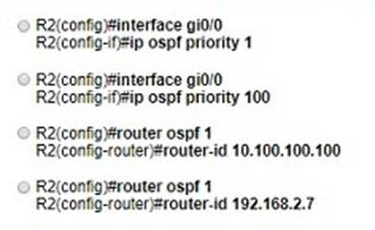

- Option A
- Option B
- Option C
- Option D

Answer: B

NEW QUESTION 498
- (Topic 1)
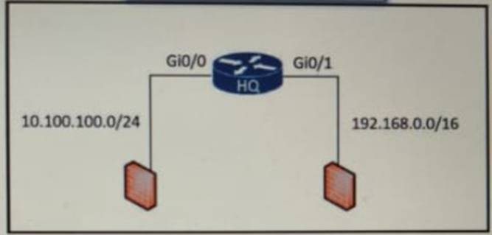
Refer to the exhibit.
An access list is required to permit traffic from any host on interface G0/0 and deny traffic from interface G/0/1. Which access list must be applied?
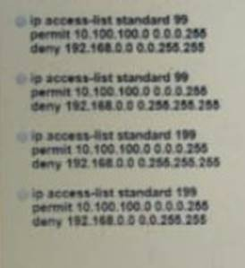

- Option A
- Option B
- Option C
- Option D

Answer: A

NEW QUESTION 503
DRAG DROP - (Topic 1)
Drag and drop the IPv6 address type characteristics from the left to the right.

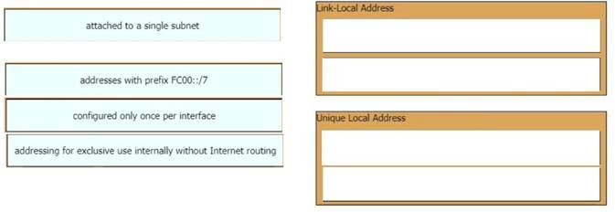

- Mastered
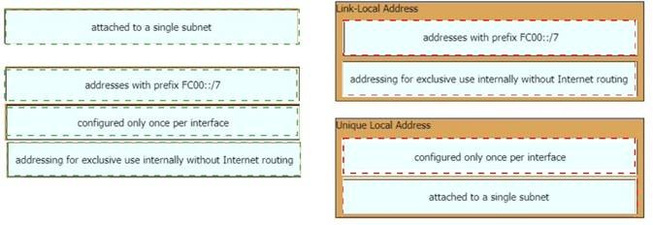
- Not Mastered Answer: A Explanation:

NEW QUESTION 508
- (Topic 1)
What is the purpose of traffic shaping?

- to mitigate delays over slow links
- to provide fair queuing for buffered flows
- to limit the bandwidth that a flow can use to
- be a marking mechanism that identifies different flows

Answer: B

Explanation:
Traffic shaping retains excess packets in a queue and then schedules the excess for later transmission over increments of time.

NEW QUESTION 512
- (Topic 1)
Which feature on the Cisco Wireless LAN Controller when enabled restricts management access from specific networks?

- CPU ACL
- TACACS
- Flex ACL
- RADIUS

Answer: A

Explanation:
Reference: https://www.cisco.com/c/en/us/support/docs/wireless-mobility/wlan-security/71978-acl-wlc.html

NEW QUESTION 514
- (Topic 1)
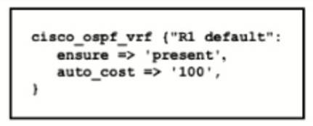
Refer to the exhibit.

Which type of configuration is represented in the output?

- Ansible
- JSON
- Chef
- Puppet

Answer: D

NEW QUESTION 516
- (Topic 1)
Which configuration ensures that the switch is always the root for VLAN 750?

- Switch(config)#spanning-tree vlan 750 priority 38003685
- Switch(config)#spanning-tree vlan 750 root primary
- Switch(config)#spanning-tree vlan 750 priority 614440
- Switch(config)#spanning-tree vlan 750 priority 0

Answer: D

Explanation:
Although the spanning-tree vlan 10 root primary command will ensure a switch will have a bridge priority value lower than other bridges introduced to the network, the spanning-tree vlan 10 priority 0 command ensures the bridge priority takes precedence over all other priorities.

NEW QUESTION 520
- (Topic 1)
Which HTTP status code is returned after a successful REST API request?

- 200
- 301
- 404
- 500

Answer: A

NEW QUESTION 524
- (Topic 1)
By default, how Does EIGRP determine the metric of a route for the routing table?

- it uses the bandwidth and delay values of the path to calculate the route metric
- it uses a default metric of 10 for all routes that are learned by the router
- it uses a reference Bandwidth and the actual bandwidth of the connected link to calculate the route metric
- it counts the number of hops between the receiving and destination routers and uses that value as the metric

Answer: A

NEW QUESTION 526
- (Topic 1)
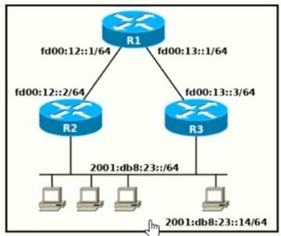
Refer to the exhibit.
Which two commands, when configured on router R1, fulfill these requirements? (Choose two.)
Packets towards the entire network 2001:db8:2::/64 must be forwarded through router R2. Packets toward host 2001:db8:23::14 preferably must be forwarded through R3.

- Ipv6 route 2001:db8:23::/128 fd00:12::2
- Ipv6 route 2001:db8:23::14/128 fd00:13::3
- Ipv6 route 2001:db8:23::14/64 fd00:12::2
- Ipv6 route 2001:db8:23::/64 fd00:12::2
- Ipv6 route 2001:db8:23::14/64 fd00:12::2 200

Answer: DE

NEW QUESTION 530
- (Topic 1)
Which WLC port connects to a switch to pass normal access-point traffic?

- redundancy
- console
- distribution system
- service

Answer: C

NEW QUESTION 535
- (Topic 1)
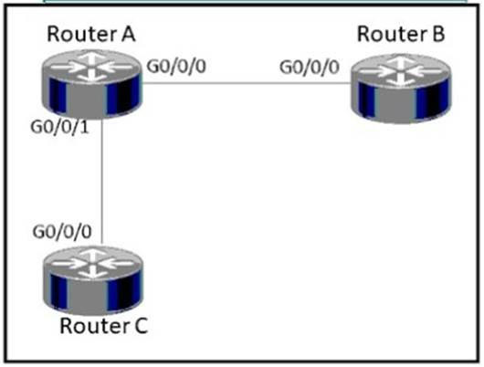
Refer to the exhibit.
How must router A be configured so that it only sends Cisco Discovery Protocol Information to router C?
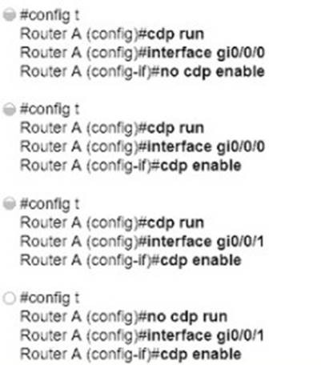

- Option A
- Option B
- Option C
- Option D

Answer: D

NEW QUESTION 537
- (Topic 1)
How does Cisco DNA Center gather data from the network?

- Network devices use different services like SNMP, syslog, and streaming telemetry to send data to the controller
- Devices establish an iPsec tunnel to exchange data with the controller
- Devices use the call-home protocol to periodically send data to the controller.
- The Cisco CU Analyzer tool gathers data from each licensed network device and streams it to the controller.

Answer: A

NEW QUESTION 540
- (Topic 1)
Aside from discarding, which two states does the switch port transition through while using RSTP (802.1w)? (Choose two)

- listening
- blocking
- forwarding
- learning
- speaking

Answer: CD

NEW QUESTION 543
- (Topic 1)
What are two functions of a server on a network? (Choose two)

- achieves redundancy by exclusively using virtual server clustering
- runs applications that send and retrieve data for workstations that make requests
- handles requests from multiple workstations at the same time
- runs the same operating system in order to communicate with other servers
- housed solely in a data center that is dedicated to a single client

Answer: BC

NEW QUESTION 546
- (Topic 1)
What is a characteristic of a SOHO network?

- connects each switch to every other switch in the network
- enables multiple users to share a single broadband connection
- provides high throughput access for 1000 or more users
- includes at least three tiers of devices to provide load balancing and redundancy

Answer: B

NEW QUESTION 549
- (Topic 1)
What are two functions of an SDN controller? (Choose two)

- Layer 2 forwarding
- coordinating VTNs
- tracking hosts
- managing the topology
- protecting against DDoS attacks

Answer: BD

NEW QUESTION 553
- (Topic 1)
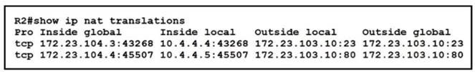
Refer to the exhibit.
An engineer configured NAT translations and has verified that the configuration is correct. Which IP address is the source IP?

- 10.4.4.4
- 10.4.4.5
- 172.23.103.10
- 172.23.104.4

Answer: D

Explanation:
NAT is used to send a packet to the outside network, using a public IP address to make it routable. The NAT logic is "inside-to-outside" FIRST and "outside-to- inside" THEN. This way, configuring NAT means "choosing a public IP address" for any outbound packet" IN THE FIRST PLACE, where "public IP address" translates to "inside global address". Among the given answers, the only inside global address is 172.123.104.4.

NEW QUESTION 557
- (Topic 1)
Which option about JSON is true?

- uses predefined tags or angle brackets () to delimit markup text
- used to describe structured data that includes arrays
- used for storing information
- similar to HTML, it is more verbose than XML

Answer: B

Explanation:
JSON data is written as name/value pairs.A name/value pair consists of a field name (in double quotes), followed by a colon, followed by a value:“name”:”Mark”JSON can use arrays. Array values must be of type string, number, object, array, boolean or null..For example:{“name”:”John”,“age”:30,“cars”:[ “Ford”, “BMW”, “Fiat” ]}

NEW QUESTION 559
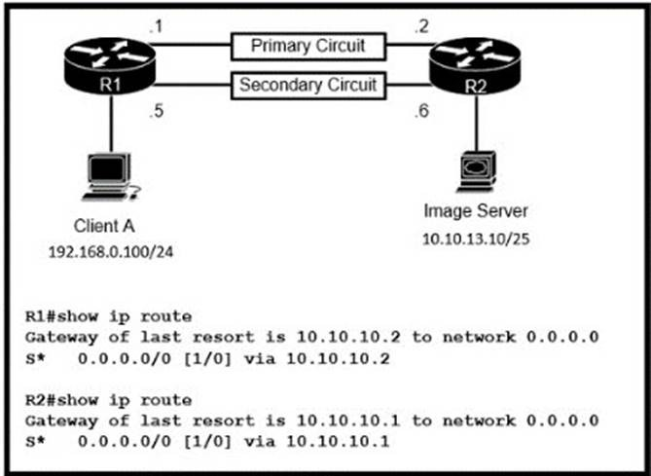
- (Topic 1)
Refer to the exhibit Routers R1 and R2 have been configured with their respective LAN interfaces The two circuits are operational and reachable across WAN Which command set
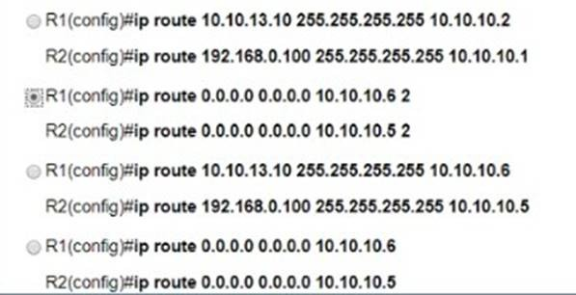
establishes failover redundancy if the primary circuit goes down?

- Option A
- Option B
- Option C
- Option D

Answer: B

NEW QUESTION 563
- (Topic 1)

Which two WAN architecture options help a business scalability and reliability for the network? (Choose two)

- asychronous routing
- single-homed branches
- dual-homed branches
- static routing
- dynamic routing

Answer: AC

NEW QUESTION 568
- (Topic 1)
Which device tracks the state of active connections in order to make a decision to forward a packet through?

- wireless access point
- firewall
- wireless LAN controller
- router

Answer: B

Explanation:
Stateful inspection, also known as dynamic packet filtering, is a firewall technology that monitors the state of active connections and uses this information to determine which network packets to allow through the firewall.

NEW QUESTION 573
- (Topic 1)
Router R1 must send all traffic without a matching routing-table entry to 192.168.1.1. Which configuration accomplishes this task?
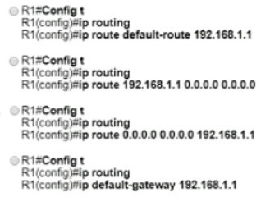

- Option A
- Option B
- Option C
- Option D

Answer: C

NEW QUESTION 577
- (Topic 1)
What facilitates a Telnet connection between devices by entering the device name?

- SNMP
- DNS lookup
- syslog
- NTP

Answer: B

NEW QUESTION 581
DRAG DROP - (Topic 1)
Drag and drop the attack-mitigation techniques from the left onto the Types of attack that they mitigate on the right.

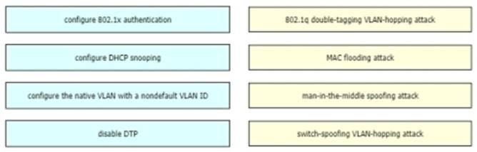

- Mastered
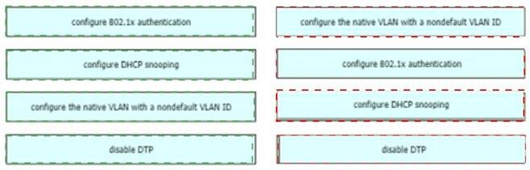
- Not Mastered Answer: A Explanation:

NEW QUESTION 584
- (Topic 1)
Which type of security program is violated when a group of employees enters a building using the ID badge of only one person?

- intrusion detection
- user awareness
- physical access control
- network authorization

Answer: C

NEW QUESTION 586
- (Topic 1)
If a notice-level messaging is sent to a syslog server, which event has occurred?

- A network device has restarted
- An ARP inspection has failed
- A routing instance has flapped
- A debug operation is running

Answer: C

Explanation:
Usually no action is required when a route flaps so it generates the notification syslog level message (level 5).

NEW QUESTION 590
- (Topic 1)
What protocol allows an engineer to back up 20 network router configurations globally while using the copy function?

- SMTP
- SNMP
- TCP
- FTP

Answer: B

NEW QUESTION 592
- (Topic 1)
Which command entered on a switch configured with Rapid PVST* listens and learns for a specific time period?

- switch(config)#spanning-tree vlan 1 max-age 6
- switch(config)#spanning-tree vlan 1 hello-time 10
- switch(config)#spanning-tree vlan 1 priority 4096

- switch(config)#spanning-tree vlan 1 forward-time 20

Answer: D

Explanation:
Forward time : Determines how long each of the listening and learning states last before the port begins forwarding.
Switch(config)# [ no ] spanning-tree vlan vlan_ID forward-time forward_timeConfigures the forward time of a VLAN. The forward_time value can be from 4 to 30 seconds. https://www.cisco.com/c/en/us/td/docs/switches/lan/catalyst4500/12-2/15-02SG/configuration/guide/config/spantree.html#56177

NEW QUESTION 594
- (Topic 1)
Where does the configuration reside when a helper address Is configured lo support DHCP?

- on the router closest to the server
- on the router closest to the client
- on every router along the path
- on the switch trunk interface

Answer: B

NEW QUESTION 597
- (Topic 1)
Which technology is appropriate for communication between an SDN controller and applications running over the network?

- OpenFlow
- REST API
- NETCONF
- Southbound API

Answer: B

NEW QUESTION 600
- (Topic 1)
On workstations running Microsoft Windows, which protocol provides the default gateway for the device?

- DHCP
- STP
- SNMP
- DNS

Answer: A

NEW QUESTION 601
- (Topic 1)
An organization has decided to start using cloud-provided services. Which cloud service allows the organization to install its own operating system on a virtual machine?

- platform-as-a-service
- software-as-a-service
- network-as-a-service
- infrastructure-as-a-service

Answer: B

Explanation:
Below are the 3 cloud supporting services cloud providers provide to customer:
+ SaaS (Software as a Service): SaaS uses the web to deliver applications that are managed by a thirdparty vendor and whose interface is accessed on the clients’ side. Most SaaS applications can be run directly from a web browser without any downloads or installations required, although some require plugins.
+ PaaS (Platform as a Service): are used for applications, and other development, while providing cloud components to software. What developers gain with PaaS is a framework they can build upon to develop or customize applications. PaaS makes the development, testing, and deployment of applications quick, simple, and cost-effective. With this technology, enterprise operations, or a thirdparty provider, can manage OSes, virtualization, servers, storage, networking, and the PaaS software itself. Developers, however, manage the applications.
+ IaaS (Infrastructure as a Service): self-service models for accessing, monitoring, and managing remote datacenter infrastructures, such as compute (virtualized or bare metal), storage, networking, and networking services (e.g. firewalls). Instead of having to purchase hardware outright, users can purchase IaaS based on consumption, similar to electricity or other utility billing.
In general, IaaS provides hardware so that an organization can install their own operating system.

NEW QUESTION 604
- (Topic 1)
Which QoS Profile is selected in the GUI when configuring a voice over WLAN deployment?

- Bronze
- Platinum
- Silver
- Gold

Answer: B

Explanation:
Reference: https://www.cisco.com/c/en/us/support/docs/wireless-mobility/wireless-lan-wlan/81831-qos-wlc-lap.html
Cisco Unified Wireless Network solution WLANs support four levels of QoS: Platinum/Voice, Gold/Video, Silver/Best Effort (default), and Bronze/Background.

NEW QUESTION 607
- (Topic 1)
When a switch receives a frame for a known destination MAC address, how is the frame handed?

- sent to the port identified for the known MAC address
- broadcast to all ports
- forwarded to the first available port
- flooded to all ports except the one from which it originated

Answer: A

NEW QUESTION 609
- (Topic 1)
Which technology allows for multiple operating systems to be run on a single host computer?

- virtual routing and forwarding
- network port ID visualization
- virtual device contexts
- server visualization

Answer: D

NEW QUESTION 610
- (Topic 1)
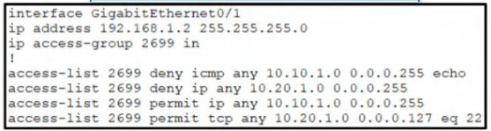
Refer to the exhibit.
A network administrator must permit SSH access to remotely manage routers in a network. The operations team resides on the 10.20.1.0/25 network. Which command will accomplish this task?

- access-list 2699 permit udp 10.20.1.0 0.0.0.255
- no access-list 2699 deny tcp any 10.20.1.0 0.0.0.127 eq 22
- access-list 2699 permit tcp any 10.20.1.0 0.0.0.255 eq 22
- no access-list 2699 deny ip any 10.20.1.0 0.0.0.255

Answer: D

Explanation:
Note : Already a statement is there in last to allow SSH Traffic for network 10.20.1.0 0.0.0.127, but Second statement says deny ip any 10.20.1.0 0.0.0.255, so how it will work once it is denied. So the right answer is remove the --- no access-list 2699 deny ip any 10.20.1.0 0.0.0.255.

NEW QUESTION 614
SIMULATION - (Topic 5)

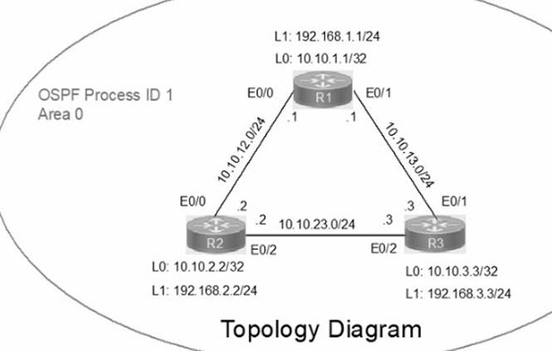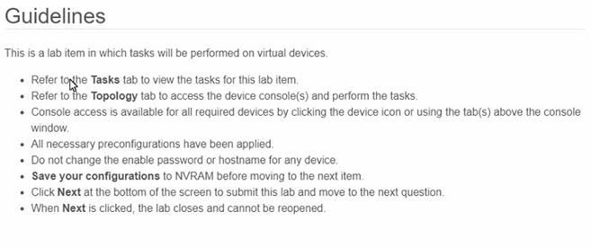
IP connectivity between the three routers is configured. OSPF adjacencies must be established.
- 1. Configure R1 and R2 Router IDs using the interface IP addresses from the link that is shared between them.
- 2. Configure the R2 links with a max value facing R1 and R3. R2 must become the DR. R1 and R3 links facing R2 must remain with the default OSPF configuration for DR election. Verify the configuration after clearing the OSPF process.
- 3. Using a host wildcard mask, configure all three routers to advertise their respective Loopback1 networks.
- 4. Configure the link between R1 and R3 to disable their ability to add other OSPF routers.

- Mastered
- Not Mastered

Answer: A

Explanation:
Answer as below configuration: on R1
conf terminal interface Loopback0
ip address 10.10.1.1 255.255.255.255
!
interface Loopback1
ip address 192.168.1.1 255.255.255.0
!
interface Ethernet0/0 no shut
ip address 10.10.12.1 255.255.255.0
ip ospf 1 area 0 duplex auto
!
interface Ethernet0/1 no shut
ip address 10.10.13.1 255.255.255.0
ip ospf 1 area 0 duplex auto
!
router ospf 1
router-id 10.10.12.1
network 10.10.1.1 0.0.0.0 area 0
network 192.168.1.0 0.0.0.255 area 0
!
copy run star

On R2
conf terminal interface Loopback0
ip address 10.10.2.2 255.255.255.255
!

interface Loopback1
ip address 192.168.2.2 255.255.255.0
!
interface Ethernet0/0 no shut
ip address 10.10.12.2 255.255.255.0
ip ospf priority 255 ip ospf 1 area 0 duplex auto
!
interface Ethernet0/2 no shut
ip address 10.10.23.2 255.255.255.0
ip ospf priority 255 ip ospf 1 area 0 duplex auto
!
router ospf 1
network 10.10.2.2 0.0.0.0 area 0
network 192.168.2.0 0.0.0.255 area 0
!
copy runs start

On R3
conf ter
interface Loopback0
ip address 10.10.3.3 255.255.255.255
!
interface Loopback1
ip address 192.168.3.3 255.255.255.0
!
interface Ethernet0/1 no shut
ip address 10.10.13.3 255.255.255.0
ip ospf 1 area 0 duplex auto
!
interface Ethernet0/2 no shut
ip address 10.10.23.3 255.255.255.0
ip ospf 1 area 0 duplex auto
!
router ospf 1
network 10.10.3.3 0.0.0.0 area 0
network 192.168.3.0 0.0.0.255 area 0
!
copy run start
!

NEW QUESTION 616
SIMULATION - (Topic 5)
All physical cabling is in place. Router R4 and PCI are fully configured and inaccessible. R4's WAN interfaces use .4 in the last octet for each subnet. Configurations should ensure that connectivity is established end-to-end. 1 . Configure static routing to ensure RI prefers the path through R2 to reach only PCI on R4's LAN
- 2. Configure static routing that ensures traffic sourced from RI will take an alternate path through R3 to PCI in the event of an outage along the primary path
- 3. Configure default routes on RI and R3 to the Internet using the least number of hops Guidelines
This is a lab item in which tasks will be performed on virtual devices.
- Refer to the Tasks tab to view the tasks for this lab item.
- Refer to the Topology tab to access the device console(s) and perform the tasks.
- Console access is available for all required devices by clicking the device icon or using the tab(s) above the console window.
- All necessary preconfigurations have been applied.
- Do not change the enable password or hostname for any device.
- Save your configurations to NVRAM before moving to the next item.
- Click Next at the bottom of the screen to submit this lab and move to the next question.
- When Next is clicked, the lab closes and cannot be reopened.

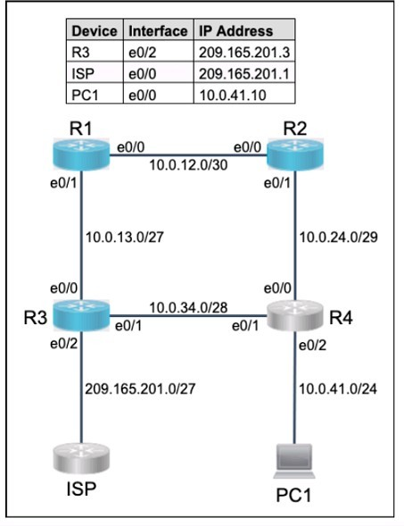

- Mastered
- Not Mastered

Answer: A

Explanation:
? To configure static routing on R1 to ensure that it prefers the path through R2 to reach only PC1 on R4’s LAN, you need to create a static route for the host 10.0.0.100/8 with a next-hop address of 20.0.0.2, which is the IP address of R2’s interface connected to R1. You also need to assign a lower administrative distance (AD) to this route than the default AD of 1 for static routes, so that it has a higher preference over other possible routes. For example, you can use an AD of 10 for this route. To create this static route, you need to enter the following commands on R1’s console:
R1#configure terminal R1(config)#ip route 10.0.0.100 255.0.0.0 20.0.0.2 10 R1(config)#end
? To configure static routing on R1 that ensures that traffic sourced from R1 will take an alternate path through R3 to PC1 in the event of an outage along the primary path, you need to create another static route for the host 10.0.0.100/8 with a next- hop address of 40.0.0.2, which is the IP address of R3’s interface connected to R1. You also need to assign a higher AD to this route than the AD of the primary route, so that it has a lower preference and acts as a backup route. For example, you can use an AD of 20 for this route. This type of static route is also known as a floating static route. To create this static route, you need to enter the following commands on R1’s console:
R1#configure terminal R1(config)#ip route 10.0.0.100 255.0.0.0 40.0.0.2 20 R1(config)#end
? To configure default routes on R1 and R3 to the Internet using the least number of hops, you need to create a static route for the network 0.0.0.0/0 with a next- hop address of the ISP’s interface connected to each router respectively. A default route is a special type of static route that matches any destination address and is used when no other specific route is available. The ISP’s interface connected to R1 has an IP address of 10.0.0.4, and the ISP’s interface connected to R3 has an IP address of 50.0.0.4. To create these default routes, you need to enter the following commands on each router’s console:
On R1: R1#configure terminal R1(config)#ip route 0.0.0.0 0.0.0.0 10.0.0.4 R1(config)#end On R3: R3#configure terminal R3(config)#ip route 0.0.0.0 0.0.0.0
50.0.0.4 R3(config)#end

NEW QUESTION 617
SIMULATION - (Topic 5)
Physical connectivity is implemented between the two Layer 2 switches, and the network connectivity between them must be configured
- 1. Configure an LACP EtherChannel and number it as 1; configure it between switches SW1 and SVV2 using interfaces Ethernet0/0 and Ethernet0/1 on both sides. The LACP mode must match on both ends
- 2 Configure the EtherChannel as a trunk link.
- 3. Configure the trunk link with 802.1 q tags.
- 4. Configure the native VLAN of the EtherChannel as VLAN 15.

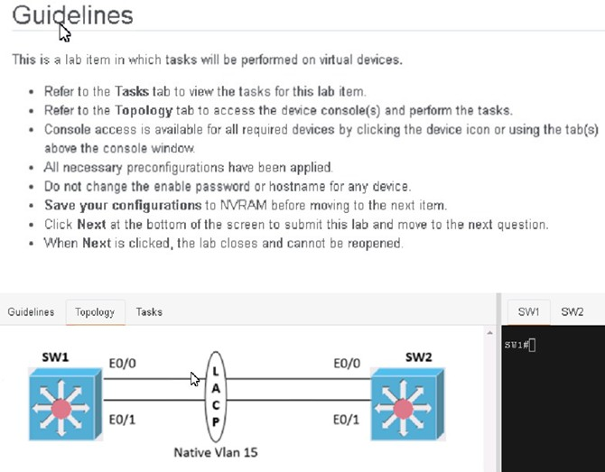

- Mastered
- Not Mastered

Answer: A

Explanation:
Answer as below configuration:
On SW1:
conf terminal vlan 15 exit
interface range eth0/0 - 1 channel-group 1 mode active exit interface port-channel 1
switchport trunk encapsulation dot1q switchport mode trunk switchport trunk native vlan 15 end
copy run start on SW2:
conf terminal vlan 15 exit
interface range eth0/0 - 1 channel-group 1 mode active exit interface port-channel 1
switchport trunk encapsulation dot1q switchport mode trunk switchport trunk native vlan 15 end
copy run start

NEW QUESTION 620
- (Topic 4)
Which IPsec encryption mode is appropriate when the destination of a packet differs from the security termination point?

- tunnel
- transport
- aggressive
- main

Answer: B

Explanation:
IPsec encryption mode is the way IPsec secures the data packets that are sent over an IP network. There are two main modes of IPsec encryption: tunnel mode and transport mode1. Tunnel mode encrypts the entire IP packet, including the original header, and adds a new IP header with the source and destination addresses of the security gateways (routers, firewalls, or VPN servers) that perform the encryption and decryption2. Transport mode encrypts only the payload (data) of the IP packet, leaving the original header intact, and uses the original source and destination addresses of the endpoints that generate and consume the data3. Therefore, transport mode is appropriate when the destination of a packet differs from the security termination point, as it does not change the original IP header information. Tunnel mode is more suitable when the security termination point is also the destination of the packet, as it provides more protection for the original IP header information.

NEW QUESTION 623
DRAG DROP - (Topic 4)

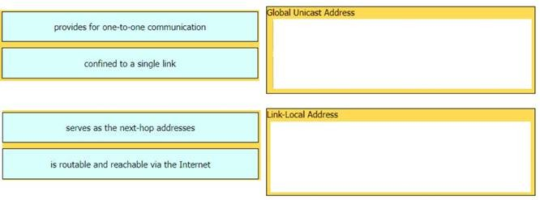
Drag and drop the characteristic from the left onto the IPv6 address type on the right.

- Mastered
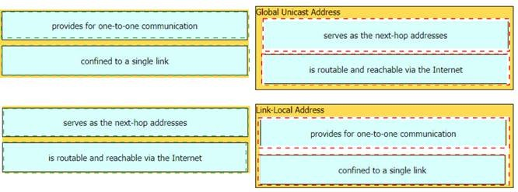
- Not Mastered Answer: A Explanation:

NEW QUESTION 624
DRAG DROP - (Topic 4)
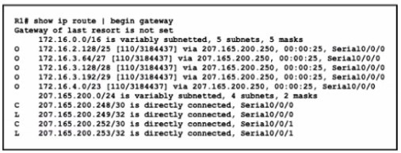
Refer to the exhibit.
Drag and drop the learned prefixes from the left onto the subnet masks on the right
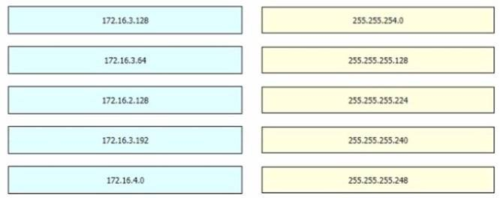

- Mastered
- Not Mastered Answer: A Explanation:

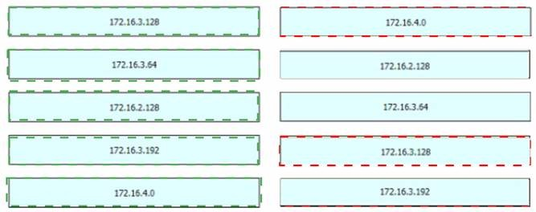

NEW QUESTION 629
......

Thank You for Trying Our Product

We offer two products:

1st - We have Practice Tests Software with Actual Exam Questions 2nd - Questons and Answers in PDF Format

200-301 Practice Exam Features:

- 200-301 Questions and Answers Updated Frequently

- 200-301 Practice Questions Verified by Expert Senior Certified Staff

- 200-301 Most Realistic Questions that Guarantee you a Pass on Your FirstTry

- 200-301 Practice Test Questions in Multiple Choice Formats and Updatesfor 1 Year

100% Actual & Verified — Instant Download, Please Click Order The 200-301 Practice Test Here

