Automated report for MONS-Pelagic-Fish

# Introduction

This automated report provides a detailed overview of Plankton Imager data collected during the MONS-Pelagic-Fish cruise between 2024-01-10 16:00:00 to 2024-01-18 18:00:00. In total, 16,968,754 images were collected in the region from approximately 5.90°E to 5.90°E longitude and 53.84°N to 53.85°N latitude.  
  
This automated report provides an overview of the data processed using the ResNet50 model developed by van Walraven et al. (in prep), see method section. The report contains information on the number of images per class, density statistics (N/L), and the model confidence in predicting the class. Moreover, figures are created on the 10-minute bins of detected objects visualized in density and spatio-temporal plots. A first attempt at deriving an index of patchiness is provided as well, through dividing the number of images by 340, corresponding to the volume of water (in L) flowing through the Plankton Imager in 10 minutes.

# Methodology

The analysis was conducted using the ResNet50 developed in Van Walraven et al. (in prep) which predicts 49 different plankton and non-plankton classes. Detailed information on the code, weights, and datasets can be found at: https://git.wur.nl/marine-vision-and-robotics/mons. The density calculations are created by dividing the estimated volume of water that passes through the flow cell 34 L/min, for a total of 340 L per 10 minutes. Therefore, the number of predictions can be binned per 10 minutes and divided to get the density per L, which we report as N/L. Afterwards, we process this dataset to compute descriptive statistics on the entire dataset, and class-specific derived information. Density graphs and maps are created to illustrate the distribution of each predicted class over time and geographic locations.  
  
Moreover, to provide an estimate of the model's confidence in predicting specific classes, we generate descriptive statistics and a violin plot illustrating the confidence distribution. This visualization helps in understanding the variability and uncertainty in the model's predictions.We focus on the top five classes most related to the actual target by computing the mean confidence values for all non-target classes and selecting the five with the highest mean confidence. These classes are considered the most related to the target and represent areas where the model might struggle to differentiate between the actual target and similar classes. For example, the model might show lower certainty in predictions for the class 'Crustacea Amphipoda', particularly when differentiating it from other closely related Crustacea targets. This adds a layer of nuance to the model, and shows potential areas for improvements.

# General statistics

During the MONS-Pelagic-Fish survey, a total of 16,968,754 images were collected along the transect. The table below shows the amount of images predicted for each class and as percentage of the total images collected. Also shown is the minimum, mean, and maximum density (n/L) for each class.

General statistics on the predictions made using the model, such as the number of images predicted as each class, the density (N/L), and the confidence for each class.

|  |  |  |  |  |
| --- | --- | --- | --- | --- |
| ID | Class | # of Images | Density | Confidence |
| 0 | Annelida Polychaeta larvae | 17,662 0.10% | Min: 0.00 Mean: 0.09 Max: 1.20 | Min: 0.12 Mean: 0.53 Max: 1.00 |
| 3 | Branchiostomatidae | 904 0.01% | Min: 0.00 Mean: 0.01 Max: 0.03 | Min: 0.12 Mean: 0.55 Max: 1.00 |
| 1 | Annelida Polychaeta Tomopteris | 601 0.00% | Min: 0.00 Mean: 0.01 Max: 0.04 | Min: 0.17 Mean: 0.56 Max: 1.00 |
| 2 | Brachiopoda larvae | 197 0.00% | Min: 0.00 Mean: 0.00 Max: 0.01 | Min: 0.18 Mean: 0.47 Max: 0.89 |

# Class: Annelida_Polychaeta-larvae

## Statistics

|  |  |
| --- | --- |
| Metric | Value |
| Class ID | 0 |
| Class | Annelida Polychaeta larvae |
| Number of predictions | 17,662 |
| Percentage of total images | 0.10 % |
| Min confidence | 0.12 % |
| Max confidence | 1.00 % |
| Average confidence | 0.53 % |
| Min density | 0.00 n/L |
| Max density | 1.20 n/L |
| Average density | 0.09 n/L |

## Model confidence

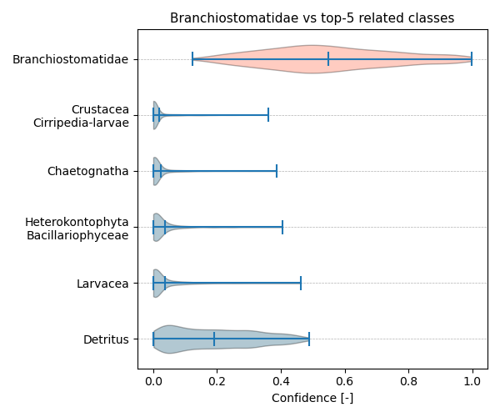

Figure showcasing the confidence distribution of the top-5 most related classes, which are determined by computing the mean confidence value of all non-target classes and selecting the five with the highest means, compared to Annelida_Polychaeta-larvae.

## Temporal density

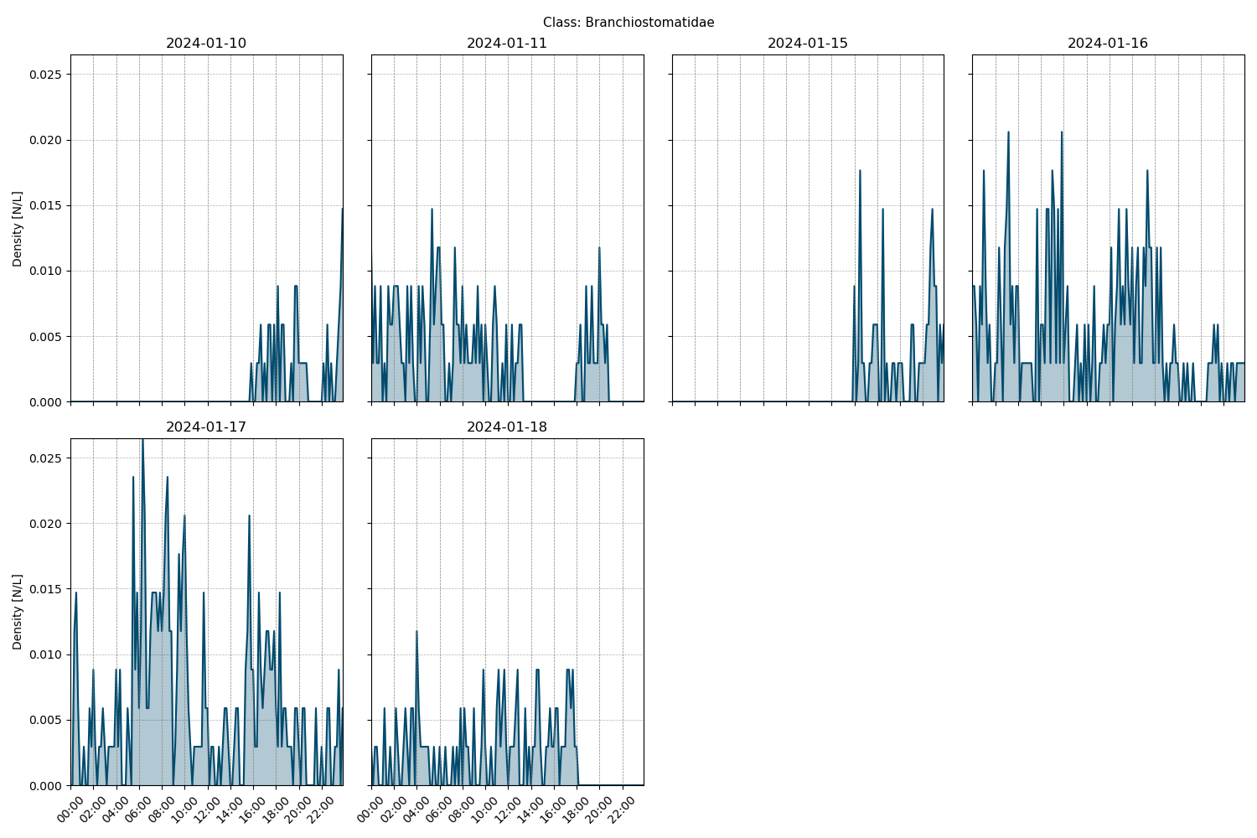

Figure showcasing the daily density estimates for Annelida_Polychaeta-larvae per 10 minutes.

## Spatio-temporal density

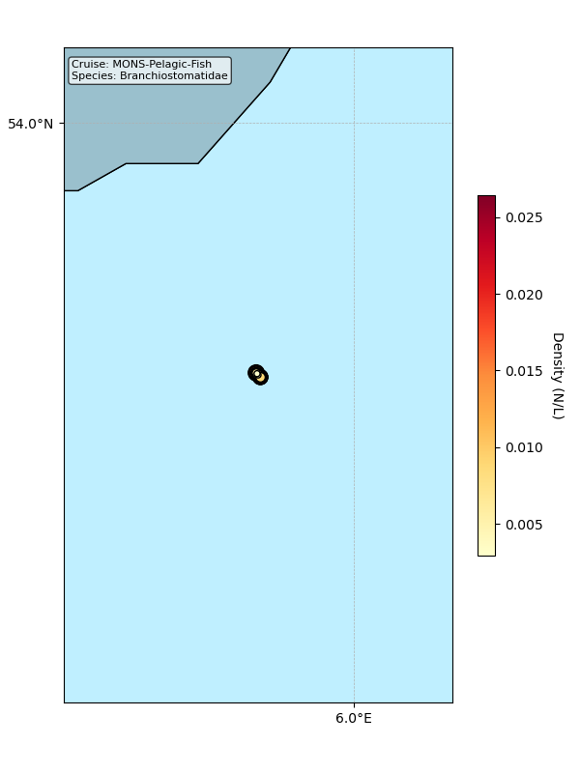

Map showing mean density estimates for Annelida_Polychaeta-larvae along the cruise transect. OSPAR eutrophication areas are plotted in the background with different colours.

## Classification examples

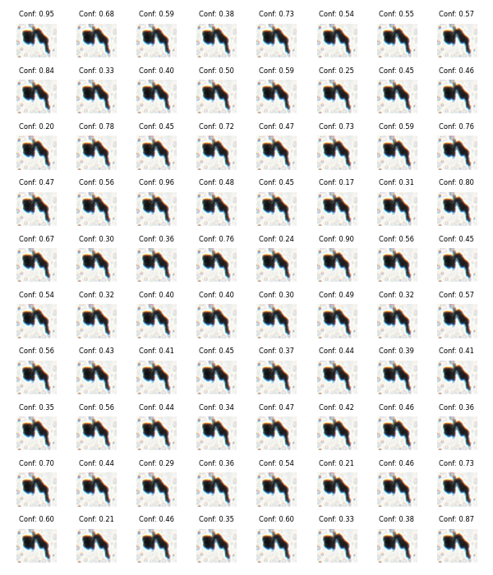

Figure showing several images classified as Annelida_Polychaeta-larvae with model confidence.

# Class: Branchiostomatidae

## Statistics

|  |  |
| --- | --- |
| Metric | Value |
| Class ID | 3 |
| Class | Branchiostomatidae |
| Number of predictions | 904 |
| Percentage of total images | 0.01 % |
| Min confidence | 0.12 % |
| Max confidence | 1.00 % |
| Average confidence | 0.55 % |
| Min density | 0.00 n/L |
| Max density | 0.03 n/L |
| Average density | 0.01 n/L |

## Model confidence



Figure showcasing the confidence distribution of the top-5 most related classes, which are determined by computing the mean confidence value of all non-target classes and selecting the five with the highest means, compared to Branchiostomatidae.

## Temporal density



Figure showcasing the daily density estimates for Branchiostomatidae per 10 minutes.

## Spatio-temporal density



Map showing mean density estimates for Branchiostomatidae along the cruise transect. OSPAR eutrophication areas are plotted in the background with different colours.

## Classification examples



Figure showing several images classified as Branchiostomatidae with model confidence.

# Class: Annelida_Polychaeta_Tomopteris

## Statistics

|  |  |
| --- | --- |
| Metric | Value |
| Class ID | 1 |
| Class | Annelida Polychaeta Tomopteris |
| Number of predictions | 601 |
| Percentage of total images | 0.00 % |
| Min confidence | 0.17 % |
| Max confidence | 1.00 % |
| Average confidence | 0.56 % |
| Min density | 0.00 n/L |
| Max density | 0.04 n/L |
| Average density | 0.01 n/L |

## Model confidence



Figure showcasing the confidence distribution of the top-5 most related classes, which are determined by computing the mean confidence value of all non-target classes and selecting the five with the highest means, compared to Annelida_Polychaeta_Tomopteris.

## Temporal density



Figure showcasing the daily density estimates for Annelida_Polychaeta_Tomopteris per 10 minutes.

## Spatio-temporal density



Map showing mean density estimates for Annelida_Polychaeta_Tomopteris along the cruise transect. OSPAR eutrophication areas are plotted in the background with different colours.

## Classification examples



Figure showing several images classified as Annelida_Polychaeta_Tomopteris with model confidence.

# Class: Brachiopoda-larvae

## Statistics

|  |  |
| --- | --- |
| Metric | Value |
| Class ID | 2 |
| Class | Brachiopoda larvae |
| Number of predictions | 197 |
| Percentage of total images | 0.00 % |
| Min confidence | 0.18 % |
| Max confidence | 0.89 % |
| Average confidence | 0.47 % |
| Min density | 0.00 n/L |
| Max density | 0.01 n/L |
| Average density | 0.00 n/L |

## Model confidence



Figure showcasing the confidence distribution of the top-5 most related classes, which are determined by computing the mean confidence value of all non-target classes and selecting the five with the highest means, compared to Brachiopoda-larvae.

## Temporal density



Figure showcasing the daily density estimates for Brachiopoda-larvae per 10 minutes.

## Spatio-temporal density



Map showing mean density estimates for Brachiopoda-larvae along the cruise transect. OSPAR eutrophication areas are plotted in the background with different colours.

## Classification examples



Figure showing several images classified as Brachiopoda-larvae with model confidence.