# 

# 

# 

# 

# Programming Distributed

# Components

# COMP1690

## Logbook

## Joe Schofield

## 000776975

## Due Date: 09/04/2017

## 

## Word Count: 93

Contents

Lab Based Quiz 1 - 31/01/2017 3

Lab Based Quiz 2 - 21/02/2017 4

Lab Based Quiz 3 - 14/03/2017 5

Lab Based Quiz 1 - 31/01/2017

Below is the screenshot from the first lab based quiz. I achieved a score of 80% in this quiz.

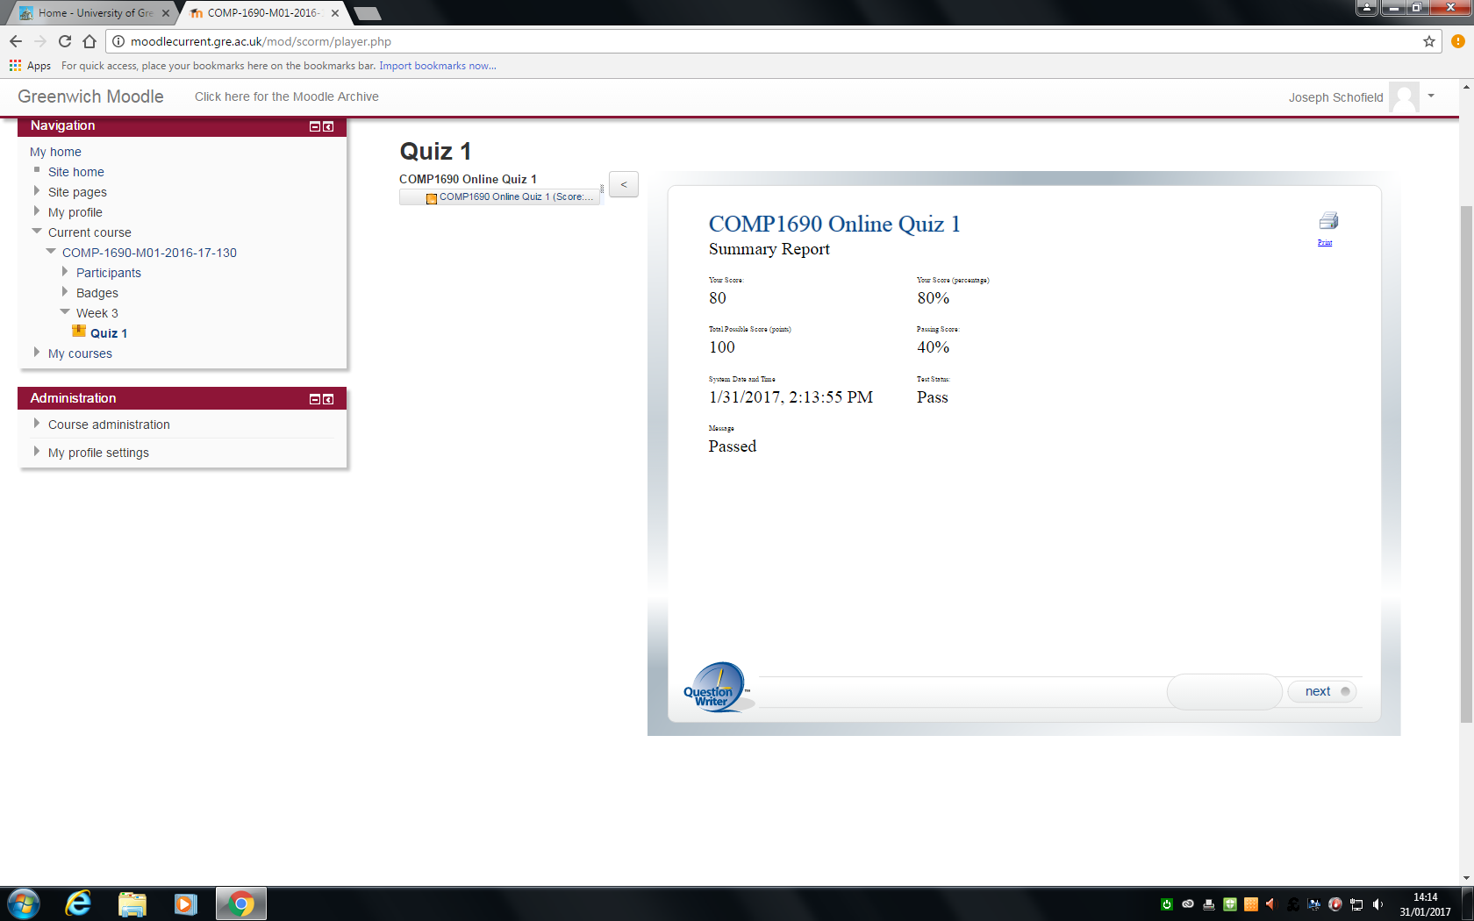

Lab Based Quiz 2 - 21/02/2017

Below is the screenshot from the second lab based quiz. I achieved a score of 90% in this quiz.

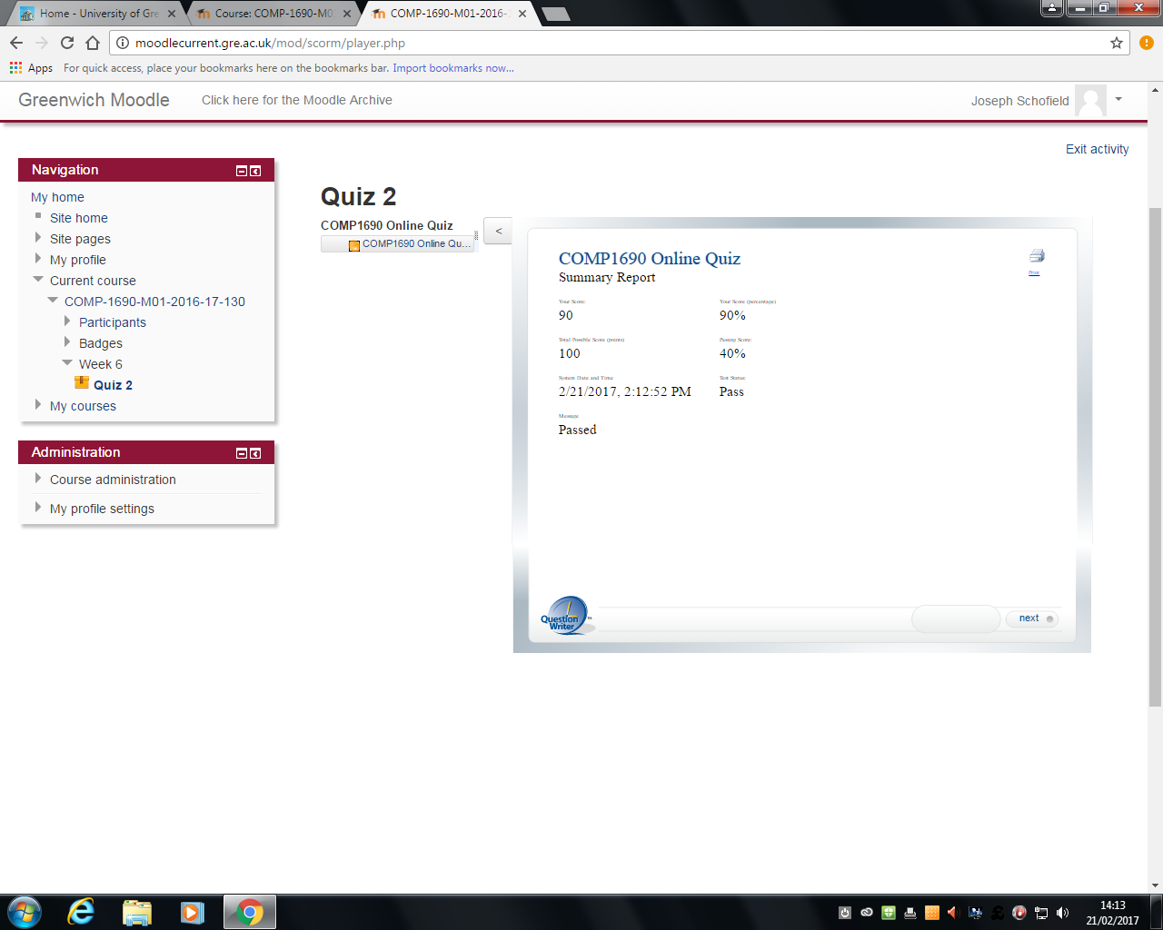

Lab Based Quiz 3 - 14/03/2017

Below is the screenshot from the final lab based quiz. I achieved a score of 80% in this quiz.

