 | Memorandum for File: DQC
 | Date: | 03Aug2026
 | Project: | Mount St Helens Monitoring
 | Subject: | Cowlitz River Flow-Frequency update
 | Prepared By: | Josh Roach, CENWP-ECH-E
 | Reviewer: | Ryan Cahill, CENWP-ECH-E
Review Description
This memo provides the District Quality Control (DQC) comments on the Chapter 4 (Hydrologic Hazards) document for the Lost Creek Lake dam safety risk assessment. Significant comments are given below. Other editorial comments were provided in track changes, directly in the Word document titled “MEMO_CAS_Unreg_FF_DQC_Comments.docx”, provided on August 3, 2026.

Editorial comments on the complete draft are given in “MEMO_CAS_Combined_FlowFrequency_26Aug2026_DQC_comments.docx”
Review Charge
Reviewer is charged with reviewing the calculations, data sources and uses, assumptions, and report documentation.

Reviewer Comments with Resolution (Unregulated Flow-Frequency, drafted 24 July 2026)

  - Comment: There is no data point used for the 3-day and 5-day duration for water year 2026, but there is data for the peak and 1-day. Recommend including the peak for WY2026, since data is available and it was a sizeable event.
  - Evaluation: Added 2026
  - Backcheck: Concur with edit

Reviewer Comments with Resolution (Regulated Flow-Frequency, drafted 26 Aug 2026)

  - Comment: The synthetic events simulated in ResSim do not appear appropriate. The guide curve zone is undefined for all simulations, which causes Mossyrock to dump storage in the lead-up to the flood, eventually pushing it below the WCM rule curve in most cases. This ends up creating more space, which decreases the regulated flow estimate. Recommend re-running with the guide curve properly defined in the area circled below. This will affect the unregulated-regulated relationship (including the convergence point, which will likely drop) and regulated curve.
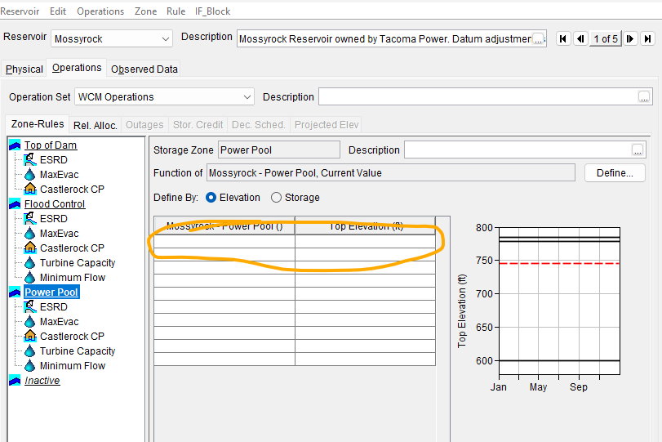
  - Evaluation: Checked box for “use external timeseries.” The guide curve zone is now defined and the synthetic ensemble was re-run. The effect is as predicted: the regulated curve rose through the tail, from 189,434 to 213,481 cfs at the 1,000-year (+12.7 percent) and from 224,427 to 256,186 cfs at the 2,000-year (+14.2 percent). At and below the 20 percent AEP the curve is essentially unchanged. Section 5, Section 8, Table 5-2, Table 8-3 and Appendices E and F are regenerated from the new run, and the drawn convergence point is redrawn against the revised transform.
  - Backcheck:

  - Comment: The text in section 4.5 states: “A search of USGS qualification codes, the 2009 Restudy, and published USGS/NWS accounts of major southwest Washington floods turned up no pre-1927 event at Castle Rock that could be quantified or reliably bounded so no historical events or Bulletin 17C perception thresholds were used.” This makes it sound like no previous study used any flow estimates before 1927, but the 2009 study did include a historic event for 1906 based on some newspaper clippings. Recommend describing that this was done in 2009 and why it wasn’t deemed appropriate here.
  - Evaluation: Concur. Section 4.5 will be expanded to state that the 2009 Restudy carried a historical peak for 1906 developed from contemporary newspaper accounts, and to give the reason it was not carried forward here, rather than implying that no pre-1927 estimate has ever been made. The sentence as written overreaches and will be rewritten.
  - [To be completed before issue: the specific basis for not carrying the 1906 event forward, i.e. whether it was set aside for lack of a defensible stage-discharge basis at the present gage datum, or for lack of a perception threshold that could be bounded numerically under Bulletin 17C. Both are defensible grounds but the memo should state which one applies.]
  - Backcheck:

  - Comment: The ResSim model had some development work applied to make it suitable for this study, but the ResSim modifications from the CWMS model are not discussed in the report. Recommend adding a new section (perhaps 5.1) that discusses the basics: rule curve, the minimum flow assumption, the downstream control rule at Castle Rock, max evac rate, and special curves. Discuss how calibration was challenging because of the power operations, which are not really rule-based.
  - Evaluation: Concur. A new Section 5.1 will describe the ResSim model as used here and how it differs from the CWMS model: the rule curve, the minimum-flow assumption, the downstream control rule at Castle Rock, the maximum evacuation rate, and the special curves. It will also note that calibration was constrained by power operations at Mossyrock and Mayfield, which are not rule-based and cannot be reproduced by a release schedule, so agreement was sought on flood-period volumes and peaks rather than on the full hydrograph.
  - Backcheck:

  - Comment: The development of uncertainty bounds in the unregulated-regulated transform are not discussed in the text, though they are applied in Section 5.6. Recommend including text explaining how these 5/95% bounds were drawn and including them in Figure 5-3.
  - Evaluation: Concur. Section 5.4 will describe how the transform bounds were drawn, and they will be shown on the transform figure, which is being merged with the following figure per the in-document comments. The band reported on the regulated curve is the root-sum-of-squares combination of the frequency standard deviation and the transform standard deviation, with a single z of 1.960 applied once to the combined value. That combination is stated in Section 5.6, but the transform half of it was never explained, which is the gap identified here.
  - Backcheck:

  - Comment: In Section 8.2, a drainage area ratio is used to estimate contributions from tributaries below Castle Rock. However, no justification is given. If possible, recommend including a scatter plot that shows Coweeman peak flow vs Castle Rock unreg peak flow to bolster the case for using a drainage area ratio.
  - Evaluation: Concur, and the plot already exists. The Coweeman historic peak-ratio analysis pairs USGS 14245000 annual peaks for WY1950-1996 against the routed unregulated Castle Rock peak for the same storm; that scatter will be added to Section 8.2. It shows the Coweeman running about 1.5 times its drainage-area share at common events and converging monotonically toward 1.0 as events grow, reaching 1.04 at WY1996, a 212,245 cfs unregulated event and about 92 percent of the 1,000-year flow.
  - Two independent checks will be cited alongside it. Ecology gage 26C075 storm events give 1.11 in the above-60,000 cfs bin, and that figure is a lower bound because the gage's rating ceiling censors its largest events. PRISM basin precipitation over the StreamStats delineations gives a ratio of 1.04, which tests the equal-depth assumption the area ratio rests on directly. All three lines of evidence sit at or near area proportionality at the magnitudes that matter, so no unit-runoff uplift is applied.
  - Backcheck:

  - Comment: In Section 8.4, the below equation is given. Q_{AEP} = AEP_{CAS} * 0.8 * DA_{LOCAL} / DA_{CAS}
However, this does not appear correct. This equation looks like the regulated flows at Castle Rock were used and the drainage area ratio was applied there, when really the drainage area ratio should be applied to the unreg flows at Castle Rock, and then this value should be added to the regulated flows at Castle Rock.
  - Evaluation: Concur, the equation as printed is wrong. It omits the regulated term entirely and its first factor is ambiguous. The calculation actually performed, and what the text will show, is Q(AEP) = Q_reg,CAS(AEP) + Q_unreg,CAS(AEP) x (DA_site - DA_CAS) / DA_CAS x 0.80. The drainage-area ratio is applied to the unregulated Castle Rock flow, as recommended, and the result is then added to the regulated Castle Rock flow. The recommendation matches what the code does; only the printed equation was wrong.
  - Two related errors in the same section were found while checking this. First, Table 8-1's incremental-area and percentage columns were computed against a gage drainage area of 2,220 square miles while the table itself lists 2,238. The increments should be 40, 97 and 238 square miles and the percentages 1.8, 4.3 and 10.6, in place of 58, 115 and 256 and 2.6, 5.1 and 11.4. Second, the Section 8 lead-in gives the gage area as 2,229 square miles and the added area as 247. Three different gage areas are therefore in use across the section. The calculation itself consistently uses 2,238, so the flow numbers are unaffected; the text and table are being brought to that value.
  - Backcheck:

  - Comment: In Section 5.6 and Appendix F, the uncertainty is described as a 95% interval, but the default for SSP is a 90% interval (5%/95% bounds). Recommend adjusting the description to make it more clear. It invites confusion to call it lower 95% and upper 95%, recommend just saying 5% and 95% like SSP does (and labeling it that way in the table headers), or lower 90% interval and upper 90% interval if desired.
  - Evaluation: Do not concur, although the readability point is taken and is being acted on. The limits reported in Section 5.6 and Appendices E and F are a 95 percent two-sided interval, 2.5 and 97.5 percent, not SSP's native 90 percent. SSP's 5 and 95 percent limits are used only to back out a standard deviation; that standard deviation is combined by root-sum-of-squares with the transform standard deviation, and a single z of 1.960 is then applied once to the combined value, following EM 1110-2-1619 Sec 4-4.c(1). This was verified numerically: the published bounds reproduce exactly as the best estimate plus or minus the root-sum-of-squares of the frequency and transform terms at every ordinate except the two where the unregulated-upper constraint binds. Relabelling them 5 and 95 percent would understate the interval.
  - The labelling criticism is fair, since "Lower 95%" and "Upper 95%" reads as though both were 95th percentiles. The column headers become "2.5%" and "97.5%", and Section 5.6 will state that SSP's native 5 and 95 percent limits were converted to a standard deviation and recombined at the 95 percent two-sided level. Note that Appendix B correctly labels SSP's own limits 5% and 95%, which is the likely source of the apparent conflict between the two.
  - Backcheck:

Conclusions/Recommendations

