
US Army Corps of Engineers
Portland District

Cowlitz County Consolidated Drainage Improvement District No. 3
National Flood Insurance Program Levee Evaluation
Phase 2a: Hydraulics and Hydrology
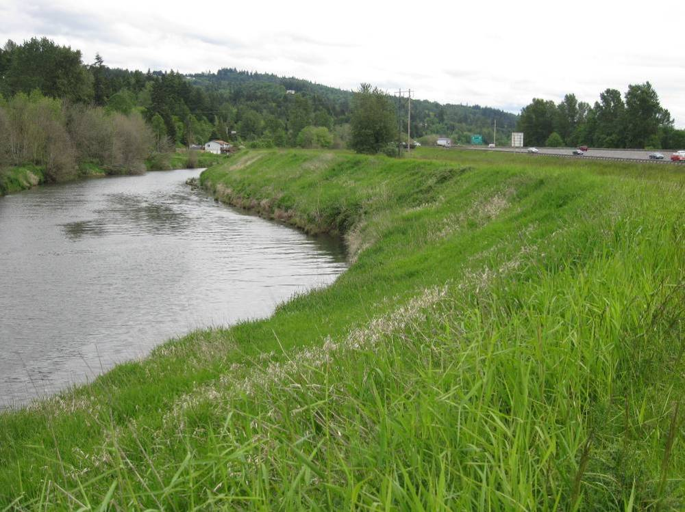
Coweeman River Levee, 2010
FINAL REPORT: June 30, 2016

Executive Summary
To maintain accredited status in the National Flood Insurance Program (NFIP), levee systems must be periodically evaluated for eligibility. More stringent criteria for reaccreditation were put in place after Hurricane Katrina, and the Cowlitz County Consolidated Drainage Improvement District No. 3 (CDID3) levee system has not yet been reaccredited under the new criteria. In 2011, CDID3 requested Portland District of the U.S. Army Corps of Engineers (USACE) perform a levee evaluation study in support of NFIP accreditation.
USACE NFIP Levee Evaluations are done in two phases: Phase 1 is a screening level assessment, and Phase 2 is a full analysis that can result in certification documents. Phase 1 was completed in 2012, and it found that the Coweeman River Levee is not likely to satisfy minimum levee height requirements. The Phase 1 report recommended a more detailed study (termed Phase 2a) to calculate the minimum required levee height before proceeding to Phase 2. This Phase 2a analysis includes only the hydraulics and hydrology component of the full Phase 2 report, which includes other engineering disciplines.
This Phase 2a study confirms the initial findings of the Phase 1 study: areas of the Coweeman Levee must be raised to achieve NFIP accreditation. Areas at the upstream end of the levee require modest increases (less than one foot) to satisfy FEMA criteria. The minimum required levee heights from this study are shown in Table 9-1 and Figure 9-2.
The minimum required levee height is quite uncertain due to lack of data. It may be prudent to raise the levee beyond the minimum height to provide additional risk reduction and more confidence the levee will pass FEMA re-accreditation in the future. After the levee height is raised to satisfy minimum levels, proof of the new levee height must be submitted to USACE. At this point, a full Phase 2 NFIP Levee Evaluation study that includes other disciplines can be initiated. If no other deficiencies are discovered, the deliverable of the Phase 2 study will be certification documents.
This Phase 2a study applies an unorthodox technical approach when calculating the 1% Annual Chance Exceedance (ACE) flood. Peak stage at the Coweeman levee system is affected by three flooding sources: the Cowlitz River, the Coweeman River, and the Columbia River. The Phase 1 study conservatively assumed that all three flooding sources are perfectly correlated. In reality, the three flooding sources are partially correlated, which complicates the analysis. This Phase 2a study uses a Monte Carlo simulation approach to account for this correlation of flooding sources. This approach is uncommon for levee evaluation studies, but the complexity of the CDID3 system justifies it.
The estimate of the 1% ACE flood profile here is higher than the current effective FEMA Flood Insurance Study (FIS). The results of this study should be disseminated to the agencies responsible for floodplain management along the Coweeman River. Since a future update to the FIS will likely result in higher base flood elevations, it is recommended that any proposed development be closely scrutinized below the 1% ACE event provided in this report. The 1% ACE water surface elevation in this report could be adopted as an interim floodplain management standard, since it is more restrictive than the current effective study.

Contents
Executive Summary i
1 Purpose 1
2 System Description 1
2.1 Project Description and Stationing 3
2.2 Local Sponsor 4
2.3 Authorized Height 4
2.4 Construction and Improvements 5
2.5 Characterization of Flood Hazard 6
2.6 Performance History 7
2.7 Stream Gages 8
2.7.1 Data Availability 8
2.7.2 Datums 11
3 Recent Hydraulics and Hydrology Studies 11
4 Study Approach 12
5 Frequency Curves 14
5.1 Time Duration 15
5.2 Seasonality 16
5.3 Cowlitz River Flow Frequency Curve 18
5.4 Coweeman River Flow Frequency Curve 19
5.5 Columbia River Stage Frequency Curve 21
6 Coincidence Analysis Inputs 26
6.1 Event Magnitude 26
6.2 Event Timing 31
7 Monte Carlo Simulations 34
7.1 HEC-WAT model 36
7.2 Normality of 1% ACE Stage Uncertainty 36
7.3 Convergence 37
7.4 Computed 1% ACE Event 40
8 Uncertainty of 1% ACE stage 42
8.1 Hydrologic Uncertainty 43
8.2 Hydraulic Natural Uncertainty 43
8.3 Hydraulic Model Uncertainty 44
8.4 Sediment Uncertainty 44
8.5 Total Uncertainty 45
9 Results 46
10 Conclusions and Recommendations 54
11 References 55
Appendix A-Hydraulic Model of the Lower Coweeman River A-1
Introduction A-1
Study Reach Description A-1
Model Development A-6
Cross-sections A-7
Bridges A-7
Levees A-9
Channel Roughness A-11
Boundary Conditions A-12
Initial Conditions A-13
Model Calibration A-14
Calibration Data A-14
Calibration Results A-20
Stress Testing A-32
Appendix B-Wind-Wave Analysis B-1
Appendix C-Memorandum of Agreement C-1
Appendix D-Record of Review D-1

Purpose
A levee system must demonstrate an acceptable level of performance to qualify for Federal Emergency Management (FEMA) accreditation under the requirements of 44 CFR 65.10. When a levee is accredited, there is still a probability of failure, but the probability is deemed to be less than 1% annually. Accreditation allows the leveed area to avoid National Flood Insurance Program (NFIP) mandatory flood insurance requirements, and it reduces the rates charged for flood insurance. In general, levee evaluations use deterministic analyses to determine the level of protection provided by the levee system. When USACE performs a levee evaluation to check if a system meets NFIP requirements for accreditation, the criteria are risk-based rather than deterministic, which can result in more stringent requirements. USACE policy for levee evaluations is outlined in EC 1110-2-6067; FEMA will accept certification documents from USACE in lieu of the requirements in 44 CFR 65.10(b)(1-7). In other words, if a levee passes the requirements in EC 1110-2-6067, it is eligible for accreditation. Typically, USACE NFIP Levee System Evaluation Reports (NLSER) are done in two phases: Phase 1 is a screening level assessment, and Phase 2 is a full analysis that results in certification documents. The Phase 2 analysis is often done incrementally, since the results of one analysis depend on the results of another discipline (e.g. geotechnical analysis is dependent on hydraulics and hydrology results).
This Phase 2a analysis includes only the hydraulics and hydrology component of the full Phase 2 report, which includes other engineering disciplines. This Phase 2a analysis is done before other disciplines are involved because it is possible that this analysis will reveal areas of the levee subject to overtopping during the 1% ACE event. It is generally more efficient for the levee sponsor to perform any necessary modifications to the levee prior to initiating reviews from other engineering disciplines, since facilities and infrastructure may be modified during construction. This Phase 2a study will identify any low spots of the levee that will need to be raised in order to obtain FEMA certification.
The CDID3 levee system contains a levee segment along the Coweeman River and a levee segment along the Cowlitz River. The Phase 1 evaluation (USACE 2013a) and the 2009 Level of Protection update (USACE 2010b) show that the Cowlitz levee segment passes the levee height criteria as specified in EC 1110-2-6067. The analysis in this report focuses only on the Coweeman levee segment.

System Description
A brief description of the Cowlitz CDID3 Flood Damage Reduction (FDR) Project is provided here. Only information pertinent to the current study is included—for more details, refer to the 2010 Periodic Inspection (USACE 2010a). CDID3 and Portland District have copies of drawings that illustrate easements, right-of-ways, and ownership boundaries for the levee system. These drawings were not included in this report, but can be obtained from CDID3 and Portland District if needed. A site map of the project is shown in Figure 2-1.

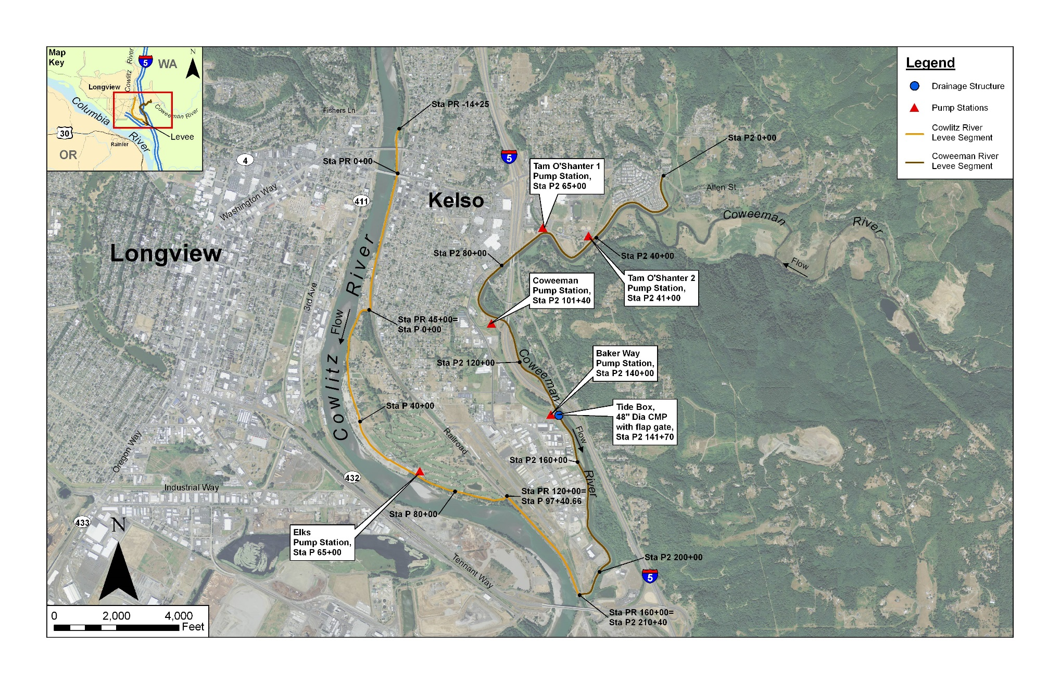
Figure 2-1: CDID3 Project Overview Map (USACE 2010a)

Project Description and Stationing
The CDID3 system is a federally authorized and non-federally operated and maintained urban flood damage reduction system in Cowlitz County, Washington. The CDID3 system was designed to provide flood risk reduction at Kelso, Washington from high flows on the Cowlitz and Coweeman Rivers. Originally comprised of two districts, Cowlitz #13 and Cowlitz #2, the current levee system of CDID3 system consists of two levee segments: (1) the Cowlitz River Levee Segment, located on the left bank of the Cowlitz River between River Mile (RM) 2.0 and RM 7.3; and (2) the Coweeman River Levee Segment, located on the right bank of the Coweeman River from approximately RM 3.8 to its confluence with the Cowlitz River. The Cowlitz CDID3 FDR Project consists of approximately 21,925 linear feet of earthen levee along the Cowlitz River, 21,040 linear feet of earthen levee along the Coweeman River, a drainage structure penetrating the levee embankment, and five pump stations. The 1,360-acre leveed area is just over a mile wide at its widest point.
Three stationing systems are present throughout the project area. Station P₂ 0+00 is located at Allen Street, at the northern end of the Coweeman River Levee Segment, and continues south along the Coweeman River to its junction with the Cowlitz River at approximately Station P₂ 210+40. Station P_{R} -14+25, located north of West Cowlitz Way, marks the northern end of the Cowlitz River levee system. The Coweeman River segment extends south along the Cowlitz River past Station P_{R} 0+00 at Allen Street, continues south until it branches off from the Cowlitz River, and continues south along the Northern Pacific Railroad from approximately Station P_{R} 45+00 to Station P_{R} 125+00, where it again meets up with the Cowlitz River and continues until Station P_{R} 150+00. Station P 0+00 begins at Station P_{R} 45+00, at the point where P_{R} stationing branches off along the railroad, and continues south along the Cowlitz River to approximately Station P 97+40.66, where P_{R} stationing rejoins the Cowlitz River (Drawing CLW 67-10/1; USACE 1965). Detailed information specific to the project features is included, below, in Table 2-1.
Table 2-1: Summary of System Features (USACE 2010a)
Project Station (ft) |  | Feature  Type | Description | Station  Length (ft)
Start (U/S) | End (D/S)
P_{R} -14+25 | P_{R} 45+00 | Cowlitz River Levee | Earthen levee with riprap | 5,925
P_{R} 45+00/  P 0+00 | P 160+00 | Cowlitz River Levee | Earthen levee with riprap | 16,000
P 65+00 |  | Pump Station | Elks Pump Station | N/A
P₂ 0+00 | P₂ 210+40 | Coweeman River Levee | Earthen levee with riprap | 21,040
P₂ 41+00 |  | Pump Station | Tam O’Shanter No. 2 | N/A
P₂ 65+00 |  | Pump Station | Tam O’Shanter No. 1 | N/A
P₂ 101+40 |  | Pump Station | Coweeman | N/A
P₂ 140+00 |  | Pump Station | Baker Way | N/A
P₂ 141+77 |  | Drainage Structure | 48-inch diameter CMP with Tide box with flap gate and slide gate | N/A

Local Sponsor
The local sponsor for this project is the Consolidated Diking Improvement District No. 3 of Cowlitz County, located in Kelso, Washington as summarized in Table 2-2. The Cowlitz County Public Works Department provides technical support to CDID3 in matters pertaining to the operation and maintenance of the levee system.
Table 2-2: Local Sponsor Contact Information
Local Sponsor | Cowlitz County Consolidated Drainage Improvement District No. 3 (CDID3)
Point of Contact | Ms. Susan Eugenis, P.E., Cowlitz County
Address | 1600 – 13th Avenue South, Kelso WA 98626
Phone No. | (360) 577-3030
Email | eugeniss@co.cowlitz.wa.us

Authorized Height
The original Coweeman River Levee, built in 1915, was designed with one foot of freeboard above the 1876 Columbia River flood level. In 1935 and 1936, a Works Progress Administration (WPA) program helped to raise the height of the Coweeman River Levee to provide 3 feet of freeboard above the December 1894 flood height on the Columbia River (USACE 2010a). It is currently authorized to three feet of freeboard above the 1894 level (USACE 1989, USACE 1952). The 1894 flood height at Longview was between 23.7’ NGVD29 (USACE 1966) and 24.3’ NGVD29 (USACE 1962).
The original Cowlitz River levee was built to a height of 2 feet above the 1876 flood level at the downstream end, and to a height of 5 feet above the 1876 flood level at the upstream end. In 1936, the WPA improved the levee to provide 3 feet of freeboard above the 1933 flood level. It remained at this authorized level until the volcanic eruption of Mt. St. Helens in 1980, and the levee was raised in response to the sedimentation from this event. The height of the Cowlitz River Levee Segment is currently authorized to provide protection for a 1 in 143-year flood (USACE 1982; USACE 1987), as confirmed in the Cowlitz River Levees Safe Water Level Study (USACE 2010d).

Construction and Improvements
The Consolidated Diking Improvement District No. 3 of Cowlitz County was organized by the local sponsor in December, 1960, by combining Cowlitz County Diking Improvement District No. 2 (CDID2), whose levee ran along the Coweeman River, and No. 13 (CDID13), whose levee ran along the Cowlitz River. CDID2 and CDID13 were organized in 1913 and 1918, respectively (USACE 1969), and the two diking districts were separated by the Northern Pacific Railroad embankment. The 1950 federally authorized project at CDID13 and CDID2 was completed in 1965 after the two districts had formed together.
Drawings on file at the Portland District USACE depict layouts for both the Cowlitz River and Coweeman River Segments—Figure 2-2 and Figure 2-3 depict typical improved levee cross-sections for both the Cowlitz and Coweeman segments. The Cowlitz River Levee Segment has a varying crown-width of 12 feet to 30 feet whereas the Coweeman River Levee Segment varies from 12 feet to 20 feet in width. The original Cowlitz River Levee Segment had flatter slopes but was steepened to 2H:1V on the riverward side and 1.5H:1V to 2H:1V on the landward side for the emergency improvements after the Mt. St. Helens eruption. Emergency improvements were completed without engineering analysis since they were assumed to be temporary improvements. The Coweeman River Levee Segment is shown to have a side-slope of 2H:1V on both the riverward side and the landward side (USACE 1987). EM 1110-2-1913, paragraph 6(c), requires that levees should have a side-slope flatter than or equal to 2H:1V. In several instances, the field-verified conditions of the levee segments do not meet current levee design criteria (USACE 2000).
Figure 2-2: Typical Improved Coweeman Levee Section (USACE 1976)
Figure 2-3: Typical Improved Cowlitz Levee Sections “A” and “B” (USACE 1976)
Both the Cowlitz and Coweeman River Levee Segments have seen various changes since their original construction as separate districts, ranging from increasing freeboard height to adding protective riprap. Pertinent major modifications to CDID3 system project include the following:
- 1949: Borrow pit adjacent to the Coweeman Levee was backfilled by USACE, and the railroad embankment was buttressed with sand fill to the height of the 1894 flood elevation.
- 1956: USACE placed materials at the landward toe of the levee embankment to construct a seepage blanket due to seepage noted in 1948.
- 1960: In order to resolve freeboard deficiencies, the Coweeman levee was raised approximately 2.5 feet between Station P₂ 24+00 and Station P₂ 40+50, using about 11,000 cubic yards of locally-sourced clayey, sandy gravel.
- 1965: Raised and strengthened Cowlitz levee with riprap, installed toe drains, added additional pumping capacity, and filled depressions adjacent to the landward toe of the levee.
- 1980-1981: USACE completed emergency improvements to the entire length of the Cowlitz Levee by raising or reinforcing the embankment to provide flood protection against the 100-year event due to sedimentation of the Cowlitz River as a result of the Mt. St. Helens eruption.

Characterization of Flood Hazard
Flooding on the Cowlitz and Coweeman Rivers can occur in the rain flood and snowmelt seasons:
- Spring (snowmelt): Flooding in the Columbia River Basin can be caused by snowmelt runoff in the spring freshet. While the Cowlitz and Coweeman rivers are typically low during this season, high Columbia River stages can cause backwater flooding up to the levee. As discussed later, significant reservoir regulation has curbed much of the severity of spring flooding.
- Winter (rain flood): The primary source of flood risk at CDID3 comes from heavy rains during the winter. The most severe winter floods occur from a large rain event on snowpack. Heavy, warm rains on a sizable snowpack can cause a rapid melt, leading to flooding. Winter flood events at CDID3 tend to be quick, typically lasting only a few days at most. Flooding is also impacted by the Columbia River stages and tidal effects. Tidal effects from the Pacific Ocean reach the Coweeman River and can increase the flood stage height.
The frequency of high water events has changed through time. Three historic events have significantly impacted flood risk at the CDID3 levee:
- Upstream Columbia River Regulation (1973): When the Coweeman and Cowlitz levees were first built, there was no significant reservoir regulation upstream. In 1973, the reservoir system upstream on the Columbia River was nearly fully constructed. The completion of Canadian storage reservoirs with flood risk management purposes, combined with U.S. reservoirs, greatly reduced the frequency and severity of spring freshet flood events.
- Upstream Cowlitz River Regulation (1968): The completion of Mayfield and Mossyrock reservoirs on the Cowlitz altered the seasonal distribution of flows and the frequency of high flow events. The Mayfield/Mossyrock complex significantly reduces the risk of high flow events on the Cowlitz in the winter.
- Mt. St. Helens Eruption (1980): The eruption of Mt. St. Helens sent large quantities of sediment down the Cowlitz River. The sedimentation of the Cowlitz River bed raised water surface elevations. In response, levees along the Cowlitz River were raised to maintain levels of protection, but the Coweeman River levee was not raised as a result of the eruption.
The CDID3 system handles interior drainage emanating from approximately 1,960 acres. Pumping requirements are designed around assumed rainfall frequency events (USACE 1962). CDID3 currently has a separate contract to complete an interior drainage study, which will be included with the full Phase 2 levee evaluation.

Performance History
Inspections of the CDID3 system have been conducted regularly beginning in 1974. The CDID3 system has generally received good reviews from previous inspections using the Levee Encroachment Standards and Procedures, PDR 1130-2-5, 17 March 1980, and since 2007 with the Levee Inspection Checklist. A continued requirement for maintenance of overgrowth of vegetation has been highlighted in inspections. The first Periodic Inspection was conducted in 2010 in accordance with Engineering Regulations (ER) 1110-2-100 (1995).
In these inspections, individual components of the levee system are rated as Acceptable (A), Minimally Acceptable (M), or Unacceptable (U). Based on criteria set forth in current USACE guidance, the following definitions apply:
- Acceptable: The inspected item is in satisfactory conditions, with no deficiencies, and will function as intended during the next flood event.
- Minimally Acceptable: The inspected item has one or more minor deficiencies that need to be corrected. The minor deficiency or deficiencies will not seriously impair the functioning of the item as intended during the next flood event.
- Unacceptable: The inspected item has one or more serious deficiencies that need to be corrected. The serious deficiency or deficiencies will seriously impair the functioning of the time as intended during the next flood event.
Every routine inspection to date has resulted in an “acceptable” system rating (2007, 2010, 2012, and 2014). The CDID3 system received an Acceptable rating in the 2010 Periodic Inspection for its Operations Manual for the entire levee system. The Emergency Action Plan, which needs updating to reflect current personnel, equipment, and general information, was rated as Minimally Acceptable. USACE guidance, EC 1110-2-6067, has specific requirements for both the Operation Manual and the Emergency Action Plan for levee system evaluation for NFIP certification; and therefore, these plans may need to be updated prior to completion of Phase 2.

Stream Gages
Stream gages provide the foundational data for this study, so a detailed discussion of the data availability and quality in the basin is provided here.

Data Availability
The Cowlitz River Basin has fairly good streamgage coverage due to the lasting impact of the Mount Saint Helens eruption and the successive need for continual monitoring. A network of water surface recorder gages (HOBO/Sutron/Global Water) were installed by USACE in the mid 2000’s and provide short-interval (15 minute) data along the lower Cowlitz River. While many of these gages have been discontinued over the years due to lack of funding, they provide valuable information during large events.
On the Cowlitz River, the only gage within the boundaries of the CDID3 levee is the Gearhart Gardens gage, which was operational in 2008-2009. The only gage at which a flow measurement is taken on the lower Cowlitz is the USGS gage at Castle Rock (14243000)—the other seven gages record water surface elevation.
The Coweeman River does not share the same degree of gage coverage as the Cowlitz River.
- There is one USACE water level gage on the Coweeman River under the most upstream I-5 bridge crossing.
- There is one streamgage site where a rating curve allows for a flow calculation on the Coweeman River, about 8 miles upstream of the mouth. USGS operated the gage from 1950-1984, and then the gage was discontinued until 2006. At this point, the Washington Department of Ecology (Ecology) restored the old gaging site to operation. However, Ecology has a different mission than the USGS, and the primary purpose of Ecology is not to estimate high flow events. Therefore, few field measurements have been taken during high flow events, and no reliable flow estimate was provided by Ecology for the December 2015 event, which was the highest stage reading on record.
- CDID3 has two staff gages on the Coweeman River: one at the Coweeman pump station, and one at the Tam O’Shanter pump station. These staff gages are read by pump station personnel periodically during high water events and archived in log books, which were provided by CDID3.
On the Columbia River, the water elevation recorder at the Port of Longview provides reliable historic data. The gage station is located just downstream of the mouth of the Cowlitz River at river mile 66.3. The Corps of Engineers archived readings at the Longview gage beginning in 1974, and NOAA assumed operation of the gage in 2002. The gage is located just upstream of the I-5 bridge over the Columbia at Longview.
Figure 2-4 shows an overview of the gaging stations in the project area.

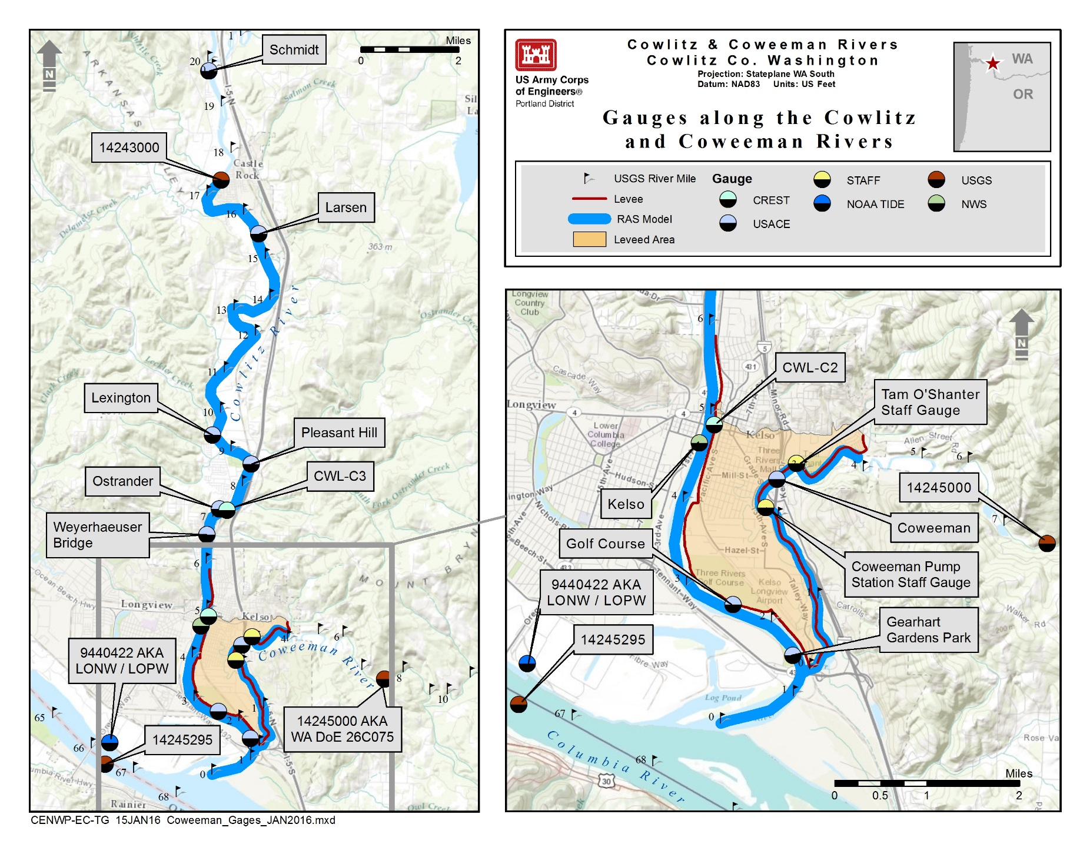
Figure 2-4: Lower Cowlitz Basin Gages

Datums
In accordance with USACE policy, all elevations in this study are referenced to the North American Vertical Datum of 1988 (NAVD88). The National Geodetic Vertical Datum of 1929 (NGVD29) may be found on historic documents, but it is no longer used institutionally. Unfortunately, in the Lower Columbia River, vertical datums are often a source of confusion. A brief summary of the vertical datum adjustments used in this report is provided here (see Table 2-3):
- Columbia River. At the Longview (RM 66.3) and Rainier gages (RM 67.5), gage zero is set to the Columbia River Datum (CRD). In the vicinity of Longview, CRD is a sloping datum that approximates the lowest expected water surface elevation of the Columbia River. USACE established CRD in 1911, and USACE is the authoritative source on the definition of CRD. Recently, USACE discovered an inconsistency in CRD to NAVD88 conversion near Longview (USACE 2014a). The numbers provided in this report reflect the most current understanding of CRD. As of January 2016, the NOAA website lists a conflicting number for the datum shift from CRD to NAVD88 at the gage location (2.49’), but the USACE version is used here (2.62’).
- Coweeman River. For the USACE water level recorder, the conversion from gage reading to NAVD88 was established by a survey on February 22, 2008. Since the water level recorder measures depth rather than absolute height, the conversion factor is larger for that point than the other nearby gages. Datum shifts for the staff gages were provided by CDID3 surveys. The conversion for the Tam O’Shanter staff gage is only valid from November 2015 to the present.
- Cowlitz River. Water surface elevations are not of much interest on the Cowlitz River for this study, except as a check on hydraulic model calibration.
Table 2-3: Vertical Datum conversions
Gage Location | Conversion From:  Gage Reading  to:  NAVD88 | Conversion From:  NGVD29  to:  NAVD88
Columbia River at Longview (RM 66.3) | +2.62’ | +3.2’
Columbia River at Rainier (RM 67.5) | +2.74’ | +3.2’
USACE Coweeman Water Level Gage | +7.10’ | +3.3’
Coweeman Pump Station Staff Gage | +3.33’ | +3.3’
Tam O’Shanter Pump Station Staff Gage | -0.45’ | +3.3’
USACE Gearhart Gardens Water Level Gage | +5.72’ | +3.3’

Recent Hydraulics and Hydrology Studies
The Lower Cowlitz basin has been studied extensively in the past due to the impact of the Mount St. Helens eruption. Since much of this report draws from previous studies, the most relevant hydraulics and hydrology studies are summarized below:
- 2009 Level of Protection (LOP) Report (USACE 2010b): This complete hydraulic and hydrologic analysis of the Lower Cowlitz River evaluated the expected levels of protection of the Cowlitz River levees. Pertinent information from this report includes flow frequency curves and water surface profiles for various flood frequencies along the Cowlitz River. Risk and uncertainty were included in this report, as opposed to deterministic approaches. The Coweeman River levee was not included in this report.
- 2009 Study of Cowlitz Sedimentation on the Coweeman River (USACE 2010c): This report found that sedimentation on the Cowlitz significantly influences water surface elevations on the Coweeman River levee throughout its entire length.
- 2015 Flood Insurance Study (FIS) (FEMA 2015): The effective FIS was completed recently, but does not include detailed hydraulic modeling for the Lower Coweeman River. It draws on the 2009 LOP report for the Cowlitz, but assumes the flooding mechanism on the lower Coweeman River is purely backwater from the Columbia. There is no slope to the 1% Annual Chance Exceedance (ACE) flood profile on the Lower Coweeman River—it is a constant 22.7 feet NAVD88 for the length of the Coweeman levee (Panel 41P). Prior studies have shown that there is some slope to the water surface elevation for large flood events (USACE 1969). The 1% ACE flood profile in the effective FIS appears to be underestimated: observed water surfaces have exceeded 24’ three times in the past twenty years.
- Phase 1 Levee System Evaluation (USACE 2013a): The Phase 1 assessment is a screening level analysis that quickly identifies any potential areas of deficiency that would impede FEMA accreditation. The Phase 1 assessment evaluated available hydraulic data to estimate the 1% ACE flood water surface elevation and compared this to existing survey data of the top of levee elevation. The hydraulic model from the 2009 study was used, and perfect correlation was assumed between the Columbia, Cowlitz, and Coweeman Rivers. This was a conservative assumption to identify whether the levee would qualify under the most extreme conditions. The resulting 1% ACE water surface profile was combined with minimum freeboard requirements to estimate the minimum levee height requirements. The Phase 1 report indicates that the levee crest elevation does not meet minimum freeboard requirements at the upper end of the Coweeman levee. The Phase 1 report recommended a more detailed investigation of the coincidence of the three flooding sources to get a more complete analysis of the 1% ACE flood with associated uncertainty.

Study Approach
The requirements of EC 1110-2-6067 are risk based and specified in terms of Conditional Non-exceedance Probability (CNP). The CNP of a flood event provides the likelihood that a levee will perform adequately during an event of specified magnitude. A levee is eligible for accreditation if it provides a 90% CNP of excluding the 1% annual chance exceedance (ACE) flood. In this case, the levee must also provide 3’ of freeboard above the 1% ACE flood, with additional freeboard requirements near bridges, constrictions, and at the upstream end of the levee. Alternately, the levee may provide only 2’ of freeboard above the 1% ACE flood if it provides a 95% CNP of excluding the 1% ACE flood. The 1% ACE flood is synonymous with a “100-year” flood, but the exceedance probability terminology is used in this report.
For most levee evaluation studies, the approach is clearly laid out in EC 1110-2-6067. Typically, flow-frequency curves are combined with flow-stage curves (rating curves) to develop the 90% CNP of the 1% ACE event. Uncertainty incorporated into both input curves propagates to the final stage numbers with confidence limits. The Hydrologic Engineering Center’s (HEC) Flood Damage Reduction Analysis (FDA) software is typically used for these simple cases.
However, peak stages on Coweeman levee system are affected by three flooding sources: the Cowlitz River, the Coweeman River, and the Columbia River. All three sources contribute to the peak stage seen by the levee, and they are partially correlated (neither independent nor perfectly correlated, see Section 6). EC 1110-2-6067 states that in cases such as these, the analysis can be quite complex and case specific analysis is necessary. The HEC-FDA software is not designed to handle these situations, so a different approach is required.
Since the Lower Coweeman River cannot be accurately represented with a simple flow-stage rating curve, a hydraulic model is used instead to generate predictions of peak water surface elevation experienced at the levee for a given storm event. The HEC-River Analysis System (RAS) software is used for this hydraulic modeling, and the development of the model is detailed in Appendix A. Once developed, the hydraulic model can be used to predict peak water surface elevations at the levee for a wide range of synthetic events.
To account for the partial correlation between the three flooding sources and the uncertainty of the frequency curves from each flooding source, a Monte Carlo sampling approach is used. In this method, the correlations between the frequency curves from the three flooding sources are calculated first. Uncertainty in the three frequency curves is based upon the years of equivalent record—more years of data reduces uncertainty in the frequency curves. The Monte Carlo process randomly samples a frequency curve for all three flooding sources. Then, an event is randomly sampled from each frequency curve while maintaining the specified cross-correlations. This creates a simulated event, and the hydraulic model calculates the resulting peak stage for this simulated event. This process is repeated many times until convergence of the 1% ACE water surface elevation and associated uncertainty is reached. Statistics can then be calculated from the model runs, and additional sources of uncertainty can then be added to the results. At this point, parameters such as the 90% CNP of the 1% ACE water surface elevation can be retrieved.
While more technically challenging than the traditional levee evaluation approach, the Monte Carlo event-based approach is a better solution than the traditional FDA analysis for an area as complex as the Coweeman River. The Monte Carlo event-based approach here allows each input frequency curve to be fully incorporated into the analysis and allows for partial correlation of flooding sources. For more details on the Monte Carlo simulation process, see Section 7.
After detailed discussion of the development of flow and stage frequency curves used for this study is provided in Section 5, the inputs for the coincidence analysis are detailed in Section 6. The Monte Carlo simulation process is presented in Section 7, and the uncertainty discussion is provided in Section 8. Lastly, final results are shown in Section 9, with conclusions in Section 10.

Frequency Curves
Flood frequency curves provide information on the likelihood and magnitude of large flood events. They are used to generate the flow and stage inputs to the hydraulic model during the Monte Carlo simulation process. Frequency curves are typically calculated from observed gage data, and the understanding of each frequency curve changes through time as new information is gathered. Therefore, this study considers not only the most likely frequency curve based on current understanding, but also explicitly includes the uncertainty around these estimates. This uncertainty is expressed in terms of the equivalent years of record (EYR). More confidence is placed in frequency curves with longer periods of record: the uncertainty associated with a frequency curve shrinks as the EYR increases. Before discussion and presentation of the derivations of the frequency curves for the Cowlitz, Coweeman, and Columbia rivers, the duration and seasonality of frequency curves is given. The locations of the frequency curves for the three flooding sources is shown in Figure 5-1.
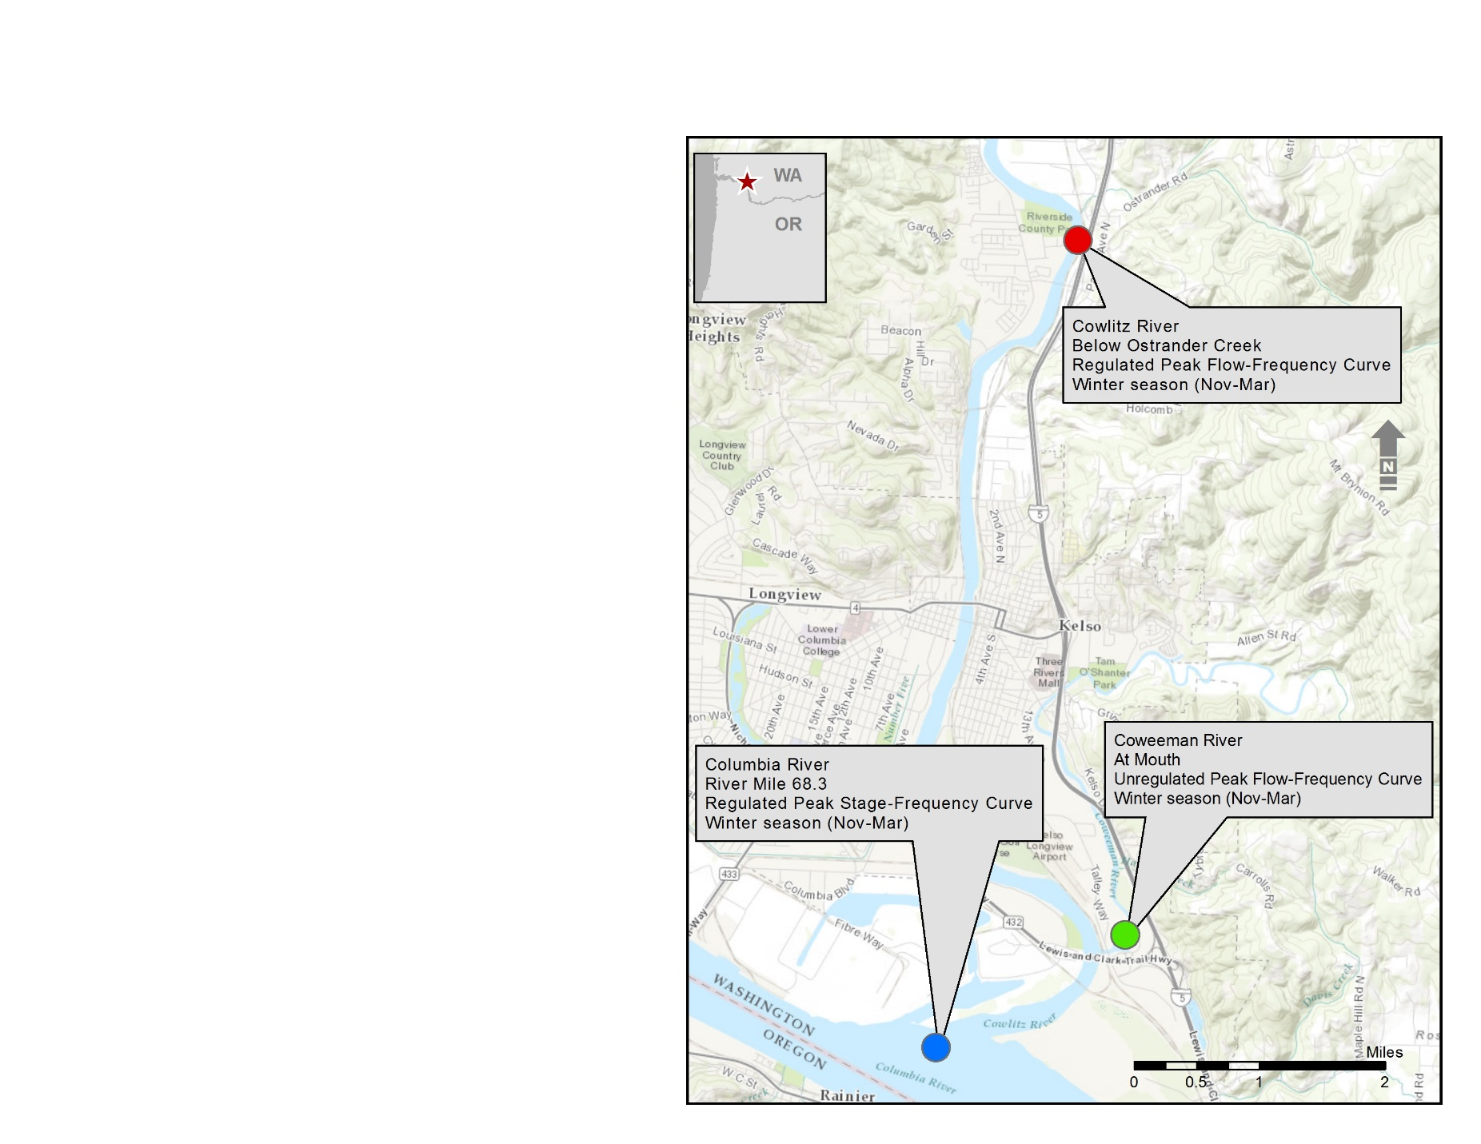
Figure 5-1: Locations of Frequency Curves

Time Duration
For every frequency curve, there is an associated duration of time, which can vary based on the application of the frequency curve. For instance, agricultural users may be interested in the probability of a certain flow volume over a long period of time during which they expect to pump (e.g. 30-day). For this study, the parameter of interest is the peak water surface elevation at the Coweeman levee. Gage records at the levee (shown in Figure 5-2) show that there can be large variability in the water surface elevation during a short period of time (less than 1-day). Therefore, using daily average frequency curves would not be appropriate for this study. Rather, the instantaneous peak is used as the duration for all frequency curves in order to adequately capture the peak water surface elevation experienced by the levee.
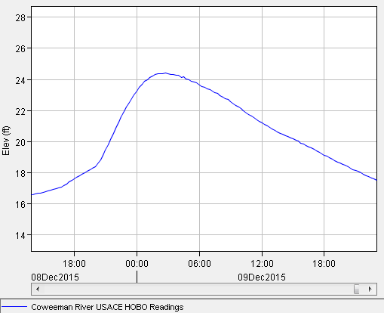
Figure 5-2: Coweeman River gage readings, 8-9 December 2015

Seasonality
One of the goals of this study is to produce an estimate of the 1% annual chance exceedance (ACE) water surface elevation. This provides a water surface elevation that there is a 1% chance of exceeding every year. While the annual number is desired as the end product, breaking the year into separate seasons for interim calculations provides a more realistic estimate in the end for this annual number.
For the purposes of this analysis, the winter (Nov-Mar) season is equated with the annual period. This approach is taken because in the spring and summer, potential for high flows on the Cowlitz and Coweeman is much lower than in the winter, as shown by the daily average seasonal frequency curves in Figure 5-3. At Castle Rock, the peak flow values almost always occur during the winter. From 1927 to 2014, 82 of the 88 annual peaks occurred between November and March, and the peaks that occurred outside those months are on the lower end of the flow frequency curve when no significant winter storms occurred. While the Columbia River can have high peaks during the spring due to the freshet, the spring frequency curve is lower than the winter frequency curve for large events (see Figure 5-7). The fact that the Columbia frequency curve is lower, combined with the fact that the Cowlitz/Coweeman frequency curves are greatly reduced in the spring, allows the spring period to be ignored for this study. If the spring period were included in the analysis, it would be completely dominated by the winter results for large events. The results from this study should not be used to infer the water surface elevations for smaller events (e.g. 50% ACE), since the spring season would affect those values.
The use of a winter season maximum frequency curve implies that the winter maximum for the three flooding sources occurs during the same event. This is a reasonable assumption, since typically the same storm systems impact both the Lower Columbia and Cowlitz basins, causing the highest stages of the winter to result from the same event. In the historical record, all three flooding sources generally experience their maximum winter peak as a result of the same storm event (e.g. February 1996, January 2009, December 2015).
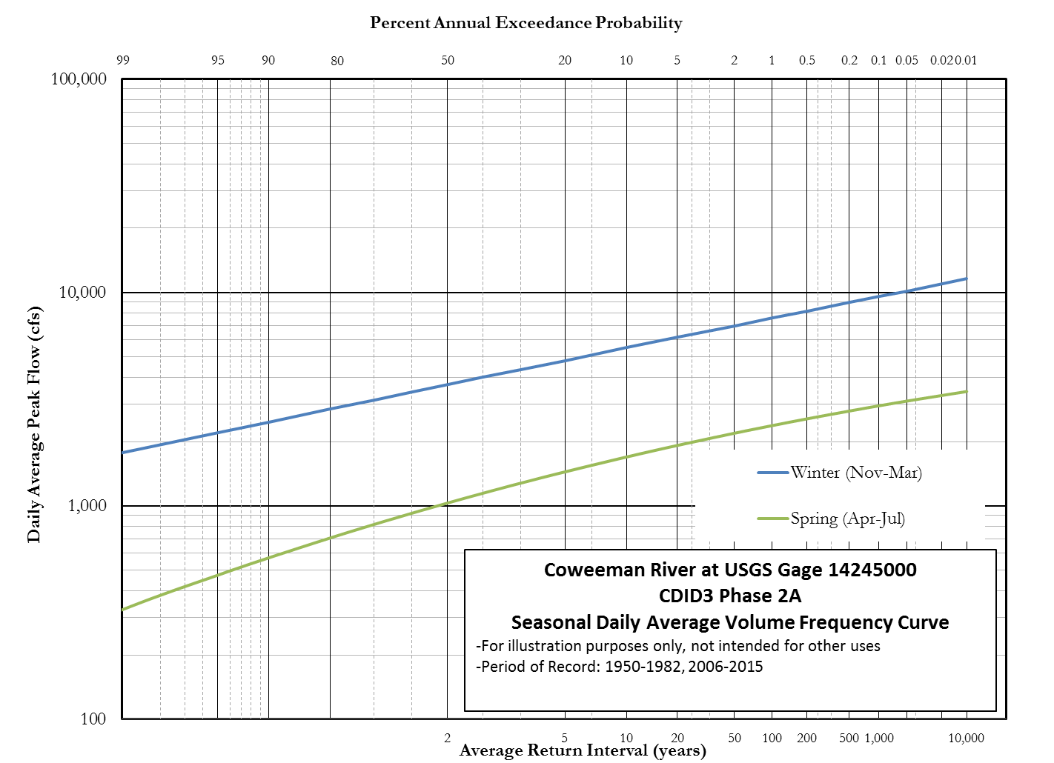
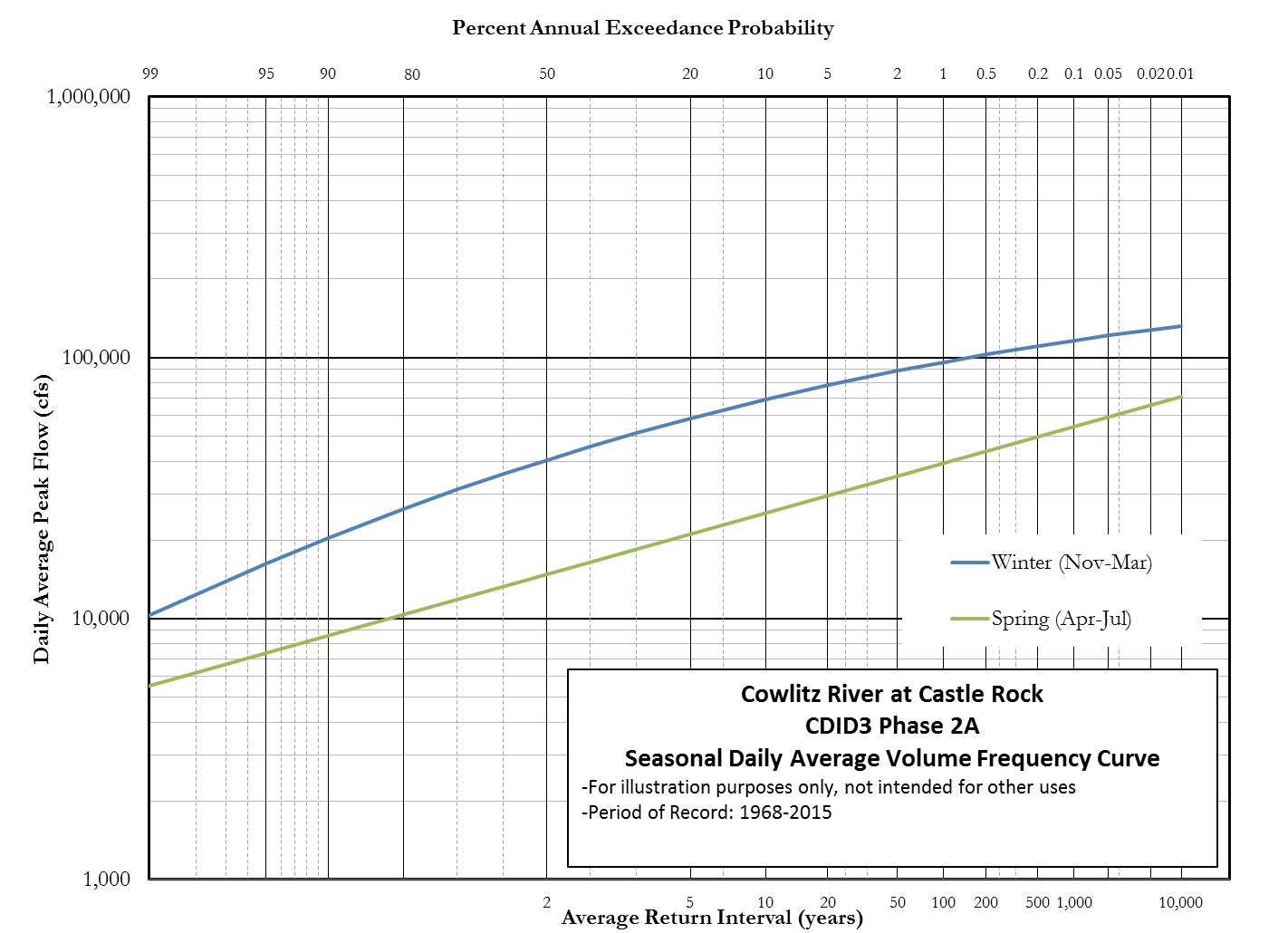
Figure 5-3: Seasonal daily average frequency curves for the Cowlitz and Coweeman rivers

Cowlitz River Flow Frequency Curve
The regulated flow-frequency curve for the Cowlitz River is taken directly from Table 3-1 of the 2009 Level of Protection report (USACE 2010b). It is reproduced in Figure 5-4, with corresponding tabular data given in Table 5-2. Since the flow is regulated, no analytical distribution was assigned to the flow frequency curve. This frequency curve from the 2009 LOP report is assumed to represent the winter season, since nearly all data used to generate it comes from the November-March period. The annual peak occurs between November and March in over 90% of years, and the remaining years largely had small peak flows. This frequency curve was based on a combination of input source data:
- Observed flows from 1969-2009 (period including significant regulation from Mossyrock and Mayfield dams).
- Simulated regulated flows for selected large events prior to 1969
- Conversion of other 1927-1969 peak flows to regulated flows using an unregulated-regulated relationship.
- Peak flows from synthetic hydrology.
The 2009 Level of Protection report assumes 90 equivalent years of record, which is also assumed in this study as an estimate of uncertainty around the peak regulated frequency curve, as shown by the 5% and 95% confidence limits (Figure 5-4).
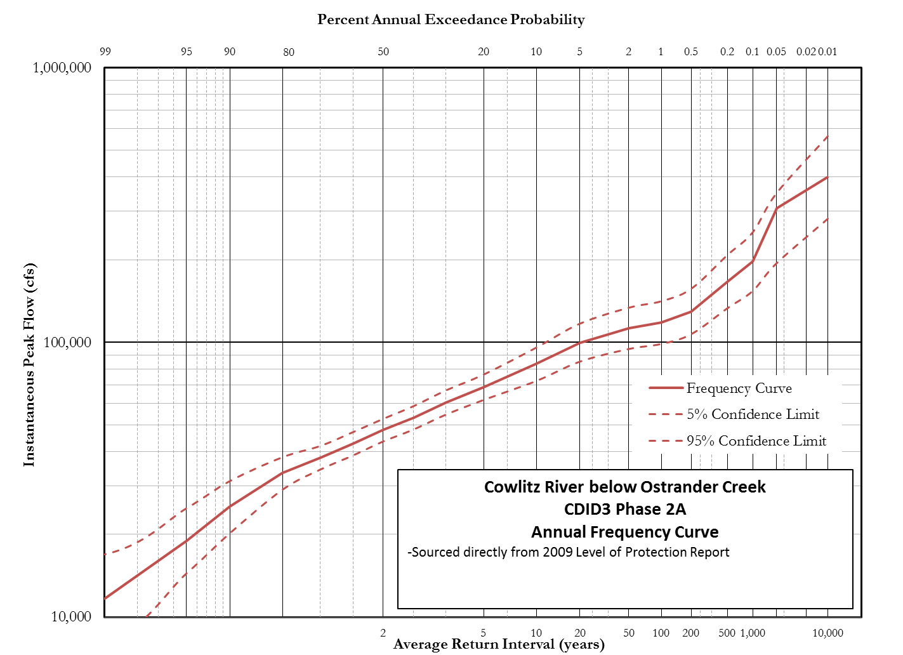
Figure 5-4: Cowlitz River below Ostrander Creek regulated flow-frequency curve

Coweeman River Flow Frequency Curve
While the 2009 Level of Protection report and the Phase 1 analysis for CDID3 provided an estimate of the Coweeman River unregulated flow-frequency curve, they did not include new data from the Ecology gage from 2006-2015 or the estimated peak flow from the December 1933 event. To develop the frequency curve, the 2009 Level of Protection report used USGS peak flows from 1950-1982, and included the flow estimated from the 1996 event as a historic peak. The streamgage site is a few miles upstream of the point of interest for the final frequency curve, so the frequency curve was scaled up using a drainage area ratio.
In this study, the frequency curve is recalculated with the additional data from 2006-2015, as well as the estimated flow from the 1933 event. The methods used for the frequency curve calculation include those found in the draft Bulletin 17C guidance (USGS 2015). While Bulletin 17C has not been published yet, it represents the most current science regarding frequency curves, and is used in many flow-frequency studies today. The modifications it proposes are particularly applicable to a location like the Coweeman River, where there is a broken streamflow record with some knowledge of historic events.
The multiple Grubbs-Beck test methodology outlined in bulletin 17C is used in this study, which more aggressively prevents low flow values from having undue influence on the frequency curve. The expected moments algorithm (EMA) and concept of perception thresholds is included as well. The knowledge that no floods larger than the 1996 flood occurred between 1985 and 2006 helps improve the curve estimate. Furthermore, the December 2015 event was the highest stage on record (1.5’ higher than the 1996 peak stage), but there is no reliable flow measurement or calculation for this event from the Washington Department of Ecology. Since no flow data is available for the 2015 event, it was assumed to have a lower perception threshold of the 1996 event (11,700 cfs), and an upper perception threshold of infinity. The December 1933 had an estimated flow of 12,000 cfs (FEMA 2015), and this was included in the EMA input as a historic event. HEC-Statistical Software Package (SSP) version 2.1.00.32 was used for the calculations.
Table 5-1: Perception Thresholds used in EMA analysis
Start Year | End Year | Low Perception Threshold | High Perception Threshold
1933 | 1949 | 12000 | infinity
1950 | 1984 | 0 | infinity
1985 | 2006 | 11700 | infinity
2007 | 2015 | 0 | infinity
2016 | 2016 | 11700 | infinity

A regional skew estimate was used to improve the frequency curve. A USGS regional skew study calculated a skew value of 0.2 at the Coweeman River gage, with a mean square error of 0.112 (Cooper 2005). This regional estimate was blended with the at-site estimate based on the gaged peak flows to develop a weighted estimate of the frequency curve skew.
The frequency curve was developed at the gage site, but the input to the hydraulic model is further downstream, so the flow frequency curve is scaled up to account for the increased drainage area. Since the drainage area at the mouth of the Coweeman is 127 mi² and the drainage area at the gage site is 119 mi², a simple drainage area ratio adjustment was applied to the frequency curve (127/119=1.07). This adjustment incorporates the small tributaries entering the Coweeman River downstream of the gage.
The use of a nearby streamflow station with more years of data to improve the estimate of the Coweeman frequency curve was explored, but ultimately rejected. The East Fork Lewis near Heisson, USGS gage 14222500 has the best correlation to the Coweeman River (Duren 2015). The two-station comparison method detailed in Bulletin 17B was investigated, but it was not applied because the mean and standard deviation for the East Fork Lewis are similar between the concurrent period and the non-concurrent period (less than 5% difference). Therefore, the frequency curve would have changed very little if the two-station comparison method were applied. Furthermore, the East Fork Lewis gage is approximately 25 miles away.
The final flow-frequency curve for the Coweeman River is shown in Figure 5-5, with tabular data in Table 5-2. Forty-four equivalent years of record are assumed for the Coweeman frequency curve (number of systematic years) confidence limits.
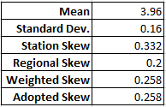
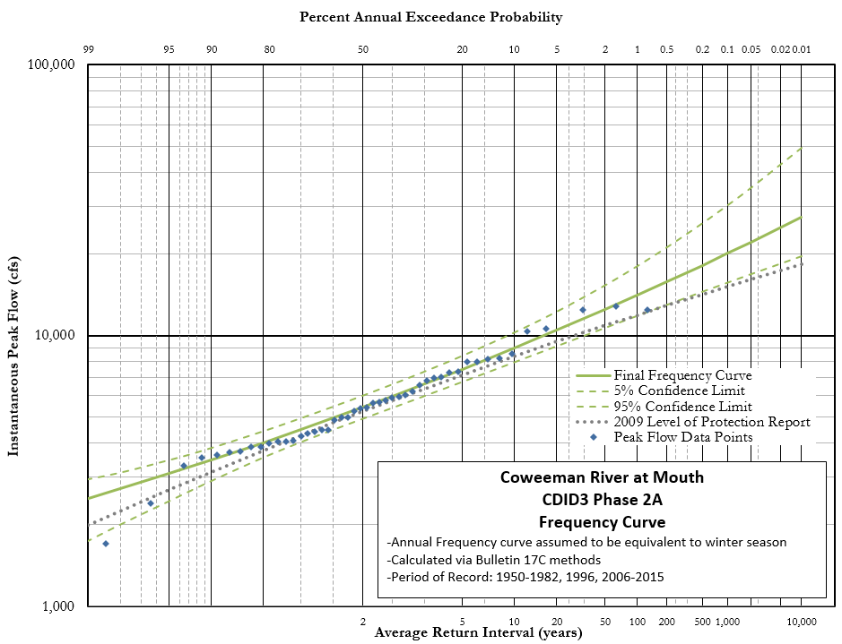
Figure 5-5: Coweeman River at Mouth Unregulated Flow-Frequency Curve

Columbia River Stage Frequency Curve
Since the Lower Columbia River is tidally-influenced, the frequency curve used for the Columbia River is a stage-frequency curve, and will act as the downstream boundary to the hydraulic model. The annual peak stage-frequency curves are well established in the combined Columbia River Flood Profiles, which were generated in the late 1980s (USACE 2007a). The process of computing these curves is detailed in the CRT-63 study (USACE 1991). These frequency curves include regulation effects from reservoirs present in 1975, which has not changed appreciably up to the current time for large events. This is particularly true during the winter season. The effect of regulation on the winter stage frequency curve is more limited than in the spring, as Figure 5-6 shows. The effect of regulation would be further suppressed downstream at Longview (river mile 68) than at Vancouver (river mile 106).
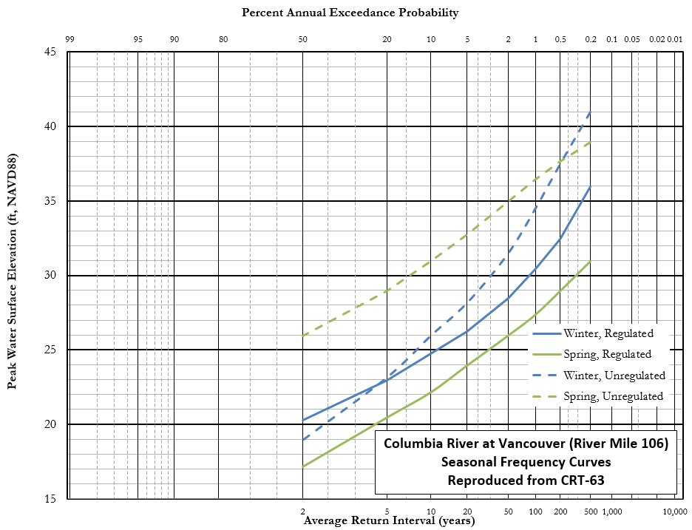
Figure 5-6: Stage-Frequency curves at Vancouver from CRT-63 (1993)
In 2012, the SBU (Survival Benefit Unit) 50% ACE profile was generated, superseding the 50% ACE curves from the CRT-63 study (USACE 2012). This SBU analysis used observed flow data from 1973-2010, assuming fairly homogenous regulation during this period. A HEC-RAS model of the Lower Columbia River was used to run the observed period of record (POR), and the 50% exceedance water surface elevation was calculated from these results. No spring/winter division was made in these curves—the maximum annual for each water year was taken. Different river mileage was used in this study than the previous studies.
The annual frequency curve used in this study is based off the CRT-63 study, and includes the 2012 SBU modification. However, the annual frequency curve includes the effect of both winter and spring events. For the purposes of this report, it is more helpful to break the annual curve into winter and spring components, since the Cowlitz and Coweeman rivers have lower flows in the spring and higher peaks in the winter. The winter and spring curves were derived from various sources of data and manually adjusted so that the combination of the two curves matches the official annual frequency curve. Assumptions made to derive the winter/spring curves are as follows, and the result of the winter/spring derivation is shown in Figure 5-7:
- The profiles in CRT-63 (USACE 1991) were computed by generating winter and spring frequency curves separately, and then statistically combining them. However, the final report does not provide the intermediate spring and winter calculations for all locations, instead providing the final annual curves everywhere. The winter and spring frequency curves used in the analysis could not be located in Portland District files. While the CRT-63 report does not provide complete winter and spring frequency curves for every location, it does include some values for selected locations. For the CDID3 levee, it provides winter and spring stages for the 5%, 1% and 0.2% ACE events. Since the official Columbia River Flood Profiles are based directly off CRT-63 analysis, these values were used directly after conversion to NAVD88.
- Columbia at Longview gage data from 1985 to 2015 was used to calculate the 50% ACE elevation for the winter and spring periods, which was necessary because the 2012 SBU analysis was not separated by season. While this approach would not be valid for estimating less frequent events (e.g. 1% ACE) due to lack of data, 30 years of record provides enough information to make a good estimate of the median stage. This data was used directly in the seasonal curves, and the result of statistically combining these seasonal curves matched the 2012 SBU 50% ACE elevation well.
- Intermediate values of the winter and spring frequency curves were interpolated or filled in manually to ensure the combined annual curve matched the official annual curve. The combined annual curve is calculated via the following equation for any given stage S:
P_{a} = P_{s} + P_{w} – (P_{s})(P_{w}) , where
P_{a} = the annual probability of exceeding stage S
P_{s} = the probability of exceeding stage S during the spring (from frequency curve)
P_{w} = the probability of exceeding stage S during the winter (from frequency curve)
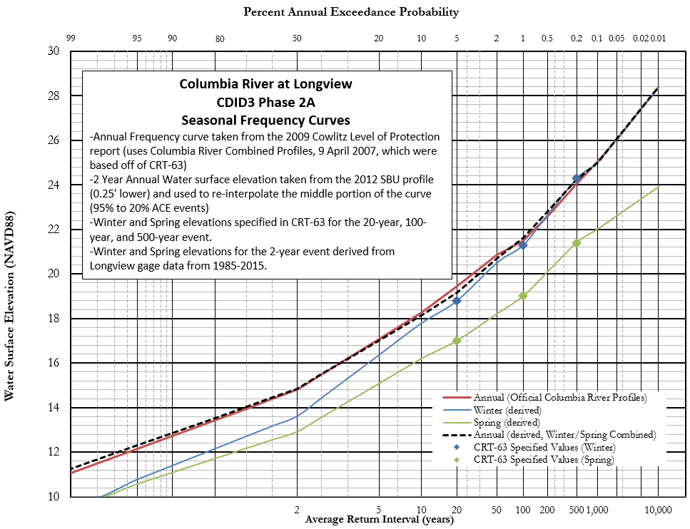
Figure 5-7: Columbia River at Longview Seasonal Stage-Frequency Curves
As Figure 5-7 shows, the winter frequency curve is very close to the annual curve for large events. However, the winter curve is well below the annual curve for the more common events (e.g. 50% event). This has an impact on the study results, since the Cowlitz and Coweeman rivers may experience very high flows even when the Columbia River is at relatively benign levels, and the three components all have an impact on the peak stage experienced by the Coweeman levee. The Phase 1 study used the annual frequency curve, which increased the results in that preliminary analysis. This study uses the winter stage-frequency curve to maintain consistency between the frequency curves of other two flooding sources in keeping with the understanding of the seasonality of flooding for the Coweeman River.
Uncertainty around the stage-frequency curve is not well defined. In the 1990’s, a memo to Peninsula Diking District No. 1 provides some assumptions about the equivalent years of record at Vancouver, stating that the equivalent years of record was 60 years for the spring and 100 years for the winter. Using a weighted average, the equivalent years of record for the combined regulated stage-frequency curves was calculated to be 93 years. For the hydrologic uncertainty in the Peninsula Diking District, 60 years was chosen (USACE 1993). A Phase 2a report for the Scappoose Drainage District assumed only 30 years of equivalent record to be more conservative (USACE 2014b).
In this study, 60 equivalent years of record are assumed as the basis for the confidence limits of the Columbia winter regulated frequency curve. This selection is based upon a few factors:
- The winter frequency curve at Vancouver (river mile 106) has a higher equivalent record length than the spring curve (100 years and 60 years, respectively) (USACE 1993). Longview is further downstream than Vancouver, and is more affected by tides.
- The derivation of stage-frequency curves at Longview (river mile 68) in CRT-63 was heavily dependent on the assumed frequency curve at Wauna (river mile 42). The frequency curves at Wauna are based on observed data alone, since it was assumed that reservoir regulation has no impact on peak stages that far downstream (USACE 1991, Knutson 1985). This historic documentation is unclear on the exact EYR of the Wauna frequency curve, but it is at least 60 years (USACE 1991, Knutson 1985). Hydraulic model runs used Wauna as the downstream boundary condition to generate the upstream profile shape for CRT-63.
Based upon this information, this study considered a reasonably conservative estimate for the EYR length at Longview should by 60 years. This reflects a blend between the EYR at Wauna and Vancouver for the winter season, both of which exceeded 60 years. The final assumed frequency curve and confidence limits used in this analysis are shown in Figure 5-8:
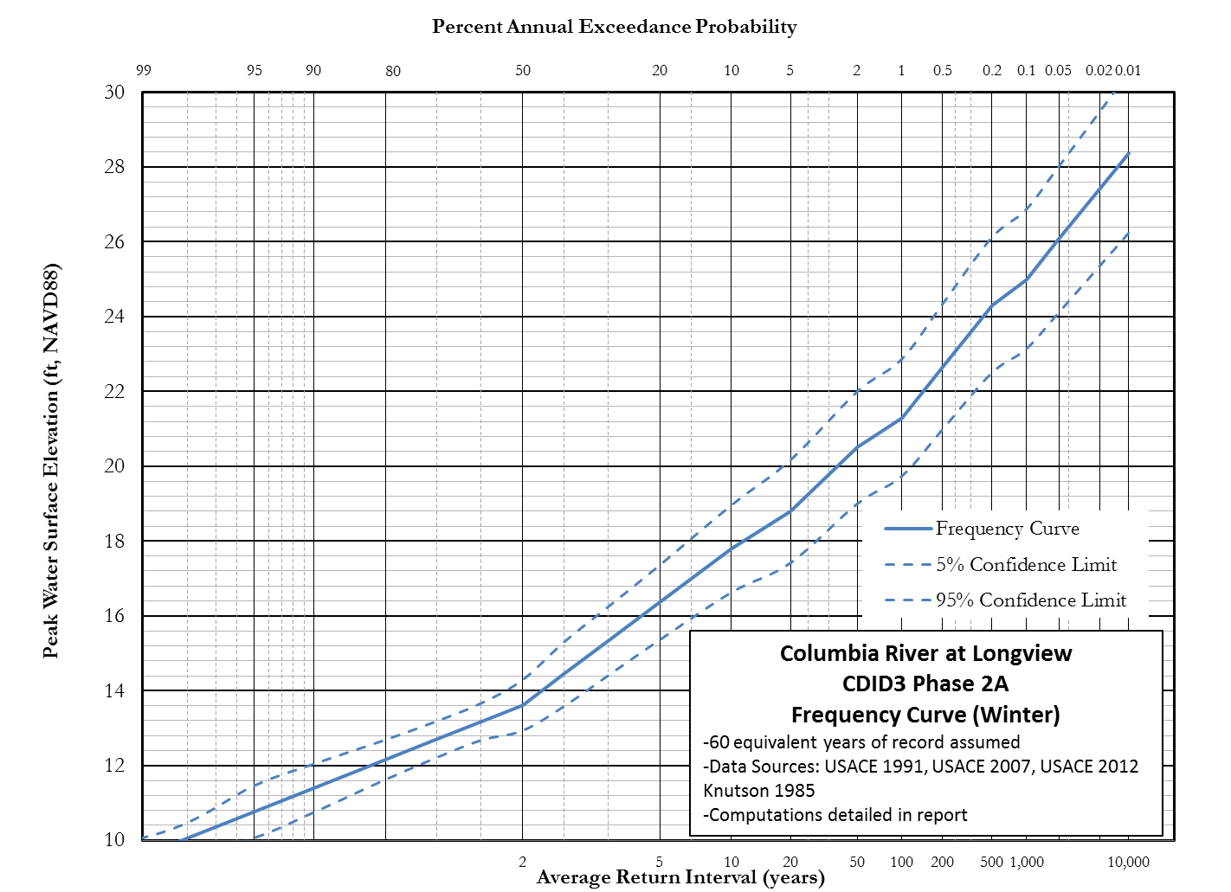
Figure 5-8: Columbia River at Longview Winter Regulated Stage-Frequency Curve

A summary of the final frequency curves used in the analysis is given below in Table 5-2.
Table 5-2: Frequency curve data used in the analysis
Source: |  | Bulletin 17C Analysis | 2009 Level of Protection Report | From various sources
River: |  | Coweeman | Cowlitz | Columbia
Location: |  | Mouth | Below Ostrander Creek | Longview
Regulation: |  | Unregulated | Regulated | Regulated
Season: |  | Winter | Winter | Winter
Type of curve: |  | Log-Pearson 3 | Graphical | Graphical
Time duration: |  | Peak | Peak | Peak
Equivalent Years of Record: |  | 44 | 90 | 60
Return Interval | Percent Chance Exceedance | Flow (cfs) | Flow (cfs) | Elev-NAVD88 (ft)
 | 99.99% | 1,700 | 10,400 | 9.0
 | 99% | 2,500 | 11,700 | 9.6
 | 95% | 3,100 | 19,000 | 10.8
 | 90% | 3,500 | 25,200 | 11.4
 | 80% | 4,000 | 33,400 | 12.2
 | 70% | 4,500 | 38,100 | 12.7
 | 60% | 4,900 | 42,800 | 13.2
2-year | 50% | 5,400 | 48,000 | 13.6
 | 40% | 6,000 | 53,200 | 14.4
 | 30% | 6,600 | 60,500 | 15.3
5-year | 20% | 7,500 | 68,800 | 16.4
10-year | 10% | 9,000 | 83,400 | 17.8
 | 5% | 10,500 | 99,900 | 18.8
50-year | 2% | 12,500 | 112,600 | 20.5
100-year | 1% | 14,100 | 118,200 | 21.3
 | 0.5% | 15,800 | 129,700 | 22.7
500-year | 0.2% | 18,200 | 166,500 | 24.3
 | 0.1% | 20,100 | 197,000 | 25.0
 | 0.05% | 22,200 | 307,500 | 26.1
 | 0.01% | 27,400 | 398,800 | 28.4

Coincidence Analysis Inputs
As discussed, there are three flooding sources that contribute to peak stages on the Coweeman levee:
- Flow on the Coweeman River
- Flow on the Cowlitz River
- Stage on the Columbia River
If the flood sources were perfectly correlated, the 1% ACE event would occur at all three sources at the same time. This assumption was used in the Phase 1 analysis to provide a conservative estimate of the 1% ACE flood. Alternately, if the flood sources were completely independent, then the flood event for each source could be separately randomly sampled. In reality, these three sources of flood loading are partially correlated, which makes the analysis more difficult. The partial correlation between the flooding sources means that the flooding sources generally trend together, but the relationship is not perfect.
Complicating the analysis further, there are actually two relationships between the three sources that affect peak stages:
- Relative magnitude of the event
- Relative timing of the event
It may be possible that the three flooding sources all are experiencing an event of similar magnitude (e.g. 1% ACE event), but they may not be timed concurrently, which reduces the peak stage experienced by the levee. Both of these relationships are accounted for in this analysis, and the methods for doing so are explained in the following sections.

Event Magnitude
To capture the relationship of event magnitude between the three flooding sources, a correlation matrix approach is used. In this approach, the relative magnitudes of historic events are used to calculate correlations between the flooding sources. The criteria for selecting these historic events has an impact on the resulting correlations. General guidelines and constraints for selecting events are as follows:
- There are no reliable peak stage estimates on the Columbia River near Longview prior to 1974. Data from the Columbia River at Rainier gage location is used from 1972-1974.
- Regulation of the Cowlitz River via Mayfield and Mossyrock Dams began in 1968, so no data is used prior to that for the event correlation. There is not much Columbia peak data available before 1968 either, and only 18 years of Coweeman data.
- Since fine-resolution data (instantaneous peak flow/stage) is quite sparse prior to 2007 and typically only the maximum annual event was recorded, only one event per year is used prior to 2007.
- After 2007 when fine resolution data is available, multiple events per year were used if they were suitably large. Since the application of this data is not intended to generate annual flow frequency curves, but rather to capture the relative variability of event magnitude for large storms, such data can provide additional data points to strengthen the analysis.
- Only events with instantaneous peaks within a few days of each other are selected. The correlation should not be influenced by cases where the peak flow for each source occurs from a different storm event.
- The full length of concurrent gage record is used. For instance, the Coweeman gage was inactive from 1986-1996, but the Columbia and Cowlitz gages were still active, and this data was used when generating correlations between the Columbia and Cowlitz. The correlations for each location pair is based on all available data, but the period of concurrent data varies for each relationship pair. While the Coweeman gage record could be extended based on other nearby gages and used for correlation, this approach was not taken, since applying that transformation may simply inject more uncertainty into the relationship.
A summary of the events selected for the correlation analysis is shown in Table 6-1 and Figure 6-1.
Table 6-1: Number of events used to generate correlation matrix
Relationship | Number of events used for correlation
Columbia-Cowlitz | 44
Columbia-Coweeman | 30
Cowlitz-Coweeman | 32

Figure 6-1: Events used for correlation matrix generation

Since the contributing drainage areas for the gages on the Coweeman and Cowlitz Rivers are adjacent, it is intuitive that the correlation between these two sources is strong. This is borne out in the results, but the correlation is not perfect between the Coweeman and Cowlitz. The basins are affected by the same meteorological events, but the resulting discharge ACE for a given storm varies due to differences in watershed size (2,238 mi² vs 119 mi²), the presence of regulation on the Cowlitz, and storm centering. For instance, a high intensity, short duration storm typically results in higher flow ACE values on the Coweeman than on the Cowlitz. These differences cause the Coweeman-Cowlitz correlation to be less than perfect. Due to heavy tidal influence, reservoir regulation, and watershed size differences, the Columbia-Coweeman and Columbia-Cowlitz correlations are relatively weak. While a short duration, intense storm can cause high flows on the Coweeman and Cowlitz, the Columbia Basin is large enough at Longview (~257,000 mi²) that a longer duration atmospheric river event is necessary to produce high stages in the winter.
The correlation analysis here is based on the relative magnitude of the event, which is best described by the event frequency (rather than the absolute flow/stage) for the location of interest. The flow and stage data for each event are transformed into ACE probabilities by interpolating each data point on the frequency curve. The ACE for each event is then transformed to a z-statistic based on the normal distribution, which will then be used to generate the correlation matrix.
As mentioned, the correlations between the three locations is based on all available data, but the period of available data varies for each relationship pair. The difference in correlation between the concurrent period and the full period of record is substantial for the Columbia-Cowlitz relationship: the correlation drops significantly when the full period of record is taken into account (Table 6-2). Since the Cowlitz-Columbia correlation drops and the Cowlitz and Coweeman are well correlated, it follows that the Coweeman-Columbia relationship should be adjusted downward as well, similar to the Cowlitz-Coweeman change in correlation from the concurrent period to the full period of record. If no adjustment were made, the Coweeman-Columbia correlation would be higher than the Cowlitz-Columbia correlation, which is not reasonable based on the concurrent period results. First, the Coweeman-Columbia correlation was adjusted downward by the same ratio as the Cowlitz-Columbia reduction from the concurrent period to the full period of record. However, this calculation has the potential to underestimate the true correlation, since the Cowlitz and Coweeman are not perfectly correlated. To be conservative and produce a higher correlation, the Coweeman-Columbia correlation was then factored up by the strength of the Coweeman-Cowlitz relationship. The following equation was used to adjust the Coweeman-Columbia relationship, and the final results are shown in Table 6-2.

$r_{Coweeman-Columbia, final}=\frac{r_{Coweeman-Columbia,concurrent_POR}\left(\frac{r_{Cowlitz-Columbia,full_POR}}{r_{Cowlitz-Columbia, concurrent_POR}}\right)}{r_{Coweeman-Cowlitz,full_POR}}$

Table 6-2: Adopted Correlation (r) Matrix
Concurrent Period of all 3 gages
 | Coweeman | Cowlitz | Columbia
Coweeman | 1 | 0.818 | 0.464
Cowlitz | 0.818 | 1 | 0.624
Columbia | 0.464 | 0.624 | 1
Full Period of Record for each pair
 | Coweeman | Cowlitz | Columbia
Coweeman | 1 | 0.814 | 0.464
Cowlitz | 0.814 | 1 | 0.358
Columbia | 0.464 | 0.358 | 1
Final Adopted Correlation Matrix
 | Coweeman | Cowlitz | Columbia
Coweeman | 1 | 0.814 | 0.327
Cowlitz | 0.814 | 1 | 0.358
Columbia | 0.327 | 0.358 | 1

Event Timing
The relative timing of the event between the three flooding sources can be as influential as the relative magnitude. The relative timing of the peak flow/stages can vary significantly, as shown by the box-and-whisker plot in Figure 6-2. The events used to generate this plot are the same events described in Section 6.1—the data points are large events where the peaks are within a few days of each other. Generally, the Coweeman peaks first, followed by the Cowlitz, with the Columbia peaking later. The plot implies that the peak stages experienced at the upstream end of the Coweeman levee are generally more influenced by peak flows on the Cowlitz and Coweeman rivers, rather than the Columbia. However, this is not always the case, and there is significant variability in event timing.

Figure 6-2: Box-and-Whisker Plot of event timing variability (2007-2015 data)
To address the uncertainty of event timing, three representative event timings (or “shape sets”) from the observed record are used as surrogates (Figure 6-3). The Coweeman gage record was lagged by one hour to account the fact that the gaging station is upstream of the hydraulic model. Each event in the Monte Carlo process will randomly sample one of the representative events, which will then be scaled up or down based on the sampled event magnitude. Timing patterns from different observed events are not mixed—if the November 2012 pattern is selected for a random sample, the November 2012 shape will apply for all 3 flooding sources. Three representative events (November 2012, February 2012, and January 2011) were selected based upon resolution of available data and variability in event timing and storm type (which can affect event timing). The three selected events capture most of the variability expected in the event timing, and the meteorology for each storm displays a distinct, representative pattern. The November 2012 event was a more typical rain flood event in the Northwest in which a subtropical jet stream traveling north/northeast towards the low pressure region in the Gulf of Alaska merged with a polar jet stream coming in from the north. The February 2012 event was an extratropical cyclone event with a low pressure center that moved south from the coast of British Columbia to the Oregon coast. The January 2011 event was caused by a cold east to west wind trajectory traveling through the Columbia River Gorge while a strong Pacific moisture system moved inland from the west to east. This caused extensive precipitation over the Columbia River Gorge, which started as snow and changed to freezing rain as the air mass warmed from the Pacific frontal system contact. All of these events caused flooding, landslides, and debris flows. These events represent a reasonable sample of extreme storms experienced in the region – atmospheric rivers, extratropical cyclones, and merging of a system coming in from the Columbia River gorge and a Pacific front.
However, the three representative events are not equally likely. Event timings (time to peak of the Cowlitz, Columbia, and Coweeman relative to each other) from 2007-2015 were examined and cataloged to estimate which event timing type is more common. The relative recurrence of the event timing types seen in the period of record 2007-2015 were also consistent with the relative recurrence of meteorological patterns seen in the area. This process was used to assign relative arbitrary weights to the representative events (Table 6-3). In the Monte Carlo process, scenario A will be sampled 3 times as often as scenario C, and scenario B will be sampled twice as often as scenario C.
Table 6-3: Representative events for event timing variability
Scenario | Surrogate Event | Assigned Weight | Scenario Description
A | Nov-2012 | 3 | Cowlitz/Coweeman peak within 4 hours
B | Feb-2012 | 2 | Cowlitz/Coweeman peak within 8 hours
C | Jan-2011 | 1 | Columbia peaks significantly later

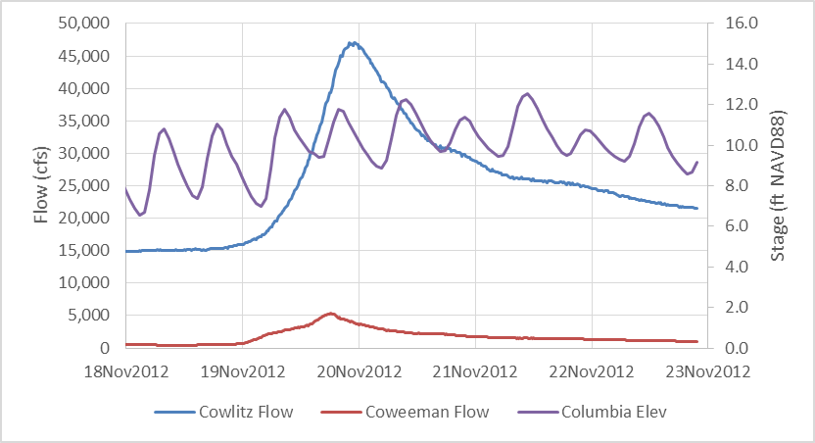
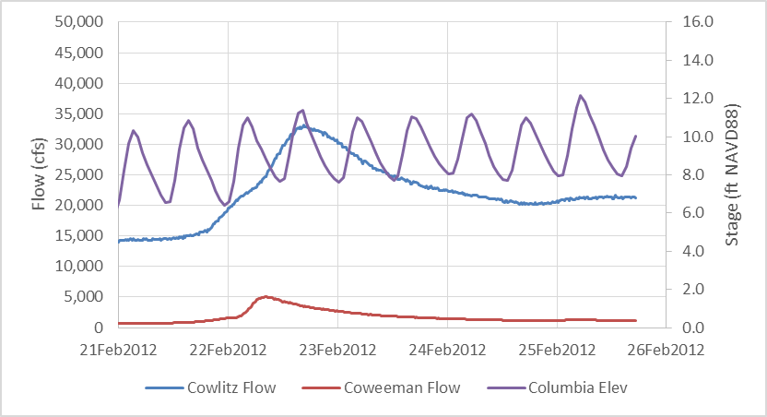
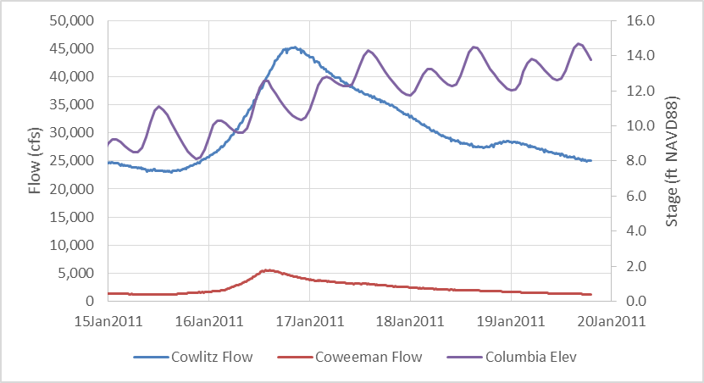
Figure 6-3: Events selected for timing patterns

Monte Carlo Simulations
The Monte Carlo component of this study produces 1% ACE water surface elevations with initial estimates of uncertainty. A generalized “event-based” Monte Carlo simulation involves:
- Quantifying the probability distribution of all input parameters
- Randomly sampling these distributions many times (each sample is an “event”)
- Running each event through a model to get an output parameter of interest
- Calculating statistics of interest from the set of outputs.
It is the most computationally intensive component of the study, since it involves generating thousands of random samples and running them through the HEC-RAS hydraulic model. Two types of variability are sampled in this Monte Carlo process (USACE 2013b):
- Knowledge Uncertainty (epistemic): There is not enough information available to fully know the value of a parameter. An example of this is the uncertainty around a flow-frequency curve. If there were thousands of years of observed data and conditions had remained the same through time, there would be no uncertainty around the frequency curve—it would be known perfectly. When the word “uncertainty” is used in this report, it typically refers to this knowledge uncertainty.
- Natural Variability (aleatory): Many variables are random by nature, and their values change naturally from event to event. Randomly sampling an event from an assumed frequency curve is an example of incorporating natural variability, since the event magnitude for a particular year is not predictable.
Natural variability influences the best estimate of the 1% ACE event, while knowledge uncertainty influences the uncertainty about the 1% ACE event (90% CNP). While the distinction between natural variability and knowledge uncertainty may seem pedantic, it has bearing on the results. If all variability was assumed as natural variability, there would be no uncertainty about the resulting 1% ACE flood. As a result, the 90% CNP would be exactly the same as the best estimate of the 1% event, assuming a large enough number of events were sampled to achieve convergence. In reality, there are many parameters that are not perfectly known, and the knowledge uncertainty concept allows the uncertainty in the results to be decoupled from the number of Monte Carlo simulations. In other words, even if an infinite amount of Monte Carlo samples are computed, there will still be uncertainty about the 1% ACE event when knowledge uncertainty is incorporated.
The Monte Carlo sampling plan in this study uses a two-loop computational structure, with knowledge uncertainty incorporated in an outer loop, and natural variability incorporated in an inner loop. Each iteration of the outer loop is known as a realization, and each iteration of the inner loop is known as an event. Parameters that fall into the knowledge uncertainty category get sampled once per realization, while parameters in the natural variability category get sampled once per event. See Figure 7-1 for a flowchart of the Monte Carlo computations.

Randomly sample a frequency curve for each location
Generate hydrologic inputs for an event, using randomly sampled event frequency and shape
Run HEC-RAS hydraulic model with the sampled inputs, extract peak stage profile
Estimate 1% event from the hydraulic results for the realization
Estimate uncertainty of 1% event from realization 1% event estimates
FINISH
START
Repeat until estimate of uncertainty around 1% ACE event converges
Repeat until estimate of 1% ACE event converges
One outer loop =
One “Realization”
One inner loop =
One “Event”
Figure 7-1 Schematic of Monte Carlo Simulation process
FINISH
Ideally, all sources of uncertainty would be directly incorporated in the Monte Carlo computations, including detailed meteorologic, hydrologic, and hydraulic parameter uncertainty distributions. However, much of this information is resource and time intensive to develop and is beyond the scope of this study. A few additional sources of uncertainty are included in the final results, but are not incorporated into the Monte Carlo simulations (e.g. sedimentation, channel roughness). Therefore, the uncertainty bounds from the Monte Carlo simulations are an initial estimate, and will increase when the other sources are included (see section 8). Since the Monte Carlo modeling results only include uncertainty from frequency curves, the resulting uncertainty in the output stage will be referred to as hydrologic uncertainty.

HEC-WAT model
The Hydrologic Engineering Center’s Watershed Analysis Tool (HEC-WAT) software was used to perform the Monte Carlo simulations. A beta version of HEC-WAT 1.0 was used for this study. While the Flood Damage Assessment (HEC-FDA) is more commonly used for levee safety studies, it is not designed to deal with the coincident analysis approach taken here. HEC-FDA is recommended for use by EC 1110-2-6067, but it allows for other approaches “for systems with partially correlated flooding sources”.
HEC-WAT is software that allows the user to string multiple models together and compute event-based Monte Carlo simulations via the flood risk analysis (FRA) option (USACE 2013b). In the case of the CDID3 system, only two models were combined:
- Hydrologic sampler: Randomly samples frequency curves and event shapes to generate input data for the HEC-RAS model. The output from the hydrologic sampler is a set of event hydrographs with stage at the Columbia River and flow at the Cowlitz and Coweeman Rivers. Inputs to this model include:
  - Frequency curves (section 5)
  - Cross-correlation matrix (section 6.1)
  - Shape sets, or event timing (section 0)
- HEC-RAS model: Transforms the randomly sampled flows and stages into a peak stage along the levee. The calibrated HEC-RAS model described in Appendix A is used.

Normality of 1% ACE Stage Uncertainty
As previously noted, the results from this Monte Carlo process do not include all sources of uncertainty. If the uncertainty from the Monte Carlo runs is normally distributed, it can be combined more easily with the other sources. However, the assumption of normality does not always apply to the uncertainty about the 1% ACE event, and must be demonstrated. The uncertainty often tends to be positively skewed rather than normally distributed. If the 1% ACE event estimates from the Monte Carlo runs are normally distributed, it follows that the hydrologic uncertainty is normally distributed as well. A 1% ACE flood profile is calculated for each realization by taking the 99th percentile of the individual event results, and the final best estimate 1% ACE flood profile takes the 99th percentile of all events in all realizations. Figure 7-2 shows Monte Carlo results from 100 realizations plotted against the normal distribution.

Upper 90% statistic
Figure 7-2: Normality of 1% ACE event distribution

This plot shows that the assumption of normality is not unreasonable. The normal distribution appears to fit the simulated results quite well, especially near the 90% uncertainty value, which is required for this study. The z-statistic for the upper 90% uncertainty interval is 1.28, and the normal distribution matches the model results well around this point. The 90th percentile of the realization estimates is 28.0 ft, while the upper 90% estimate using an assumed normal distribution with the 1.28 z-statistic is 27.9 ft. From the figure, it appears the data may be skewed, but this would mostly affect the extreme values. This may be more of a concern if the 95% statistic were to be computed, but the 95% CNP is unnecessary for this study, as will be shown later.
While the data appears to be normal by inspection, the Kolmogorov-Smirnov goodness-of-fit test provides a quantitative basis for evaluation of the distribution selection. This statistical test tests the null hypothesis (H₀) against the alternate hypothesis (H_{A}):
H₀: The distribution is normally distributed
H_{A}: The distribution is not normally distributed
The p-value from this test is 0.25 (D-value of 0.1), which is well above a typical rejection threshold of 0.05. The test does not provide good evidence for rejecting the null hypothesis, so the distribution of 1% ACE events is assumed to be normal.

Convergence
Monte Carlo analysis requires a sufficient number of runs to accurately calculate output statistics of interest. The point at which the calculated output statistic of interest stabilizes is known as convergence—there is no benefit to creating additional runs after convergence has been reached. Criteria for convergence depend on both the statistic of interest and how precise the output needs to be. If larger errors are tolerable, fewer runs are required.
In this application, the statistics of interest are:
- The 1% ACE flood profile
- The upper 90% uncertainty limit about the 1% ACE flood profile
The 1% ACE flood profile requires more runs to converge than less extreme statistics, such as the 50% ACE flood profile. 100 realizations with 500 events each (for a total of 50,000 runs) provides suitable convergence for the needs of this study. The results of the calculated 1% ACE event for the first few realizations are shown in Figure 7-3.

Figure 7-3: Convergence of 1% ACE estimate for each realization
The figure shows that the estimate of the 1% ACE after 500 events has not fully stabilized. While each individual estimate of the 1% event has variability, the final results taken from accumulating events from realizations is the output of interest, and shows better convergence (Figure 7-4).

Figure 7-4: Convergence of estimate of 1% ACE Event
Since the estimates of the 1% event for each realization have not converged, it is not possible to formally prove convergence of the error of the 1% ACE event. To get a sense of the degree of convergence, the upper edge of a 90% interval around the percent error of the 1% ACE stage is estimated. In this approach, the estimate of the mean of 1% ACE stages across realizations is used as an estimator of the 1% ACE stage. Since the data is assumed to be normally distributed, the following equation can be used to quantify the expected error in the 1% ACE event estimate from using 100 realizations (Faber 2016):
$$\left|\frac{z_{(1-\frac{∝}{2})}S}{\overline{X}*\sqrt{N}}\right|=\%error$$
Where:
$z_{(1-\frac{∝}{2})}$ = z-statistic for significance level α
S = Sample standard deviation
$\overline{X}$ = Sample mean
N = number of realizations
At the upstream end of the levee, using $\overline{X}$=26 (Figure 7-4), S=1.5 (Figure 7-5), α=10%, and N=100, the percent error is approximately 1%, which is quite small. In this case, since the individual estimates of the 1% ACE event have not converged, more realizations are not necessary. Rather, each realization should have more events for this convergence or percent error to be fully meaningful. While more model runs would increase precision, the results of the 1% ACE water surface elevation would not likely change by an appreciable amount.
The 1% ACE water surface elevation is not the only value of interest—the uncertainty about the 1% event is also desired. The uncertainty about the 1% event is assumed to have a normal distribution, as discussed in more detail in Section 7.2. Therefore, the uncertainty about the 1% event can be represented by the standard deviation of 1% ACE estimates from all realizations. A plot showing the convergence of the standard deviation is shown in Figure 7-5.

Figure 7-5: Convergence of uncertainty around the 1% ACE Event
A rigorous quantitative test of convergence is not applied for the standard deviation, but Figure 7-5 shows the results have stabilized by inspection. The estimate of the standard deviation would become more precise with additional realizations, but other uncertainties are combined with this hydrologic uncertainty later, dampening the effect of this parameter on the final results.

Computed 1% ACE Event
The computed 1% ACE event and associated uncertainty from the Monte Carlo analysis are provided in Table 7-1. A graphical plot of these results is shown later in the report in section 9.

Table 7-1: Monte Carlo 1% ACE Water surface elevation results
Coweeman River Station (ft) | 1% ACE Water Surface Elevation (ft NAVD88) | Standard Deviation of 1% ACE WSE (ft), S_{hydrologic}
20016 | 25.98 | 1.52
19347 | 25.83 | 1.53
18776 | 25.55 | 1.52
18197 | 25.35 | 1.54
17368 | 25.22 | 1.56
16411 | 25.10 | 1.58
15269 | 24.80 | 1.58
14914 | 24.68 | 1.59
14408 | 24.68 | 1.61
14029 | 24.67 | 1.61
13846 | 24.56 | 1.61
13796 | 24.51 | 1.61
13669 | 24.44 | 1.62
13430 | 24.31 | 1.65
13221 | 24.23 | 1.66
12824 | 24.11 | 1.69
12613 | 24.10 | 1.69
12527 | 23.94 | 1.64
12335 | 24.01 | 1.64
11680 | 23.92 | 1.66
11137 | 23.78 | 1.70
10939 | 23.60 | 1.73
10669 | 23.52 | 1.76
10428 | 23.51 | 1.76
9350 | 23.48 | 1.79
8607 | 23.28 | 1.84
8149 | 23.19 | 1.86
7854 | 23.22 | 1.85
7373 | 23.18 | 1.86
6880 | 23.06 | 1.89
6374 | 22.94 | 1.93
5826 | 22.91 | 1.95
4892 | 22.83 | 1.99
3956 | 22.81 | 2.01
2995 | 22.78 | 2.02
2297 | 22.76 | 2.04
1841 | 22.73 | 2.06
1526 | 22.63 | 2.10
1129 | 22.58 | 2.14
695 | 22.49 | 2.16
418 | 22.54 | 2.16
349 | 22.54 | 2.16
279 | 22.53 | 2.16
198 | 22.52 | 2.16
149 | 22.51 | 2.16
28 | 22.53 | 2.14
0 | 22.53 | 2.14

As Table 7-1 shows, standard deviation for the 1% ACE event generally ranges from 1.6’ to 2.4’, with more uncertainty near the confluence than at the upstream end. This trend appears reasonable, since the effect of coincidence between the three flooding sources is expected to be more pronounced downstream, where the relative effects from all three sources are seen most clearly. The computed 1% ACE water surface elevation is generally higher than the flat value of 22.7’ assumed in the FIS (FEMA 2015). Table 7-2 shows the computed 1% ACE water surface elevation in relation to other historic events for which there are staff gage readings at the Coweeman pump station.
Table 7-2: Notable peak water surface elevations at Coweeman Pump Station (river station 11680)
Event | Peak Water surface elevation (ft NAVD88)
Computed 1% ACE event | 23.9’
February 1986 | 21.0’
February 1996 | 26.0’
January 2009 | 24.0’

Uncertainty of 1% ACE stage
While the Monte Carlo calculations provide hydrologic uncertainty from frequency curves and coincidence, there are other sources of uncertainty that must be incorporated. EM 1110-2-1619 assumes a normal probability distribution for errors in stage, although this may not always be the case in reality. Since a normal distribution is assumed, uncertainty numbers are provided as standard deviations (S). As described in USACE technical guidance (EM 1110-2-1619), typical sources of uncertainty include hydraulic model and data limitations and natural variations. EM 1110-2-1619 allows for additional hydraulic uncertainty terms to be added when there is legitimate justification and the errors are independent of each other. Sedimentation uncertainty is a concern for the Coweeman River, since the Cowlitz River is just downstream of the Coweeman levee, and sedimentation in the Cowlitz affects water surface elevations through the upstream end of the Coweeman levee (USACE 2010c). The Cowlitz River continues to experience sedimentation effects from the 1980 Mount St. Helens eruption, and the river morphology and thalweg elevation of the Cowlitz have been dynamic over the years. To address the uncertainty associated with single event sedimentation, a sedimentation uncertainty term is added to the total hydraulic uncertainty. The total hydraulic uncertainty is estimated as:
$$S_{hydraulic}=\sqrt{{S_{natural}}^{2}+{S_{model}}^{2}+{S_{sedimentation}}^{2}}$$
Stage uncertainty in EM 1110-2-1619 is geared toward hydraulic uncertainty in a stage-discharge (rating) curve. However, in this study, the hydrologic uncertainty is also accounted for explicitly via the Monte Carlo simulation process. Therefore, rather than uncertainty in a stage-discharge curve, the uncertainty in the final computed stage is the parameter of interest. To combine these sources of uncertainty, the hydrologic uncertainty is combined with the hydraulic uncertainty to produce the total uncertainty, as shown below:
$$S_{total}=\sqrt{{{{S_{hydrologic}}^{2}+S}_{hydraulic}}^{2}}$$
Each element of uncertainty is further detailed in the following sections, and the combination of all sources is shown in Section 8.5.

Hydrologic Uncertainty
The hydrologic uncertainty represents the variability in resulting stages due to the uncertainty in input frequency curves and coincidence analysis using Monte Carlo methods. This term is taken directly from the Monte Carlo results (Section 7.4), and varies by river station. The results (shown in Table 7-1) show that the standard deviation generally ranges from 1.6’ to 2.4’.

Hydraulic Natural Uncertainty
Uncertainty in the computed stage due to natural variation of channel conditions is developed in a more deterministic fashion using sensitivity analysis in the HEC-RAS model. Natural variability is represented in the model as variations in Manning’s roughness coefficient (n). The Manning’s roughness parameter includes both natural variability, which reflects changes in roughness between flood events, and knowledge uncertainty, which reflects the principle that the value cannot be known precisely. As discussed in section 7, natural variability affects the best estimate of the 1% ACE WSE, while knowledge uncertainty affects the uncertainty surrounding the 1% ACE WSE. This section details how natural variability of channel roughness is captured—the knowledge uncertainty is described in the following section.
The natural variability in channel roughness would best be incorporated into the Monte Carlo process directly, which would increase the best estimate of the 1% ACE profile. However, current technology does not allow for sampling of Manning’s roughness directly in the Monte Carlo iterations. For this study, the variation in channel conditions is treated as knowledge uncertainty and subsequently combined with other uncertainty terms. This treatment of Manning’s n is consistent with other approaches used: HEC-FDA treats variation in a stage-discharge rating curve as knowledge uncertainty. Additionally, EM 1110-2-1619 includes a description of hydraulic natural variability, but treats it as if it were an uncertainty term. In the 2009 LOP report, uncertainty in the Cowlitz River water surface elevations is computed by using a 30 percent variation in Manning’s roughness coefficient from RM 0.01 to RM 8.11 and a 14 percent variation in Manning’s roughness from RM 8.11 to RM 20.06, based upon reference documents and the calibration for a range of historic events. This was more appropriate for the study than the general guidance tables in EM 1110-2-1619. In the 2009 LOP report, this variation in Manning’s roughness was assumed to represent four standard deviations and was divided by four to obtain the natural uncertainty in stage.
For the Coweeman River, the natural variability in Manning’s n cannot be estimated by gage data alone, since there is very limited gage data to work with in the lower Coweeman River. Therefore, the general guidance from Figure 5-4 in EM 1110-2-1619 is used. Figure 5-4 of EM 1110-2-1619 indicates that for an n value of 0.04, the standard deviation of n value estimate is 0.012. Variation in Manning’s n will have different impact for events of different magnitude, but the event of interest here is the 1% ACE event. Since the 1% ACE event is unknown and the limited historic record does not contain any suitable events similar to the 1% ACE event, a sampled event from the Monte Carlo process was used for the sensitivity runs that approximated the 1% ACE results.
To calculate the standard deviation in stage from natural variability, the Coweeman River Manning’s n were increased by 0.012 (EM 1110-2-1619), from 0.04 to 0.052. For the Cowlitz River, the same approach as the 2009 LOP study was used, rather than the general guidance tables in EM 1110-2-1619. The 2009 LOP study increased Manning’s n by 14% in the upper reach and 30% in the lower reach, which was assumed to represent two standard deviations. For this study, the Cowlitz River Manning’s n were raised by 7% in the upper reach and 15% in the lower reach (one standard deviation rather than two). The results from this hydraulic model were compared to the results using the calibrated Manning’s n, and the ensuing variation in stage is assumed to represent one standard deviation of the natural variability. Since one standard deviation of the natural variability may not equate to one standard deviation of the 1% ACE stage, this represents a conservative assumption. For a summary of the results, see Table 8-1. The full results of the standard deviation calculation for all points can be found in Table 8-2.
Table 8-1: Sensitivity Analysis for changing Manning's roughness
Coweeman River Station (ft) | Maximum Water Surface from event similar to 1% ACE Flood (ft) | Maximum Water Surface with Manning’s n increased by 1 standard deviation (ft) | Standard Deviation of Hydraulic natural uncertainty, S_{natural}, (ft)
20016 | 26.02 | 27.97 | 1.95
15269 | 24.31 | 26.24 | 1.93
10939 | 22.41 | 24.04 | 1.63
5826 | 21.39 | 22.18 | 0.79
0 | 20.17 | 20.44 | 0.27

Hydraulic Model Uncertainty
Model uncertainty incorporates that uncertainty involved with the model selection and the overall ability of the particular computer model to describe actual water surface profiles. The roughness values that were used to calibrate the computed water surface profile were verified with gage data, measured high water marks, and computed theoretical roughness values. However, the model calibration does not include high quality data for the highest flow events, and calibration results had varying degrees of success (all were within 1 ft). Therefore, model variation from Table 5-2 of EM 1110-2-1619 is based on a fair estimate of Manning’s n reliability. For this case, the table recommends model uncertainty of 0.7 ft.

Sediment Uncertainty
The supply of sediment from the Toutle watershed resulting from the 1980 Mount St. Helens eruption continues to affect the stage-discharge relationship in the Cowlitz River. Movement of channel bedforms and high sediment loads during storm events introduce additional uncertainty in the computed water surface profiles. To address the flooding and sedimentation problems resulting from the eruption of Mount St. Helens (MSH), USACE constructed a single sediment-retention structure (SRS) and dredged in the Cowlitz River. The SRS was completed in 1989, but since 1998 has been operating as run-of-river and in recent years has become less efficient at trapping sediment. The 2015 MSH Limited Reevaluation Report proposed a three phase approach for sediment management: two SRS spillway raises for a total increase of 23’ above the existing crest elevation, grade building structures in the sediment plain above the SRS, and Cowlitz River dredging as needed to respond to unusual events (USACE 2015). However, until a long-term sediment management plan is implemented, uncertainty exists regarding Cowlitz River sediment inflows and related channel conveyance capacity.
To address the uncertainty associated with single event sedimentation, an additional uncertainty term is added to the total uncertainty. The sediment uncertainty for this study was set uniformly to 0.7 ft, which is adopted directly from the 2009 Level of Protection report (USACE 2010b).

Total Uncertainty
The total uncertainty incorporates all uncertainty terms and is used to compute CNP values for the levee. Total uncertainty is computed using the equations shown in Section 8, and results are shown in Table 8-2.

Table 8-2: Uncertainty of 1% ACE Stage
 | Standard Deviation of 1% ACE stage (ft)
Coweeman River Station (ft) | S_{natural} | S_{model} | S_{sediment} | S_{hydraulic} | S_{hydrologic} | S_{Total}
20016.32 | 1.95 | 0.7 | 0.7 | 2.19 | 1.52 | 2.73
19346.84 | 2 | 0.7 | 0.7 | 2.23 | 1.53 | 2.77
18776.42 | 2 | 0.7 | 0.7 | 2.23 | 1.52 | 2.77
18196.73 | 2 | 0.7 | 0.7 | 2.23 | 1.54 | 2.78
17368.18 | 1.98 | 0.7 | 0.7 | 2.21 | 1.56 | 2.79
16410.62 | 1.96 | 0.7 | 0.7 | 2.20 | 1.58 | 2.79
15268.6 | 1.93 | 0.7 | 0.7 | 2.17 | 1.58 | 2.78
14913.97 | 1.93 | 0.7 | 0.7 | 2.17 | 1.59 | 2.79
14408.06 | 1.9 | 0.7 | 0.7 | 2.14 | 1.61 | 2.77
14029.24 | 1.88 | 0.7 | 0.7 | 2.12 | 1.61 | 2.76
13845.79 | 1.9 | 0.7 | 0.7 | 2.14 | 1.61 | 2.78
13795.79 | 1.9 | 0.7 | 0.7 | 2.14 | 1.61 | 2.78
13668.75 | 1.89 | 0.7 | 0.7 | 2.13 | 1.62 | 2.78
13430.26 | 1.88 | 0.7 | 0.7 | 2.12 | 1.65 | 2.79
13220.88 | 1.89 | 0.7 | 0.7 | 2.13 | 1.66 | 2.81
12823.53 | 1.84 | 0.7 | 0.7 | 2.09 | 1.69 | 2.80
12613.11 | 1.8 | 0.7 | 0.7 | 2.05 | 1.69 | 2.78
12526.96 | 1.64 | 0.7 | 0.7 | 1.92 | 1.64 | 2.64
12335.34 | 1.62 | 0.7 | 0.7 | 1.90 | 1.64 | 2.62
11679.89 | 1.63 | 0.7 | 0.7 | 1.91 | 1.66 | 2.65
11136.56 | 1.63 | 0.7 | 0.7 | 1.91 | 1.70 | 2.68
10938.64 | 1.63 | 0.7 | 0.7 | 1.91 | 1.73 | 2.70
10668.83 | 1.59 | 0.7 | 0.7 | 1.87 | 1.76 | 2.70
10427.85 | 1.54 | 0.7 | 0.7 | 1.83 | 1.76 | 2.67
9349.561 | 1.48 | 0.7 | 0.7 | 1.78 | 1.79 | 2.65
8606.666 | 1.29 | 0.7 | 0.7 | 1.63 | 1.84 | 2.60
8148.567 | 1.12 | 0.7 | 0.7 | 1.49 | 1.86 | 2.54
7853.687 | 1.09 | 0.7 | 0.7 | 1.47 | 1.85 | 2.52
7373.456 | 0.99 | 0.7 | 0.7 | 1.40 | 1.86 | 2.49
6879.758 | 0.87 | 0.7 | 0.7 | 1.32 | 1.89 | 2.48
6373.691 | 0.82 | 0.7 | 0.7 | 1.29 | 1.93 | 2.50
5826.038 | 0.79 | 0.7 | 0.7 | 1.27 | 1.95 | 2.51
4892.052 | 0.72 | 0.7 | 0.7 | 1.22 | 1.99 | 2.52
3956.085 | 0.68 | 0.7 | 0.7 | 1.20 | 2.01 | 2.53
2994.813 | 0.67 | 0.7 | 0.7 | 1.20 | 2.02 | 2.54
2296.706 | 0.67 | 0.7 | 0.7 | 1.20 | 2.04 | 2.56
1841.252 | 0.64 | 0.7 | 0.7 | 1.18 | 2.06 | 2.57
1526.031 | 0.6 | 0.7 | 0.7 | 1.16 | 2.10 | 2.60
1128.832 | 0.51 | 0.7 | 0.7 | 1.11 | 2.14 | 2.63
695.117 | 0.38 | 0.7 | 0.7 | 1.06 | 2.16 | 2.63
418 | 0.32 | 0.7 | 0.7 | 1.04 | 2.16 | 2.61
348.735 | 0.31 | 0.7 | 0.7 | 1.04 | 2.16 | 2.62
278.7 | 0.31 | 0.7 | 0.7 | 1.04 | 2.16 | 2.61
197.591 | 0.3 | 0.7 | 0.7 | 1.03 | 2.16 | 2.61
148.971 | 0.27 | 0.7 | 0.7 | 1.03 | 2.16 | 2.61
28.151 | 0.27 | 0.7 | 0.7 | 1.03 | 2.14 | 2.59

Results
For the CDID3 system, the minimum levee height required for USACE to provide FEMA certification is the higher of the following criteria at every point on the levee:
- The 90% CNP of the 1% ACE water surface elevation
- The 1% ACE water surface elevation plus freeboard requirements (3’, with 1’ additional around bridges and 0.5’ additional at the upstream end)
Alternately, a levee may be certified with only 2 feet of freeboard as long as it is higher than the 95% CNP value. In the case of the CDID3 system, the 90% CNP typically results in a higher requirement than the 3 foot freeboard requirement. Since the 90% CNP criteria governs, the alternative criteria (2 feet freeboard with 95% CNP) is not applicable to the CDID3 system. The 1% ACE event is calculated from the Monte Carlo simulations, as described in Section 7.4. The uncertainty of the 1% ACE event used to calculate the 90% CNP value is shown in Section 8. Results showing these two criteria are shown in Figure 9-1. Coincidentally, the 90% CNP values tend to be quite close to the 3 foot freeboard requirement for this system, especially at the downstream end.

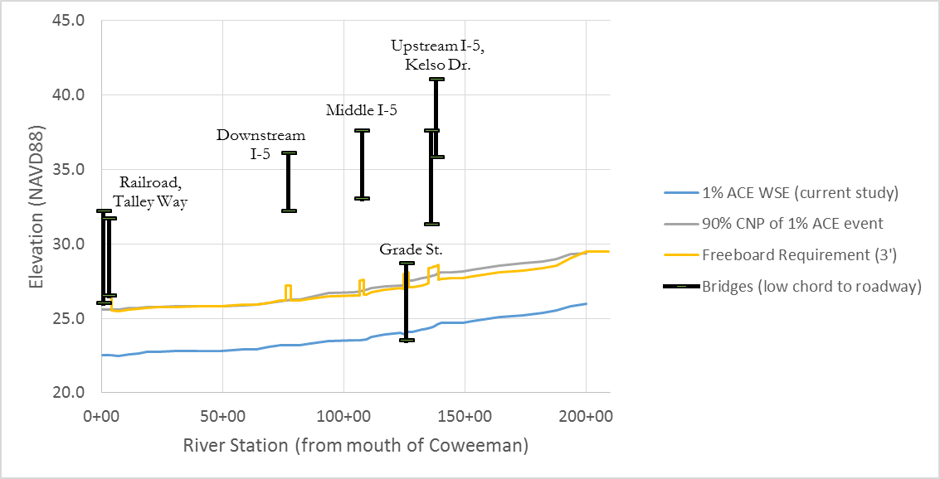
Figure 9-1: Interim calculations of minimum levee height for FEMA accreditation
Taking the maximum of these two water surface elevations provides the minimum required levee height for FEMA certification. Wind-wave effects were evaluated in Appendix B, but did not control the minimum levee heights. This minimum levee height is compared to the existing levee height in Figure 9-2. The levee centerline elevations (in NAVD88) are from the 2007 National Levee Database survey data (USACE 2007b). This survey used Real-time Kinematic GPS methods, with points spaced approximately 100 foot apart and precision of ±8 cm (0.03 feet). If conditions have changed since the last survey, a new top of levee survey should be performed to verify the existing levee height.
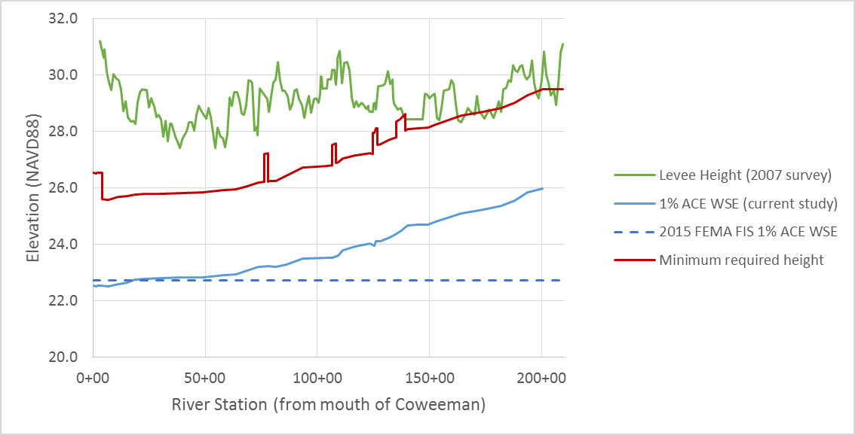
Figure 9-2 Minimum required levee height compared to existing levee height
The figure shows that there are some areas on the upstream end of the Coweeman levee that are slightly below the minimum required height. In order to qualify for FEMA accreditation, these low spots will need to be filled in and shown to be above the minimum height. The minimum required levee height is lower than the tie-in to high ground south of Allen Street. The minimum required levee heights are shown in Table 9-1.
Table 9-1: Minimum required levee height for CDID3 Coweeman River Levee
Levee Station (2007 Survey) | River Station (RAS Model) | Levee Elevation, 2007 Survey (ft NAVD88) | Minimum Required Levee Height (ft NAVD88) | Difference, Existing - Minimum (ft)
296+00 | 3+20 | 31.22 | 26.53 | 4.7
297+66 | 4+85 | 30.63 | 25.59 | 5.0
297+96 | 5+16 | 30.91 | 25.59 | 5.3
298+98 | 6+18 | 30.11 | 25.59 | 4.5
300+01 | 7+21 | 29.74 | 25.59 | 4.2
301+05 | 8+25 | 29.47 | 25.61 | 3.9
302+13 | 9+32 | 30.02 | 25.63 | 4.4
303+20 | 10+40 | 29.87 | 25.65 | 4.2
304+24 | 11+43 | 29.82 | 25.67 | 4.1
305+34 | 12+54 | 29.48 | 25.68 | 3.8
306+38 | 13+57 | 28.72 | 25.69 | 3.0
307+42 | 14+62 | 29.06 | 25.70 | 3.4
308+48 | 15+67 | 28.50 | 25.71 | 2.8
309+56 | 16+76 | 28.35 | 25.73 | 2.6
310+62 | 17+82 | 28.36 | 25.75 | 2.6
311+67 | 18+87 | 28.27 | 25.77 | 2.5
312+75 | 19+95 | 29.04 | 25.77 | 3.3
313+79 | 20+99 | 29.38 | 25.77 | 3.6
314+80 | 22+00 | 29.50 | 25.78 | 3.7
315+82 | 23+01 | 29.48 | 25.78 | 3.7
316+82 | 24+02 | 29.48 | 25.78 | 3.7
317+89 | 25+09 | 28.86 | 25.78 | 3.1
318+90 | 26+10 | 29.18 | 25.79 | 3.4
319+97 | 27+17 | 28.88 | 25.79 | 3.1
321+07 | 28+27 | 28.52 | 25.79 | 2.7
322+07 | 29+27 | 28.59 | 25.79 | 2.8
323+11 | 30+31 | 28.42 | 25.79 | 2.6
324+15 | 31+35 | 27.80 | 25.79 | 2.0
325+20 | 32+39 | 28.37 | 25.80 | 2.6
326+21 | 33+41 | 27.66 | 25.80 | 1.9
327+28 | 34+48 | 28.27 | 25.80 | 2.5
327+86 | 35+06 | 28.27 | 25.80 | 2.5
329+46 | 36+66 | 27.81 | 25.81 | 2.0
330+55 | 37+75 | 27.63 | 25.81 | 1.8
331+59 | 38+79 | 27.40 | 25.81 | 1.6
332+60 | 39+80 | 27.70 | 25.81 | 1.9
333+65 | 40+85 | 27.87 | 25.82 | 2.1
334+68 | 41+87 | 27.99 | 25.82 | 2.2
335+72 | 42+92 | 28.33 | 25.82 | 2.5
336+80 | 44+00 | 28.31 | 25.82 | 2.5
337+83 | 45+03 | 28.02 | 25.82 | 2.2
338+86 | 46+06 | 28.58 | 25.82 | 2.8
339+94 | 47+14 | 28.91 | 25.83 | 3.1
341+01 | 48+20 | 28.76 | 25.83 | 2.9
342+08 | 49+27 | 28.61 | 25.83 | 2.8
343+15 | 50+35 | 28.45 | 25.84 | 2.6
344+17 | 51+37 | 28.84 | 25.85 | 3.0
345+20 | 52+40 | 28.50 | 25.86 | 2.6
346+26 | 53+46 | 27.94 | 25.87 | 2.1
347+27 | 54+47 | 27.43 | 25.88 | 1.5
348+28 | 55+48 | 28.12 | 25.89 | 2.2
349+54 | 56+74 | 27.81 | 25.90 | 1.9
350+65 | 57+85 | 27.77 | 25.91 | 1.9
351+67 | 58+87 | 27.43 | 25.91 | 1.5
352+72 | 59+92 | 27.92 | 25.92 | 2.0
353+73 | 60+93 | 29.19 | 25.92 | 3.3
354+83 | 62+03 | 28.92 | 25.93 | 3.0
355+83 | 63+03 | 29.38 | 25.94 | 3.4
356+94 | 64+14 | 29.39 | 25.95 | 3.4
357+94 | 65+14 | 29.12 | 25.97 | 3.2
359+00 | 66+19 | 28.64 | 26.00 | 2.6
360+05 | 67+25 | 28.58 | 26.02 | 2.6
361+06 | 68+26 | 28.93 | 26.05 | 2.9
362+06 | 69+26 | 29.81 | 26.07 | 3.7
363+13 | 70+33 | 29.79 | 26.10 | 3.7
363+84 | 71+03 | 29.70 | 26.11 | 3.6
364+88 | 72+08 | 28.03 | 26.14 | 1.9
365+93 | 73+13 | 28.16 | 26.17 | 2.0
366+25 | 73+45 | 27.88 | 26.17 | 1.7
367+08 | 74+28 | 29.52 | 26.18 | 3.3
370+40 | 77+60 | 29.16 | 27.21 | 1.9
371+22 | 78+42 | 28.69 | 26.24 | 2.5
371+48 | 78+67 | 28.83 | 26.25 | 2.6
372+19 | 79+39 | 29.22 | 26.25 | 3.0
373+21 | 80+41 | 29.73 | 26.25 | 3.5
374+23 | 81+43 | 29.84 | 26.25 | 3.6
375+24 | 82+44 | 30.47 | 26.29 | 4.2
376+29 | 83+49 | 29.80 | 26.33 | 3.5
377+32 | 84+52 | 29.45 | 26.37 | 3.1
378+38 | 85+58 | 29.45 | 26.41 | 3.0
379+46 | 86+66 | 29.25 | 26.45 | 2.8
380+48 | 87+68 | 28.79 | 26.49 | 2.3
381+51 | 88+71 | 28.95 | 26.53 | 2.4
382+52 | 89+72 | 29.45 | 26.57 | 2.9
383+66 | 90+86 | 29.49 | 26.61 | 2.9
384+75 | 91+95 | 29.14 | 26.65 | 2.5
385+83 | 93+02 | 28.94 | 26.69 | 2.2
386+96 | 94+16 | 28.48 | 26.72 | 1.8
387+96 | 95+16 | 28.90 | 26.72 | 2.2
388+99 | 96+19 | 29.26 | 26.73 | 2.5
390+13 | 97+33 | 28.67 | 26.73 | 1.9
391+25 | 98+45 | 29.14 | 26.74 | 2.4
392+28 | 99+48 | 29.16 | 26.75 | 2.4
393+37 | 100+57 | 29.03 | 26.75 | 2.3
394+02 | 101+22 | 29.33 | 26.76 | 2.6
394+46 | 101+66 | 29.96 | 26.76 | 3.2
394+58 | 101+78 | 29.92 | 26.76 | 3.2
395+16 | 102+36 | 29.52 | 26.76 | 2.8
395+65 | 102+85 | 29.52 | 26.76 | 2.8
396+10 | 103+30 | 29.52 | 26.77 | 2.8
397+01 | 104+21 | 29.52 | 26.77 | 2.7
397+54 | 104+74 | 29.85 | 26.78 | 3.1
398+24 | 105+43 | 29.85 | 26.79 | 3.1
398+56 | 105+76 | 29.85 | 26.80 | 3.1
399+10 | 106+30 | 29.95 | 26.80 | 3.1
399+28 | 106+48 | 30.18 | 27.52 | 2.7
399+94 | 107+14 | 30.16 | 27.53 | 2.6
400+28 | 107+48 | 30.18 | 27.54 | 2.6
400+76 | 107+96 | 29.85 | 27.56 | 2.3
401+08 | 108+28 | 29.66 | 27.57 | 2.1
401+75 | 108+95 | 30.37 | 26.89 | 3.5
401+89 | 109+09 | 30.59 | 26.89 | 3.7
402+90 | 110+10 | 30.86 | 26.96 | 3.9
403+92 | 111+11 | 29.71 | 27.03 | 2.7
404+93 | 112+13 | 30.43 | 27.07 | 3.4
405+95 | 113+15 | 30.44 | 27.09 | 3.4
407+06 | 114+26 | 30.15 | 27.11 | 3.0
408+08 | 115+27 | 29.21 | 27.13 | 2.1
409+15 | 116+34 | 28.84 | 27.15 | 1.7
410+25 | 117+44 | 29.06 | 27.17 | 1.9
411+30 | 118+50 | 28.89 | 27.18 | 1.7
412+34 | 119+54 | 29.01 | 27.19 | 1.8
413+34 | 120+54 | 28.94 | 27.20 | 1.7
414+35 | 121+55 | 28.80 | 27.21 | 1.6
415+41 | 122+61 | 28.90 | 27.22 | 1.7
415+60 | 122+80 | 28.78 | 27.22 | 1.6
416+14 | 123+34 | 28.70 | 27.23 | 1.5
416+45 | 123+65 | 28.70 | 27.22 | 1.5
417+21 | 124+40 | 28.70 | 27.20 | 1.5
417+39 | 124+58 | 28.70 | 27.19 | 1.5
417+39 | 124+59 | 28.70 | 27.19 | 1.5
417+41 | 124+61 | 28.70 | 27.19 | 1.5
417+80 | 125+00 | 29.00 | 27.95 | 1.0
417+88 | 125+08 | 29.00 | 27.95 | 1.1
417+89 | 125+09 | 29.00 | 27.95 | 1.1
417+93 | 125+12 | 29.00 | 27.95 | 1.1
418+22 | 125+42 | 29.00 | 27.97 | 1.0
418+38 | 125+58 | 29.00 | 28.00 | 1.0
418+88 | 126+08 | 28.78 | 28.09 | 0.7
419+90 | 127+10 | 29.59 | 27.53 | 2.1
422+02 | 129+22 | 29.63 | 27.59 | 2.0
423+05 | 130+25 | 29.68 | 27.63 | 2.1
424+10 | 131+30 | 30.14 | 27.66 | 2.5
425+15 | 132+35 | 29.69 | 27.70 | 2.0
425+95 | 133+15 | 29.77 | 27.72 | 2.0
426+17 | 133+37 | 29.86 | 27.73 | 2.1
426+72 | 133+92 | 29.18 | 27.75 | 1.4
427+10 | 134+30 | 28.98 | 27.76 | 1.2
428+51 | 135+71 | 28.77 | 28.39 | 0.4
429+83 | 137+03 | 28.83 | 28.46 | 0.4
430+20 | 137+40 | 28.78 | 28.48 | 0.3
431+29 | 138+48 | 28.50 | 28.57 | -0.1
432+25 | 139+45 | 28.42 | 28.05 | 0.4
432+45 | 139+65 | 28.42 | 28.06 | 0.4
433+23 | 140+43 | 28.42 | 28.09 | 0.3
434+33 | 141+53 | 28.42 | 28.09 | 0.3
435+42 | 142+62 | 28.42 | 28.10 | 0.3
436+48 | 143+67 | 28.42 | 28.11 | 0.3
437+56 | 144+76 | 28.42 | 28.11 | 0.3
438+64 | 145+84 | 28.42 | 28.12 | 0.3
439+69 | 146+89 | 28.42 | 28.12 | 0.3
440+72 | 147+92 | 29.35 | 28.12 | 1.2
441+79 | 148+99 | 29.31 | 28.13 | 1.2
442+87 | 150+07 | 29.17 | 28.16 | 1.0
443+93 | 151+13 | 29.29 | 28.19 | 1.1
444+94 | 152+14 | 29.33 | 28.22 | 1.1
446+02 | 153+22 | 28.47 | 28.26 | 0.2
447+04 | 154+24 | 28.40 | 28.28 | 0.1
448+08 | 155+28 | 28.84 | 28.31 | 0.5
449+11 | 156+31 | 29.44 | 28.34 | 1.1
450+17 | 157+37 | 29.48 | 28.37 | 1.1
451+40 | 158+60 | 29.49 | 28.41 | 1.1
452+49 | 159+69 | 29.82 | 28.44 | 1.4
453+57 | 160+77 | 29.68 | 28.47 | 1.2
454+60 | 161+80 | 28.95 | 28.50 | 0.5
455+62 | 162+82 | 28.39 | 28.53 | -0.1
456+70 | 163+90 | 28.32 | 28.56 | -0.2
457+70 | 164+90 | 28.48 | 28.57 | -0.1
458+72 | 165+92 | 28.61 | 28.59 | 0.0
459+72 | 166+92 | 28.82 | 28.60 | 0.2
460+80 | 168+00 | 28.73 | 28.61 | 0.1
461+88 | 169+07 | 28.65 | 28.63 | 0.0
462+92 | 170+12 | 28.59 | 28.64 | 0.0
463+95 | 171+14 | 29.25 | 28.66 | 0.6
465+01 | 172+21 | 28.71 | 28.67 | 0.0
466+07 | 173+27 | 28.62 | 28.68 | -0.1
467+18 | 174+38 | 28.46 | 28.70 | -0.2
468+25 | 175+45 | 28.60 | 28.72 | -0.1
469+32 | 176+52 | 28.78 | 28.74 | 0.0
470+41 | 177+61 | 28.64 | 28.76 | -0.1
471+41 | 178+61 | 28.47 | 28.77 | -0.3
472+53 | 179+73 | 28.78 | 28.79 | 0.0
473+57 | 180+77 | 29.08 | 28.81 | 0.3
474+68 | 181+87 | 28.68 | 28.83 | -0.1
475+74 | 182+94 | 29.50 | 28.86 | 0.6
476+84 | 184+04 | 29.54 | 28.89 | 0.6
477+93 | 185+13 | 29.81 | 28.92 | 0.9
478+95 | 186+14 | 29.76 | 28.96 | 0.8
479+96 | 187+15 | 30.36 | 28.99 | 1.4
480+99 | 188+19 | 30.15 | 29.03 | 1.1
482+04 | 189+24 | 30.10 | 29.08 | 1.0
483+10 | 190+30 | 30.30 | 29.13 | 1.2
484+16 | 191+35 | 30.35 | 29.19 | 1.2
485+18 | 192+38 | 29.99 | 29.24 | 0.8
486+23 | 193+43 | 29.83 | 29.29 | 0.5
487+28 | 194+48 | 29.98 | 29.32 | 0.7
488+31 | 195+50 | 30.51 | 29.35 | 1.2
489+34 | 196+54 | 29.71 | 29.38 | 0.3
490+35 | 197+55 | 29.34 | 29.41 | -0.1
491+36 | 198+56 | 29.17 | 29.44 | -0.3
492+66 | 199+86 | 29.83 | 29.47 | 0.4
493+69 | 200+89 | 30.82 | 29.48 | 1.3
494+74 | 201+94 | 30.01 | 29.48 | 0.5
495+78 | 202+98 | 29.71 | 29.48 | 0.2
496+79 | 203+99 | 29.28 | 29.48 | -0.2
498+05 | 205+25 | 29.45 | 29.48 | 0.0
499+12 | 206+32 | 28.93 | 29.48 | -0.6
500+16 | 207+36 | 29.71 | 29.48 | 0.2
501+17 | 208+37 | 30.81 | 29.48 | 1.3
502+23 | 209+43 | 31.09 | 29.48 | 1.6

Conclusions and Recommendations
There are some areas on the upstream end of the Coweeman River levee that must be raised to obtain FEMA certification. The minimum required levee height is below the authorized height (30 ft NAVD88), so no action is necessary to reauthorize the levee system. After these deficiencies are remedied, proof of the new levee height must be submitted to USACE. Following verification of the new levee height, a full Phase 2 NFIP Levee Evaluation study that includes other disciplines can be initiated. If no other deficiencies are discovered, the deliverable of the Phase 2 study will be certification documents. The level of effort for the hydrologic and hydraulic analysis for this future effort will be minimal—the new top of levee will simply be checked against the results of this report.
As this study shows, there remains a large degree of uncertainty about the 1% ACE flood elevations on the Coweeman River levee due to lack of data. Therefore, it is quite possible that an estimate of the 1% ACE event could rise significantly in the coming years, as additional data is gathered. For instance, the Columbia River frequency curves are nearly 30 years old, and may be updated with a Columbia basin-wide system flood risk study. If the low spots in the levee were just to be filled to the minimum required height, it is possible that the levee would need to be raised again in the future as understanding of the 1% ACE event increases. It may be prudent to raise the levee above than the minimum height to provide additional risk reduction and more confidence the levee will pass FEMA re-accreditation ten years from now. The recent data from the USACE water level gages from 2007-2015 proved invaluable, and this data should be maintained to aid future studies on the Coweeman River.
As the focus of this study was for FEMA accreditation, results should not be extracted for other applications. For instance, a computed stage-frequency curve is not provided here, since the frequency curve would be incorrect for events more common than the 1% ACE flood.
The estimate of the 1% ACE flood profile here is higher than the current effective FEMA FIS. It is recommended that the results of this study be disseminated to the agencies responsible for floodplain management along the Coweeman River. Since a future update to the FIS will likely result in higher base flood elevations, it is recommended that any proposed development be closely scrutinized below the 1% ACE event provided in this report. The 1% ACE water surface elevation in this report could be adopted as an interim floodplain management standard, since it is more restrictive than the current effective study.

References
Chow, V.T., 1959. Open-channel hydraulics. New York: McGraw-Hill.
Cooper, R. 2005. Estimation of Peak Discharges for Rural, Unregulated Streams in Western Oregon. USGS Scientific Investigations Report 2005-5116
Duren, et al 2015. Lower Columbia River Hydrology. Memorandum for Record. Prepared by Portland District. February 19, 2015.
Faber, B 2016. Monte Carlo Convergence, as computed by FDA and ResSim Monte Carlo. Personal correspondence. USACE-Hydrologic Engineering Center.
FEMA 2015. Flood Insurance Study-Cowlitz County, Washington and Unincorporated Areas. Study 53015CV001A. Effective Date: December 16, 2015.
Holman, R.A. 1986. Extreme value statistics for wave run-up on a natural beach. Coastal Engineering, v. 9, p. 527-544.
Knutson, R 1985. Chronological History of Combined Probability Profiles. Handwritten Notes. Portland District EC-HY library, File 1180. 27 November 1985.
Mase, H 1989. Random wave run up height on gentle slope. Journal of Waterway, Port, Coastal, and Ocean Engineering, vol. 115, no. 5. American Society of Civil Engineers, pp. 649– 661.
Read, W 2007. The Strongest Windstorms in the Western Pacific Northwest. http://www.climate.washington.edu/stormking/PNWStormRanks.html
USACE 1952. Letter Report on Authorized Projects, Lower Columbia River and Tributaries, Washington and Oregon. Volume 1. Prepared by Portland District. June 1952.
USACE 1962. Design Memorandum, Cowlitz County Diking Improvement District Nos. 2 and 13. Prepared by Portland District. October 1962.
USACE 1966. Postflood report: December 1964, January 1965 flood. Prepared by Portland District, Portland, Oregon. July 1966.
USACE 1969. Flood Plain Information, Cowlitz County, Washington, Columbia River and Tributaries. Prepared by Portland District. January 1969.
USACE 1989. Columbia River and Tributaries Study – Oregon and Washington, Lower Columbia River Flood Control Study – River Miles 0 to 145, Summary Report Vol. 1 and 2. Detailed Review of Drainage Districts. Prepared by Portland District, Portland, Oregon. January 1989.
USACE 1991. Review of Flood Control, Columbia River Basin. Columbia River and Tributaries Study, CRT-63. Prepared by North Pacific Division. June 1991.
USACE 1993 (circa). Equivalent Years of Record for the Columbia River at Vancouver Stage-Frequency Curve. Memo for Record. Prepared by Portland District for Peninsula Diking District No. 1.
USACE 1997. Engineering Manual 1110-2-1420, Hydrologic Engineering Requirements for Reservoirs. 31 October 1997.
USACE 2007a, Columbia River Combined Flood Profiles. Prepared by Portland District EC-HY, 9 April 2007.
USACE 2007b, Portland District National Levee Footprint Database Surveys. Prepared by PBS&J Consultants, Sacramento, CA. 30 September 2007.
USACE 2008. Engineering Manual 1110-2-1100 (Part II), Coastal Engineering Manual – Part II. 01 August 2008.
USACE 2010a. Periodic Inspection No. 1, Cowlitz Consolidated Diking Improvement District No. 3 Flood Damage Reduction Project. Prepared by Tetra Tech.
USACE 2010b. Mount St. Helens Project, Cowlitz River Levee Systems: 2009 Level of Flood Protection Update. Prepared by Portland District, February 4, 2010.
USACE 2010c. Mount St. Helens Project, 2009 Study of Cowlitz Sedimentation on the Coweeman River. Prepared by Portland District, February 22, 2010.
USACE 2010d. Engineering Circular 1110-2-6067, USACE Process for the National Flood Insurance Program (NFIP) Levee System Evaluation. 31 August 2010.
USACE 2012. A 50% Annual Exceedance Probability Stage Approach for Calculating the Survival Benefit Units Profile for Lower Columbia River Estuary. Prepared by Portland District EC-HY, 11 May 2012.
USACE 2013a. Phase 1 National Flood Insurance Program Levee System Evaluation, Cowlitz County Consolidated Drainage Improvement District No. 3. Prepared by Portland District. 22 April 2013.
USACE 2013b. Statistical Methods in Hydrology. PROSPECT course materials. Prepared by Hydrologic Engineering Center. July 2013.
USACE 2014a. Comprehensive Evaluation of Project Datum: Compliance Report 2014. Portland District Land Survey, July 28, 2014.
USACE 2014b. National Flood Insurance Program Levee System Evaluation Phase 2a Report for Scappoose Drainage Improvement Company. Prepared by Portland District, 15 September 2014
USACE 2015. Limited Re-evaluation Report, Mount St. Helens Long-Term Sediment Management Plan, Final Supplemental Environmental Impact Statement. Prepared by Portland District, May 2015.
USGS 2015. Bulletin 17C: Guidelines for Determining Flood Flow Frequency. Draft. June 18, 2015.
Wantz, J & Sinclair, R 1981. Distribution of Extreme Winds in the Bonneville Power Administration Service Area. Bonneville Power Administration, U.S. Department of Energy. Journal of Applied Meteorology, 20, pp. 1400-1411.

Appendix A-Hydraulic Model of the Lower Coweeman River

Introduction
This appendix details the unsteady hydraulic model of the lower Coweeman River from river mile (RM) 3.8 to the confluence with the Cowlitz River and Columbia River. This appendix documents and summarizes the background, development, and calibration of that model.
This hydraulic model is intended for use in the levee evaluation of the CDID3 Coweeman River levee segment. This model application is focused on the 1% ACE water surface elevations with associated uncertainty. This model is not suitable for other purposes (e.g. probable maximum flood routing, ecological purposes) as it currently exists. While the model includes areas other than the Coweeman River, the only results from this model that will be applied are from the Coweeman River reach. The Cowlitz River levee segment of CDID3 has been extensively studied in the recent past (USACE 2010b).
The hydraulic model will be run many times as part of a Monte Carlo simulation process. This appendix does not detail the results of the Monte Carlo simulations, but rather the development of the RAS model that is run in the sampling process. Ultimately, the model results will be used to predict the 1% ACE flood water surface elevation at the CDID3 Levee on the Coweeman River with uncertainty. Refer to the main report for more details on the Monte Carlo simulation process.

Study Reach Description
Figure 0-5 shows the extent of the hydraulic model with nearby gages highlighted. The downstream end of the hydraulic model is the mouth of the Cowlitz. The upstream bounds extend to RM 3.8 of the Coweeman and RM 16.64 of the Cowlitz (just downstream of the Castle Rock Bridge). All elevations in the model and report refer to the North American Vertical Datum of 1988 (NAVD88).
While the area of interest in this study is the Coweeman River, portions of the Cowlitz River were included in the model to better approximate conditions affecting the Coweeman. Ocean tides have a large effect on water levels in much of the lower Cowlitz River. To separate the tidal effects from the upstream flow inputs, the upstream boundary condition on the Cowlitz was selected at a point at which tidal influences no longer have an effect (completely riverine). The Castle Rock Bridge is an ideal upstream boundary location, since there is a USGS gage at this location as well. This location of the boundary condition more correctly models the relationship between flow attenuation/timing and downstream tidal effects from the Columbia River. Figure 0-6 shows the full HEC-RAS geometry of the 2016 model, with the most upstream extent of the Cowlitz just downstream of the USGS Castle Rock gage.
This approach to modeling the lower Cowlitz River is similar to National Weather Service standard practices. NWS routinely issues stage forecasts for the Cowlitz River at Kelso. They generate these predictions by running a HEC-RAS model that extends up to the gage at Castle Rock, since that point is assumed to have a reliable flow measurement free of tidal influences.
For the Coweeman River, a similar approach of extending the RAS model to the closest upstream gage was considered, but was not feasible due to lack of data. The surveyed cross-section data used in this study only extended to RM 3.8, not to the upstream streamgage at RM 8 (USGS #14245000).
The Lower Coweeman River is heavily channelized, with very little overbank area or floodplain. The lower Coweeman is influenced by backwater from the Columbia and Cowlitz rivers, and tidal effects can be seen to the upstream end of the hydraulic model (at RM 3.8). For more details on the history of the Coweeman River and levee, refer to the main report.
The following figures provide some representative photos of the lower Coweeman River and levee for reference.
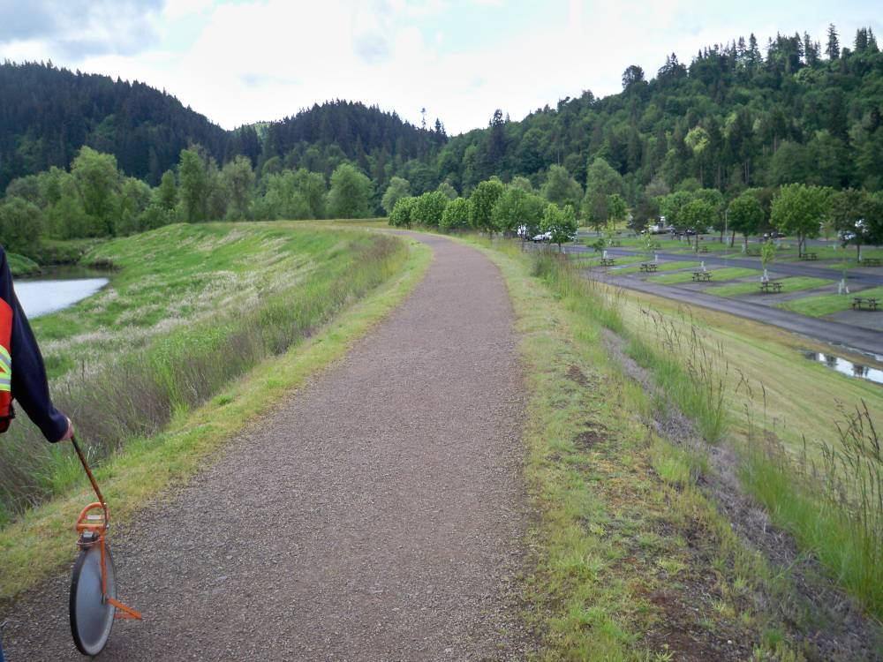
Figure 0-1: Photo looking forward toward levee crown (Station P2 1+40)
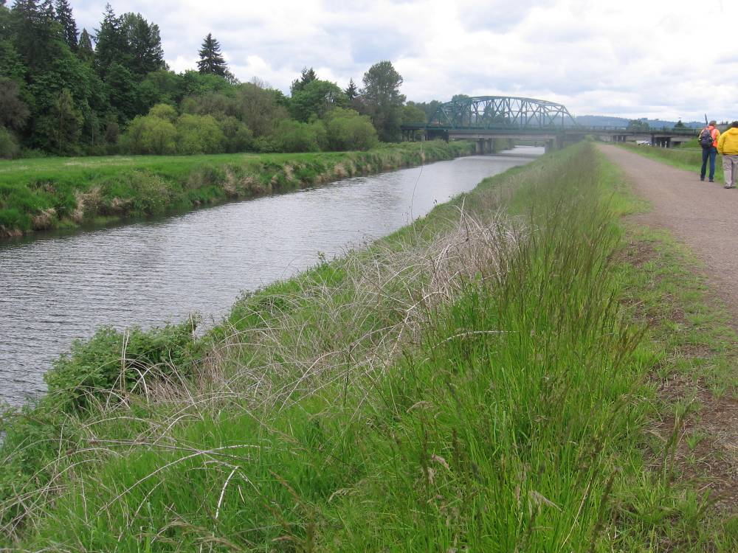
Figure 0-2: Typical levee conditions looking downstream located on riverward slope (Station P2 65+00)

Figure 0-3: Photo near Station P2 121+00 (May 24, 2010)
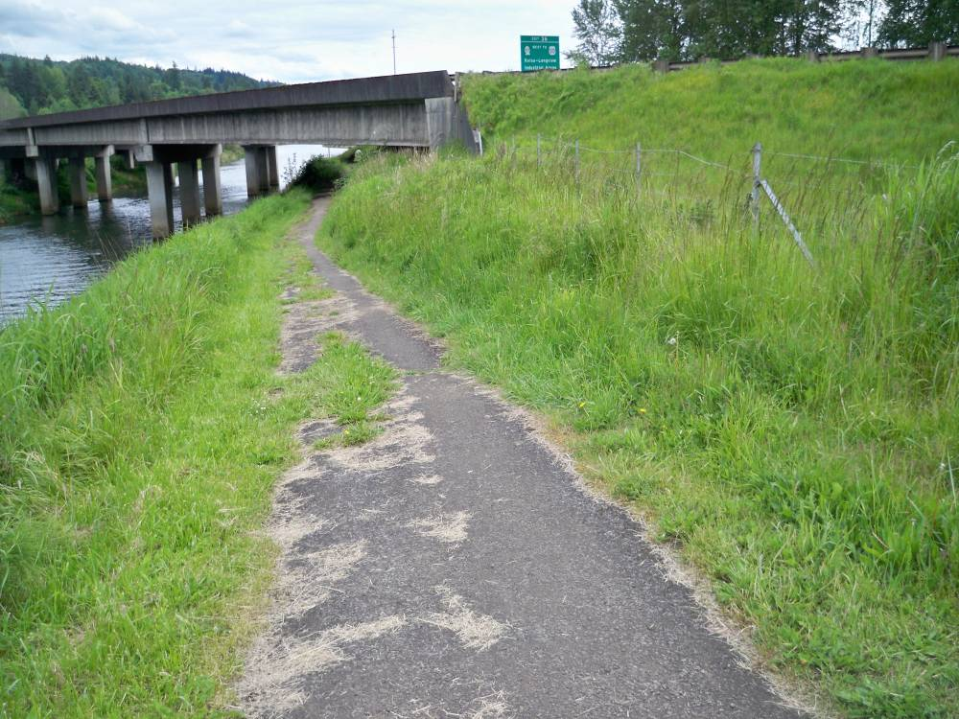
Figure 0-4: Levee traversing under I-5 overpass on overbuilt landward side (Station P2 132+60)

Figure 0-5: Coweeman River and Cowlitz River Location Map

Model Development
Geometry and bridge development were taken from previous Portland District models and revised to the most up to date data available. The one-dimensional model was developed with HEC-RAS version 5.0. A schematic of the model geometry is shown in Figure 0-6.
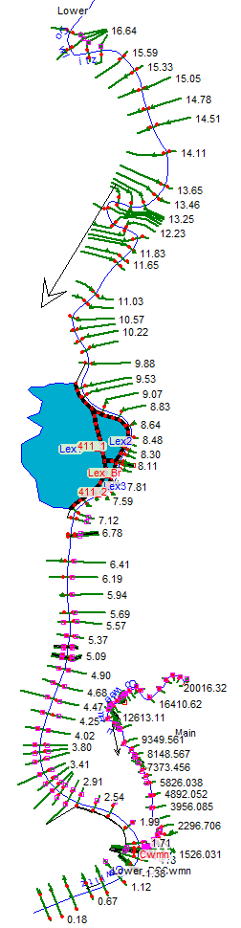
Figure 0-6: Extent of 2016 HEC-RAS Coweeman-Cowlitz Model

Cross-sections
Geometry of this model originated from a steady state Coweeman River Level of Protection (LOP) model produced in 2011, completed for Mount St. Helens Project purposes and based on survey data from 2009 (USACE 2010c). Cowlitz River cross sections were updated from the Cowlitz 2014 LOP model data, using a Cowlitz River Hydrosurvey by David Evans and Associates, completed in September 2013. There is no survey data available for the Coweeman River more recent than that from the 2011 LOP; all modifications to Coweeman cross sections were done using the 2011 model terrain. The contributing watershed for the Coweeman River does not include significant sediment loads from the Mount St. Helens debris avalanche; it is anticipated that the channel geometry for the Coweeman River is relatively stable and has no significant changes from 2009 to 2016.
Since this study requires an unsteady model, some changes to the geometry were necessary. Two cross sections were added to the geometry due to the proximity of the bridges near the junction. Cowlitz River station (RS) 1.63 is a copy of RS 1.61. RS 1.63 was placed 100 feet upstream of RS 1.61. Coweeman RS 0.15115 is a copy cross section of RS 28.15115. RS 0.15115 was placed 28 feet downstream of RS 28.15115. These additional cross sections were added due to unsteady flow requirements. They were both copied from nearby cross sections because geometry of these areas did not change enough to warrant new cross section terrain cuts.
Additional cross sections were added for model stability. On the Coweeman reach, RS 418 was cut from the terrain data used in the Coweeman 2011 LOP model, with bathymetry adapted using RS 348.7354. This cross section was added to increase stability, as the river makes a sharp turn travelling southward to westward. RS 1.50 was added to the Lower Cowlitz reach, downstream of the Coweeman confluence. There was a large gap and no intermediate cross section between the State Route 432 Bridge and the downstream railroad bridge. RS 1.50 was cut with terrain from the Coweeman 2011 LOP model with bathymetry filled in using RS 1.38.
There are many permanent ineffective areas in the Cowlitz and Coweeman River cross sections due to the overbank terrain. These areas do not convey flow, so they are accounted for by making them permanently ineffective. There are also multiple normal ineffective areas, mostly upstream and downstream of the modeled bridges, which will be discussed in the following section.

Bridges
There are 10 bridges across the 3.8 miles of the lower Coweeman River, which adds complexity to the model. David Evans and Associates produced a detailed survey in 2010 of the ten bridges. The three pairs of I-5 bridge crossings were modeled as three single bridges due to their close proximity. This survey information and Google Earth were used to update bridge deck and pier data with more detail. Bridge deck and pier stationing, widths, pier dimensions, and skew were revised as needed.
There are six bridges on the Cowlitz River within the extents of this model, two of which are downstream of the Coweeman confluence. Bridges were copied directly from the Cowlitz 2014 LOP model. The most upstream bridge is just upstream of RM 8.0. Table 0-1 gives bridge name, station, and skew for the modeled bridges on the Coweeman River reach starting at the most upstream bridge.
Table 0-1: Bridges on the Coweeman River Reach
Bridge/Street Name | River Station | Bridge Deck Skew | Bridge Pier Skew | Minimum elevation of low chord (ft NAVD88) | Minimum elevation of top of roadway (ft NAVD88)
Kelso Drive | 13813.69 | 40 degrees | 40 degrees | 35.8 | 41.0
Upstream I-5 Bridge | 13614.40 | 45 degrees | None | 31.3 | 37.6
Grade Street Bridge | 12578.63 | None | None | 23.5 | 27.4
Mid I-5 Bridge | 10744.34 | 40 degrees | None | 33.0 | 37.6
Downstream I-5 Bridge | 7720.178 | 45 degrees | None | 32.2 | 36.1
Talley Way | 307.3995 | None | None | 26.5 | 31.7
Railroad Bridge | 82.18506 | None | None | 26.0 | 32.2

All ineffective areas on the cross sections upstream and downstream of each bridge were checked for misplacement, especially on the Coweeman bridges. The Kelso Drive Bridge required special attention. Skew was added to the Kelso Drive Bridge deck and piers to account for the 40 degree angle to the flow of water at which the bridge crosses the Coweeman River. When adding skew to the piers, an error occurred on the most northern pier, causing the pier to disappear from the model. A permanent ineffective area was added to represent the pier so that there is no conveyance of water where that missing pier should be.
The Cowlitz and Coweeman River confluence area has multiple bridges that overlap each other. The left overbanks of cross sections bounding the SR-432 Bridge on the Cowlitz River (River Stations 1.57 to 1.63) were truncated to prevent overlap with the railroad bridge on the Coweeman. Cropping the bridge and cross sections was possible because the water level of the Columbia River in the model is not expected to exceed 32 feet, the height of the most downstream railroad bridge on the Coweeman. This bridge acts as a levee, so there is no need for more overbank cross section data beyond the railroad bridge levee.
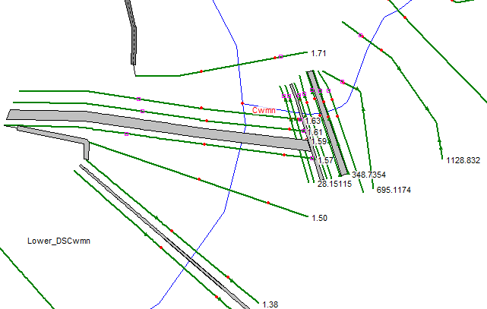
Coweeman River
SR-432 Bridge
Railroad Bridge
Area of overlapping cross-sections
Cowlitz River
Figure 0-7: Cowlitz-Coweeman confluence detail
However, to encompass the railroad bridge height of 32 feet, the Cowlitz cross sections were forced to cross the Coweeman railroad bridge’s downstream cross sections (RS 28.15115 and RS 0.15115), as shown in Figure 0-7. Though overlapping cross-sections are not ideal, it was necessary to reach the railroad bridge on the Coweeman, as it is the control elevation of the Cowlitz River left overbank and will more accurately model water running through the Cowlitz channel geometry. This configuration was carefully considered due to the complexity of the confluence, but the error from this simplifying assumption is minimal during an extreme high flow event. The overlapping cross sections add a small amount of extra volume in that area because the model accounts for volume twice – from the Cowlitz reach and from the Coweeman reach – during calculations. This volume amount is negligible and does not affect the results of the model.

Levees
The lower Cowlitz basin is heavily leveed—there are 5 separate levee systems within the extents of the RAS model, as shown in Figure 0-8.
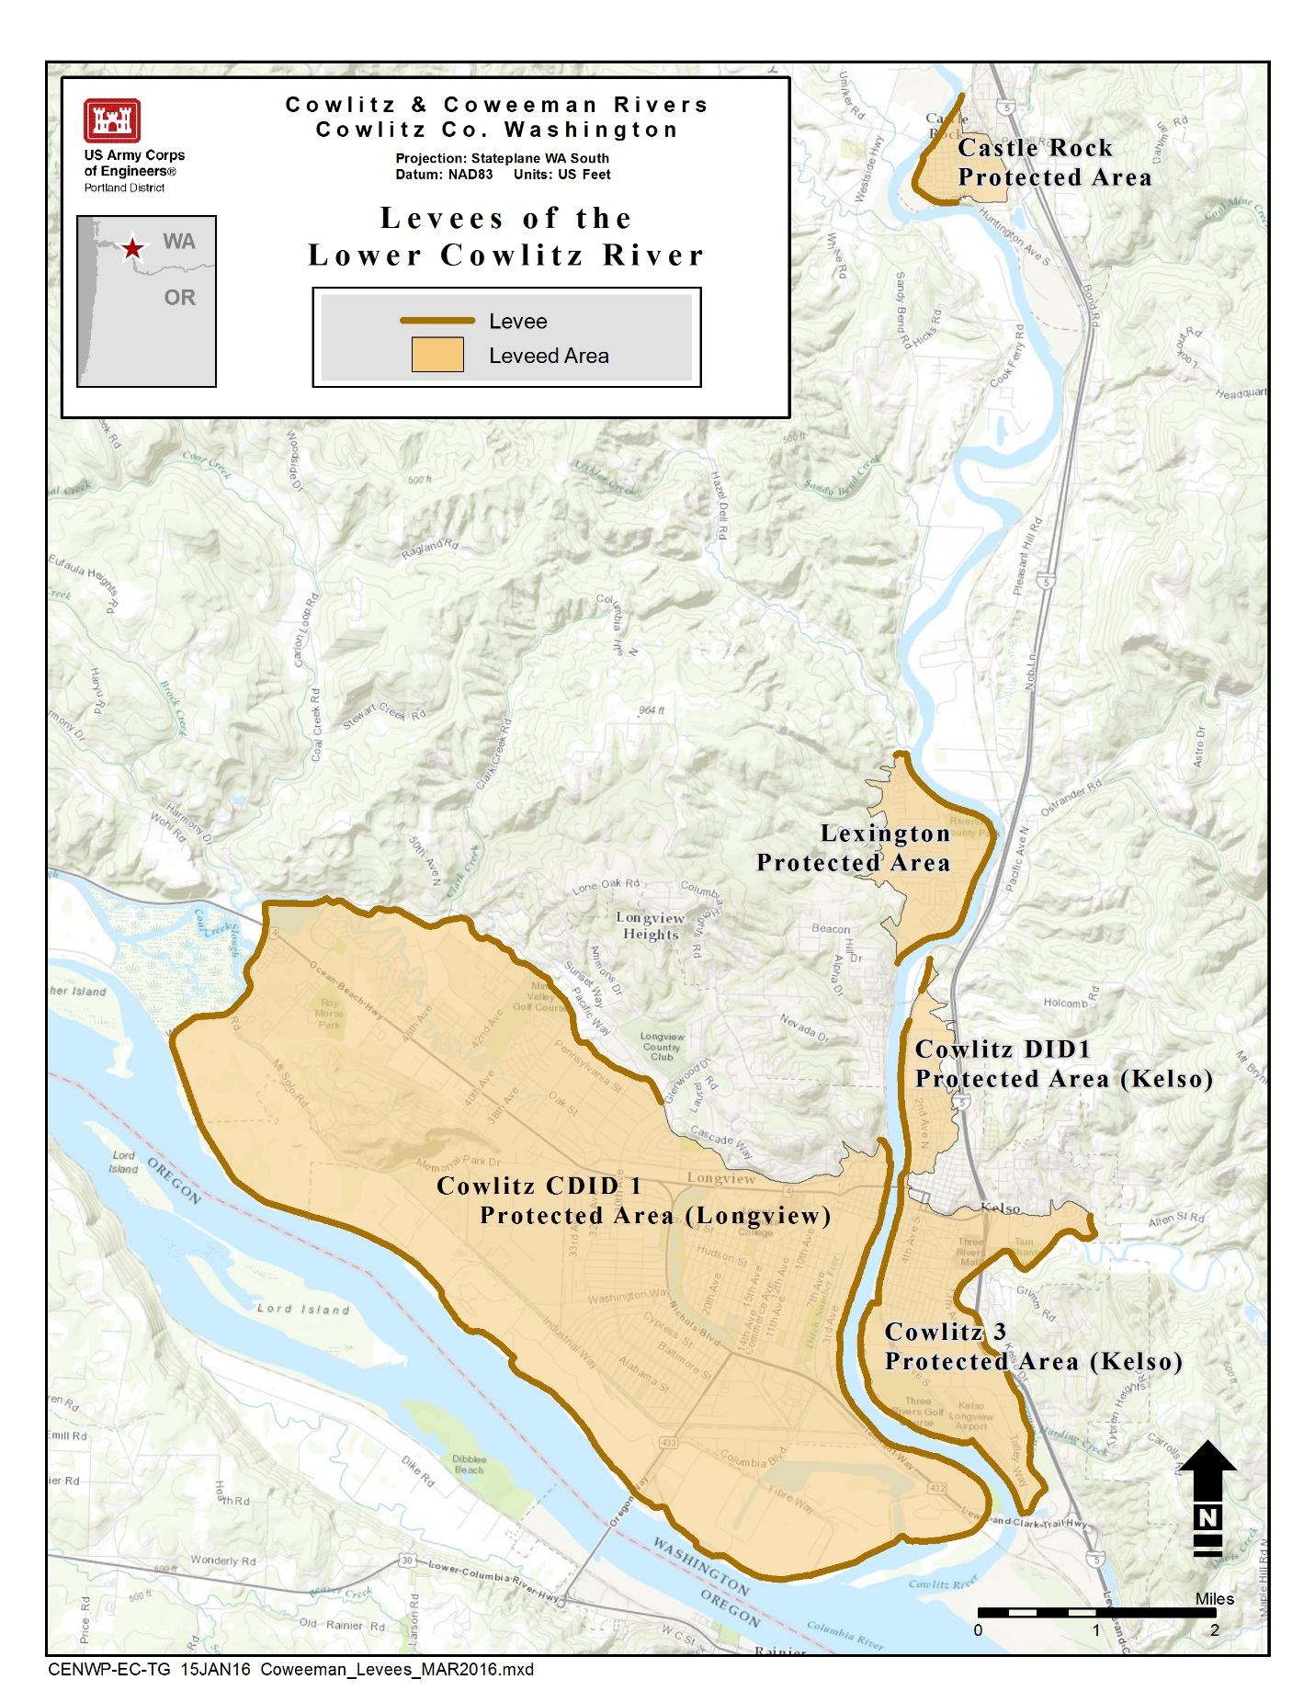
Figure 0-8: Leveed Areas in the Lower Cowlitz Basin

The main levee of interest is the Coweeman levee: the goal of this study is to determine a design levee height that will satisfy levee safety criteria. The purpose of this model is to provide a design elevation, not to assess existing levee conditions. Therefore, the levee tool in RAS was used to represent the Coweeman River levee, and it was set to an infinite height. This assumes that the levee will be raised where necessary to meet the resulting height requirements, and closure structures at bridge crossings will be erected as necessary.
Other levees along the Cowlitz are not quite as important to model precisely, but they can affect flows if they fail. In this study, the Cowlitz levees are assumed to perform adequately until they overtop—other modes of failure, such as seepage, are not considered. The 2009 LOP report shows that all of these levees have a high degree of assurance of withstanding the 1% ACE event, so they become an issue in modeling only for the most extreme events. The approach taken in modeling each levee system is shown in Table 0-2.
Table 0-2: Modeling approaches for levee systems
Levee System | Modeling Approach
CDID3  (Kelso) | Infinitely high levee on the Coweeman River. Cowlitz River segment has levee set to top of left bank.
Cowlitz CDID1 (Longview) | Lateral structure used to represent levee. When overtopped, water leaves the system completely. Since the Longview storage area is quite large, this is a reasonable assumption.
Cowlitz DID1  (Kelso) | Levee tool used to represent levee, with height set to top of bank.
Lexington | Lateral structures are used to represent the levee, and storage areas represent the leveed area. This was modeled primarily to increase stability of the RAS model under extreme hydrologic events.
Castle Rock | Levee tool used to represent levee, with height set to top of bank.

Channel Roughness
A detailed roughness analysis for this study was not available. Initial roughness coefficients used for the lower Cowlitz River were taken from the calibrated hydraulic model prepared for the 2009 LOP analysis for the Cowlitz River levee system. The model used a Manning’s coefficient (n) ranging from 0.035 to 0.015 in the main channel and 0.07 on the overbanks in the Cowlitz. The Coweeman reach had a constant main channel roughness coefficient of 0.031 with left and right overbank values set to 0.065 through the reach. These values were taken directly from the 1999 Coweeman LOP study. (USACE 2010b).
The 2016 model started with these roughness coefficients and was adjusted during calibration, using available observed stage data and high water marks for reference. Reference tables of typical roughness coefficients for open channel flow were also considered when calibrating the model (Chow, 1959). The final n-values are discussed in the calibration section.

Boundary Conditions
Flow hydrographs were used for the Coweeman and Cowlitz River upstream boundary conditions and a stage hydrograph was used for the Columbia River downstream boundary condition. Table 0-3 gives sources and information about these hydrographs. Refer to Figure 0-5 for all boundary condition locations.
Table 0-3: Gages Used for Boundary Conditions
Gage Name | Gage Type | Period of Record | Data Source
Coweeman River near Kelso, OR | Flow  (15 minute) | 08 Sep 2006 – 31 Dec 2015 | Washington Department of Ecology (26C075)
Cowlitz River at Castle Rock | Flow  (15 minute) | 01 Oct 2007 – 31 Dec 2015 | U.S. Geological Survey (14243000)
Columbia River at Longview, WA | Stage  (1 hour) | 01 Jan 2002 – 30 Dec 2015 | NOAA  (9440422)

There are a few minor tributaries (e.g. Ostrander Creek, Arkansas Creek) that enter the system below the upstream boundary conditions. However, there is little to no gage data for these small creeks. Rather than including these as separate boundary conditions, the upstream inflow hydrographs were modified to account for these additional drainages. For the Coweeman River, a simple drainage area ratio of 7% was used to approximate the additional flow between the gage location and the river mouth. As discussed in the 2009 LOP report, a drainage area ratio is not appropriate for the Cowlitz River adjustment. A drainage area ratio assumes that the hydrologic condition of the area to be added is similar to the upstream drainage. This is not the case for the Cowlitz, which is influenced by regulation. The 2009 LOP report generated frequency curves using approximate techniques for the smaller streams. At each frequency ordinate, the flow for each creek was added to the upstream inflow at Castle Rock. This had the net effect of increasing the Castle Rock flows by a consistent ratio. Therefore, the same approach as the 2009 LOP report was used, and flows were increased by 4%.
The Coweeman River gage data was lagged by 1 hour to account for the fact that the gage data is approximately 4 miles upstream. While a more sophisticated routing technique could be applied, this approximation has a relatively small impact on the results. These boundary conditions used for calibration are analogous to the inputs used in the Monte Carlo process.
The Coweeman gage record (26C075) has a few peak flows that are unrealistically steep and short in duration. The Coweeman gage flow data was compared to South Fork Toutle River (14241500) and East Fork Lewis River (14222500) flow data from USGS to check for reasonability. These USGS gages have similar drainage areas, and they are the closest to the Coweeman gage. The three gages typically show similar timing and magnitude of flows. The January 2009 event appears to have some discrepancies in the record. Figure 0-9 shows the three flow hydrographs and the stage hydrograph from January 6-10, 2009. The Washington Department of Ecology’s Coweeman River gage, the South Toutle gage, and the East Lewis gage are represented with red, black, and green lines, respectively, on the lower hydrograph. The USACE Coweeman HOBO gage (5 miles downstream) is the blue line on the upper hydrograph.
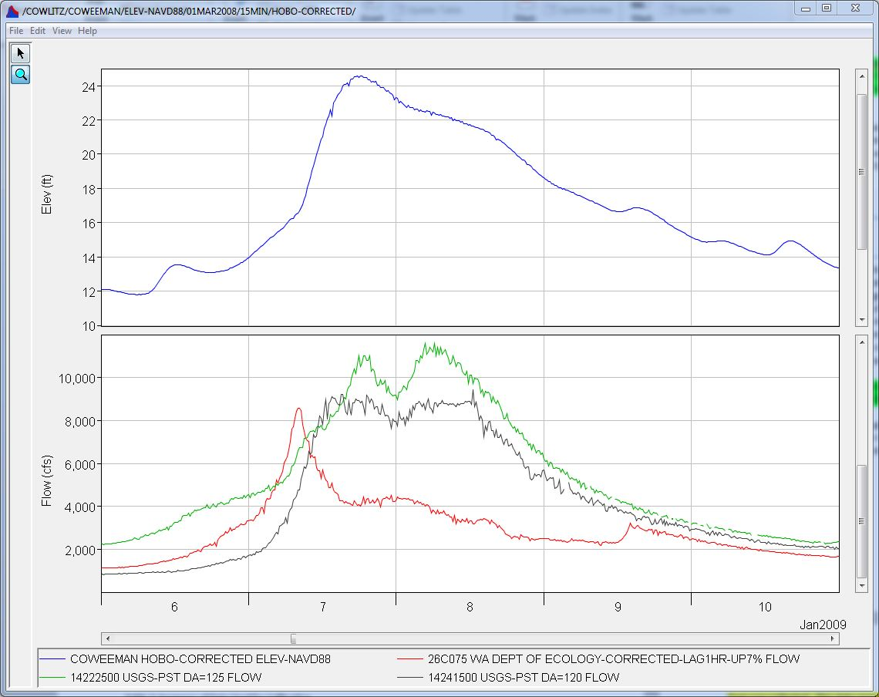
Figure 0-9: Hydrograph Comparison of Coweeman, South Toutle and East Lewis Rivers
In Figure 0-9, the Coweeman flow drops off very quickly after it peaks on January 7th, while the South Toutle and East Lewis Rivers take approximately 24 hours before the flow starts to steadily decrease. The USACE Coweeman elevation gage has a longer duration that matches more closely with the South Toutle and East Lewis peaks. The small, sharp peak in the Coweeman flow data on January 9, 2009, is unexplained and may signal gage error. These observations cast doubt on the quality of data for the 2009 event, which resulted in not considering the January 2009 storm event for calibration.
The event in December 2007 was another peak that showed some discrepancies in the Coweeman flow gage. After the peak on December 3, 2007, a drop of almost 1000 cfs within a 15 minute period was observed, which was not reflected in the HOBO gage readings or nearby gages. Therefore, the December of 2007 event was not considered suitable for calibration.

Initial Conditions
Initial conditions were left blank so they would be auto-generated by HEC-RAS, a new function available in HEC-RAS 5.0. A restart file could have been used, but did not make a significant difference for the simulation.

Model Calibration
The objective of model calibration is to adjust variables in the hydraulic model (i.e. roughness coefficients, ineffective flow areas) such that the model output adequately represents observed conditions. The calibration of this model focuses on peak flow events because the model will be used to estimate the elevation of the 1% ACE flood event.

Calibration Data
The calibration dataset is a collection of observed stage data and high water marks that will be used to compare against the model results. Since the model will be applied in extreme hydrologic conditions, the ideal calibration dataset would include the largest events in the period of record. Unfortunately, there is very little short-interval data available for calibration prior to 2007. Since the unsteady model will be run with 15-minute boundary condition inputs, nearly all of the historic data is unsuitable for unsteady calibration efforts. For older events, stage data on the Coweeman is very rare, and the flow and stage inputs do not have a short enough time step to adequately model the peak stage on the levee. Furthermore, events prior to 1980 are not suitable for calibration due to the changed conditions on the Cowlitz from the Mount St. Helens eruption. For more information on data availability, see the main report.
The most commonly used calibration data point is the USACE HOBO gage on the Coweeman River. The gage has a generally complete record from December of 2007 through January of 2013. Data is also available from November of 2013 to May of 2014 and again in August of 2015 to January of 2016. This observed data was input at the immediate upstream and downstream cross section of the bridge because the gage was installed under the bridge itself. There was no significant change in water surface elevation when comparing the upstream and downstream cross sections. The Coweeman HOBO gage was shifted in time by one hour to align with the other input data—the shift is likely a daylight savings time conversion.
High water mark data for selected events was available on the Coweeman River. The Coweeman Pump Station staff gage is read periodically by project staff during significant storms, and is present for most years of the Coweeman stage POR. A description of each calibration point and the data available for each point are presented in Table 0-4. Refer to Figure 0-5 for the locations of all gages used for calibration. Any gages not shown in Table 0-4 did not have a sufficient period of record or good-quality data, and were not used for calibration.

Table 0-4: Summary of Calibration Data
Reach | Gage ID & Location | Data Collected (Source) | Period of Record
Coweeman | Coweeman River, under upper I-5 Bridge - USACE HOBO gage | Instantaneous (10 minute) stage data, NAVD88 | Dec 2007 - Mar 2008
 | Coweeman River, under upper I-5 Bridge - USACE HOBO gage | Instantaneous (15 minute) stage data, NAVD88 | Mar 2008 - Jan 2016
 | Tam O’Shanter Staff Gage – CDID3 | High Water Marks, NAVD88 | Dec 2015
 | Coweeman Pump Station Staff Gage – CDID3 | High Water Marks, NAVD88 | Dec 1977 - Dec 2015
Lower Cowlitz – U/S of Coweeman | Gearhart Gardens Park - USACE | Instantaneous (10 minute) stage data, NAVD88 | Dec 2007 – Mar 2008
 | Gearhart Gardens Park - USACE | Instantaneous (15 minute) stage data, NAVD88 | Mar 2008 – Oct 2009
 | Ostrander – USACE | Hourly | Nov 2007 – Jan 2008,  Nov 2008 – Jan 2009
 | Lexington – USACE | Hourly | Jul 2009 – Jul 2011

The Cowlitz River gage data includes some lingering effects of debris from the Mount St. Helens eruption in 1980. This has caused some gages to become silted in, resulting in inaccurate gage readings. Gearhart Gardens Park had issues with observed and simulated peaks matching up in 2008 and 2009. When comparing the results of observed and simulated stage hydrographs, the Ostrander and Lexington gages matched up relatively well, while Gearhart Gardens Park elevation seemed to be dampened at the peak. Reducing the roughness coefficient downstream was not an option here because it created other issues in the simulation and did not change the height of the Gearhart Gardens Park gage by any significant amount. For the Cowlitz River, the roughness coefficients were kept similar to those found in the 2009 and 2014 Cowlitz LOP, as those studies were previously calibrated in detail. The main focus of this study is on the Coweeman River, not the Cowlitz; the Cowlitz results are sufficiently calibrated for the purpose of this model.

Data Corrections
Some corrections were applied to the input data to ensure they would suit the purposes of this study. Minor corrections included eliminating spurious values and filling in small data gaps. However, there were a few more substantial pieces of data correction that merit discussion. The staff gage at the Coweeman pump station is quite close to the USACE HOBO water level logger (about a half-mile downstream). Since the gages are close together, they should provide similar data, with the staff gage a bit lower than the HOBO gage. However, these two gage readings diverge through time. Unfortunately, the staff gage is only read episodically during large events, so it is not possible to identify the precise point in time where this divergence occurred from the staff gage data alone. Figure 0-11 through Figure 0-14 show the original HOBO gage readings versus the staff gage readings through time. The 2009 event is fairly well aligned, but there are differences of over a foot after that.
Since the Coweeman pump station staff gage is on pilings in the river, it is more reliable and permanent than the HOBO gage, which must be physically removed and replaced each time data is retrieved (about every 6 months). It is possible that the HOBO gage became caught in its pipe housing after a reading. Another source of data provides confirmation that it was indeed the HOBO gage that drifted, and not the staff gage. The Columbia at Longview gage has consistent elevation readings that track with the Coweeman gage readings during times of low Cowlitz basin flows due to backwater effects. Therefore, the difference between the Columbia gage and the Coweeman gage should be fairly consistent during times of low flow (summer). Figure 0-10 shows that the gage elevation shifted on October 16, 2009, which is one of the dates the gage was serviced.
The HOBO gage readings were adjusted to compensate for this gage drift. The average elevation difference between the Coweeman and Columbia during the summer low flow period was used to adjust the readings. The adjustments made to the HOBO gage readings are found in Table 0-5.
Table 0-5: Data corrections to the Coweeman HOBO water surface elevation gage
From Date: | To Date: | Adjustment (ft)
12/1/2007 | 10/16/2009 | 0.0
10/16/2009 | 8/1/2010 | -1.1
8/1/2010 | 8/1/2011 | -1.2
8/1/2011 | 8/1/2012 | -1.1
8/1/2012 | 8/1/2015 | -1.0
8/1/2015 | 12/31/2015 | -0.7

The Tam O’Shanter staff gage readings are only available for one event (December 2015), and it is about a quarter mile upstream of the HOBO gage. It appears to track well with the HOBO gage in the December 2015 event, but trends a bit lower than the HOBO gage readings, suggesting that the HOBO gage may have been restored closer to the original elevation readings in 2015.
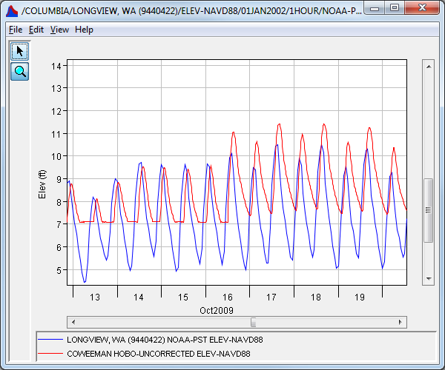
Figure 0-10: Coweeman HOBO gage drift
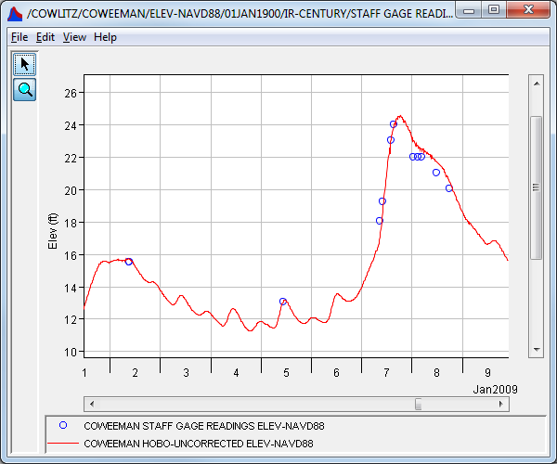
Figure 0-11: Coweeman gage elevations, Jan 2009
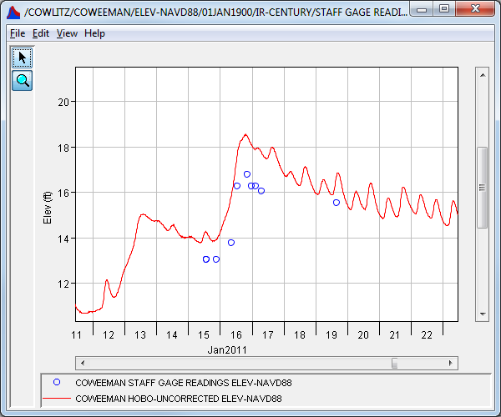
Figure 0-12: Coweeman gage elevations, Jan 2011
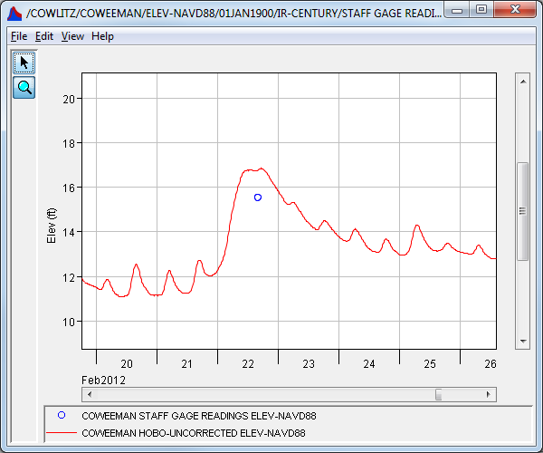
Figure 0-13: Coweeman gage elevations, Feb 2012
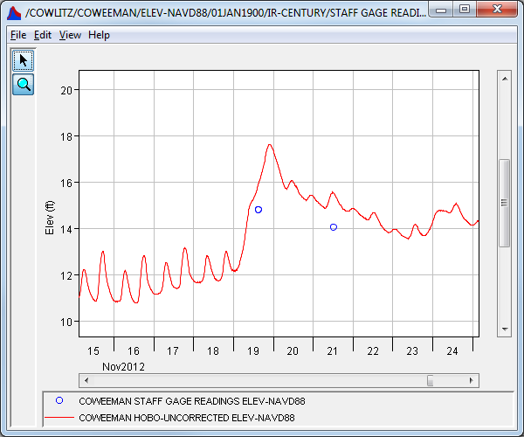
Figure 0-14: Coweeman gage elevations, Nov 2012
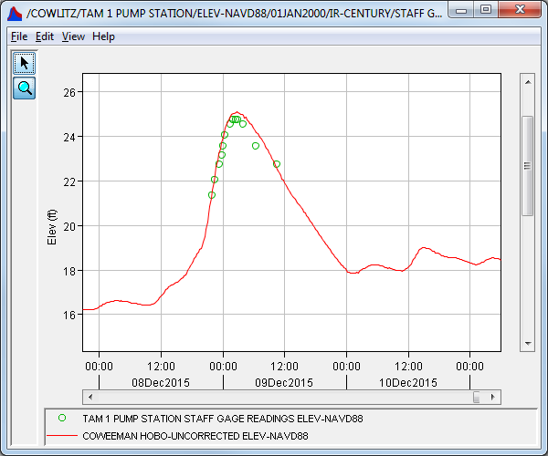
Figure 0-15: Coweeman gage elevations, Dec 2015

Calibration Results
All roughness coefficients for the Coweeman River were adjusted from 0.031 to 0.04 in the channel and were left as 0.065 in the left and right overbanks (as they were in the 2011 Coweeman model). This produced the most comparable results with the observed data. The Cowlitz reaches had minor adjustments from the 2009 and 2014 Cowlitz LOPs. Table 0-6 shows the most upstream Cowlitz River Station with each block of consistent Manning’s n values. In the table, the Manning’s n apply until the next downstream adjustment location is encountered. Bridges are also noted in Table 0-6; the Manning’s n value of the overbanks immediately upstream and downstream of the bridges were adjusted to a large n value to increase stability.
As previously mentioned, this calibration dataset does not include very many of the largest events on record. This introduces additional uncertainty in the overbank roughness coefficients, but since the rivers are heavily leveed, the overbank areas have less influence on results than is the case in other rivers.
Table 0-6: Roughness Coefficients on the Cowlitz River
Reach Name | River Station | Manning's n Values
 |  | Left Overbank | Main Channel | Right Overbank
Cowlitz Lower | 16.64 | 0.07 | 0.035 | 0.07
 | 11.55 | 0.07 | 0.03 | 0.07
 | 8.48 | 0.07 | 0.025 | 0.07
 | 8.11 | 0.2 | 0.025 | 0.2
 | 8.09 | Bridge
 | 8.07 | 0.02 | 0.025 | 0.02
 | 8.01 | 0.07 | 0.025 | 0.07
 | 6.78 | 0.2 | 0.025 | 0.2
 | 6.76 | Bridge
 | 6.75 | 0.2 | 0.025 | 0.2
 | 6.41 | 0.07 | 0.025 | 0.07
 | 5.37 | 0.07 | 0.02 | 0.07
 | 5.23 | 0.2 | 0.02 | 0.2
 | 5.21 | Bridge
 | 5.20 | 0.2 | 0.02 | 0.2
 | 5..09 | 0.2 | 0.02 | 0.2
 | 5.07 | Bridge
 | 5.05 | 0.2 | 0.018 | 0.2
 | 4.90 | 0.07 | 0.18 | 0.07
Lower – D/S of Coweeman | 1.63 | 0.07 | 0.015 | 0.07
 | 0.01 | 0.07 | 0.015 | 0.07

Adjusting roughness coefficients was a major contributor to model calibration, but verifying geometry and ineffective areas were also key factors. The Cowlitz and Coweeman rivers started as two separate models that were combined into one. This created some issues at the Coweeman River confluence with the Cowlitz River. The 2011 Coweeman model started as a steady state model, so parameters needed to be adjusted and added to make an unsteady model run. For example, there was no maximum head water elevation required for bridges in the steady state model, so this parameter was added for the unsteady model. As the model was run with different n values, ineffective areas were also checked upstream and downstream of bridges to make sure that the new bridge geometry found from the David Evans and Associates 2010 survey had ineffective areas at reasonable elevations and stations.
The tables below show the difference in feet of modeled (simulated) and observed stage peaks during the calibrated HEC-RAS simulation from October 2007 through December 2015. As is the case with any model, the simulated results do not match observed data for all events. The focus of calibration here is the peak stage, so discrepancies in low flows are not of great concern. The maximum error in calibration was just under a foot, with most events within a half of a foot. While the calibration is not especially tight for some events, this uncertainty in model performance can be accounted for in the final results. If the model were calibrated perfectly, there would be no need to account for uncertainty in the calibration. However, in this case, the errors in the model can be incorporated into the final results by adjusting the uncertainty term relating to model performance. Refer to the main report to see more details on how this uncertainty was incorporated.
Table 0-7: Calibration Results for Coweeman (instantaneous)
Date of Observed Peak Elevation | Observed WSE (feet) Coweeman – Under I-5 Bridge | Date of Modeled Peak Elevation | Modeled WSE (feet) Coweeman – Under I-5 Bridge | Delta +/-
07-Jan-2009, 1830 | 24.57 | N/A | N/A | N/A  A
16-Jan-2011, 1800 | 17.32 | 16-Jan-2011, 1600 | 17.41 | 0.09
05-Jun-2011, 0600 | 16.02 | 05-Jun-2011, 0600 | 15.74 | -0.28
23-Nov-2011, 1400 | 16.21 | 23-Nov-2011, 1400 | 16.11 | -0.10
30-Dec-2011, 0900 | 14.22 | 30-Dec-2011, 0900 | 14.14 | -0.06
21-Jan-2012, 1415 | 16.93 | 21-Jan-2012, 1400 | 16.18 | -0.75
22-Feb-2012, 1615 | 15.78 | 22-Feb-2012, 1000 | 16.49 | 0.82
19-Nov-2012, 2045 | 16.67 | 19-Nov-2012, 2000 | 17.05 | 0.43
17-Nov-2015, 2130 | 17.74 | 17-Nov-2015, 2100 | 17.83 | 0.11
09-Dec-2015, 0245 | 24.40 | N/A | N/A | N/A

Table 0-8: Calibration Results for Lexington (hourly)
Date of Observed Peak Elevation | Observed WSE (feet) Lexington | Date of Modeled Peak Elevation | Modeled WSE (feet) Lexington | Delta +/-
03-Dec-2007, 2000 | 32.27 | 03-Dec-2007, 2200 | 32.47 | 0.20
08-Jan-2009, 1000 | 37.80 | 08-Jan-2009, 1000 | 38.29 | 0.49

Table 0-9: Calibration Results for Ostrander (hourly)
Date of Observed Peak Elevation | Observed WSE (feet) Ostrander | Date of Modeled Peak Elevation | Modeled WSE (feet) Ostrander | Delta +/-
03-Dec-2007, 2300 | 27.19 | 03-Dec-2007, 2200 | 27.84 | 0.65
08-Jan-2009, 1300 | 30.62 | 08-Jan02009, 1000 | 32.76 | 2.14

Table 0-10: Calibration Results for Gearhart Garden (hourly)
Date of Observed Peak Elevation | Observed WSE (feet) Gearhart Garden | Date of Modeled Peak Elevation | Modeled WSE (feet) Gearhart Garden | Delta +/-
03-Dec-2007, 1130 | 14.86 | 03-Dec-2007, 2200 | 15.05 | 0.19
08-Jan-2009, 1300 | 17.94 | 08-Jan-2009, 1100 | 19.43 | 1.49

The following sections discuss selected events in the calibration. The figures with hydrographs compare the simulated (red line) and observed (black circles) data. For selected events, profile plots are shown as well with high water marks as circles.

January 2011 Event
The January 2011 calibration appeared reasonable. The peak flow matches quite well, with the lower flow periods diverging a bit more. Since the focus of this study is on the peaks of each event, this was considered acceptable.
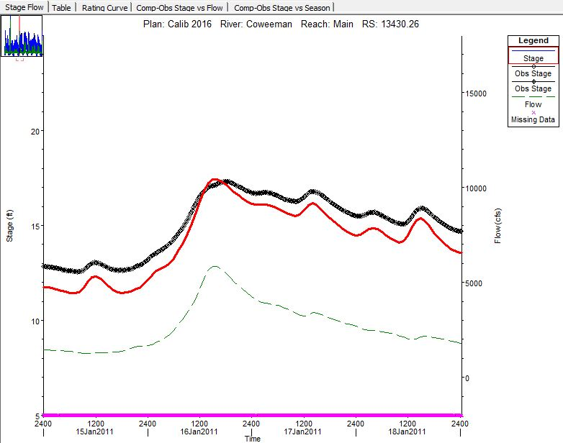
Figure 0-16: January 2011 Calibration at Coweeman River HOBO gage
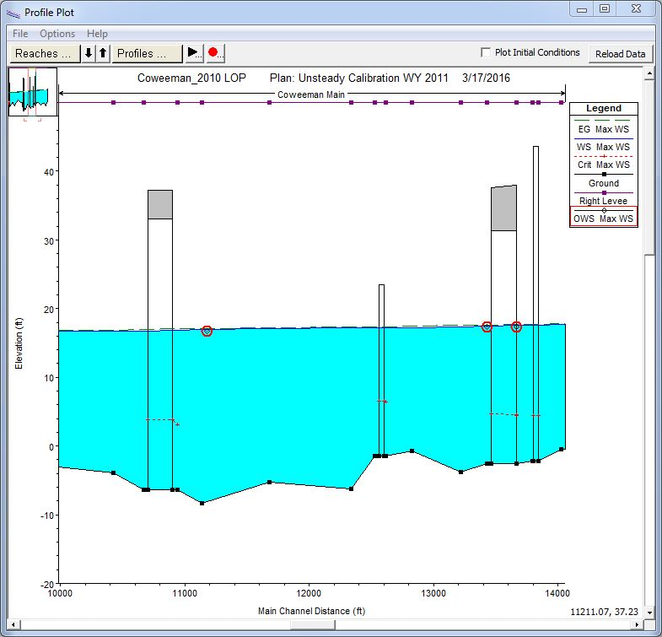
Figure 0-17: January 2011 Calibration Profile at Coweeman River
Figure 0-17 shows the high water marks associated with the peak simulated flow of the January 2011 event. The circle on the left of the figure is the high water mark at Coweeman Pump Station, while the two circles on the right represent the observed Coweeman HOBO gage peak elevation that is also shown in Figure 0-16. All three observed maximum water surface elevations match the simulated water surface elevation relatively well in the above profile plot.

June 2011 Event
The June 2011 event is included because it shows how the model performs under a scenario when only the Columbia River is peaking. Spring snowmelt led to high Columbia River flows in 2011, but the rain-driven Cowlitz and Coweeman Rivers remained at low levels. This calibration event gives confidence to the model under the scenario where only the Columbia is peaking. As seen in Figure 0-18 and numerically shown in Table 0-7, there is a difference of less than half a foot between observed and modeled elevation.
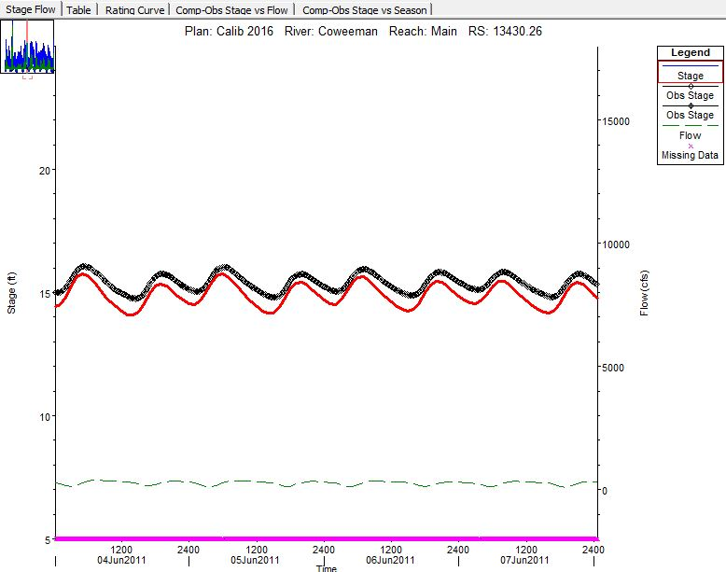
Figure 0-18: June 2011 Calibration at Coweeman River HOBO gage

November 2011 Event
The November 2011 event is not particularly large, but good calibration was achieved. Notice in Figure 0-19 that the peak matches up almost exactly, with only 0.1 foot of error.
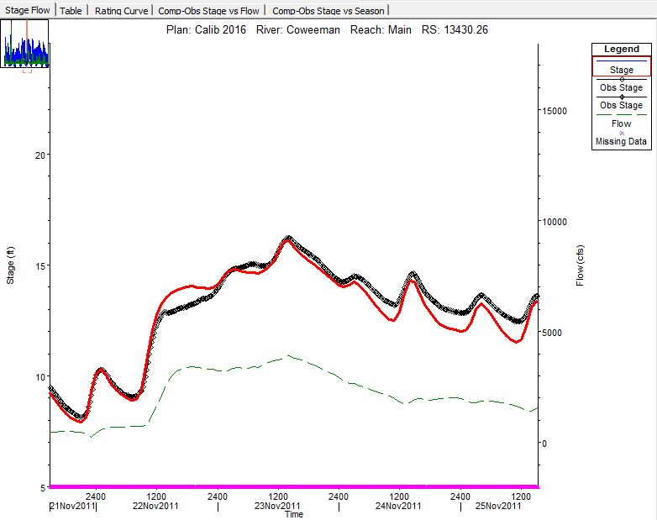
Figure 0-19: November 2011 Calibration at Coweeman River HOBO gage

December 2011 Event
Good calibration was achieved for the peak of the December 2011 event. The simulated elevation is low before and after the peak (see Figure 0-20), but the peak itself matches up well, with 0.06 foot of error.
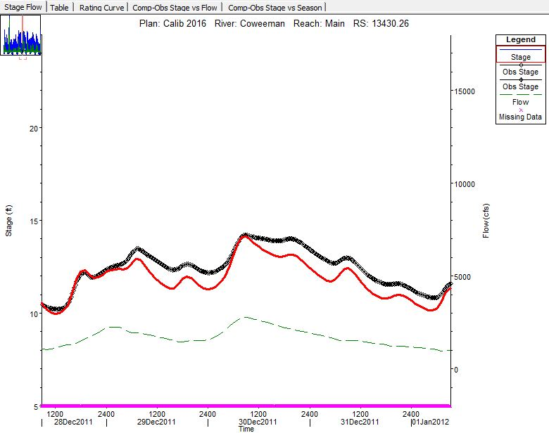
Figure 0-20: December 2011 Calibration at Coweeman River HOBO gage

January 2012 Event
The January 2012 showed one of the largest errors in model calibration. The model predicted stages significantly lower than what actually occurred in reality, but the timing of the event appears reasonable. It is unclear why this event was under predicted. See Figure 0-21 for graphical representation of this comparison.
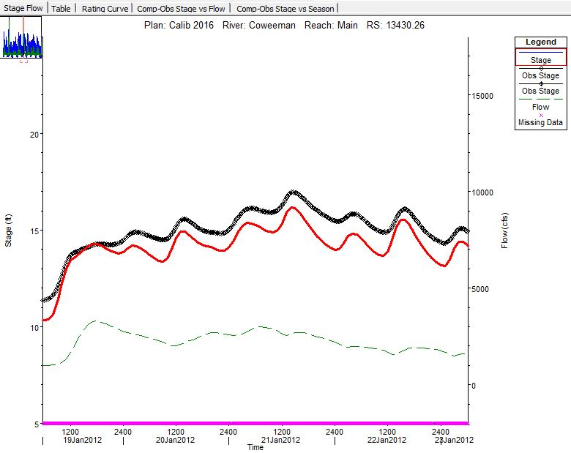
Figure 0-21: January 2012 Calibration at Coweeman River HOBO gage

February 2012 Event
In contrast to the January 2012 event, the February 2012 event over predicted stages (see Figure 0-22). Due to the under and over predictions of the January and February 2012 events, the roughness coefficients were left as is. Figure 0-23 shows the high water mark at the Coweeman Pump Station, with a maximum water surface elevation that matches well with the Coweeman HOBO gage.
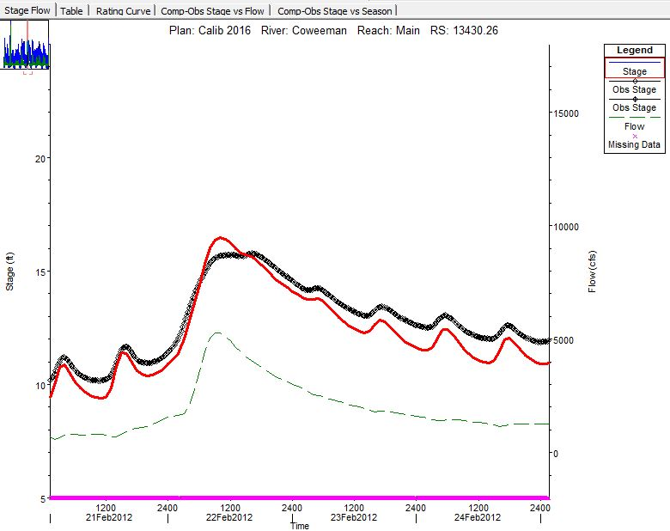
Figure 0-22: February 2012 Calibration at Coweeman River HOBO gage
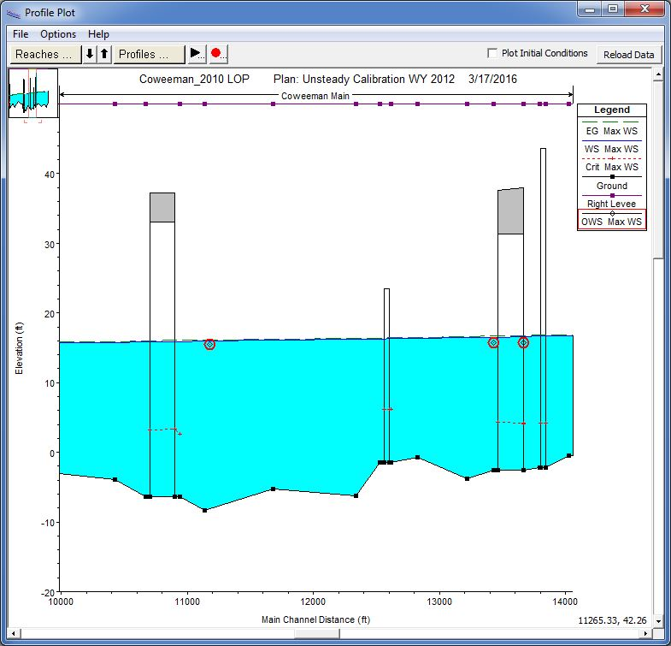
Figure 0-23: February 2012 Calibration Profile at Coweeman River

November 2012 Event
The shape and magnitude of the November 2012 event appears reasonable. It is possible that the staff gage reading at the Coweeman pump station was not taken at the precise peak water surface of the event, since the high water mark appears a bit low; see Figure 0-25 for reference to the Coweeman Pump Station high water mark as the left circle compared to the Coweeman HOBO gage results as the right two circles.
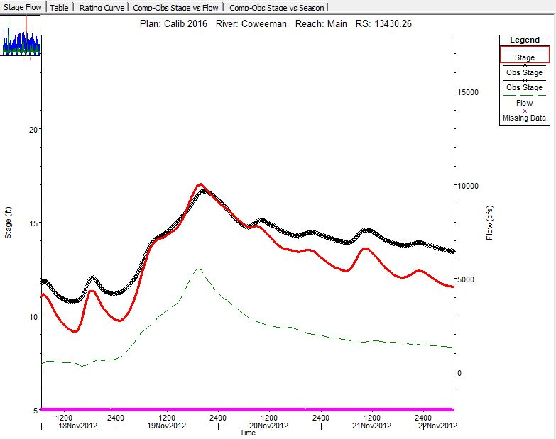
Figure 0-24: November 2012 Calibration at Coweeman River HOBO gage
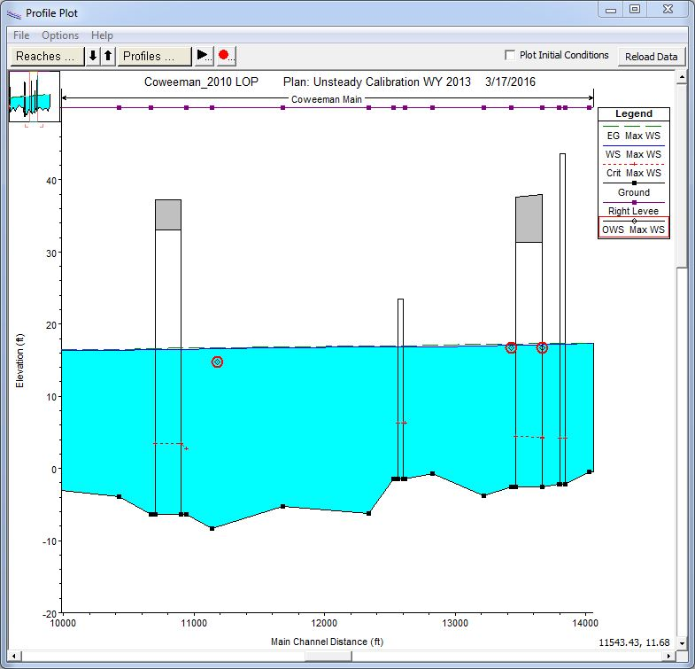
Figure 0-25: November 2012 Calibration Profile at Coweeman River

November 2015 Event
While the November 2015 event matches the peak stage fairly well, the simulated stage displays a much sharper peak than the more broad shape of the observed stage (see Figure 0-26). It is possible that more attenuation on the Cowlitz occurred in reality than in the model, or that the Coweeman input flow hydrograph was too low for the lower flow periods.
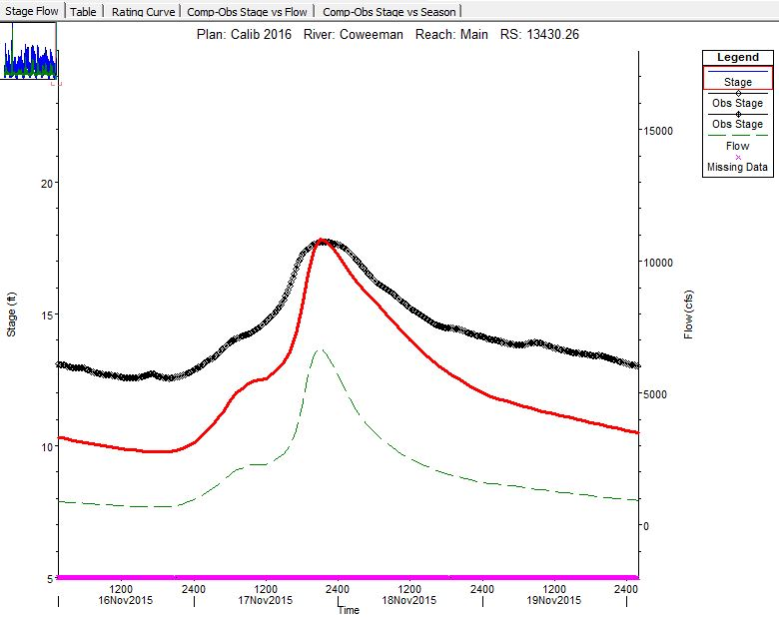
Figure 0-26: November 2015 Calibration at Coweeman River HOBO gage

January 2009 Event
The January 2009 event is one of the largest on record, but a suitable calibration was not possible. As previously discussed, the Coweeman River streamgage appeared to have some unreasonable data for this event. This is borne out by the model results. If the Coweeman flow data is used without modification, an extremely poor calibration occurs, missing the peak stage by over 5 feet. Efforts were made to reconstruct the flow hydrograph for the 2009 event, but this was not of much benefit. The development of the inflow hydrograph was so uncertain that the calibration became unusable. The January 2009 event is shown at the Coweeman HOBO gage in Figure 0-27. Note the large difference in elevation at the peak and the dip in the simulated data that occurs.
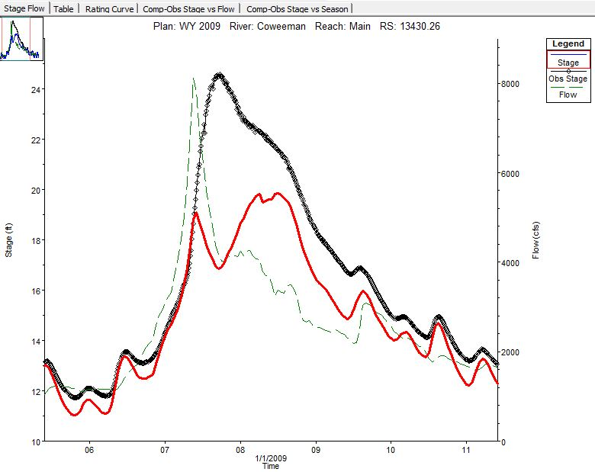
Figure 0-27: January 2009 Calibration at Coweeman River HOBO gage
On the Cowlitz River, the 2009 event has a much better calibration. As previously discussed, the Gearhart Gardens gage readings may be suspect in this event (see Figure 0-28), but the Lexington gage shows a relatively good representation of the elevation peak, as shown in Figure 0-29.
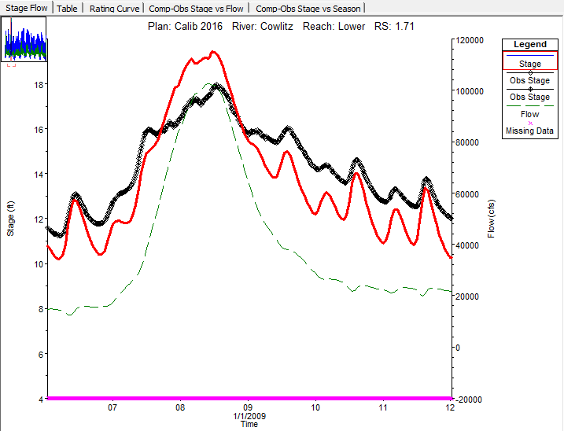
Figure 0-28: January 2009 Calibration at Gearhart Gardens Park Gage
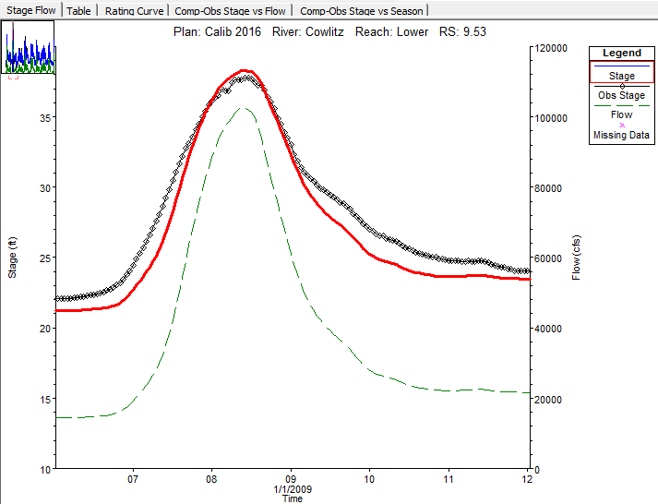
Figure 0-29: January 2009 Calibration at Lexington Gage

December 2007 Event
The December 2007 event also showed extremely poor calibration, and was not used to inform the adjustment of parameters during calibration. Figure 0-30 shows a hydrograph with the large observed and modeled difference in elevation at the peak. As previously discussed, the input flow data for this event appears to be questionable, dropping off suddenly, while other nearby gages do not show this pattern.
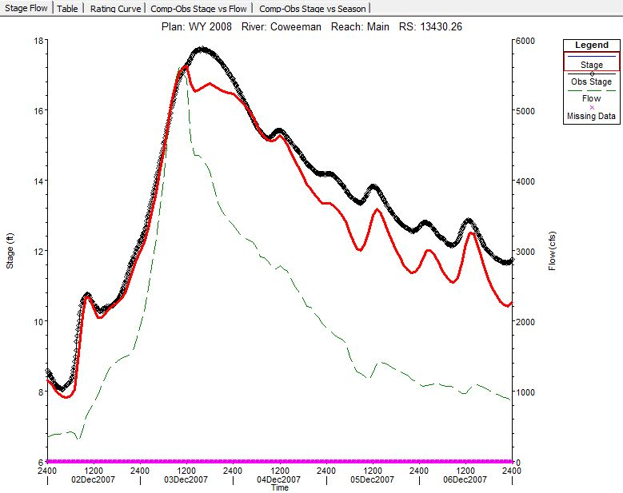
Figure 0-30: December 2007 Calibration at Coweeman River HOBO gage
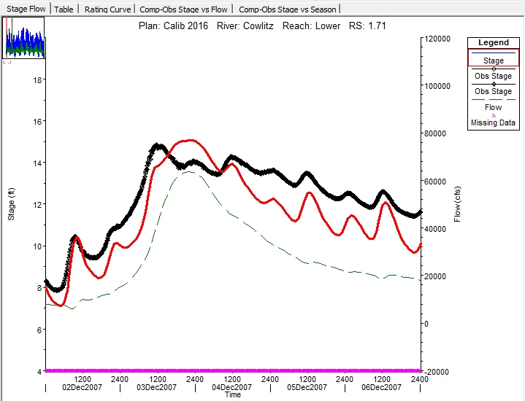
Figure 0-31: December 2007 Calibration at Gearhart Gardens Park Gage
Similar to the 2009 event, the 2007 event on the Cowlitz has a much better calibration further upstream. Figure 0-32 shows a small difference in peak elevation for simulated and modeled elevations at the Ostrander gage. Figure 0-31 shows the suspect Gearhart Gardens gage readings during the December 2007 event, as previously mentioned. The height of the event at Gearhart Gardens is similar, but the timing is off and this may be due to the gage being silted in.
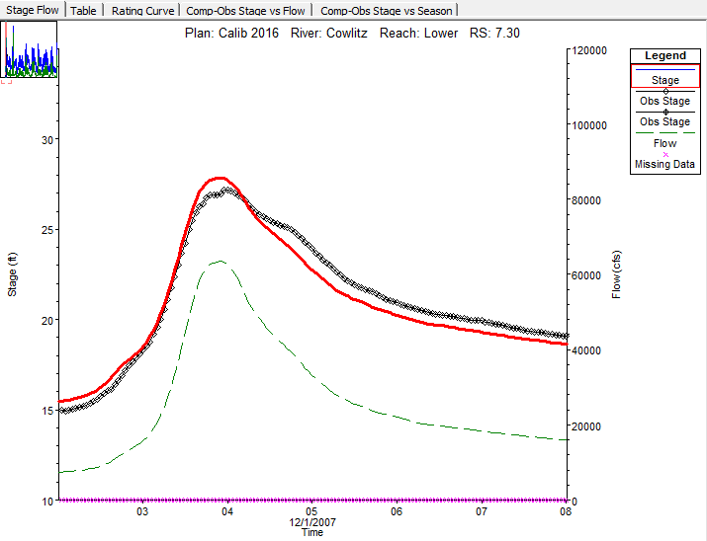
Figure 0-32: December 2007 Calibration at Ostrander Gage

Stress Testing
The hydraulic model is intended to be run many times as part of a Monte Carlo simulation process. Therefore, this model must be flexible enough to handle a variety of input hydrologic conditions, since the sampling produces flow combinations that have not been seen in the historical record before. Stress testing refers to the process of running simulations with extreme conditions and verifying the reasonableness of results. Stress testing often reveals instabilities in the model that must be rectified. Modifications made as a result of stress testing do not significantly affect calibration results, but are primarily made to increase model stability.
When stress testing the Coweeman RAS model, a variety of combinations of extreme events were used. To adequately capture large events, the assumed 0.01% ACE boundary conditions were input to the model. Extreme low water conditions were examined as well with the 99% ACE boundary conditions. Combinations of these events, as well as other intermediate events, were applied at the 3 boundary conditions. Hydraulic performance of bridges and levees are of special concern during stress testing.
Adjustments made during stress testing included the following:
- Cross-sections were added to provide additional definition in sensitive areas.
- The computational time step was decreased to 10 seconds to better capture events with levee overtopping.
- Lateral structures were added to represent some levees, and storage areas were added to represent the Lexington leveed area. The native RAS “levee tool” showed oscillatory behavior without this correction. Refer to the “Levees” section for more details
- The Coweeman flow hydrograph input was stress-tested up to the best-estimate 0.01% ACE event (27,400 cfs). The Monte Carlo process may generate synthetic hydrographs larger than this, since there is uncertainty about the 0.01% ACE event. The maximum sampled value in the Monte Carlo simulations was capped to 27,400 cfs, as additional instabilities apply during larger events. Since the model is used for the 1% ACE event, this change will not affect the results.

Appendix B-Wind-Wave Analysis
Wind causes two concerns for the levees: wave height and wave run-up. Two basic considerations are used in establishing the wind driven wave height: wave characteristics and wind setup. This wind-wave analysis evaluates the significant wave characteristics and wind setup for winds blowing along the fetch of the river towards the levee and wave run-up, using the methodologies outlined in EM 1110-2-1100, Coastal Engineering Manual (USACE 2008), and in EM 1110-2-1420, Hydrologic Engineering Requirements for Reservoirs (USACE 1997).
The criteria for evaluating wind-wave effects are deterministic rather than probabilistic. The wind-wave analysis results in freeboard requirements that must be satisfied to obtain levee accreditation. The minimum required levee freeboard above the 1% ACE flood event for wind-wave purposes is the greater of the calculated wave height and wave run-up.
The CDID3 system is not expected to experience large wind-wave effects, since the fetch lengths are relatively small. Wind-wave effects tend to be more of a concern in estuaries, coastal settings, and large rivers. The analysis detailed here generally shows that wind-wave effects will not be the governing factor in the required levee height for the CDID3 system—the wind-wave effects are lower than 3 feet.
Wind-wave effects were evaluated at two locations, which are considered to represent the most critical scenarios. The downstream end of the levee at the confluence of the Cowlitz and Coweeman rivers has the largest fetch length (0.8 miles), and will experience the largest wave action. The second location of interest is near the Tam O’Shanter Pump Station 1 (see Figure 2-4). This represents a location further upstream that has the longest fetch length of the Coweeman River alone (0.5 miles). All other locations would have smaller fetch lengths, resulting in smaller wind-wave effects than the Tam O’Shanter Pump Station 1 location.
Bonneville Power Administration (BPA) produced maps of the 2-year and 50-year mean recurrence interval annual extreme one-minute average wind speeds for Oregon, Washington, Idaho, and part of Montana (Wantz & Sinclair 1981). The 2-year and 50-year wind speeds were taken from these maps, plotted on probability paper, and connected with a straight line. This allowed the 100-year and 500-year wind speed to be estimated from the plot. A second report from a former professor at Oregon State University lists the strongest winds at various locations throughout the northwest (Main 2007). Portland, Oregon was the closest location in the report to Kelso, and this value was assumed to apply to the CDID3 area in this study. The maximum wind speeds are provided for reference only, and do not affect the decision making process of the wind-wave analysis per EC 1110-2-6067. The maximum wind speeds are from the 1962 Columbus Day storm, which was an extremely large event. Table 0-1 summarizes the 1-minute wind speeds used in this wind-wave analysis.

Table 0-1 Wind Speeds at Portland, Oregon (assumed equivalent to Kelso, WA)
Recurrence Interval | 1-Minute Wind Speed, U (mph)
2-year | 40
50-year | 62
100-year | 65
500-year | 71
Maximum | 104

The procedures in the Costal Engineering Manual require a 1-hour wind speed based on equivalent duration (U₁₀) for the wind-wave analysis. The U₁₀ is also dependent on the fetch length. The 1-minute wind speeds listed in Table 0-1 were converted to a U₁₀ speed using the procedures in the Costal Engineering Manual, and the significant wave height was calculated. The U₁₀ value was applied in the direction of the fetch (southwesterly). This is a conservative assumption, since it is unlikely that 100% of the U₁₀ would be in the same direction of the fetch. However, the largest wind speeds observed in the 1962 Columbus Day storm were southwesterly, so this is a reasonable assumption (Read 2007). The results are shown on Table 0-2.
Table 0-2 Significant Wave, Peak Period, and Wavelength
Design Parameters |  | Recurrence Interval
 |  | 100-yr | 500-yr | Max
Design Wind Velocity, U₁₀ (mph) | Downstream | 50 | 54 | 80
 | Tam 1 Pump | 49 | 54 | 80
Design Duration, t_{d} (min) | Downstream | 23 | 22 | 20
 | Tam 1 Pump | 16 | 14 | 12
Significant Wave Height, H_{m0} (ft) | Downstream | 1.25 | 1.41 | 2.37
 | Tam 1 Pump | 0.98 | 1.11 | 1.88
Wave Period, T (sec) | Downstream | 1.39 | 1.45 | 1.73
 | Tam 1 Pump | 1.19 | 1.24 | 1.48
Wave Length, L (ft) | Downstream | 9.9 | 10.8 | 15.3
 | Tam 1 Pump | 7.2 | 7.9 | 11.3

Note: Design duration, significant wave height, wave period, and wave length are values that were computed from the procedures found in EM 1110-2-1100 and EM 1110-2-1420).

The wind set-up was computed using Equation 15-1 in EM 1110-2-1420. Wind set-up is the mounding of water against the lee shore caused by a sustained wind pushing the water. Wind set-up increases with the sustained wind velocity and fetch. It decreases proportionately as water surface depth in front of the impacting surface increases. The wind set-up for various return periods was computed using the values determined in Table 0-1 and Table 0-2. To get the maximum wind driven wave height on the levee, the significant wave height and the wind set-up are added together. The results are shown in Table 0-3.
Table 0-3 Wind Set-up and Total Wind-induced Wave Height
Parameters |  | Recurrence Interval
 |  | 100-yr | 500-yr | Max
Wind Set-up, S (ft) | Downstream | 0.05 | 0.05 | 0.12
 | Tam 1 Pump | 0.02 | 0.03 | 0.07
100-year Maximum Wind-driven Wave Height, H_{T} (ft) | Downstream | 1.3 | 1.5 | 2.5
 | Tam 1 Pump | 1.0 | 1.1 | 1.9

Wave run-up was calculated for irregular wave run-up on a smooth mildly sloping beach (Mase 1989) using the following equation:
R_{ux} = H_{s0}aI^{b}
Where R_{ux} is the run-up level above Static Water Level (SWL), for exceedance level x (e.g. R_{u2%} is the run-up level exceeded by 2% of the run-up). The 2% exceedance value of wave run-up maxima is used because it shows the highest swash events in a wave run-up distribution that are initially responsible for erosion and overtopping (Holman 1986). H_{s0} is the deep-water significant wave height, coefficients a and b for R_{u2%} are 1.86 and 0.71, respectively, and I is the Iribaren number defined as follows:
I = tan Θ / [(2 Π/g)(H_{s0}/T_{p}²)]^{1/2}
tan Θ= the tangent of the levee slope,
H_{s0} = H_{m0} = Deepwater Wave Height,
T_{p} = wave period, and
g = acceleration of gravity.

The wave run-up results are given in Table 0-4.
Table 0-4 Wind-induced Wave Run-up
Parameters |  | Recurrence Interval
 |  | 100-yr | 500-yr | Max
Total Wave Run-up, R_{ux} (ft) | Downstream | 3.0 | 3.3 | 5.2
 | Tam 1 Pump | 2.3 | 2.5 | 4.0

The requirements of both the total 100-year wind induced wave height and the 100-year wave run-up must be satisfied. The larger of these two parameters is added to the 1% ACE flood height, which results in a minimum levee elevation. In the case of CDID3, the required freeboard above the 1% ACE flood is less than 3 feet, so the wind-wave analysis does not control the results. Since 3 feet of freeboard is required in 44 CFR 65.10 for the CDID3 system, this more stringent requirement overrides the wind-wave freeboard requirement. Since these two index points were the most likely to not have sufficient freeboard, if the levee system meets the 3 foot freeboard requirement, the entire levee system will have the required height to likely meet or exceed NFIP wind-wave levee system evaluation requirements. Results are shown in Table 0-5.
Table 0-5: Required Freeboard for Wind-Wave effects
Index  Point | Total Wind Induced Wave Height (ft) | Total Wave Run-up (ft) | Freeboard required above 1% ACE Flood for wind-wave purposes (ft)¹
Downstream End | 1.3 | 3.0 | 3.0
Tam 1 Pump Station | 1.0 | 2.3 | 2.3
Notes:
1. Required freeboard above the 1% ACE flood for wind-wave purposes is the greater of the 1% wind induced wave height and the 1% wave run-up.

Appendix C-Memorandum of Agreement
Copies of the memorandums of agreement between CDID3 and USACE authorizing USACE to perform levee certification work are provided here for reference.
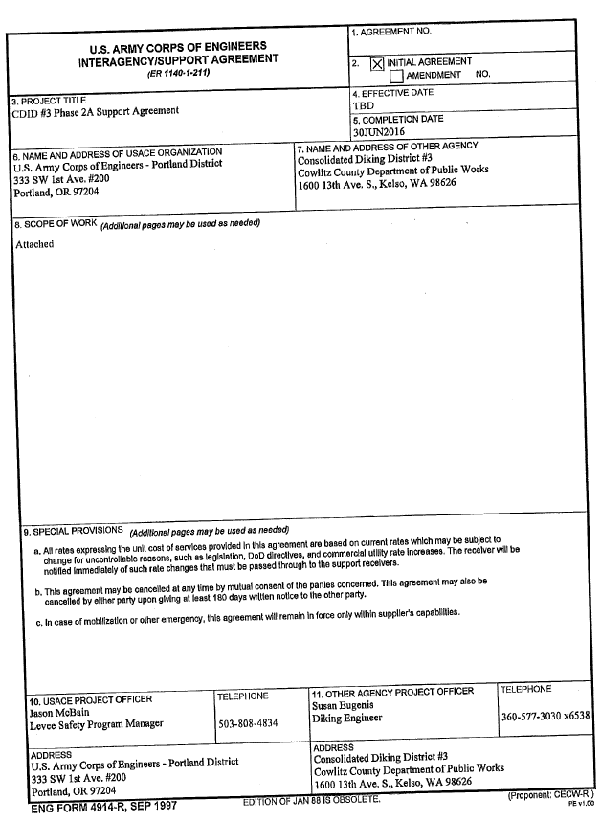
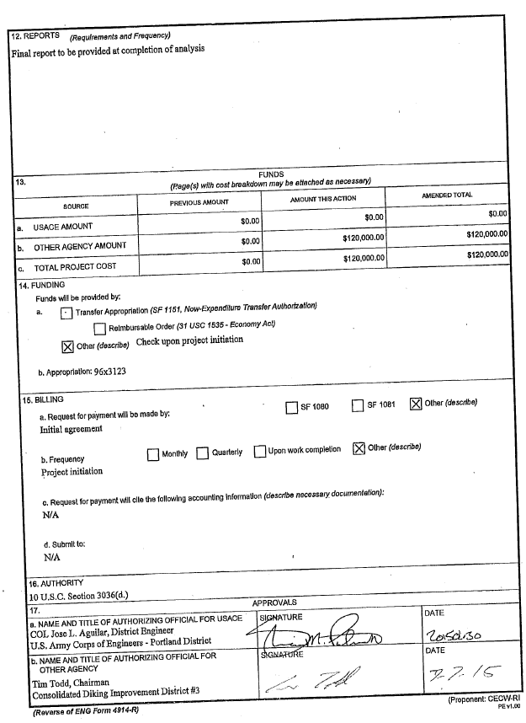
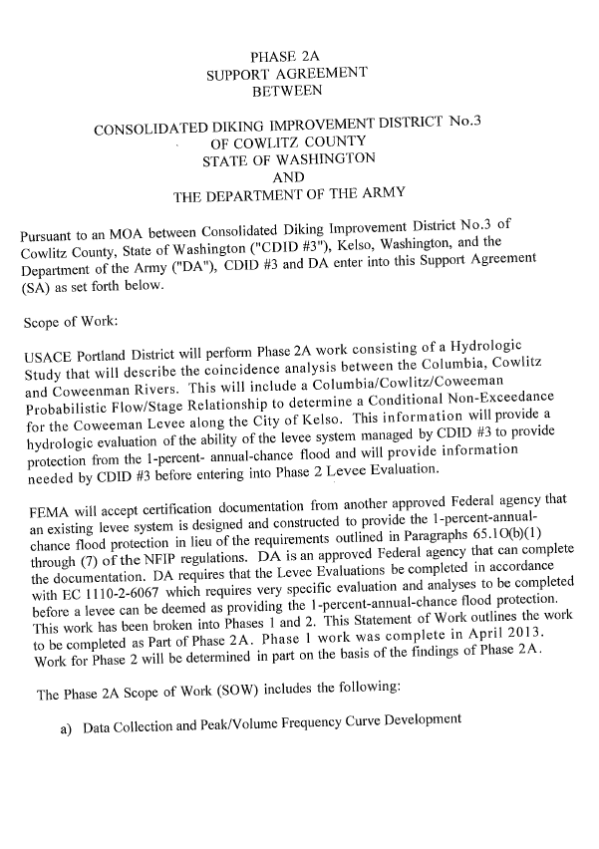
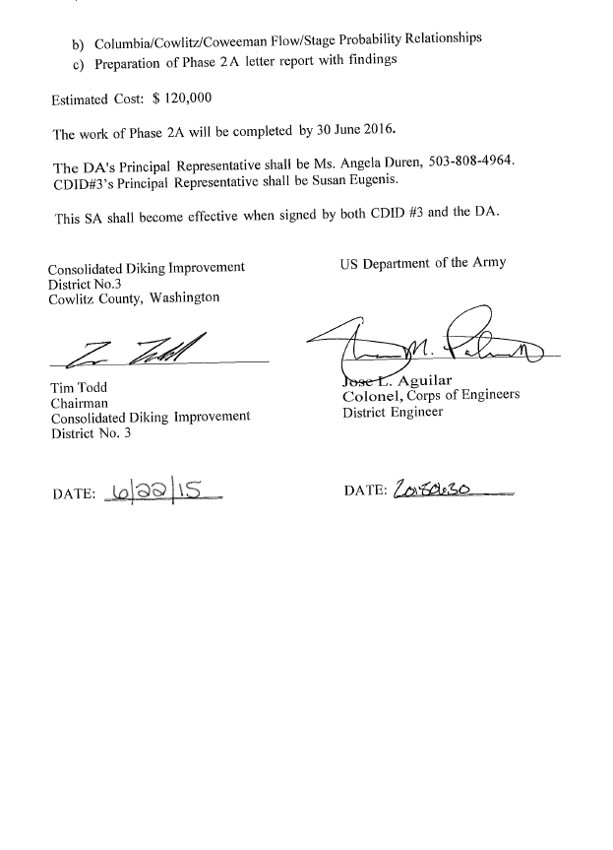
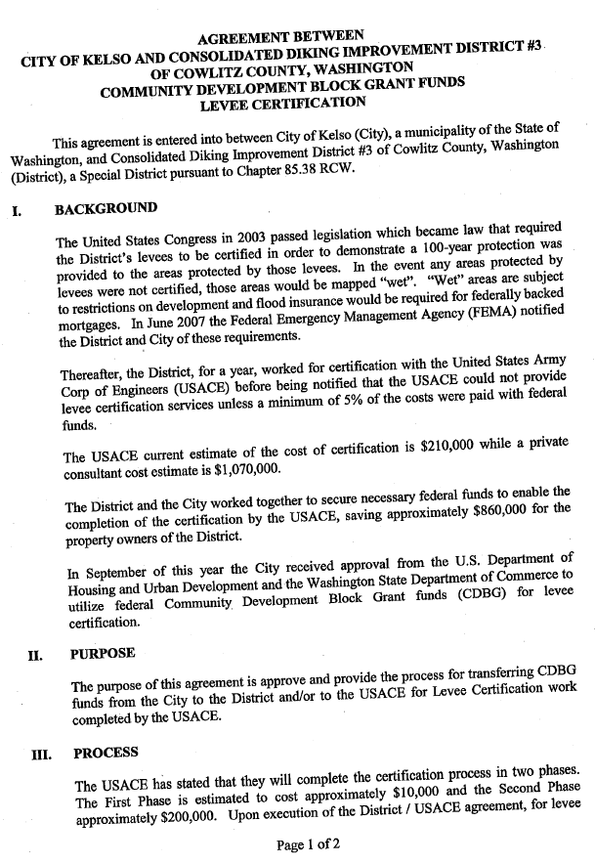
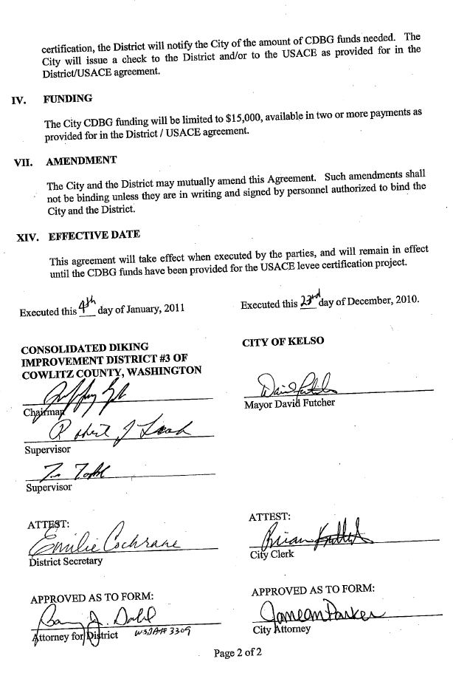
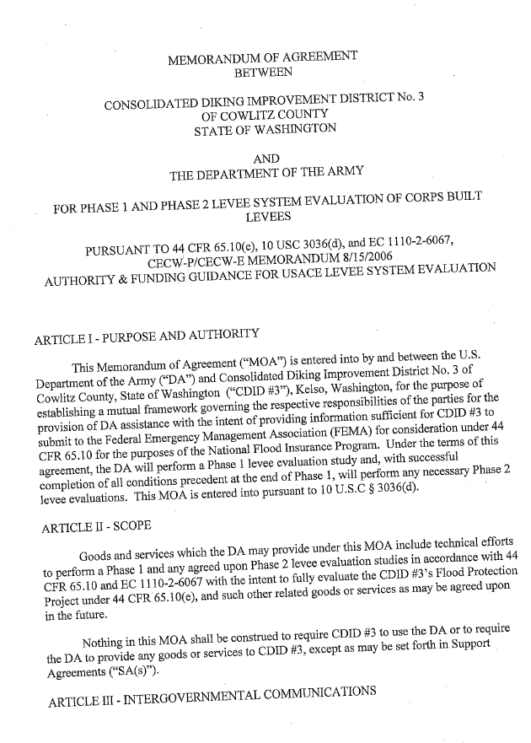
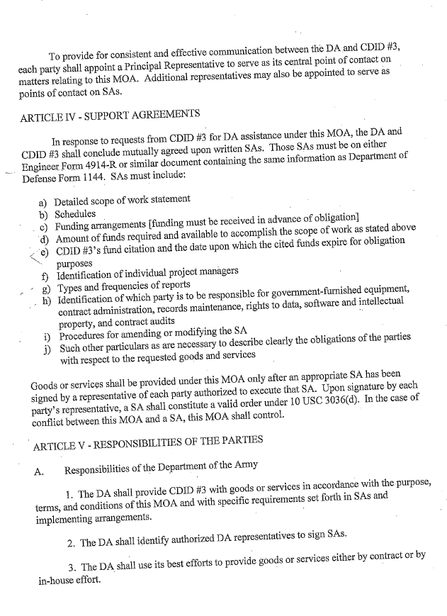
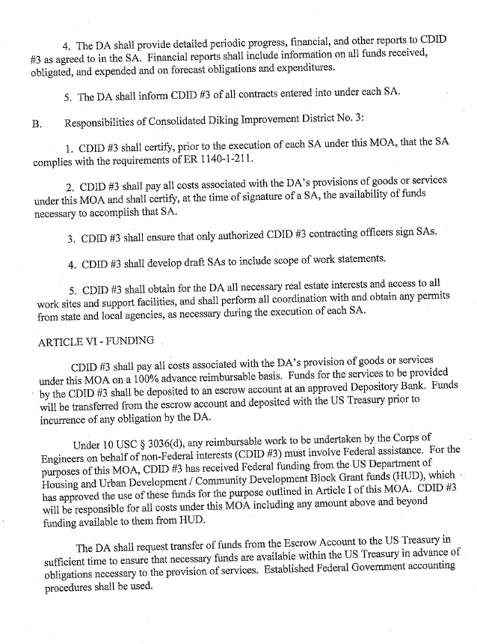
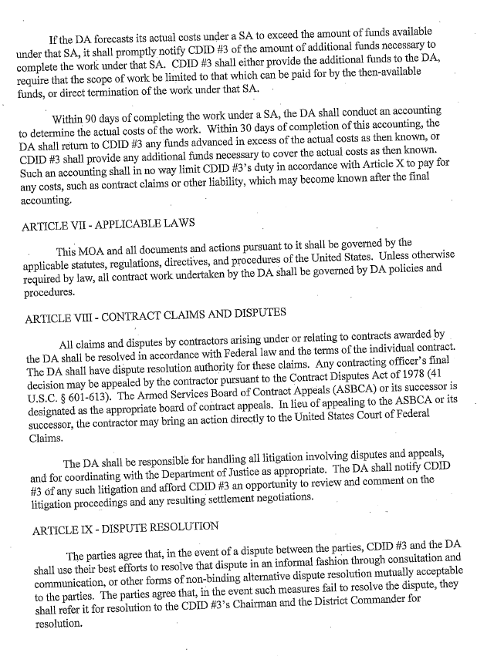
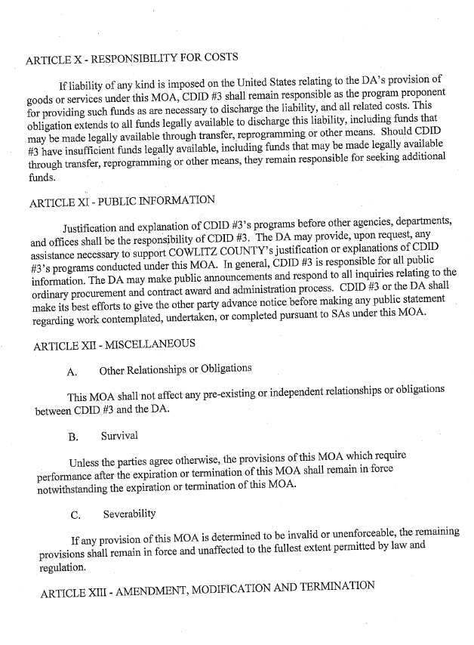
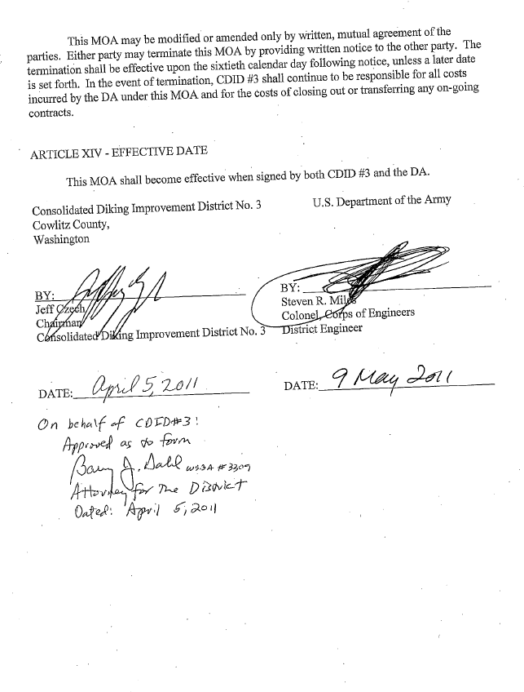

Appendix D-Record of Review
A District Quality Review (DQC) and an Agency Technical Review (ATR) were performed. The comments and responses raised during the ATR review are provided below.

