 | Technical Memorandum
 | Date: | 09/03/2026
 | Project: | Mount St. Helens Project Cowlitz River Levee Systems
 | Subject: | Regulated Flow Frequency, Lower Cowlitz River
 | From: | Hydrology and River and Engineering Section, Portland District

1. Purpose
This memorandum documents the development of a regulated peak flow frequency curve for the lower Cowlitz valley in Cowlitz County, Washington to inform levee assessments and floodplain mapping. Unregulated curves are developed for the instantaneous peak, 1-, 3-, and 5-day durations (Section 4) and used to develop regulated flow frequency curves resulting from operations at Mossyrock and Mayfield dams at locations along the lower Cowlitz River (Section 5).

2. Basin Description and Project Operation
The Cowlitz River drains the southern Washington Cascades and enters the Columbia River near Longview. The U.S. Geological Survey (USGS) operates the Castle Rock gage (USGS 14243000) located in the lower valley, downstream of the Toutle River confluence, with a peak-flow record spanning water years 1927 through 2026. The total Cowlitz basin area is 2,480 square miles, of which 1,170 square miles (roughly half) are regulated by Mossyrock Dam. Mossyrock Dam, completed in 1968, provides the only usable flood storage in the basin. Just downstream of Mossyrock is Mayfield Dam, which acts as a re-regulating dam that smooths power peaking releases from Mossyrock providing no meaningful flood regulation of its own. Cowlitz Falls Dam above Mossyrock and the Sediment Retention Structure on the Toutle River are both run-of-river.

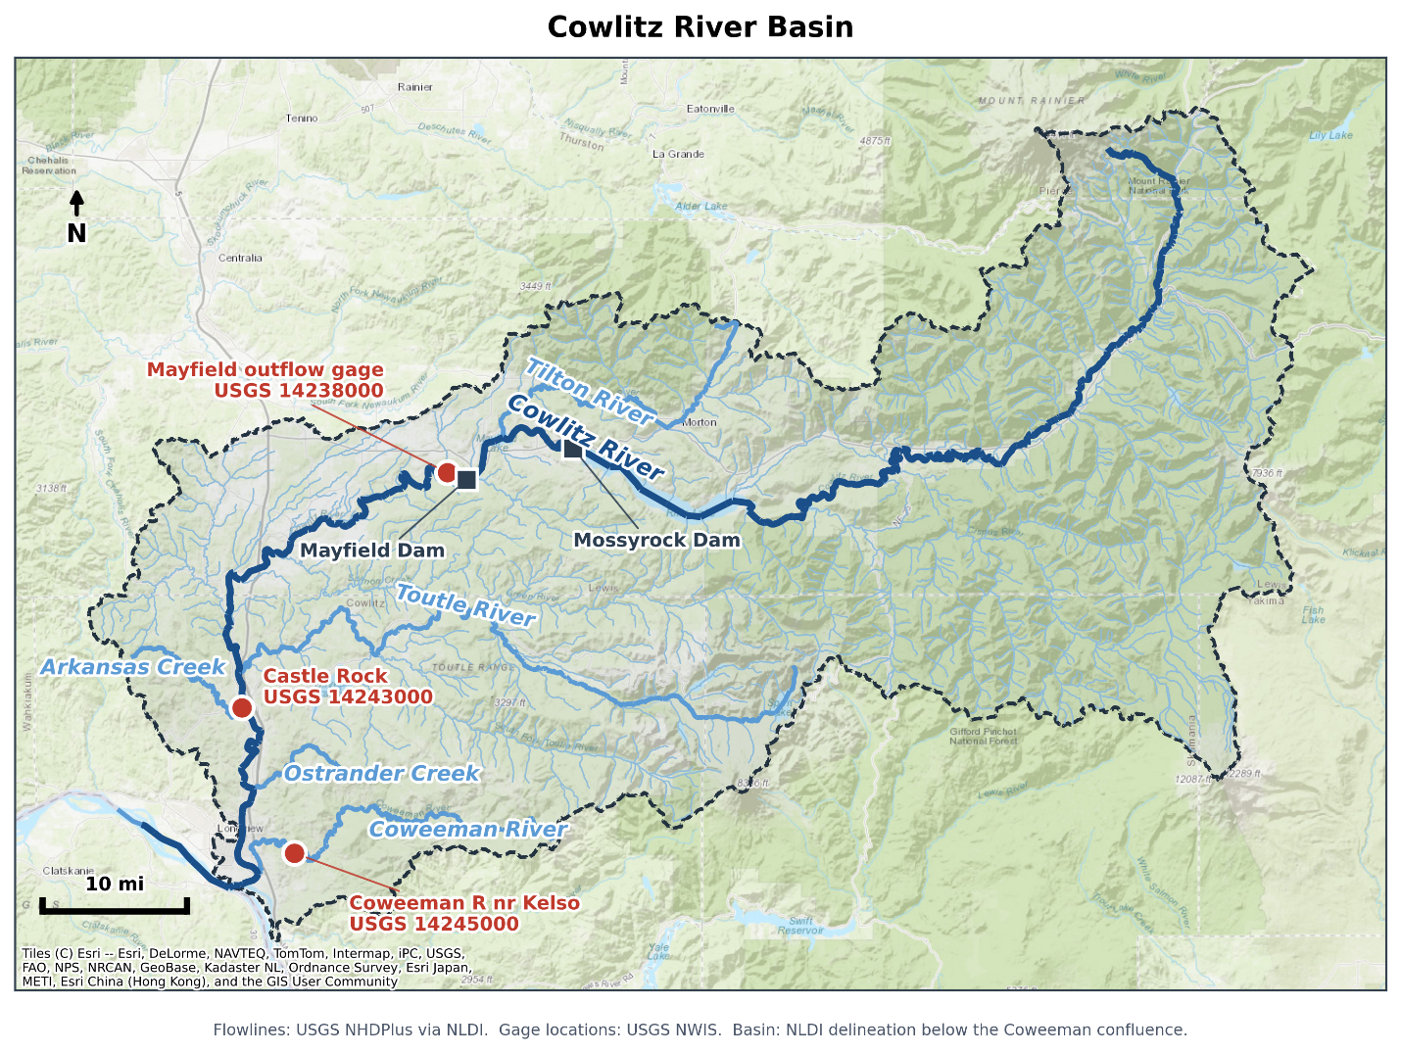
Figure 2-1. Cowlitz River basin, showing the Castle Rock gage, the Mossyrock and Mayfield projects, and the Toutle and Tilton tributaries.

2.1 Previous Studies
The previously adopted unregulated and regulated frequency curves at Castle Rock come from the 2009 Cowlitz Hydrology Restudy (USACE 2010) which predates Bulletin 17C, does not include the most recent 17 years of record, and used a limited set of synthetic hydrographs to inform the upper portion of the regulated flow frequency curve. Section 6 compares the current study results against the 2009 study.

3. Data Used
Table 3-1 lists the datasets used and the purpose each served.
Table 3-1. Datasets used, and their purpose.

Dataset or model | Period used | Purpose
Mossyrock pool elevation, hourly | Nov 1974 – May 2026 | Reservoir storage change at hourly resolution; basis of the hourly unregulated peak estimates (4.1)
Mossyrock storage telemetry, hourly | Regulated era | Data quality screening
Mossyrock pool elevation, daily | Oct 1973 – present | Storage change for developing unregulated flows (4.2, 4.3); observed starting pool for the calibration runs (5.1)
Mossyrock elevation-storage rating table | 2014 Water Control Manual (USACE 2014) | Relates pool elevation to reservoir storage
Castle Rock streamflow, hourly (USGS 14243000) | Regulated era | Regulated flow at the study location
Castle Rock streamflow, daily and annual peak flows (USGS 14243000) | WY1927 – present | Pre-regulation data used in unregulated flow-frequency; regulated daily flow later adjusted to unregulated flows and used in the frequency analysis.
Mayfield outflow, hourly (USGS 14238000) | Regulated era | Upstream boundary for routing the Mossyrock regulation signal to Castle Rock
Coweeman at Kelso streamflow, hourly (Washington Department of Ecology 26C075) | WY 2009 - 2016 | Lag between Coweeman River peak flows and Cowlitz River peak flows (7.3)
Coweeman at Kelso annual peak flows (USGS 14245000) | WY 1950 - 1996 | Peak unregulated flow correlation with Cowlitz at Castle Rock (7.2)
Prism Annual Precipitation | WY1950 - 2020 | Basis for drainage basin ratio (7.2)
Mossyrock inflow and Castle Rock local flow | WY 1929 – 2026 | Simulation inflows, back-calculated and volume-corrected

4. Unregulated Flow Frequency at Castle Rock
Unregulated flow at Castle Rock is the flow that would have occurred without regulation from Mossyrock reservoir. For water years 1927 to 1968 the gage record reflects unregulated flows (Section 4.4). The basis for calculating unregulated flows from a regulated record relies on adding back the Mossyrock reservoir holdout (reservoir storage change expressed as a flow rate) to the observed gage record downstream of the dam. The temporal change in reservoir elevation represents a holdout in flow volume. A positive holdout indicates the reservoir filling. For the post 1968 regulated period the reconstruction uses an hourly holdout, where the hourly elevation record is reliable (Section 4.1), and otherwise uses a peak estimated by regression from the daily reservoir record (Section 4.2). The 3- and 5-day durations, needing only daily resolution, come from a daily mass balance (Section 4.3).

4.1 Hourly Unregulated Record
The hourly pool elevation data was converted to storage values using the 2014 Water Control Manual (USACE 2014) rating curve and differenced to obtain an hourly holdout smoothed with a 3-hour centered moving average and restricted to the October to March flood season. Days with fewer than four valid storage readings were omitted, since they cannot be relied on to capture the annual peak.
The reservoir effect was translated to Castle Rock using the Streamflow Synthesis and Reservoir Regulations (SSARR) routing parameters in Table 4-1 from the calibrated Cowlitz Corps Water Management System (CWMS) model. Mayfield outflow plus the holdout, and Mayfield outflow alone, were each routed to Castle Rock. The difference between the two routed hydrographs is the routed reservoir effect. This time series was added to observed Castle Rock flow to give the hourly unregulated estimate. The annual unregulated peak was extracted from this dataset.
Table 4-1. SSARR routing parameters, from the calibrated lower Cowlitz routing model.

Reach | KTS | n | Phases
Mayfield outflow to Cowlitz River above Toutle River | 5 | 0.1 | 5
Cowlitz River above Toutle River to Cowlitz River below Toutle River | 1 | 0.2 | 1
Cowlitz River below Toutle River to Castle Rock | 1 | 0.2 | 5

Twenty-three water years produced holdout-based peaks (1992, 1997, 1999, 2003, 2004, and 2008 to 2026 except 2013) with earlier hourly pool elevation records too unstable to use.

4.2 Peak Estimation by Storage-Change Regression
For years without a usable hourly record (roughly a third of the regulated era) the unregulated peak must be estimated using the daily reservoir elevation, requiring a different approach. While daily data is less useful than hourly data, it still provided good predictive value in unregulated peak estimation. For the years with hourly data, the increase in peak flow from regulated to unregulated was estimated using regression analysis against various predictor candidates. The predictor candidates were the largest 1- to 4-day increase in Mossyrock storage near the event (within 7 days of the regulated peak). This is preferred over regressing the unregulated peak directly, since the change in storage at Mossyrock is directly related to the increase in flow from regulated to unregulated conditions. The predictor (daily reservoir data) and the regulated peak flow are both available for every regulated year, and because the adjustment is a fraction of the flow being reconstructed, a given percentage error translates to a much smaller error on the resulting unregulated peak. Regression results are shown in Table 4-2. The two-day window regression shown in Figure 4-1 was adopted (R² = 0.871, standard error = 5,528 cfs, n = 17). Pairs whose regulated and unregulated peaks fell more than 72 hours apart were excluded as different storms. The regression allowed for 30 additional water years to be added to the record.

Table 4-2. Candidate regressions of the regulated-minus-unregulated peak difference on Mossyrock storage change, fit to 17 water years.

Storage-change window (candidate predictor variables) | Slope | Intercept (cfs) | R² | Standard error (cfs)
1-day | -0.673 | -7,751 | 0.759 | 7,565
2-day (adopted) | -0.869 | -3,836 | 0.871 | 5,528
3-day | -0.983 | -4,537 | 0.853 | 5,896
4-day | -1.140 | -4,770 | 0.836 | 6,239

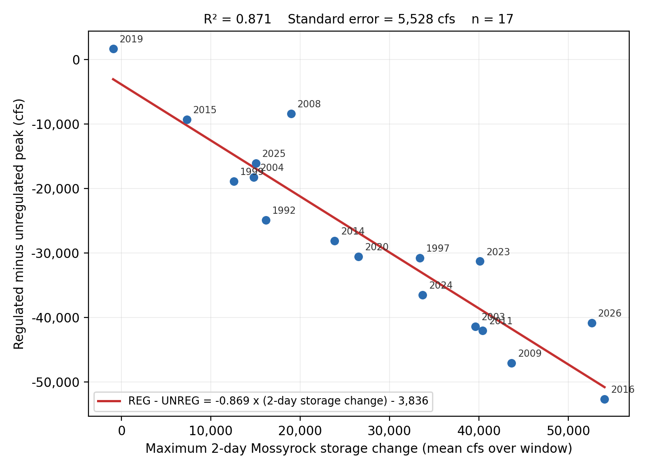
Figure 4-1. Adopted two-day storage-change regression. Points are labeled by water year.

4.3 Durations from the Daily Mass Balance
Daily unregulated flow is the observed daily flow plus the daily change in Mossyrock storage as a flow rate. No routing was applied since the travel time from Mayfield to Castle Rock is under a day. The 1-day duration flow is calculated from an hourly record, when available, since the true 1-day maximum value often spans midnight. When no hourly data is available the 1-Day duration is calculated from daily values. The 3-Day and 5-Day durations were calculated from daily data.

4.4 Pre-Regulation Period
The observed gage record before December 1968 is unregulated. Peaks for water years 1927 to 1968 are the observed instantaneous annual peaks (42 water years), and the 1-, 3-, and 5-day values are rolling maxima from the daily record at the Castle Rock gage (USGS 14243000). Water year 1927 carries a peak only.

4.5 Record Extension and Historical Floods
Correlation-based extension from a nearby gage was considered, but no suitable gage was found. Nearby long-record gages either do not predate Castle Rock by much, are themselves regulated over the period that would be used, or do not correlate strongly enough to justify the added estimation error. With roughly a century of systematic record already available, the potential gain was small. A search of USGS qualification codes in the peak flow records and published USGS accounts of major southwest Washington floods turned up no pre-1927 event at Castle Rock that could be quantified or reliably bounded. The 2009 study contained some historic estimates citing newspaper clippings, but sources were not traceable and newspaper clippings found during this study were roughly defined in terms of multiples of recorded events. No historical events or Bulletin 17C perception thresholds were used.

4.6 Assembled Record
For water years 1927 to 1968 the record is the observed gage record. For 1974 to 2026 the peak is the hourly holdout where available and a regression estimate otherwise. The 1-day value follows the same split based on hourly data availability, and the 3- and 5-day values always come from the daily mass balance (Table 4-3, Appendix A). Coverage runs from WY1927 through WY2026, except for WY1969 to 1973 that have no daily Mossyrock elevation records. Every included water year has a peak value.
Table 4-3. Assembled record, values and sources by duration.

Duration | Values | Sources
Peak | 95 | 42 pre-regulation USGS peaks; 30 storage-change regression; 23 hourly holdout
1-Day | 94 | 41 pre-regulation USGS daily; 30 daily mass balance; 23 hourly holdout
3-Day | 94 | 41 pre-regulation USGS daily; 53 daily mass balance
5-Day | 94 | 41 pre-regulation USGS daily; 53 daily mass balance

4.7 Peak Duration Flow Consistency Review
A shorter-duration flow lower than a longer-duration flow for a single peak event is physically impossible but can result from edge cases. Fifteen inconsistencies appeared, fourteen from a source mismatch (typically a regression-estimated peak below the same year's mass-balance 1-day value) and one from a double-peaked March event whose 5-day window spans both peaks while no 3-day window can (WY 2014). The record was made monotonic by increasing peak estimates to the one-day duration value when a regression estimate resulted in a smaller peak value. Seven regression-estimated peaks were lifted to their 1-day value, with the largest changes, 64, 19, and 19 percent, in WY2001, 1985, and 2006, all among the smallest years in the record that do not strongly influence the upper end of the final frequency curves.

4.8 Flow Frequency Analysis
The assembled record was analyzed using the Hydrologic Engineering Center’s Statistical Software Package (HEC-SSP). The analysis used the Bulletin 17C expected moments algorithm, fitting a log-Pearson Type III distribution to each flow duration. The fitted distribution used a weighted skew combining the station skew and published regional skew values of −0.07 for the peak (Mastin, 2016), and 0.09, 0.07, and 0.00 for the 1-, 3-, and 5-day durations, respectively (Lind, 2020). The 5-day regional skew value was interpolated between the 3- and 7-day regional skews.
Water years 1969 to 1973 have observed regulated peaks but no unregulated basis, so they were entered as censored. The peak analysis reports 95 systematic events within a 100-year period, with five flagged missing. No low outliers were identified by the multiple Grubbs-Beck procedure.
Station skews are slightly negative for every duration (−0.158 to −0.054); weighting against the regional values gives adopted skews of −0.135, −0.052, −0.009, and −0.031 for the peak, 1-, 3-, and 5-day durations, with equivalent record lengths of 100 to 112 years after censoring. Table 4-4 gives the fitted parameters and event counts; Figure 4-2 shows the four adopted curves. Individual curves with confidence limits and plotted observations appear in Appendix C, and the full ordinates in Appendix B.
Table 4-4. Distribution parameters and event counts, adopted HEC-SSP analyses.

Parameter | Peak | 1-Day | 3-Day | 5-Day
Mean of logs | 4.778 | 4.743 | 4.663 | 4.596
Standard deviation of logs | 0.202 | 0.203 | 0.194 | 0.181
Station skew | -0.158 | -0.152 | -0.079 | -0.054
Regional skew | -0.07 | 0.09 | 0.07 | 0.00
Weighted skew | -0.135 | -0.052 | -0.009 | -0.031
Adopted skew | -0.135 | -0.052 | -0.009 | -0.031
Mean square error, at-site skew | 0.064 | 0.064 | 0.060 | 0.059
Grubbs-Beck critical value | 0 | 0 | 0 | 0
Equivalent record length (years) | 100.7 | 100.4 | 106.3 | 112.0
Systematic events | 95 | 94 | 94 | 94
Historical events | 0 | 0 | 0 | 0
High outliers | 0 | 0 | 0 | 0
Low outliers | 0 | 0 | 0 | 0
Zero events | 0 | 0 | 0 | 0
Missing events | 5 | 5 | 5 | 5
Historical period (years) | 100 | 99 | 99 | 99

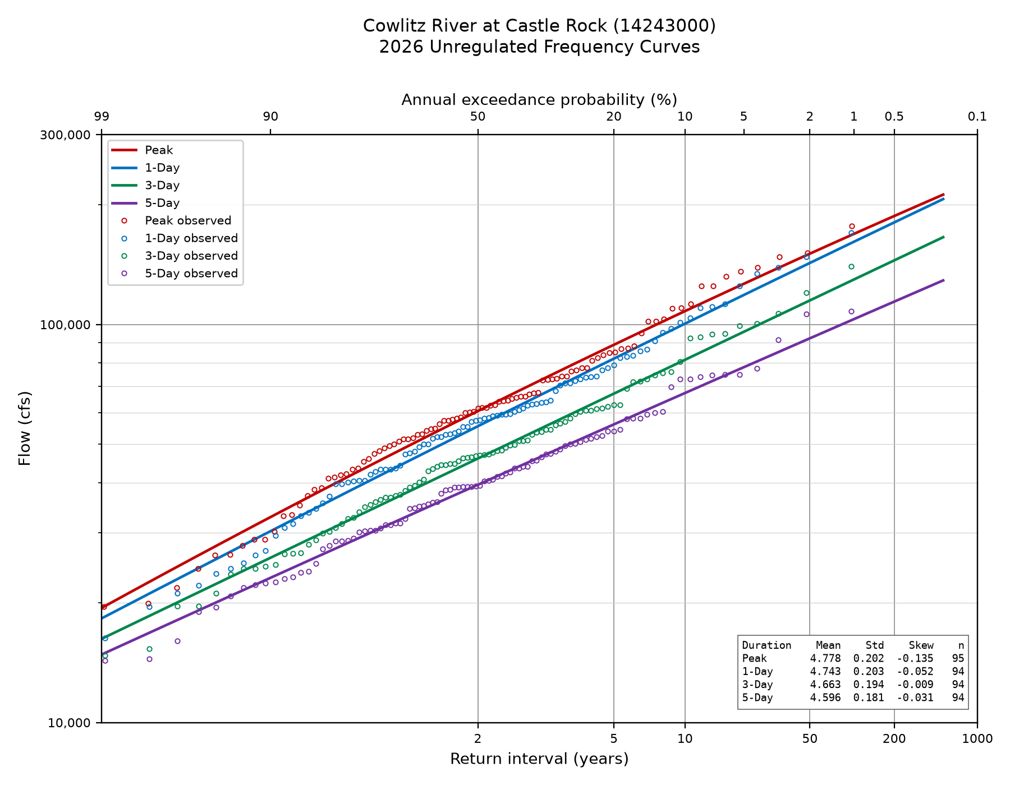
Figure 4-2. Adopted unregulated frequency curves at Castle Rock, water years 1927 through 2026, all four durations.

5. Regulated Flow Frequency at Castle Rock
The regulated peak flow frequency curve includes the effect of Mossyrock Dam on peak flows at Castle Rock. Mossyrock is operated for flood risk management and hydropower production. Mossyrock has frequently drafted deep into the power pool resulting in flood space that is not guaranteed. While this additional space can be useful to reduce flows downstream, it is incidental rather than dependable. This additional space should not be relied on to provide a flood risk management (FRM) benefit for planning purposes. EM 1110-2-1415 (USACE 1993) states that operations for project purposes other than FRM may provide incidental storage space, but the effect of this space on FRM should be estimated very conservatively. Therefore, the observed regulated flows were adjusted to remove these incidental effects and instead assume that the reservoir is operated for FRM only. This assumption is necessary to create a homogenous record. After adjusting the regulated peaks (Section 5.2), they were paired with the unregulated peak of the same event (Section 5.3) to build a relationship between unregulated peak flow and regulated peak flow. Synthetic floods were used to estimate extreme events not observed in the period of record (Section 5.4) and add additional definition to the upper end of the relationship. The final regulated frequency curve is developed by applying the unregulated-regulated relationship to the peak unregulated frequency curve (Sections 5.5 and 5.6).

5.1 HEC-ResSim Flood Operation Calibration
Operational parameters for Mossyrock dam were referenced from the Mossyrock Water Control Manual (USACE 2014) and incorporated into a Hydrologic Engineering Center’s Reservoir Simulation (HEC-ResSim) model of the study area.. Minimum, normal maximum evacuation, and special flood releases were reassessed to calibrate flood operations for large events. There are no published special curves for Mossyrock, but it is likely the project would increase releases even if it resulted in exacerbated flooding downstream to prevent overtopping much like special curves prescribes, so special curve parameters were estimated. Pertinent model parameters are shown in Table 5-1. Validating against observed operations was difficult because Mossyrock consistently releases well above its minimum releases for power generation and as a result pool elevations are frequently well below the standard minimum flood pool. For large events, starting a simulation from the observed elevation, adhering to the downstream control point regulation goals, and estimating special release parameters to prevent overtopping led to reasonable validation. Figures 5-1, 5-2, and 5-3 show validations for the largest three events with sufficient hourly data to model the system spanning the period of record, 1990 to present. The largest and third largest events simulated, 1996 and 2015, match the observed peak and 5-day volumes reasonably well whereas the second largest validation event, 2009, shows an example of less-than-ideal validation. The difference is likely attributatble to starting pool elevation. The 1996 and 2015 events began when Mossyrock was near its minimum flood pool above which regulatory releases are well defined. The 2009 event began when the reservoir was nearly 30 feet below the flood pool where operators have more discretion over releases. Section 5.2 describes a regulated peak flow adjustment capable of reducing the error associated with modeling discrepancies.
Table 5-1. Pertinent Mossyrock HEC-ResSim operational parameters.

Rule | Parameter
Special Curves | Time of recession = 35 hours, Maintain maximum release until below 750 feet
Maximum Flow at Castle Rock | 50,000 CFS when Elev below 776.5 feet, 70,000 CFS when above
Normal Maximum Evacuation Rate | 14,000 CFS
Minimum Release | 3,500 CFS

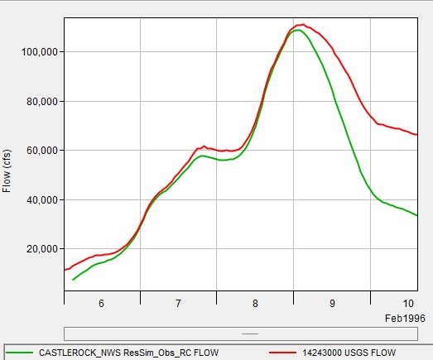
Figure 5-1. Flood simulation validation 1996.

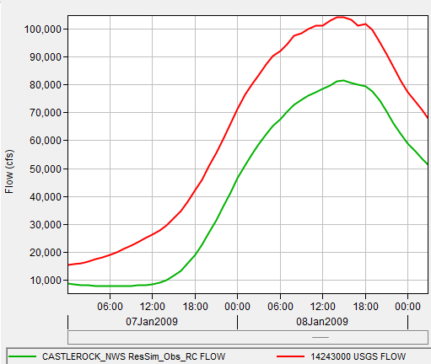
Figure 5-2. Flood simulation validation 2009.

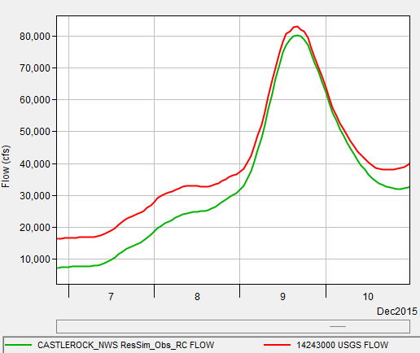
Figure 5-3. Flood simulation validation 2015.

5.2 Adjusted Regulated Peak Record
Mossyrock provides 357,000 acre-feet of authorized flood storage in Riffe Lake between the winter rule curve elevation of 749 feet and top of flood pool at 782 feet. The observed Mossyrock record of reservoir elevations shows the reservoir was frequently drafted below 749 feet, so a peak from a year that started low overstates the attenuation the project would provide from a FRM operation alone. Two period of record HEC-ResSim simulations, using the same observed hydrology and current release rules and differing only in starting pool, one from the Water Control Manual rule curve (USACE 2014) , one from the observed elevation at event onset, isolated that effect. When the rule-curve start resulted in a higher regulated peak, the difference was added to the observed peak. The adjustment was one-sided, since a negative difference means the historical operation was already at least as conservative as the rule curve requires. Taking the difference between simulated releases reduced errors associated with an inability to model the exact operations in a particular year.
Qa=Qo+QRC-QOS,if QRC-QOS>0Qo,if QRC-QOS≤0 | (1)

where the variables are defined as follows: Qa, adjusted peak flow; Qo, observed peak flow; QRC, simulated peak flow from the rule curve start simulation; and QOS, simulated peak flow from the observed-start simulation.

Fifty-one water years (1974 to 2024) were assessed. Thirty-six of the annual peak flow values received an adjustment, with a median of 10,300 cfs and a range of 260 to 24,000 cfs. Ten years of annual peak flow values were screened out, seven of which were screened due to a timing mismatch between the observed and simulated peak flows, two because the regulated peak flow exceeded the unregulated peak flow (physically possible only if release exceeds inflow during a large flood), and the water year 1980 which was the result of the lahar associated with the eruption of Mount St. Helens. Five years of annual peak flow values received no adjustment, of which four years had the two simulations produce the same peak flow, and the water year 1976 where the observed pool started above the rule curve so the observed peak flow was not reduced.

5.3 Critical Duration
Developing an unregulated-regulated relationship requires choosing which unregulated duration best corresponds to the regulated peak. Table 5-2 and Figure 5-4 show the results of correlation fits between the regulated flow peaks and the various flow durations of the unregulated peak flow data. Both the instantaneous peak and the 1-day duration are strong predictors of the regulated peak flow. The peak unregulated flow is adopted for the transform, which is standard practice per EM 1110-2-1619.
Table 5-2. Adjusted regulated against unregulated flow by duration, water years 1975 through 2024.

Duration | n | R² | Log R² | Log slope
Peak (1-hr) | 41 | 0.918 | 0.899 | 0.656
1-Day | 41 | 0.900 | 0.884 | 0.660
3-Day | 41 | 0.832 | 0.841 | 0.687
5-Day | 41 | 0.769 | 0.796 | 0.724

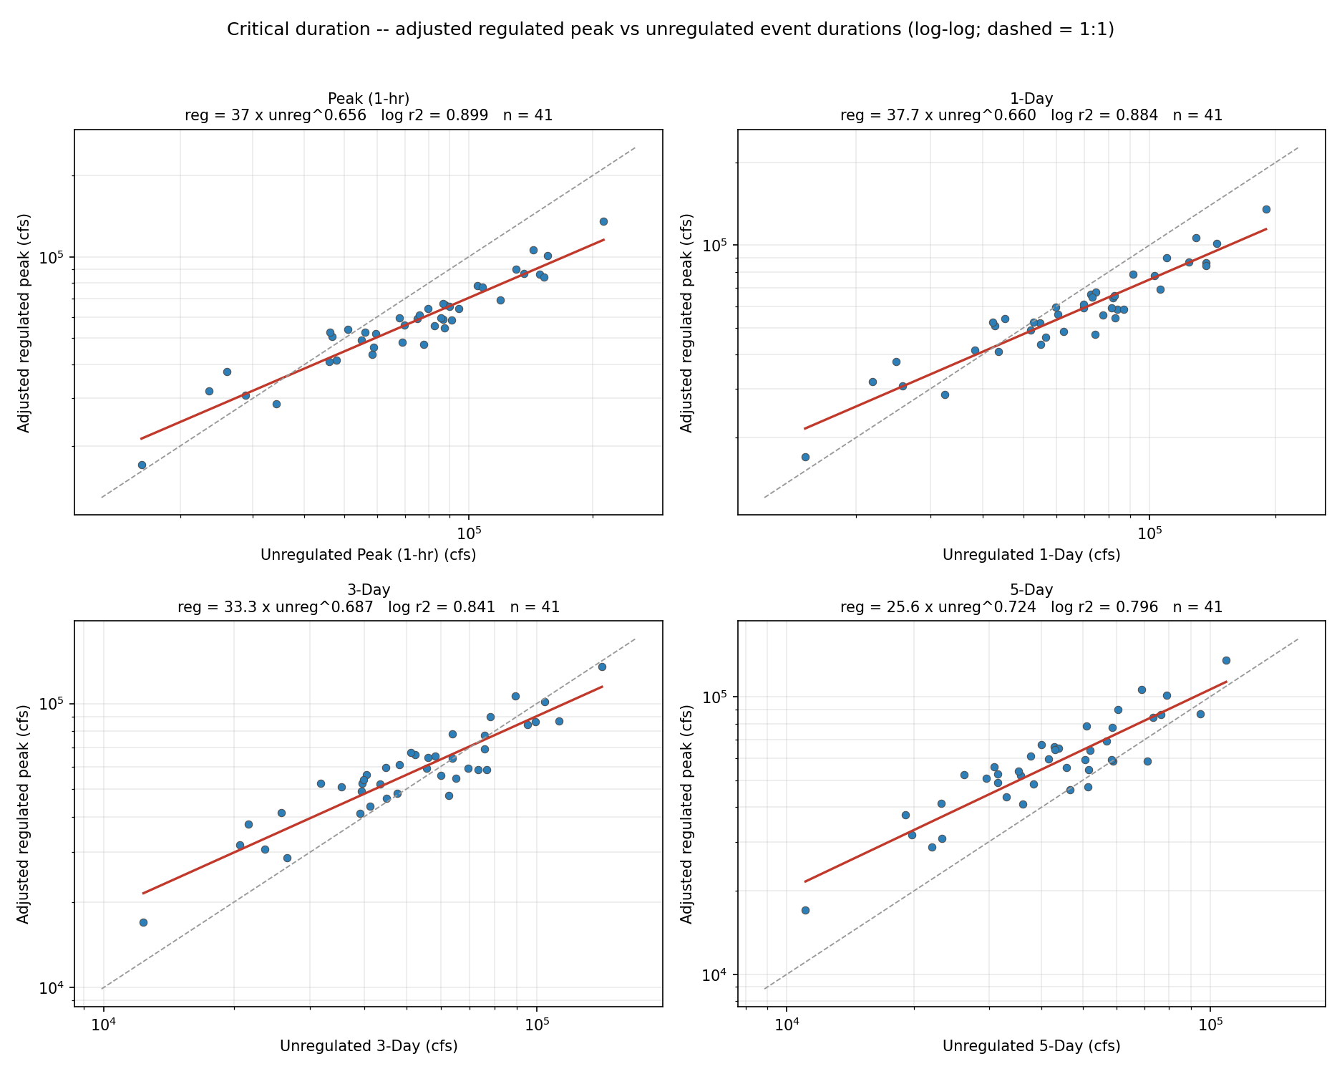
Figure 5-4. Adjusted regulated against unregulated flow, by duration.

5.4 Synthetic Flood Ensembles
The period of record is not sufficient to estimate the unregulated-regulated relationship for extreme high flows. Synthetic floods were created by scaling the largest 12 events ranked by their unregulated flow estimate at Castle Rock and scaled to target the 100-, 250-, 500-year, and 20% above the 500-year unregulated peaks, resulting in 48 synthetic events of varying shapes and sizes. Figure 5-5 depicts the 12 flood events and Figure 5-6 depicts the synthetic scaling applied to the February 1996 event.
Each source storm is scaled to hit its target unregulated peak and 5-day volume (within 5 percent), with Mossyrock inflow and Castle Rock local scaled by the same factor to preserve the observed coincidence. The events span regulated peaks of 90,000 to 267,000 cfs.
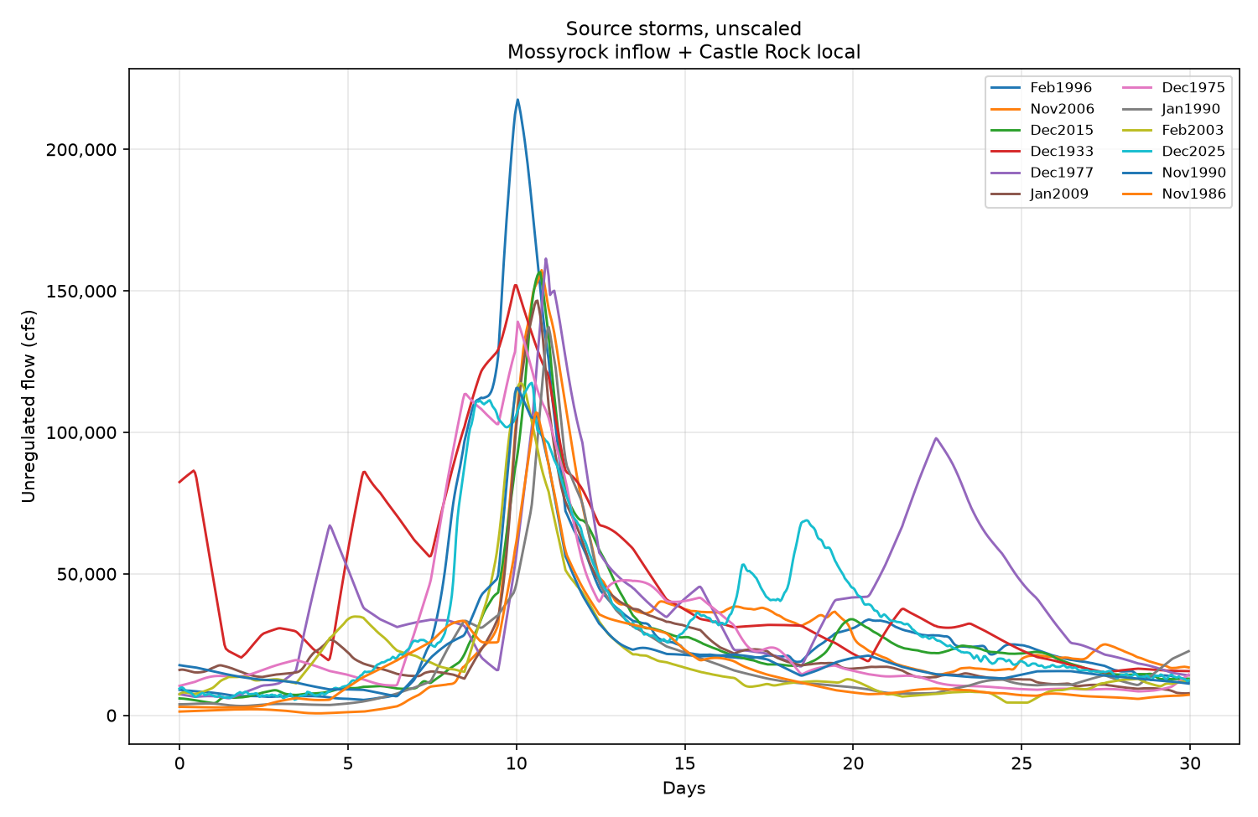

Figure 5-5. The twelve observed source storms, unscaled.
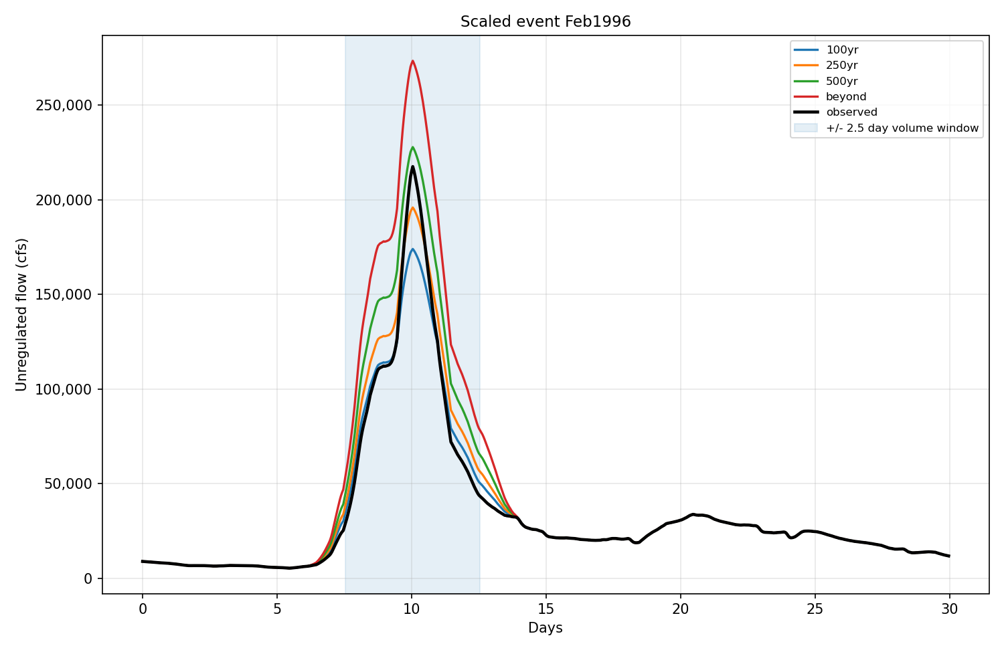

Figure 5-6. Scaling one source storm. Each member is scaled to its own target peak and 5-day volume; the shaded band is the window over which the 5-day volume is matched.

5.5 Unregulated-Regulated Transform
The regulated frequency curve is estimated by a locally weighted regression (LOESS) using the observed and synthetic regulated flow values (Figure 5-7). The scatter in the LOESS estimated curve to the observed and synthetic values is the result of storms with similar peak volumes but different shapes and starting pool elevations resulting in different regulated outcomes. The median estimated maximum regulation capacity of the reservoir can be visually identified in Figure 5-7 where the unregulated and regulated flow curves are rejoined in the upper right quadrant of the figure. Its value was estimated to be 325,000 cfs based on the maximum flood storage available and falls within the extrapolated uncertainty range. The dashed line is a straight-line extrapolation from the last calculated ordinate to the estimated convergence point.
Uncertainty is measured as the spread of the event pairs about the line fitted by a local area regression, in log space, assessed separately above and below the LOESS line so the asymmetry is preserved. Figure 5-7 shows the resulting band at the 5 to 95 percent level associated with the variation in regulation only. Section 5.7 combines the regulation uncertainty with the uncertainty introduced by mapping regulated flows to unregulated flow frequencies which carry their own uncertainty.
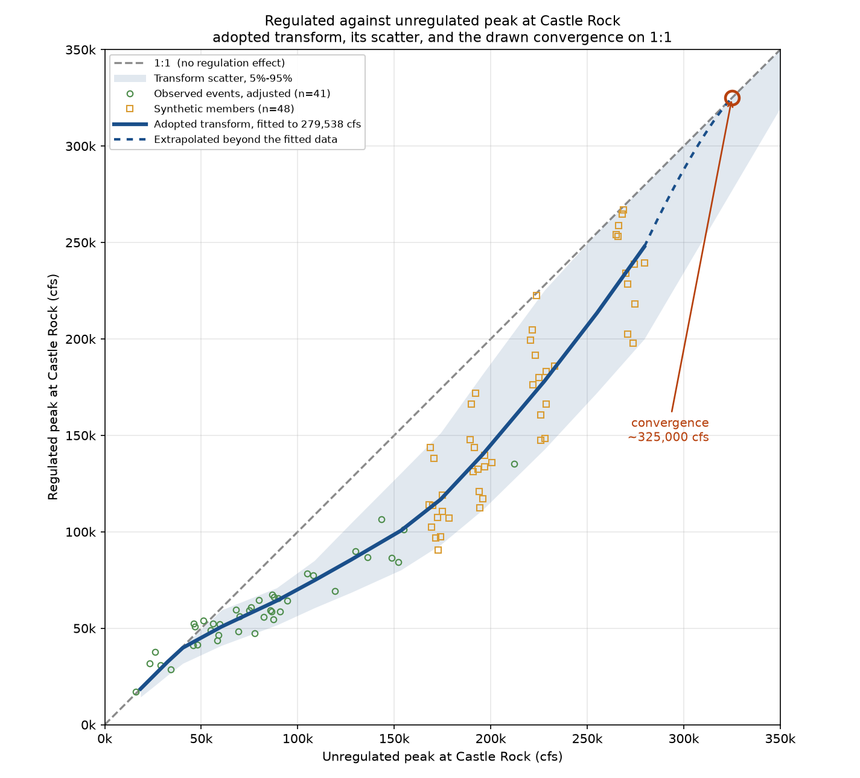

Figure 5-7. Regulated against unregulated peak at Castle Rock. The line is drawn from a locally weighted regression extended to meet an estimated regulated=unregulated convergence at ~ 325,000 cfs.

5.6 Regulated Frequency Curve with Uncertainty
The unregulated-regulated transform is used to convert every ordinate of the unregulated flow curve to produce values of the regulated flow curve (Figure 5-8). The regulated flow at a given AEP is based on the unregulated flow of that AEP (Table 5-3). The precent reduction in regulated flow peaks reaches a maximum value of 34 percent near the 50-year unregulated flow event with a 2 percent AEP. The effect of regulation is reduced at smaller more frequent flows, where events are already largely contained, and falls away again at rarer flows, where storage is exhausted and the project must pass more of the inflow, reaching about 16 percent at the 0.1 percent AEP.
The regulated flow at a given AEP carries uncertainty from two independent sources, the unregulated frequency estimate itself, and the uncertainty in the unregulated-regulated transform. Uncertainty from the unregulated frequency analysis is carried through to the regulated curve following EM 1110-2-1619 (USACE, 2025). The uncertainty band is treated as Normal on the upper and lower side of its best estimate separately, which is a reasonable approximation and preserves the asymmetry in both the HEC-SSP confidence limits and the unregulated-regulated transform uncertainty. HEC-SSP reports its own limits at 5 and 95 percent that are combined with the transform uncertainty as shown below, so every limit reported is a 5th or 95th percentile. Appendix E lists every ordinate of the adopted regulated curve uncertainty bounds.
U95=RBest+N95-NBest2+R95-RBest2 | (2)
L5=RBest-NBest-N52+RBest-R52 | (3)
where the variables are defined as follows: U95, regulated flow upper 95% uncertainty bound, incorporating unregulated flow uncertainty; L5, regulated flow lower 5% uncertainty bound, incorporating unregulated flow uncertainty; RBest, regulated curve expected value from the local area regression (LOESS); R95, regulated curve 95th percentile from the local area regression; R5, regulated curve 5th percentile from the local area regression; NBest, unregulated curve expected value from the SSP B17C analysis; N95, unregulated curve 95th percentile from the SSP B17C analysis; N5, unregulated curve 5th percentile from the SSP B17C analysis.

RegBest+ Unreg95-UnregBest2+(Reg95-RegBest2)
RegBest- UnregBest-Unreg52+(RegBest-Reg52)

Table 5-3. Adopted regulated frequency curve at Castle Rock.

Event | AEP | Unregulated (cfs) | Regulated (cfs) | Reduction | Regulated, 5%-95% (cfs)
2-year | 0.500 | 60,529 | 50,811 | 16% | 39,914 - 60,913
10-year | 0.100 | 108,618 | 74,786 | 31% | 57,542 - 91,380
50-year | 0.020 | 153,556 | 100,670 | 34% | 73,093 - 143,825
100-year | 0.010 | 174,075 | 116,809 | 33% | 83,160 - 171,777
200-year | 0.005 | 195,977 | 140,273 | 28% | 98,137 - 211,024
500-year | 0.002 | 227,900 | 178,194 | 22% | 123,500 - 272,245
1000-year | 0.001 | 255,074 | 213,481 | 16% | 147,305 - 330,897

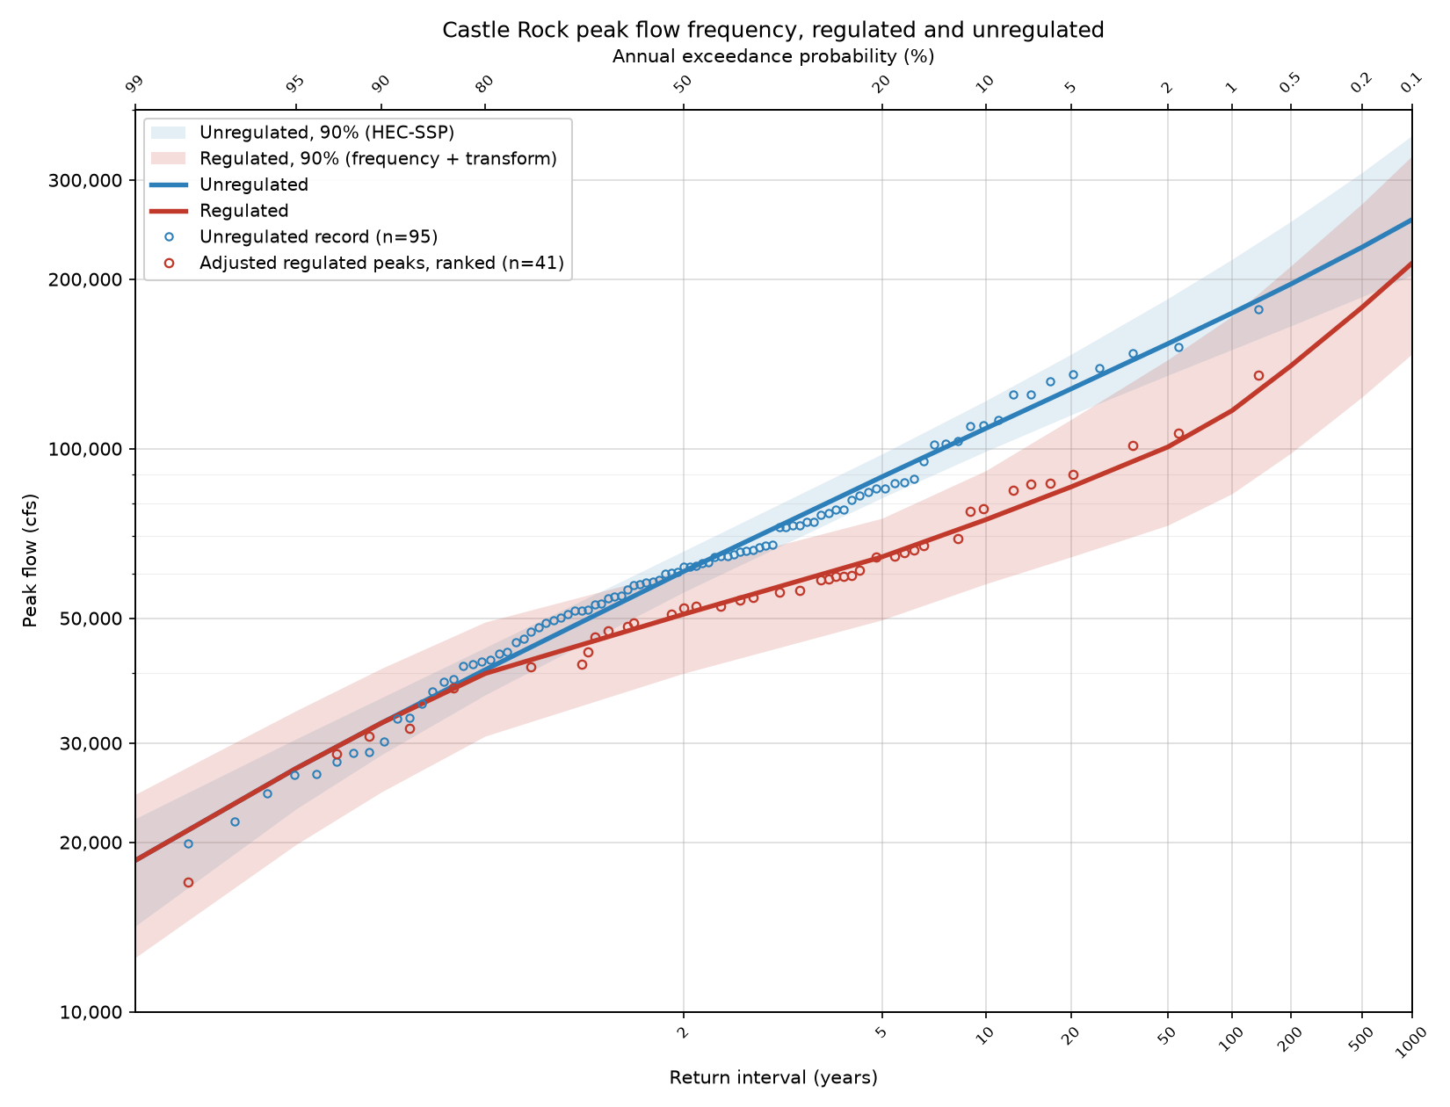
Figure 5-8. Adopted regulated and unregulated frequency curves at Castle Rock

6. Comparison with the 2009 Restudy

6.1 Unregulated Curves
Figure 6-1 places the adopted unregulated curves against the 2009 Cowlitz Hydrology Restudy. The 2009 study adhered to Bulletin 17B and a period of record spanning most of 1927 to 2009 whereas the current study used Bulletin 17C, added 17 years of peaks to the record, and benefited from an updated regional skew study. The 2009 study adopted positive skews (0.140–0.193) that bend its curves slightly upward, whereas the adopted skews here are near zero or negative bending the curves downward leading to the largest discrepancies at the very frequent and very rare AEPs.
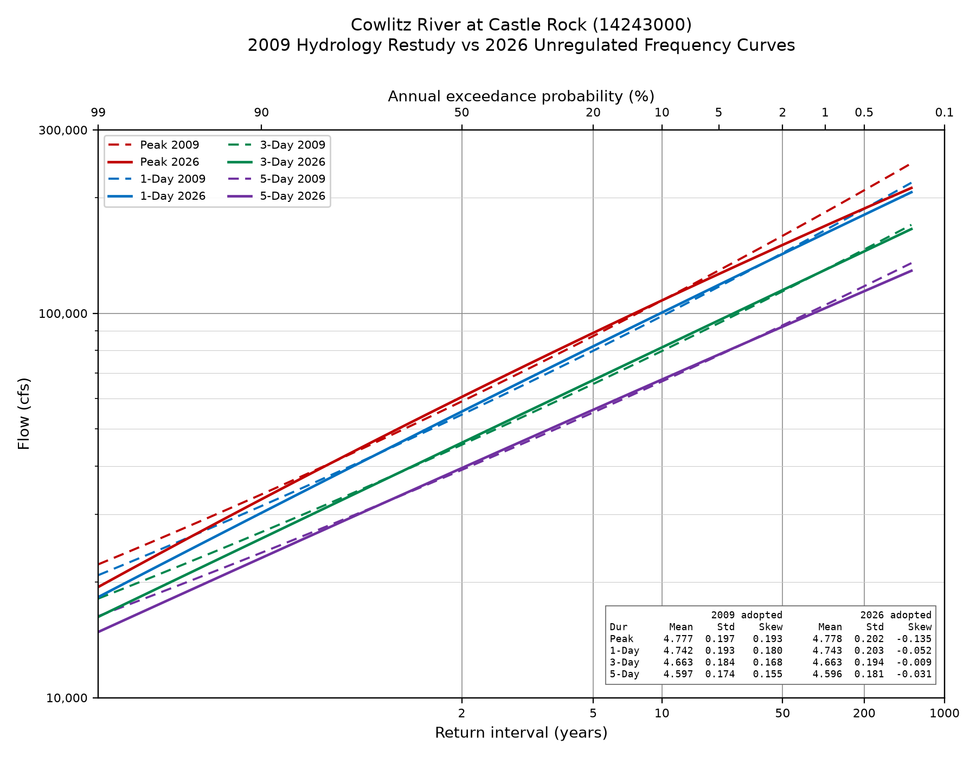
Figure 6-1. Adopted 2026 unregulated curves (solid) against the 2009 Cowlitz Hydrology restudy (dashed).

6.2 Regulated Curve
Figure 6-2 depicts the adopted regulated curve from this study against the curve from the 2009 Restudy. The most significant differences result from the current study reflecting a different starting pool assumption and a more robust accounting of uncertainty.

The 2009 curve was drawn graphically through the observed regulated peaks, which carry the benefit of the incidental reservoir space discussed in Section 5.2. The adopted curve is built on peaks adjusted to remove that space, so it sits higher wherever the reservoir historically drafted deep into the power pool. The effect is largest at the frequent end and falls away as events grow. At the 99 percent AEP the adopted curve gives 18,564 cfs against 11,000 cfs in 2009, and by the 50 percent AEP the difference has narrowed to 50,811 cfs against 46,000 cfs.

The 2009 uncertainty is a function of record length alone. That study calculated an equivalent record length of 90 years from 83 years of data, adjusted for the historical period and for the added uncertainty of estimating regulated peaks in the pre-regulation years. The uncertainty adopted in the current study combines the unregulated frequency estimate with the uncertainty in the unregulated to regulated transform, as described in Section 5.7, and the transform term grows as the relationship is extended past the observed record. As a result, the adopted band is wider than the 2009 band, and the gap widens at rarer AEPs.

The 2009 bounds are reported at the 2.5 and 97.5 percent levels, a 95 percent interval. They are rescaled to the 90 percent interval so that both bands on Figure 6-2 carry the same meaning.

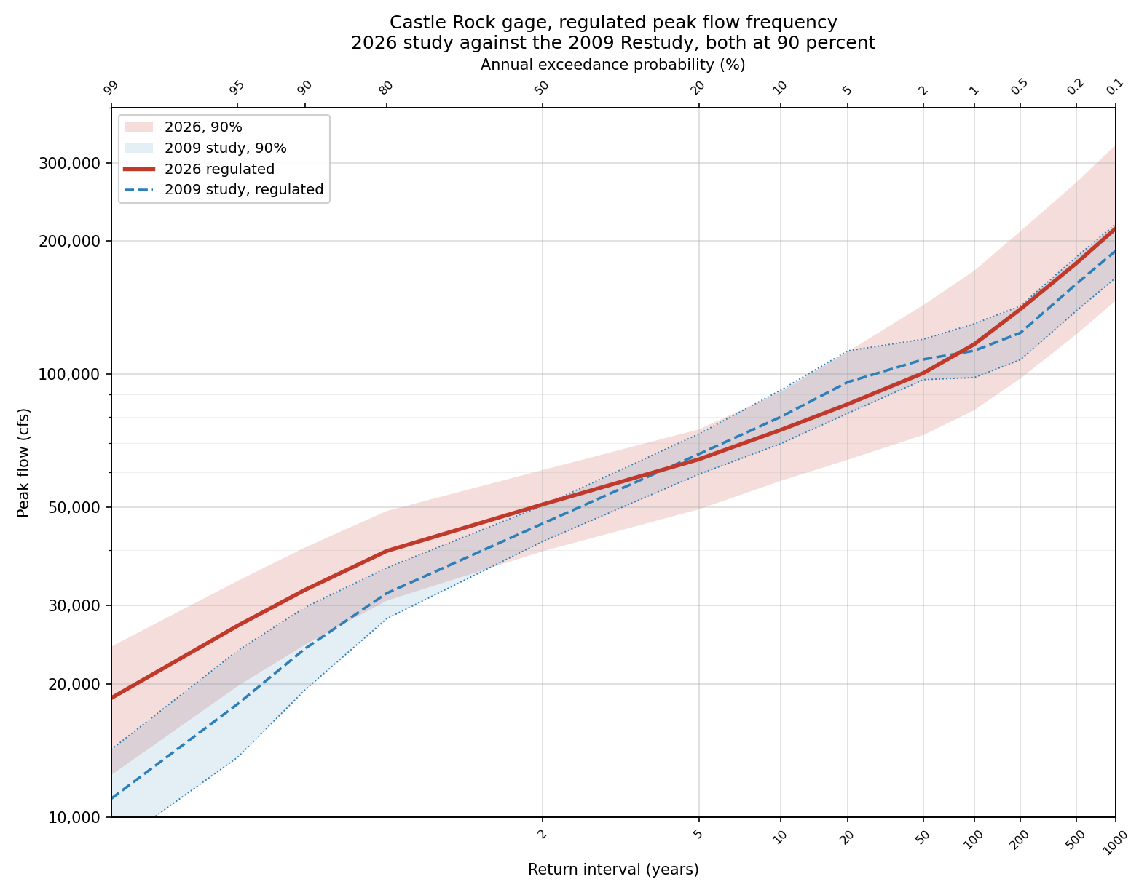
Figure 6-2. Adopted 2026 regulated curve against the 2009 Cowlitz Hydrology Restudy.

7. Extension Downstream to the Coweeman Confluence
The regulated frequency curve developed above applies at the Castle Rock gage, which drains 2,238 square miles. Between that gage and the Coweeman River confluence the Cowlitz River watershed increases in size by 238 square miles that includes drainage from Arkansas Creek, Ostrander Creek, the Coweeman River, and the ungaged local area along both banks (Figure 2-1). This section develops regulated peak frequency curves at each of those points.

7.1 Method
The contribution of local flow from a drainage area below Castle Rock to the regulated peak flow on the Cowlitz River is estimated in two steps. First, the unregulated flow is estimated using a drainage area ratio comparing the local drainage area to that of Castle Rock. Once the unregulated flow is estimated, it is then scaled to account for peak runoff timing effects resulting from the mainstem Cowlitz River peak flow being delayed by reservoir regulation and larger basin attenuation.

7.2 Local Contribution by Drainage Area
The Coweeman River peak unregulated flows for large events are roughly proportional to the drainage area ratio, although there are few large events to draw data from and ratios are much more variable for smaller events. The PRISM annual total precipitation records found a consistent proportionality, showing that the precipitation volume falling over the Coweeman River watershed is very similar to the precipitation volume falling over the Cowlitz River watershed at Castle Rock. A drainage area ratio is adopted, with no unit-runoff adjustment.
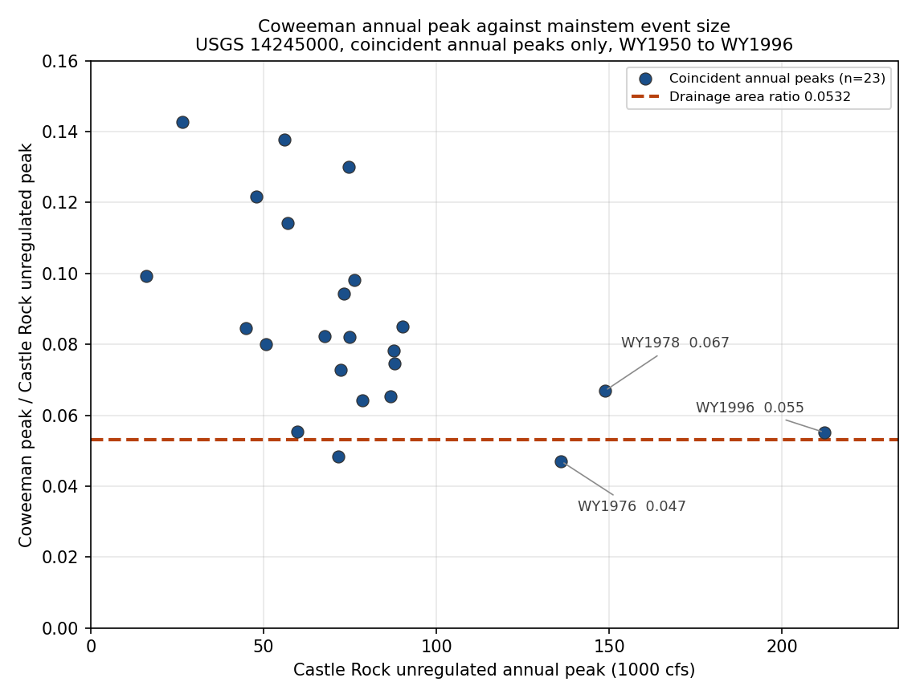
Figure 7-1. Coweeman peak unregulated flow proportion compared to Castle Ro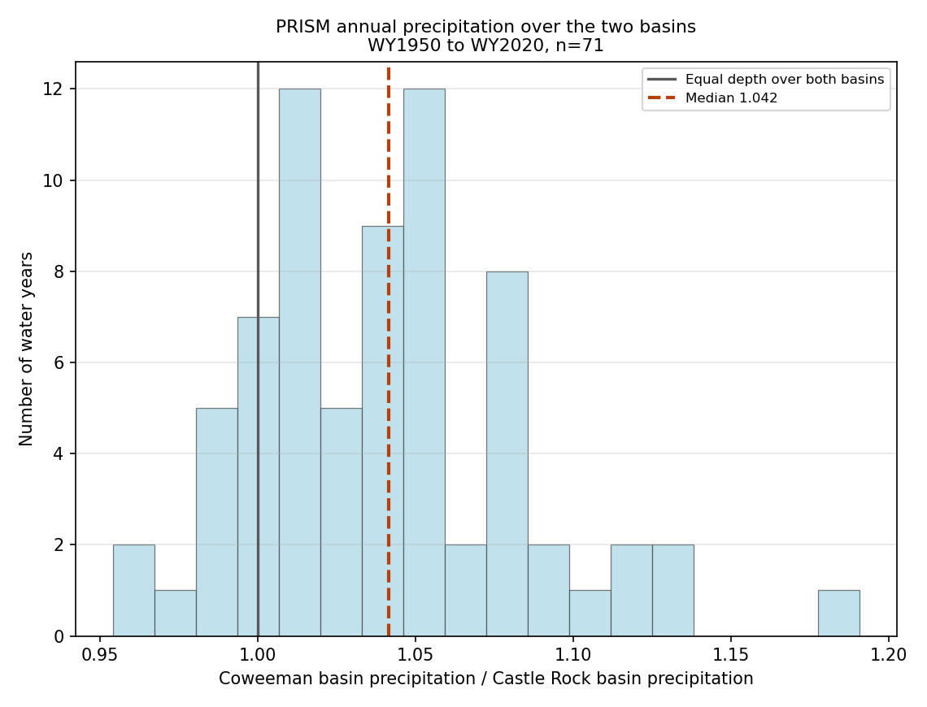
Figure 7-2. Coweeman basin precipitation proportion compared to Cowlitz at Castle Rock

Table 7-1. Drainage area at each location.

Location | Drainage area (sq mi) | Incremental (sq mi) | Local as % of gage
Castle Rock gage | 2,238 | — | —
Below Arkansas Creek | 2,278 | 40 | 1.8%
Below Ostrander Creek | 2,335 | 97 | 4.3%
Below Coweeman River | 2,476 | 238 | 10.6%

7.3 Timing Adjustment
The observed record shows tributaries do not crest when the regulated Cowlitz does. Do in part to regulation and in part to attenuation, they peak first and are already receding when the regulated mainstem arrives, so only part of each tributary peak is present at the moment that governs the combined flow. Measuring the Coweeman River flow at the hour of the regulated Castle Rock crest, as a fraction of its own peak in the same storm over 76 events (multiple events per year were assessed) resulted in a median scaling factor of 0.79. Larger events suggested a larger lag time resulting in a smaller local flow contribution, but the sample size was small, so a scaling factor of 0.8 was selected, matching what was used in the 2009 study.
Table 7-2. Coweeman River flow at the regulated Castle Rock crest, as a fraction of its own event peak.

Castle Rock unregulated peak | Events | Median ratio
20,000–40,000 cfs | 51 | 0.81
40,000–60,000 cfs | 18 | 0.76
Above 60,000 cfs | 7 | 0.42
All events | 76 | 0.79

7.4 Results
Regulated peak flows in Table 7-3 are calculated as:
Qs=Qr,C+Qu,CAs-ACACL | (4)

where Qs is the regulated peak flow at the downstream site; Qr,Cis the regulated peak flow at Castle Rock; Qu,C is the unregulated peak flow at Castle Rock; Asis the drainage area at the downstream site; ACis the drainage area at Castle Rock; and Lis the timing reduction factor (0.8).
Qsite=QregCAS+QunregCAS*DAsite-DACASDACAS*L

The drainage area ratio is applied to the unregulated flow at Castle Rock, because the tributaries below the gage respond to the storm rather than to the reservoir release. The resulting local contribution is added to the regulated flow best estimate and uncertainty bounds at Castle Rock.
Complete ordinates with confidence limits are in Appendix E.
Table 7-3. Regulated peak flow at each location, cfs.

AEP | Castle Rock gage | Below Arkansas | Below Ostrander | Below Coweeman
10% | 74,786 | 76,339 | 78,552 | 84,027
2% | 100,670 | 102,866 | 105,995 | 113,734
1% | 116,809 | 119,298 | 122,845 | 131,619
0.5% | 140,273 | 143,075 | 147,068 | 156,946
0.2% | 178,194 | 181,453 | 186,096 | 197,583
0.1% | 213,481 | 217,128 | 222,325 | 235,182

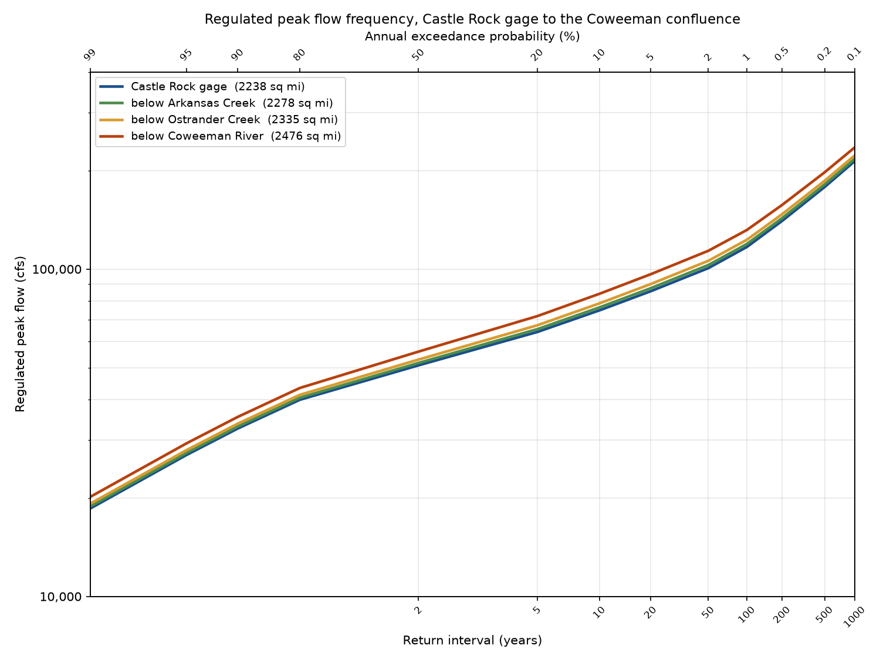
Figure 7-3. Regulated peak flow frequency at all four locations. The local contribution at each site is the incremental drainage area scaled off the unregulated curve and reduced by the 0.80 timing factor.

Appendix A. Assembled Unregulated Record by Water Year
Flows are in cubic feet per second. Source abbreviations: USGS peak, the observed instantaneous annual peak; USGS daily, rolling maxima of the observed daily record; Holdout, the hourly unregulated record from the Mossyrock holdout; Regression, the two-day storage-change relation; Mass balance, the daily unregulated series.
Table A-1. Assembled unregulated record, water years 1927 through 2026.

WY | Peak | Peak source | 1-Day | 1-Day source | 3-Day | 5-Day | Duration source
1927 | 41,100 | USGS peak | — | — | — | — | —
1928 | 74,000 | USGS peak | 71,300 | USGS daily | 56,933 | 47,940 | USGS daily
1929 | 21,800 | USGS peak | 21,100 | USGS daily | 19,633 | 18,980 | USGS daily
1930 | 30,200 | USGS peak | 29,500 | USGS daily | 26,700 | 23,840 | USGS daily
1931 | 65,900 | USGS peak | 63,200 | USGS daily | 51,200 | 40,760 | USGS daily
1932 | 50,800 | USGS peak | 49,200 | USGS daily | 44,467 | 39,140 | USGS daily
1933 | 53,000 | USGS peak | 52,200 | USGS daily | 44,467 | 43,900 | USGS daily
1934 | 139,000 | USGS peak | 134,000 | USGS daily | 120,333 | 106,300 | USGS daily
1935 | 61,800 | USGS peak | 58,100 | USGS daily | 53,800 | 45,540 | USGS daily
1936 | 48,200 | USGS peak | 39,800 | USGS daily | 35,833 | 31,400 | USGS daily
1937 | 49,000 | USGS peak | 47,200 | USGS daily | 40,167 | 34,640 | USGS daily
1938 | 62,900 | USGS peak | 60,500 | USGS daily | 53,567 | 47,440 | USGS daily
1939 | 43,600 | USGS peak | 39,800 | USGS daily | 29,867 | 27,840 | USGS daily
1940 | 41,900 | USGS peak | 40,500 | USGS daily | 36,767 | 31,660 | USGS daily
1941 | 26,400 | USGS peak | 22,100 | USGS daily | 19,633 | 16,038 | USGS daily
1942 | 58,100 | USGS peak | 55,400 | USGS daily | 47,067 | 39,400 | USGS daily
1943 | 60,500 | USGS peak | 58,300 | USGS daily | 46,867 | 39,020 | USGS daily
1944 | 37,100 | USGS peak | 33,700 | USGS daily | 26,467 | 20,760 | USGS daily
1945 | 45,300 | USGS peak | 44,200 | USGS daily | 36,333 | 30,340 | USGS daily
1946 | 54,700 | USGS peak | 51,700 | USGS daily | 45,433 | 38,940 | USGS daily
1947 | 85,100 | USGS peak | 82,400 | USGS daily | 80,767 | 74,880 | USGS daily
1948 | 38,500 | USGS peak | 37,000 | USGS daily | 32,700 | 28,560 | USGS daily
1949 | 51,500 | USGS peak | 43,300 | USGS daily | 30,167 | 28,580 | USGS daily
1950 | 54,800 | USGS peak | 54,000 | USGS daily | 49,933 | 43,920 | USGS daily
1951 | 67,200 | USGS peak | 63,900 | USGS daily | 61,467 | 54,440 | USGS daily
1952 | 41,400 | USGS peak | 35,600 | USGS daily | 31,600 | 28,680 | USGS daily
1953 | 60,000 | USGS peak | 50,000 | USGS daily | 44,000 | 40,400 | USGS daily
1954 | 73,000 | USGS peak | 63,600 | USGS daily | 51,067 | 45,440 | USGS daily
1955 | 50,100 | USGS peak | 43,300 | USGS daily | 33,800 | 29,020 | USGS daily
1956 | 67,400 | USGS peak | 63,100 | USGS daily | 49,733 | 42,260 | USGS daily
1957 | 43,200 | USGS peak | 40,400 | USGS daily | 37,400 | 34,980 | USGS daily
1958 | 35,200 | USGS peak | 34,500 | USGS daily | 30,867 | 27,280 | USGS daily
1959 | 57,800 | USGS peak | 52,900 | USGS daily | 44,733 | 39,140 | USGS daily
1960 | 62,700 | USGS peak | 61,000 | USGS daily | 56,433 | 49,620 | USGS daily
1961 | 64,500 | USGS peak | 59,000 | USGS daily | 46,133 | 43,520 | USGS daily
1962 | 42,100 | USGS peak | 40,100 | USGS daily | 34,833 | 30,240 | USGS daily
1963 | 66,900 | USGS peak | 59,500 | USGS daily | 52,900 | 41,640 | USGS daily
1964 | 72,600 | USGS peak | 55,400 | USGS daily | 46,267 | 37,680 | USGS daily
1965 | 83,900 | USGS peak | 79,100 | USGS daily | 68,933 | 60,120 | USGS daily
1966 | 28,800 | USGS peak | 27,000 | USGS daily | 24,333 | 22,400 | USGS daily
1967 | 65,000 | USGS peak | 58,800 | USGS daily | 48,167 | 38,520 | USGS daily
1968 | 49,500 | USGS peak | 47,600 | USGS daily | 44,633 | 42,600 | USGS daily
1974 | 112,486 | Regression | 112,486 | Mass balance | 92,392 | 74,846 | Mass balance
1975 | 76,896 | Regression | 71,250 | Mass balance | 54,411 | 50,666 | Mass balance
1976 | 124,946 | Regression | 110,190 | Mass balance | 106,676 | 91,422 | Mass balance
1977 | 19,899 | Regression | 16,299 | Mass balance | 14,752 | 14,436 | Mass balance
1978 | 131,885 | Regression | 110,965 | Mass balance | 94,793 | 74,569 | Mass balance
1979 | 51,587 | Regression | 40,506 | Mass balance | 28,000 | 25,107 | Mass balance
1980 | 101,895 | Regression | 42,737 | Mass balance | 37,116 | 32,514 | Mass balance
1981 | 88,345 | Regression | 86,532 | Mass balance | 71,889 | 57,905 | Mass balance
1982 | 84,883 | Regression | 77,900 | Mass balance | 62,871 | 60,342 | Mass balance
1983 | 82,466 | Regression | 72,298 | Mass balance | 55,966 | 52,485 | Mass balance
1984 | 57,352 | Regression | 57,352 | Mass balance | 46,702 | 38,367 | Mass balance
1985 | 33,098 | Regression | 33,098 | Mass balance | 28,765 | 23,969 | Mass balance
1986 | 95,135 | Regression | 83,652 | Mass balance | 62,163 | 52,287 | Mass balance
1987 | 103,298 | Regression | 90,982 | Mass balance | 61,617 | 50,210 | Mass balance
1988 | 61,876 | Regression | 59,525 | Mass balance | 39,029 | 30,728 | Mass balance
1989 | 28,884 | Regression | 23,674 | Mass balance | 21,120 | 19,496 | Mass balance
1990 | 124,824 | Regression | 95,400 | Mass balance | 76,113 | 59,391 | Mass balance
1991 | 110,107 | Regression | 104,020 | Mass balance | 75,569 | 58,070 | Mass balance
1992 | 51,845 | Holdout | 43,323 | Holdout | 38,240 | 35,850 | Mass balance
1993 | 33,272 | Regression | 31,533 | Mass balance | 26,576 | 21,802 | Mass balance
1994 | 26,300 | Regression | 26,300 | Mass balance | 24,710 | 22,556 | Mass balance
1995 | 64,114 | Regression | 59,736 | Mass balance | 48,317 | 39,125 | Mass balance
1996 | 176,855 | Regression | 170,280 | Mass balance | 139,807 | 108,126 | Mass balance
1997 | 86,921 | Holdout | 83,113 | Holdout | 74,563 | 69,706 | Mass balance
1998 | 38,925 | Regression | 30,823 | Mass balance | 23,581 | 22,965 | Mass balance
1999 | 76,193 | Holdout | 68,206 | Holdout | 60,807 | 51,702 | Mass balance
2000 | 73,070 | Regression | 72,890 | Mass balance | 58,190 | 43,549 | Mass balance
2001 | 19,568 | Regression | 19,568 | Mass balance | 15,339 | 14,332 | Mass balance
2002 | 66,027 | Regression | 64,512 | Mass balance | 49,168 | 40,567 | Mass balance
2003 | 109,719 | Holdout | 101,254 | Holdout | 72,896 | 53,892 | Mass balance
2004 | 56,223 | Holdout | 52,144 | Holdout | 43,452 | 34,949 | Mass balance
2005 | 52,859 | Regression | 50,133 | Mass balance | 39,349 | 31,339 | Mass balance
2006 | 74,082 | Regression | 74,082 | Mass balance | 62,808 | 53,945 | Mass balance
2007 | 147,777 | Regression | 147,777 | Mass balance | 100,470 | 73,836 | Mass balance
2008 | 72,455 | Holdout | 70,265 | Holdout | 54,504 | 41,446 | Mass balance
2009 | 151,296 | Holdout | 139,073 | Holdout | 99,324 | 72,961 | Mass balance
2010 | 27,802 | Holdout | 25,172 | Holdout | 24,888 | 23,204 | Mass balance
2011 | 87,160 | Holdout | 85,731 | Holdout | 71,689 | 58,118 | Mass balance
2012 | 57,286 | Holdout | 53,334 | Holdout | 40,865 | 34,419 | Mass balance
2013 | 58,409 | Regression | 47,950 | Mass balance | 36,797 | 30,359 | Mass balance
2014 | 60,268 | Holdout | 57,504 | Holdout | 46,396 | 46,396 | Mass balance
2015 | 47,323 | Holdout | 43,517 | Holdout | 32,555 | 31,664 | Mass balance
2016 | 135,790 | Holdout | 124,896 | Holdout | 92,957 | 72,910 | Mass balance
2017 | 64,342 | Holdout | 62,516 | Holdout | 51,010 | 47,186 | Mass balance
2018 | 54,188 | Holdout | 52,984 | Holdout | 47,285 | 39,300 | Mass balance
2019 | 24,389 | Holdout | 24,389 | Holdout | 24,389 | 22,197 | Mass balance
2020 | 77,812 | Holdout | 73,544 | Holdout | 60,465 | 51,297 | Mass balance
2021 | 61,703 | Holdout | 56,924 | Holdout | 42,829 | 35,700 | Mass balance
2022 | 77,833 | Holdout | 73,803 | Holdout | 60,851 | 50,050 | Mass balance
2023 | 65,623 | Holdout | 61,507 | Holdout | 47,710 | 35,341 | Mass balance
2024 | 81,192 | Holdout | 76,898 | Holdout | 59,644 | 48,589 | Mass balance
2025 | 45,954 | Holdout | 41,975 | Holdout | 35,253 | 30,112 | Mass balance
2026 | 101,833 | Holdout | 97,675 | Holdout | 94,669 | 77,439 | Mass balance

Appendix B. Unregulated Frequency Curve Ordinates
Computed curve, expected probability curve, variance of the log, and 5 and 95 percent confidence limits for every ordinate reported by HEC-SSP. Flows are in cubic feet per second. HEC-SSP numbers its confidence limits by the exceedance probability of the limit itself, so what it prints as the 0.05 limit is the upper flow. The columns here are ordered by percentile of flow instead, matching Table 5-3 and Appendix E.
Table B-1. Flow frequency curve ordinates, all four durations.

Duration | AEP | Variance of log | z | Computed | 5% | 95% | Expected probability
Peak | 0.0001 | 0.0098 | 3.72 | 296,088 | 217,104 | 476,290 | 374,643
Peak | 0.0002 | 0.0082 | 3.54 | 276,072 | 207,624 | 426,543 | 332,739
Peak | 0.0005 | 0.0064 | 3.29 | 250,134 | 194,487 | 366,728 | 285,568
Peak | 0.001 | 0.0052 | 3.09 | 230,884 | 184,044 | 325,578 | 255,074
Peak | 0.002 | 0.0041 | 2.88 | 211,932 | 173,114 | 287,635 | 227,900
Peak | 0.005 | 0.0029 | 2.58 | 187,282 | 157,818 | 241,929 | 195,977
Peak | 0.01 | 0.0022 | 2.33 | 168,884 | 145,504 | 210,386 | 174,075
Peak | 0.02 | 0.0016 | 2.05 | 150,625 | 132,434 | 181,177 | 153,556
Peak | 0.05 | 0.0010 | 1.64 | 126,514 | 113,770 | 145,732 | 127,758
Peak | 0.1 | 0.0007 | 1.28 | 108,041 | 98,383 | 121,015 | 108,618
Peak | 0.2 | 0.0005 | 0.84 | 88,923 | 81,626 | 97,624 | 89,126
Peak | 0.5 | 0.0005 | 0.00 | 60,585 | 55,691 | 65,857 | 60,529
Peak | 0.8 | 0.0006 | -0.84 | 40,671 | 36,709 | 44,531 | 40,487
Peak | 0.9 | 0.0009 | -1.28 | 32,826 | 28,836 | 36,401 | 32,573
Peak | 0.95 | 0.0013 | -1.64 | 27,417 | 23,227 | 30,925 | 27,041
Peak | 0.99 | 0.0030 | -2.33 | 19,408 | 14,842 | 23,026 | 18,564
1-Day | 0.0001 | 0.0109 | 3.72 | 299,447 | 221,040 | 479,405 | 386,105
1-Day | 0.0002 | 0.0092 | 3.54 | 276,822 | 209,249 | 426,187 | 338,896
1-Day | 0.0005 | 0.0072 | 3.29 | 247,988 | 193,367 | 362,832 | 286,800
1-Day | 0.001 | 0.0059 | 3.09 | 226,952 | 181,106 | 319,700 | 253,245
1-Day | 0.002 | 0.0047 | 2.88 | 206,550 | 168,605 | 280,306 | 223,780
1-Day | 0.005 | 0.0034 | 2.58 | 180,481 | 151,652 | 233,404 | 189,945
1-Day | 0.01 | 0.0026 | 2.33 | 161,378 | 138,445 | 201,443 | 167,060
1-Day | 0.02 | 0.0019 | 2.05 | 142,727 | 124,837 | 172,189 | 145,949
1-Day | 0.05 | 0.0012 | 1.64 | 118,581 | 106,070 | 137,189 | 119,937
1-Day | 0.1 | 0.0009 | 1.28 | 100,464 | 91,102 | 113,080 | 101,103
1-Day | 0.2 | 0.0006 | 0.84 | 82,073 | 75,165 | 90,457 | 82,324
1-Day | 0.5 | 0.0005 | 0.00 | 55,503 | 51,025 | 60,349 | 55,470
1-Day | 0.8 | 0.0006 | -0.84 | 37,319 | 33,739 | 40,830 | 37,176
1-Day | 0.9 | 0.0008 | -1.28 | 30,257 | 26,713 | 33,490 | 30,053
1-Day | 0.95 | 0.0011 | -1.64 | 25,414 | 21,767 | 28,563 | 25,130
1-Day | 0.99 | 0.0022 | -2.33 | 18,268 | 14,392 | 21,476 | 17,638
3-Day | 0.0001 | 0.0093 | 3.72 | 240,363 | 180,427 | 376,364 | 298,915
3-Day | 0.0002 | 0.0079 | 3.54 | 222,081 | 170,391 | 335,087 | 264,436
3-Day | 0.0005 | 0.0062 | 3.29 | 198,868 | 157,011 | 285,924 | 225,645
3-Day | 0.001 | 0.0051 | 3.09 | 181,994 | 146,786 | 252,436 | 200,289
3-Day | 0.002 | 0.0041 | 2.88 | 165,677 | 136,451 | 221,830 | 177,857
3-Day | 0.005 | 0.0030 | 2.58 | 144,898 | 122,577 | 185,363 | 151,689
3-Day | 0.01 | 0.0023 | 2.33 | 129,717 | 111,876 | 160,485 | 133,835
3-Day | 0.02 | 0.0017 | 2.05 | 114,932 | 100,941 | 137,687 | 117,352
3-Day | 0.05 | 0.0011 | 1.64 | 95,836 | 85,995 | 110,351 | 96,884
3-Day | 0.1 | 0.0008 | 1.28 | 81,533 | 74,157 | 91,456 | 82,033
3-Day | 0.2 | 0.0006 | 0.84 | 67,026 | 61,589 | 73,645 | 67,236
3-Day | 0.5 | 0.0004 | 0.00 | 46,042 | 42,513 | 49,861 | 46,036
3-Day | 0.8 | 0.0005 | -0.84 | 31,599 | 28,743 | 34,399 | 31,493
3-Day | 0.9 | 0.0007 | -1.28 | 25,945 | 23,109 | 28,543 | 25,784
3-Day | 0.95 | 0.0010 | -1.64 | 22,044 | 19,120 | 24,587 | 21,810
3-Day | 0.99 | 0.0020 | -2.33 | 16,230 | 13,097 | 18,847 | 15,706
5-Day | 0.0001 | 0.0085 | 3.72 | 181,018 | 138,058 | 276,627 | 225,377
5-Day | 0.0002 | 0.0072 | 3.54 | 168,477 | 131,223 | 248,520 | 200,703
5-Day | 0.0005 | 0.0057 | 3.29 | 152,387 | 122,003 | 214,676 | 172,807
5-Day | 0.001 | 0.0046 | 3.09 | 140,566 | 114,869 | 191,358 | 154,542
5-Day | 0.002 | 0.0037 | 2.88 | 129,023 | 107,577 | 169,831 | 138,364
5-Day | 0.005 | 0.0027 | 2.58 | 114,149 | 97,651 | 143,861 | 119,354
5-Day | 0.01 | 0.0020 | 2.33 | 103,144 | 89,882 | 125,913 | 106,301
5-Day | 0.02 | 0.0015 | 2.05 | 92,301 | 81,834 | 109,270 | 94,152
5-Day | 0.05 | 0.0010 | 1.64 | 78,089 | 70,643 | 89,024 | 78,888
5-Day | 0.1 | 0.0007 | 1.28 | 67,267 | 61,613 | 74,814 | 67,651
5-Day | 0.2 | 0.0005 | 0.84 | 56,108 | 51,864 | 61,221 | 56,269
5-Day | 0.5 | 0.0004 | 0.00 | 39,563 | 36,714 | 42,625 | 39,551
5-Day | 0.8 | 0.0005 | -0.84 | 27,812 | 25,439 | 30,120 | 27,720
5-Day | 0.9 | 0.0006 | -1.28 | 23,104 | 20,704 | 25,274 | 22,966
5-Day | 0.95 | 0.0008 | -1.64 | 19,810 | 17,294 | 21,961 | 19,612
5-Day | 0.99 | 0.0018 | -2.33 | 14,823 | 12,041 | 17,089 | 14,367

Appendix C. Unregulated Frequency Curves by Duration
Individual curves as produced by HEC-SSP: computed curve, expected probability curve, 5 and 95 percent confidence limits, and observed events at Hirsch-Stedinger plotting positions.
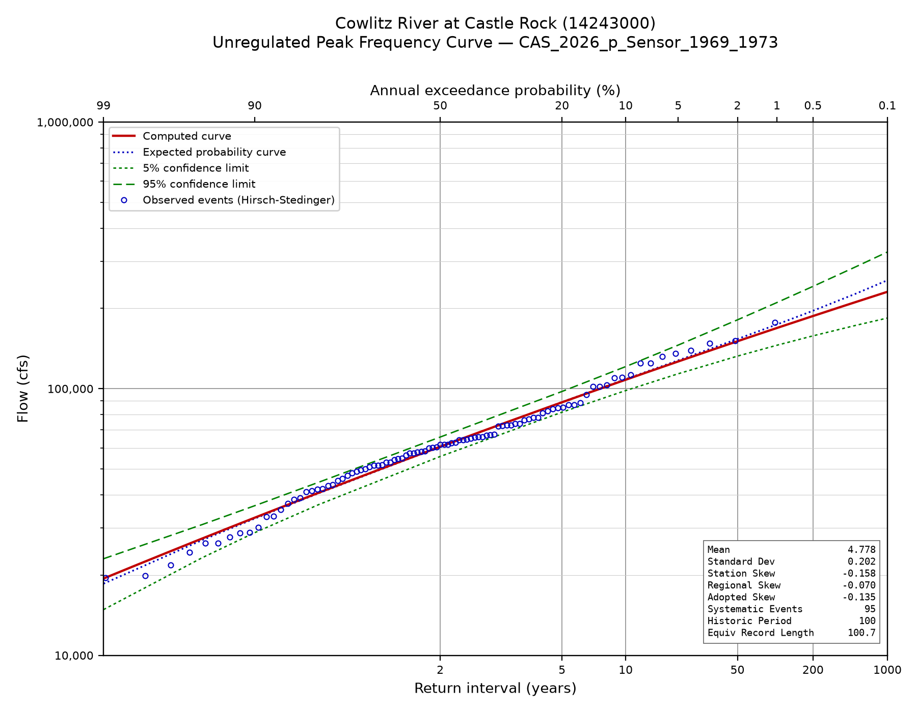
Figure C-1. Unregulated instantaneous peak frequency curve.
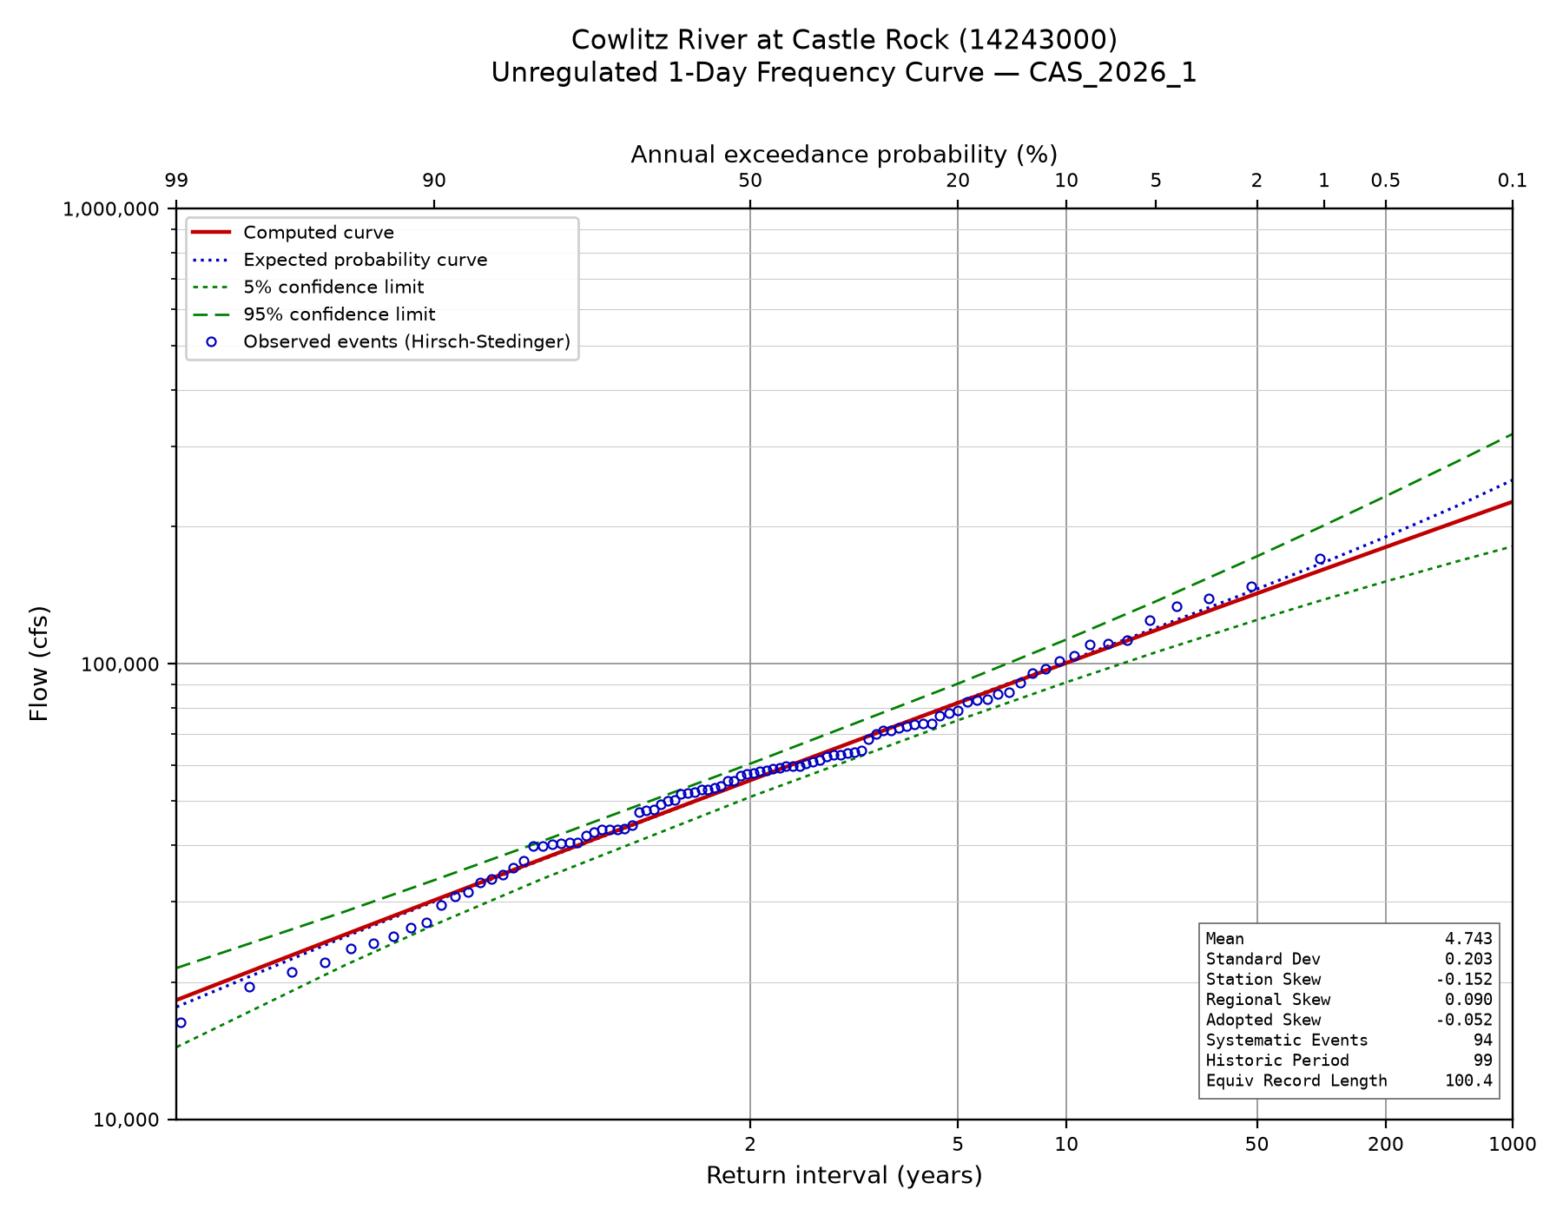
Figure C-2. Unregulated 1-day frequency curve.
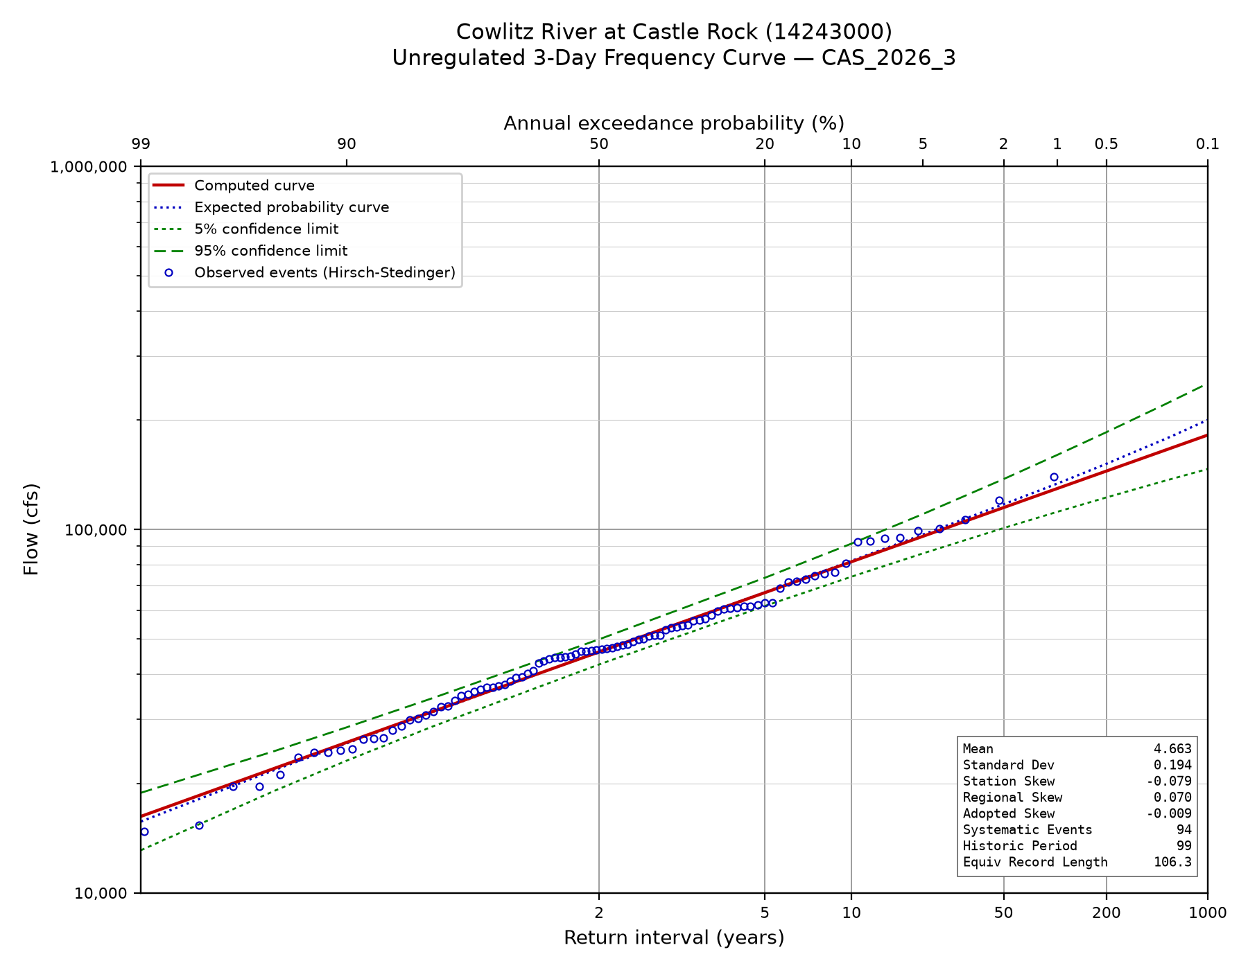
Figure C-3. Unregulated 3-day frequency curve.
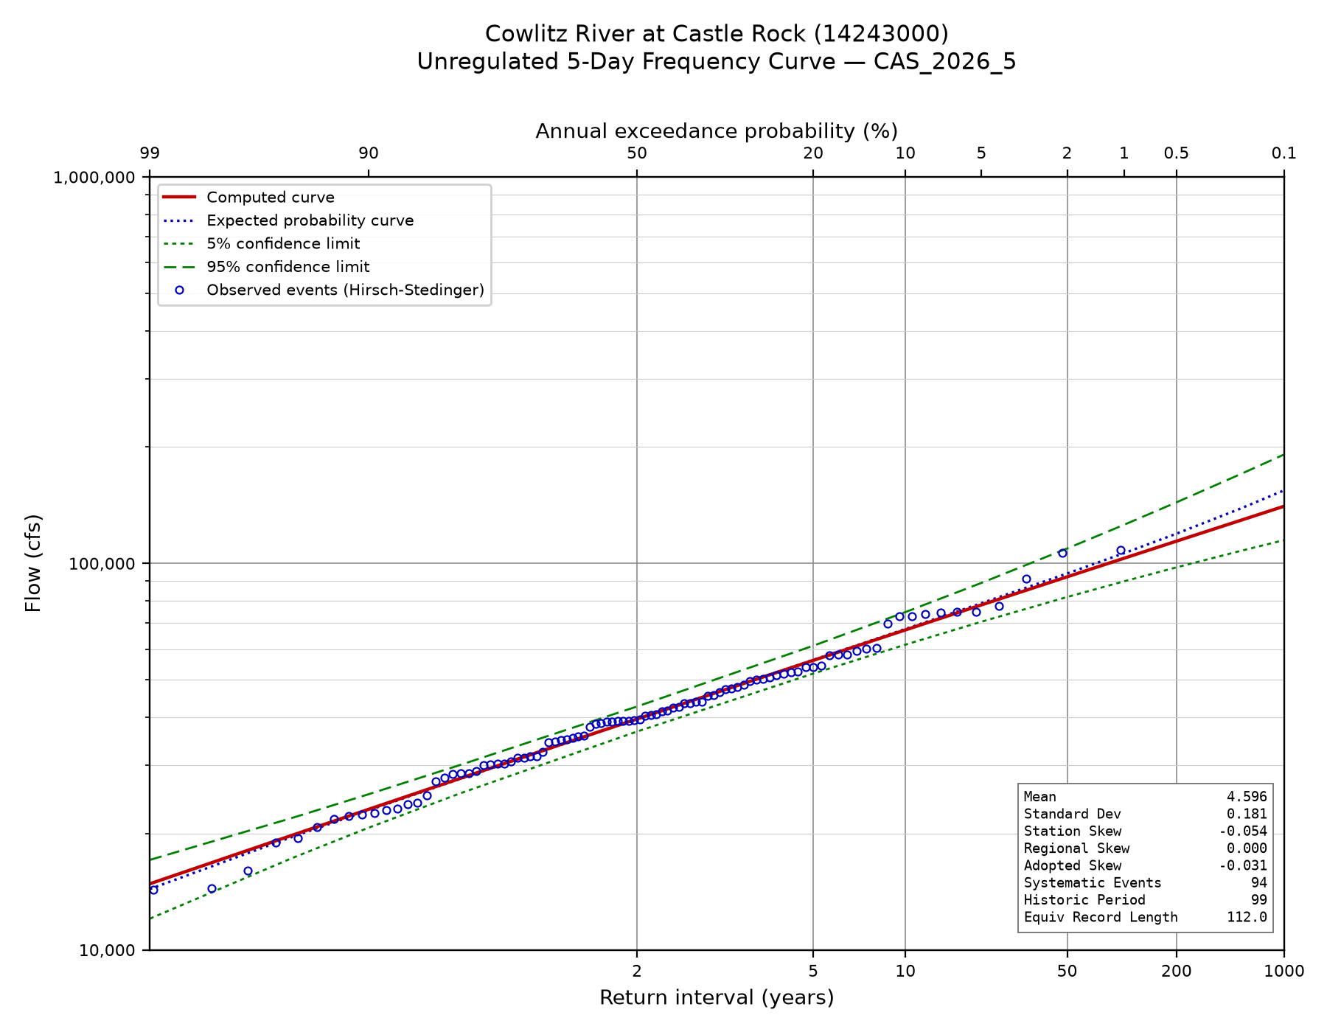
Figure C-4. Unregulated 5-day frequency curve.

Appendix D. Adjusted Regulated Peak Record by Water Year
Observed, simulated and adjusted regulated peaks for every shared water year, with the screening result recorded for each. Flows are in cubic feet per second. WCM_RC and Obs_RC start the simulation at the water control manual rule curve and observed elevation, respectively.
Table D-1. Adjusted regulated peak record, water years 1974 through 2024.

WY | Observed | WCM_RC | Obs_RC | Difference | Adjusted | Screen
1974 | 68,600 | 33,207 | 19,208 | 13,999 | 82,599 | reg_over_unreg
1975 | 58,900 | 57,075 | 56,714 | 361 | 59,261 | ok
1976 | 86,700 | 75,597 | 105,150 | -29,553 | 86,700 | ok
1977 | 15,000 | 14,187 | 12,187 | 2,000 | 17,000 | ok
1978 | 86,400 | 79,778 | 79,778 | 0 | 86,400 | ok
1979 | 39,400 | 42,972 | 40,972 | 2,000 | 41,400 | ok
1980 | 97,000 | — | — | — | 97,000 | Lahar
1981 | 46,900 | 50,909 | 39,206 | 11,703 | 58,603 | ok
1982 | 65,500 | 64,483 | 63,822 | 661 | 66,161 | ok
1983 | 67,300 | 59,457 | 59,457 | 0 | 67,300 | ok
1984 | 49,600 | — | — | — | 49,600 | different_event
1985 | 23,600 | 24,934 | 13,724 | 11,210 | 23,600 | different_event
1986 | 62,700 | 62,206 | 60,657 | 1,549 | 64,249 | ok
1987 | 77,600 | 73,775 | 73,059 | 716 | 78,316 | ok
1988 | 42,100 | 52,818 | 38,880 | 13,938 | 56,038 | ok
1989 | 23,600 | 27,470 | 13,443 | 14,026 | 37,626 | ok
1990 | 89,200 | 84,639 | 83,907 | 732 | 89,932 | ok
1991 | 76,000 | 62,368 | 61,083 | 1,286 | 77,286 | ok
1992 | 27,000 | 35,102 | 21,102 | 14,000 | 41,000 | ok
1993 | 14,700 | 25,147 | 11,148 | 14,000 | 28,700 | ok
1994 | 17,300 | — | — | — | 17,300 | different_event
1995 | 47,500 | — | — | — | 47,500 | different_event
1996 | 112,000 | 132,172 | 108,967 | 23,205 | 135,205 | ok
1997 | 56,700 | 54,439 | 52,636 | 1,803 | 58,503 | ok
1998 | 30,800 | 28,784 | 28,784 | 0 | 30,800 | ok
1999 | 57,600 | 53,768 | 50,442 | 3,326 | 60,926 | ok
2000 | 41,700 | 49,782 | 35,782 | 14,000 | 55,700 | ok
2001 | 11,600 | — | — | — | 11,600 | different_event
2002 | 51,400 | 53,728 | 45,573 | 8,155 | 59,555 | ok
2003 | 69,000 | 62,340 | 62,077 | 263 | 69,263 | ok
2004 | 38,100 | 48,301 | 34,302 | 14,000 | 52,100 | ok
2005 | 29,600 | 40,940 | 26,912 | 14,029 | 43,629 | ok
2006 | 56,200 | — | — | — | 56,200 | different_event
2007 | 77,300 | 94,857 | 70,844 | 24,013 | 101,313 | ok
2008 | 64,300 | 61,129 | 60,053 | 1,076 | 65,376 | ok
2009 | 106,000 | 81,855 | 81,470 | 385 | 106,385 | ok
2010 | 20,900 | 26,302 | 15,335 | 10,966 | 31,866 | ok
2011 | 45,300 | 44,599 | 30,599 | 14,000 | 59,300 | ok
2012 | 36,900 | 38,920 | 24,921 | 13,999 | 50,899 | ok
2013 | 47,000 | 51,961 | 37,704 | 14,257 | 61,257 | reg_over_unreg
2014 | 32,300 | 43,271 | 29,271 | 14,000 | 46,300 | ok
2015 | 38,500 | 45,556 | 31,552 | 14,004 | 52,504 | ok
2016 | 83,700 | 81,000 | 80,324 | 675 | 84,375 | ok
2017 | 40,000 | 51,716 | 39,201 | 12,515 | 52,515 | ok
2018 | 35,100 | 45,514 | 31,518 | 13,996 | 49,096 | ok
2019 | 26,000 | — | — | — | 26,000 | different_event
2020 | 47,400 | 51,580 | 51,580 | 0 | 47,400 | ok
2021 | 45,600 | 50,963 | 42,650 | 8,313 | 53,913 | ok
2022 | 63,900 | 62,387 | 61,747 | 639 | 64,539 | ok
2023 | 34,400 | 44,819 | 30,826 | 13,993 | 48,393 | ok
2024 | 44,800 | 52,638 | 42,979 | 9,659 | 54,459 | ok

Appendix E. Current Study Regulated Frequency Ordinates by Location
Regulated peak flow at each of the four locations of Section 7, with 5 percent and 95 percent confidence limits. Flows are in cubic feet per second. At the gage the adopted expected probability unregulated curve is shown alongside; downstream, the local contribution is shown, the incremental drainage area scaled off the unregulated curve and reduced by the 0.80 timing factor. Confidence limits at the three downstream locations are from Castle Rock, translated by the local contribution — see Section 7.4.
Table E-1. Castle Rock gage, 2,238 square miles.

AEP | Unregulated | Regulated | 5% | 95%
0.9900 | 18,564 | 18,564 | 12,482 | 24,322
0.9500 | 27,041 | 27,041 | 19,807 | 34,235
0.9000 | 32,573 | 32,573 | 24,573 | 40,722
0.8000 | 40,487 | 39,874 | 30,871 | 49,214
0.5000 | 60,529 | 50,811 | 39,914 | 60,913
0.2000 | 89,126 | 64,243 | 49,650 | 75,220
0.1000 | 108,618 | 74,786 | 57,542 | 91,380
0.0500 | 127,758 | 85,561 | 64,263 | 112,764
0.0200 | 153,556 | 100,670 | 73,093 | 143,825
0.0100 | 174,075 | 116,809 | 83,160 | 171,777
0.0050 | 195,977 | 140,273 | 98,137 | 211,024
0.0020 | 227,900 | 178,194 | 123,500 | 272,245
0.0010 | 255,074 | 213,481 | 147,305 | 330,897
0.0005 | 285,568 | 256,186 | 175,700 | 403,314
0.0002 | 332,739 | 328,154 | 224,302 | 514,096
0.0001 | 374,643 | 374,643 | 251,530 | 602,655

Table E-2. Below Arkansas Creek, 2,278 square miles.
AEP | Local | Regulated | 5% | 95%
0.9900 | 265 | 18,830 | 12,747 | 24,588
0.9500 | 387 | 27,428 | 20,194 | 34,621
0.9000 | 466 | 33,038 | 25,039 | 41,188
0.8000 | 579 | 40,453 | 31,449 | 49,793
0.5000 | 865 | 51,676 | 40,780 | 61,779
0.2000 | 1,274 | 65,517 | 50,924 | 76,494
0.1000 | 1,553 | 76,339 | 59,095 | 92,933
0.0500 | 1,827 | 87,388 | 66,090 | 114,590
0.0200 | 2,196 | 102,866 | 75,289 | 146,021
0.0100 | 2,489 | 119,298 | 85,649 | 174,266
0.0050 | 2,802 | 143,075 | 100,940 | 213,826
0.0020 | 3,259 | 181,453 | 126,758 | 275,503
0.0010 | 3,647 | 217,128 | 150,952 | 334,545
0.0005 | 4,083 | 260,269 | 179,783 | 407,397
0.0002 | 4,758 | 332,912 | 229,060 | 518,853
0.0001 | 5,357 | 380,000 | 256,887 | 608,012

Table E-3. Below Ostrander Creek, 2,335 square miles.
AEP | Local | Regulated | 5% | 95%
0.9900 | 644 | 19,208 | 13,125 | 24,966
0.9500 | 938 | 27,979 | 20,745 | 35,172
0.9000 | 1,129 | 33,702 | 25,703 | 41,852
0.8000 | 1,404 | 41,278 | 32,274 | 50,618
0.5000 | 2,099 | 52,909 | 42,013 | 63,012
0.2000 | 3,090 | 67,333 | 52,740 | 78,310
0.1000 | 3,766 | 78,552 | 61,308 | 95,146
0.0500 | 4,430 | 89,991 | 68,693 | 117,194
0.0200 | 5,324 | 105,995 | 78,418 | 149,150
0.0100 | 6,036 | 122,845 | 89,196 | 177,813
0.0050 | 6,795 | 147,068 | 104,933 | 217,819
0.0020 | 7,902 | 186,096 | 131,402 | 280,147
0.0010 | 8,844 | 222,325 | 156,149 | 339,742
0.0005 | 9,902 | 266,087 | 185,602 | 413,216
0.0002 | 11,537 | 339,692 | 235,839 | 525,633
0.0001 | 12,990 | 387,633 | 264,520 | 615,645

Table E-4. Below Coweeman River, 2,476 square miles.

AEP | Local | Regulated | 5% | 95%
0.9900 | 1,579 | 20,143 | 14,061 | 25,902
0.9500 | 2,301 | 29,341 | 22,108 | 36,535
0.9000 | 2,771 | 35,344 | 27,344 | 43,494
0.8000 | 3,445 | 43,319 | 34,315 | 52,659
0.5000 | 5,150 | 55,960 | 45,064 | 66,063
0.2000 | 7,582 | 71,825 | 57,232 | 82,803
0.1000 | 9,241 | 84,027 | 66,782 | 100,621
0.0500 | 10,869 | 96,430 | 75,133 | 123,633
0.0200 | 13,064 | 113,734 | 86,157 | 156,889
0.0100 | 14,810 | 131,619 | 97,970 | 186,587
0.0050 | 16,673 | 156,946 | 114,810 | 227,696
0.0020 | 19,389 | 197,583 | 142,889 | 291,633
0.0010 | 21,701 | 235,182 | 169,005 | 352,598
0.0005 | 24,295 | 280,481 | 199,995 | 427,609
0.0002 | 28,308 | 356,462 | 252,610 | 542,404
0.0001 | 31,873 | 406,516 | 283,403 | 634,528

Appendix F. 2009 Regulated Frequency Ordinates by Location

Table F-1. 2009 Study Regulated Flow Frequency at Castle Rock gage
AEP | Local | Regulated | 5% | 95%
0.99 | 22,224 | 11,000 | 8,516 | 14,209
0.95 | 29,116 | 18,000 | 13,638 | 23,757
0.9 | 33,803 | 24,000 | 19,370 | 29,736
0.8 | 40,703 | 32,000 | 28,031 | 36,531
0.5 | 58,975 | 46,000 | 41,910 | 50,489
0.2 | 87,233 | 66,000 | 59,442 | 73,281
0.1 | 107,941 | 80,000 | 69,604 | 91,949
0.05 | 129,264 | 96,000 | 81,592 | 112,953
0.02 | 159,102 | 108,000 | 97,207 | 119,991
0.01 | 183,247 | 113,000 | 98,260 | 129,951
0.005 | 208,960 | 124,000 | 107,825 | 142,601
0.002 | 245,635 | 160,000 | 139,129 | 184,001
0.001 | 275,605 | 190,000 | 165,216 | 218,502
0.0005 | 307,656 | 300,000 | 260,868 | 345,003
0.0001 | 390,943 | 390,000 | 339,128 | 448,503

Table F-2. 2009 Study Regulated Flow Frequency Below Arkansas Creek
AEP | Local | Regulated | 5% | 95%
0.99 | 500 | 11,500 | 8,901 | 14,857
0.95 | 600 | 18,600 | 14,166 | 24,423
0.9 | 700 | 24,700 | 19,975 | 30,542
0.8 | 900 | 32,900 | 28,836 | 37,537
0.5 | 1,300 | 47,300 | 43,127 | 51,877
0.2 | 1,800 | 67,800 | 61,067 | 75,275
0.1 | 2,200 | 82,200 | 71,525 | 94,469
0.05 | 2,600 | 98,600 | 83,830 | 115,972
0.02 | 3,000 | 111,000 | 99,639 | 123,657
0.01 | 3,400 | 116,400 | 100,782 | 134,438
0.005 | 3,700 | 127,700 | 110,566 | 147,489
0.002 | 4,200 | 164,200 | 142,169 | 189,645
0.001 | 4,600 | 194,600 | 168,490 | 224,756
0.0005 | 4,900 | 304,900 | 263,991 | 352,149
0.0001 | 5,800 | 395,800 | 342,695 | 457,135

Table F-2. 2009 Study Regulated Flow Frequency Below Ostrander Creek
AEP | Local | Regulated | 5% | 95%
0.99 | 700 | 11,700 | 9,043 | 15,137
0.95 | 1,000 | 19,000 | 14,464 | 24,959
0.9 | 1,200 | 25,200 | 20,424 | 31,093
0.8 | 1,400 | 33,400 | 29,306 | 38,066
0.5 | 2,000 | 48,000 | 43,746 | 52,668
0.2 | 2,800 | 68,800 | 61,979 | 76,372
0.1 | 3,400 | 83,400 | 72,614 | 95,788
0.05 | 3,900 | 99,900 | 84,930 | 117,508
0.02 | 4,600 | 112,600 | 100,915 | 125,639
0.01 | 5,200 | 118,200 | 102,350 | 136,505
0.005 | 5,700 | 129,700 | 112,307 | 149,786
0.002 | 6,500 | 166,500 | 144,173 | 192,285
0.001 | 7,000 | 197,000 | 170,583 | 227,509
0.0005 | 7,500 | 307,500 | 266,265 | 355,121
0.0001 | 8,800 | 398,800 | 345,321 | 460,561

References
England, J.F., Jr., Cohn, T.A., Faber, B.A., Stedinger, J.R., Thomas, W.O., Jr., Veilleux, A.G., Kiang, J.E., and Mason, R.R., Jr., 2019, Guidelines for determining flood flow frequency - Bulletin 17C (ver. 1.1): U.S. Geological Survey Techniques and Methods, book 4, chap. B5, 148 p.
Lind, G.D., Lamontagne, J.R., and Stonewall, A.J., 2020, Development of regional skew coefficients for selected flood durations in the Columbia River Basin, northwestern United States and British Columbia, Canada (ver. 1.1, October 2020): U.S. Geological Survey Scientific Investigations Report 2020-5073, 48 p.
Mastin, M.C., Konrad, C.P., Veilleux, A.G., and Tecca, A.E., 2016, Magnitude, frequency, and trends of floods at gaged and ungaged sites in Washington, based on data through water year 2014 (ver. 1.2, November 2017): U.S. Geological Survey Scientific Investigations Report 2016-5118, 70 p.
U.S. Army Corps of Engineers, 2025, Risk Assessment for Flood Risk Management Studies, EM 1110-2-1619, 29 September 2025.
U.S. Army Corps of Engineers, 1993, Engineering and Design for Hydrologic Frequency Analysis, EM 1110-2-1415, 05 March 1993.

U.S. Army Corps of Engineers, Portland District, 2009, Cowlitz River Hydrology Restudy.
U.S. Army Corps of Engineers, 2014, Water Control Manual, Mossyrock Project, Cowlitz River, Washington.
USACE. 2010. Mount St. Helens Project, Cowlitz River Levee Systems, 2009 Level of Flood Protection Update Summary. U.S. Army Corps of Engineers, Portland District. February 2010.
U.S. Army Corps of Engineers, Hydrologic Engineering Center, HEC-ResSim Reservoir System Simulation, and HEC-SSP Statistical Software Package.
U.S. Geological Survey, National Water Information System: streamflow and peak-flow records for station 14243000, Cowlitz River at Castle Rock, Washington.

