MEMORANDUM FOR RECORD
U.S. Army Corps of Engineers, Portland District
Item | Description
Subject | Unregulated and Regulated Flow Frequency, Cowlitz River at Castle Rock, Washington (USGS 14243000)
From | Hydrology and Hydraulics Branch, Portland District
Date | August 2026
Status | DRAFT — combines the separate unregulated and regulated memoranda into one document; Section 8 (Columbia River confluence extension) pending

1. Purpose
This memorandum documents the development of unregulated and regulated flow frequency curves for the Cowlitz River at Castle Rock, Washington. Unregulated curves are developed for the instantaneous peak and the 1-, 3-, and 5-day durations using water years 1927 through 2026 (Section 4); the regulated curve for the instantaneous peak is then obtained by transforming the adopted unregulated peak curve through a relationship between unregulated and regulated flow derived from reservoir simulation, rather than by fitting a distribution to the observed regulated record (Section 5). The regulated curve, with its uncertainty, supports levee fragility assessment and floodplain mapping in the lower Cowlitz valley.
Neither curve can be produced by fitting the observed record directly. Regulated peaks are not a homogeneous sample — operating rules and starting-pool practice have changed since Mossyrock began impounding in 1968 — and they do not follow an analytical distribution: a reservoir holds small events almost entirely, loses ground through the middle of its range, and passes the largest events through once storage is exhausted, a shape no log-Pearson Type III curve reproduces. The standard approach, used here, is to establish the frequency of the natural inflow and carry it through the projects.

2. Basin Description and Project Operation
The Cowlitz River drains the southern Washington Cascades and enters the Columbia River near Longview. The Castle Rock gage (USGS 14243000) sits in the lower valley, downstream of the Toutle River confluence and of all the basin's storage projects, with a peak-flow record spanning water years 1927 through 2026. The total basin area above Castle Rock is 2,238 square miles, of which 1,170 square miles of headwaters are regulated by Mossyrock Dam.
Three non-Federal hydroelectric projects lie on the mainstem, operated by Tacoma Power as the Cowlitz Hydroelectric Project. Mossyrock Dam, completed in 1968 and impounding Riffe Lake, provides the only usable flood storage in the basin and began actively regulating the river in December 1968; years before then are unregulated as observed. Mayfield Dam, completed in 1963, is a re-regulating dam that smooths power peaking releases from Mossyrock and provides no meaningful flood regulation of its own. Cowlitz Falls Dam, above Mossyrock, and the Sediment Retention Structure on the Toutle are both run-of-river.
Two features of the basin govern how much the projects can do, and both are visible in the results that follow. The regulated fraction is a little over half the drainage area, so roughly half the flow arriving at Castle Rock in a large event is uncontrolled. The Toutle River, the largest tributary, enters below both dams and is entirely unregulated; the Tilton River enters Mayfield Lake, which passes inflow and provides no flood regulation. At the largest events the local and Toutle contribution is a median 48 percent of unregulated flow at Castle Rock, which sets a floor on the regulated peak that no operation can reach below.
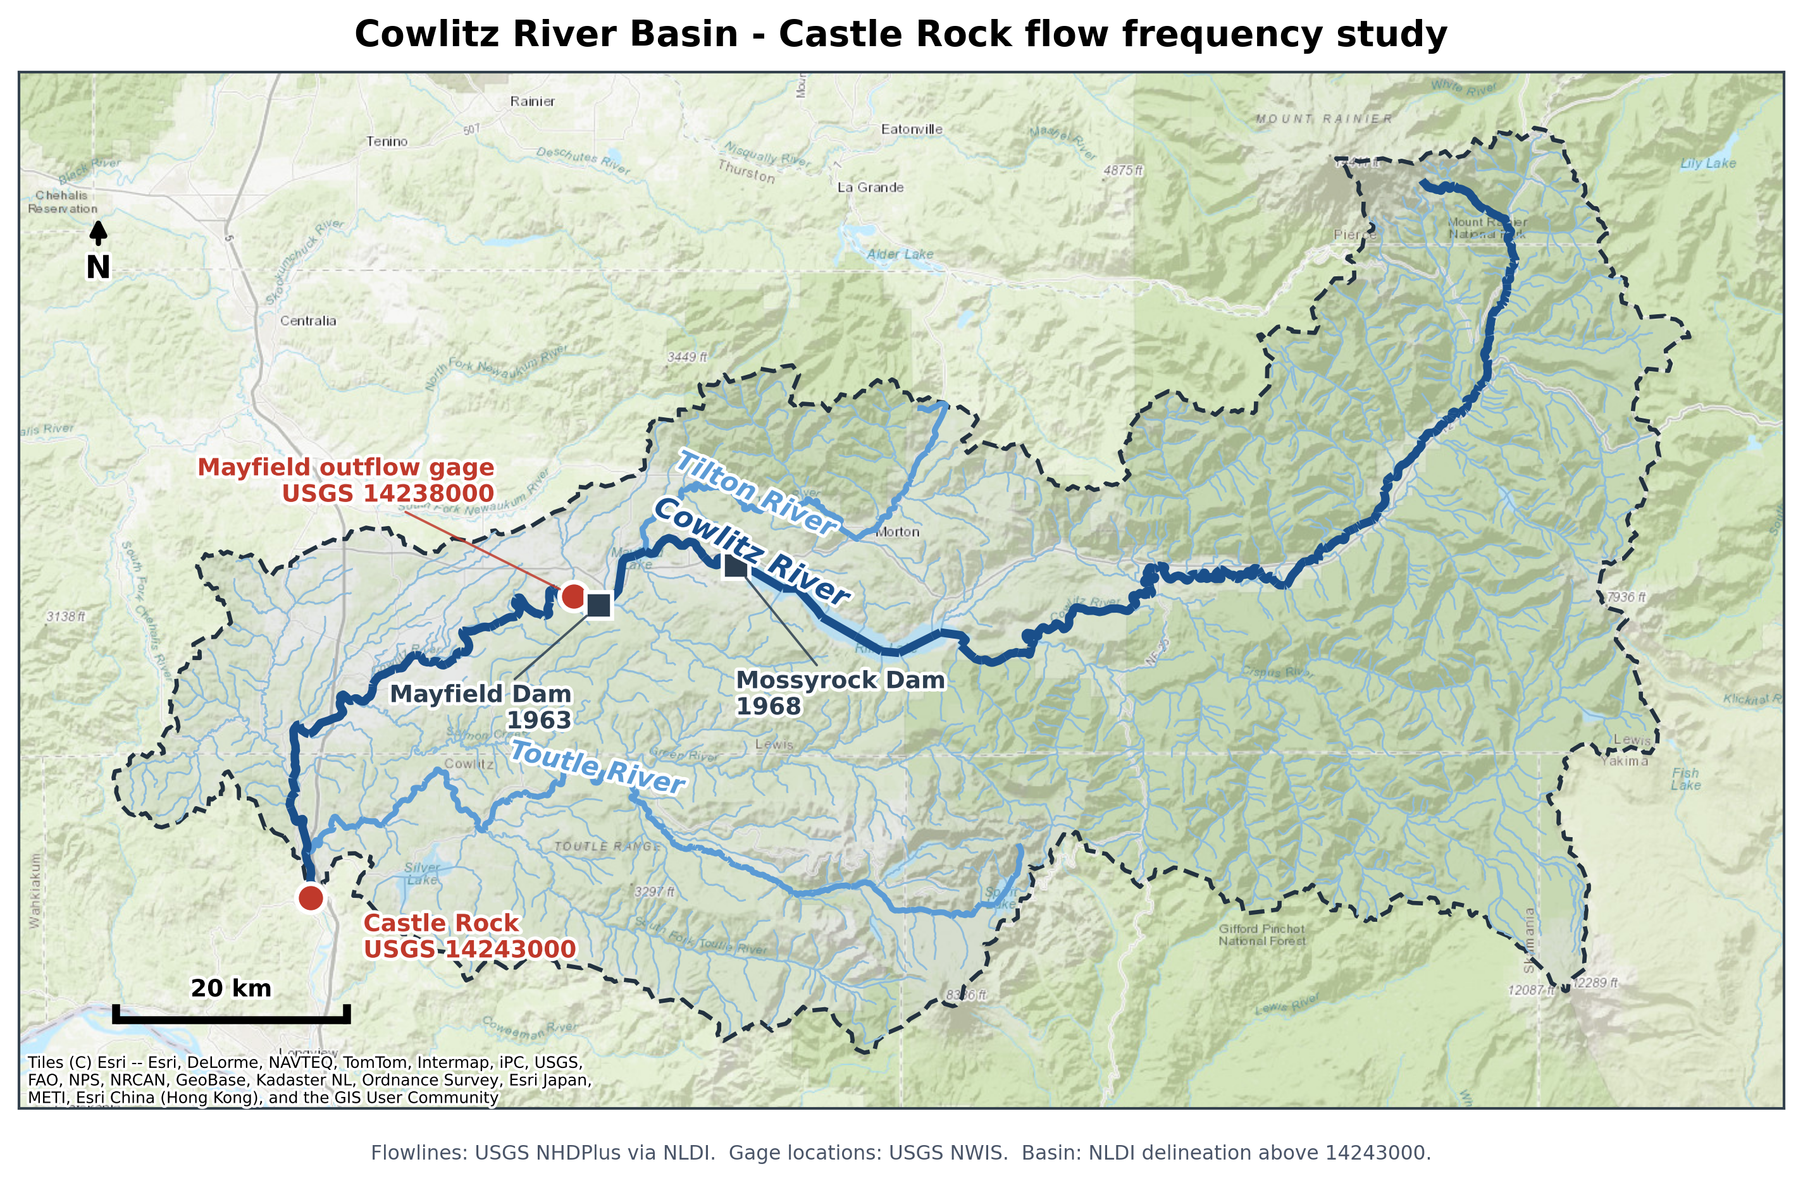
Figure 2-1. Cowlitz River basin, showing the Castle Rock gage, the Mossyrock and Mayfield projects, and the Toutle and Tilton tributaries.

2.1 Previous Studies
The previously adopted unregulated and regulated frequency curves at Castle Rock both come from the 2009 Cowlitz Hydrology Restudy, which predates Bulletin 17C, does not include the most recent 17 years of record, and derived its regulated curve by a different route than the one used here. Section 6 compares both curves against the 2009 study.

3. Data Used
Table 3-1 lists the datasets and models used and the purpose each served. The observed hydrologic records are shared by both analyses; the reservoir simulation model and its outputs are specific to the regulated study.
Dataset or model | Period used | Purpose
Mossyrock pool elevation, hourly | Nov 1974 – May 2026 | Reservoir storage change at hourly resolution; basis of the hourly unregulated peak estimates (5.2)
Mossyrock storage telemetry, hourly | Regulated era | Data quality screening
Mossyrock pool elevation, daily | Oct 1973 – present | Storage change for the regression predictors and the daily mass balance (5.3, 5.4); observed starting pool for the Obs_RC simulation (5.1)
Mossyrock elevation-storage rating table | 2014 Water Control Manual | Relates pool elevation to reservoir storage
Castle Rock streamflow, hourly (USGS 14243000) | Regulated era | Regulated flow at the study location; source of the regulated peak
Castle Rock streamflow, daily (USGS 14243000) | WY1927 – present | Pre-regulation durations; regulated daily flow used for the 3-, 5-, and select 1-day duration maxima
Castle Rock annual peak flows (USGS 14243000) | WY1927 – present | Pre-regulation peaks; regulated peak for years the hourly record does not cover; basis of the adjusted regulated peak record (5.1)
Mayfield outflow, hourly (USGS 14238000) | Regulated era | Upstream boundary for routing the Mossyrock regulation signal to Castle Rock
HEC-ResSim model, Mossyrock and Mayfield | Current (2014 WCM) rules | Routes inflow hydrographs through the projects for the adjustment (5.1) and the synthetic ensembles (5.3)
Reservoir inflow and Castle Rock local flow | WY 1929 – 2026 | Simulation inflows, back-calculated and volume-corrected
ResSim period-of-record simulation, rule-curve start (WCM_RC) | 98 water years | Regulated peak under current rules from a rule-curve starting pool
ResSim period-of-record simulation, observed start (Obs_RC) | 53 water years | Regulated peak under current rules from the observed starting pool
ResSim synthetic ensemble simulation | 48 members | Regulated response above the observed range (5.3)
Table 3-1. Datasets and models used, and their purpose.

4. Unregulated Flow Frequency
Unregulated flow is the flow that would have occurred at Castle Rock without Mossyrock. Because the reservoir changes downstream flow only by storing and releasing water, the unregulated hydrograph is reconstructed by adding back the holdout — reservoir storage change expressed as a flow rate — to the observed record. A positive holdout is the reservoir filling; a negative holdout is releasing more than inflow.
For water years 1927–1968 the gage record is unregulated by definition and used as observed (Section 4.4). For the regulated period the reconstruction runs at whatever resolution the reservoir record supports: an hourly holdout where the hourly elevation record is clean enough (Section 4.1), otherwise a peak estimated by regression from the daily reservoir record (Section 4.2). The 3- and 5-day durations, needing only daily resolution, come from a daily mass balance in all years (Section 4.3).

4.1 Hourly Unregulated Record
The cleaned hourly pool elevation was converted to storage using the 2014 Water Control Manual rating curve and differenced to obtain an hourly holdout, smoothed with a 3-hour centered moving average and restricted to the October–March flood season. Days with fewer than four valid storage readings were omitted, since they cannot be relied on to capture the annual peak.
The reservoir signal was translated to Castle Rock using the SSARR routing parameters in Table 4-1, from the calibrated Cowlitz CWMS model. Mayfield outflow plus the holdout, and Mayfield outflow alone, were each routed to Castle Rock; the difference between the two routed hydrographs is the routed reservoir effect, added to observed Castle Rock flow to give the hourly unregulated estimate. The Toutle River reach was excluded because only the mainstem reservoir signal is being routed — Toutle inflow is already in the observed Castle Rock record. Mayfield-to-Castle Rock travel time is short enough that routing barely matters there, but all three reaches carry parameters for completeness.
Reach | KTS | n | Phases
Mayfield outflow to Cowlitz River above Toutle River | 5 | 0.1 | 5
Cowlitz River above Toutle River to Cowlitz River below Toutle River | 1 | 0.2 | 1
Cowlitz River below Toutle River to Castle Rock | 1 | 0.2 | 5
Table 4-1. SSARR routing parameters, from the calibrated lower Cowlitz routing model.
Twenty-three water years produced holdout-based peaks — 1992, 1997, 1999, 2003, 2004, and 2008 through 2026 — with earlier hourly pool elevation too unstable for use.

4.2 Peak Estimation by Storage-Change Regression
For years without a usable hourly record — roughly a third of the regulated era — the unregulated peak is instead estimated by regressing the regulated-minus-unregulated peak difference on the largest 1- to 4-day increase in Mossyrock storage near the event (within 7 days of the regulated peak), then subtracting the predicted difference from the observed regulated peak. This is preferred over regressing the unregulated peak directly: the predictor and the regulated peak are both available for every regulated year, and because the adjustment is a fraction of the flow being reconstructed, a given percentage error on it translates to a much smaller error on the resulting unregulated peak.
Storage-change window | Slope | Intercept (cfs) | R² | Standard error (cfs)
1-day | -0.673 | -7,751 | 0.759 | 7,565
2-day (adopted) | -0.869 | -3,836 | 0.871 | 5,528
3-day | -0.983 | -4,537 | 0.853 | 5,896
4-day | -1.140 | -4,770 | 0.836 | 6,239
Table 4-2. Candidate regressions of the regulated-minus-unregulated peak difference on Mossyrock storage change, fit to 17 water years.
The two-day window was adopted — highest R², lowest standard error: peak difference (regulated minus unregulated) = −0.869 × two-day storage change − 3,836 cfs, R² = 0.871, standard error ≈ 5,530 cfs, n = 17. Pairs whose regulated and unregulated peaks fell more than 72 hours apart were excluded as different storms. Thirty water years were filled by regression; for 1974–1991, where the hourly record does not reach, the regulated peak came from the USGS annual peak record and the peak date centered the storage-change window.
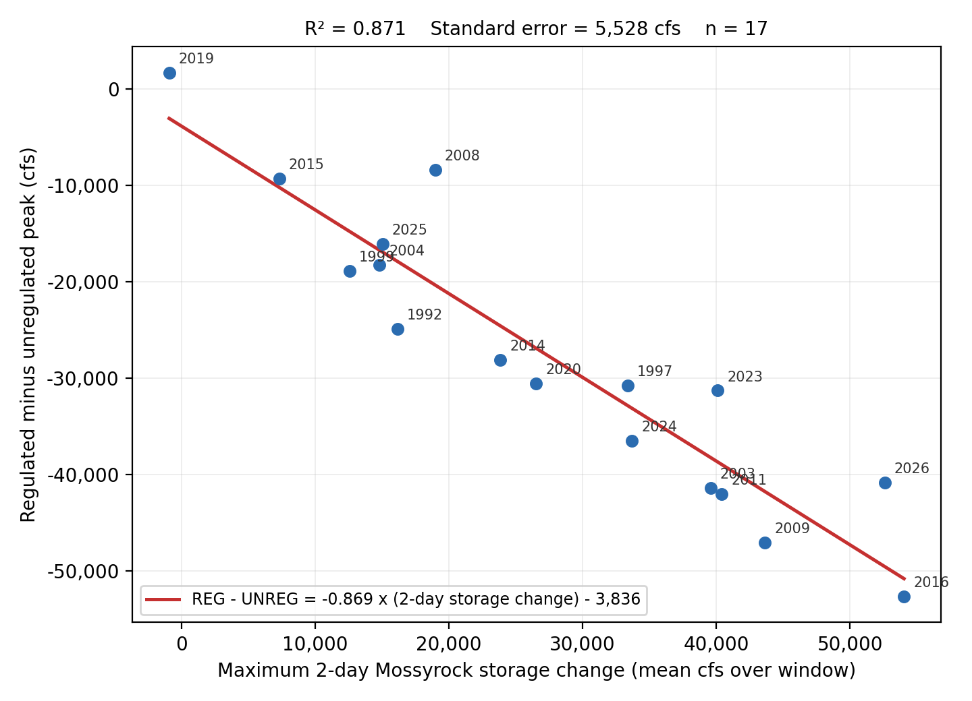
Figure 4-1. Adopted two-day storage-change regression. Points are labeled by water year.

4.3 Durations from the Daily Mass Balance
Daily unregulated flow is observed daily flow plus the daily change in Mossyrock storage as a flow rate; no routing is applied since Mayfield-to-Castle Rock travel time is under a day, and Mayfield re-regulation storage is neglected for the same reason. Rolling 1-, 3-, and 5-day maxima were computed on a complete daily grid so an N-day value always reflects N consecutive recorded days. The Castle Rock daily record runs winter-season-only through much of the 1980s–1990s, which is taken to capture the annual maximum since it spans the flood season. The one-day mass balance value also supplies the 1-day duration in the thirty regulated years without a usable hourly record.

4.4 Pre-Regulation Period
Before December 1968 the gage record is unregulated as observed. Peaks for water years 1927–1968 are the USGS observed instantaneous annual peaks (42 water years), and the 1-, 3-, and 5-day values are rolling maxima from the USGS daily record. Water year 1927 carries a peak only; the daily record begins later.

4.5 Record Extension and Historical Floods
Correlation-based extension from a nearby gage was considered but no suitable donor was found — nearby long-record gages either do not predate Castle Rock by much, are themselves regulated over the period that would be used, or do not correlate strongly enough to justify the added estimation error; with roughly a century of systematic record already in hand, the potential gain was small. A search of USGS qualification codes, the 2009 Restudy, and published USGS/NWS accounts of major southwest Washington floods turned up no pre-1927 event at Castle Rock that could be quantified or reliably bounded, so no historical events or Bulletin 17C perception thresholds were used.

4.6 Assembled Record
For water years 1927–1968 the record is the observed gage record; for 1974–2026 the peak is the hourly holdout where available and the regression estimate otherwise, the 1-day value follows the same split, and the 3- and 5-day values always come from the daily mass balance (Table 4-3, Appendix A). Coverage runs from WY1927 through WY2026 except for WY1969–1973, which have no daily Mossyrock elevation record — it begins October 1973 — and so no basis for a holdout or a regression predictor. Every included water year has a peak; WY1927 has no durations since the daily record starts later.
Duration | Values | Sources
Peak | 95 | 42 pre-regulation USGS peaks; 30 storage-change regression; 23 hourly holdout
1-Day | 94 | 41 pre-regulation USGS daily; 30 daily mass balance; 23 hourly holdout
3-Day | 94 | 41 pre-regulation USGS daily; 53 daily mass balance
5-Day | 94 | 41 pre-regulation USGS daily; 53 daily mass balance
Table 4-3. Assembled record, values and sources by duration.

4.7 Consistency Review
Each duration is the independent annual maximum of its own averaging window, so nothing in the construction forces a shorter duration to exceed a longer one — yet a shorter-duration flow lower than a longer-duration flow for a single event is physically impossible. Fifteen such violations appeared, fourteen from a source mismatch (typically a regression-estimated peak below the same year's mass-balance 1-day value) and one, WY2014, from a double-peaked March event whose 5-day window spans both peaks while no 3-day window can. The record was made monotonic by anchoring each water year at its 5-day value and raising each shorter duration wherever a longer one exceeds it, cascading upward; pre-adjustment values are retained alongside the adopted ones. Ten values across nine water years were raised — eight of them regression-estimated peaks lifted to their 1-day value — with the largest changes, 64, 19, and 19 percent, in WY2001, 1985, and 2006, all among the smallest years in the record and so of little influence on the fitted upper tail.

4.8 Flow Frequency Analysis
The assembled record was analyzed in HEC-SSP with the Bulletin 17C expected moments algorithm, fitting a log-Pearson Type III distribution to each duration and weighting station skew against a published regional value: −0.07 for the peak (Mastin et al., 2016, a constant regional skew for a Pacific Northwest region including the Cowlitz basin), and 0.09 / 0.07 / 0.00 for the 1-, 3-, and 5-day durations (Lind et al., 2020, Bayesian regional skew models for Columbia River basin durations, driven by basin mean annual precipitation — the 5-day value is interpolated between that study's bracketing 3- and 7-day models at a basin-average 77.5 inches).
Water years 1969–1973 have observed regulated peaks but no unregulated basis, so rather than omit them (shortening the record) or assign point estimates (asserting unsupported values), they were entered as censored: the peak analysis reports 95 systematic events within a 100-year period, with five flagged missing. No low outliers were identified by the multiple Grubbs-Beck procedure — the unregulated series is constructed rather than gaged, so its small years carry the same provenance as its large ones and there is no physical basis for treating the lower tail as unrepresentative.
Station skews are slightly negative for every duration (−0.158 to −0.054); weighting against the regional values gives adopted skews of −0.135, −0.052, −0.009, and −0.031 for the peak, 1-, 3-, and 5-day durations, with equivalent record lengths of 100–112 years after censoring. Table 4-4 gives the fitted parameters and event counts; Figure 4-2 shows the four adopted curves. Individual curves with confidence limits and plotted observations appear in Appendix C, and the full ordinates in Appendix B.
Parameter | Peak | 1-Day | 3-Day | 5-Day
Mean of logs | 4.778 | 4.743 | 4.660 | 4.593
Standard deviation of logs | 0.202 | 0.203 | 0.192 | 0.179
Station skew | -0.158 | -0.152 | -0.076 | -0.051
Regional skew | -0.07 | 0.09 | 0.07 | 0.00
Weighted skew | -0.135 | -0.052 | -0.007 | -0.029
Adopted skew | -0.135 | -0.052 | -0.009 | -0.031
Mean square error, at-site skew | 0.064 | 0.064 | 0.060 | 0.059
Grubbs-Beck critical value | 0 | 0 | 0 | 0
Equivalent record length (years) | 103.7 | 100.4 | 106.3 | 112.0
Systematic events | 95 | 94 | 94 | 94
Historical events | 0 | 0 | 0 | 0
High outliers | 0 | 0 | 0 | 0
Low outliers | 0 | 0 | 0 | 0
Zero events | 0 | 0 | 0 | 0
Missing events | 5 | 5 | 5 | 5
Historical period (years) | 100 | 99 | 99 | 99
Table 4-4. Distribution parameters and event counts, adopted HEC-SSP analyses.
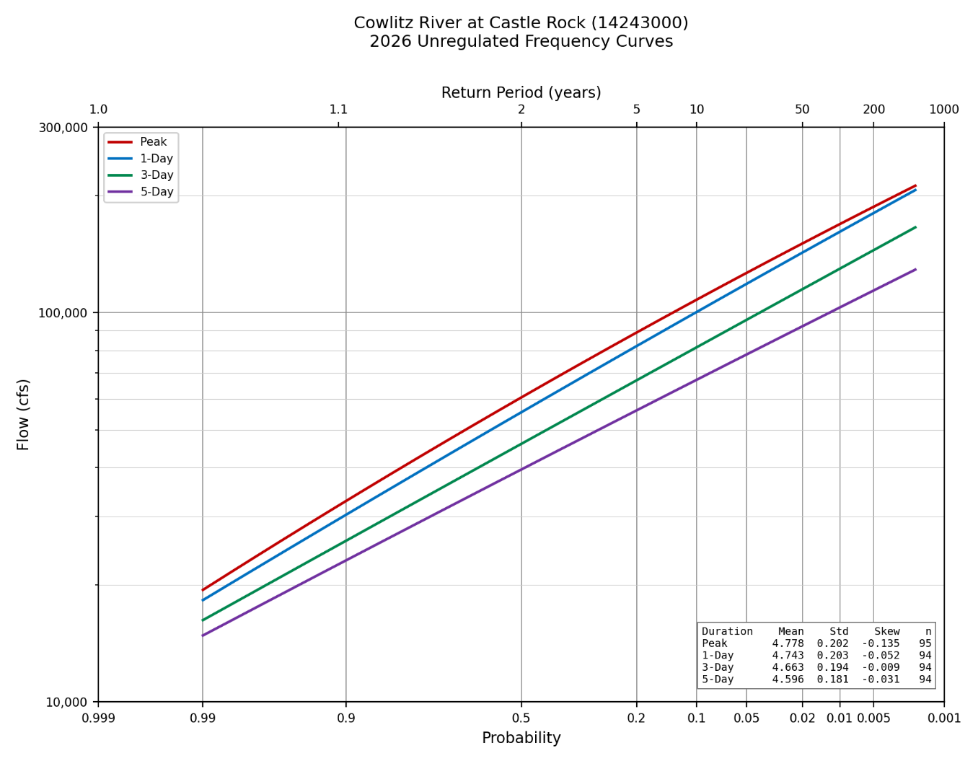
Figure 4-2. Adopted unregulated frequency curves at Castle Rock, water years 1927 through 2026, all four durations.

5. Regulated Flow Frequency
Regulated peaks cannot be fit directly, for two reasons: the observed record is not a homogeneous sample — operating rules and starting-pool practice have varied since Mossyrock began impounding in 1968 — and regulated peaks do not follow an analytical distribution, since operating rules put hard breaks in the inflow–outflow relationship that no log-Pearson Type III curve reproduces. The regulated curve is instead built by adjusting the observed peak record for the starting-pool effect (5.1), pairing adjusted peaks with the unregulated peak of the same event (5.2), augmenting the upper end with routed synthetic floods (5.3), and drawing a transform through the combined set that is applied to the adopted unregulated curve (5.4–5.5).

5.1 Adjusted Regulated Peak Record
The observed Mossyrock record shows the reservoir frequently drafted below the flood-pool minimum, so a peak from a year that started low understates the attenuation the project would provide from its full flood-control authority. Two period-of-record ResSim simulations, using the same observed hydrology and current release rules and differing only in starting pool — one from the WCM rule curve, one from the observed elevation at event onset — isolate that effect. Where the rule-curve start yields the higher regulated peak, the difference is added to the observed peak; the adjustment is one-sided, since a negative difference means the historical operation was already at least as conservative as the rule curve requires.
adjusted peak = observed peak + (simulated RC-start peak − simulated observed-start peak), where the RC-start peak is higher
The period of record is 1974 onward, set by the daily Mossyrock elevation record (beginning October 1973). Peaks are matched by event, not water year, so that both simulated peaks, the observed peak, and the unregulated peak all reflect the same storm; the annual max is used where that holds.
Of 51 shared water years (1974–2024), 38 received an adjustment (median 11,334 cfs, range 263–24,013). Screening removed 10: 7 for a timing mismatch between the observed and simulated peaks, 2 where the regulated peak exceeded the unregulated peak (physically only possible if release exceeds inflow during a large flood), and 1 for both. WY1980 is excluded outright — its peak is the Mount St. Helens lahar, not a hydrologic flood.

5.2 Critical Duration
Mapping a regulated flow onto the unregulated curve requires choosing which unregulated duration corresponds to the regulated peak (Table 5-1, Figure 5-1). Both the instantaneous peak and the 1-day duration are strong predictors; the median ratio explains why the shorter durations correlate better — at the peak the projects hold flow to about 78 percent of unregulated, while at 5 days the ratio exceeds one, because water held out of the peak is released afterward and reappears in the longer window. The projects move flood volume in time, not out of it. The peak unregulated flow is adopted for the transform.
Duration | n | R² | Log R² | Log slope | Median reg / unreg
Peak (1-hr) | 44 | 0.870 | 0.847 | 0.602 | 0.78
1-Day | 44 | 0.853 | 0.830 | 0.605 | 0.87
3-Day | 44 | 0.792 | 0.783 | 0.633 | 1.15
5-Day | 44 | 0.733 | 0.734 | 0.663 | 1.45
Table 5-1. Adjusted regulated against unregulated flow by duration, water years 1974 through 2024.
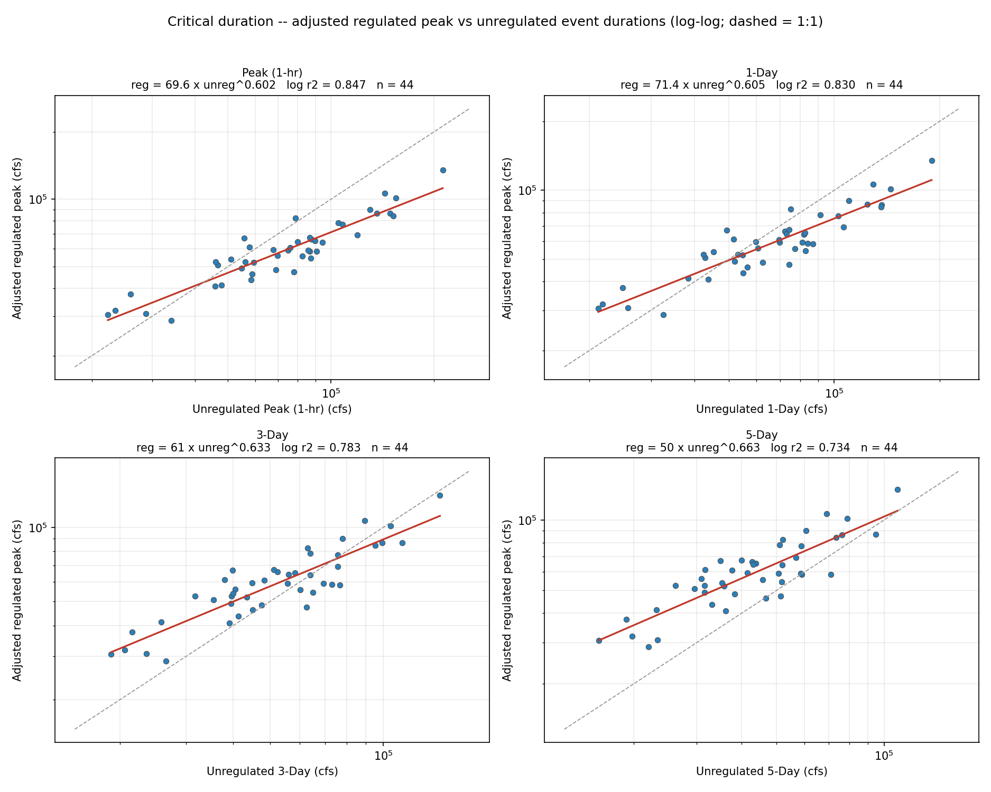
Figure 5-1. Adjusted regulated against unregulated flow, by duration.

5.3 Synthetic Flood Ensembles
Only one water year in the record exceeds the unregulated 100-year peak, so the part of the unregulated-regulated relationship that sets the 100-, 250-, and 500-year regulated flows is essentially unconstrained by observed events. Synthetic floods fill that range: magnitude is varied over four targets from the unregulated curve (the 100-, 250-, and 500-year peaks, plus a fourth 20 percent above the 500-year so the fit is not extrapolating exactly where the answer is needed), and shape is varied by scaling twelve observed storms spanning the full range of observed attenuation behavior — shape is varied rather than assumed because attenuation among large events is not predictable from magnitude, antecedent flow, or timing alone.
Each source storm is scaled to hit its target unregulated peak and 5-day volume (within 5 percent), with Mossyrock inflow and Castle Rock local scaled by the same factor to preserve the observed coincidence between the controlled and uncontrolled fractions. The 48 routed members span regulated peaks of 80,884–266,744 cfs and attenuation ratios of 0.46–1.00; the spread at a single magnitude is a shape effect, not scatter — Nov2006 is absorbed most strongly, Dec1933 exhausts storage and passes through near 1:1 — and is the physical basis for the uncertainty band in Section 5.6.
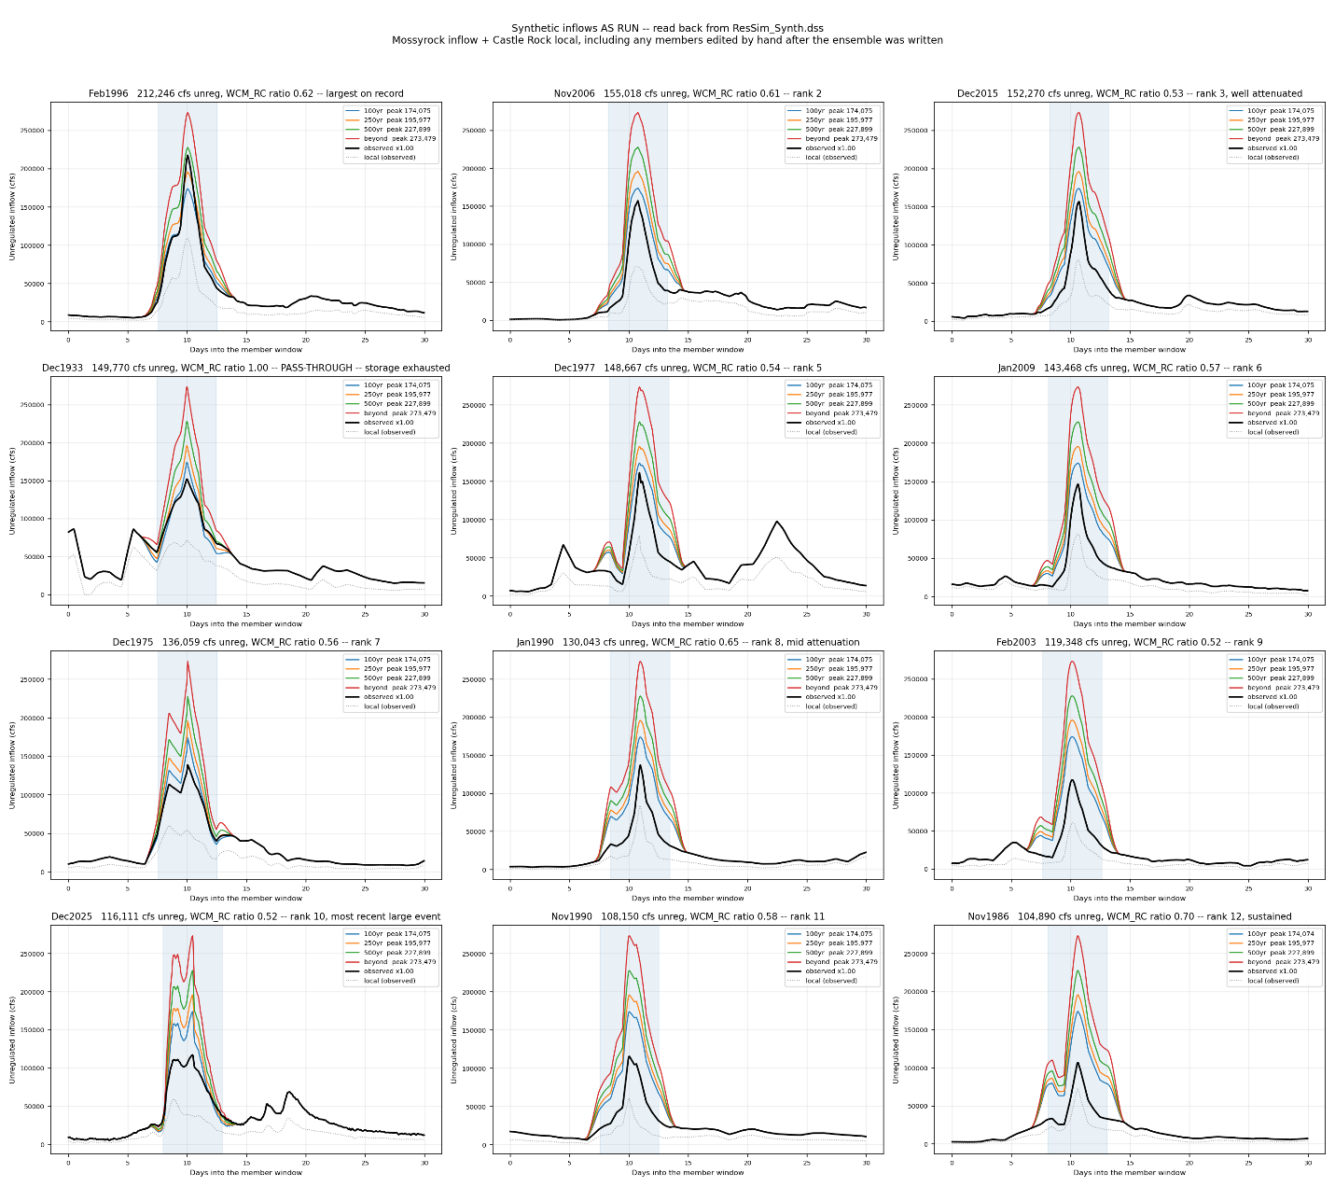
Figure 5-2. Source storms and the scaled family built from each. The shaded band is the window over which the 5-day volume is matched.

5.4 The Unregulated-Regulated Transform
The adjusted historical pairs (observed range) and the routed synthetic members (range above it) together give the (unregulated, regulated) pairs the transform is drawn through: a locally weighted regression in log-log space, tricube-weighted over the nearest 65 percent of the sample, constrained to increase monotonically and clipped at the 1:1 line, since a regulated peak cannot exceed its own unregulated peak in a large event.
The WCM_RC simulated pairs are shown for reference but not fitted — they are simulated on both axes with no observed anchor, since the historical-record adjustment (5.1) is built from the difference between the two simulations, and where no Obs_RC data exists there is no correction to apply. They speak to the shape of the relationship, not its position.
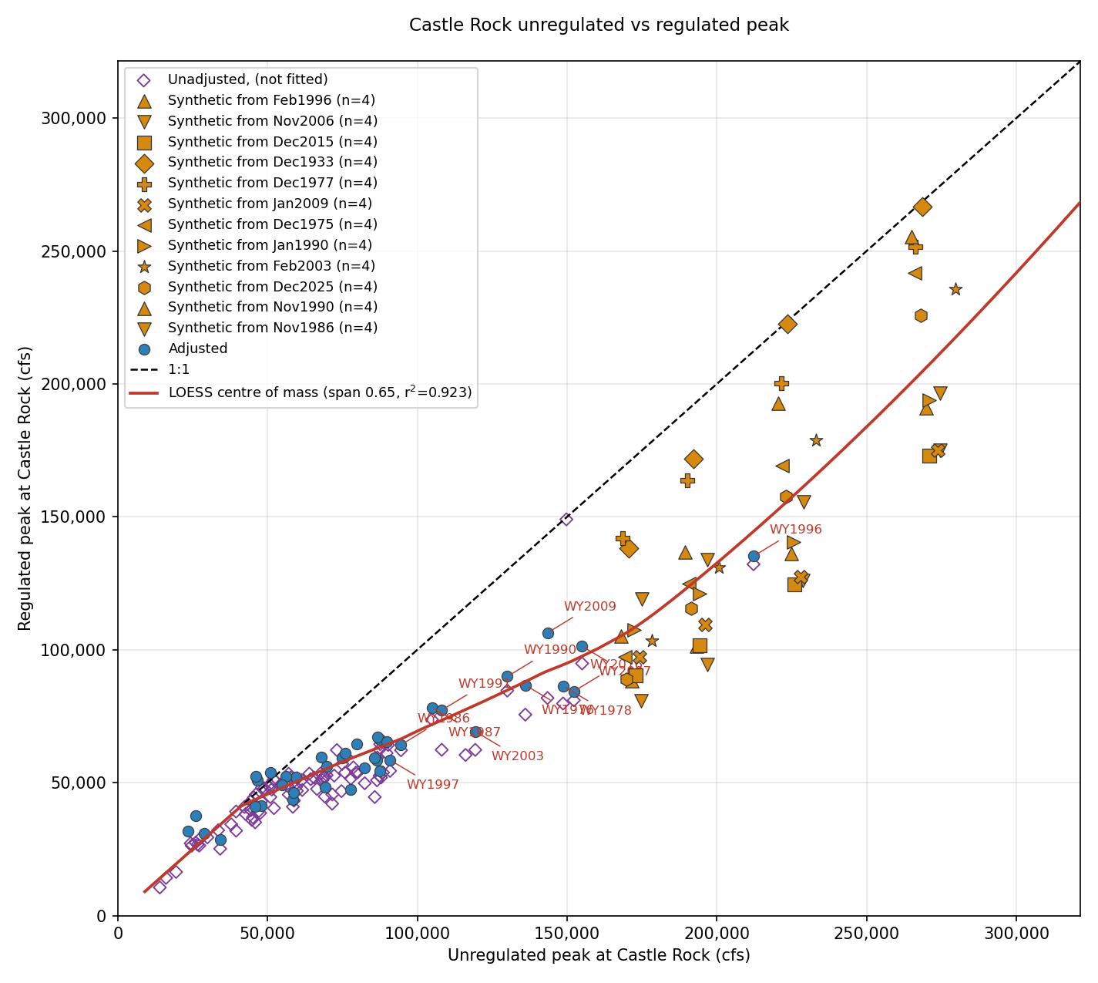
Figure 5-3. Unregulated against regulated peak at Castle Rock, log-log, with the adopted transform and the single power law for reference.

5.5 Regulated Frequency Curve
Each ordinate of the adopted unregulated curve is read through the transform, inheriting its AEP: the regulated flow at a given AEP is what the projects produce from the unregulated flow of that AEP (Table 5-2). Mossyrock reduces the peak about 37 percent near the 1–2 percent AEP; the reduction is smaller at more frequent flows, where events are already largely contained, and at rarer flows, where storage is exhausted and the project must release more to avoid overtopping — down to about 30 percent at the 0.2 percent AEP.
Event | AEP | Unregulated (cfs) | Regulated (cfs) | Reduction | Regulated, 95% band (cfs)
2-year | 0.500 | 60,529 | 50,813 | 16% | 37,799 – 62,798
10-year | 0.100 | 108,618 | 73,702 | 32% | 54,120 – 95,468
50-year | 0.020 | 153,556 | 96,784 | 37% | 62,569 – 158,023
100-year | 0.010 | 174,075 | 109,522 | 37% | 67,455 – 187,199
200-year | 0.005 | 195,977 | 128,798 | 34% | 76,214 – 228,500
500-year | 0.002 | 227,900 | 160,342 | 30% | 91,937 – 292,518
Table 5-2. Adopted regulated frequency curve at Castle Rock, selected ordinates.
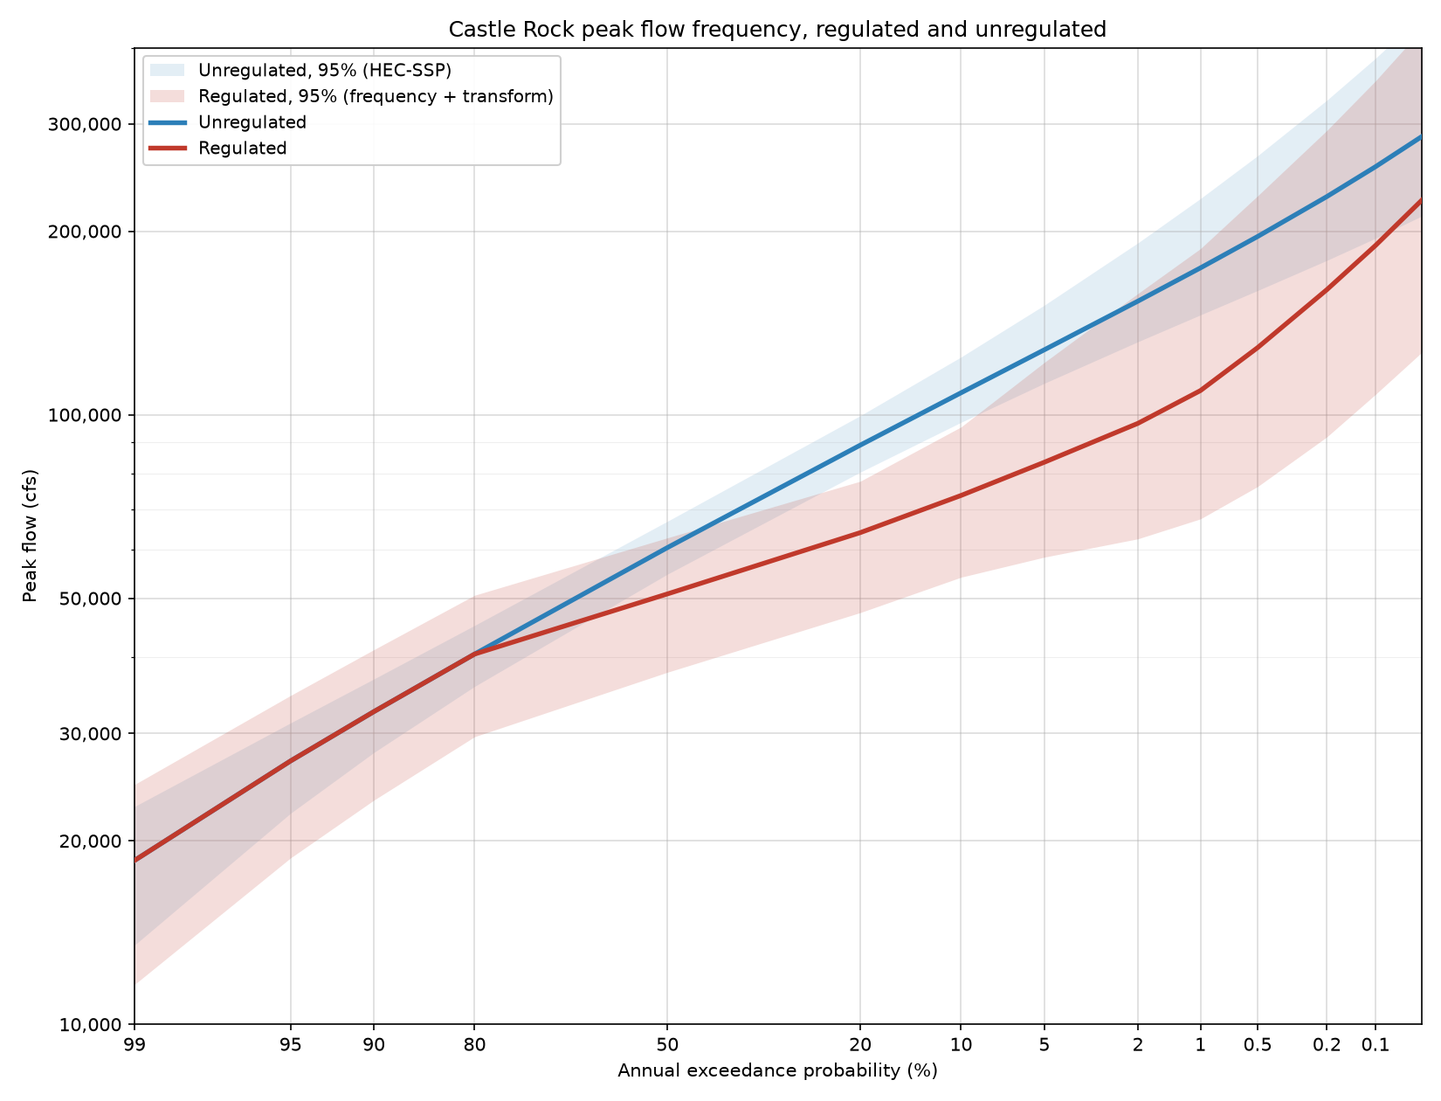
Figure 5-4. Adopted regulated and unregulated frequency curves at Castle Rock, with the 95 percent uncertainty band.

5.6 Uncertainty
The regulated flow at a given AEP carries uncertainty from two independent sources — the unregulated frequency estimate itself, and the scatter of the transform about its fitted line — combined following EM 1110-2-1619 (29 Sep 2025) Section 4-4.b(3): standard deviations from independent sources are combined by root-sum-of-squares (Eq. 4-6), and each source is treated as Normal on the upper and lower side of its best estimate separately (Section 4-6a), which preserves the real asymmetry in both the HEC-SSP confidence limits and the transform residuals rather than assuming one symmetric spread.
The adopted band is the reviewer's formula, at the 95 percent two-sided level (z = 1.960):
Upper = RegBest + √[(Unreg97.5 − Unreg_best)² + (Transform97.5 − Transform_best)²]
Lower = RegBest − √[(Unreg_best − Unreg2.5)² + (Transform_best − Transform2.5)²]
The frequency term is the HEC-SSP confidence-limit flow minus the best estimate, in unregulated cfs, taken directly rather than first pushed through the fitted transform curve — matching the reviewer's formula exactly. The two approaches differ by about 1 percent at the 1 percent AEP, growing to roughly 7 percent by the 0.1 percent AEP as the transform bends toward pass-through; close enough, and the reviewer's formula specific enough, that matching it directly was adopted (Appendix E carries both). The transform term is the LOESS fit's own upper/lower confidence spread, evaluated at the unregulated best estimate and already in regulated cfs.
Each side keeps its own sigma throughout (FREQ_TERM_MODE = 'literal' in the analysis script). The SSP confidence limits are asymmetric — wider above the best estimate than below, more so at the rarer AEPs — and so, now, is the LOESS residual scatter: it is split into an upper- and lower-half sigma from the residuals on each side of the fit rather than pooled into one number. The transform scatter also varies along the curve and by side rather than being pooled — roughly 0.03 to 0.10 dex depending on magnitude and side — because whether a large flood exhausts storage depends on its shape while a small one is simply held.
The upper bound is held at or below the unregulated upper bound above 60,000 cfs, since a regulated flood cannot exceed the unregulated flood it was routed from once Castle Rock is above its 50,000–70,000 cfs regulation goal (below that threshold the project may release more than inflow to regain flood storage). The resulting band reaches about 2.2× more lopsided on one side than the other at the rarest AEP, past the 2.0× threshold at which a two-piece lognormal should be checked against a Monte Carlo — that check has not yet been run. Appendix E gives every term by AEP.

6. Comparison with the 2009 Restudy

6.1 Unregulated Curves
Figure 6-1 places the adopted unregulated curves against the 2009 Cowlitz Hydrology Restudy; both are computed HEC-SSP curves. The two agree closely through the range supported by data — within about 2 percent at the 10 percent AEP, 3 percent at the median — and diverge in the tail: 7.8 percent lower at the 1 percent AEP (1.8–3.3 percent lower for the durations), 13.7 percent lower at the 0.2 percent AEP. The cause is skew — the 2009 study used a regional skew of 0 and adopted positive skews (0.140–0.193) that bend its curves upward in the tail, where the skews adopted here are near zero or negative and flatten it. The divergence is a difference in fitted tail behavior, not in the record through the observed range.
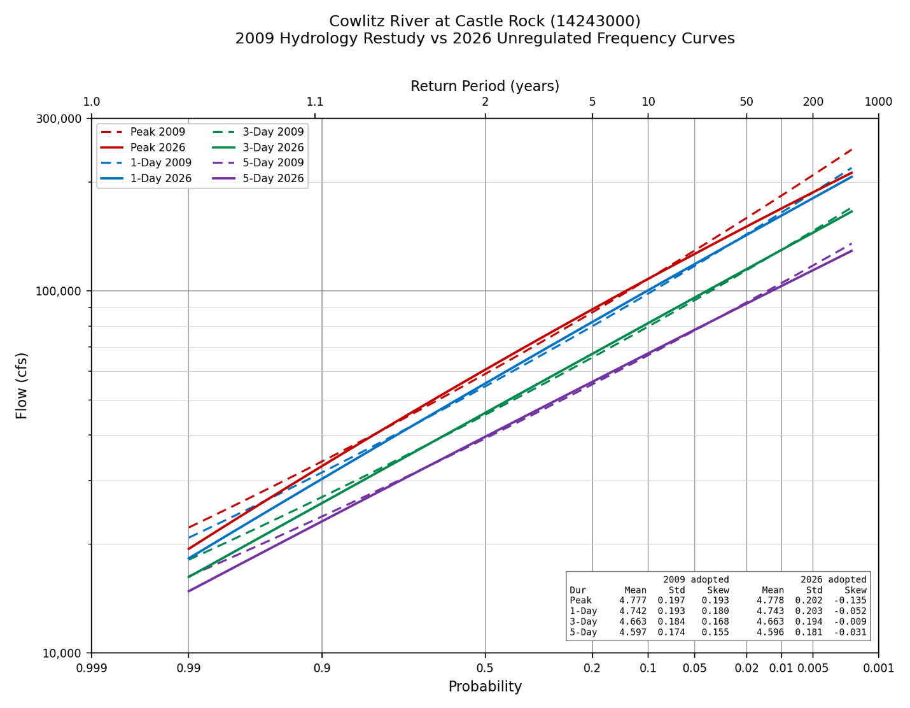
Figure 6-1. Adopted 2026 unregulated curves (solid) against the 2009 Cowlitz Hydrology Restudy (dashed).

6.2 Regulated Curve
Figure 6-2 places the adopted regulated curve against the 2009 Restudy. The two agree within about 9 percent through the range supported by observed events — 13 percent above the 2009 value at the 1 percent AEP, 3 percent above at the 0.2 percent AEP — then diverge, 21 percent below by the 0.1 percent AEP. The 2009 curve turns sharply upward above the 0.2 percent AEP (156,000 to 390,000 cfs between the 0.2 and 0.01 percent events), driven by synthetics built almost exclusively from the 1933 event, which fills and spills before its peak inflow; the current study simulates a broader set of plausible inflow shapes at similar volumes, most of which prove regulable.
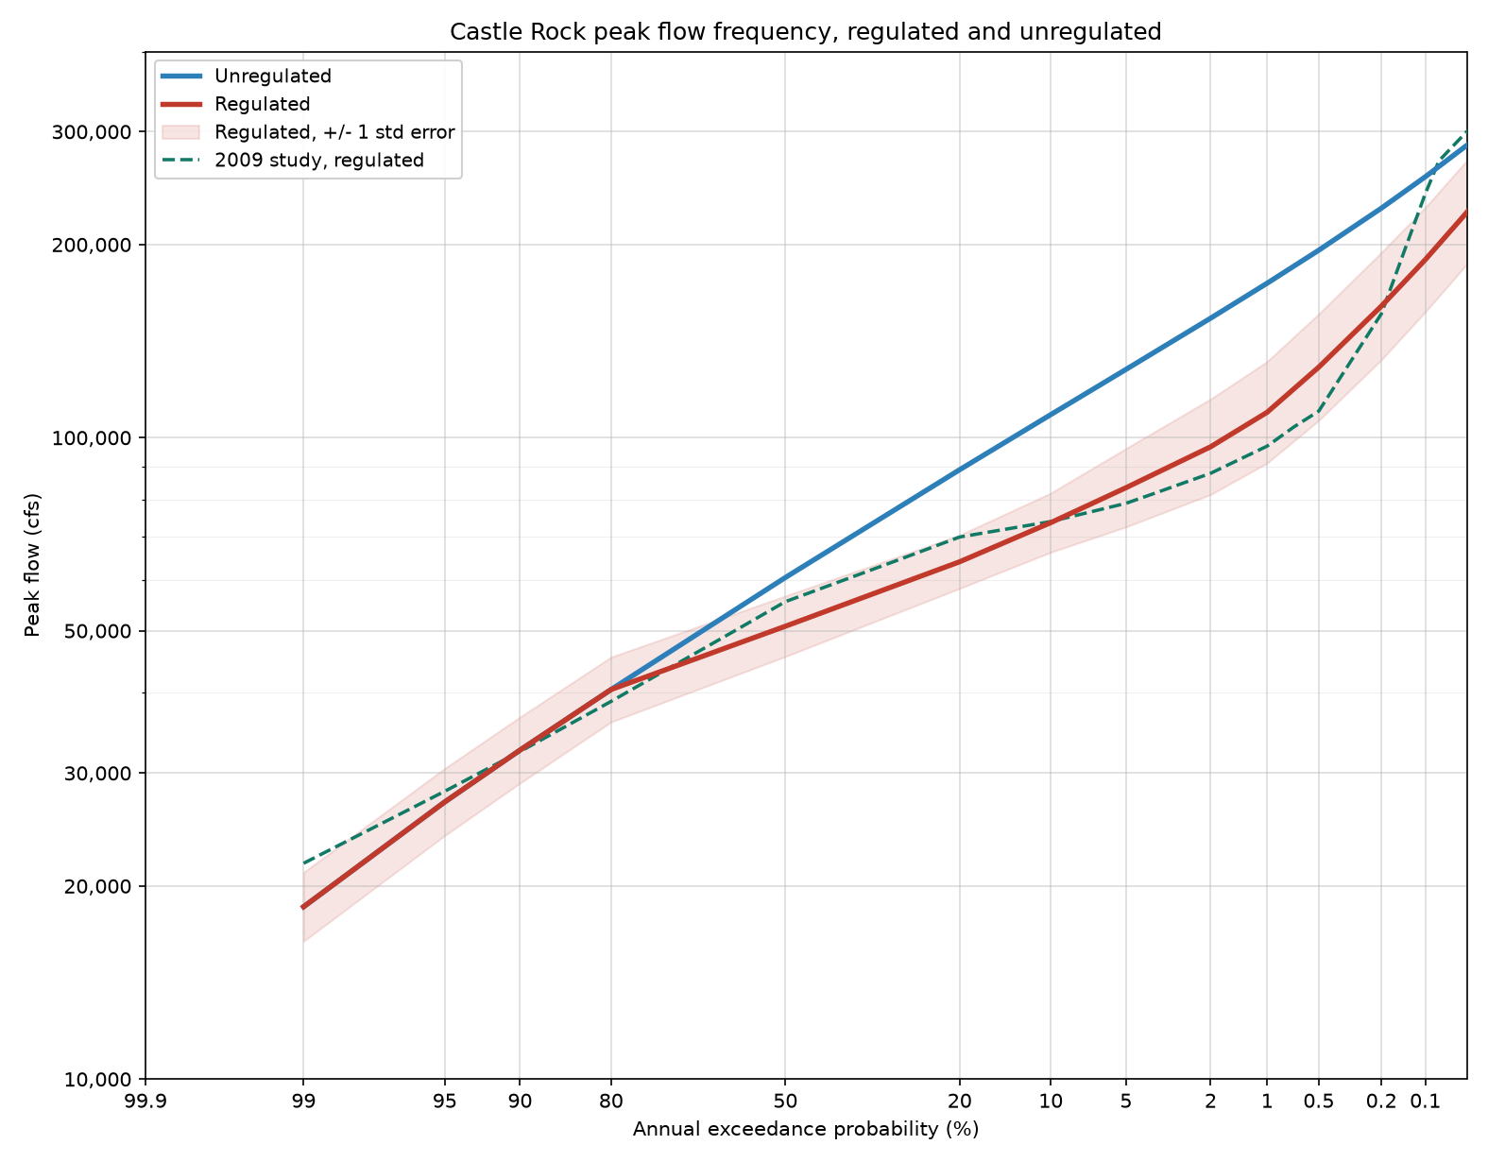
Figure 6-2. Adopted 2026 regulated curve against the 2009 Cowlitz Hydrology Restudy.
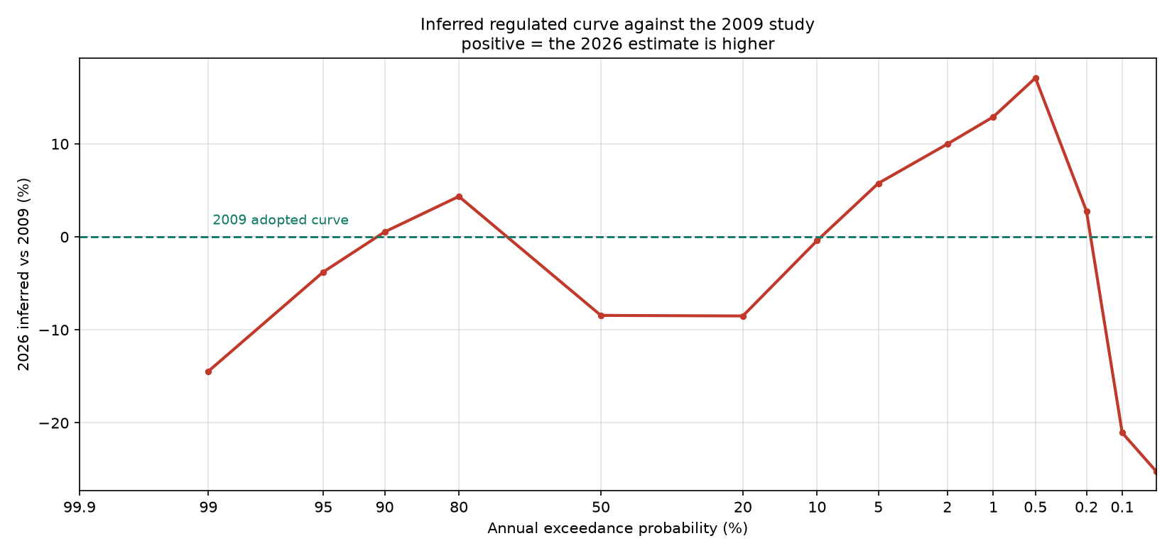
Figure 6-3. Percent change between the 2026 and 2009 regulated curves.

7. Limitations
The transform is supported by data over the unregulated range of roughly 23,000–280,000 cfs. Its upper part rests entirely on synthetic events built by scaling observed storms, and hydrograph shape is not independent of size — a large storm is large because it was widespread and sustained, so scaling a moderate storm to a rare magnitude routes a shape that storm never produced. Six of the twelve source storms are scaled past a factor of two to reach the largest target and should be read as the weaker evidence in the set.
The adjusted regulated record carries its own caveats: thirteen adjustments land within a narrow band near 14,000 cfs, more likely a fixed release constraint binding in one simulation and not the other than a pure starting-pool effect; seven adjustments exceed 40 percent of the observed peak, all moderate-peak years where a large absolute adjustment is a large fraction, influencing the lower end of the transform more than the upper.

8. Extension to the Columbia River Confluence
[TO BE COMPLETED]
The regulated frequency curve developed above applies at Castle Rock. Extending it downstream to the Columbia River confluence requires a coincident frequency analysis combining the regulated Cowlitz flow with Columbia River stage, supported by regional flood frequency estimates for the intervening ungaged area. That analysis is in progress and will be documented in this section, expected to cover the coincident frequency method and the assumed dependence between Cowlitz and Columbia flooding; the regional regression estimates for the ungaged local area below Castle Rock; the resulting regulated frequency estimates at the downstream locations required for levee analysis; and how the Section 5.6 uncertainty is carried through that combination.

Appendix A. Assembled Unregulated Record by Water Year
Flows are in cubic feet per second. Source abbreviations: USGS peak, the observed instantaneous annual peak; USGS daily, rolling maxima of the observed daily record; Holdout, the hourly unregulated record from the Mossyrock holdout; Regression, the two-day storage-change relation; Mass balance, the daily unregulated series.
WY | Peak | Peak source | 1-Day | 1-Day source | 3-Day | 5-Day | Duration source
1927 | 41,100 | USGS peak | — | — | — | — | —
1928 | 74,000 | USGS peak | 71,300 | USGS daily | 56,933 | 47,940 | USGS daily
1929 | 21,800 | USGS peak | 21,100 | USGS daily | 19,633 | 18,980 | USGS daily
1930 | 30,200 | USGS peak | 29,500 | USGS daily | 26,700 | 23,840 | USGS daily
1931 | 65,900 | USGS peak | 63,200 | USGS daily | 51,200 | 40,760 | USGS daily
1932 | 50,800 | USGS peak | 49,200 | USGS daily | 44,467 | 39,140 | USGS daily
1933 | 53,000 | USGS peak | 52,200 | USGS daily | 44,467 | 43,900 | USGS daily
1934 | 139,000 | USGS peak | 134,000 | USGS daily | 120,333 | 106,300 | USGS daily
1935 | 61,800 | USGS peak | 58,100 | USGS daily | 53,800 | 45,540 | USGS daily
1936 | 48,200 | USGS peak | 39,800 | USGS daily | 35,833 | 31,400 | USGS daily
1937 | 49,000 | USGS peak | 47,200 | USGS daily | 40,167 | 34,640 | USGS daily
1938 | 62,900 | USGS peak | 60,500 | USGS daily | 53,567 | 47,440 | USGS daily
1939 | 43,600 | USGS peak | 39,800 | USGS daily | 29,867 | 27,840 | USGS daily
1940 | 41,900 | USGS peak | 40,500 | USGS daily | 36,767 | 31,660 | USGS daily
1941 | 26,400 | USGS peak | 22,100 | USGS daily | 19,633 | 16,038 | USGS daily
1942 | 58,100 | USGS peak | 55,400 | USGS daily | 47,067 | 39,400 | USGS daily
1943 | 60,500 | USGS peak | 58,300 | USGS daily | 46,867 | 39,020 | USGS daily
1944 | 37,100 | USGS peak | 33,700 | USGS daily | 26,467 | 20,760 | USGS daily
1945 | 45,300 | USGS peak | 44,200 | USGS daily | 36,333 | 30,340 | USGS daily
1946 | 54,700 | USGS peak | 51,700 | USGS daily | 45,433 | 38,940 | USGS daily
1947 | 85,100 | USGS peak | 82,400 | USGS daily | 80,767 | 74,880 | USGS daily
1948 | 38,500 | USGS peak | 37,000 | USGS daily | 32,700 | 28,560 | USGS daily
1949 | 51,500 | USGS peak | 43,300 | USGS daily | 30,167 | 28,580 | USGS daily
1950 | 54,800 | USGS peak | 54,000 | USGS daily | 49,933 | 43,920 | USGS daily
1951 | 67,200 | USGS peak | 63,900 | USGS daily | 61,467 | 54,440 | USGS daily
1952 | 41,400 | USGS peak | 35,600 | USGS daily | 31,600 | 28,680 | USGS daily
1953 | 60,000 | USGS peak | 50,000 | USGS daily | 44,000 | 40,400 | USGS daily
1954 | 73,000 | USGS peak | 63,600 | USGS daily | 51,067 | 45,440 | USGS daily
1955 | 50,100 | USGS peak | 43,300 | USGS daily | 33,800 | 29,020 | USGS daily
1956 | 67,400 | USGS peak | 63,100 | USGS daily | 49,733 | 42,260 | USGS daily
1957 | 43,200 | USGS peak | 40,400 | USGS daily | 37,400 | 34,980 | USGS daily
1958 | 35,200 | USGS peak | 34,500 | USGS daily | 30,867 | 27,280 | USGS daily
1959 | 57,800 | USGS peak | 52,900 | USGS daily | 44,733 | 39,140 | USGS daily
1960 | 62,700 | USGS peak | 61,000 | USGS daily | 56,433 | 49,620 | USGS daily
1961 | 64,500 | USGS peak | 59,000 | USGS daily | 46,133 | 43,520 | USGS daily
1962 | 42,100 | USGS peak | 40,100 | USGS daily | 34,833 | 30,240 | USGS daily
1963 | 66,900 | USGS peak | 59,500 | USGS daily | 52,900 | 41,640 | USGS daily
1964 | 72,600 | USGS peak | 55,400 | USGS daily | 46,267 | 37,680 | USGS daily
1965 | 83,900 | USGS peak | 79,100 | USGS daily | 68,933 | 60,120 | USGS daily
1966 | 28,800 | USGS peak | 27,000 | USGS daily | 24,333 | 22,400 | USGS daily
1967 | 65,000 | USGS peak | 58,800 | USGS daily | 48,167 | 38,520 | USGS daily
1968 | 49,500 | USGS peak | 47,600 | USGS daily | 44,633 | 42,600 | USGS daily
1974 | 112,486 | Regression | 112,486 | Mass balance | 92,392 | 74,846 | Mass balance
1975 | 76,896 | Regression | 71,250 | Mass balance | 54,411 | 50,666 | Mass balance
1976 | 124,946 | Regression | 110,190 | Mass balance | 106,676 | 91,422 | Mass balance
1977 | 19,899 | Regression | 16,299 | Mass balance | 14,752 | 14,436 | Mass balance
1978 | 131,885 | Regression | 110,965 | Mass balance | 94,793 | 74,569 | Mass balance
1979 | 51,587 | Regression | 40,506 | Mass balance | 28,000 | 25,107 | Mass balance
1980 | 101,895 | Regression | 42,737 | Mass balance | 37,116 | 32,514 | Mass balance
1981 | 88,345 | Regression | 86,532 | Mass balance | 71,889 | 57,905 | Mass balance
1982 | 84,883 | Regression | 77,900 | Mass balance | 62,871 | 60,342 | Mass balance
1983 | 82,466 | Regression | 72,298 | Mass balance | 55,966 | 52,485 | Mass balance
1984 | 57,352 | Regression | 57,352 | Mass balance | 46,702 | 38,367 | Mass balance
1985 | 33,098 | Regression | 33,098 | Mass balance | 28,765 | 23,969 | Mass balance
1986 | 95,135 | Regression | 83,652 | Mass balance | 62,163 | 52,287 | Mass balance
1987 | 103,298 | Regression | 90,982 | Mass balance | 61,617 | 50,210 | Mass balance
1988 | 61,876 | Regression | 59,525 | Mass balance | 39,029 | 30,728 | Mass balance
1989 | 28,884 | Regression | 23,674 | Mass balance | 21,120 | 19,496 | Mass balance
1990 | 124,824 | Regression | 95,400 | Mass balance | 76,113 | 59,391 | Mass balance
1991 | 110,107 | Regression | 104,020 | Mass balance | 75,569 | 58,070 | Mass balance
1992 | 51,845 | Holdout | 43,323 | Holdout | 38,240 | 35,850 | Mass balance
1993 | 33,272 | Regression | 31,533 | Mass balance | 26,576 | 21,802 | Mass balance
1994 | 26,300 | Regression | 26,300 | Mass balance | 24,710 | 22,556 | Mass balance
1995 | 64,114 | Regression | 59,736 | Mass balance | 48,317 | 39,125 | Mass balance
1996 | 176,855 | Regression | 170,280 | Mass balance | 139,807 | 108,126 | Mass balance
1997 | 86,921 | Holdout | 83,113 | Holdout | 74,563 | 69,706 | Mass balance
1998 | 38,925 | Regression | 30,823 | Mass balance | 23,581 | 22,965 | Mass balance
1999 | 76,193 | Holdout | 68,206 | Holdout | 60,807 | 51,702 | Mass balance
2000 | 73,070 | Regression | 72,890 | Mass balance | 58,190 | 43,549 | Mass balance
2001 | 19,568 | Regression | 19,568 | Mass balance | 15,339 | 14,332 | Mass balance
2002 | 66,027 | Regression | 64,512 | Mass balance | 49,168 | 40,567 | Mass balance
2003 | 109,719 | Holdout | 101,254 | Holdout | 72,896 | 53,892 | Mass balance
2004 | 56,223 | Holdout | 52,144 | Holdout | 43,452 | 34,949 | Mass balance
2005 | 52,859 | Regression | 50,133 | Mass balance | 39,349 | 31,339 | Mass balance
2006 | 74,082 | Regression | 74,082 | Mass balance | 62,808 | 53,945 | Mass balance
2007 | 147,777 | Regression | 147,777 | Mass balance | 100,470 | 73,836 | Mass balance
2008 | 72,455 | Holdout | 70,265 | Holdout | 54,504 | 41,446 | Mass balance
2009 | 151,296 | Holdout | 139,073 | Holdout | 99,324 | 72,961 | Mass balance
2010 | 27,802 | Holdout | 25,172 | Holdout | 24,888 | 23,204 | Mass balance
2011 | 87,160 | Holdout | 85,731 | Holdout | 71,689 | 58,118 | Mass balance
2012 | 57,286 | Holdout | 53,334 | Holdout | 40,865 | 34,419 | Mass balance
2013 | 58,409 | Regression | 47,950 | Mass balance | 36,797 | 30,359 | Mass balance
2014 | 60,268 | Holdout | 57,504 | Holdout | 46,396 | 46,396 | Mass balance
2015 | 47,323 | Holdout | 43,517 | Holdout | 32,555 | 31,664 | Mass balance
2016 | 135,790 | Holdout | 124,896 | Holdout | 92,957 | 72,910 | Mass balance
2017 | 64,342 | Holdout | 62,516 | Holdout | 51,010 | 47,186 | Mass balance
2018 | 54,188 | Holdout | 52,984 | Holdout | 47,285 | 39,300 | Mass balance
2019 | 24,389 | Holdout | 24,389 | Holdout | 24,389 | 22,197 | Mass balance
2020 | 77,812 | Holdout | 73,544 | Holdout | 60,465 | 51,297 | Mass balance
2021 | 61,703 | Holdout | 56,924 | Holdout | 42,829 | 35,700 | Mass balance
2022 | 77,833 | Holdout | 73,803 | Holdout | 60,851 | 50,050 | Mass balance
2023 | 65,623 | Holdout | 61,507 | Holdout | 47,710 | 35,341 | Mass balance
2024 | 81,192 | Holdout | 76,898 | Holdout | 59,644 | 48,589 | Mass balance
2025 | 45,954 | Holdout | 41,975 | Holdout | 35,253 | 30,112 | Mass balance
2026 | 101,833 | Holdout | 97,675 | Holdout | 94,669 | 77,439 | Mass balance
Table A-1. Assembled unregulated record, water years 1927 through 2026.

Appendix B. Unregulated Frequency Curve Ordinates
Computed curve, expected probability curve, variance of the log, and 5 and 95 percent confidence limits for every ordinate reported by HEC-SSP. Flows are in cubic feet per second.
Duration | AEP | Variance of log | z | Computed | 5% limit | 95% limit | Expected probability
Peak | 0.0001 | 0.0098 | 3.72 | 296,088 | 476,290 | 217,104 | 374,643
Peak | 0.0002 | 0.0082 | 3.54 | 276,072 | 426,543 | 207,624 | 332,739
Peak | 0.0005 | 0.0064 | 3.29 | 250,134 | 366,728 | 194,487 | 285,568
Peak | 0.001 | 0.0052 | 3.09 | 230,884 | 325,578 | 184,044 | 255,074
Peak | 0.002 | 0.0041 | 2.88 | 211,932 | 287,635 | 173,114 | 227,900
Peak | 0.005 | 0.0029 | 2.58 | 187,282 | 241,929 | 157,818 | 195,977
Peak | 0.01 | 0.0022 | 2.33 | 168,884 | 210,386 | 145,504 | 174,075
Peak | 0.02 | 0.0016 | 2.05 | 150,625 | 181,177 | 132,434 | 153,556
Peak | 0.05 | 0.0010 | 1.64 | 126,514 | 145,732 | 113,770 | 127,758
Peak | 0.1 | 0.0007 | 1.28 | 108,041 | 121,015 | 98,383 | 108,618
Peak | 0.2 | 0.0005 | 0.84 | 88,923 | 97,624 | 81,626 | 89,126
Peak | 0.5 | 0.0005 | 0.00 | 60,585 | 65,857 | 55,691 | 60,529
Peak | 0.8 | 0.0006 | -0.84 | 40,671 | 44,531 | 36,709 | 40,487
Peak | 0.9 | 0.0009 | -1.28 | 32,826 | 36,401 | 28,836 | 32,573
Peak | 0.95 | 0.0013 | -1.64 | 27,417 | 30,925 | 23,227 | 27,041
Peak | 0.99 | 0.0030 | -2.33 | 19,408 | 23,026 | 14,842 | 18,564
1-Day | 0.0001 | 0.0109 | 3.72 | 299,447 | 479,405 | 221,040 | 386,105
1-Day | 0.0002 | 0.0092 | 3.54 | 276,822 | 426,187 | 209,249 | 338,896
1-Day | 0.0005 | 0.0072 | 3.29 | 247,988 | 362,832 | 193,367 | 286,800
1-Day | 0.001 | 0.0059 | 3.09 | 226,952 | 319,700 | 181,106 | 253,245
1-Day | 0.002 | 0.0047 | 2.88 | 206,550 | 280,306 | 168,605 | 223,780
1-Day | 0.005 | 0.0034 | 2.58 | 180,481 | 233,404 | 151,652 | 189,945
1-Day | 0.01 | 0.0026 | 2.33 | 161,378 | 201,443 | 138,445 | 167,060
1-Day | 0.02 | 0.0019 | 2.05 | 142,727 | 172,189 | 124,837 | 145,949
1-Day | 0.05 | 0.0012 | 1.64 | 118,581 | 137,189 | 106,070 | 119,937
1-Day | 0.1 | 0.0009 | 1.28 | 100,464 | 113,080 | 91,102 | 101,103
1-Day | 0.2 | 0.0006 | 0.84 | 82,073 | 90,457 | 75,165 | 82,324
1-Day | 0.5 | 0.0005 | 0.00 | 55,503 | 60,349 | 51,025 | 55,470
1-Day | 0.8 | 0.0006 | -0.84 | 37,319 | 40,830 | 33,739 | 37,176
1-Day | 0.9 | 0.0008 | -1.28 | 30,257 | 33,490 | 26,713 | 30,053
1-Day | 0.95 | 0.0011 | -1.64 | 25,414 | 28,563 | 21,767 | 25,130
1-Day | 0.99 | 0.0022 | -2.33 | 18,268 | 21,476 | 14,392 | 17,638
3-Day | 0.0001 | 0.0093 | 3.72 | 240,363 | 376,364 | 180,427 | 298,915
3-Day | 0.0002 | 0.0079 | 3.54 | 222,081 | 335,087 | 170,391 | 264,436
3-Day | 0.0005 | 0.0062 | 3.29 | 198,868 | 285,924 | 157,011 | 225,645
3-Day | 0.001 | 0.0051 | 3.09 | 181,994 | 252,436 | 146,786 | 200,289
3-Day | 0.002 | 0.0041 | 2.88 | 165,677 | 221,830 | 136,451 | 177,857
3-Day | 0.005 | 0.0030 | 2.58 | 144,898 | 185,363 | 122,577 | 151,689
3-Day | 0.01 | 0.0023 | 2.33 | 129,717 | 160,485 | 111,876 | 133,835
3-Day | 0.02 | 0.0017 | 2.05 | 114,932 | 137,687 | 100,941 | 117,352
3-Day | 0.05 | 0.0011 | 1.64 | 95,836 | 110,351 | 85,995 | 96,884
3-Day | 0.1 | 0.0008 | 1.28 | 81,533 | 91,456 | 74,157 | 82,033
3-Day | 0.2 | 0.0006 | 0.84 | 67,026 | 73,645 | 61,589 | 67,236
3-Day | 0.5 | 0.0004 | 0.00 | 46,042 | 49,861 | 42,513 | 46,036
3-Day | 0.8 | 0.0005 | -0.84 | 31,599 | 34,399 | 28,743 | 31,493
3-Day | 0.9 | 0.0007 | -1.28 | 25,945 | 28,543 | 23,109 | 25,784
3-Day | 0.95 | 0.0010 | -1.64 | 22,044 | 24,587 | 19,120 | 21,810
3-Day | 0.99 | 0.0020 | -2.33 | 16,230 | 18,847 | 13,097 | 15,706
5-Day | 0.0001 | 0.0085 | 3.72 | 181,018 | 276,627 | 138,058 | 225,377
5-Day | 0.0002 | 0.0072 | 3.54 | 168,477 | 248,520 | 131,223 | 200,703
5-Day | 0.0005 | 0.0057 | 3.29 | 152,387 | 214,676 | 122,003 | 172,807
5-Day | 0.001 | 0.0046 | 3.09 | 140,566 | 191,358 | 114,869 | 154,542
5-Day | 0.002 | 0.0037 | 2.88 | 129,023 | 169,831 | 107,577 | 138,364
5-Day | 0.005 | 0.0027 | 2.58 | 114,149 | 143,861 | 97,651 | 119,354
5-Day | 0.01 | 0.0020 | 2.33 | 103,144 | 125,913 | 89,882 | 106,301
5-Day | 0.02 | 0.0015 | 2.05 | 92,301 | 109,270 | 81,834 | 94,152
5-Day | 0.05 | 0.0010 | 1.64 | 78,089 | 89,024 | 70,643 | 78,888
5-Day | 0.1 | 0.0007 | 1.28 | 67,267 | 74,814 | 61,613 | 67,651
5-Day | 0.2 | 0.0005 | 0.84 | 56,108 | 61,221 | 51,864 | 56,269
5-Day | 0.5 | 0.0004 | 0.00 | 39,563 | 42,625 | 36,714 | 39,551
5-Day | 0.8 | 0.0005 | -0.84 | 27,812 | 30,120 | 25,439 | 27,720
5-Day | 0.9 | 0.0006 | -1.28 | 23,104 | 25,274 | 20,704 | 22,966
5-Day | 0.95 | 0.0008 | -1.64 | 19,810 | 21,961 | 17,294 | 19,612
5-Day | 0.99 | 0.0018 | -2.33 | 14,823 | 17,089 | 12,041 | 14,367
Table B-1. Frequency curve ordinates, all four durations.

Appendix C. Unregulated Frequency Curves by Duration
Individual curves as produced by HEC-SSP: computed curve, expected probability curve, 5 and 95 percent confidence limits, and observed events at Hirsch-Stedinger plotting positions. The peak figure reflects the censored treatment described in Section 4.8.
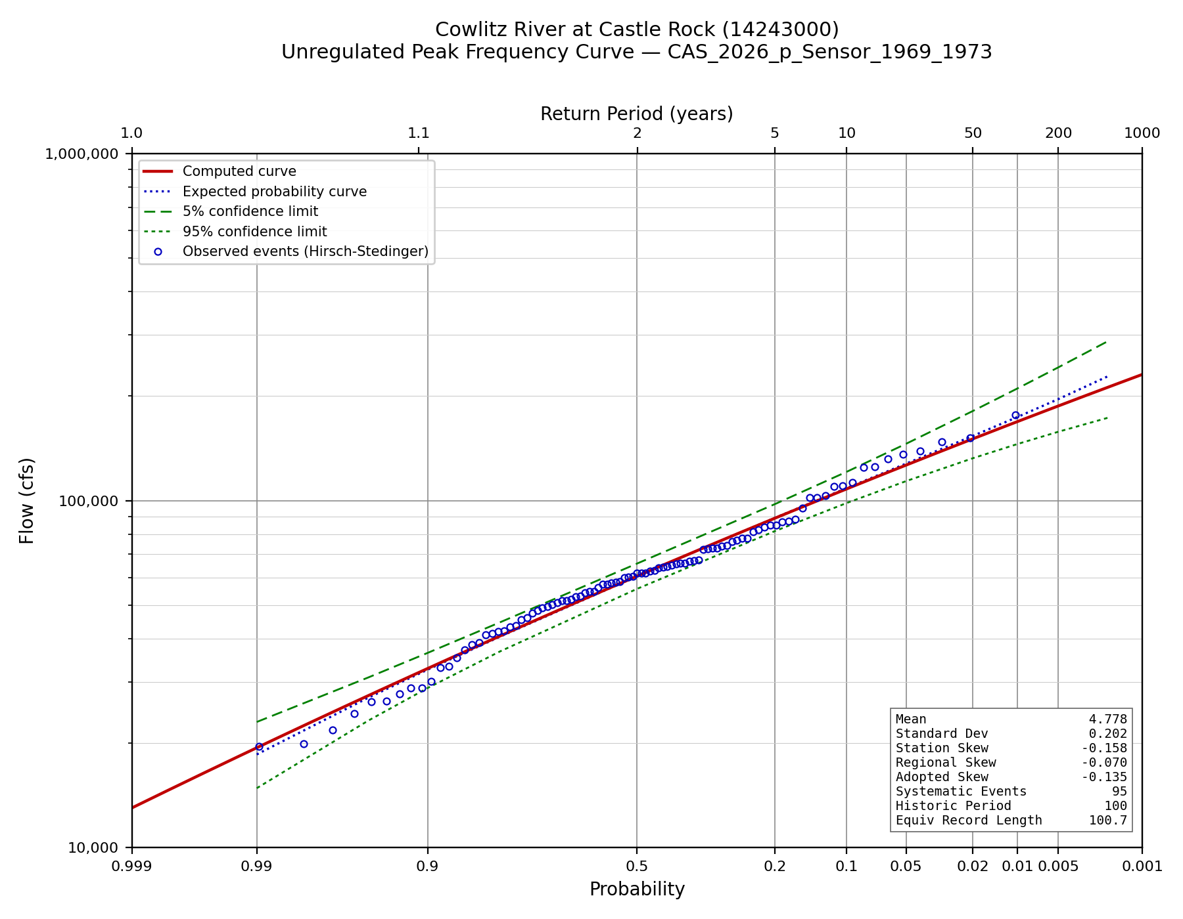
Figure C-1. Unregulated instantaneous peak frequency curve.
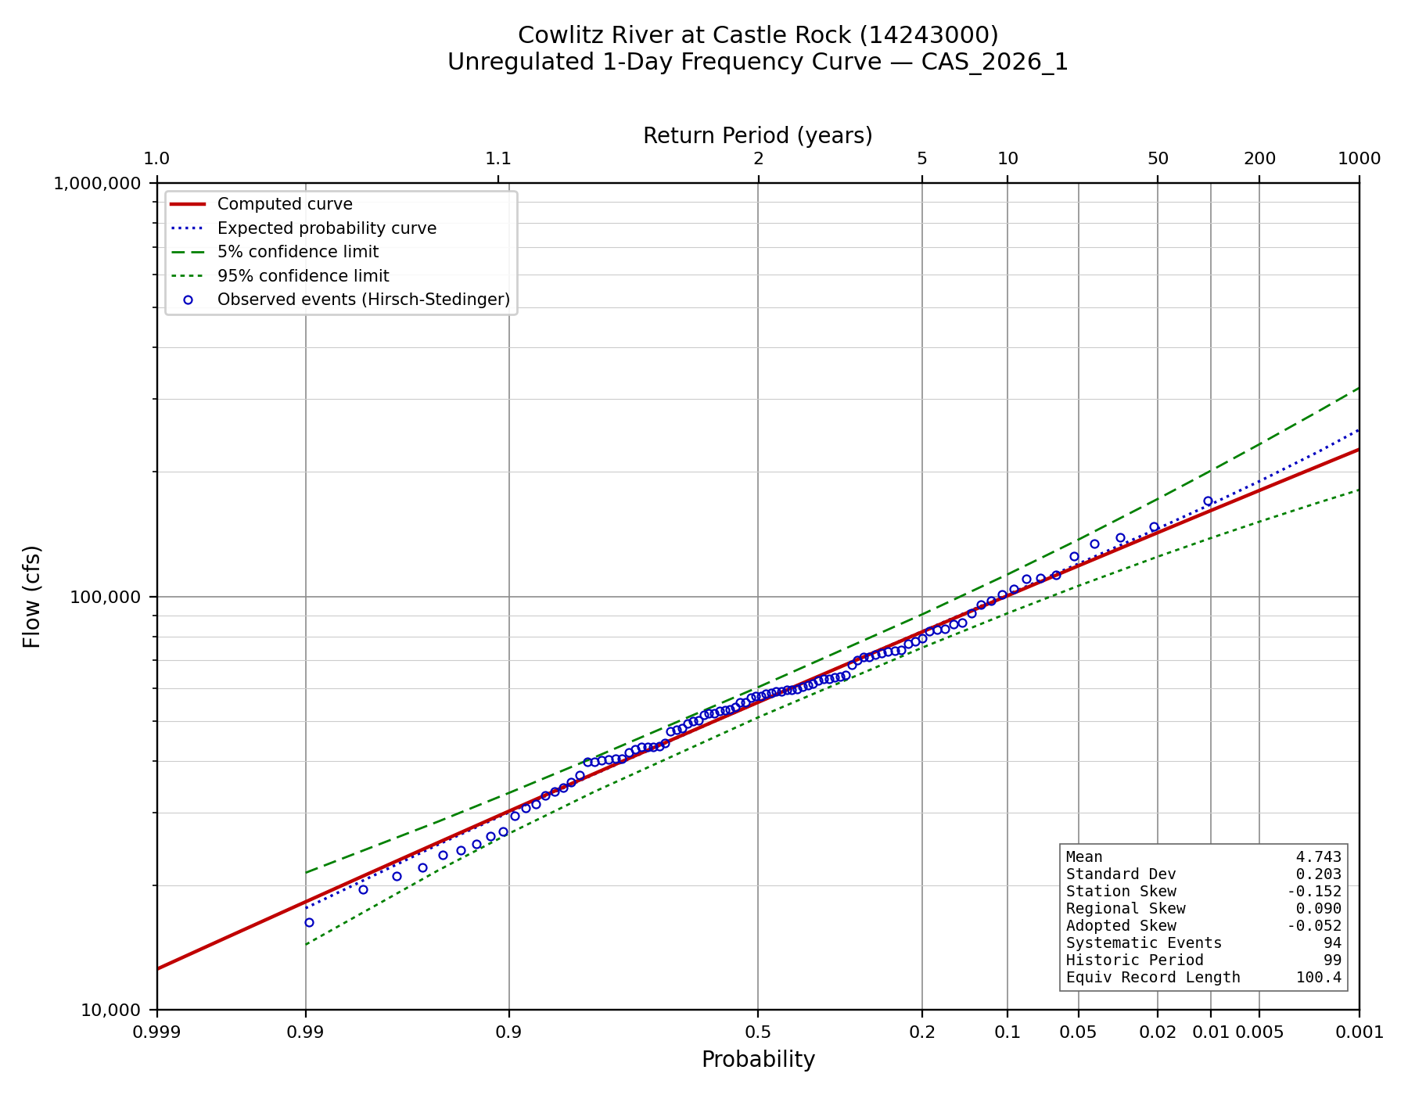
Figure C-2. Unregulated 1-day frequency curve.
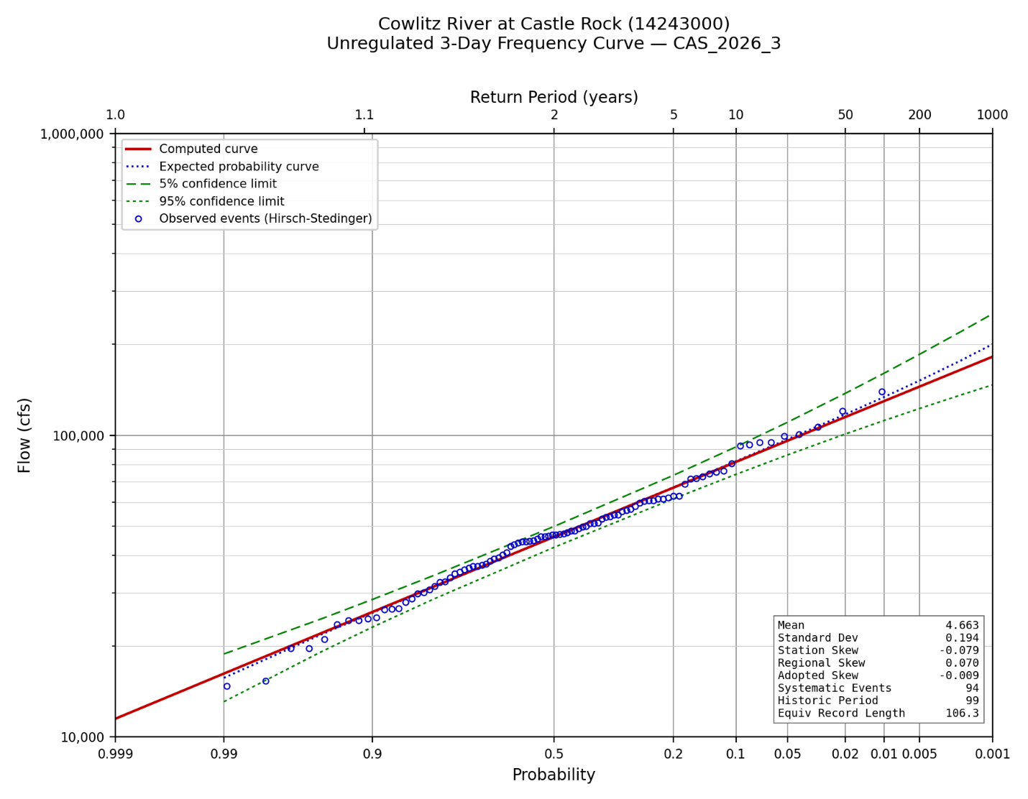
Figure C-3. Unregulated 3-day frequency curve.
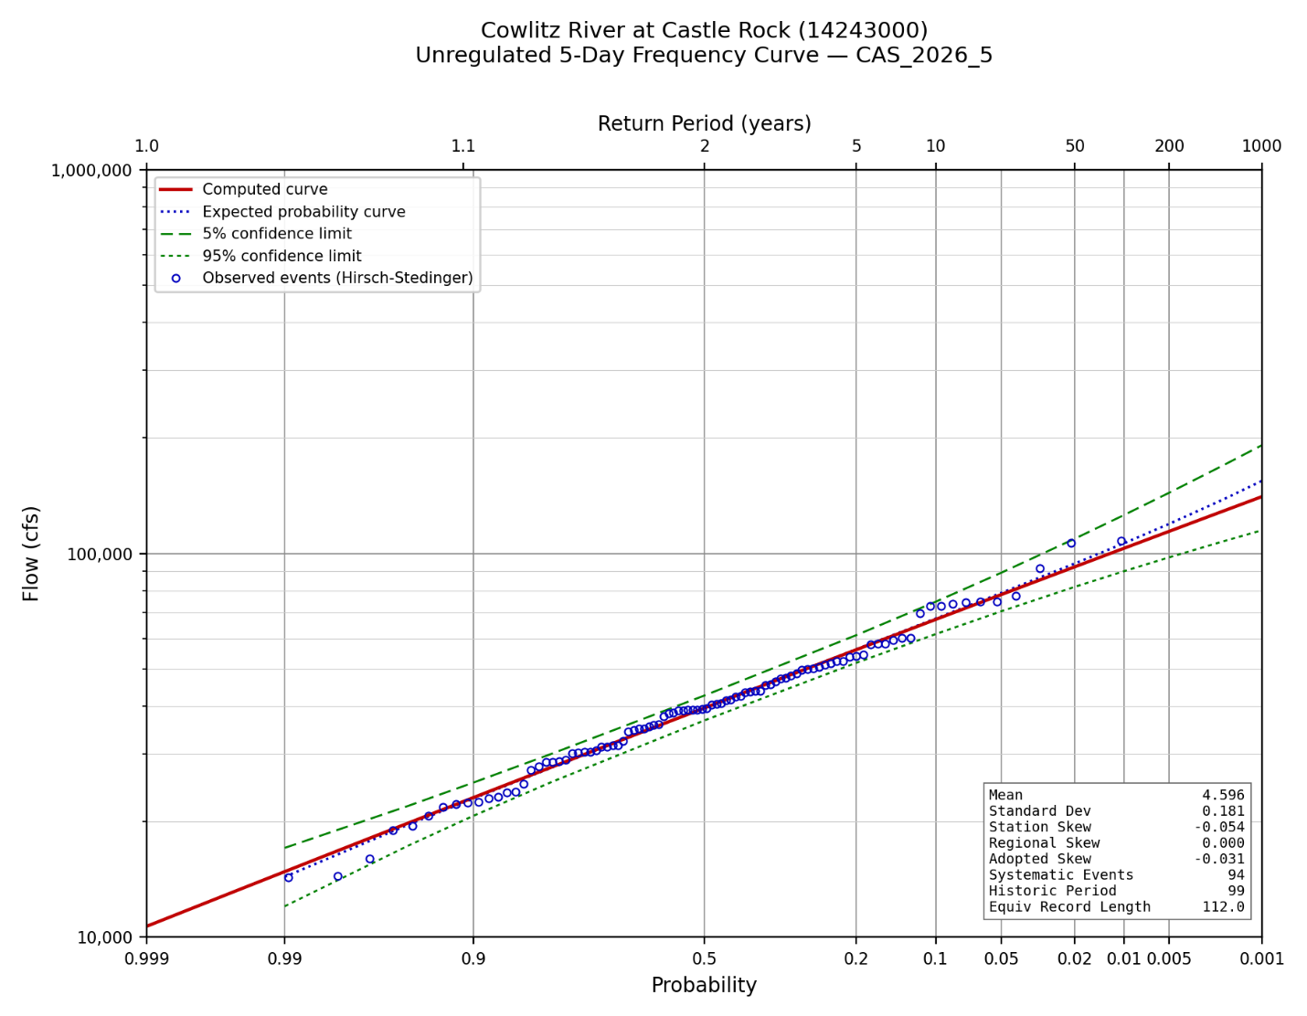
Figure C-4. Unregulated 5-day frequency curve.

Appendix D. Adjusted Regulated Peak Record by Water Year
Observed, simulated and adjusted regulated peaks for every shared water year, with the screening result recorded for each. Flows are in cubic feet per second.
WY | Observed | WCM_RC | Obs_RC | Difference | Adjusted | Screen
1974 | 68,600 | 33,207 | 19,208 | 13,999 | 82,599 | reg_over_unreg
1975 | 58,900 | 57,075 | 56,714 | 361 | 59,261 | ok
1976 | 86,700 | 75,597 | 105,150 | -29,553 | 86,700 | ok
1977 | 15,000 | 14,187 | 12,187 | 2,000 | 17,000 | ok
1978 | 86,400 | 79,778 | 79,778 | 0 | 86,400 | ok
1979 | 39,400 | 42,972 | 40,972 | 2,000 | 41,400 | ok
1980 | 97,000 | — | — | — | 97,000 | both
1981 | 46,900 | 50,909 | 39,206 | 11,703 | 58,603 | ok
1982 | 65,500 | 64,483 | 63,822 | 661 | 66,161 | ok
1983 | 67,300 | 59,457 | 59,457 | 0 | 67,300 | ok
1984 | 49,600 | — | — | — | 49,600 | different_event
1985 | 23,600 | 24,934 | 13,724 | 11,210 | 23,600 | different_event
1986 | 62,700 | 62,206 | 60,657 | 1,549 | 64,249 | ok
1987 | 77,600 | 73,775 | 73,059 | 716 | 78,316 | ok
1988 | 42,100 | 52,818 | 38,880 | 13,938 | 56,038 | ok
1989 | 23,600 | 27,470 | 13,443 | 14,026 | 37,626 | ok
1990 | 89,200 | 84,639 | 83,907 | 732 | 89,932 | ok
1991 | 76,000 | 62,368 | 61,083 | 1,286 | 77,286 | ok
1992 | 27,000 | 35,102 | 21,102 | 14,000 | 41,000 | ok
1993 | 14,700 | 25,147 | 11,148 | 14,000 | 28,700 | ok
1994 | 17,300 | — | — | — | 17,300 | different_event
1995 | 47,500 | — | — | — | 47,500 | different_event
1996 | 112,000 | 132,172 | 108,967 | 23,205 | 135,205 | ok
1997 | 56,700 | 54,439 | 52,636 | 1,803 | 58,503 | ok
1998 | 30,800 | 28,784 | 28,784 | 0 | 30,800 | ok
1999 | 57,600 | 53,768 | 50,442 | 3,326 | 60,926 | ok
2000 | 41,700 | 49,782 | 35,782 | 14,000 | 55,700 | ok
2001 | 11,600 | — | — | — | 11,600 | different_event
2002 | 51,400 | 53,728 | 45,573 | 8,155 | 59,555 | ok
2003 | 69,000 | 62,340 | 62,077 | 263 | 69,263 | ok
2004 | 38,100 | 48,301 | 34,302 | 14,000 | 52,100 | ok
2005 | 29,600 | 40,940 | 26,912 | 14,029 | 43,629 | ok
2006 | 56,200 | — | — | — | 56,200 | different_event
2007 | 77,300 | 94,857 | 70,844 | 24,013 | 101,313 | ok
2008 | 64,300 | 61,129 | 60,053 | 1,076 | 65,376 | ok
2009 | 106,000 | 81,855 | 81,470 | 385 | 106,385 | ok
2010 | 20,900 | 26,302 | 15,335 | 10,966 | 31,866 | ok
2011 | 45,300 | 44,599 | 30,599 | 14,000 | 59,300 | ok
2012 | 36,900 | 38,920 | 24,921 | 13,999 | 50,899 | ok
2013 | 47,000 | 51,961 | 37,704 | 14,257 | 61,257 | reg_over_unreg
2014 | 32,300 | 43,271 | 29,271 | 14,000 | 46,300 | ok
2015 | 38,500 | 45,556 | 31,552 | 14,004 | 52,504 | ok
2016 | 83,700 | 81,000 | 80,324 | 675 | 84,375 | ok
2017 | 40,000 | 51,716 | 39,201 | 12,515 | 52,515 | ok
2018 | 35,100 | 45,514 | 31,518 | 13,996 | 49,096 | ok
2019 | 26,000 | — | — | — | 26,000 | different_event
2020 | 47,400 | 51,580 | 51,580 | 0 | 47,400 | ok
2021 | 45,600 | 50,963 | 42,650 | 8,313 | 53,913 | ok
2022 | 63,900 | 62,387 | 61,747 | 639 | 64,539 | ok
2023 | 34,400 | 44,819 | 30,826 | 13,993 | 48,393 | ok
2024 | 44,800 | 52,638 | 42,979 | 9,659 | 54,459 | ok
Table D-1. Adjusted regulated peak record, water years 1974 through 2024.

Appendix E. Regulated Frequency Curve Ordinates and Uncertainty Terms
The adopted regulated curve with its uncertainty band (Section 5.6, FREQ_TERM_MODE = 'literal'), and the terms that produced it, for every ordinate. Flows are in cubic feet per second.
AEP | Unregulated | Regulated | Lower 95% | Upper 95% | Local slope | Reduction % | Extrap.
0.9900 | 18,564 | 18,564 | 11,620 | 24,732 | 1.00 | 0.0 | no
0.9500 | 27,041 | 27,041 | 18,746 | 34,623 | 1.00 | 0.0 | no
0.9000 | 32,573 | 32,573 | 23,312 | 41,155 | 1.00 | 0.0 | no
0.8000 | 40,487 | 40,487 | 29,630 | 50,555 | 1.00 | 0.0 | no
0.5000 | 60,529 | 50,813 | 37,799 | 62,798 | 0.57 | 16.1 | no
0.2000 | 89,126 | 64,047 | 47,349 | 77,770 | 0.61 | 28.1 | no
0.1000 | 108,618 | 73,702 | 54,120 | 95,468 | 0.73 | 32.1 | no
0.0500 | 127,758 | 83,553 | 58,380 | 121,799 | 0.81 | 34.6 | no
0.0200 | 153,556 | 96,784 | 62,569 | 158,023 | 0.86 | 37.0 | no
0.0100 | 174,075 | 109,522 | 67,455 | 187,199 | 1.23 | 37.1 | no
0.0050 | 195,977 | 128,798 | 76,214 | 228,500 | 1.43 | 34.3 | no
0.0020 | 227,900 | 160,342 | 91,937 | 292,518 | 1.47 | 29.6 | no
0.0010 | 255,074 | 189,434 | 107,941 | 352,665 | 1.49 | 25.7 | no
0.0005 | 285,568 | 224,427 | 126,346 | 427,472 | 1.51 | 21.4 | yes
0.0002 | 332,739 | 282,959 | 157,731 | 553,993 | 1.52 | 15.0 | yes
0.0001 | 374,643 | 339,018 | 188,364 | 660,115 | 1.53 | 9.5 | yes
Table E-1. Regulated frequency curve ordinates and uncertainty terms.

References
England, J.F., Jr., Cohn, T.A., Faber, B.A., Stedinger, J.R., Thomas, W.O., Jr., Veilleux, A.G., Kiang, J.E., and Mason, R.R., Jr., 2019, Guidelines for determining flood flow frequency - Bulletin 17C (ver. 1.1): U.S. Geological Survey Techniques and Methods, book 4, chap. B5, 148 p.
Lind, G.D., Lamontagne, J.R., and Stonewall, A.J., 2020, Development of regional skew coefficients for selected flood durations in the Columbia River Basin, northwestern United States and British Columbia, Canada (ver. 1.1, October 2020): U.S. Geological Survey Scientific Investigations Report 2020-5073, 48 p.
Mastin, M.C., Konrad, C.P., Veilleux, A.G., and Tecca, A.E., 2016, Magnitude, frequency, and trends of floods at gaged and ungaged sites in Washington, based on data through water year 2014 (ver. 1.2, November 2017): U.S. Geological Survey Scientific Investigations Report 2016-5118, 70 p.
U.S. Army Corps of Engineers, 2025, Risk Assessment for Flood Risk Management Studies, EM 1110-2-1619, 29 September 2025.
U.S. Army Corps of Engineers, Portland District, 2009, Cowlitz River Hydrology Restudy.
U.S. Army Corps of Engineers, 2014, Water Control Manual, Mossyrock Project, Cowlitz River, Washington.
U.S. Army Corps of Engineers, Hydrologic Engineering Center, HEC-ResSim Reservoir System Simulation, and HEC-SSP Statistical Software Package.
U.S. Geological Survey, National Water Information System: streamflow and peak-flow records for station 14243000, Cowlitz River at Castle Rock, Washington.

