MEMORANDUM FOR RECORD
U.S. Army Corps of Engineers, Portland District
Item | Description
Subject | Unregulated Flow Frequency, Cowlitz River at Castle Rock, Washington (USGS 14243000)
From | Hydrology and Hydraulics Branch, Portland District
Date | August 2026
Status | Final

1. Purpose
This memorandum documents the development of an unregulated annual maximum flow record and the resulting unregulated flow frequency curves for the Cowlitz River at Castle Rock, Washington. Curves were developed for the instantaneous peak and for the 1-, 3-, and 5-day durations using water years 1927 through 2026.
The unregulated curves are an intermediate product. They are the input to the regulated flow frequency analysis that follows in the next phase of the study, and the regulated curves in turn support levee fragility assessment and floodplain mapping in the lower Cowlitz valley. The unregulated record is developed first because regulated frequency cannot be estimated directly from the regulated gage record: reservoir operations have changed over the period of record, so the regulated peaks are not a homogeneous sample. The standard approach is to establish the frequency of the natural inflow, then route those events using current reservoir operations.

2. Basin Description
The Cowlitz River drains the southern Washington Cascades and enters the Columbia River near Longview. The Castle Rock gage sits in the lower valley, downstream of the Toutle River confluence and downstream of all the basin's storage projects. The total basin area above Castle Rock is 2,238 square miles with 1,170 square miles of headwaters regulated by Mossyrock Dam
Three non-Federal hydroelectric projects lie on the mainstem of the Cowlitz River. Mayfield Dam, completed in 1963, and Mossyrock Dam, completed in 1968, are operated by Tacoma Power as part of the Cowlitz Hydroelectric Project. Mossyrock, which impounds Riffe Lake, provides the only usable flood storage in the basin and is subsequently the only project that materially reshapes flood hydrographs at Castle Rock. Mayfield dam is a re-regulating dam whose purpose is to smooth out power peaking releases from Mossyrock, providing no meaningful flood regulation of its own. Mossyrock began actively impounding the river in December 1968. Cowlitz Falls dam above Mossyrock and a Sediment Retention Structure on the Toutle are run of river providing no flood regulation. The Castle Rock gauge has a peak flow record spanning the years 1927 through 2026, with years before 1968 representing unregulated peaks.
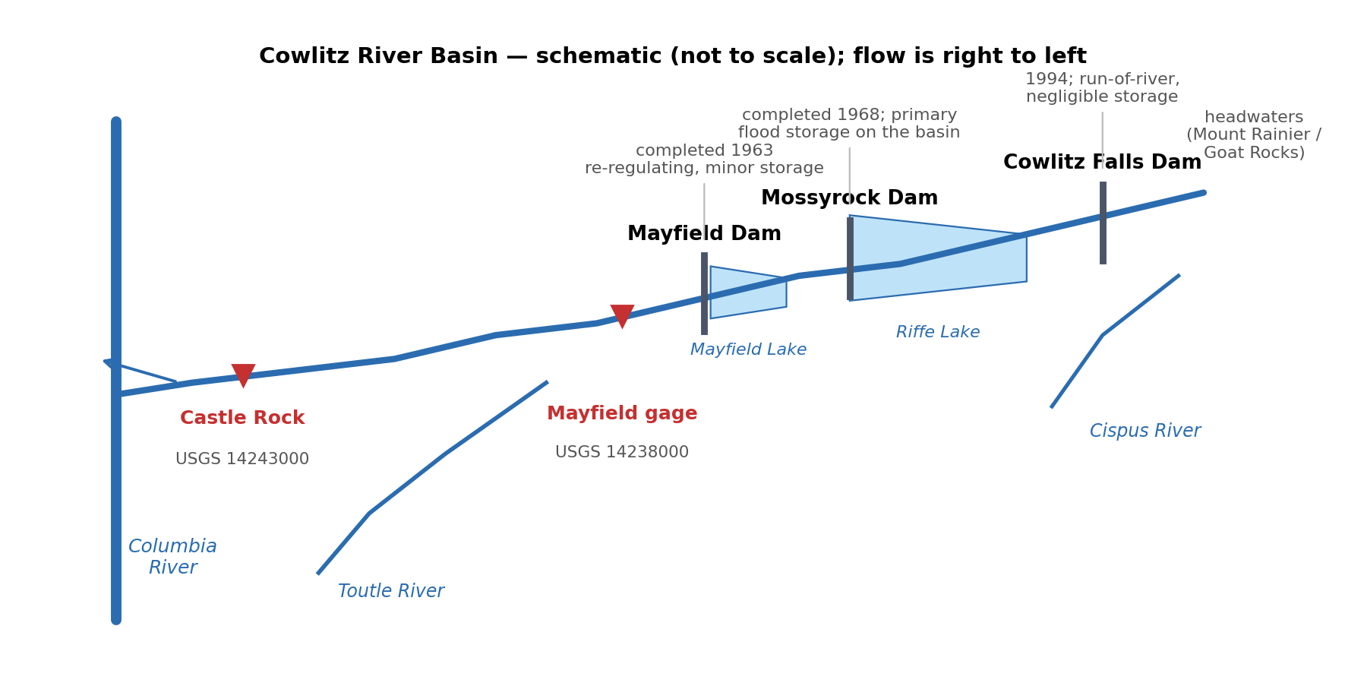
Figure 2-1. Cowlitz River basin schematic showing the mainstem projects, the two gages used in this analysis, and the Toutle River confluence. Not to scale.

2.3 Previous Studies
The previously adopted unregulated frequency curves at Castle Rock come from the 2009 Cowlitz Hydrology Restudy. That study predates Bulletin 17C and does not include the 17 most recent years of data. The present study extends the record and adopts the Bulletin 17C expected moments algorithm and uses the current published regional skew studies. Section 11 compares results between the two unregulated flow frequency studies.

3. Data Used
Table 3-1 lists the datasets used to build the record and the purpose each one served. Records underwent extensive QA/QC with the hourly Mossyrock elevation record requiring the most substantial manual editing to remove the noise resulting from power peaking operations.
Dataset | Period Used | Purpose
Mossyrock pool elevation, hourly | Nov 1974 - May 2026 | Reservoir storage change at hourly resolution; basis for the hourly unregulated peak estimates.
Mossyrock storage telemetry, hourly | Regulated era | Data quality screening
Mossyrock pool elevation, daily | Oct 1973 - present | Storage change used for the regression predictors and for the daily mass balance.
Mossyrock elevation-storage rating table | 2014 Water Control Manual | Relates pool elevation to reservoir storage.
Castle Rock streamflow, hourly (USGS 14243000) | Regulated era | Regulated flow at the study location; source of the regulated peak.
Castle Rock streamflow, daily (USGS 14243000) | WY1927 - present | Pre-regulation durations, and the regulated daily flow used in calculations for 3, 5, and select 1 day duration maxima
Castle Rock annual peak flows (USGS 14243000) | WY1927 - present | Pre-regulation peaks, and the regulated peak for years that the hourly record does not cover.
Mayfield outflow, hourly (USGS 14238000) | Regulated era | Upstream boundary for routing the Mossyrock reservoir regulation signal to Castle Rock.
Table 3-1. Datasets used and their purpose.

4. Methods
Unregulated flow is the flow that would have occurred at Castle Rock in the absence of Mossyrock. Because Mossyrock changes downstream flow only by storing and releasing water, the unregulated hydrograph can be reconstructed by adding back the rate at which the reservoir was filling. That quantity, the change in reservoir storage expressed as a flow rate, is referred to throughout this memorandum as the holdout: the flow held out of the river by the project. A positive holdout means the reservoir was filling and withholding water from the reach below. A negative holdout indicates the reservoir’s release is greater than the inflow.
For the pre-regulation period, water years 1927 through 1968, the gage record is unregulated by definition and was used as observed. For the regulated period, the reconstruction was carried out at the resolution the reservoir record supported. Where the hourly elevation record was clean enough to compute an hourly holdout, the holdout was routed downstream and added to observed flow, producing an hourly unregulated hydrograph from which the peak and the 1-day maximum were taken. Where it was not, the peak was estimated by regression from the daily reservoir record, as described in Section 7.
For the 3- and 5-day durations, hourly resolution is unnecessary. Those values were computed from a daily mass balance that requires only the daily reservoir elevation record and the daily gage record, both of which span most of the regulated era.

5. Hourly Unregulated Record
The cleaned hourly pool elevation was converted to storage using the 2014 Water Control Manual rating curve and differenced to obtain an hourly holdout in cubic feet per second. The result was smoothed with a three-hour centered moving average to suppress gage noise amplified by the differencing and restricted to the October through March flood season. Days on which the underlying storage telemetry carried fewer than four valid readings (~ 6 hour data) were omitted because of no guarantee they capture the annual peak.
The reservoir signal was translated to the study location using the routing parameters in Table 5-1 sourced from the Cowlitz CWMS model after validating with recent data. Travel times between Mayfield Reservoir and Castle Rock were found to be insensitive to routing because the distance is short, but parameters for all three reaches were used for completeness. Mayfield outflow plus the holdout was routed to Castle Rock, and Mayfield outflow alone was routed to Castle Rock; the difference between the two routed hydrographs is the routed effect of the reservoir, which was added to observed Castle Rock flow to give the hourly unregulated estimate. The Toutle River reach was excluded because only the mainstem reservoir signal is being routed, not the Toutle inflow itself, which is already present in the observed Castle Rock record.
Reach | KTS | n | Phases
Mayfield outflow to Cowlitz River above Toutle River | 5 | 0.1 | 5
Cowlitz River above Toutle River to Cowlitz River below Toutle River | 1 | 0.2 | 1
Cowlitz River below Toutle River to Castle Rock | 1 | 0.2 | 5
Table 5-1. SSARR routing parameters, from the calibrated lower Cowlitz routing model.
Twenty-three water years produced holdout-based peaks: 1992, 1997, 1999, 2003, 2004, and 2008 through 2026. The earlier hourly pool elevation record was too unstable for use estimating an hourly holdout.

6. Peak Estimation by Storage-Change Regression
Roughly a third of the regulated era has no usable hourly reservoir record, so another way to estimate the unregulated peak was needed for those years. Two formulations were considered: regress the unregulated peak directly on a predictor or regress the adjustment from regulated to unregulated and apply it to the observed regulated peak.
The second was selected, for two reasons. First, it uses only data that exists for every regulated year. The daily reservoir elevation record and the regulated annual peak record are both nearly complete, so a relation built on those two quantities can be applied throughout the regulated era, including the years before the hourly record begins. The regulated peak is observed, so the only estimated quantity is the adjustment, which is a fraction of the flow being reconstructed. An error of a given percentage on the adjustment translates to a much smaller error on the resulting unregulated peak than the same percentage error would if the unregulated flow were regressed directly.
The predictor is the largest increase in Mossyrock storage near the event, computed from the daily elevation record over candidate windows of one to four days falling within seven days of the regulated peak. Table 7-1 summarizes the four candidate relations. The two-day window was adopted: it has the highest coefficient of determination and the lowest standard error, and the fit is good enough that the resulting estimates are defensible for frequency analysis.
Storage-change window | Slope | Intercept (cfs) | R-squared | Standard error (cfs)
1-day | -0.673 | -7,751 | 0.759 | 7,565
2-day (adopted) | -0.869 | -3,836 | 0.871 | 5,528
3-day | -0.983 | -4,537 | 0.853 | 5,896
4-day | -1.140 | -4,770 | 0.836 | 6,239
Table 7-1. Candidate regressions of the regulated-minus-unregulated peak difference on Mossyrock storage change, fit to 17 water years.
The adopted relation is a peak difference, regulated minus unregulated, of -0.869 times the two-day storage change less 3,836 cubic feet per second, with a coefficient of determination of 0.871, a standard error of about 5,530 cubic feet per second, and seventeen years in the fit set. The unregulated peak is the regulated peak minus the predicted difference.
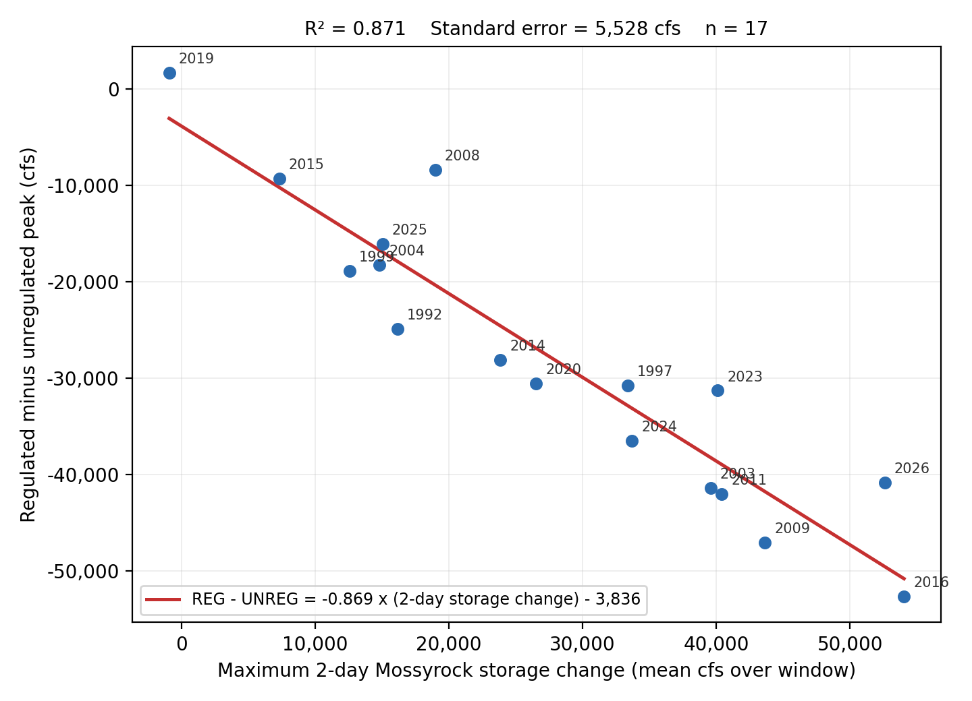
Figure 7-1. Adopted two-day storage-change regression. Points are labeled by water year.
Pairs whose regulated and unregulated peaks fell more than 72 hours apart were treated as different storms and excluded from the fit. Thirty water years were filled by regression. For water years 1974 through 1991, which the hourly record does not cover, the regulated peak came from the USGS annual peak record and the peak date centered the storage-change window.

7. Durations from the Daily Mass Balance
Daily unregulated flow at Castle Rock was computed as observed daily flow plus the daily change in Mossyrock storage expressed as a flow rate. Travel time from Mayfield to Castle Rock is less than a day, so no routing is applied at daily resolution. Mayfield re-regulation storage is neglected for the reasons given in Section 2.2.
Rolling 1-, 3-, and 5-day maxima were computed on a complete daily grid so that an N-day value always represents N consecutive recorded days. The Castle Rock daily record is published for the winter season only through much of the 1980s and 1990s; because the recorded season spans the October through March flood period, it is taken to capture the annual maximum. The one-day mass balance value also supplies the 1-day duration for the thirty regulated water years that have no usable hourly record.

8. Pre-Regulation Period
Before Mossyrock began impounding the river in December 1968 the gage record is unregulated as observed. Peaks for water years 1927 through 1968 are the USGS observed instantaneous annual peaks, forty-two water years in all, and the 1-, 3-, and 5-day values are rolling maximum computed directly from the USGS daily record. Water year 1927 carries a peak only, because the daily record begins later.

9. Record Extension Considerations
Correlation-based record extension from a nearby site was considered as a way to lengthen the systematic record, but no suitable donor station was identified. Nearby long-record gages either do not extend materially earlier than the Castle Rock record, are themselves regulated over the period that would be used, or do not correlate strongly enough over the concurrent period to justify the added estimation error. With roughly a century of systematic record already available, the potential gain from extension was small relative to the uncertainty it would introduce, so no extension was applied.

10. Historical Flood Information
A search for pre-systematic and historical flood information was made so that any documented large event outside the systematic record could be incorporated through Bulletin 17C historical event and perception threshold procedures. Sources reviewed included the qualification codes and remarks in the USGS annual peak file for Castle Rock and nearby Cowlitz basin gages, the documentation of the 2009 Cowlitz Hydrology Restudy, and published U.S. Geological Survey and National Weather Service accounts of major southwest Washington floods.No historical flood at Castle Rock outside the systematic record could be quantified or reliably bounded and so no historic events prior to 1927 were used in the analysis.

11. Assembled Record
For water years 1927 through 1968 the record is the observed gage record: peaks are the USGS annual instantaneous peaks, and the 1-, 3-, and 5-day values are rolling maximum of the USGS daily record.
For water years 1974 through 2026 the peak is the hourly holdout estimate where the hourly record supported one, and the storage-change regression estimate otherwise. The 1-day value comes from the hourly unregulated record in the same years the peak did, and from the daily mass balance in all other years. The 3- and 5-day values always come from the daily mass balance.
Duration | Values | Sources
Peak | 95 | 42 pre-regulation USGS peaks; 30 storage-change regression; 23 hourly holdout
1-Day | 94 | 41 pre-regulation USGS daily; 30 daily mass balance; 23 hourly holdout
3-Day | 94 | 41 pre-regulation USGS daily; 53 daily mass balance
5-Day | 94 | 41 pre-regulation USGS daily; 53 daily mass balance
Table 11-1. Assembled record, values and sources by duration.
Coverage runs from water year 1927 through water year 2026, with only water years 1969 through 1973 absent. Those five years have no daily Mossyrock elevation record, which begins in October 1973, no hourly record, and therefore no basis for either a holdout or a regression predictor. Every included water year has a peak. Water year 1927 has no durations because the daily record begins later. The full record by water year is given in Appendix A.

12. Consistency Review
Each duration is the annual maximum of its own averaging window, searched independently across the water year, so the four series can be drawn from different events and, in the regulated era, from different sources. Nothing in that construction forces a shorter-duration value to exceed a longer-duration one, and fifteen ordering violations appeared in the assembled record.
Fourteen of the fifteen arose from a source mismatch, most often a regression-estimated peak falling below the mass balance 1-day value computed for the same year. The remaining case, water year 2014, is internal to the daily series: a double-peaked March event whose 5-day window spans both peaks while no 3-day window can. A shorter-duration flow lower than a longer-duration flow for a single peak event is impossible, and in general, even given multiple large events in a single year, shorter durations should have higher peaks. Violations of these assumptions would distort both the frequency fits and any later volume-duration work, so the record was made monotonic. The 5-day value anchors each water year and each shorter duration is raised to the longer value wherever the longer is higher, cascading upward. Values before adjustment are retained alongside the adopted values. Ten values across nine water years were raised. Eight are regression-estimated peaks lifted to their 1-day value. The largest changes are in water years 2001, 1985, and 2006, at 64, 19, and 19 percent. Those years are among the smallest in the record, so the adjustment has little influence on the fitted upper tail.

13. Flow Frequency Analysis
The assembled record was analyzed in HEC-SSP using the Bulletin 17C expected moments algorithm, one analysis per duration. All four fit a log-Pearson Type III distribution to the unregulated record described above, with the station skew weighted against a published regional value.

13.1 Regional Skew
The regional skew for the instantaneous peak is taken from Mastin, Konrad, Veilleux, and Tecca (2016), which developed a constant regional skew of -0.07 for a Pacific Northwest region that includes the Cowlitz basin.
Regional skews for the durations are taken from Lind, Lamontagne, and Stonewall (2020), which developed Bayesian regional skew models for selected flood durations in the Columbia River basin and found basin mean annual precipitation to be the strongest predictor. Using a basin-average mean annual precipitation of 77.5 inches above Castle Rock, that study's models give regional skews of 0.09 for the 1-day and 0.07 for the 3-day duration. The report models 1-, 3-, 7-, 10-, 15-, 30-, and 60-day durations; the 5-day value of 0.00 was interpolated between the 3- and 7-day models that bracket it.

13.2 Treatment of Water Years 1969 through 1973
Water years 1969 through 1973 have observed regulated peaks but no basis for an unregulated estimate. Omitting them would shorten the period of record and discard the knowledge that those years occurred within the observed span, while assigning point estimates would assert values the data do not support. They were therefore entered as censored, so the analysis retains the correct record length without asserting magnitudes. The peak analysis reports 95 systematic events within a 100-year period, with five events flagged as missing.

13.3 Low Outliers
No low-flow outliers were identified by the multiple Grubbs-Beck procedure, and none were imposed. The record contains no zero or near-zero annual maxima. Because the unregulated series is constructed rather than gaged, its small years carry the same provenance as its large ones, so there is no physical basis for treating the lower tail as unrepresentative of the population being fit.

13.4 Adopted Statistics
Station skews are slightly negative for every duration, from -0.158 for the peak to -0.054 for the 5-day. Weighting against the regional values moves the peak to -0.135 and the longer durations toward zero, giving adopted skews of -0.135, -0.052, -0.009, and -0.031. Equivalent record lengths after censoring range from 100 to 112 years. Table 13-1 gives the fitted parameters and event counts reported by HEC-SSP, and Figure 13-1 shows the four adopted curves. Individual curves with confidence limits and plotted observations appear in Appendix C, and the full set of ordinates in Appendix B.
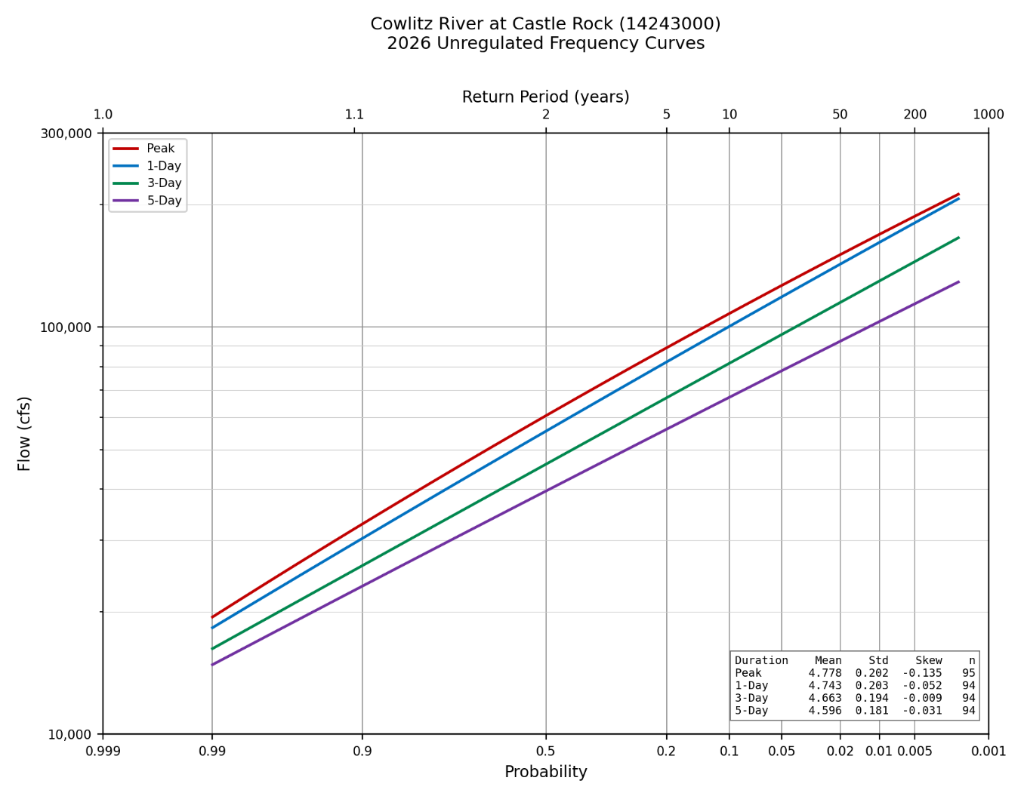
Figure 13-1. Adopted unregulated frequency curves at Castle Rock, water years 1927 through 2026, all four durations.
Parameter | Peak | 1-Day | 3-Day | 5-Day
Mean of logs | 4.778 | 4.743 | 4.660 | 4.593
Standard deviation of logs | 0.202 | 0.203 | 0.192 | 0.179
Station skew | -0.158 | -0.152 | -0.076 | -0.051
Regional skew | -0.07 | 0.09 | 0.07 | 0.00
Weighted skew | -0.135 | -0.052 | -0.007 | -0.029
Adopted skew | -0.135 | -0.052 | -0.009 | -0.031
Mean square error, at-site skew | 0.064 | 0.064 | 0.060 | 0.059
Grubbs-Beck critical value | 0 | 0 | 0 | 0
Equivalent record length (years) | 103.7 | 100.4 | 106.3 | 112.0
Systematic events | 95 | 94 | 94 | 94
Historical events | 0 | 0 | 0 | 0
High outliers | 0 | 0 | 0 | 0
Low outliers | 0 | 0 | 0 | 0
Zero events | 0 | 0 | 0 | 0
Missing events | 5 | 5 | 5 | 5
Historical period (years) | 100 | 99 | 99 | 99
Table 13-1. Distribution parameters and event counts, adopted HEC-SSP analyses.

14. Comparison with the 2009 Restudy
Figure 14-1 places the adopted curves against the 2009 Cowlitz Hydrology Restudy. Both sets are computed curves from HEC-SSP. The two studies agree closely through the range supported by data and diverge in the tail. At the 10 percent annual chance exceedance all four durations fall within about 2 percent of the 2009 values, and at the median within 3 percent. Beyond the 2 percent chance event the 2026 curves fall progressively below: at the 1 percent chance the peak is 7.8 percent lower and the durations 1.8 to 3.3 percent lower, and at the 0.2 percent chance the peak is 13.7 percent lower.
The cause is skew. The 2009 study used a regional skew of 0 and resulted in adopted positive skews for every duration, from 0.140 to 0.193, which bend those curves upward in the tail, while the skews adopted here are near zero or negative and flatten it. The divergence is a difference in fitted tail behavior rather than a difference in the record through the observed range.
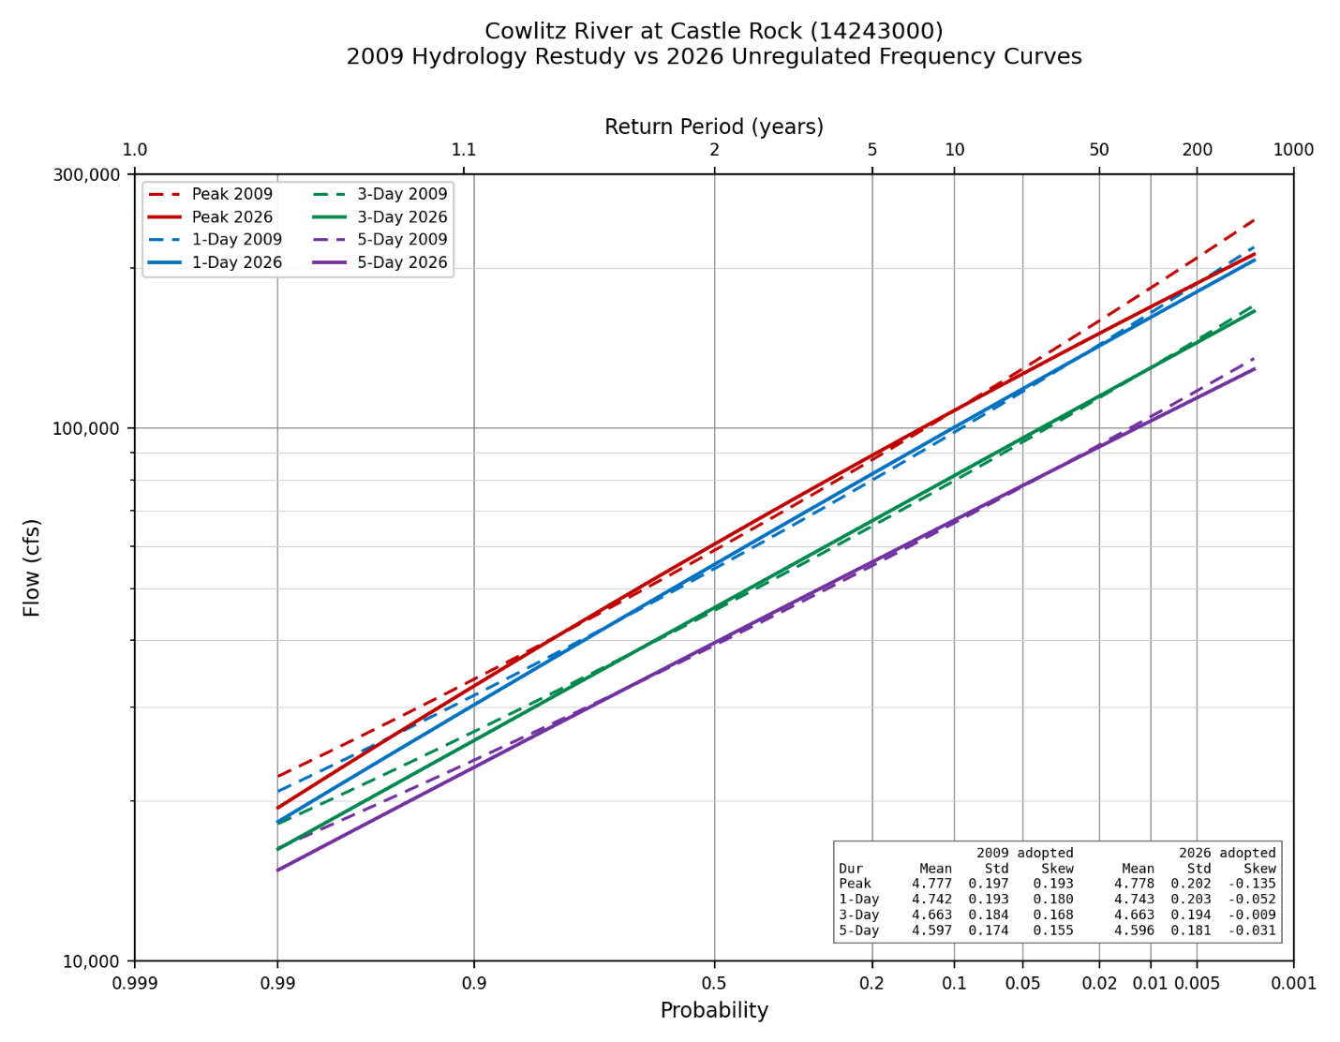
Figure 14-1. Adopted 2026 curves (solid) against the 2009 Cowlitz Hydrology Restudy (dashed).

Appendix A. Assembled Record by Water Year
Flows are in cubic feet per second. Source abbreviations: USGS peak, the observed instantaneous annual peak; USGS daily, rolling maxima of the observed daily record; Holdout, the hourly unregulated record from the Mossyrock holdout; Regression, the two-day storage-change relation; Mass balance, the daily unregulated series.
WY | Peak | Peak source | 1-Day | 1-Day source | 3-Day | 5-Day | Duration source
1927 | 41,100 | USGS peak
1928 | 74,000 | USGS peak | 71,300 | USGS daily | 56,933 | 47,940 | USGS daily
1929 | 21,800 | USGS peak | 21,100 | USGS daily | 19,633 | 18,980 | USGS daily
1930 | 30,200 | USGS peak | 29,500 | USGS daily | 26,700 | 23,840 | USGS daily
1931 | 65,900 | USGS peak | 63,200 | USGS daily | 51,200 | 40,760 | USGS daily
1932 | 50,800 | USGS peak | 49,200 | USGS daily | 44,467 | 39,140 | USGS daily
1933 | 53,000 | USGS peak | 52,200 | USGS daily | 44,467 | 43,900 | USGS daily
1934 | 139,000 | USGS peak | 134,000 | USGS daily | 120,333 | 106,300 | USGS daily
1935 | 61,800 | USGS peak | 58,100 | USGS daily | 53,800 | 45,540 | USGS daily
1936 | 48,200 | USGS peak | 39,800 | USGS daily | 35,833 | 31,400 | USGS daily
1937 | 49,000 | USGS peak | 47,200 | USGS daily | 40,167 | 34,640 | USGS daily
1938 | 62,900 | USGS peak | 60,500 | USGS daily | 53,567 | 47,440 | USGS daily
1939 | 43,600 | USGS peak | 39,800 | USGS daily | 29,867 | 27,840 | USGS daily
1940 | 41,900 | USGS peak | 40,500 | USGS daily | 36,767 | 31,660 | USGS daily
1941 | 26,400 | USGS peak | 22,100 | USGS daily | 19,633 | 16,038 | USGS daily
1942 | 58,100 | USGS peak | 55,400 | USGS daily | 47,067 | 39,400 | USGS daily
1943 | 60,500 | USGS peak | 58,300 | USGS daily | 46,867 | 39,020 | USGS daily
1944 | 37,100 | USGS peak | 33,700 | USGS daily | 26,467 | 20,760 | USGS daily
1945 | 45,300 | USGS peak | 44,200 | USGS daily | 36,333 | 30,340 | USGS daily
1946 | 54,700 | USGS peak | 51,700 | USGS daily | 45,433 | 38,940 | USGS daily
1947 | 85,100 | USGS peak | 82,400 | USGS daily | 80,767 | 74,880 | USGS daily
1948 | 38,500 | USGS peak | 37,000 | USGS daily | 32,700 | 28,560 | USGS daily
1949 | 51,500 | USGS peak | 43,300 | USGS daily | 30,167 | 28,580 | USGS daily
1950 | 54,800 | USGS peak | 54,000 | USGS daily | 49,933 | 43,920 | USGS daily
1951 | 67,200 | USGS peak | 63,900 | USGS daily | 61,467 | 54,440 | USGS daily
1952 | 41,400 | USGS peak | 35,600 | USGS daily | 31,600 | 28,680 | USGS daily
1953 | 60,000 | USGS peak | 50,000 | USGS daily | 44,000 | 40,400 | USGS daily
1954 | 73,000 | USGS peak | 63,600 | USGS daily | 51,067 | 45,440 | USGS daily
1955 | 50,100 | USGS peak | 43,300 | USGS daily | 33,800 | 29,020 | USGS daily
1956 | 67,400 | USGS peak | 63,100 | USGS daily | 49,733 | 42,260 | USGS daily
1957 | 43,200 | USGS peak | 40,400 | USGS daily | 37,400 | 34,980 | USGS daily
1958 | 35,200 | USGS peak | 34,500 | USGS daily | 30,867 | 27,280 | USGS daily
1959 | 57,800 | USGS peak | 52,900 | USGS daily | 44,733 | 39,140 | USGS daily
1960 | 62,700 | USGS peak | 61,000 | USGS daily | 56,433 | 49,620 | USGS daily
1961 | 64,500 | USGS peak | 59,000 | USGS daily | 46,133 | 43,520 | USGS daily
1962 | 42,100 | USGS peak | 40,100 | USGS daily | 34,833 | 30,240 | USGS daily
1963 | 66,900 | USGS peak | 59,500 | USGS daily | 52,900 | 41,640 | USGS daily
1964 | 72,600 | USGS peak | 55,400 | USGS daily | 46,267 | 37,680 | USGS daily
1965 | 83,900 | USGS peak | 79,100 | USGS daily | 68,933 | 60,120 | USGS daily
1966 | 28,800 | USGS peak | 27,000 | USGS daily | 24,333 | 22,400 | USGS daily
1967 | 65,000 | USGS peak | 58,800 | USGS daily | 48,167 | 38,520 | USGS daily
1968 | 49,500 | USGS peak | 47,600 | USGS daily | 44,633 | 42,600 | USGS daily
1974 | 112,486 | Regression | 112,486 | Mass balance | 92,392 | 74,846 | Mass balance
1975 | 76,896 | Regression | 71,250 | Mass balance | 54,411 | 50,666 | Mass balance
1976 | 124,946 | Regression | 110,190 | Mass balance | 106,676 | 91,422 | Mass balance
1977 | 19,899 | Regression | 16,299 | Mass balance | 14,752 | 14,436 | Mass balance
1978 | 131,885 | Regression | 110,965 | Mass balance | 94,793 | 74,569 | Mass balance
1979 | 51,587 | Regression | 40,506 | Mass balance | 28,000 | 25,107 | Mass balance
1980 | 101,895 | Regression | 42,737 | Mass balance | 37,116 | 32,514 | Mass balance
1981 | 88,345 | Regression | 86,532 | Mass balance | 71,889 | 57,905 | Mass balance
1982 | 84,883 | Regression | 77,900 | Mass balance | 62,871 | 60,342 | Mass balance
1983 | 82,466 | Regression | 72,298 | Mass balance | 55,966 | 52,485 | Mass balance
1984 | 57,352 | Regression | 57,352 | Mass balance | 46,702 | 38,367 | Mass balance
1985 | 33,098 | Regression | 33,098 | Mass balance | 28,765 | 23,969 | Mass balance
1986 | 95,135 | Regression | 83,652 | Mass balance | 62,163 | 52,287 | Mass balance
1987 | 103,298 | Regression | 90,982 | Mass balance | 61,617 | 50,210 | Mass balance
1988 | 61,876 | Regression | 59,525 | Mass balance | 39,029 | 30,728 | Mass balance
1989 | 28,884 | Regression | 23,674 | Mass balance | 21,120 | 19,496 | Mass balance
1990 | 124,824 | Regression | 95,400 | Mass balance | 76,113 | 59,391 | Mass balance
1991 | 110,107 | Regression | 104,020 | Mass balance | 75,569 | 58,070 | Mass balance
1992 | 51,845 | Holdout | 43,323 | Holdout | 38,240 | 35,850 | Mass balance
1993 | 33,272 | Regression | 31,533 | Mass balance | 26,576 | 21,802 | Mass balance
1994 | 26,300 | Regression | 26,300 | Mass balance | 24,710 | 22,556 | Mass balance
1995 | 64,114 | Regression | 59,736 | Mass balance | 48,317 | 39,125 | Mass balance
1996 | 176,855 | Regression | 170,280 | Mass balance | 139,807 | 108,126 | Mass balance
1997 | 86,921 | Holdout | 83,113 | Holdout | 74,563 | 69,706 | Mass balance
1998 | 38,925 | Regression | 30,823 | Mass balance | 23,581 | 22,965 | Mass balance
1999 | 76,193 | Holdout | 68,206 | Holdout | 60,807 | 51,702 | Mass balance
2000 | 73,070 | Regression | 72,890 | Mass balance | 58,190 | 43,549 | Mass balance
2001 | 19,568 | Regression | 19,568 | Mass balance | 15,339 | 14,332 | Mass balance
2002 | 66,027 | Regression | 64,512 | Mass balance | 49,168 | 40,567 | Mass balance
2003 | 109,719 | Holdout | 101,254 | Holdout | 72,896 | 53,892 | Mass balance
2004 | 56,223 | Holdout | 52,144 | Holdout | 43,452 | 34,949 | Mass balance
2005 | 52,859 | Regression | 50,133 | Mass balance | 39,349 | 31,339 | Mass balance
2006 | 74,082 | Regression | 74,082 | Mass balance | 62,808 | 53,945 | Mass balance
2007 | 147,777 | Regression | 147,777 | Mass balance | 100,470 | 73,836 | Mass balance
2008 | 72,455 | Holdout | 70,265 | Holdout | 54,504 | 41,446 | Mass balance
2009 | 151,296 | Holdout | 139,073 | Holdout | 99,324 | 72,961 | Mass balance
2010 | 27,802 | Holdout | 25,172 | Holdout | 24,888 | 23,204 | Mass balance
2011 | 87,160 | Holdout | 85,731 | Holdout | 71,689 | 58,118 | Mass balance
2012 | 57,286 | Holdout | 53,334 | Holdout | 40,865 | 34,419 | Mass balance
2013 | 58,409 | Regression | 47,950 | Mass balance | 36,797 | 30,359 | Mass balance
2014 | 60,268 | Holdout | 57,504 | Holdout | 46,396 | 46,396 | Mass balance
2015 | 47,323 | Holdout | 43,517 | Holdout | 32,555 | 31,664 | Mass balance
2016 | 135,790 | Holdout | 124,896 | Holdout | 92,957 | 72,910 | Mass balance
2017 | 64,342 | Holdout | 62,516 | Holdout | 51,010 | 47,186 | Mass balance
2018 | 54,188 | Holdout | 52,984 | Holdout | 47,285 | 39,300 | Mass balance
2019 | 24,389 | Holdout | 24,389 | Holdout | 24,389 | 22,197 | Mass balance
2020 | 77,812 | Holdout | 73,544 | Holdout | 60,465 | 51,297 | Mass balance
2021 | 61,703 | Holdout | 56,924 | Holdout | 42,829 | 35,700 | Mass balance
2022 | 77,833 | Holdout | 73,803 | Holdout | 60,851 | 50,050 | Mass balance
2023 | 65,623 | Holdout | 61,507 | Holdout | 47,710 | 35,341 | Mass balance
2024 | 81,192 | Holdout | 76,898 | Holdout | 59,644 | 48,589 | Mass balance
2025 | 45,954 | Holdout | 41,975 | Holdout | 35,253 | 30,112 | Mass balance
2026 | 101,833 | Holdout | 97,675 | Holdout | 94,669 | 77,439 | Mass balance
Table A-1. Assembled unregulated record, water years 1927 through 2026.

Appendix B. Frequency Curve Ordinates
Computed curve, expected probability curve, variance of the log, and 5 and 95 percent confidence limits for every ordinate reported by HEC-SSP. Flows are in cubic feet per second.
Duration | Annual chance exceedance | Variance of log | z | Computed | 5% limit | 95% limit | Expected probability
Peak | 0.0001 | 0.0098 | 3.72 | 296,088 | 476,290 | 217,104 | 374,643
Peak | 0.0002 | 0.0082 | 3.54 | 276,072 | 426,543 | 207,624 | 332,739
Peak | 0.0005 | 0.0064 | 3.29 | 250,134 | 366,728 | 194,487 | 285,568
Peak | 0.001 | 0.0052 | 3.09 | 230,884 | 325,578 | 184,044 | 255,074
Peak | 0.002 | 0.0041 | 2.88 | 211,932 | 287,635 | 173,114 | 227,900
Peak | 0.005 | 0.0029 | 2.58 | 187,282 | 241,929 | 157,818 | 195,977
Peak | 0.01 | 0.0022 | 2.33 | 168,884 | 210,386 | 145,504 | 174,075
Peak | 0.02 | 0.0016 | 2.05 | 150,625 | 181,177 | 132,434 | 153,556
Peak | 0.05 | 0.0010 | 1.64 | 126,514 | 145,732 | 113,770 | 127,758
Peak | 0.1 | 0.0007 | 1.28 | 108,041 | 121,015 | 98,383 | 108,618
Peak | 0.2 | 0.0005 | 0.84 | 88,923 | 97,624 | 81,626 | 89,126
Peak | 0.5 | 0.0005 | 0.00 | 60,585 | 65,857 | 55,691 | 60,529
Peak | 0.8 | 0.0006 | -0.84 | 40,671 | 44,531 | 36,709 | 40,487
Peak | 0.9 | 0.0009 | -1.28 | 32,826 | 36,401 | 28,836 | 32,573
Peak | 0.95 | 0.0013 | -1.64 | 27,417 | 30,925 | 23,227 | 27,041
Peak | 0.99 | 0.0030 | -2.33 | 19,408 | 23,026 | 14,842 | 18,564
1-Day | 0.0001 | 0.0109 | 3.72 | 299,447 | 479,405 | 221,040 | 386,105
1-Day | 0.0002 | 0.0092 | 3.54 | 276,822 | 426,187 | 209,249 | 338,896
1-Day | 0.0005 | 0.0072 | 3.29 | 247,988 | 362,832 | 193,367 | 286,800
1-Day | 0.001 | 0.0059 | 3.09 | 226,952 | 319,700 | 181,106 | 253,245
1-Day | 0.002 | 0.0047 | 2.88 | 206,550 | 280,306 | 168,605 | 223,780
1-Day | 0.005 | 0.0034 | 2.58 | 180,481 | 233,404 | 151,652 | 189,945
1-Day | 0.01 | 0.0026 | 2.33 | 161,378 | 201,443 | 138,445 | 167,060
1-Day | 0.02 | 0.0019 | 2.05 | 142,727 | 172,189 | 124,837 | 145,949
1-Day | 0.05 | 0.0012 | 1.64 | 118,581 | 137,189 | 106,070 | 119,937
1-Day | 0.1 | 0.0009 | 1.28 | 100,464 | 113,080 | 91,102 | 101,103
1-Day | 0.2 | 0.0006 | 0.84 | 82,073 | 90,457 | 75,165 | 82,324
1-Day | 0.5 | 0.0005 | 0.00 | 55,503 | 60,349 | 51,025 | 55,470
1-Day | 0.8 | 0.0006 | -0.84 | 37,319 | 40,830 | 33,739 | 37,176
1-Day | 0.9 | 0.0008 | -1.28 | 30,257 | 33,490 | 26,713 | 30,053
1-Day | 0.95 | 0.0011 | -1.64 | 25,414 | 28,563 | 21,767 | 25,130
1-Day | 0.99 | 0.0022 | -2.33 | 18,268 | 21,476 | 14,392 | 17,638
3-Day | 0.0001 | 0.0093 | 3.72 | 240,363 | 376,364 | 180,427 | 298,915
3-Day | 0.0002 | 0.0079 | 3.54 | 222,081 | 335,087 | 170,391 | 264,436
3-Day | 0.0005 | 0.0062 | 3.29 | 198,868 | 285,924 | 157,011 | 225,645
3-Day | 0.001 | 0.0051 | 3.09 | 181,994 | 252,436 | 146,786 | 200,289
3-Day | 0.002 | 0.0041 | 2.88 | 165,677 | 221,830 | 136,451 | 177,857
3-Day | 0.005 | 0.0030 | 2.58 | 144,898 | 185,363 | 122,577 | 151,689
3-Day | 0.01 | 0.0023 | 2.33 | 129,717 | 160,485 | 111,876 | 133,835
3-Day | 0.02 | 0.0017 | 2.05 | 114,932 | 137,687 | 100,941 | 117,352
3-Day | 0.05 | 0.0011 | 1.64 | 95,836 | 110,351 | 85,995 | 96,884
3-Day | 0.1 | 0.0008 | 1.28 | 81,533 | 91,456 | 74,157 | 82,033
3-Day | 0.2 | 0.0006 | 0.84 | 67,026 | 73,645 | 61,589 | 67,236
3-Day | 0.5 | 0.0004 | 0.00 | 46,042 | 49,861 | 42,513 | 46,036
3-Day | 0.8 | 0.0005 | -0.84 | 31,599 | 34,399 | 28,743 | 31,493
3-Day | 0.9 | 0.0007 | -1.28 | 25,945 | 28,543 | 23,109 | 25,784
3-Day | 0.95 | 0.0010 | -1.64 | 22,044 | 24,587 | 19,120 | 21,810
3-Day | 0.99 | 0.0020 | -2.33 | 16,230 | 18,847 | 13,097 | 15,706
5-Day | 0.0001 | 0.0085 | 3.72 | 181,018 | 276,627 | 138,058 | 225,377
5-Day | 0.0002 | 0.0072 | 3.54 | 168,477 | 248,520 | 131,223 | 200,703
5-Day | 0.0005 | 0.0057 | 3.29 | 152,387 | 214,676 | 122,003 | 172,807
5-Day | 0.001 | 0.0046 | 3.09 | 140,566 | 191,358 | 114,869 | 154,542
5-Day | 0.002 | 0.0037 | 2.88 | 129,023 | 169,831 | 107,577 | 138,364
5-Day | 0.005 | 0.0027 | 2.58 | 114,149 | 143,861 | 97,651 | 119,354
5-Day | 0.01 | 0.0020 | 2.33 | 103,144 | 125,913 | 89,882 | 106,301
5-Day | 0.02 | 0.0015 | 2.05 | 92,301 | 109,270 | 81,834 | 94,152
5-Day | 0.05 | 0.0010 | 1.64 | 78,089 | 89,024 | 70,643 | 78,888
5-Day | 0.1 | 0.0007 | 1.28 | 67,267 | 74,814 | 61,613 | 67,651
5-Day | 0.2 | 0.0005 | 0.84 | 56,108 | 61,221 | 51,864 | 56,269
5-Day | 0.5 | 0.0004 | 0.00 | 39,563 | 42,625 | 36,714 | 39,551
5-Day | 0.8 | 0.0005 | -0.84 | 27,812 | 30,120 | 25,439 | 27,720
5-Day | 0.9 | 0.0006 | -1.28 | 23,104 | 25,274 | 20,704 | 22,966
5-Day | 0.95 | 0.0008 | -1.64 | 19,810 | 21,961 | 17,294 | 19,612
5-Day | 0.99 | 0.0018 | -2.33 | 14,823 | 17,089 | 12,041 | 14,367
Table B-1. Frequency curve ordinates, all four durations.

Appendix C. Frequency Curves by Duration
Individual curves as produced by HEC-SSP: computed curve, expected probability curve, 5 and 95 percent confidence limits, and observed events at Hirsch-Stedinger plotting positions. The peak figure reflects the censored treatment described in Section 13.2.
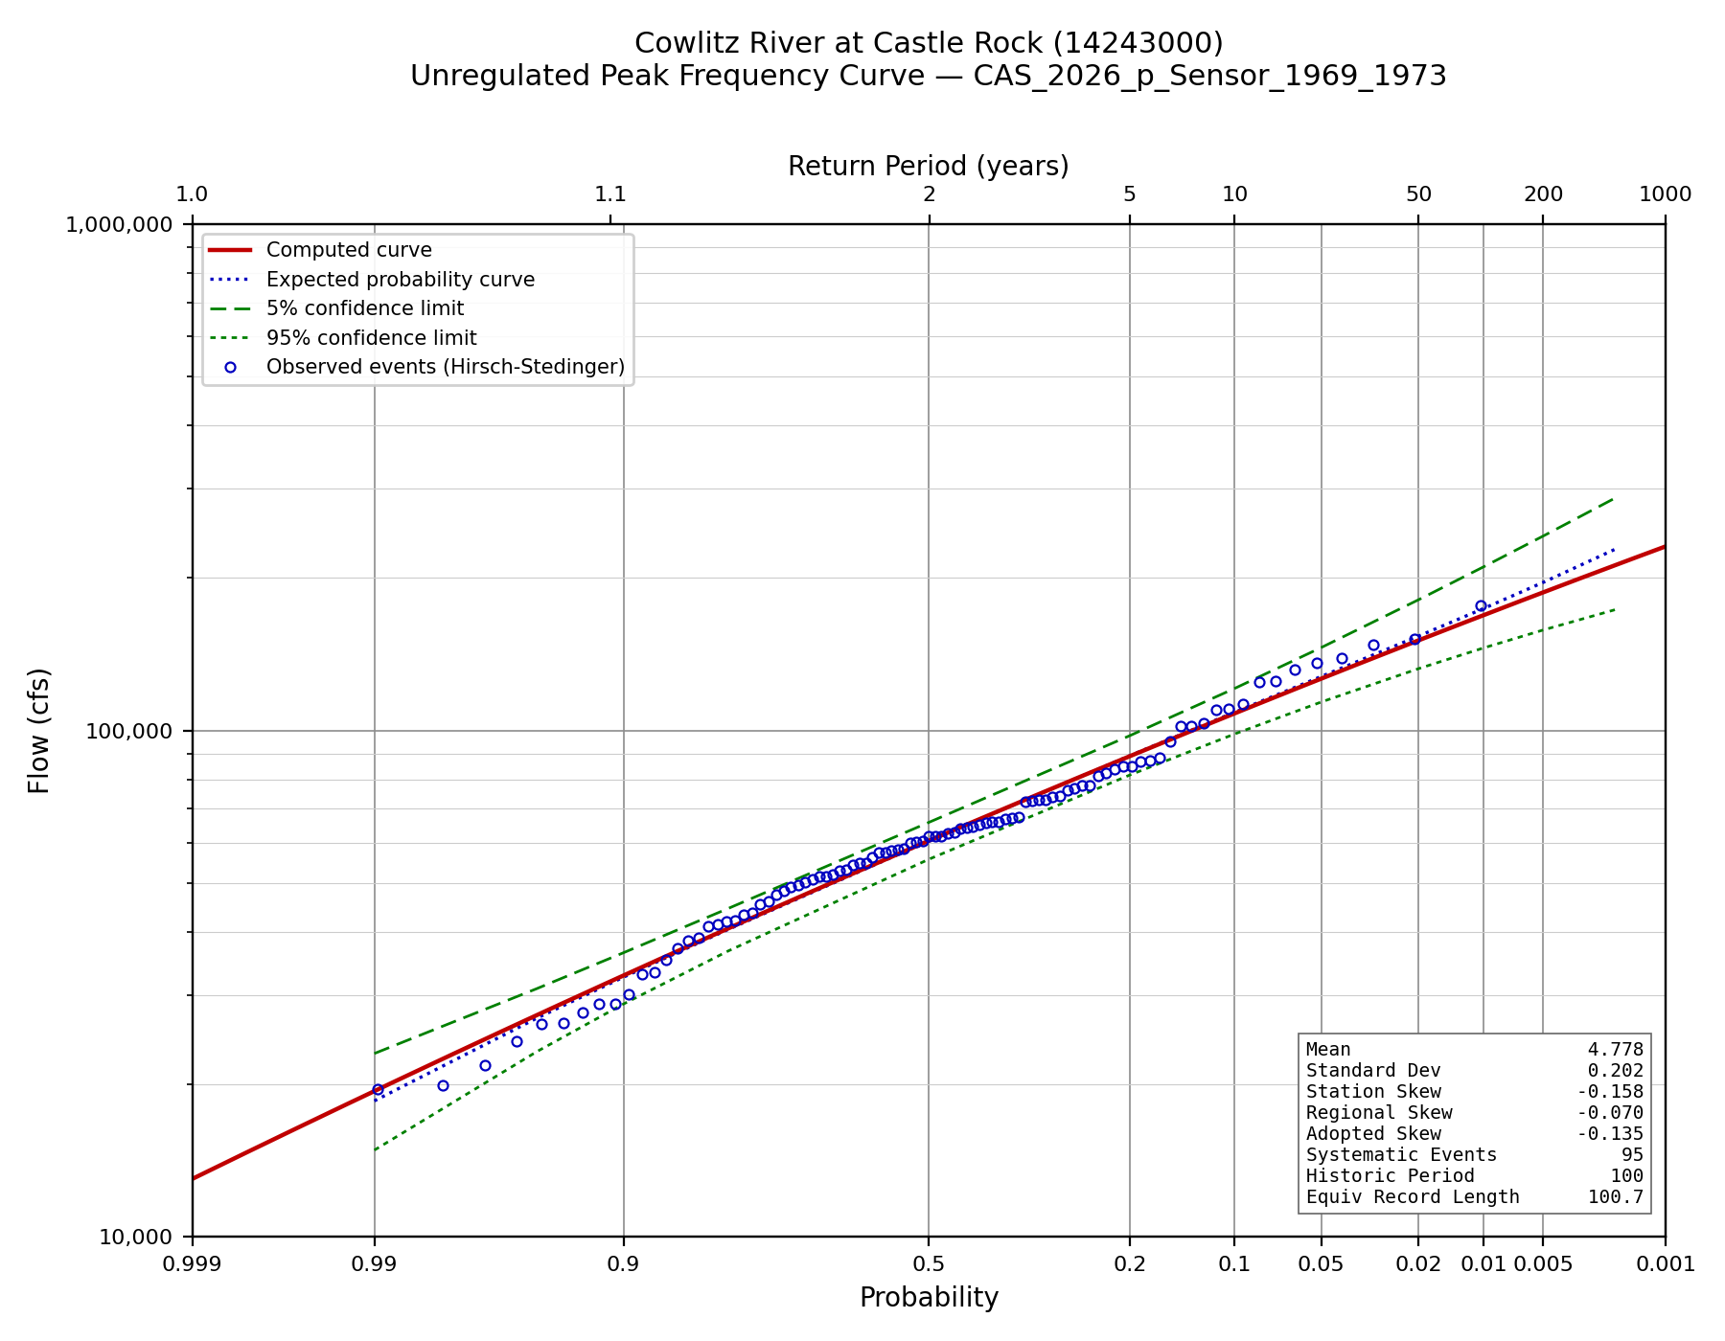
Figure C-1. Unregulated instantaneous peak frequency curve.
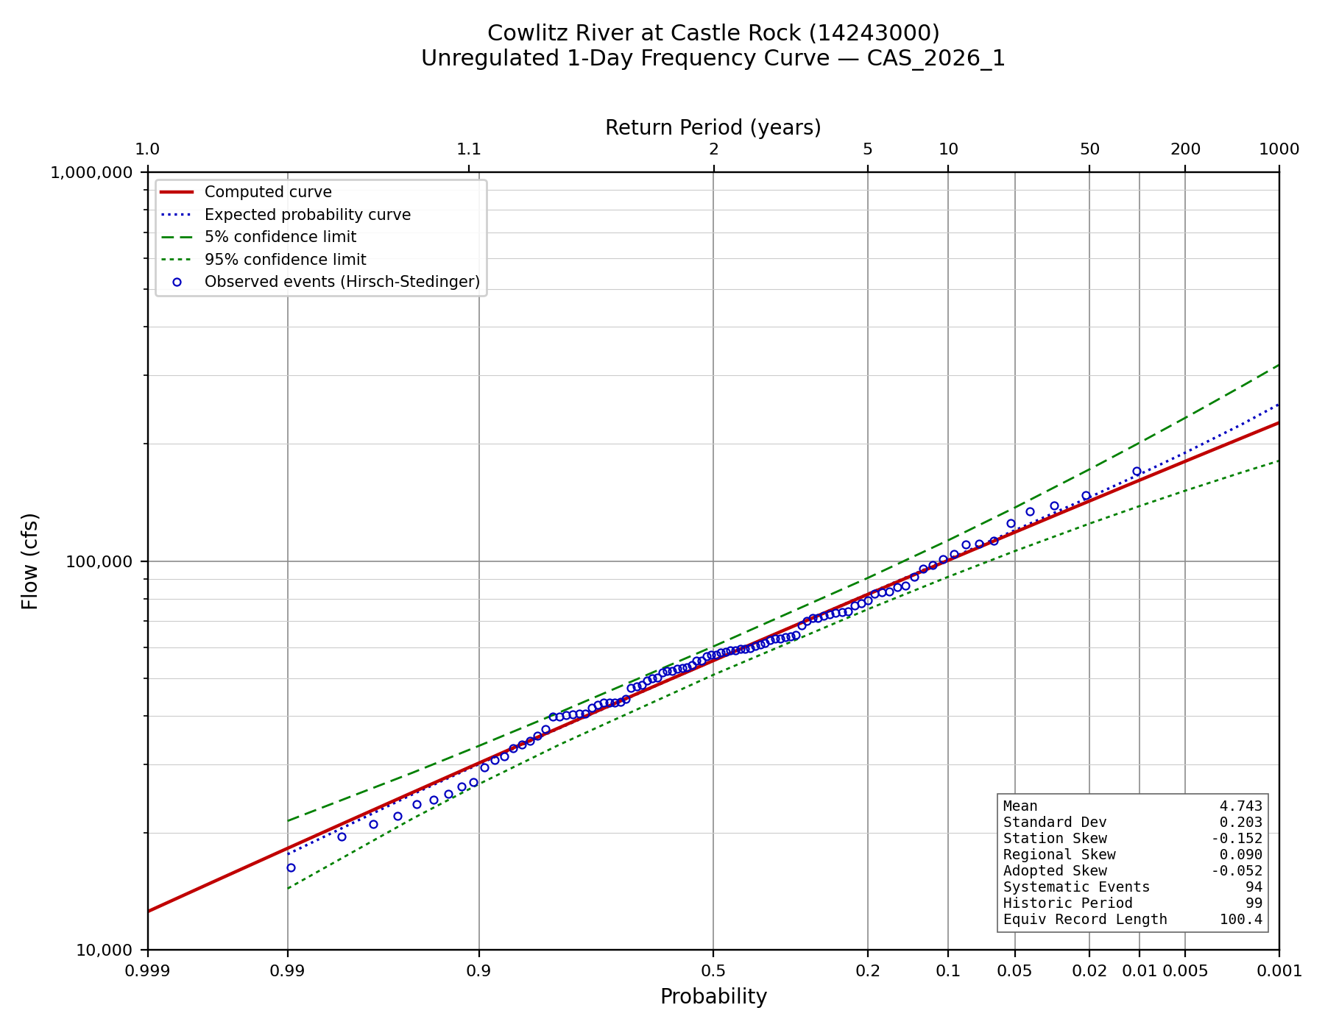
Figure C-2. Unregulated 1-day frequency curve.
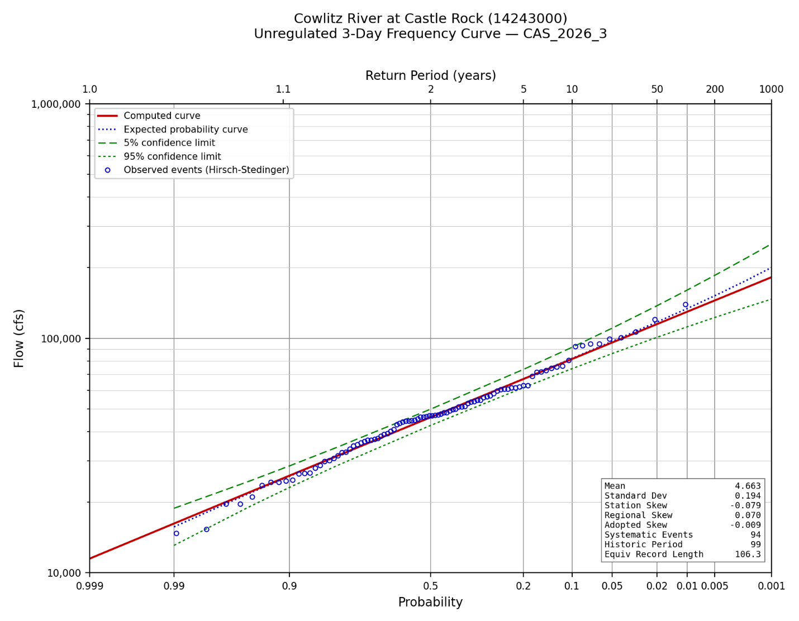
Figure C-3. Unregulated 3-day frequency curve.
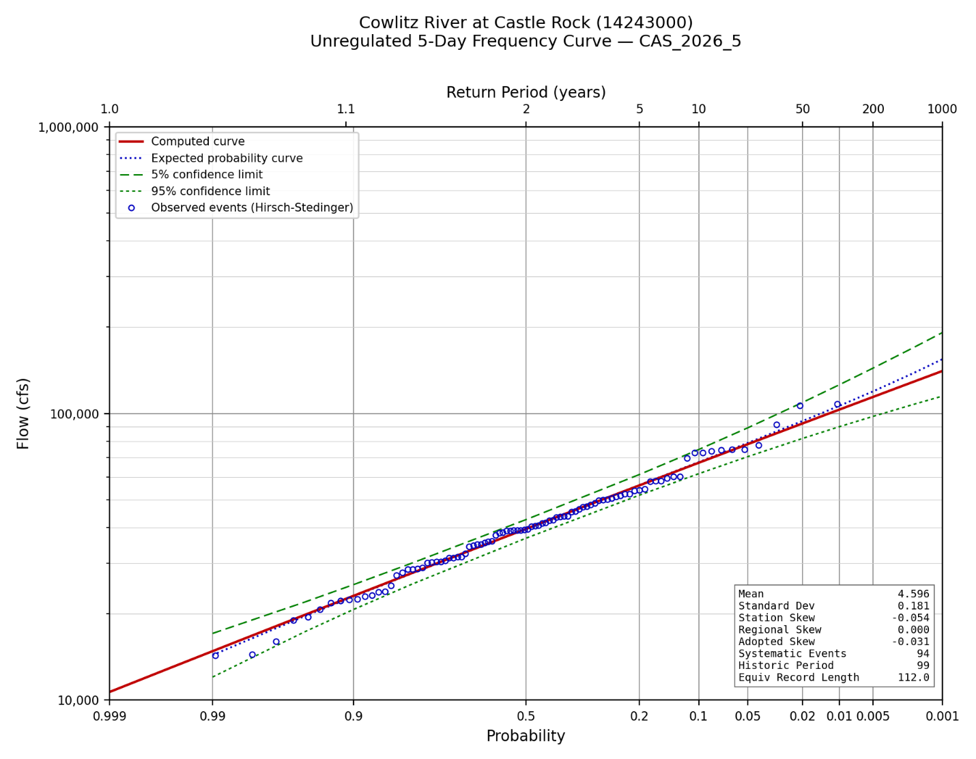
Figure C-4. Unregulated 5-day frequency curve.

References
England, J.F., Jr., Cohn, T.A., Faber, B.A., Stedinger, J.R., Thomas, W.O., Jr., Veilleux, A.G., Kiang, J.E., and Mason, R.R., Jr., 2019, Guidelines for determining flood flow frequency - Bulletin 17C (ver. 1.1): U.S. Geological Survey Techniques and Methods, book 4, chap. B5, 148 p.
Lind, G.D., Lamontagne, J.R., and Stonewall, A.J., 2020, Development of regional skew coefficients for selected flood durations in the Columbia River Basin, northwestern United States and British Columbia, Canada (ver. 1.1, October 2020): U.S. Geological Survey Scientific Investigations Report 2020-5073, 48 p.
Mastin, M.C., Konrad, C.P., Veilleux, A.G., and Tecca, A.E., 2016, Magnitude, frequency, and trends of floods at gaged and ungaged sites in Washington, based on data through water year 2014 (ver. 1.2, November 2017): U.S. Geological Survey Scientific Investigations Report 2016-5118, 70 p.
U.S. Army Corps of Engineers, Portland District, 2009, Cowlitz River Hydrology Restudy.
U.S. Army Corps of Engineers, 2014, Water Control Manual, Mossyrock Project, Cowlitz River, Washington.

