MEMORANDUM FOR RECORD
U.S. Army Corps of Engineers, Portland District
Item | Description
Subject | Regulated Flow Frequency, Lower Cowlitz River, Washington
From | Hydrology and Hydraulics Branch, Portland District
Date | August 2026
Status | DRAFT — 08/26/2026

1. Purpose
This memorandum documents the development of a regulated peak flow frequency curve for the lower Cowlitz valley in Cowlitz County, Washington to inform levee fragility assessment and floodplain mapping. Unregulated curves are developed for the instantaneous peak, 1-, 3-, and 5-day durations (Section 4) and used to develop a regulated flow frequency curves reflecting current Water Control Manual flood risk management operations below Castle Rock (Section 5).

2. Basin Description and Project Operation
The Cowlitz River drains the southern Washington Cascades and enters the Columbia River near Longview. The Castle Rock gage (USGS 14243000) sits in the lower valley, downstream of the Toutle River confluence, with a peak-flow record spanning water years 1927 through 2026. The total Cowlitz basin area is 2,480 square miles, of which 1,170 square miles (roughly half) of headwaters are regulated by Mossyrock Dam. Mossyrock Dam. Completed in 1968, provides the only usable flood storage in the basin. Just downstream of Mossyrock is Mayfield Dam which acts as a re-regulating dam that smooths power peaking releases from Mossyrock providing no meaningful flood regulation of its own. Cowlitz Falls Dam, above Mossyrock, and the Sediment Retention Structure on the Toutle are both run-of-river.

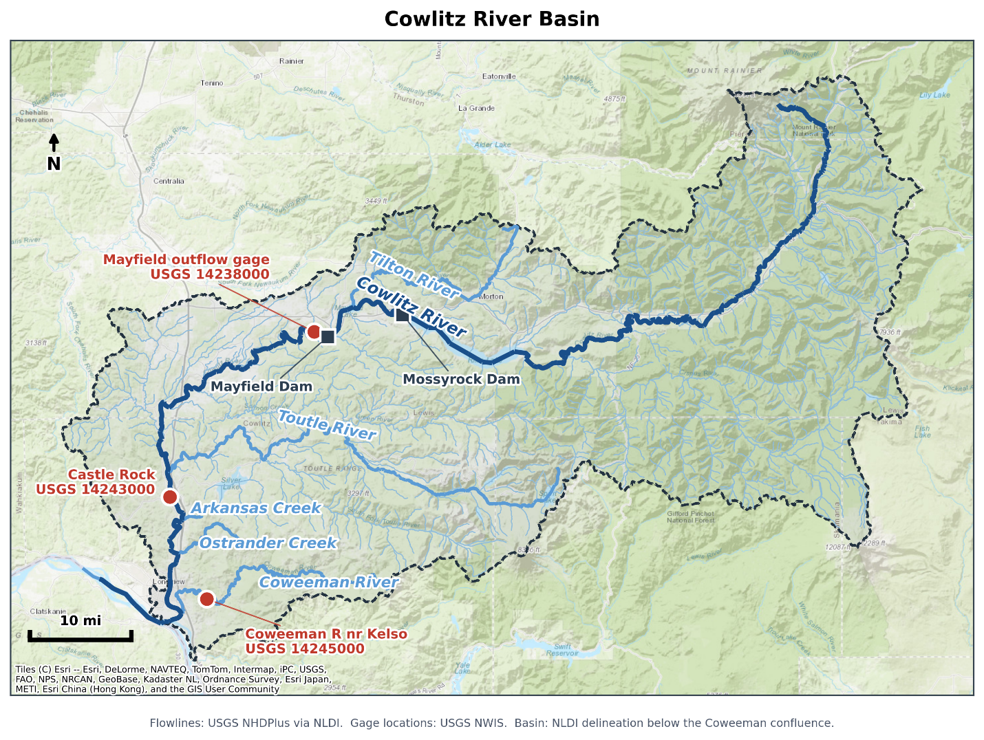
Figure 2-1. Cowlitz River basin, showing the Castle Rock gage, the Mossyrock and Mayfield projects, and the Toutle and Tilton tributaries.

2.1 Previous Studies
The previously adopted unregulated and regulated frequency curves at Castle Rock both come from the 2009 Cowlitz Hydrology Restudy, which predates Bulletin 17C and, does not include the most recent 17 years of record, and used a limited set of synthetic hydrographs to inform the upper portion of the regulated flow frequency curve. Section 6 compares the current study results against the 2009 study.

3. Data Used
Table 3-1 lists the datasets and models used and the purpose each served. The observed hydrologic records are shared by both analyses; the reservoir simulation model and its outputs are specific to the regulated study.
Dataset or model | Period used | Purpose
Mossyrock pool elevation, hourly | Nov 1974 – May 2026 | Reservoir storage change at hourly resolution; basis of the hourly unregulated peak estimates (5.2)
Mossyrock storage telemetry, hourly | Regulated era | Data quality screening
Mossyrock pool elevation, daily | Oct 1973 – present | Storage change for the regression predictors and the daily mass balance (5.3, 5.4); observed starting pool for the Obs_RC simulation (5.1)
Mossyrock elevation-storage rating table | 2014 Water Control Manual | Relates pool elevation to reservoir storage
Castle Rock streamflow, hourly (USGS 14243000) | Regulated era | Regulated flow at the study location; source of the regulated peak
Castle Rock streamflow, daily (USGS 14243000) | WY1927 – present | Pre-regulation durations; regulated daily flow used for the 3-, 5-, and select 1-day duration maxima
Castle Rock annual peak flows (USGS 14243000) | WY1927 – present | Pre-regulation peaks; regulated peak for years the hourly record does not cover; basis of the adjusted regulated peak record (5.1)
Mayfield outflow, hourly (USGS 14238000) | Regulated era | Upstream boundary for routing the Mossyrock regulation signal to Castle Rock
Coweeman at Kelso streamflow, hourly (Washington Department of Ecology 26C075) | WY 2009 - 2016 | Peak lag coincident with Castle Rock unregulated and regulated peaks (8.3)
Coweeman at Kelso annual peak flows (USGS 14245100) | WY 1950 - 1996 | Peak unregulated flow correlation with Cowlitz at Castle Rock (8.2)
HEC-ResSim model, Mossyrock and Mayfield | Current (2014 WCM) rules | Routes inflow hydrographs through the projects for the adjustment (5.1) and the synthetic ensembles (5.3)
Prism Annual Precipitation | WY1950 - 2020 | Basis for drainage basin ratio (8.2)
Reservoir inflow and Castle Rock local flow | WY 1929 – 2026 | Simulation inflows, back-calculated and volume-corrected
ResSim period-of-record simulation, rule-curve start (WCM_RC) | 98 water years | Regulated peak under current rules from a rule-curve starting pool
ResSim period-of-record simulation, observed start (Obs_RC) | 53 water years | Regulated peak under current rules from the observed starting pool
ResSim synthetic ensemble simulation | 48 members | Regulated response above the observed range (5.3)
Table 3-1. Datasets and models used, and their purpose.

4. Unregulated Flow Frequency
Unregulated flow at Castle Rock is the flow that would have occurred without regulation from Mossyrock reservoir. For water years 1927–1968 the gage record reflects unregulated flows (Section 4.4). For the post 1968 regulated period the reconstruction uses an hourly holdout where the hourly elevation record is reliable (Section 4.1) and otherwise uses a peak estimated by regression from the daily reservoir record (Section 4.2). The 3- and 5-day durations, needing only daily resolution, come from a daily mass balance in all years (Section 4.3). The basis for calculating unregulated flows from a regulated record relies on adding back the Mossyrock reservoir holdout ( reservoir storage change expressed as a flow rate) to the observed gage record downstream of the dam. A positive holdout indicates the reservoir filling.

4.1 Hourly Unregulated Record
The cleaned hourly pool elevation was converted to storage using the 2014 Water Control Manual rating curve and differenced to obtain an hourly holdout, smoothed with a 3-hour centered moving average and restricted to the October–March flood season. Days with fewer than four valid storage readings were omitted, since they cannot be relied on to capture the annual peak.
The reservoir signal was translated to Castle Rock using the SSARR routing parameters in Table 4-1, from the calibrated Cowlitz CWMS model. Mayfield outflow plus the holdout, and Mayfield outflow alone, were each routed to Castle Rock; the difference between the two routed hydrographs is the routed reservoir effect, added to observed Castle Rock flow to give the hourly unregulated estimate.
Reach | KTS | n | Phases
Mayfield outflow to Cowlitz River above Toutle River | 5 | 0.1 | 5
Cowlitz River above Toutle River to Cowlitz River below Toutle River | 1 | 0.2 | 1
Cowlitz River below Toutle River to Castle Rock | 1 | 0.2 | 5
Table 4-1. SSARR routing parameters, from the calibrated lower Cowlitz routing model.
Twenty-three water years produced holdout-based peaks (1992, 1997, 1999, 2003, 2004, and 2008 through 2026) with earlier hourly pool elevation too unstable for use.

4.2 Peak Estimation by Storage-Change Regression
For years without a usable hourly record (roughly a third of the regulated era) the unregulated peak is instead estimated by regressing the regulated-minus-unregulated peak difference on the largest 1- to 4-day increase in Mossyrock storage near the event (within 7 days of the regulated peak), then subtracting the predicted difference from the observed regulated peak. This is preferred over regressing the unregulated peak directly. The predictor and the regulated peak are both available for every regulated year, and because the adjustment is a fraction of the flow being reconstructed, a given percentage error translates to a much smaller error on the resulting unregulated peak.
Storage-change window | Slope | Intercept (cfs) | R² | Standard error (cfs)
1-day | -0.673 | -7,751 | 0.759 | 7,565
2-day (adopted) | -0.869 | -3,836 | 0.871 | 5,528
3-day | -0.983 | -4,537 | 0.853 | 5,896
4-day | -1.140 | -4,770 | 0.836 | 6,239
Table 4-2. Candidate regressions of the regulated-minus-unregulated peak difference on Mossyrock storage change, fit to 17 water years.
The two-day window was adopted (R² = 0.871, standard error ≈ 5,530 cfs, n = 17). Pairs whose regulated and unregulated peaks fell more than 72 hours apart were excluded as different storms. Thirty water years were filled by regression; for 1974–1991, where the hourly record does not reach, the regulated peak came from the USGS annual peak record and the peak date centered the storage-change window.
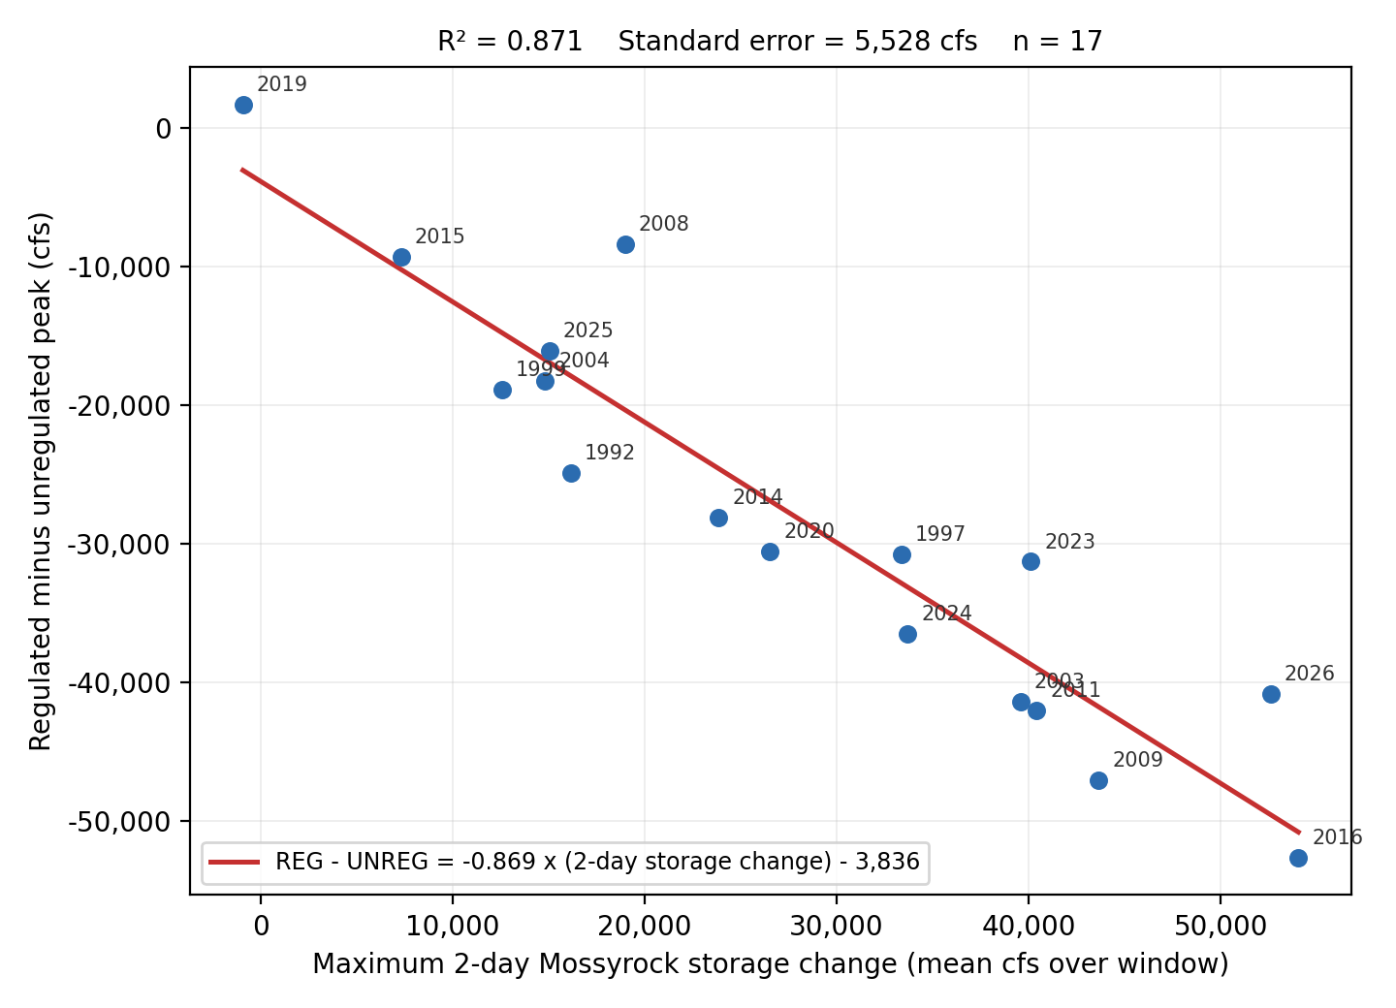
Figure 4-1. Adopted two-day storage-change regression. Points are labeled by water year.

4.3 Durations from the Daily Mass Balance
Daily unregulated flow is the observed daily flow plus the daily change in Mossyrock storage as a flow rate. No routing is applied since Mayfield-to-Castle Rock travel time is under a day. The 1-day duration flow is calculated from an hourly record, when available, to catch peaks that include midnight values. When no hourly data is available the 1-Day duration is calculated from daily values. The 3-Day and 5-Day durations were calculated from daily data.

4.4 Pre-Regulation Period
Before December 1968 the gage record is unregulated as observed. Peaks for water years 1927–1968 are the USGS observed instantaneous annual peaks (42 water years), and the 1-, 3-, and 5-day values are rolling maxima from the USGS daily record. Water year 1927 carries a peak only; the daily record begins later.

4.5 Record Extension and Historical Floods
Correlation-based extension from a nearby gage was considered but no suitable donor was found. Nearby long-record gages either do not predate Castle Rock by much, are themselves regulated over the period that would be used, or do not correlate strongly enough to justify the added estimation error. With roughly a century of systematic record already in hand, the potential gain was small. A search of USGS qualification codes, the 2009 Restudy, and published USGS/NWS accounts of major southwest Washington floods turned up no pre-1927 event at Castle Rock that could be quantified or reliably bounded, so no historical events or Bulletin 17C perception thresholds were used.

4.6 Assembled Record
For water years 1927–1968 the record is the observed gage record; for 1974–2026 the peak is the hourly holdout where available and the regression estimate otherwise, the 1-day value follows the same split, and the 3- and 5-day values always come from the daily mass balance (Table 4-3, Appendix A). Coverage runs from WY1927 through WY2026 except for WY1969–1973, which have no daily Mossyrock elevation record. Every included water year has a peak.
Duration | Values | Sources
Peak | 95 | 42 pre-regulation USGS peaks; 30 storage-change regression; 23 hourly holdout
1-Day | 94 | 41 pre-regulation USGS daily; 30 daily mass balance; 23 hourly holdout
3-Day | 94 | 41 pre-regulation USGS daily; 53 daily mass balance
5-Day | 94 | 41 pre-regulation USGS daily; 53 daily mass balance
Table 4-3. Assembled record, values and sources by duration.

4.7 Consistency Review
A shorter-duration flow lower than a longer-duration flow for a single peaked event is physically impossible but can result from methodological edge cases. Fifteen inconsistencies appeared, fourteen from a source mismatch (typically a regression-estimated peak below the same year's mass-balance 1-day value) and one, WY2014, from a double-peaked March event whose 5-day window spans both peaks while no 3-day window can. The record was made monotonic by anchoring each water year at its 5-day value and raising each shorter duration wherever a longer one exceeds it, cascading upward. Ten values across nine water years were raised , eight of them regression-estimated peaks lifted to their 1-day value, with the largest changes, 64, 19, and 19 percent, in WY2001, 1985, and 2006, all among the smallest years in the record that do not strongly influence the upper end of the final frequency curves.

4.8 Flow Frequency Analysis
The assembled record was analyzed in HEC-SSP with the Bulletin 17C expected moments algorithm, fitting a log-Pearson Type III distribution to each duration and weighting station skew against a published regional value of −0.07 for the peak (Mastin, 2016), and 0.09 / 0.07 / 0.00 for the 1-, 3-, and 5-day durations (Lind, 2020). The 5-day value is interpolated between that study's bracketing 3- and 7-day regional skews.
Water years 1969–1973 have observed regulated peaks but no unregulated basis, so rather than omit them (shortening the record) or assign point estimates (asserting unsupported values), they were entered as censored: the peak analysis reports 95 systematic events within a 100-year period, with five flagged missing. No low outliers were identified by the multiple Grubbs-Beck procedure. The unregulated series is constructed rather than gaged, so its small years carry the same provenance as its large ones and there is no physical basis for treating the lower tail as unrepresentative.
Station skews are slightly negative for every duration (−0.158 to −0.054); weighting against the regional values gives adopted skews of −0.135, −0.052, −0.009, and −0.031 for the peak, 1-, 3-, and 5-day durations, with equivalent record lengths of 100–112 years after censoring. Table 4-4 gives the fitted parameters and event counts; Figure 4-2 shows the four adopted curves. Individual curves with confidence limits and plotted observations appear in Appendix C, and the full ordinates in Appendix B.
Parameter | Peak | 1-Day | 3-Day | 5-Day
Mean of logs | 4.778 | 4.743 | 4.660 | 4.593
Standard deviation of logs | 0.202 | 0.203 | 0.192 | 0.179
Station skew | -0.158 | -0.152 | -0.076 | -0.051
Regional skew | -0.07 | 0.09 | 0.07 | 0.00
Weighted skew | -0.135 | -0.052 | -0.007 | -0.029
Adopted skew | -0.135 | -0.052 | -0.009 | -0.031
Mean square error, at-site skew | 0.064 | 0.064 | 0.060 | 0.059
Grubbs-Beck critical value | 0 | 0 | 0 | 0
Equivalent record length (years) | 103.7 | 100.4 | 106.3 | 112.0
Systematic events | 95 | 94 | 94 | 94
Historical events | 0 | 0 | 0 | 0
High outliers | 0 | 0 | 0 | 0
Low outliers | 0 | 0 | 0 | 0
Zero events | 0 | 0 | 0 | 0
Missing events | 5 | 5 | 5 | 5
Historical period (years) | 100 | 99 | 99 | 99
Table 4-4. Distribution parameters and event counts, adopted HEC-SSP analyses.
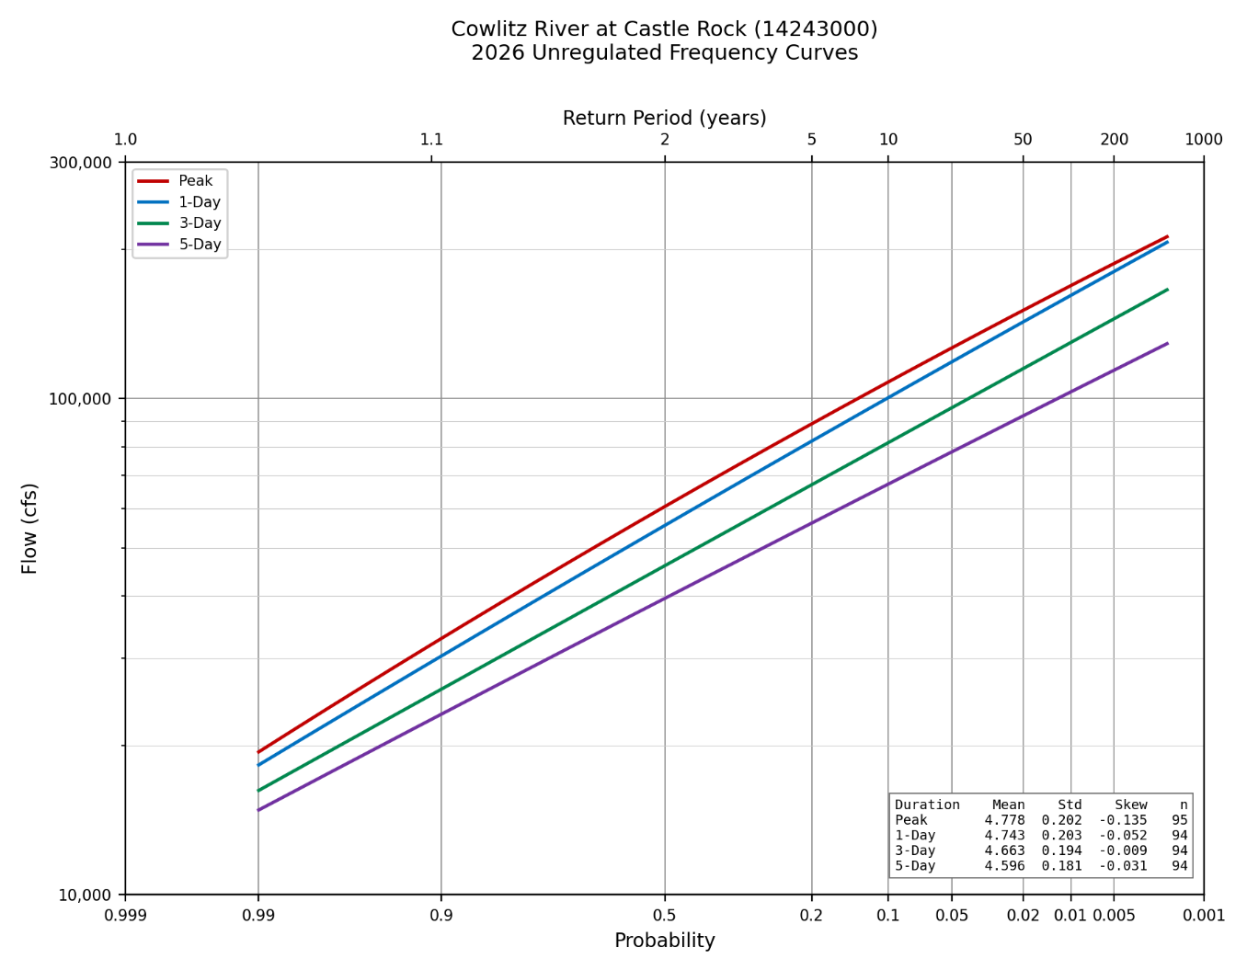
Figure 4-2. Adopted unregulated frequency curves at Castle Rock, water years 1927 through 2026, all four durations.

5. Regulated Flow Frequency
The regulated peak flow frequency curve is developed from observed regulated flows corrected to assume the reservoir operated to maintain the minimum conservation elevation. This assumption is necessary to create a homogenous record and is conservative because Mossyrock has frequently drafted deep into the power pool throughout the period-of-record resulting in flood storage that is not guaranteed. The adjusted regulated peaks (5.1) are paired with the unregulated peak of the same event (5.2). Synthetic floods are used to estimate extreme events not observed in the period of record (5.3). The final regulated frequency curve is developed by mapping regulated flows to the peak unregulated frequency curve (5.4–5.5).

5.1 Adjusted Regulated Peak Record
The observed Mossyrock record shows the reservoir frequently drafted below the flood-pool minimum, so a peak from a year that started low understates the attenuation the project would provide from its full flood-control authority. Two period-of-record ResSim simulations, using the same observed hydrology and current release rules and differing only in starting pool, one from the WCM rule curve, one from the observed elevation at event onset, isolate that effect. Where the rule-curve start yields the higher regulated peak, the difference is added to the observed peak. The adjustment is one-sided, since a negative difference means the historical operation was already at least as conservative as the rule curve requires.
adjusted peak = observed peak + (simulated RC-start peak − simulated observed-start peak), where the RC-start peak is higher
Of the fifty-one water years (1974–2024) were assessed, 38 received an adjustment (median 11,334 cfs, range 263–24,013). Screening removed 10, 7 for a timing mismatch between the observed and simulated peaks, 2 where the regulated peak exceeded the unregulated peak (physically only possible if release exceeds inflow during a large flood), and 1 for both. WY1980 is excluded outright because its peak is the result of the Mount St. Helens lahar.

5.2 Critical Duration
Mapping a regulated flow onto the unregulated curve requires choosing which unregulated duration corresponds to the regulated peak (Table 5-1, Figure 5-1). Both the instantaneous peak and the 1-day duration are strong predictors. The peak unregulated flow is adopted for the transform.
Duration | n | R² | Log R² | Log slope
Peak (1-hr) | 44 | 0.870 | 0.847 | 0.602
1-Day | 44 | 0.853 | 0.830 | 0.605
3-Day | 44 | 0.792 | 0.783 | 0.633
5-Day | 44 | 0.733 | 0.734 | 0.663
Table 5-1. Adjusted regulated against unregulated flow by duration, water years 1974 through 2024.
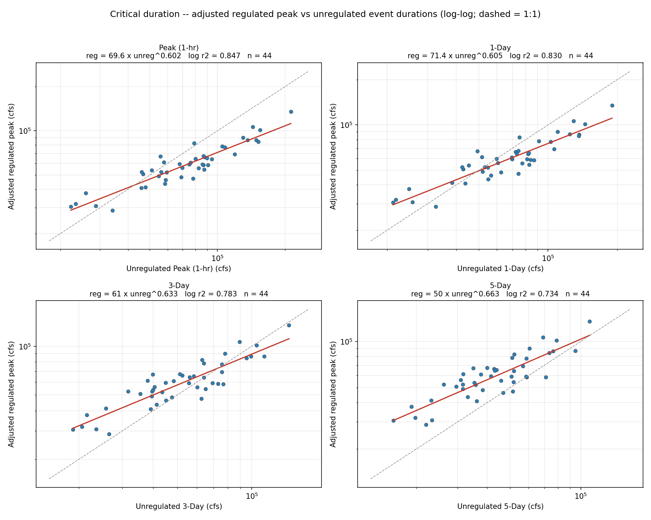
Figure 5-1. Adjusted regulated against unregulated flow, by duration.

5.3 Synthetic Flood Ensembles
Only one water year in the record exceeds the unregulated 100-year peak, so the part of the unregulated-regulated relationship that sets the 100-, 250-, and 500-year regulated flows is essentially unconstrained by observed events. Synthetic floods are created by scaling the largest 12 events ranked by their unregulated flow estimate at Castle Rock and scaled to target the 100-, 250-, and 500-year unregulated peaks, plus a fourth that is 20 percent above the 500-year, resulting in 48 synthetic events of varying shapes and sizes.
Each source storm is scaled to hit its target unregulated peak and 5-day volume (within 5 percent), with Mossyrock inflow and Castle Rock local scaled by the same factor to preserve the observed coincidence. The events span regulated peaks of 80,884–266,744 cfs and attenuation ratios of 0.46–1.00.
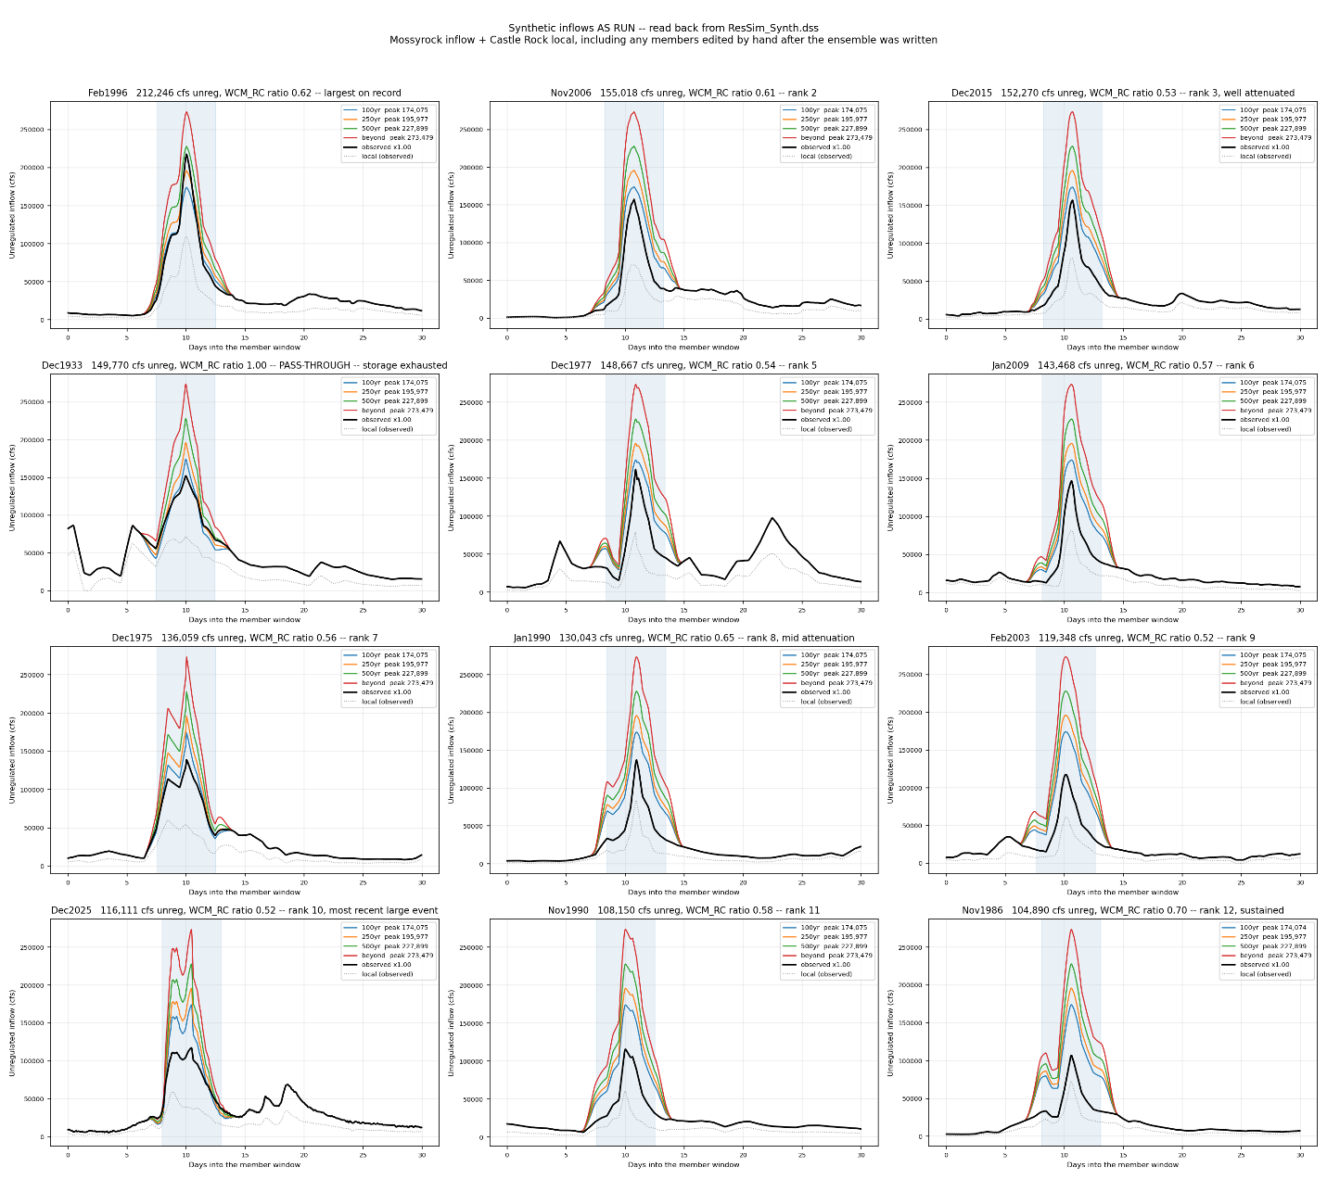
Figure 5-2. Source storms and the scaled family built from each. The shaded band is the window over which the 5-day volume is matched.

5.4 The Unregulated-Regulated Transform
The regulated frequency curve is drawn through the observed and synthetic regulated flows with a locally weighted regression. The adjusted historical pairs (observed range) and the routed synthetic members (range above it) together give the (unregulated, regulated) pairs the transform is drawn through a locally weighted regression. The curve is constrained to increase monotonically and clipped at the 1:1 line since a regulated peak during a large event exceeding the regulation goal at Castle Rock would not exceed the unregulated peak.
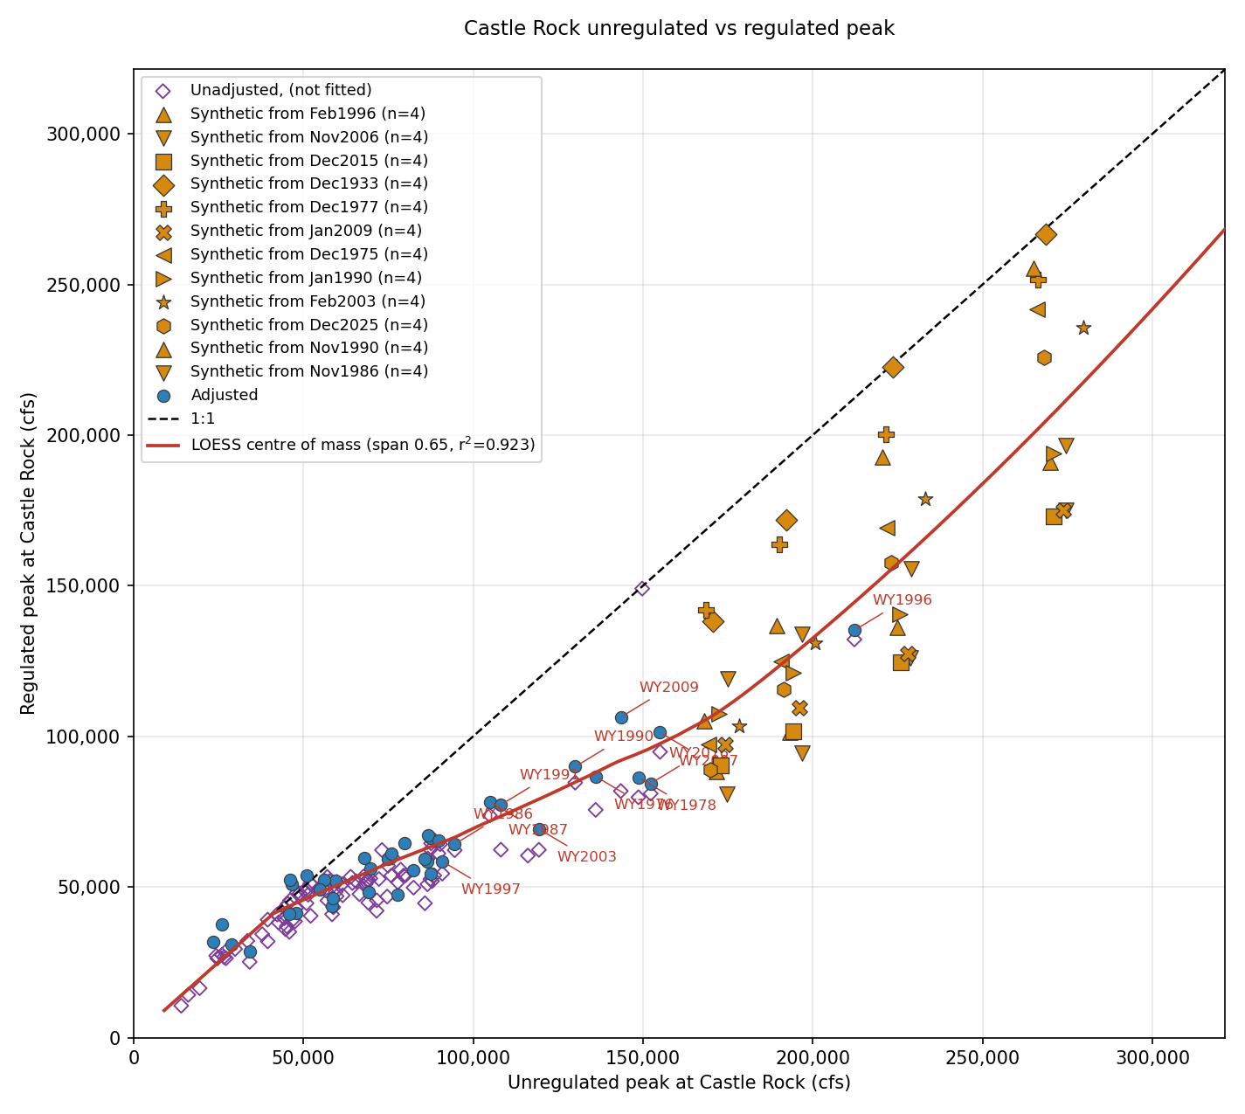
Figure 5-3. Unregulated against regulated peak at Castle Rock.

Mossyrock's ability to cut a Castle Rock peak depends on the event's shape and starting pool, not magnitude alone, so the maximum regulation capacity of the reservoir must be estimated. Figure 5-4 extrapolates the unregulated to regulated relationship before graphically estimating the transition to the 1:1 line where the flows about the peak of the event are passed without regulation because the reservoir is assumed to be completely filled.

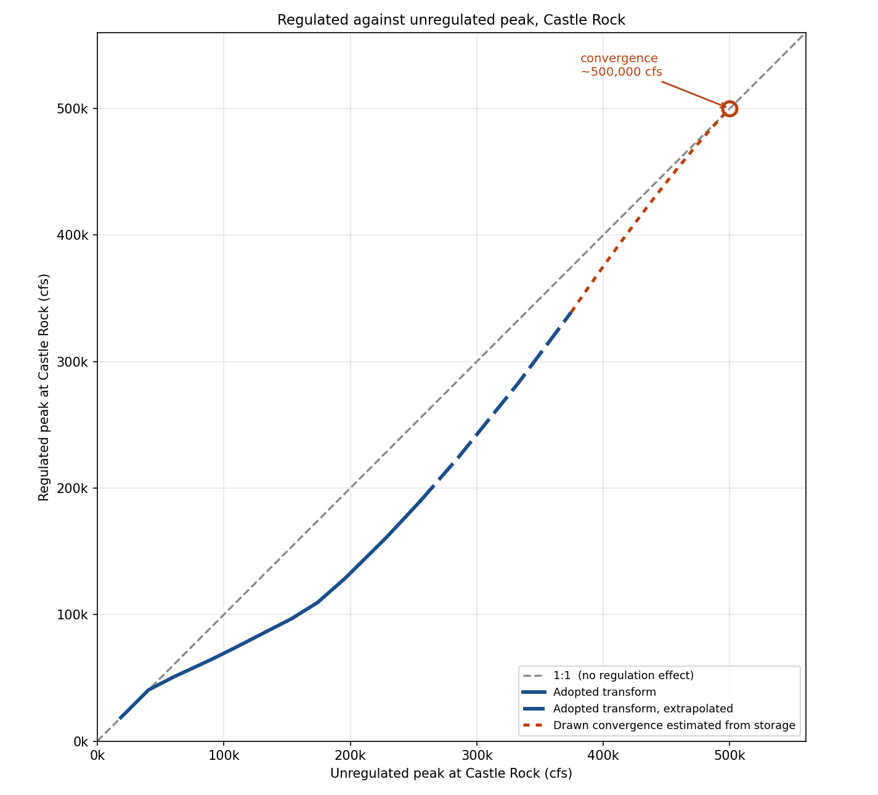
Figure 5-4. Regulated against unregulated peak at Castle Rock, with the transform drawn converging on the 1:1 line. The convergence limb is estimated based on available flood storage.

5.5 Regulated Frequency Curve
Each ordinate of the adopted unregulated curve is read through the transform, inheriting its AEP. The regulated flow at a given AEP is what the projects produce from the unregulated flow of that AEP (Table 5-2). Mossyrock reduces the peak about 37 percent near the 1–2 percent AEP. The reduction is smaller at more frequent flows, where events are already largely contained, and at rarer flows, where storage is exhausted and the project must release more to avoid overtopping diminishing to about 26 percent at 0.1 percent AEP.
Event | AEP | Unregulated (cfs) | Regulated (cfs) | Reduction | Regulated, 95% band (cfs)
2-year | 0.500 | 60,529 | 50,813 | 16% | 37,799 – 62,798
10-year | 0.100 | 108,618 | 73,702 | 32% | 54,120 – 95,468
50-year | 0.020 | 153,556 | 96,784 | 37% | 62,569 – 158,023
100-year | 0.010 | 174,075 | 109,522 | 37% | 67,455 – 187,199
200-year | 0.005 | 195,977 | 128,798 | 34% | 76,214 – 228,500
500-year | 0.002 | 227,900 | 160,342 | 30% | 91,937 – 292,518
1000-year | 0.001 | 255,074 | 189,434 | 26% | 107,941 – 352,665
Table 5-2. Adopted regulated frequency curve at Castle Rock.
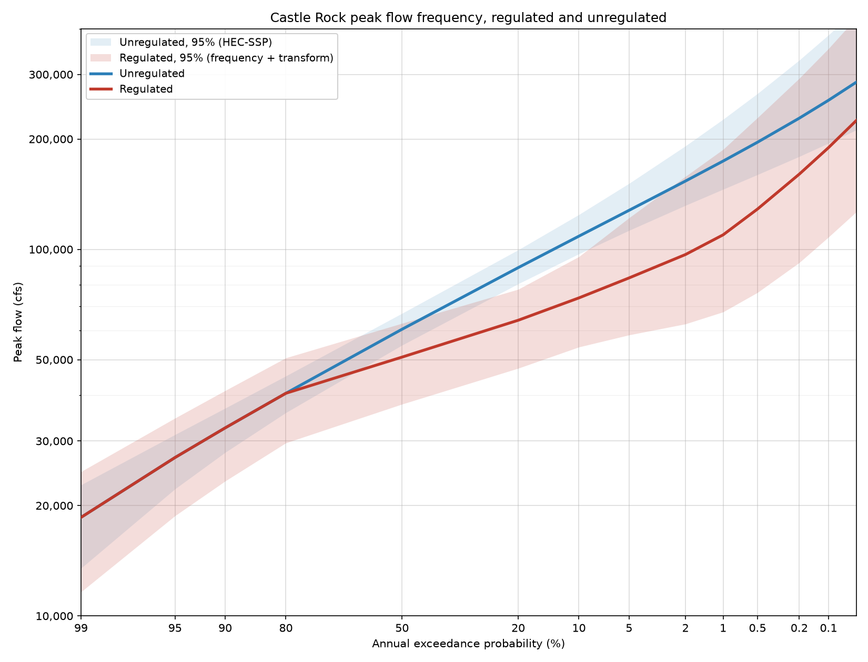
Figure 5-4. Adopted regulated and unregulated frequency curves at Castle Rock.

5.6 Uncertainty
The regulated flow at a given AEP carries uncertainty from two independent sources, the unregulated frequency estimate itself, and the scatter of the transform about its fitted line. Uncertainty from the unregulated frequency analysis is carried through to the regulated curve following EM 1110-2-1619 (UACE, 2025). The uncertainty band is treated as Normal on the upper and lower side of its best estimate separately which preserves the real asymmetry in both the HEC-SSP confidence limits.
The adopted band at the 95 percent two-sided level (z = 1.960):
Upper = RegBest + √[(Unreg97.5 − Unreg_best)² + (Transform97.5 − Transform_best)²]
Lower = RegBest − √[(Unreg_best − Unreg2.5)² + (Transform_best − Transform2.5)²]
The regulated upper bound is held at or below the unregulated upper bound above 60,000 cfs, since a regulated flood cannot exceed the unregulated flood it was routed from when Castle Rock is above its 50,000–70,000 cfs regulation goal. Below that threshold the project may release more than inflow to regain flood storage.

6. Comparison with the 2009 Restudy

6.1 Unregulated Curves
Figure 6-1 places the adopted unregulated curves against the 2009 Cowlitz Hydrology Restudy. The 2009 study adhered to Bulletin 17B and a period of record spanning most of 1927-2009 whereas the current study used Bulleting 17C, added 17 years of peaks to the record, and benefited from an updated regional skew study. The two studies agree within about 3 percent at the median and diverge at the tails. The 2009 adopted positive skews (0.140–0.193) that bend its curves upward in the tail, whereas the adopted skews here are near zero or negative.
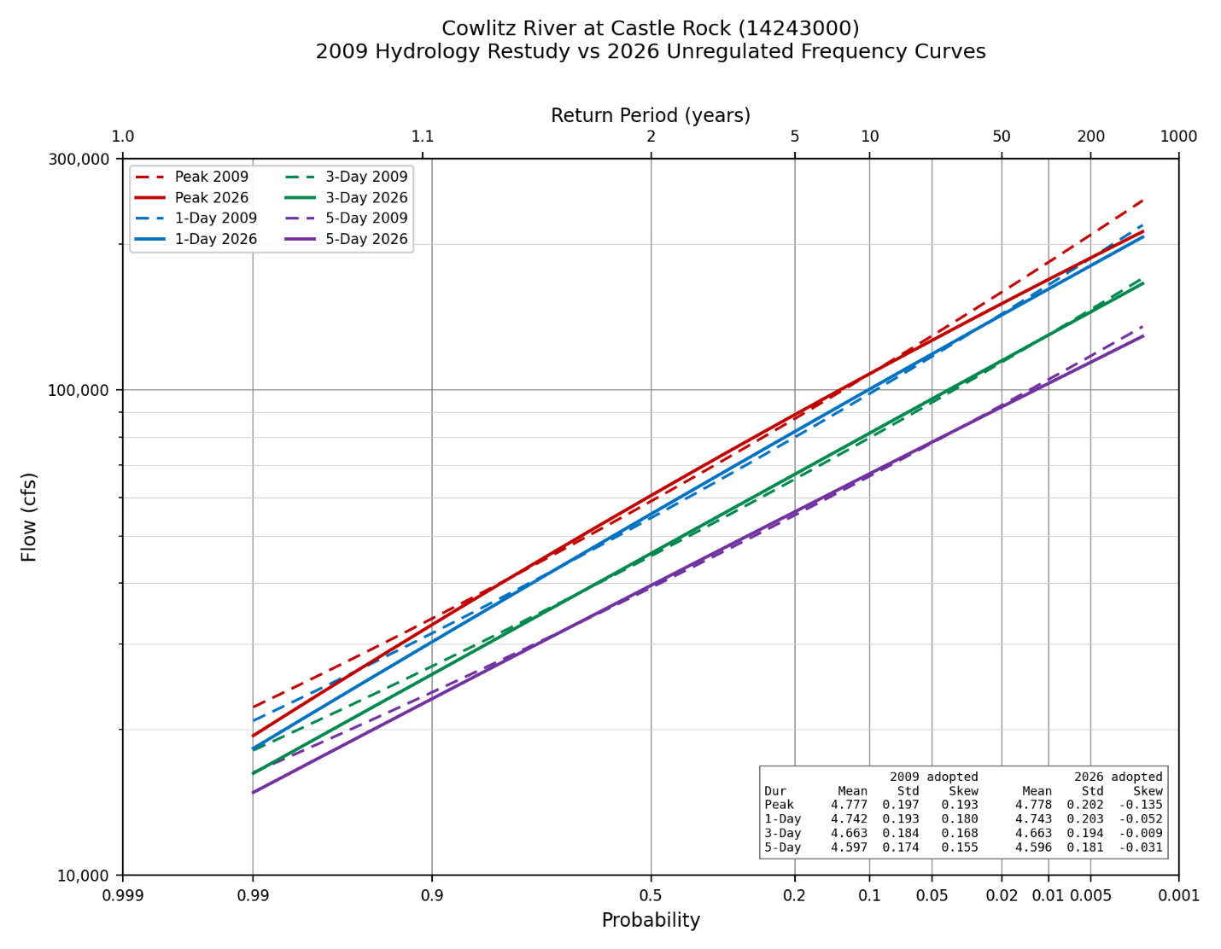
Figure 6-1. Adopted 2026 unregulated curves (solid) against the 2009 Cowlitz Hydrology Restudy (dashed).

6.2 Regulated Curve
Figure 6-2 places the adopted regulated curve against the 2009 Restudy. The most notable divergence occurs beyond the 0.2 percent AEP when the 2009 regulated curve sharply approaches the unregulated curve. The 2009 study relied on the shape 1933 event as the sole starting point for synthetic storm development, which, as noted in section 5.5, has a shape that is likely to cause the reservoir to fill and spill. The current study scaled 12 events, including the 1933 event, to produce synthetics of varying shapes and found the 1933 event response to be atypical compared to other events with different shapes but similar peak and 5-day volumes that the reservoir was more successful in regulating. Uncertainty was not defined for the 2009 regulated curve since only one synthetic event was simulated per AEP at the upper tail and the curve was fit directly through those points and then hand drawn to converge with the unregulated curve.
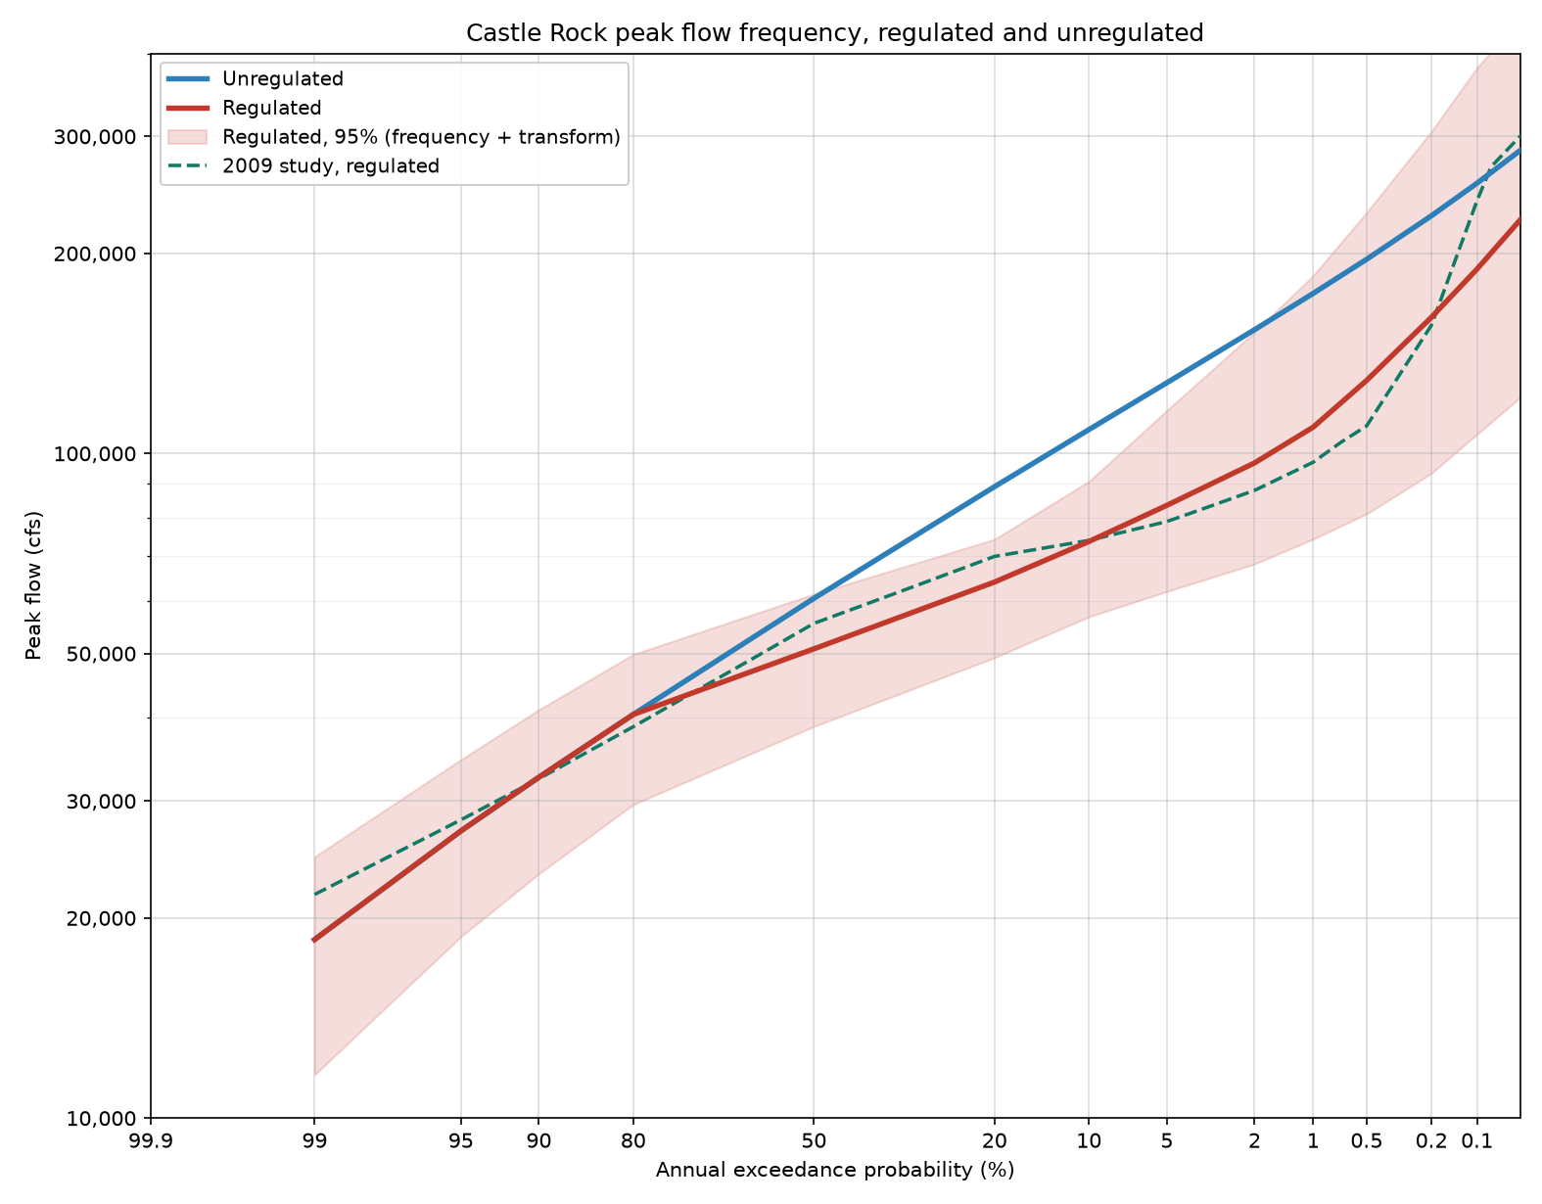
Figure 6-2. Adopted 2026 regulated curve against the 2009 Cowlitz Hydrology Restudy.
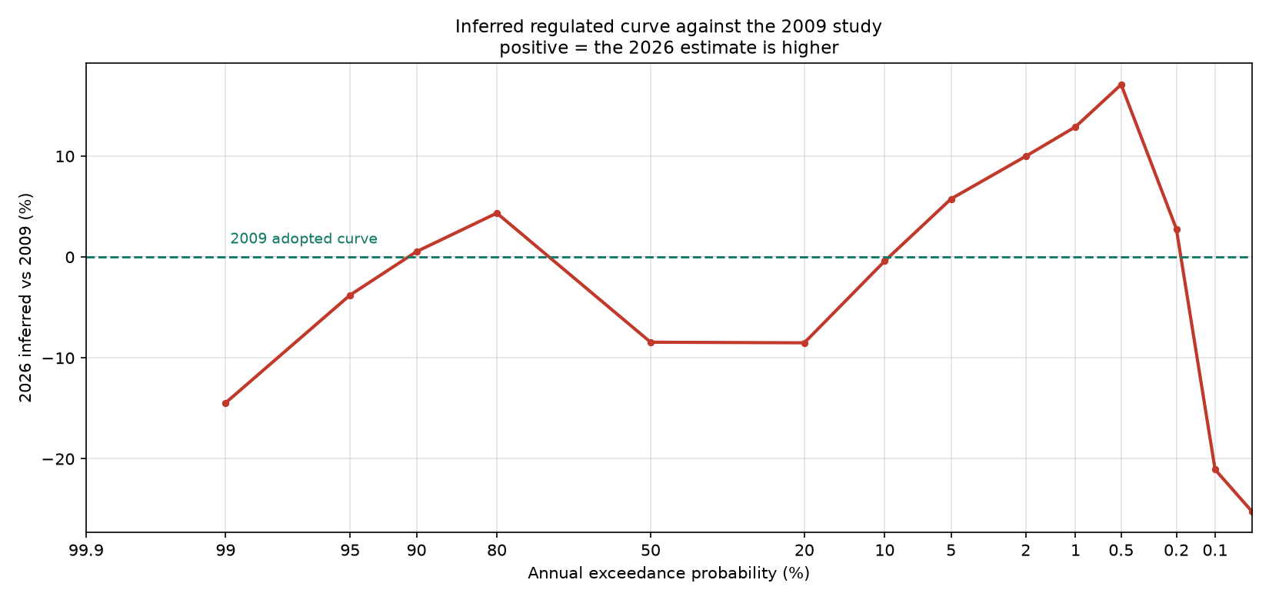
Figure 6-3. Percent change between the 2026 and 2009 regulated curves.
The transform is supported by data over the unregulated range of roughly 23,000–280,000 cfs. Its upper part rests entirely on synthetic events built by scaling observed storms, and hydrograph shape is not independent of size. A large storm is large because it was widespread and sustained, so scaling a moderate storm to a rare magnitude routes a shape that the storm never produced. Six of the twelve source storms are scaled past a factor of two to reach the largest target and should be read as the weaker evidence in the set.
The adjusted regulated record carries its own caveats: thirteen adjustments land within a narrow band near 14,000 cfs, more likely a fixed release constraint binding in one simulation and not the other than a pure starting-pool effect; seven adjustments exceed 40 percent of the observed peak, all moderate-peak years where a large absolute adjustment is a large fraction, influencing the lower end of the transform more than the upper.

8. Extension Downstream to the Coweeman Confluence
The regulated frequency curve developed above applies at the Castle Rock gage, which drains 2,229 square miles. Between that gage and the Coweeman River confluence the Cowlitz picks up 247 square miles of additional drainage from Arkansas Creek, Ostrander Creek, the Coweeman River, and the ungaged local area along both banks. This section develops regulated peak frequency curves at each of those points.
The contribution of local frlow from a drainage area below Castle Rock to the regulated peak flow on the Cowlitz is estimated in stwo steps. First, the unregulated flow is estimated using a drainage area ratio comparing the local drainage area to that of Castle Rock. Once the unregulated flow is estimated, it is then scaled to account for peak runoff timing effects resulting from the mainstem Cowlitz peak being delayed by reservoir regulation and larger basin attenuation.

8.1 Method
The local flow contribution of a drainage area below Castle Rock to the regulated peak flow is estimated by first estimating the unregulated flow using a drainage area ratio and then scaling that unregulated flow to account for the lag in the peak of the mainstem resulting from reservoir regulation which because the peak regulated flow of the basin lags due to regulation and attenuation of the storm resulting from the large basin size.

8.2 Local Contribution by Drainage Area
A plain drainage area ratio is adopted, with no unit-runoff adjustment. Coweeman peak unregulated flows for large events are roughly proportional to the drainage area ratio and PRISM annual total precipitation was found to be similarly proportional supporting the drainage area scaling approach.
Location | Drainage area (sq mi) | Incremental (sq mi) | Local as % of gage
Castle Rock gage | 2,238 | — | —
Below Arkansas Creek | 2,278 | 58 | 2.6%
Below Ostrander Creek | 2,335 | 115 | 5.1%
Below Coweeman River | 2,476 | 256 | 11.4%
Table 8-1. Drainage area at each location.

8.3 Timing Adjustment
The tributaries do not crest when the regulated Cowlitz does. They peak first and are already receding when the regulated mainstem arrives, so only part of each tributary peak is present at the moment that governs the combined flow. Measuring the Coweeman flow at the hour of the regulated Castle Rock crest, as a fraction of its own peak in the same storm over 78 events (multiple events per year were assessed) resulted in an average scaling factor of 0.79. Larger events suggested a larger lag time resulting in a smaller local flow contribution, but the sample size was small so a scaling factor of 0.8 matching what was used in the 2009 stdy.
Castle Rock unregulated peak | Events | Median ratio
20,000–40,000 cfs | 52 | 0.81
40,000–60,000 cfs | 19 | 0.78
Above 60,000 cfs | 7 | 0.41
All events | 78 | 0.79
Table 8-2. Coweeman flow at the regulated Castle Rock crest, as a fraction of its own event peak.

8.4 Results
Regulated peak flows in table 8-3 are calculated as:
Q_{AEP} = AEP_{CAS} * 0.8 * DA_{LOCAL} / DA_{CAS}
Complete ordinates with confidence limits are in Appendix F.
AEP | Castle Rock gage | Below Arkansas | Below Ostrander | Below Coweeman
10% | 73,702 | 75,602 | 77,812 | 83,280
2% | 96,784 | 99,433 | 102,515 | 110,137
1% | 109,522 | 112,492 | 115,947 | 124,494
0.5% | 128,798 | 132,092 | 135,923 | 145,401
0.2% | 160,342 | 164,069 | 168,404 | 179,129
0.1% | 189,434 | 193,494 | 198,218 | 209,902
Table 8-3. Regulated peak flow at each location, cfs.
At the 1,000-year event the local contribution below the Coweeman confluence is 20,468 cfs, raising the regulated peak 10.8 percent above the gage. The increase is proportionally largest in the middle of the range, near the 2 percent event, and falls away in the extreme tail: the regulated curve steepens there as the projects lose the ability to hold back a rare inflow, while the local term grows only with the flatter unregulated curve.
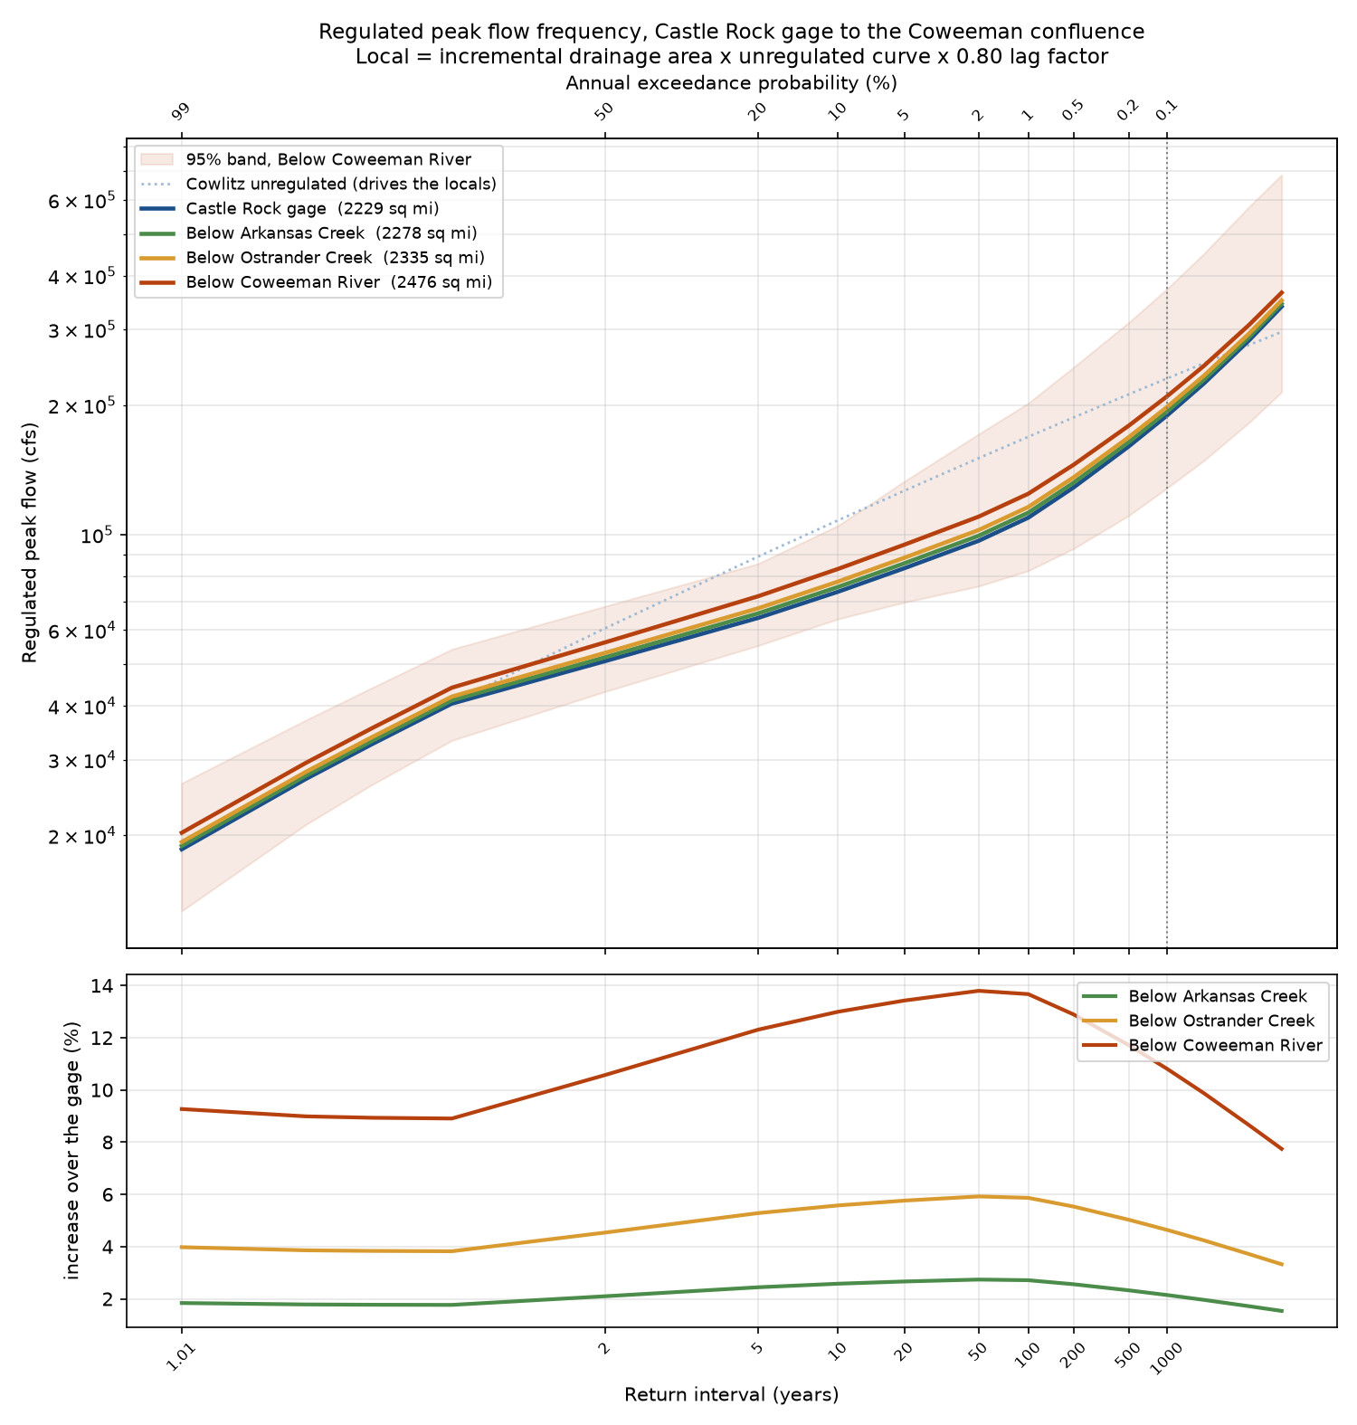
Figure 8-1. Regulated peak flow frequency at all four locations. The local contribution at each site is the incremental drainage area scaled off the unregulated curve and reduced by the 0.80 timing factor. The lower panel gives each site as a percentage increase over the gage.
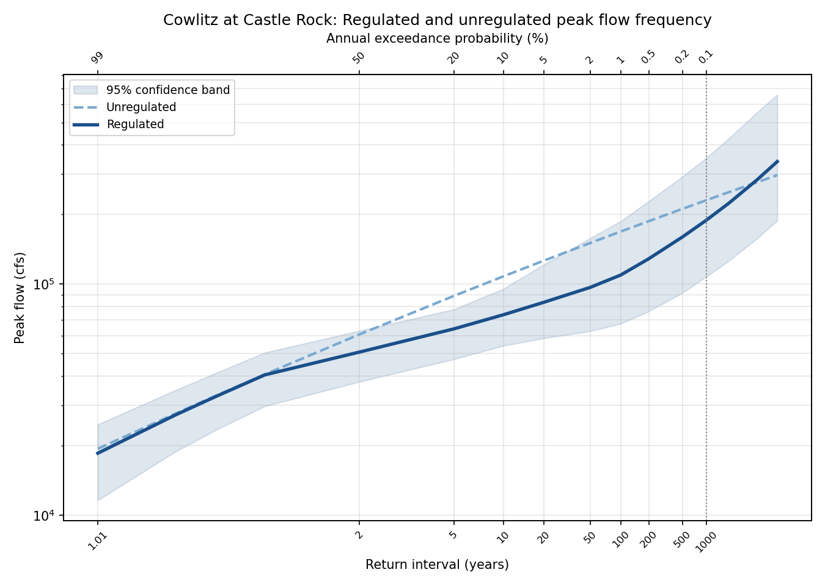
Figure 8-2. Cowlitz at Castle Rock regulated and unregulated flow frequency
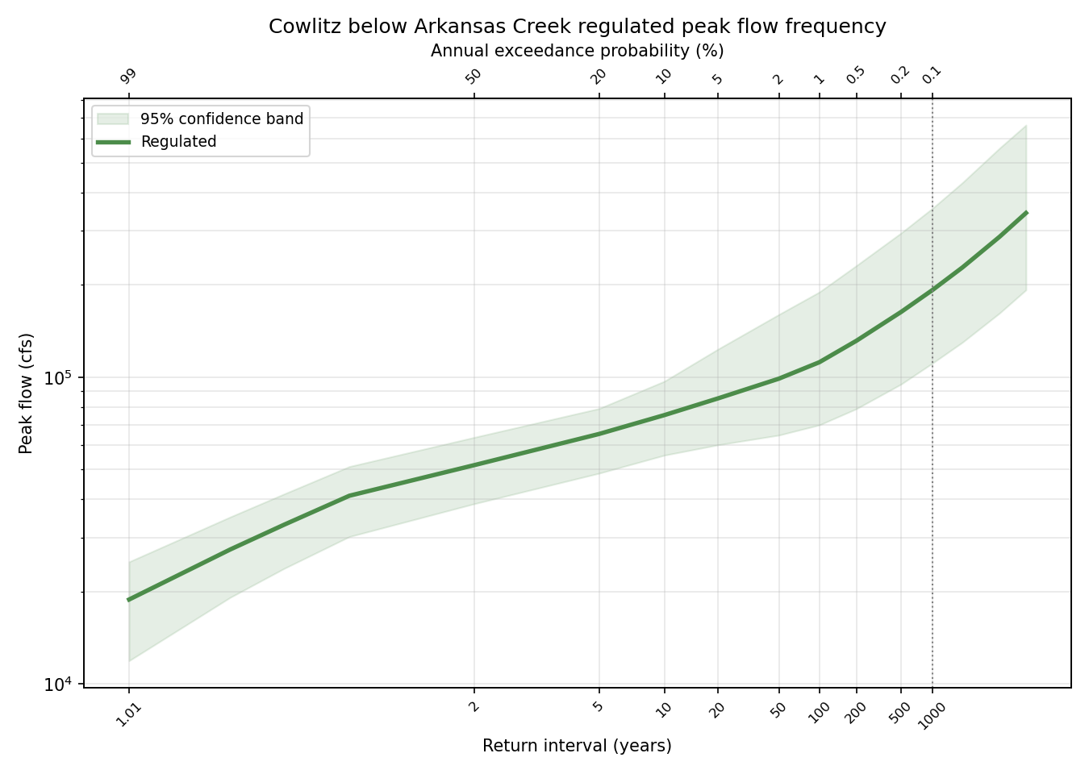
Figure 8-3. Cowlitz Below Arkansas Creek, regulated flow frequency.
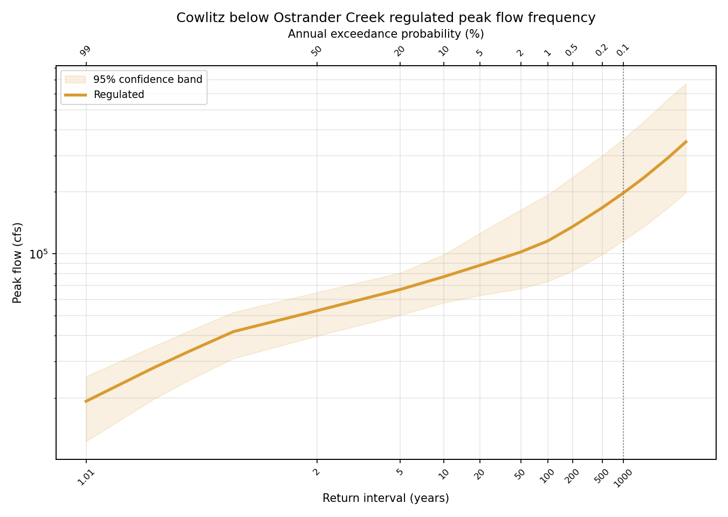
Figure 8-4. Cowlitz Below Ostrander Creek, regulated flow frequency.
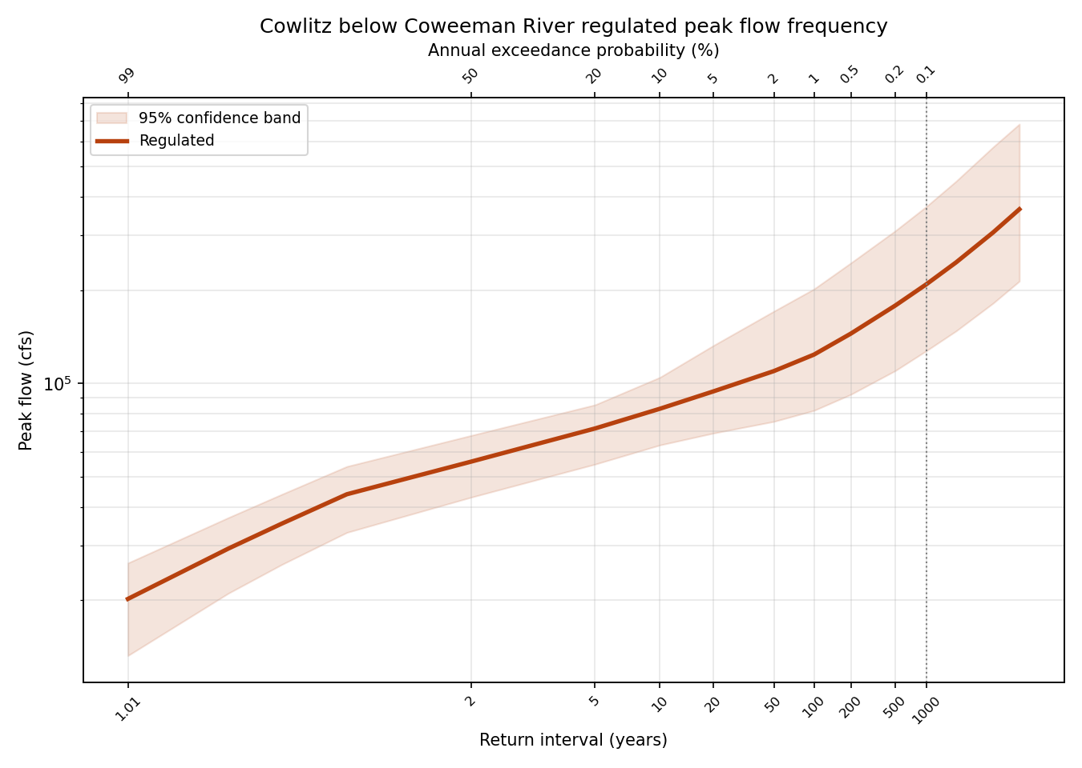
Figure 8-5. Cowlitz Below the Coweeman River, regulated flow frequency.

Appendix A. Assembled Unregulated Record by Water Year
Flows are in cubic feet per second. Source abbreviations: USGS peak, the observed instantaneous annual peak; USGS daily, rolling maxima of the observed daily record; Holdout, the hourly unregulated record from the Mossyrock holdout; Regression, the two-day storage-change relation; Mass balance, the daily unregulated series.
WY | Peak | Peak source | 1-Day | 1-Day source | 3-Day | 5-Day | Duration source
1927 | 41,100 | USGS peak | — | — | — | — | —
1928 | 74,000 | USGS peak | 71,300 | USGS daily | 56,933 | 47,940 | USGS daily
1929 | 21,800 | USGS peak | 21,100 | USGS daily | 19,633 | 18,980 | USGS daily
1930 | 30,200 | USGS peak | 29,500 | USGS daily | 26,700 | 23,840 | USGS daily
1931 | 65,900 | USGS peak | 63,200 | USGS daily | 51,200 | 40,760 | USGS daily
1932 | 50,800 | USGS peak | 49,200 | USGS daily | 44,467 | 39,140 | USGS daily
1933 | 53,000 | USGS peak | 52,200 | USGS daily | 44,467 | 43,900 | USGS daily
1934 | 139,000 | USGS peak | 134,000 | USGS daily | 120,333 | 106,300 | USGS daily
1935 | 61,800 | USGS peak | 58,100 | USGS daily | 53,800 | 45,540 | USGS daily
1936 | 48,200 | USGS peak | 39,800 | USGS daily | 35,833 | 31,400 | USGS daily
1937 | 49,000 | USGS peak | 47,200 | USGS daily | 40,167 | 34,640 | USGS daily
1938 | 62,900 | USGS peak | 60,500 | USGS daily | 53,567 | 47,440 | USGS daily
1939 | 43,600 | USGS peak | 39,800 | USGS daily | 29,867 | 27,840 | USGS daily
1940 | 41,900 | USGS peak | 40,500 | USGS daily | 36,767 | 31,660 | USGS daily
1941 | 26,400 | USGS peak | 22,100 | USGS daily | 19,633 | 16,038 | USGS daily
1942 | 58,100 | USGS peak | 55,400 | USGS daily | 47,067 | 39,400 | USGS daily
1943 | 60,500 | USGS peak | 58,300 | USGS daily | 46,867 | 39,020 | USGS daily
1944 | 37,100 | USGS peak | 33,700 | USGS daily | 26,467 | 20,760 | USGS daily
1945 | 45,300 | USGS peak | 44,200 | USGS daily | 36,333 | 30,340 | USGS daily
1946 | 54,700 | USGS peak | 51,700 | USGS daily | 45,433 | 38,940 | USGS daily
1947 | 85,100 | USGS peak | 82,400 | USGS daily | 80,767 | 74,880 | USGS daily
1948 | 38,500 | USGS peak | 37,000 | USGS daily | 32,700 | 28,560 | USGS daily
1949 | 51,500 | USGS peak | 43,300 | USGS daily | 30,167 | 28,580 | USGS daily
1950 | 54,800 | USGS peak | 54,000 | USGS daily | 49,933 | 43,920 | USGS daily
1951 | 67,200 | USGS peak | 63,900 | USGS daily | 61,467 | 54,440 | USGS daily
1952 | 41,400 | USGS peak | 35,600 | USGS daily | 31,600 | 28,680 | USGS daily
1953 | 60,000 | USGS peak | 50,000 | USGS daily | 44,000 | 40,400 | USGS daily
1954 | 73,000 | USGS peak | 63,600 | USGS daily | 51,067 | 45,440 | USGS daily
1955 | 50,100 | USGS peak | 43,300 | USGS daily | 33,800 | 29,020 | USGS daily
1956 | 67,400 | USGS peak | 63,100 | USGS daily | 49,733 | 42,260 | USGS daily
1957 | 43,200 | USGS peak | 40,400 | USGS daily | 37,400 | 34,980 | USGS daily
1958 | 35,200 | USGS peak | 34,500 | USGS daily | 30,867 | 27,280 | USGS daily
1959 | 57,800 | USGS peak | 52,900 | USGS daily | 44,733 | 39,140 | USGS daily
1960 | 62,700 | USGS peak | 61,000 | USGS daily | 56,433 | 49,620 | USGS daily
1961 | 64,500 | USGS peak | 59,000 | USGS daily | 46,133 | 43,520 | USGS daily
1962 | 42,100 | USGS peak | 40,100 | USGS daily | 34,833 | 30,240 | USGS daily
1963 | 66,900 | USGS peak | 59,500 | USGS daily | 52,900 | 41,640 | USGS daily
1964 | 72,600 | USGS peak | 55,400 | USGS daily | 46,267 | 37,680 | USGS daily
1965 | 83,900 | USGS peak | 79,100 | USGS daily | 68,933 | 60,120 | USGS daily
1966 | 28,800 | USGS peak | 27,000 | USGS daily | 24,333 | 22,400 | USGS daily
1967 | 65,000 | USGS peak | 58,800 | USGS daily | 48,167 | 38,520 | USGS daily
1968 | 49,500 | USGS peak | 47,600 | USGS daily | 44,633 | 42,600 | USGS daily
1974 | 112,486 | Regression | 112,486 | Mass balance | 92,392 | 74,846 | Mass balance
1975 | 76,896 | Regression | 71,250 | Mass balance | 54,411 | 50,666 | Mass balance
1976 | 124,946 | Regression | 110,190 | Mass balance | 106,676 | 91,422 | Mass balance
1977 | 19,899 | Regression | 16,299 | Mass balance | 14,752 | 14,436 | Mass balance
1978 | 131,885 | Regression | 110,965 | Mass balance | 94,793 | 74,569 | Mass balance
1979 | 51,587 | Regression | 40,506 | Mass balance | 28,000 | 25,107 | Mass balance
1980 | 101,895 | Regression | 42,737 | Mass balance | 37,116 | 32,514 | Mass balance
1981 | 88,345 | Regression | 86,532 | Mass balance | 71,889 | 57,905 | Mass balance
1982 | 84,883 | Regression | 77,900 | Mass balance | 62,871 | 60,342 | Mass balance
1983 | 82,466 | Regression | 72,298 | Mass balance | 55,966 | 52,485 | Mass balance
1984 | 57,352 | Regression | 57,352 | Mass balance | 46,702 | 38,367 | Mass balance
1985 | 33,098 | Regression | 33,098 | Mass balance | 28,765 | 23,969 | Mass balance
1986 | 95,135 | Regression | 83,652 | Mass balance | 62,163 | 52,287 | Mass balance
1987 | 103,298 | Regression | 90,982 | Mass balance | 61,617 | 50,210 | Mass balance
1988 | 61,876 | Regression | 59,525 | Mass balance | 39,029 | 30,728 | Mass balance
1989 | 28,884 | Regression | 23,674 | Mass balance | 21,120 | 19,496 | Mass balance
1990 | 124,824 | Regression | 95,400 | Mass balance | 76,113 | 59,391 | Mass balance
1991 | 110,107 | Regression | 104,020 | Mass balance | 75,569 | 58,070 | Mass balance
1992 | 51,845 | Holdout | 43,323 | Holdout | 38,240 | 35,850 | Mass balance
1993 | 33,272 | Regression | 31,533 | Mass balance | 26,576 | 21,802 | Mass balance
1994 | 26,300 | Regression | 26,300 | Mass balance | 24,710 | 22,556 | Mass balance
1995 | 64,114 | Regression | 59,736 | Mass balance | 48,317 | 39,125 | Mass balance
1996 | 176,855 | Regression | 170,280 | Mass balance | 139,807 | 108,126 | Mass balance
1997 | 86,921 | Holdout | 83,113 | Holdout | 74,563 | 69,706 | Mass balance
1998 | 38,925 | Regression | 30,823 | Mass balance | 23,581 | 22,965 | Mass balance
1999 | 76,193 | Holdout | 68,206 | Holdout | 60,807 | 51,702 | Mass balance
2000 | 73,070 | Regression | 72,890 | Mass balance | 58,190 | 43,549 | Mass balance
2001 | 19,568 | Regression | 19,568 | Mass balance | 15,339 | 14,332 | Mass balance
2002 | 66,027 | Regression | 64,512 | Mass balance | 49,168 | 40,567 | Mass balance
2003 | 109,719 | Holdout | 101,254 | Holdout | 72,896 | 53,892 | Mass balance
2004 | 56,223 | Holdout | 52,144 | Holdout | 43,452 | 34,949 | Mass balance
2005 | 52,859 | Regression | 50,133 | Mass balance | 39,349 | 31,339 | Mass balance
2006 | 74,082 | Regression | 74,082 | Mass balance | 62,808 | 53,945 | Mass balance
2007 | 147,777 | Regression | 147,777 | Mass balance | 100,470 | 73,836 | Mass balance
2008 | 72,455 | Holdout | 70,265 | Holdout | 54,504 | 41,446 | Mass balance
2009 | 151,296 | Holdout | 139,073 | Holdout | 99,324 | 72,961 | Mass balance
2010 | 27,802 | Holdout | 25,172 | Holdout | 24,888 | 23,204 | Mass balance
2011 | 87,160 | Holdout | 85,731 | Holdout | 71,689 | 58,118 | Mass balance
2012 | 57,286 | Holdout | 53,334 | Holdout | 40,865 | 34,419 | Mass balance
2013 | 58,409 | Regression | 47,950 | Mass balance | 36,797 | 30,359 | Mass balance
2014 | 60,268 | Holdout | 57,504 | Holdout | 46,396 | 46,396 | Mass balance
2015 | 47,323 | Holdout | 43,517 | Holdout | 32,555 | 31,664 | Mass balance
2016 | 135,790 | Holdout | 124,896 | Holdout | 92,957 | 72,910 | Mass balance
2017 | 64,342 | Holdout | 62,516 | Holdout | 51,010 | 47,186 | Mass balance
2018 | 54,188 | Holdout | 52,984 | Holdout | 47,285 | 39,300 | Mass balance
2019 | 24,389 | Holdout | 24,389 | Holdout | 24,389 | 22,197 | Mass balance
2020 | 77,812 | Holdout | 73,544 | Holdout | 60,465 | 51,297 | Mass balance
2021 | 61,703 | Holdout | 56,924 | Holdout | 42,829 | 35,700 | Mass balance
2022 | 77,833 | Holdout | 73,803 | Holdout | 60,851 | 50,050 | Mass balance
2023 | 65,623 | Holdout | 61,507 | Holdout | 47,710 | 35,341 | Mass balance
2024 | 81,192 | Holdout | 76,898 | Holdout | 59,644 | 48,589 | Mass balance
2025 | 45,954 | Holdout | 41,975 | Holdout | 35,253 | 30,112 | Mass balance
2026 | 101,833 | Holdout | 97,675 | Holdout | 94,669 | 77,439 | Mass balance
Table A-1. Assembled unregulated record, water years 1927 through 2026.

Appendix B. Unregulated Frequency Curve Ordinates
Computed curve, expected probability curve, variance of the log, and 5 and 95 percent confidence limits for every ordinate reported by HEC-SSP. Flows are in cubic feet per second.
Duration | AEP | Variance of log | z | Computed | 5% limit | 95% limit | Expected probability
Peak | 0.0001 | 0.0098 | 3.72 | 296,088 | 476,290 | 217,104 | 374,643
Peak | 0.0002 | 0.0082 | 3.54 | 276,072 | 426,543 | 207,624 | 332,739
Peak | 0.0005 | 0.0064 | 3.29 | 250,134 | 366,728 | 194,487 | 285,568
Peak | 0.001 | 0.0052 | 3.09 | 230,884 | 325,578 | 184,044 | 255,074
Peak | 0.002 | 0.0041 | 2.88 | 211,932 | 287,635 | 173,114 | 227,900
Peak | 0.005 | 0.0029 | 2.58 | 187,282 | 241,929 | 157,818 | 195,977
Peak | 0.01 | 0.0022 | 2.33 | 168,884 | 210,386 | 145,504 | 174,075
Peak | 0.02 | 0.0016 | 2.05 | 150,625 | 181,177 | 132,434 | 153,556
Peak | 0.05 | 0.0010 | 1.64 | 126,514 | 145,732 | 113,770 | 127,758
Peak | 0.1 | 0.0007 | 1.28 | 108,041 | 121,015 | 98,383 | 108,618
Peak | 0.2 | 0.0005 | 0.84 | 88,923 | 97,624 | 81,626 | 89,126
Peak | 0.5 | 0.0005 | 0.00 | 60,585 | 65,857 | 55,691 | 60,529
Peak | 0.8 | 0.0006 | -0.84 | 40,671 | 44,531 | 36,709 | 40,487
Peak | 0.9 | 0.0009 | -1.28 | 32,826 | 36,401 | 28,836 | 32,573
Peak | 0.95 | 0.0013 | -1.64 | 27,417 | 30,925 | 23,227 | 27,041
Peak | 0.99 | 0.0030 | -2.33 | 19,408 | 23,026 | 14,842 | 18,564
1-Day | 0.0001 | 0.0109 | 3.72 | 299,447 | 479,405 | 221,040 | 386,105
1-Day | 0.0002 | 0.0092 | 3.54 | 276,822 | 426,187 | 209,249 | 338,896
1-Day | 0.0005 | 0.0072 | 3.29 | 247,988 | 362,832 | 193,367 | 286,800
1-Day | 0.001 | 0.0059 | 3.09 | 226,952 | 319,700 | 181,106 | 253,245
1-Day | 0.002 | 0.0047 | 2.88 | 206,550 | 280,306 | 168,605 | 223,780
1-Day | 0.005 | 0.0034 | 2.58 | 180,481 | 233,404 | 151,652 | 189,945
1-Day | 0.01 | 0.0026 | 2.33 | 161,378 | 201,443 | 138,445 | 167,060
1-Day | 0.02 | 0.0019 | 2.05 | 142,727 | 172,189 | 124,837 | 145,949
1-Day | 0.05 | 0.0012 | 1.64 | 118,581 | 137,189 | 106,070 | 119,937
1-Day | 0.1 | 0.0009 | 1.28 | 100,464 | 113,080 | 91,102 | 101,103
1-Day | 0.2 | 0.0006 | 0.84 | 82,073 | 90,457 | 75,165 | 82,324
1-Day | 0.5 | 0.0005 | 0.00 | 55,503 | 60,349 | 51,025 | 55,470
1-Day | 0.8 | 0.0006 | -0.84 | 37,319 | 40,830 | 33,739 | 37,176
1-Day | 0.9 | 0.0008 | -1.28 | 30,257 | 33,490 | 26,713 | 30,053
1-Day | 0.95 | 0.0011 | -1.64 | 25,414 | 28,563 | 21,767 | 25,130
1-Day | 0.99 | 0.0022 | -2.33 | 18,268 | 21,476 | 14,392 | 17,638
3-Day | 0.0001 | 0.0093 | 3.72 | 240,363 | 376,364 | 180,427 | 298,915
3-Day | 0.0002 | 0.0079 | 3.54 | 222,081 | 335,087 | 170,391 | 264,436
3-Day | 0.0005 | 0.0062 | 3.29 | 198,868 | 285,924 | 157,011 | 225,645
3-Day | 0.001 | 0.0051 | 3.09 | 181,994 | 252,436 | 146,786 | 200,289
3-Day | 0.002 | 0.0041 | 2.88 | 165,677 | 221,830 | 136,451 | 177,857
3-Day | 0.005 | 0.0030 | 2.58 | 144,898 | 185,363 | 122,577 | 151,689
3-Day | 0.01 | 0.0023 | 2.33 | 129,717 | 160,485 | 111,876 | 133,835
3-Day | 0.02 | 0.0017 | 2.05 | 114,932 | 137,687 | 100,941 | 117,352
3-Day | 0.05 | 0.0011 | 1.64 | 95,836 | 110,351 | 85,995 | 96,884
3-Day | 0.1 | 0.0008 | 1.28 | 81,533 | 91,456 | 74,157 | 82,033
3-Day | 0.2 | 0.0006 | 0.84 | 67,026 | 73,645 | 61,589 | 67,236
3-Day | 0.5 | 0.0004 | 0.00 | 46,042 | 49,861 | 42,513 | 46,036
3-Day | 0.8 | 0.0005 | -0.84 | 31,599 | 34,399 | 28,743 | 31,493
3-Day | 0.9 | 0.0007 | -1.28 | 25,945 | 28,543 | 23,109 | 25,784
3-Day | 0.95 | 0.0010 | -1.64 | 22,044 | 24,587 | 19,120 | 21,810
3-Day | 0.99 | 0.0020 | -2.33 | 16,230 | 18,847 | 13,097 | 15,706
5-Day | 0.0001 | 0.0085 | 3.72 | 181,018 | 276,627 | 138,058 | 225,377
5-Day | 0.0002 | 0.0072 | 3.54 | 168,477 | 248,520 | 131,223 | 200,703
5-Day | 0.0005 | 0.0057 | 3.29 | 152,387 | 214,676 | 122,003 | 172,807
5-Day | 0.001 | 0.0046 | 3.09 | 140,566 | 191,358 | 114,869 | 154,542
5-Day | 0.002 | 0.0037 | 2.88 | 129,023 | 169,831 | 107,577 | 138,364
5-Day | 0.005 | 0.0027 | 2.58 | 114,149 | 143,861 | 97,651 | 119,354
5-Day | 0.01 | 0.0020 | 2.33 | 103,144 | 125,913 | 89,882 | 106,301
5-Day | 0.02 | 0.0015 | 2.05 | 92,301 | 109,270 | 81,834 | 94,152
5-Day | 0.05 | 0.0010 | 1.64 | 78,089 | 89,024 | 70,643 | 78,888
5-Day | 0.1 | 0.0007 | 1.28 | 67,267 | 74,814 | 61,613 | 67,651
5-Day | 0.2 | 0.0005 | 0.84 | 56,108 | 61,221 | 51,864 | 56,269
5-Day | 0.5 | 0.0004 | 0.00 | 39,563 | 42,625 | 36,714 | 39,551
5-Day | 0.8 | 0.0005 | -0.84 | 27,812 | 30,120 | 25,439 | 27,720
5-Day | 0.9 | 0.0006 | -1.28 | 23,104 | 25,274 | 20,704 | 22,966
5-Day | 0.95 | 0.0008 | -1.64 | 19,810 | 21,961 | 17,294 | 19,612
5-Day | 0.99 | 0.0018 | -2.33 | 14,823 | 17,089 | 12,041 | 14,367
Table B-1. Frequency curve ordinates, all four durations.

Appendix C. Unregulated Frequency Curves by Duration
Individual curves as produced by HEC-SSP: computed curve, expected probability curve, 5 and 95 percent confidence limits, and observed events at Hirsch-Stedinger plotting positions. The peak figure reflects the censored treatment described in Section 4.8.
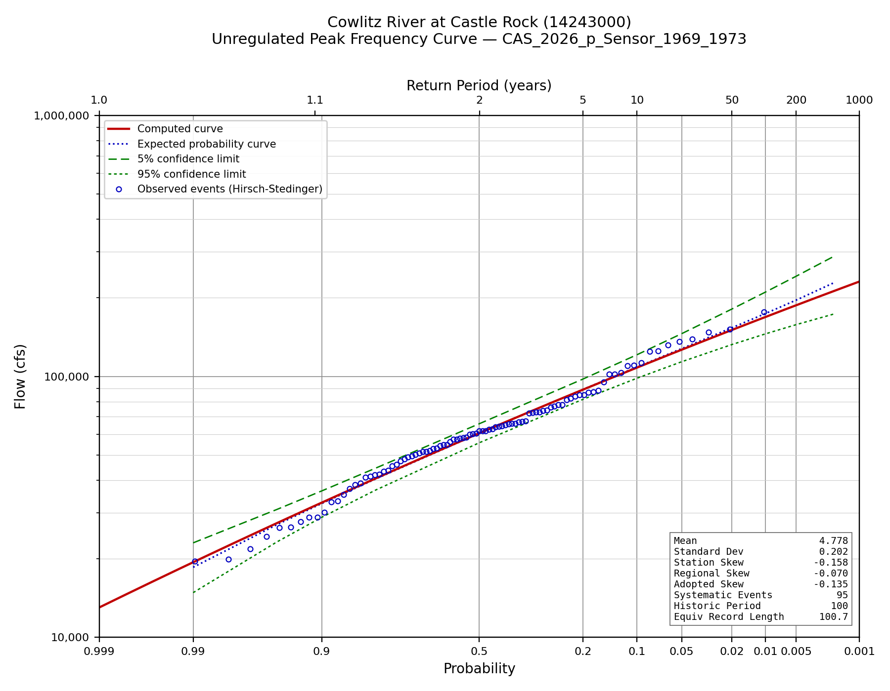
Figure C-1. Unregulated instantaneous peak frequency curve.
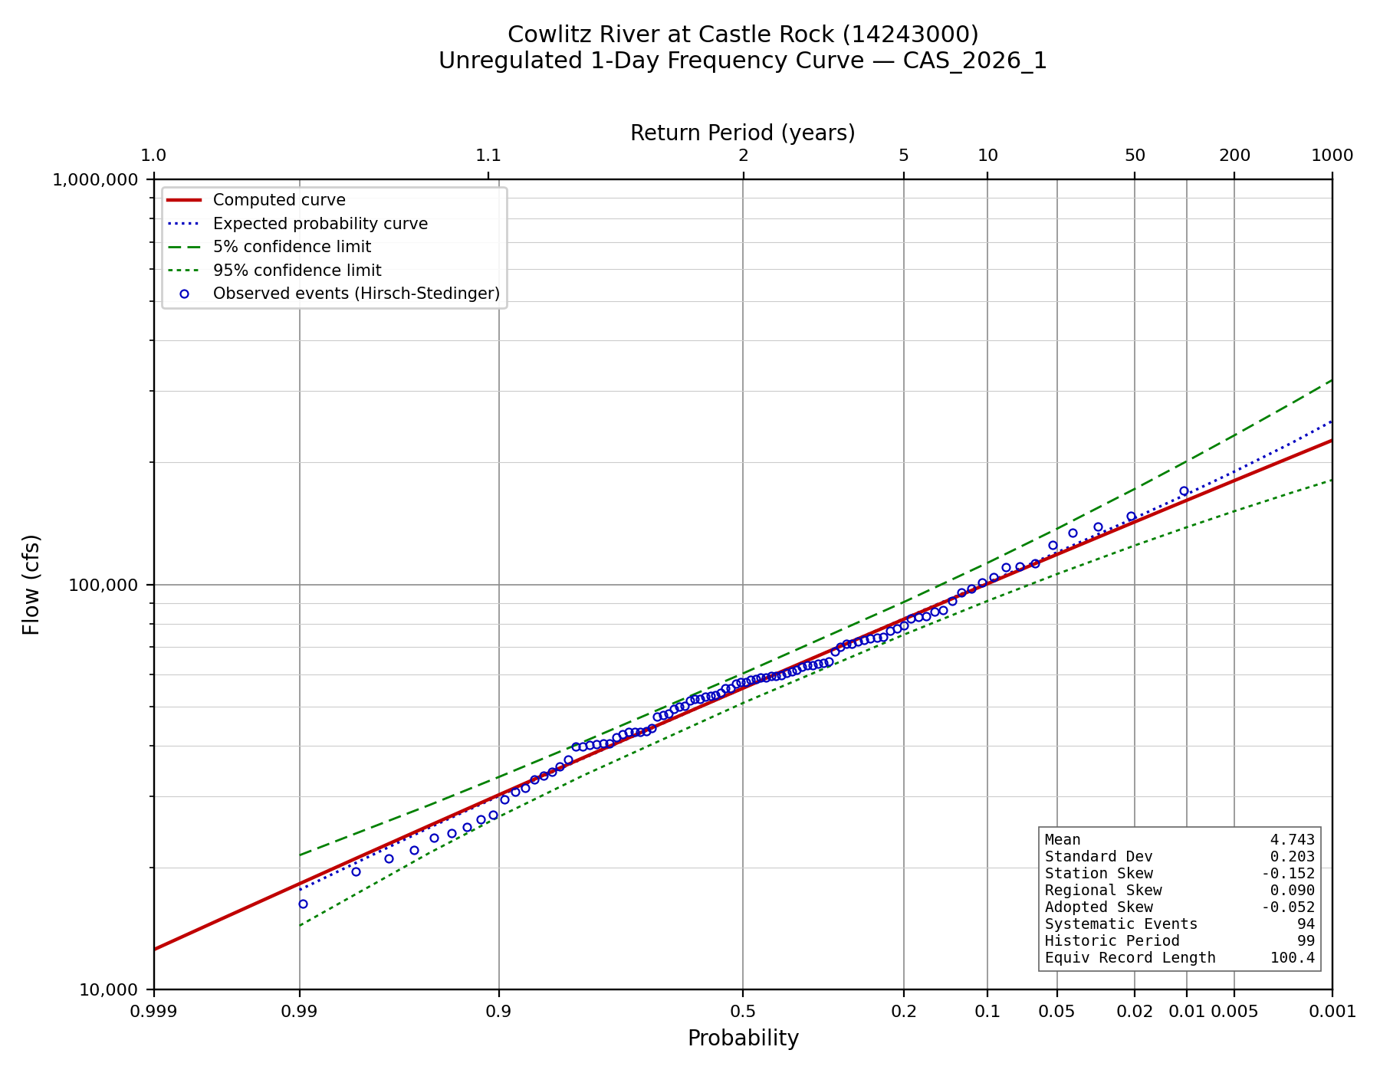
Figure C-2. Unregulated 1-day frequency curve.
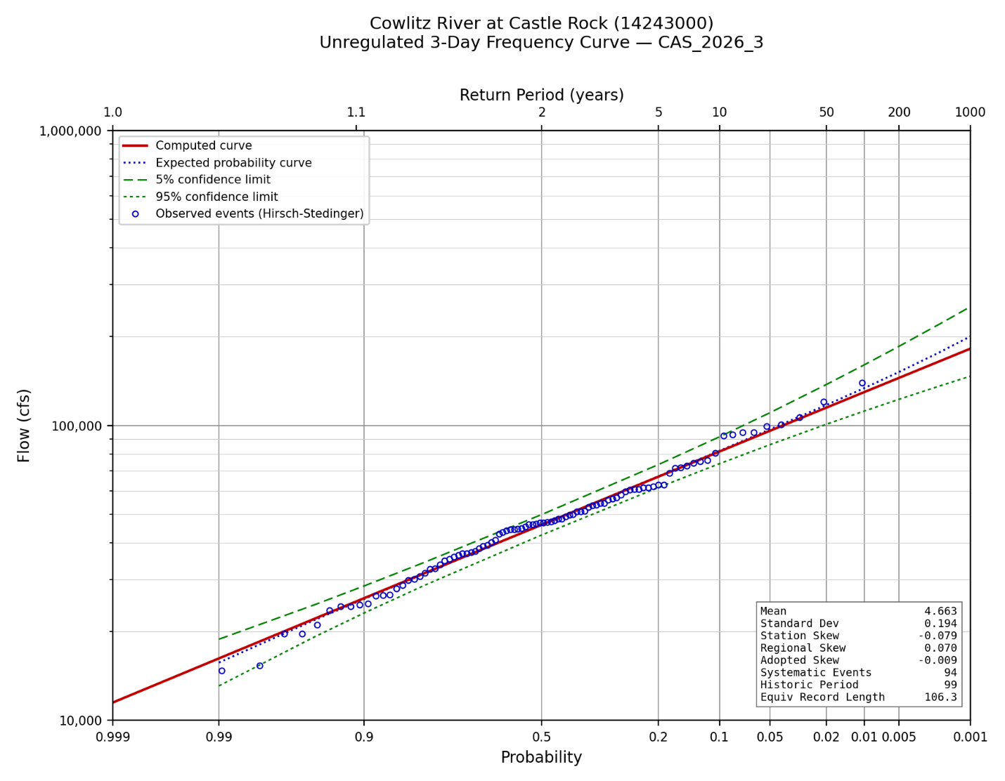
Figure C-3. Unregulated 3-day frequency curve.
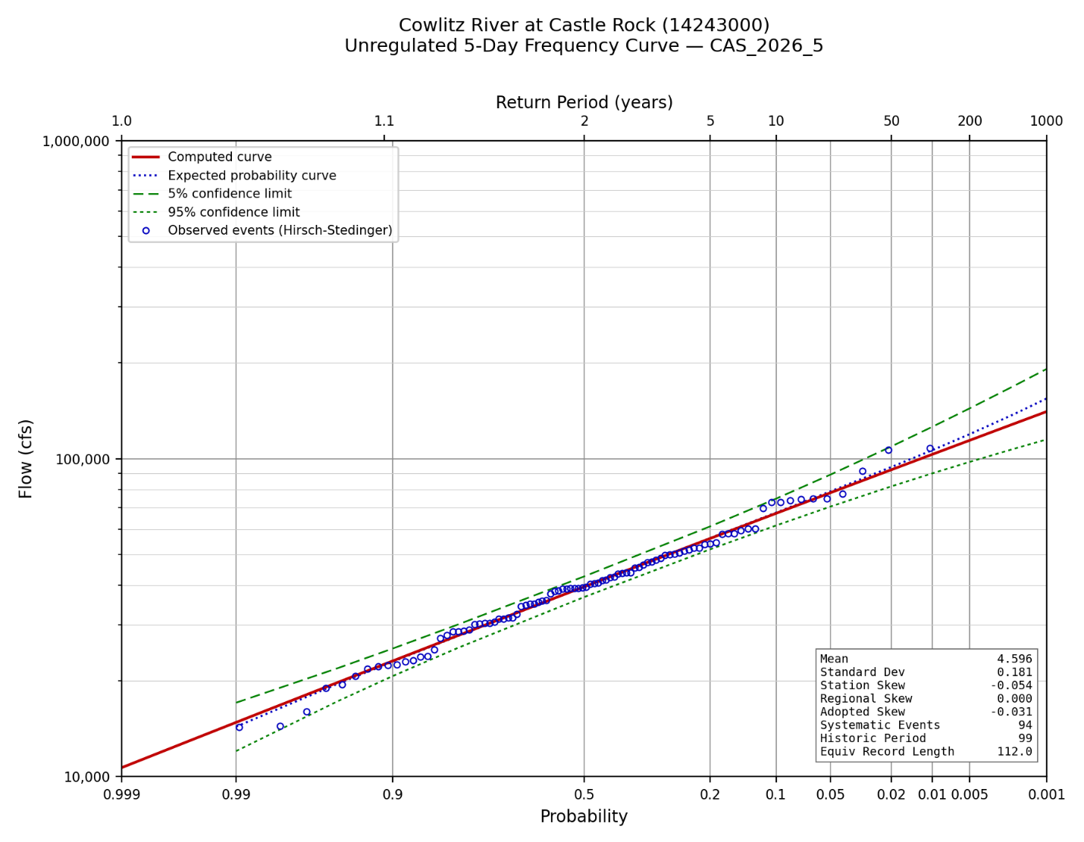
Figure C-4. Unregulated 5-day frequency curve.

Appendix D. Adjusted Regulated Peak Record by Water Year
Observed, simulated and adjusted regulated peaks for every shared water year, with the screening result recorded for each. Flows are in cubic feet per second.
WY | Observed | WCM_RC | Obs_RC | Difference | Adjusted | Screen
1974 | 68,600 | 33,207 | 19,208 | 13,999 | 82,599 | reg_over_unreg
1975 | 58,900 | 57,075 | 56,714 | 361 | 59,261 | ok
1976 | 86,700 | 75,597 | 105,150 | -29,553 | 86,700 | ok
1977 | 15,000 | 14,187 | 12,187 | 2,000 | 17,000 | ok
1978 | 86,400 | 79,778 | 79,778 | 0 | 86,400 | ok
1979 | 39,400 | 42,972 | 40,972 | 2,000 | 41,400 | ok
1980 | 97,000 | — | — | — | 97,000 | both
1981 | 46,900 | 50,909 | 39,206 | 11,703 | 58,603 | ok
1982 | 65,500 | 64,483 | 63,822 | 661 | 66,161 | ok
1983 | 67,300 | 59,457 | 59,457 | 0 | 67,300 | ok
1984 | 49,600 | — | — | — | 49,600 | different_event
1985 | 23,600 | 24,934 | 13,724 | 11,210 | 23,600 | different_event
1986 | 62,700 | 62,206 | 60,657 | 1,549 | 64,249 | ok
1987 | 77,600 | 73,775 | 73,059 | 716 | 78,316 | ok
1988 | 42,100 | 52,818 | 38,880 | 13,938 | 56,038 | ok
1989 | 23,600 | 27,470 | 13,443 | 14,026 | 37,626 | ok
1990 | 89,200 | 84,639 | 83,907 | 732 | 89,932 | ok
1991 | 76,000 | 62,368 | 61,083 | 1,286 | 77,286 | ok
1992 | 27,000 | 35,102 | 21,102 | 14,000 | 41,000 | ok
1993 | 14,700 | 25,147 | 11,148 | 14,000 | 28,700 | ok
1994 | 17,300 | — | — | — | 17,300 | different_event
1995 | 47,500 | — | — | — | 47,500 | different_event
1996 | 112,000 | 132,172 | 108,967 | 23,205 | 135,205 | ok
1997 | 56,700 | 54,439 | 52,636 | 1,803 | 58,503 | ok
1998 | 30,800 | 28,784 | 28,784 | 0 | 30,800 | ok
1999 | 57,600 | 53,768 | 50,442 | 3,326 | 60,926 | ok
2000 | 41,700 | 49,782 | 35,782 | 14,000 | 55,700 | ok
2001 | 11,600 | — | — | — | 11,600 | different_event
2002 | 51,400 | 53,728 | 45,573 | 8,155 | 59,555 | ok
2003 | 69,000 | 62,340 | 62,077 | 263 | 69,263 | ok
2004 | 38,100 | 48,301 | 34,302 | 14,000 | 52,100 | ok
2005 | 29,600 | 40,940 | 26,912 | 14,029 | 43,629 | ok
2006 | 56,200 | — | — | — | 56,200 | different_event
2007 | 77,300 | 94,857 | 70,844 | 24,013 | 101,313 | ok
2008 | 64,300 | 61,129 | 60,053 | 1,076 | 65,376 | ok
2009 | 106,000 | 81,855 | 81,470 | 385 | 106,385 | ok
2010 | 20,900 | 26,302 | 15,335 | 10,966 | 31,866 | ok
2011 | 45,300 | 44,599 | 30,599 | 14,000 | 59,300 | ok
2012 | 36,900 | 38,920 | 24,921 | 13,999 | 50,899 | ok
2013 | 47,000 | 51,961 | 37,704 | 14,257 | 61,257 | reg_over_unreg
2014 | 32,300 | 43,271 | 29,271 | 14,000 | 46,300 | ok
2015 | 38,500 | 45,556 | 31,552 | 14,004 | 52,504 | ok
2016 | 83,700 | 81,000 | 80,324 | 675 | 84,375 | ok
2017 | 40,000 | 51,716 | 39,201 | 12,515 | 52,515 | ok
2018 | 35,100 | 45,514 | 31,518 | 13,996 | 49,096 | ok
2019 | 26,000 | — | — | — | 26,000 | different_event
2020 | 47,400 | 51,580 | 51,580 | 0 | 47,400 | ok
2021 | 45,600 | 50,963 | 42,650 | 8,313 | 53,913 | ok
2022 | 63,900 | 62,387 | 61,747 | 639 | 64,539 | ok
2023 | 34,400 | 44,819 | 30,826 | 13,993 | 48,393 | ok
2024 | 44,800 | 52,638 | 42,979 | 9,659 | 54,459 | ok
Table D-1. Adjusted regulated peak record, water years 1974 through 2024.

Appendix E. Regulated Frequency Curve Ordinates and Uncertainty Terms
The adopted regulated curve with its uncertainty band (Section 5.6, FREQ_TERM_MODE = 'literal'), and the terms that produced it, for every ordinate. Flows are in cubic feet per second.
AEP | Unregulated | Regulated | Lower 95% | Upper 95% | Local slope | Reduction % | Extrap.
0.9900 | 18,564 | 18,564 | 11,620 | 24,732 | 1.00 | 0.0 | no
0.9500 | 27,041 | 27,041 | 18,746 | 34,623 | 1.00 | 0.0 | no
0.9000 | 32,573 | 32,573 | 23,312 | 41,155 | 1.00 | 0.0 | no
0.8000 | 40,487 | 40,487 | 29,630 | 50,555 | 1.00 | 0.0 | no
0.5000 | 60,529 | 50,813 | 37,799 | 62,798 | 0.57 | 16.1 | no
0.2000 | 89,126 | 64,047 | 47,349 | 77,770 | 0.61 | 28.1 | no
0.1000 | 108,618 | 73,702 | 54,120 | 95,468 | 0.73 | 32.1 | no
0.0500 | 127,758 | 83,553 | 58,380 | 121,799 | 0.81 | 34.6 | no
0.0200 | 153,556 | 96,784 | 62,569 | 158,023 | 0.86 | 37.0 | no
0.0100 | 174,075 | 109,522 | 67,455 | 187,199 | 1.23 | 37.1 | no
0.0050 | 195,977 | 128,798 | 76,214 | 228,500 | 1.43 | 34.3 | no
0.0020 | 227,900 | 160,342 | 91,937 | 292,518 | 1.47 | 29.6 | no
0.0010 | 255,074 | 189,434 | 107,941 | 352,665 | 1.49 | 25.7 | no
0.0005 | 285,568 | 224,427 | 126,346 | 427,472 | 1.51 | 21.4 | yes
0.0002 | 332,739 | 282,959 | 157,731 | 553,993 | 1.52 | 15.0 | yes
0.0001 | 374,643 | 339,018 | 188,364 | 660,115 | 1.53 | 9.5 | yes
Table E-1. Regulated frequency curve ordinates and uncertainty terms.

Appendix F. Regulated Frequency Ordinates by Location
Regulated peak flow at each of the four locations of Section 8, with 95 percent confidence limits. Flows are in cubic feet per second. At the gage the unregulated curve is shown alongside; downstream, the local contribution is shown, being the incremental drainage area scaled off the unregulated curve and reduced by the 0.80 timing factor. Confidence limits at the three downstream locations are the gage's own, translated by the local contribution — see Section 8.4.
AEP | Unregulated | Regulated | Lower 95% | Upper 95%
0.9900 | 19,408 | 18,564 | 11,620 | 24,732
0.9500 | 27,417 | 27,041 | 18,746 | 34,623
0.9000 | 32,826 | 32,573 | 23,312 | 41,155
0.8000 | 40,671 | 40,487 | 29,630 | 50,555
0.5000 | 60,585 | 50,813 | 37,799 | 62,798
0.2000 | 88,923 | 64,047 | 47,349 | 77,770
0.1000 | 108,041 | 73,702 | 54,120 | 95,468
0.0500 | 126,514 | 83,553 | 58,380 | 121,799
0.0200 | 150,625 | 96,784 | 62,569 | 158,023
0.0100 | 168,884 | 109,522 | 67,455 | 187,199
0.0050 | 187,282 | 128,798 | 76,214 | 228,500
0.0020 | 211,932 | 160,342 | 91,937 | 292,518
0.0010 | 230,884 | 189,434 | 107,941 | 352,665
0.0005 | 250,134 | 224,427 | 126,346 | 427,472
0.0002 | 276,072 | 282,959 | 157,731 | 553,993
0.0001 | 296,088 | 339,018 | 188,364 | 660,115
Table F-1. Castle Rock gage, 2,229 square miles.
AEP | Local | Regulated | Lower 95% | Upper 95%
0.9900 | 341 | 18,905 | 11,961 | 25,074
0.9500 | 482 | 27,523 | 19,228 | 35,105
0.9000 | 577 | 33,150 | 23,890 | 41,732
0.8000 | 715 | 41,203 | 30,345 | 51,271
0.5000 | 1,065 | 51,879 | 38,864 | 63,864
0.2000 | 1,564 | 65,611 | 48,913 | 79,334
0.1000 | 1,900 | 75,602 | 56,020 | 97,369
0.0500 | 2,225 | 85,778 | 60,605 | 124,024
0.0200 | 2,649 | 99,433 | 65,218 | 160,672
0.0100 | 2,970 | 112,492 | 70,425 | 190,169
0.0050 | 3,294 | 132,092 | 79,508 | 231,794
0.0020 | 3,727 | 164,069 | 95,664 | 296,245
0.0010 | 4,060 | 193,494 | 112,002 | 356,725
0.0005 | 4,399 | 228,826 | 130,745 | 431,871
0.0002 | 4,855 | 287,814 | 162,587 | 558,848
0.0001 | 5,207 | 344,225 | 193,571 | 665,322
Table F-2. Below Arkansas Creek, 2,278 square miles.
AEP | Local | Regulated | Lower 95% | Upper 95%
0.9900 | 738 | 19,302 | 12,358 | 25,471
0.9500 | 1,043 | 28,084 | 19,789 | 35,666
0.9000 | 1,249 | 33,822 | 24,561 | 42,403
0.8000 | 1,547 | 42,035 | 31,177 | 52,103
0.5000 | 2,305 | 53,118 | 40,104 | 65,103
0.2000 | 3,383 | 67,430 | 50,732 | 81,153
0.1000 | 4,110 | 77,812 | 58,231 | 99,579
0.0500 | 4,813 | 88,366 | 63,193 | 126,612
0.0200 | 5,730 | 102,515 | 68,299 | 163,753
0.0100 | 6,425 | 115,947 | 73,880 | 193,624
0.0050 | 7,125 | 135,923 | 83,339 | 235,625
0.0020 | 8,063 | 168,404 | 100,000 | 300,581
0.0010 | 8,784 | 198,218 | 116,725 | 361,448
0.0005 | 9,516 | 233,943 | 135,862 | 436,988
0.0002 | 10,503 | 293,461 | 168,234 | 564,496
0.0001 | 11,264 | 350,282 | 199,628 | 671,379
Table F-3. Below Ostrander Creek, 2,335 square miles.
AEP | Local | Regulated | Lower 95% | Upper 95%
0.9900 | 1,721 | 20,285 | 13,340 | 26,453
0.9500 | 2,430 | 29,471 | 21,177 | 37,054
0.9000 | 2,910 | 35,483 | 26,222 | 44,065
0.8000 | 3,605 | 44,093 | 33,236 | 54,161
0.5000 | 5,371 | 56,184 | 43,170 | 68,169
0.2000 | 7,883 | 71,930 | 55,232 | 85,653
0.1000 | 9,578 | 83,280 | 63,698 | 105,046
0.0500 | 11,215 | 94,768 | 69,596 | 133,015
0.0200 | 13,353 | 110,137 | 75,921 | 171,375
0.0100 | 14,971 | 124,494 | 82,427 | 202,171
0.0050 | 16,603 | 145,401 | 92,817 | 245,103
0.0020 | 18,788 | 179,129 | 110,725 | 311,306
0.0010 | 20,468 | 209,902 | 128,409 | 373,132
0.0005 | 22,174 | 246,601 | 148,520 | 449,647
0.0002 | 24,474 | 307,432 | 182,205 | 578,467
0.0001 | 26,248 | 365,266 | 214,612 | 686,363
Table F-4. Below Coweeman River, 2,476 square miles.

References
England, J.F., Jr., Cohn, T.A., Faber, B.A., Stedinger, J.R., Thomas, W.O., Jr., Veilleux, A.G., Kiang, J.E., and Mason, R.R., Jr., 2019, Guidelines for determining flood flow frequency - Bulletin 17C (ver. 1.1): U.S. Geological Survey Techniques and Methods, book 4, chap. B5, 148 p.
Lind, G.D., Lamontagne, J.R., and Stonewall, A.J., 2020, Development of regional skew coefficients for selected flood durations in the Columbia River Basin, northwestern United States and British Columbia, Canada (ver. 1.1, October 2020): U.S. Geological Survey Scientific Investigations Report 2020-5073, 48 p.
Mastin, M.C., Konrad, C.P., Veilleux, A.G., and Tecca, A.E., 2016, Magnitude, frequency, and trends of floods at gaged and ungaged sites in Washington, based on data through water year 2014 (ver. 1.2, November 2017): U.S. Geological Survey Scientific Investigations Report 2016-5118, 70 p.
U.S. Army Corps of Engineers, 2025, Risk Assessment for Flood Risk Management Studies, EM 1110-2-1619, 29 September 2025.
U.S. Army Corps of Engineers, Portland District, 2009, Cowlitz River Hydrology Restudy.
U.S. Army Corps of Engineers, 2014, Water Control Manual, Mossyrock Project, Cowlitz River, Washington.
U.S. Army Corps of Engineers, Hydrologic Engineering Center, HEC-ResSim Reservoir System Simulation, and HEC-SSP Statistical Software Package.
U.S. Geological Survey, National Water Information System: streamflow and peak-flow records for station 14243000, Cowlitz River at Castle Rock, Washington.

