MEMORANDUM
Subject: Unregulated Flow Frequency Record at Castle Rock (USGS 14243000) — Mossyrock Holdout Method (CAS_Unreg_FF)
From: Water Management / Hydraulic Engineering, USACE Portland District
Date: 24 July 2026
Status: Final — record assembled (WY1927–2026) and written to CAS_Unreg_SSP.dss for HEC-SSP

1. Purpose
This memo documents the methodology and results for the unregulated annual-maximum flow record at Castle Rock used for flow frequency analysis. The regulated-era record is built from a Mossyrock (MOS) storage holdout derived from a hand-cleaned hourly elevation record, a storage-change regression for years without a usable holdout, and a daily mass balance for the 1/3/5-day durations, with the observed USGS record supplying the pre-regulation period. The assembled record covers WY1927–2026 (95 water years; only WY1969–1973 are absent).

2. Data Sources
Record | Role
//MOS/ELEV//1HOUR/CWMS-CLEAN/ (obsData.dss) | Hand-cleaned hourly MOS elevation (iterative DSSVue edits; manual product, not script-reproducible). Used ONLY in the holdout workflow during flood season when the STOR record it was built from had at least 4 records a day (6-hour) with minor fills from CDB records.
//MOS/STOR//1HOUR/CWMS/ | Raw storage telemetry; daily valid-value counts gates which days the hourly elevation is trusted (≥ 4 values/day, with manual overrides).
//MOS/ELEV//1DAY/USGS/ | Daily MOS elevation (separate record, 01Oct1973–present; not derived from the hourly). Source of the storage-change regression predictors and the daily mass balance.
Castle Rock 14243000 hourly and daily FLOW (USGS) | Regulated flows. The regulated peak is the 1-hr max of the hourly record so regulated and unregulated peaks are computed identically. The daily record is winter-only / winter only through much of the regulated era (see Sec. 6).
Mayfield 14238000 hourly FLOW (USGS) | Routing input, Mayfield → Castle Rock.
CastleRock_USGS_peaks.csv | USGS observed instantaneous annual peaks. Peak source for pre-regulation WYs, and the regulated-peak source for regression-filled WYs that predate the hourly record.

3. Hourly Unregulated Record (Holdout Method)
The hourly MOS elevation was copied and hand-edited iteratively in HEC-DSSVue (edit → compute holdout → scrutinize → edit). The elevation was converted to storage using the current WCM rating curve dated 2014 difference to a raw hourly holdout (cfs); 3-hour centered rolling average; October–March season; blank any day with fewer than 4 valid raw storage-telemetry values (manual date-range overrides where quality is known to differ from the count). Route (Mayfield + holdout) and (Mayfield alone) to Castle Rock through three chained SSARR reaches (Table 3 calibration, lower Cowlitz model; Toutle reach excluded; only stretches with ≥ 10 continuous valid days routed). The routed difference added to observed Castle Rock flow is the hourly unregulated estimate. Many of the post-1974 hourly elevation records are not usable at hourly resolution. Twenty-three water years carry holdout-based peaks: WY1992, 1997, 1999, 2003, 2004 and WY2008–2026.

4. Water-Year Peaks and Missing-Window Review
From the hourly series, the 1-hour maximum and the maximum 24-hour mean are extracted per water year for both the unregulated estimate and the regulated record, with timestamps and the timing offset between the two peaks. Every October–March missing window ≥ 3 hours in either series is cataloged with its distance to that year's computed peak (diagnostics/wy_missing_windows.csv), and per-year gap-summary columns facilitated screening before data was filled when appropriate. Remaining years become candidates to be filled by regression (Sec. 5).

5. Peak Correction — Storage-Change Regression
For water years without a usable holdout peak from hourly data, the regulated peak is corrected to unregulated by regressing the water-year peak difference (regulated minus unregulated, 1-hr peaks) at Castle Rock on the maximum daily MOS storage increase near the event, computed from the daily elevation record over candidate 1–4-day windows within ±7 days of the regulated peak. Pairs with peaks more than 72 hours apart would be excluded as different storms; in the fit set (n = 17, WY1992–2026) offsets ranged −69 to +6 hours (median −3) and no pair was excluded.
Predictor | Slope | Intercept (cfs) | R² | SE (cfs)
dS_1day | −0.673 | −7,751 | 0.759 | 7,565
dS_2day (ADOPTED) | −0.869 | −3,836 | 0.871 | 5,528
dS_3day | −0.983 | −4,537 | 0.853 | 5,896
dS_4day | −1.140 | −4,770 | 0.836 | 6,239

The adopted relation is (REG − UNREG) = −0.869 · dS_2day − 3,836 cfs (R² = 0.871, SE ≈ 5,530 cfs, n = 17); the estimated unregulated peak is the regulated peak minus the predicted difference. Thirty water years were filled. The regulated peak comes from the USGS peak flow record for WY1974–1991 (18 years the hourly record does not cover; the USGS peak date centers the storage-change window) and from the 1-hr max of the hourly record for the other twelve — ten with no computable unregulated peak, and WY2006 and WY2013, where the unregulated record has no data covering the regulated peak event, so its apparent annual maximum comes from an unrelated period.

6. 1/3/5-Day Durations — Daily Mass Balance
Daily unregulated flow = observed Castle Rock daily flow + daily change in MOS storage (daily elevation record, 2014 rating). Travel time Mayfield-to-Castle-Rock is under one day, so no routing is applied at daily resolution; Mayfield re-regulation storage is neglected (small relative to Mossyrock, largely canceling out over 1-day-and-longer windows). Rolling 1/3/5-day maxima are computed on a full daily grid, so an N-day value always represents N consecutive recorded days. The Castle Rock daily record is winter-only through much of the 1980s and 1990s but is presumed to have covered the peak. The one-day mass-balance values also serve as the One_day source for years without hourly data (30 water years).

7. Pre-Regulation Period (WY1927–1968)
Before Mossyrock began actively impounding the river in December 1968, the gauge record is unregulated by definition. Peaks are the USGS observed instantaneous annual peaks (42 water years). The 1/3/5-day values are rolling maxima computed directly from the USGS daily record. WY1927 carries a peak only (the daily record begins later).

8. Assembled Record
Pre-1968 peaks are from the USGS peak flow record and 1, 3, and 5-day durations come straight from the USGS daily record. Post-1968, peaks come from the calculated hourly unregulated record, else the dS_2day regression; One_day from the 1-day average of the hourly unregulated record, else the one-day max of the daily unregulated record; 3- and 5-day from the unregulated daily averages.
Duration | Values | Sources
Peak | 95 | 42 USGS pre-reg peaks; 30 dS_2day regression; 23 hourly holdout
One_day | 94 | 41 USGS daily pre-reg; 30 daily mass balance; 23 hourly holdout
Three_Day | 93 | 41 USGS daily pre-reg; 52 daily mass balance
Five_Day | 93 | 41 USGS daily pre-reg; 52 daily mass balance

Coverage includes WY1927–2026 with only WY1969–1973 absent (no daily MOS elevation before October 1973, no hourly record, and no basis for a holdout or regression predictor). Every included water year has a peak. WY1927 lacks durations (the daily record begins later)

9. Consistency Adjustments and QA
Because each duration is the annual maximum of its own averaging window, searched independently over the water year, the four series can be drawn from different events and are not guaranteed to decrease with duration. Every ordering violation is logged before adjustment (diagnostics/record_qa_flags.csv; 15 in this record). Fourteen involve two different sources — most often a regression-estimated peak sitting below the daily-average 1-day value — and one, WY2014, is internal to the daily series: a double-peaked March event whose 5-day window spans both peaks while no 3-day window can. The record is then made monotonic working backwards from the 5-day value: the 5-day is the anchor, and each shorter duration is raised to the longer one where the longer is higher, cascading upward. Ten values across nine water years were raised (diagnostics/record_monotonic_adjustments.csv); pre-adjustment values are retained in the record's *_Raw columns. Eight of the ten are regression-estimated peaks lifted to their 1-day value — a physical floor, since a 1-day average cannot exceed the instantaneous peak — with WY2001 (+64%), WY1985 (+19%) and WY2006 (+19%) the largest.

10. Flow Frequency
The assembled record was analyzed in HEC-SSP using the Bulletin 17C expected moments algorithm (EMA), one analysis per duration: CAS_2026_pfor the instantaneous peak and CAS_2026_1, CAS_2026_3, and CAS_2026_5 for the 1-, 3- and 5-day durations. All four fit a log-Pearson Type III distribution to the unregulated record described in Sections 3 through 9, with the station skew weighted against a regional value.
WY1969–1973 are censored in the peak analysis. Those five water years have observed regulated peaks but no basis for an unregulated estimate: the daily Mossyrock elevation record begins in October 1973, so no storage-change predictor exists, and there is no hourly record from which to compute a holdout. Rather than omit them, which would discard the knowledge that no extreme unregulated flood occurred in those years, or assign point estimates the data do not support, they are entered as censored intervals. EMA then uses that constraint without asserting a value. The peak analysis accordingly reports 95 systematic events within a 100-year historic period, with five events flagged as missing.
No low-flow outliers were identified by the multiple Grubbs-Beck procedure. The record contains no zero or near-zero annual maxima, and because the unregulated series is constructed rather than gaged, its small years carry the same provenance as its large ones; there is no physical basis for treating the lower tail as unrepresentative.
Station skews are slightly negative for every duration, from −0.158 for the peak to −0.051 for the 5-day. Weighting against the regional skew moves the peak to −0.135 and the longer durations toward zero, giving adopted skews of −0.135, −0.052, −0.007 and −0.029. Equivalent record lengths after censoring range from 100 to 111 years.
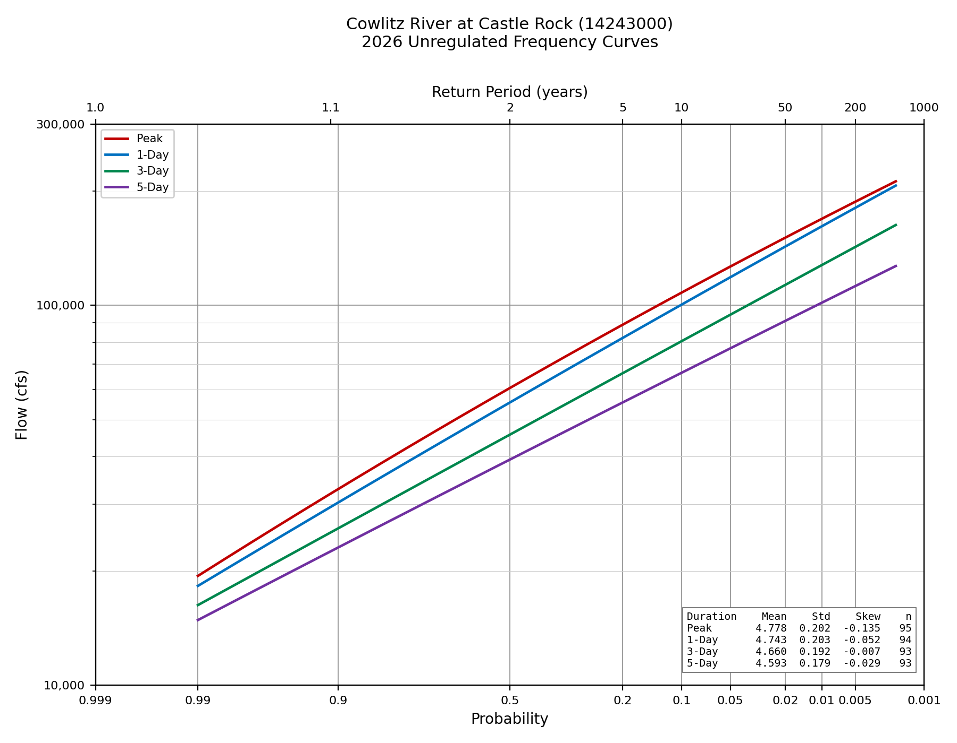
Figure 10-1. Adopted unregulated frequency curves at Castle Rock, WY1927–2026, all four durations.
Figure 10-2 places the same curves against the 2009 Hydrology Restudy. Both sets are computed curves rather than expected probability curves: the expected probability adjustment scales with record length, and the 2009 study had shorter records, so comparing adjusted curves would fold a data-quantity difference into what is meant to be a comparison of flood estimates. The 2009 study's shortest duration is 0.20 day rather than an instantaneous peak, so that pairing is approximate, though the two means agree to within 0.001 log units.
The two studies agree closely through the range supported by data and diverge in the tail. At the 10% chance exceedance all four durations fall within about 2% of the 2009 values, and at the median within 3%. Beyond the 2% chance event the 2026 curves fall progressively below: at the 1% chance the peak is 7.8% lower and the durations 1.8% to 3.3% lower, and at the 0.2% chance the peak is 13.7% lower. The cause is skew. The 2009 study adopted positive skews for every duration, from +0.140 to +0.193, which bend those curves upward in the tail, while the skews adopted here are near zero or negative and flatten it. The divergence is a difference in fitted tail behavior rather than in the record through the observed range.
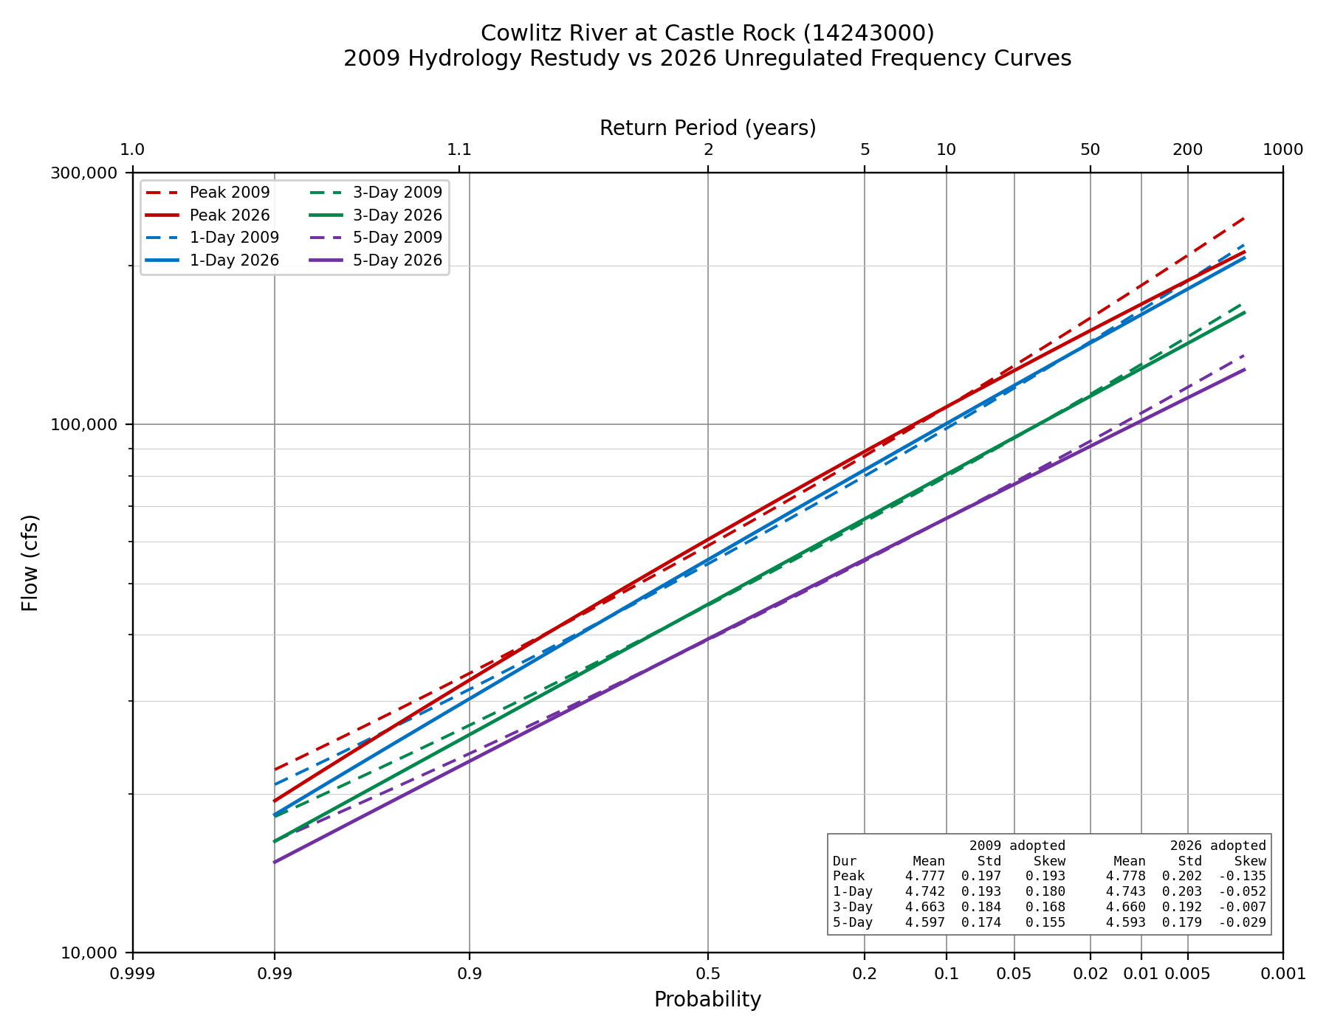
Figure 10-2. Adopted 2026 curves (solid) against the 2009 Hydrology Restudy (dashed).
Table 10-1 gives the fitted distribution parameters and event counts reported by SSP for each adopted analysis.
Parameter | Peak | 1-Day | 3-Day | 5-Day
Mean | 4.778 | 4.743 | 4.66 | 4.593
Standard Dev | 0.202 | 0.203 | 0.192 | 0.179
Station Skew | -0.158 | -0.152 | -0.076 | -0.051
Regional Skew | -0.07 | 0.09 | 0.07 | 0.0
Weighted Skew | -0.135 | -0.052 | -0.007 | -0.029
Adopted Skew | -0.135 | -0.052 | -0.007 | -0.029
EMA MSE [G at-site] | 0.064 | 0.064 | 0.061 | 0.06
Grubbs-Beck Critical Value | 0.0 | 0.0 | 0.0 | 0.0
Equivalent Record Length | 100.657 | 100.369 | 105.405 | 110.932
Systematic Events | 95.0 | 94.0 | 93.0 | 93.0
Historic Events | 0.0 | 0.0 | 0.0 | 0.0
High Outliers | 0.0 | 0.0 | 0.0 | 0.0
Low Outliers | 0.0 | 0.0 | 0.0 | 0.0
Zero Events | 0.0 | 0.0 | 0.0 | 0.0
Missing Events | 5.0 | 5.0 | 5.0 | 5.0
Historic Period | 100.0 | 99.0 | 98.0 | 98.0
Table 10-1. Distribution parameters and event counts, adopted SSP analyses.

Appendix A. Assembled Record by Water Year

WY | Peak | Peak_Source | One_day | One_day_Source | Three_Day | Five_Day | Durations_Source
1927 | 41,100 | usgs_peak_prereg
1928 | 74,000 | usgs_peak_prereg | 71,300 | usgs_daily_prereg | 56,933 | 47,940 | usgs_daily_prereg
1929 | 21,800 | usgs_peak_prereg | 21,100 | usgs_daily_prereg | 19,633 | 18,980 | usgs_daily_prereg
1930 | 30,200 | usgs_peak_prereg | 29,500 | usgs_daily_prereg | 26,700 | 23,840 | usgs_daily_prereg
1931 | 65,900 | usgs_peak_prereg | 63,200 | usgs_daily_prereg | 51,200 | 40,760 | usgs_daily_prereg
1932 | 50,800 | usgs_peak_prereg | 49,200 | usgs_daily_prereg | 44,467 | 39,140 | usgs_daily_prereg
1933 | 53,000 | usgs_peak_prereg | 52,200 | usgs_daily_prereg | 44,467 | 43,900 | usgs_daily_prereg
1934 | 139,000 | usgs_peak_prereg | 134,000 | usgs_daily_prereg | 120,333 | 106,300 | usgs_daily_prereg
1935 | 61,800 | usgs_peak_prereg | 58,100 | usgs_daily_prereg | 53,800 | 45,540 | usgs_daily_prereg
1936 | 48,200 | usgs_peak_prereg | 39,800 | usgs_daily_prereg | 35,833 | 31,400 | usgs_daily_prereg
1937 | 49,000 | usgs_peak_prereg | 47,200 | usgs_daily_prereg | 40,167 | 34,640 | usgs_daily_prereg
1938 | 62,900 | usgs_peak_prereg | 60,500 | usgs_daily_prereg | 53,567 | 47,440 | usgs_daily_prereg
1939 | 43,600 | usgs_peak_prereg | 39,800 | usgs_daily_prereg | 29,867 | 27,840 | usgs_daily_prereg
1940 | 41,900 | usgs_peak_prereg | 40,500 | usgs_daily_prereg | 36,767 | 31,660 | usgs_daily_prereg
1941 | 26,400 | usgs_peak_prereg | 22,100 | usgs_daily_prereg | 19,633 | 16,038 | usgs_daily_prereg
1942 | 58,100 | usgs_peak_prereg | 55,400 | usgs_daily_prereg | 47,067 | 39,400 | usgs_daily_prereg
1943 | 60,500 | usgs_peak_prereg | 58,300 | usgs_daily_prereg | 46,867 | 39,020 | usgs_daily_prereg
1944 | 37,100 | usgs_peak_prereg | 33,700 | usgs_daily_prereg | 26,467 | 20,760 | usgs_daily_prereg
1945 | 45,300 | usgs_peak_prereg | 44,200 | usgs_daily_prereg | 36,333 | 30,340 | usgs_daily_prereg
1946 | 54,700 | usgs_peak_prereg | 51,700 | usgs_daily_prereg | 45,433 | 38,940 | usgs_daily_prereg
1947 | 85,100 | usgs_peak_prereg | 82,400 | usgs_daily_prereg | 80,767 | 74,880 | usgs_daily_prereg
1948 | 38,500 | usgs_peak_prereg | 37,000 | usgs_daily_prereg | 32,700 | 28,560 | usgs_daily_prereg
1949 | 51,500 | usgs_peak_prereg | 43,300 | usgs_daily_prereg | 30,167 | 28,580 | usgs_daily_prereg
1950 | 54,800 | usgs_peak_prereg | 54,000 | usgs_daily_prereg | 49,933 | 43,920 | usgs_daily_prereg
1951 | 67,200 | usgs_peak_prereg | 63,900 | usgs_daily_prereg | 61,467 | 54,440 | usgs_daily_prereg
1952 | 41,400 | usgs_peak_prereg | 35,600 | usgs_daily_prereg | 31,600 | 28,680 | usgs_daily_prereg
1953 | 60,000 | usgs_peak_prereg | 50,000 | usgs_daily_prereg | 44,000 | 40,400 | usgs_daily_prereg
1954 | 73,000 | usgs_peak_prereg | 63,600 | usgs_daily_prereg | 51,067 | 45,440 | usgs_daily_prereg
1955 | 50,100 | usgs_peak_prereg | 43,300 | usgs_daily_prereg | 33,800 | 29,020 | usgs_daily_prereg
1956 | 67,400 | usgs_peak_prereg | 63,100 | usgs_daily_prereg | 49,733 | 42,260 | usgs_daily_prereg
1957 | 43,200 | usgs_peak_prereg | 40,400 | usgs_daily_prereg | 37,400 | 34,980 | usgs_daily_prereg
1958 | 35,200 | usgs_peak_prereg | 34,500 | usgs_daily_prereg | 30,867 | 27,280 | usgs_daily_prereg
1959 | 57,800 | usgs_peak_prereg | 52,900 | usgs_daily_prereg | 44,733 | 39,140 | usgs_daily_prereg
1960 | 62,700 | usgs_peak_prereg | 61,000 | usgs_daily_prereg | 56,433 | 49,620 | usgs_daily_prereg
1961 | 64,500 | usgs_peak_prereg | 59,000 | usgs_daily_prereg | 46,133 | 43,520 | usgs_daily_prereg
1962 | 42,100 | usgs_peak_prereg | 40,100 | usgs_daily_prereg | 34,833 | 30,240 | usgs_daily_prereg
1963 | 66,900 | usgs_peak_prereg | 59,500 | usgs_daily_prereg | 52,900 | 41,640 | usgs_daily_prereg
1964 | 72,600 | usgs_peak_prereg | 55,400 | usgs_daily_prereg | 46,267 | 37,680 | usgs_daily_prereg
1965 | 83,900 | usgs_peak_prereg | 79,100 | usgs_daily_prereg | 68,933 | 60,120 | usgs_daily_prereg
1966 | 28,800 | usgs_peak_prereg | 27,000 | usgs_daily_prereg | 24,333 | 22,400 | usgs_daily_prereg
1967 | 65,000 | usgs_peak_prereg | 58,800 | usgs_daily_prereg | 48,167 | 38,520 | usgs_daily_prereg
1968 | 49,500 | usgs_peak_prereg | 47,600 | usgs_daily_prereg | 44,633 | 42,600 | usgs_daily_prereg
1974 | 112,486 | dS2day_regression | 112,486 | daily_massbalance | 92,392 | 74,846 | daily_massbalance
1975 | 76,896 | dS2day_regression | 71,250 | daily_massbalance | 54,411 | 50,666 | daily_massbalance
1976 | 124,946 | dS2day_regression | 110,190 | daily_massbalance | 106,676 | 91,422 | daily_massbalance
1977 | 19,899 | dS2day_regression | 16,299 | daily_massbalance | 14,752 | 14,436 | daily_massbalance
1978 | 131,885 | dS2day_regression | 110,965 | daily_massbalance | 94,793 | 74,569 | daily_massbalance
1979 | 51,587 | dS2day_regression | 40,506 | daily_massbalance | 28,000 | 25,107 | daily_massbalance
1980 | 101,895 | dS2day_regression | 42,737 | daily_massbalance | 37,116 | 32,514 | daily_massbalance
1981 | 88,345 | dS2day_regression | 86,532 | daily_massbalance | 71,889 | 57,905 | daily_massbalance
1982 | 84,883 | dS2day_regression | 77,900 | daily_massbalance | 62,871 | 60,342 | daily_massbalance
1983 | 82,466 | dS2day_regression | 72,298 | daily_massbalance | 55,966 | 52,485 | daily_massbalance
1984 | 57,352 | dS2day_regression | 57,352 | daily_massbalance | 46,702 | 38,367 | daily_massbalance
1985 | 33,098 | dS2day_regression | 33,098 | daily_massbalance | 28,765 | 23,969 | daily_massbalance
1986 | 95,135 | dS2day_regression | 83,652 | daily_massbalance | 62,163 | 52,287 | daily_massbalance
1987 | 103,298 | dS2day_regression | 90,982 | daily_massbalance | 61,617 | 50,210 | daily_massbalance
1988 | 61,876 | dS2day_regression | 59,525 | daily_massbalance | 39,029 | 30,728 | daily_massbalance
1989 | 28,884 | dS2day_regression | 23,674 | daily_massbalance | 21,120 | 19,496 | daily_massbalance
1990 | 124,824 | dS2day_regression | 95,400 | daily_massbalance | 76,113 | 59,391 | daily_massbalance
1991 | 110,107 | dS2day_regression | 104,020 | daily_massbalance | 75,569 | 58,070 | daily_massbalance
1992 | 51,845 | hourly_holdout | 43,323 | hourly_holdout | 38,240 | 35,850 | daily_massbalance
1993 | 33,272 | dS2day_regression | 31,533 | daily_massbalance | 26,576 | 21,802 | daily_massbalance
1994 | 26,300 | dS2day_regression | 26,300 | daily_massbalance | 24,710 | 22,556 | daily_massbalance
1995 | 64,114 | dS2day_regression | 59,736 | daily_massbalance | 48,317 | 39,125 | daily_massbalance
1996 | 176,855 | dS2day_regression | 170,280 | daily_massbalance | 139,807 | 108,126 | daily_massbalance
1997 | 86,921 | hourly_holdout | 83,113 | hourly_holdout | 74,563 | 69,706 | daily_massbalance
1998 | 38,925 | dS2day_regression | 30,823 | daily_massbalance | 23,581 | 22,965 | daily_massbalance
1999 | 76,193 | hourly_holdout | 68,206 | hourly_holdout | 60,807 | 51,702 | daily_massbalance
2000 | 73,070 | dS2day_regression | 72,890 | daily_massbalance | 58,190 | 43,549 | daily_massbalance
2001 | 19,568 | dS2day_regression | 19,568 | daily_massbalance | 15,339 | 14,332 | daily_massbalance
2002 | 66,027 | dS2day_regression | 64,512 | daily_massbalance | 49,168 | 40,567 | daily_massbalance
2003 | 109,719 | hourly_holdout | 101,254 | hourly_holdout | 72,896 | 53,892 | daily_massbalance
2004 | 56,223 | hourly_holdout | 52,144 | hourly_holdout | 43,452 | 34,949 | daily_massbalance
2005 | 52,859 | dS2day_regression | 50,133 | daily_massbalance | 39,349 | 31,339 | daily_massbalance
2006 | 74,082 | dS2day_regression | 74,082 | daily_massbalance | 62,808 | 53,945 | daily_massbalance
2007 | 147,777 | dS2day_regression | 147,777 | daily_massbalance | 100,470 | 73,836 | daily_massbalance
2008 | 72,455 | hourly_holdout | 70,265 | hourly_holdout | 54,504 | 41,446 | daily_massbalance
2009 | 151,296 | hourly_holdout | 139,073 | hourly_holdout | 99,324 | 72,961 | daily_massbalance
2010 | 27,802 | hourly_holdout | 25,172 | hourly_holdout | 24,888 | 23,204 | daily_massbalance
2011 | 87,160 | hourly_holdout | 85,731 | hourly_holdout | 71,689 | 58,118 | daily_massbalance
2012 | 57,286 | hourly_holdout | 53,334 | hourly_holdout | 40,865 | 34,419 | daily_massbalance
2013 | 58,409 | dS2day_regression | 47,950 | daily_massbalance | 36,797 | 30,359 | daily_massbalance
2014 | 60,268 | hourly_holdout | 57,504 | hourly_holdout | 46,396 | 46,396 | daily_massbalance
2015 | 47,323 | hourly_holdout | 43,517 | hourly_holdout | 32,555 | 31,664 | daily_massbalance
2016 | 135,790 | hourly_holdout | 124,896 | hourly_holdout | 92,957 | 72,910 | daily_massbalance
2017 | 64,342 | hourly_holdout | 62,516 | hourly_holdout | 51,010 | 47,186 | daily_massbalance
2018 | 54,188 | hourly_holdout | 52,984 | hourly_holdout | 47,285 | 39,300 | daily_massbalance
2019 | 24,389 | hourly_holdout | 24,389 | hourly_holdout | 24,389 | 22,197 | daily_massbalance
2020 | 77,812 | hourly_holdout | 73,544 | hourly_holdout | 60,465 | 51,297 | daily_massbalance
2021 | 61,703 | hourly_holdout | 56,924 | hourly_holdout | 42,829 | 35,700 | daily_massbalance
2022 | 77,833 | hourly_holdout | 73,803 | hourly_holdout | 60,851 | 50,050 | daily_massbalance
2023 | 65,623 | hourly_holdout | 61,507 | hourly_holdout | 47,710 | 35,341 | daily_massbalance
2024 | 81,192 | hourly_holdout | 76,898 | hourly_holdout | 59,644 | 48,589 | daily_massbalance
2025 | 45,954 | hourly_holdout | 41,975 | hourly_holdout | 35,253 | 30,112 | daily_massbalance
2026 | 101,833 | hourly_holdout | 97,675 | hourly_holdout

Appendix B. Frequency Curve Ordinates
Computed curve, expected probability curve, EMA variance of the log and 5%/95% confidence limits for every ordinate reported by SSP, all four durations. UpperConf is SSP's 0.05 limit and LowerConf its 0.95 limit.
Duration | AEP | VarianceLog | zScore | Value | UpperConf | LowerConf | Expected
Peak | 0.0001 | 0.0098 | 3.72 | 296088 | 476290 | 217104 | 374643
Peak | 0.0002 | 0.0082 | 3.54 | 276072 | 426543 | 207624 | 332739
Peak | 0.0005 | 0.0064 | 3.29 | 250134 | 366728 | 194487 | 285568
Peak | 0.001 | 0.0052 | 3.09 | 230884 | 325578 | 184044 | 255074
Peak | 0.002 | 0.0041 | 2.88 | 211932 | 287635 | 173114 | 227900
Peak | 0.005 | 0.0029 | 2.58 | 187282 | 241929 | 157818 | 195977
Peak | 0.01 | 0.0022 | 2.33 | 168884 | 210386 | 145504 | 174075
Peak | 0.02 | 0.0016 | 2.05 | 150625 | 181177 | 132434 | 153556
Peak | 0.05 | 0.0010 | 1.64 | 126514 | 145732 | 113770 | 127758
Peak | 0.1 | 0.0007 | 1.28 | 108041 | 121015 | 98383 | 108618
Peak | 0.2 | 0.0005 | 0.84 | 88923 | 97624 | 81626 | 89126
Peak | 0.5 | 0.0005 | 0.00 | 60585 | 65857 | 55691 | 60529
Peak | 0.8 | 0.0006 | -0.84 | 40671 | 44531 | 36709 | 40487
Peak | 0.9 | 0.0009 | -1.28 | 32826 | 36401 | 28836 | 32573
Peak | 0.95 | 0.0013 | -1.64 | 27417 | 30925 | 23227 | 27041
Peak | 0.99 | 0.0030 | -2.33 | 19408 | 23026 | 14842 | 18564
1-Day | 0.0001 | 0.0109 | 3.72 | 299447 | 479405 | 221040 | 386105
1-Day | 0.0002 | 0.0092 | 3.54 | 276822 | 426187 | 209249 | 338896
1-Day | 0.0005 | 0.0072 | 3.29 | 247988 | 362832 | 193367 | 286800
1-Day | 0.001 | 0.0059 | 3.09 | 226952 | 319700 | 181106 | 253245
1-Day | 0.002 | 0.0047 | 2.88 | 206550 | 280306 | 168605 | 223780
1-Day | 0.005 | 0.0034 | 2.58 | 180481 | 233404 | 151652 | 189945
1-Day | 0.01 | 0.0026 | 2.33 | 161378 | 201443 | 138445 | 167060
1-Day | 0.02 | 0.0019 | 2.05 | 142727 | 172189 | 124837 | 145949
1-Day | 0.05 | 0.0012 | 1.64 | 118581 | 137189 | 106070 | 119937
1-Day | 0.1 | 0.0009 | 1.28 | 100464 | 113080 | 91102 | 101103
1-Day | 0.2 | 0.0006 | 0.84 | 82073 | 90457 | 75165 | 82324
1-Day | 0.5 | 0.0005 | 0.00 | 55503 | 60349 | 51025 | 55470
1-Day | 0.8 | 0.0006 | -0.84 | 37319 | 40830 | 33739 | 37176
1-Day | 0.9 | 0.0008 | -1.28 | 30257 | 33490 | 26713 | 30053
1-Day | 0.95 | 0.0011 | -1.64 | 25414 | 28563 | 21767 | 25130
1-Day | 0.99 | 0.0022 | -2.33 | 18268 | 21476 | 14392 | 17638
3-Day | 0.0001 | 0.0092 | 3.72 | 235398 | 368086 | 176954 | 292617
3-Day | 0.0002 | 0.0078 | 3.54 | 217611 | 327938 | 167179 | 259048
3-Day | 0.0005 | 0.0061 | 3.29 | 195015 | 280087 | 154142 | 221219
3-Day | 0.001 | 0.0050 | 3.09 | 178580 | 247469 | 144176 | 196491
3-Day | 0.002 | 0.0041 | 2.88 | 162679 | 217639 | 134098 | 174635
3-Day | 0.005 | 0.0029 | 2.58 | 142416 | 182067 | 120563 | 149084
3-Day | 0.01 | 0.0023 | 2.33 | 127601 | 157781 | 110117 | 131656
3-Day | 0.02 | 0.0017 | 2.05 | 113162 | 135506 | 99436 | 115547
3-Day | 0.05 | 0.0011 | 1.64 | 94495 | 108771 | 84824 | 95531
3-Day | 0.1 | 0.0008 | 1.28 | 80498 | 90270 | 73238 | 80991
3-Day | 0.2 | 0.0006 | 0.84 | 66282 | 72810 | 60924 | 66491
3-Day | 0.5 | 0.0004 | 0.00 | 45680 | 49454 | 42192 | 45674
3-Day | 0.8 | 0.0005 | -0.84 | 31459 | 34234 | 28626 | 31353
3-Day | 0.9 | 0.0007 | -1.28 | 25879 | 28457 | 23061 | 25718
3-Day | 0.95 | 0.0010 | -1.64 | 22022 | 24550 | 19114 | 21789
3-Day | 0.99 | 0.0019 | -2.33 | 16264 | 18871 | 13139 | 15740
5-Day | 0.0001 | 0.0085 | 3.72 | 177615 | 271167 | 135644 | 221032
5-Day | 0.0002 | 0.0072 | 3.54 | 165384 | 243746 | 128970 | 196967
5-Day | 0.0005 | 0.0056 | 3.29 | 149687 | 210711 | 119965 | 169699
5-Day | 0.001 | 0.0046 | 3.09 | 138149 | 187940 | 112997 | 151853
5-Day | 0.002 | 0.0037 | 2.88 | 126878 | 166907 | 105872 | 136061
5-Day | 0.005 | 0.0027 | 2.58 | 112347 | 141520 | 96171 | 117463
5-Day | 0.01 | 0.0020 | 2.33 | 101590 | 123964 | 88574 | 104702
5-Day | 0.02 | 0.0015 | 2.05 | 90984 | 107674 | 80701 | 92812
5-Day | 0.05 | 0.0010 | 1.64 | 77073 | 87844 | 69746 | 77864
5-Day | 0.1 | 0.0007 | 1.28 | 66470 | 73912 | 60900 | 66850
5-Day | 0.2 | 0.0005 | 0.84 | 55525 | 60573 | 51340 | 55685
5-Day | 0.5 | 0.0004 | 0.00 | 39271 | 42299 | 36453 | 39260
5-Day | 0.8 | 0.0005 | -0.84 | 27696 | 29984 | 25343 | 27605
5-Day | 0.9 | 0.0006 | -1.28 | 23049 | 25204 | 20665 | 22912
5-Day | 0.95 | 0.0008 | -1.64 | 19794 | 21931 | 17290 | 19596
5-Day | 0.99 | 0.0017 | -2.33 | 14855 | 17112 | 12080 | 14398

Appendix C. Frequency Curves by Duration
Individual frequency curves as produced by HEC-SSP: computed curve, expected probability curve, 5% and 95% confidence limits, and observed events at Hirsch-Stedinger plotting positions. The peak figure reflects the censored analysis described in Section 10.
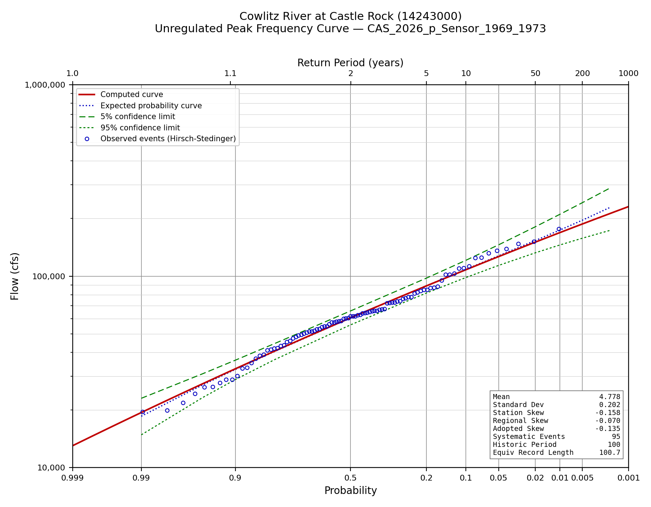
Figure C-1. Unregulated Peak frequency curve.
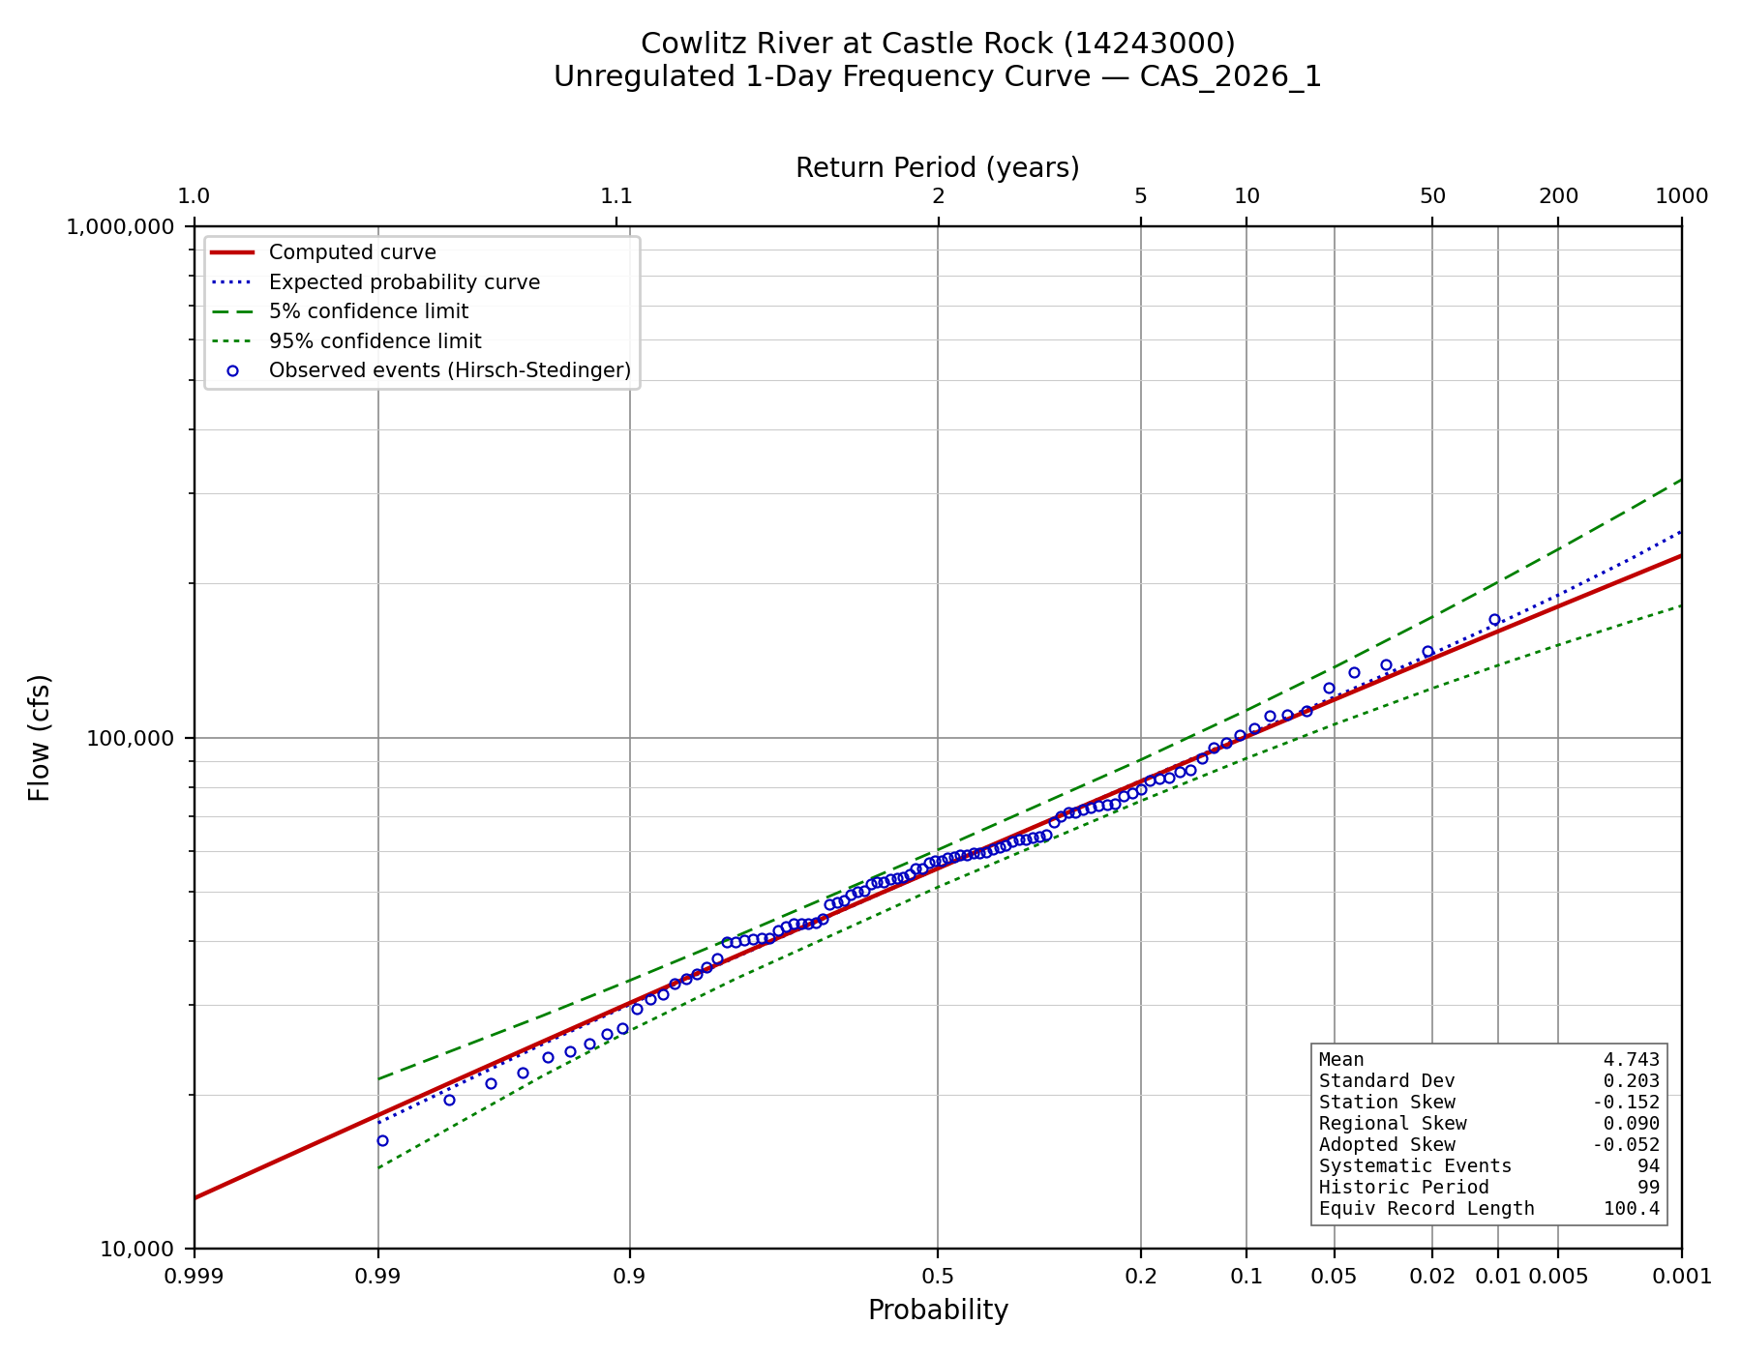
Figure C-2. Unregulated 1-Day frequency curve.
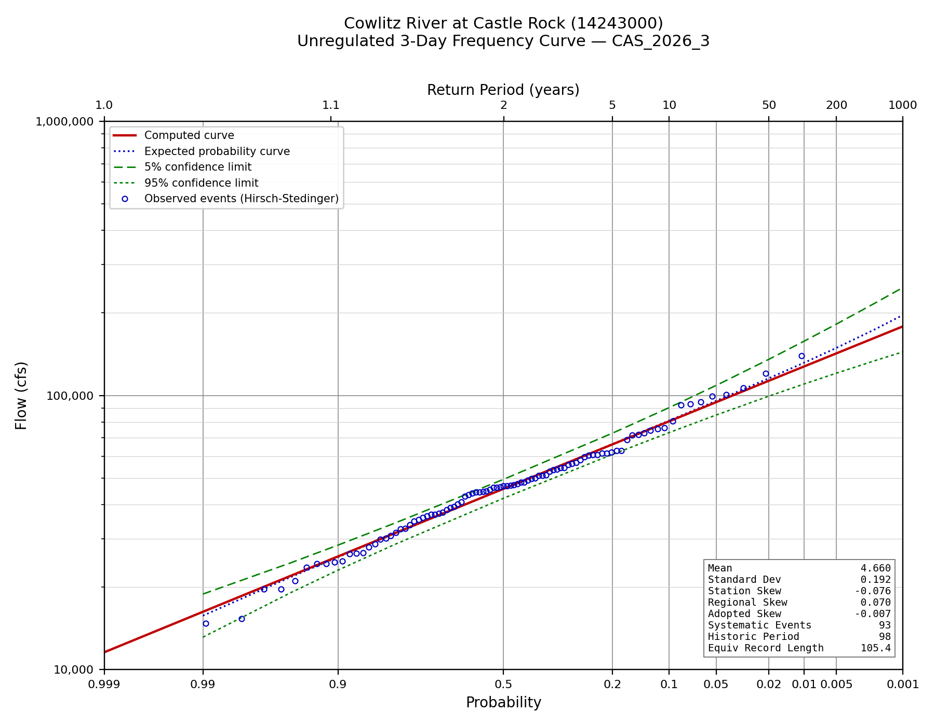
Figure C-3. Unregulated 3-Day frequency curve.
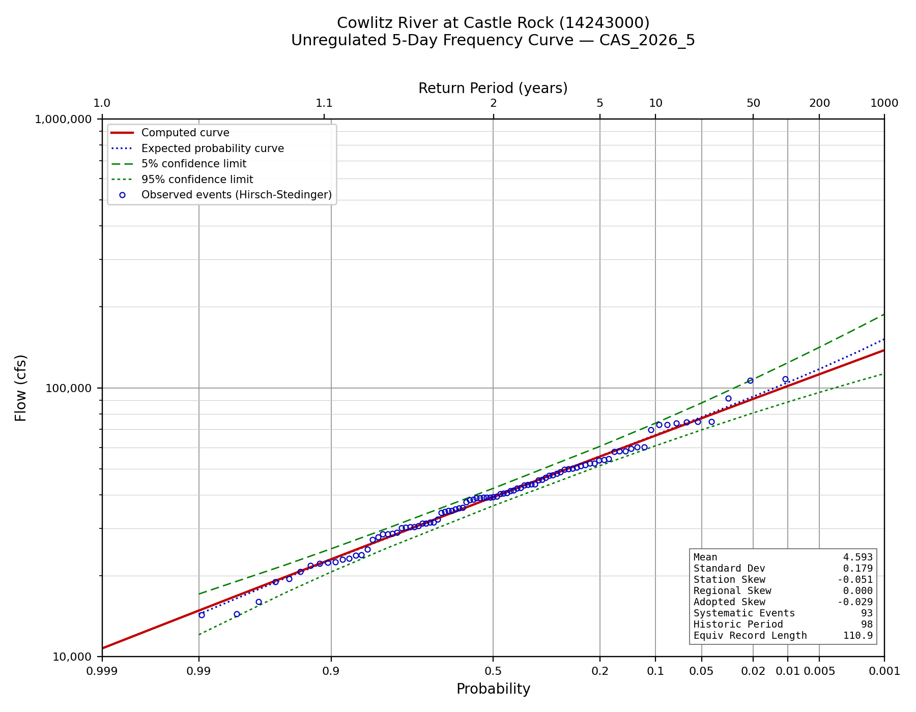
Figure C-4. Unregulated 5-Day frequency curve.

