MEMORANDUM FOR RECORD
U.S. Army Corps of Engineers, Portland District
Item | Description
Subject | Regulated Flow Frequency, Cowlitz River at Castle Rock, Washington (USGS 14243000)
From | Hydrology and Hydraulics Branch, Portland District
Date | August 2026
Status | DRAFT — Section 14 pending

1. Purpose
This memorandum documents the development of regulated flow frequency curves for the Cowlitz River at Castle Rock, Washington. The regulated curves are obtained by transforming the adopted unregulated curves through a relationship between unregulated and regulated peak flow derived from reservoir simulation, rather than by fitting a distribution to the observed regulated record.
The unregulated frequency analysis that supplies the input to this study is documented separately in the memorandum for record on unregulated flow frequency at Castle Rock (Portland District, August 2026). This memorandum begins where that one ends: with an adopted unregulated frequency curve for the instantaneous peak, and takes it through the projects to a regulated curve with uncertainty. The regulated curves support levee fragility assessment and floodplain mapping in the lower Cowlitz valley.
Regulated peak flows cannot be fit directly. Two independent reasons apply. First, the observed regulated record is not a homogeneous sample: Mossyrock began impounding in December 1968, and operating rules and starting pool practice have varied since, so the regulated peaks in the record were not all produced by the same system. Second, regulated peaks do not follow an analytical distribution. Operating rules put hard breaks in the relationship between inflow and outflow — a reservoir holds small events almost entirely, loses ground through the middle of its range, and passes the largest events through once storage is exhausted — and no log-Pearson Type III curve reproduces that shape. The standard approach, and the one used here, is to establish the frequency of the natural inflow and carry it through the projects.

2. Basin Description and Project Operation
The Cowlitz River drains the southern Washington Cascades and enters the Columbia River near Longview. The Castle Rock gage sits in the lower valley, downstream of the Toutle River confluence and downstream of all the basin's storage projects. The total basin area above Castle Rock is 2,238 square miles, of which 1,170 square miles of headwaters are regulated by Mossyrock Dam.
Three non-Federal hydroelectric projects lie on the mainstem, operated by Tacoma Power as the Cowlitz Hydroelectric Project. Mossyrock Dam, completed in 1968, impounds Riffe Lake and provides the only usable flood storage in the basin. Mayfield Dam, completed in 1963, is a re-regulating dam that smooths power peaking releases from Mossyrock and provides no meaningful flood regulation of its own. Cowlitz Falls Dam, above Mossyrock, is run-of-river.
Two features of the basin govern how much the projects can do, and both are visible in the results that follow. The regulated fraction is a little over half the drainage area, so roughly half the flow arriving at Castle Rock in a large event is uncontrolled. The Toutle River, the largest tributary, enters below both dams and is entirely unregulated; the Tilton River enters Mayfield Lake and is caught by the projects. At the largest events the local and Toutle contribution is a median 48 percent of unregulated flow at Castle Rock, which sets a floor on the regulated peak that no operation can reach below.
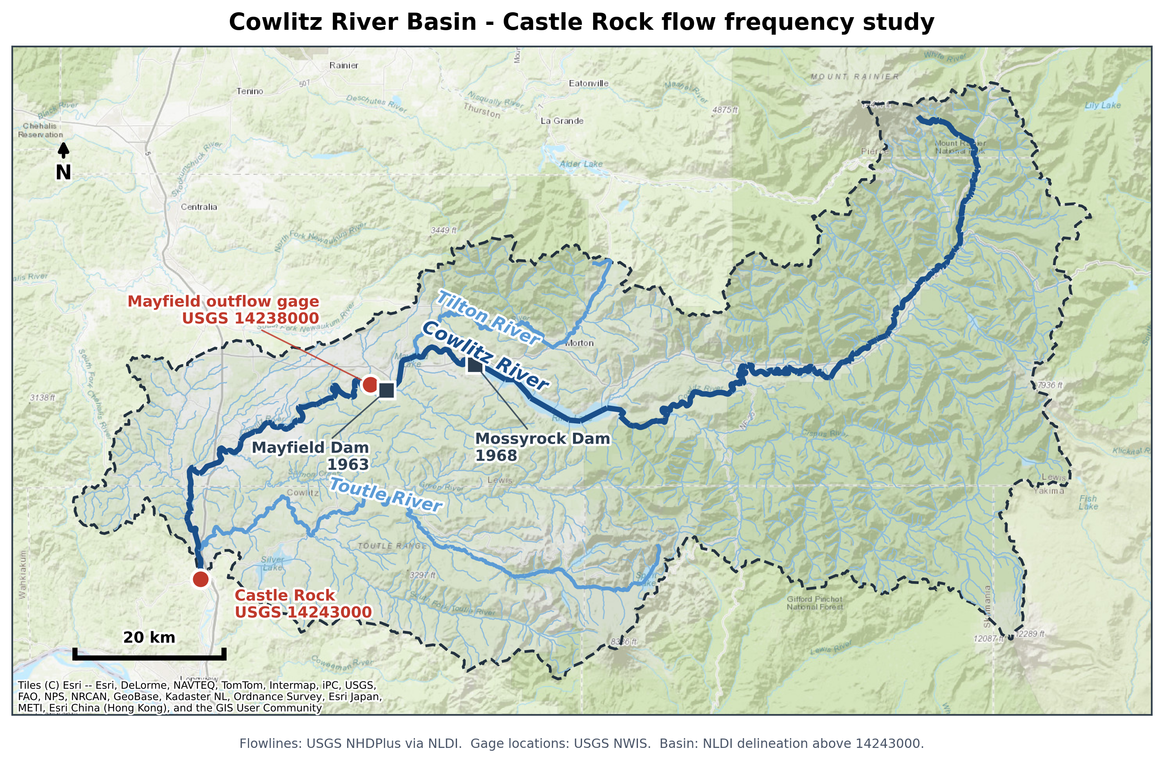
Figure 2-1. Cowlitz River basin, showing the Castle Rock gage, the Mossyrock and Mayfield projects, and the Toutle and Tilton tributaries.

2.1 Previous Studies
The previously adopted regulated frequency curve at Castle Rock comes from the 2009 Cowlitz Hydrology Restudy. That study predates Bulletin 17C, does not include the most recent 17 years of record, and derived its regulated curve by a different route. Section 11 compares the two.

3. Data Used
Table 3-1 lists the datasets and models used and the purpose each one served. The observed records are the same ones assembled for the unregulated study and are documented there; the additions specific to this study are the reservoir simulation model and the simulation outputs it produced.
Dataset or model | Period used | Purpose
Adopted unregulated frequency curve, Castle Rock | WY 1927–2026 | Input to the transform; supplies the AEP of every regulated ordinate
HEC-ResSim model, Mossyrock and Mayfield | Current (2014 WCM) rules | Routes inflow hydrographs through the projects
USGS 14243000 annual peak record | WY 1927–2026 | Observed regulated peaks; basis of the adjusted record
Mossyrock pool elevation, daily (USGS) | Oct 1973–present | Observed starting pool for the Obs_RC simulation
Reservoir inflow and Castle Rock local flow | WY 1929–2026 | Simulation inflows, back-calculated and volume-corrected
ResSim period-of-record simulation, rule-curve start (WCM_RC) | 98 water years | Regulated peak under current rules from a rule-curve starting pool
ResSim period-of-record simulation, observed start (Obs_RC) | 53 water years | Regulated peak under current rules from the observed starting pool
ResSim synthetic ensemble simulation | 48 members | Regulated response above the observed range
Table 3-1. Datasets and models used, and their purpose.

4. Methods
The regulated curve is built in four steps, each documented in its own section below.
First, an adjusted regulated peak record is assembled from the observed record, placing every historical peak on a consistent starting-pool basis so that peaks from different decades can be compared with one another (Section 5). Second, those adjusted peaks are paired with the unregulated peak for the same event, giving a set of observed (unregulated, regulated) pairs (Section 6). Third, because only one water year in the record exceeds the unregulated 100-year peak, synthetic flood ensembles are constructed and routed to populate the range above the record, where the answer is needed and the record is silent (Section 7). Fourth, a relationship is drawn through the combined set of pairs and applied to the unregulated frequency curve, transferring the AEP of each unregulated ordinate to the regulated flow it produces (Section 8).
The transform is applied peak-to-peak. The instantaneous peak and the 1-day duration are effectively tied as the critical duration for the regulated response (Section 6), and a peak-to-peak transform is the simpler of the two to explain and to audit.

5. Adjusted Regulated Peak Record
The observed regulated peaks are the direct evidence of what the projects do to a flood, but they are not directly comparable to one another. A flood arriving on a full pool is attenuated less than the same flood arriving on a drawn-down pool, so a peak from a year that happened to start low understates what the same storm would do under the operation being evaluated. The record has to be placed on a consistent starting-pool basis before it can be used.
Two period-of-record ResSim simulations were run for this purpose. Both use the same observed hydrology and the same current operating rules, and differ only in the reservoir's starting pool: WCM_RC starts each event at the Water Control Manual rule curve, and Obs_RC starts it at the observed elevation at event onset. Because everything else is held fixed, the difference between them isolates the effect of the starting pool alone. Obs_RC is limited to water year 1974 onward because the observed daily Mossyrock elevation record begins in October 1973.
Where the rule-curve start produces a higher regulated peak than the observed start, the historical operation benefited from storage the rule curve does not credit. That benefit is removed from the observed peak:
adjusted peak = observed peak + (WCM_RC peak − Obs_RC peak), where WCM_RC exceeds Obs_RC
The adjustment is one-sided by design: the observed peak is only ever increased, never reduced. A negative difference means the observed pool started above the rule curve, so the historical operation was already at least as conservative as the rule curve requires and there is nothing to remove. Only water year 1976 falls in that category.
Peaks are matched by event rather than by water year. Each simulation's peak is taken within three days of the observed peak date, not as that run's annual maximum. This matters because a low starting pool attenuates the first storm of a window more, which can promote a later storm to the annual maximum; differencing annual maxima would then subtract two different storms. Event matching yields 40 usable years against 29 for annual maxima.
Of 51 shared water years (1974 through 2024), 38 received an adjustment, with a median of 11,334 cubic feet per second and a range of 263 to 24,013. Screening removed 10 years from the fit: 7 failed a timing screen, where the observed and simulated peaks are not the same storm; 2 failed a physical screen in which the regulated peak exceeded the unregulated peak at or above 60,000 cubic feet per second, which a reservoir cannot produce; and 1 failed both. Screened years are carried through the record unadjusted rather than deleted, so the reason is recorded against each one in Appendix A.
Water year 1980 is excluded explicitly. The observed 97,000 cubic feet per second peak on 18 May 1980 is the Mount St. Helens eruption, a debris-flow event with no meteorological analogue; both simulations peak five months earlier on an ordinary winter storm. Whether that event belongs in a flood frequency analysis at all is a separate question this study does not decide.
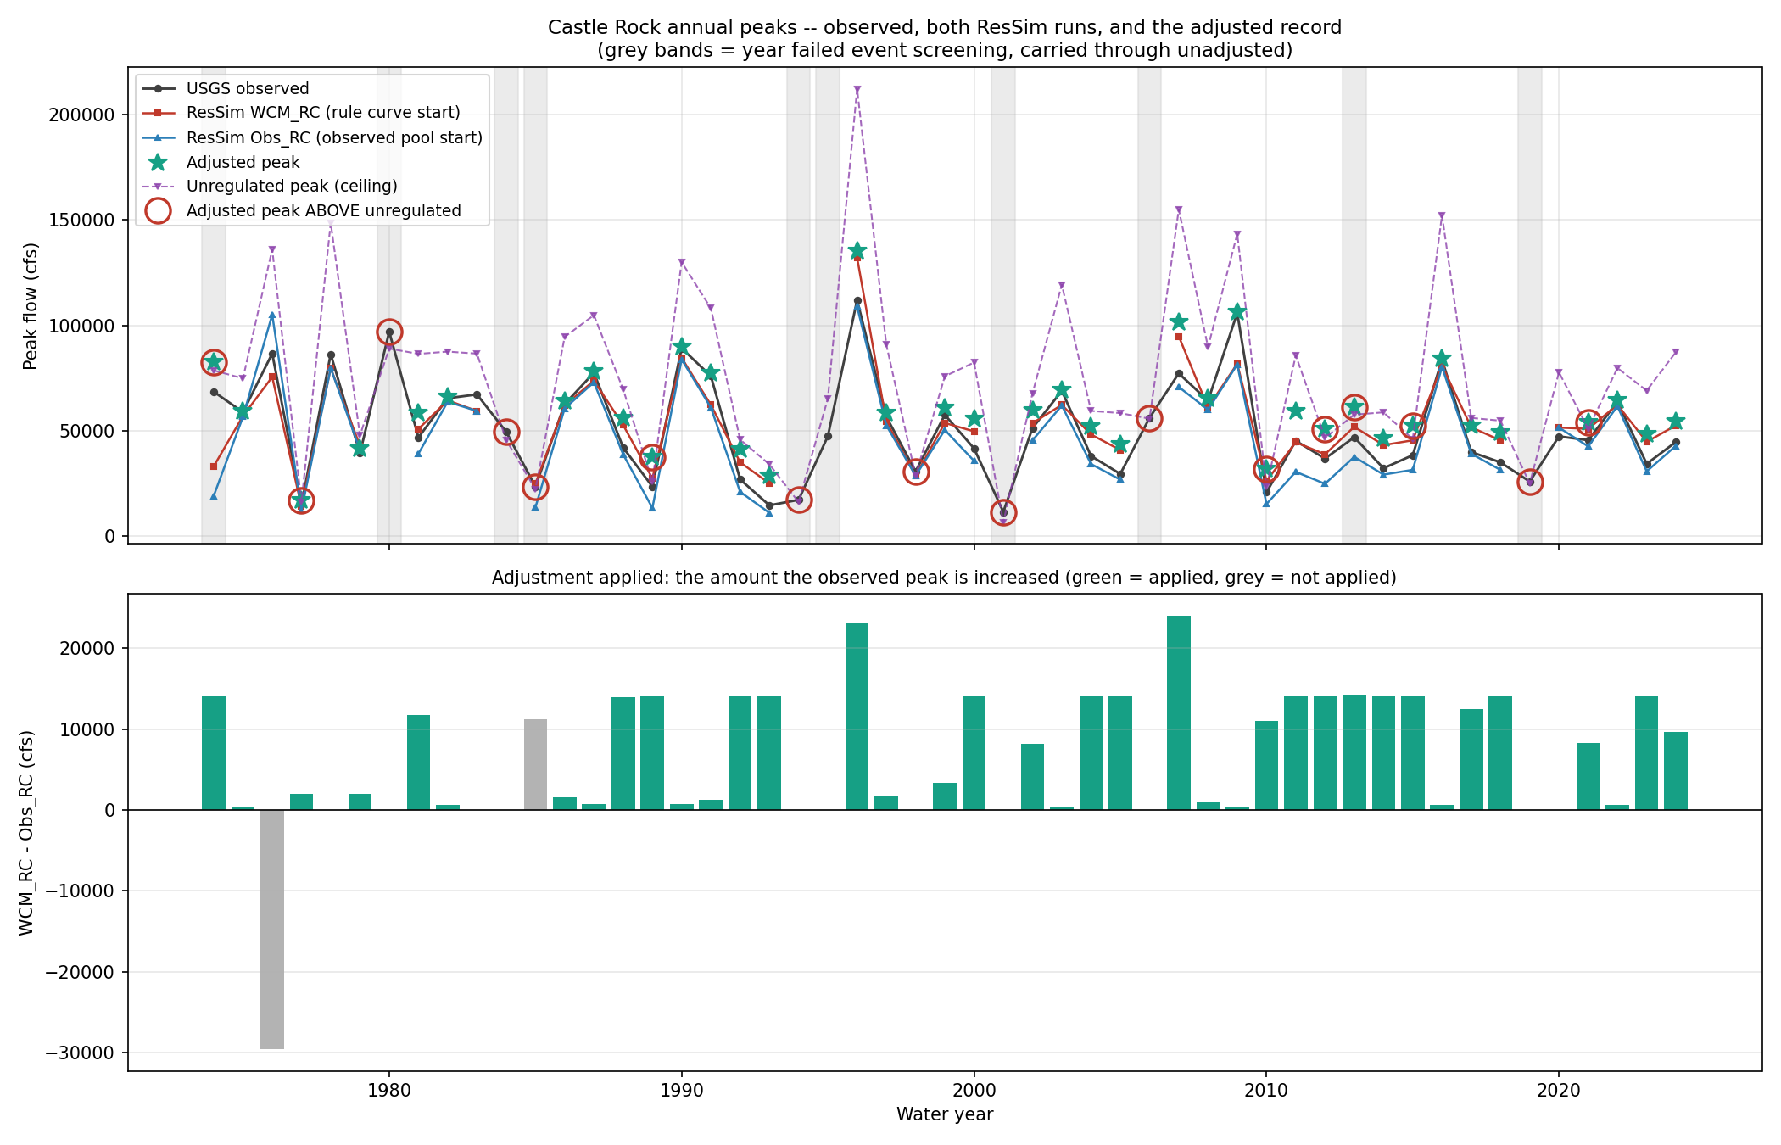
Figure 5-1. Observed, WCM_RC and Obs_RC regulated peaks by water year, and the resulting adjustment.

6. Critical Duration
The duration at which the unregulated and regulated records correspond most closely identifies the averaging window over which the projects actually operate, and therefore the duration the transform should be built on. Adjusted regulated values were regressed on unregulated values at the instantaneous peak and at the 1-, 3- and 5-day durations.
Duration | n | R-squared | Log R-squared | Log slope | Median reg / unreg
Peak (1-hr) | 44 | 0.870 | 0.847 | 0.602 | 0.78
1-Day | 44 | 0.853 | 0.830 | 0.605 | 0.87
3-Day | 44 | 0.792 | 0.783 | 0.633 | 1.15
5-Day | 44 | 0.733 | 0.734 | 0.663 | 1.45
Table 6-1. Adjusted regulated against unregulated flow by duration, water years 1974 through 2024.
The instantaneous peak and the 1-day duration are not distinguishable on this evidence, and both are stronger than the longer durations. The peak-to-peak relation was adopted. The median ratio column shows the physical reason the shorter durations correlate better: at the peak the projects reduce flow to about 78 percent of unregulated, while at 5 days the ratio exceeds one, because the water held out of a peak is released afterward and reappears in the longer averaging window. The projects move flood volume in time; they do not remove it.
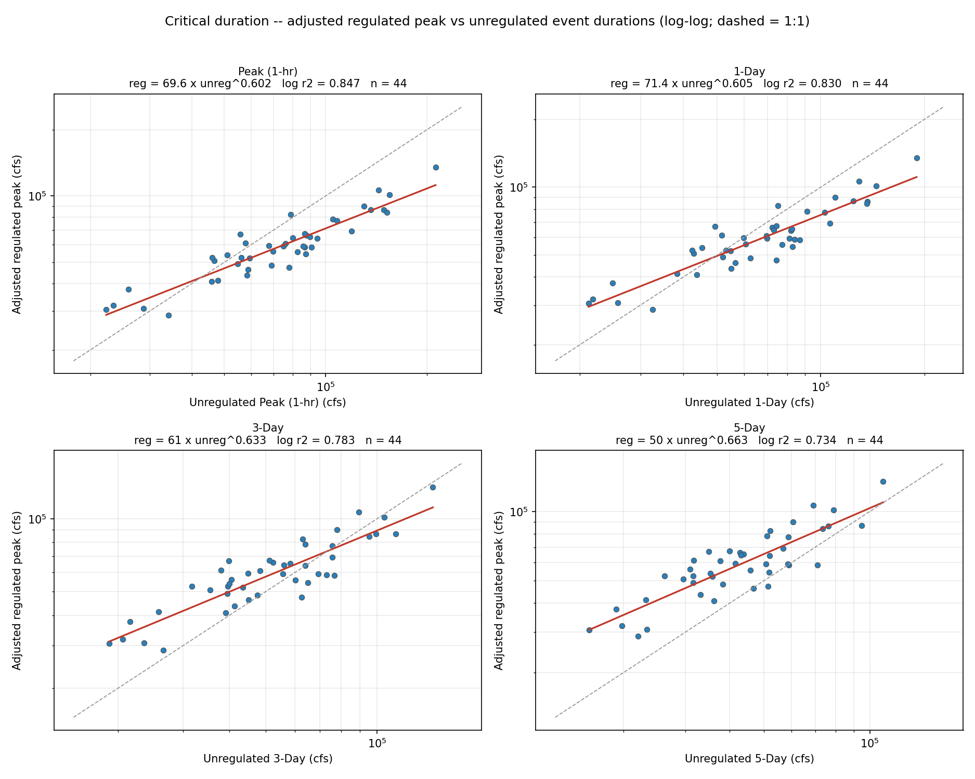
Figure 6-1. Adjusted regulated against unregulated flow, by duration.

7. Synthetic Flood Ensembles
Only one water year in the record exceeds the unregulated 100-year peak, so the upper end of the unregulated-regulated relationship — the part that sets the 100-, 250- and 500-year regulated flows — is essentially unconstrained by observed events. Synthetic floods were constructed and routed to populate that range.
The design is a factorial over the two things that could matter. Magnitude is varied over four targets taken from the unregulated frequency curve: the 100-, 250- and 500-year peaks, and a fourth target 20 percent above the 500-year so that the drawn relationship is not extrapolating past its final point exactly where the answer is needed. Shape is varied by scaling twelve different observed storms, selected from the record by unregulated peak and spanning the full range of observed attenuation behavior, from storms the projects absorbed to one that passed straight through. Shape is varied rather than assumed because attenuation among large observed events is not predictable from shape, magnitude, antecedent flow or timing.
Each source storm is scaled to hit its target unregulated peak exactly and its target 5-day volume by iteration, using a multiplier that is a function of flow rather than of time. A flow-based multiplier cannot reorder the hydrograph, so the peak stays the peak; a time-based taper can scale a shoulder harder than the peak and invent a new maximum. Both the Mossyrock inflow and the Castle Rock local are scaled by the same factor, so the observed coincidence between the controlled and uncontrolled fractions is preserved.
Two members required manual editing. Matching a peak and a 5-day volume on a sharp storm forces the shoulders to stretch harder than the peak itself, which turned a small rise already present in the December 1977 and November 1986 hydrographs into what read as a separate flood ahead of the main peak. Both were removed by hand before the ensemble was routed. The effect on the result is confined to four members, whose regulated peaks fell by 1.4 to 5.4 percent; the remaining 44 are unchanged.
The 48 routed members span regulated peaks from 80,884 to 266,744 cubic feet per second and attenuation ratios, regulated over unregulated peak, from 0.46 to 1.00. The spread at a single magnitude is a shape effect rather than scatter: the Nov2006 storm is absorbed most strongly, while Dec1933 exhausts storage and passes through near the 1:1 line, and the two land far apart at the same unregulated peak. That spread is the physical basis for the uncertainty band in Section 10.
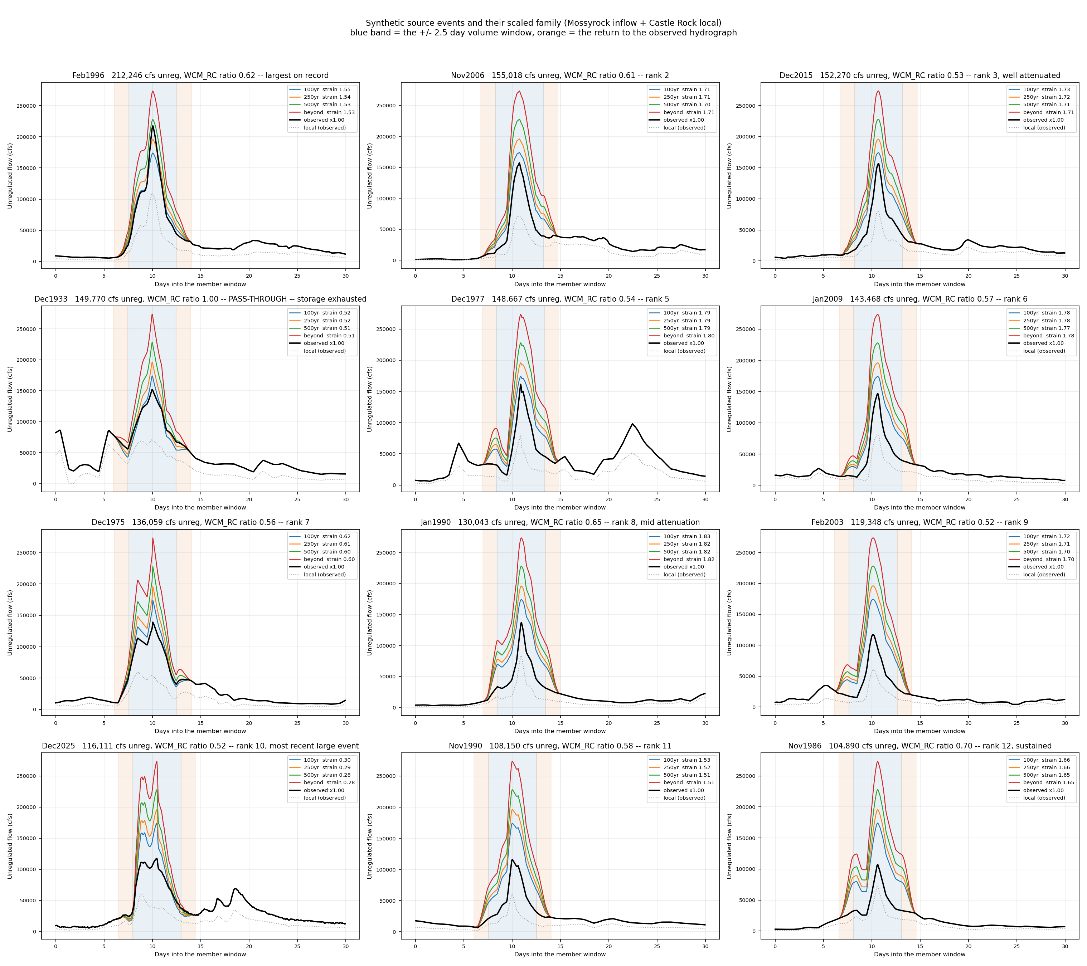
Figure 7-1. Source storms and the scaled family built from each. The shaded band is the window over which the 5-day volume is matched.

8. The Unregulated-Regulated Transform
The adjusted historical pairs and the routed synthetic members together give the set of (unregulated, regulated) pairs the transform is drawn through. The historical pairs carry the observed range; the synthetics carry the range above it.
A single power law was considered and rejected as the adopted form. A power law is a straight line in log-log space, and a straight line is the wrong shape for this relationship: the projects hold small events almost entirely, lose ground through the middle of the range, and flatten toward the unregulated flow at the top as storage is exhausted. Forcing one slope through all of that places the line above the data in one range and below it in another, and the error lands at the upper end, where it matters most.
The adopted transform is a locally weighted regression through the scatter in log-log space, using tricube weights over the nearest 65 percent of the sample, so the slope at any point comes from nearby data only and the line is free to bend where the data bends. It is constrained to increase monotonically, and clipped at the 1:1 line at large flows, since a regulated peak above its own unregulated peak is not physical there. The single power law is retained as a reference line on the diagnostic figures.
The WCM_RC simulated pairs are shown on the diagnostic figures but are deliberately not fitted. They are simulated on both axes and carry no observed anchor: the adjustment that corrects the historical record is built from the difference between the two simulations, and where no Obs_RC data exists there is no correction to apply. They are evidence about the shape of the relationship, not about its position.
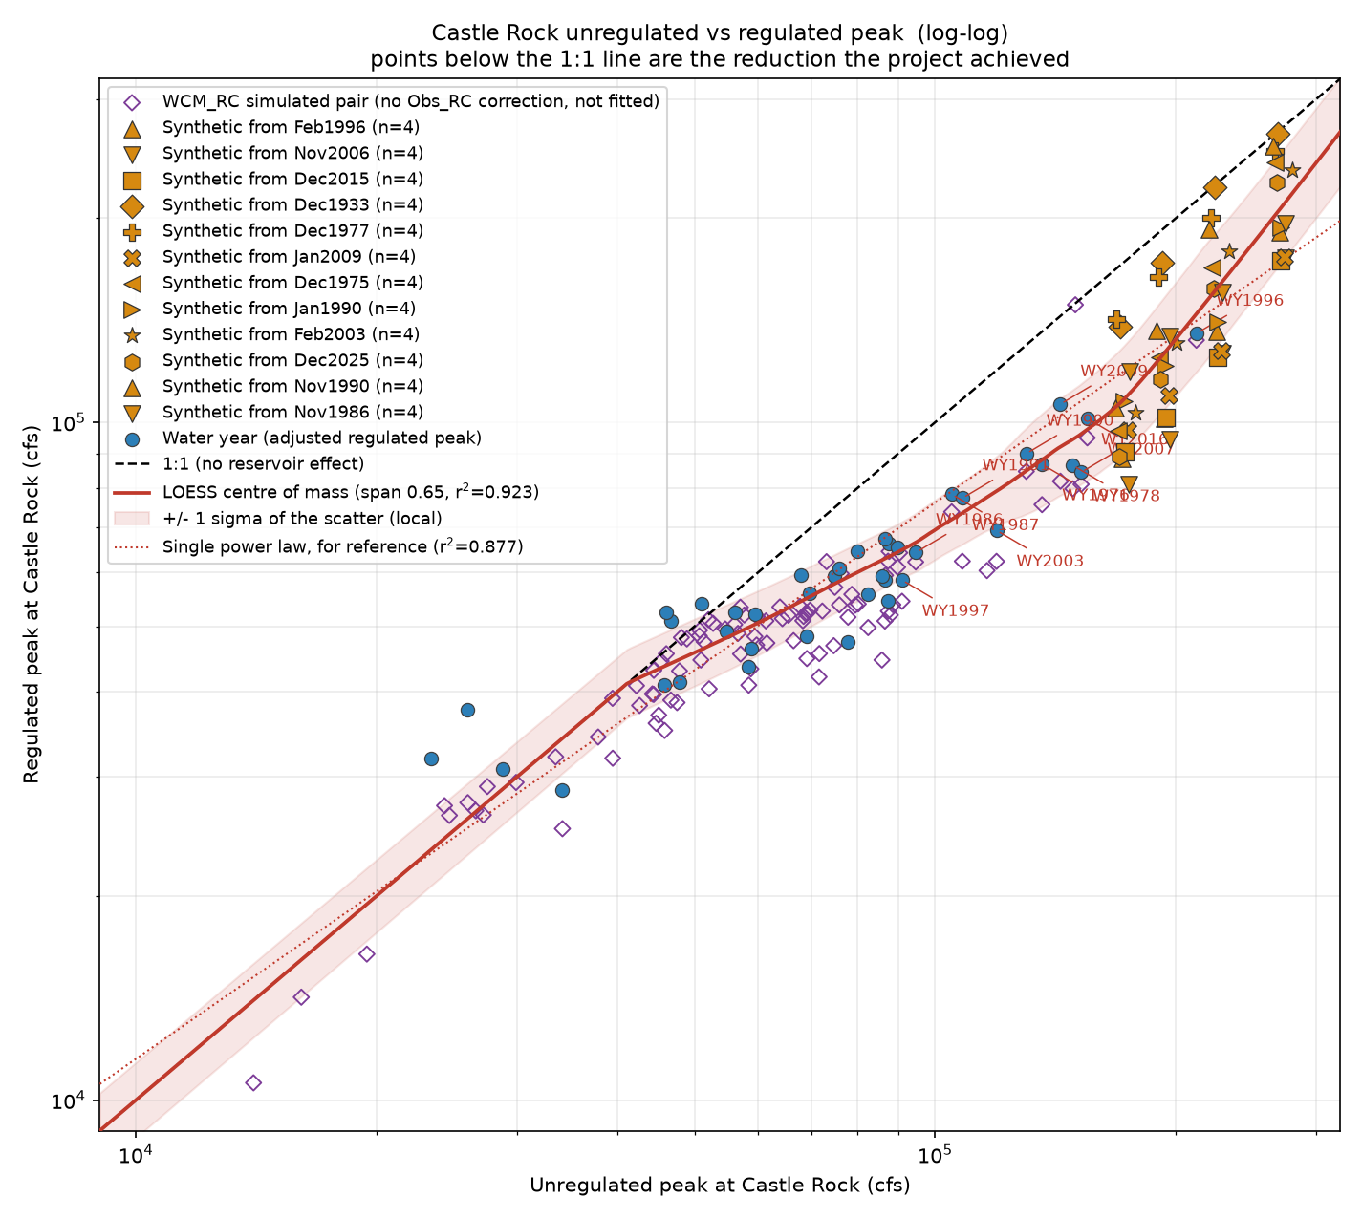
Figure 8-1. Unregulated against regulated peak at Castle Rock, log-log, with the adopted transform and the single power law for reference.

9. Regulated Frequency Curve
The regulated curve is obtained by reading each ordinate of the adopted unregulated curve through the transform. The annual exceedance probability is inherited from the unregulated side: the regulated flow plotted at a given AEP is the flow the projects produce from the unregulated flow of that AEP. No distribution is fitted to regulated flow at any point in this procedure.
Event | AEP | Unregulated (cfs) | Regulated (cfs) | Reduction | Regulated, 90% band (cfs)
2-year | 0.500 | 60,529 | 50,813 | 16% | 42,214 – 61,157
10-year | 0.100 | 108,618 | 73,702 | 32% | 61,084 – 89,435
50-year | 0.020 | 153,556 | 96,784 | 37% | 71,482 – 133,786
100-year | 0.010 | 174,075 | 109,522 | 37% | 77,039 – 164,103
200-year | 0.005 | 195,977 | 128,798 | 34% | 86,441 – 208,751
500-year | 0.002 | 227,900 | 160,342 | 30% | 103,814 – 277,782
Table 9-1. Adopted regulated frequency curve at Castle Rock, selected ordinates.
The reduction the projects achieve is not monotonic in magnitude. It peaks at about 37 percent near the 1 to 2 percent annual chance event and falls away on both sides: below, because small events are already largely contained and the unregulated flow is itself small; above, because storage is finite and the largest floods increasingly pass through. At the 0.2 percent chance event the reduction is down to about 30 percent. This shape, not any property of a fitted distribution, is what the transform exists to capture.
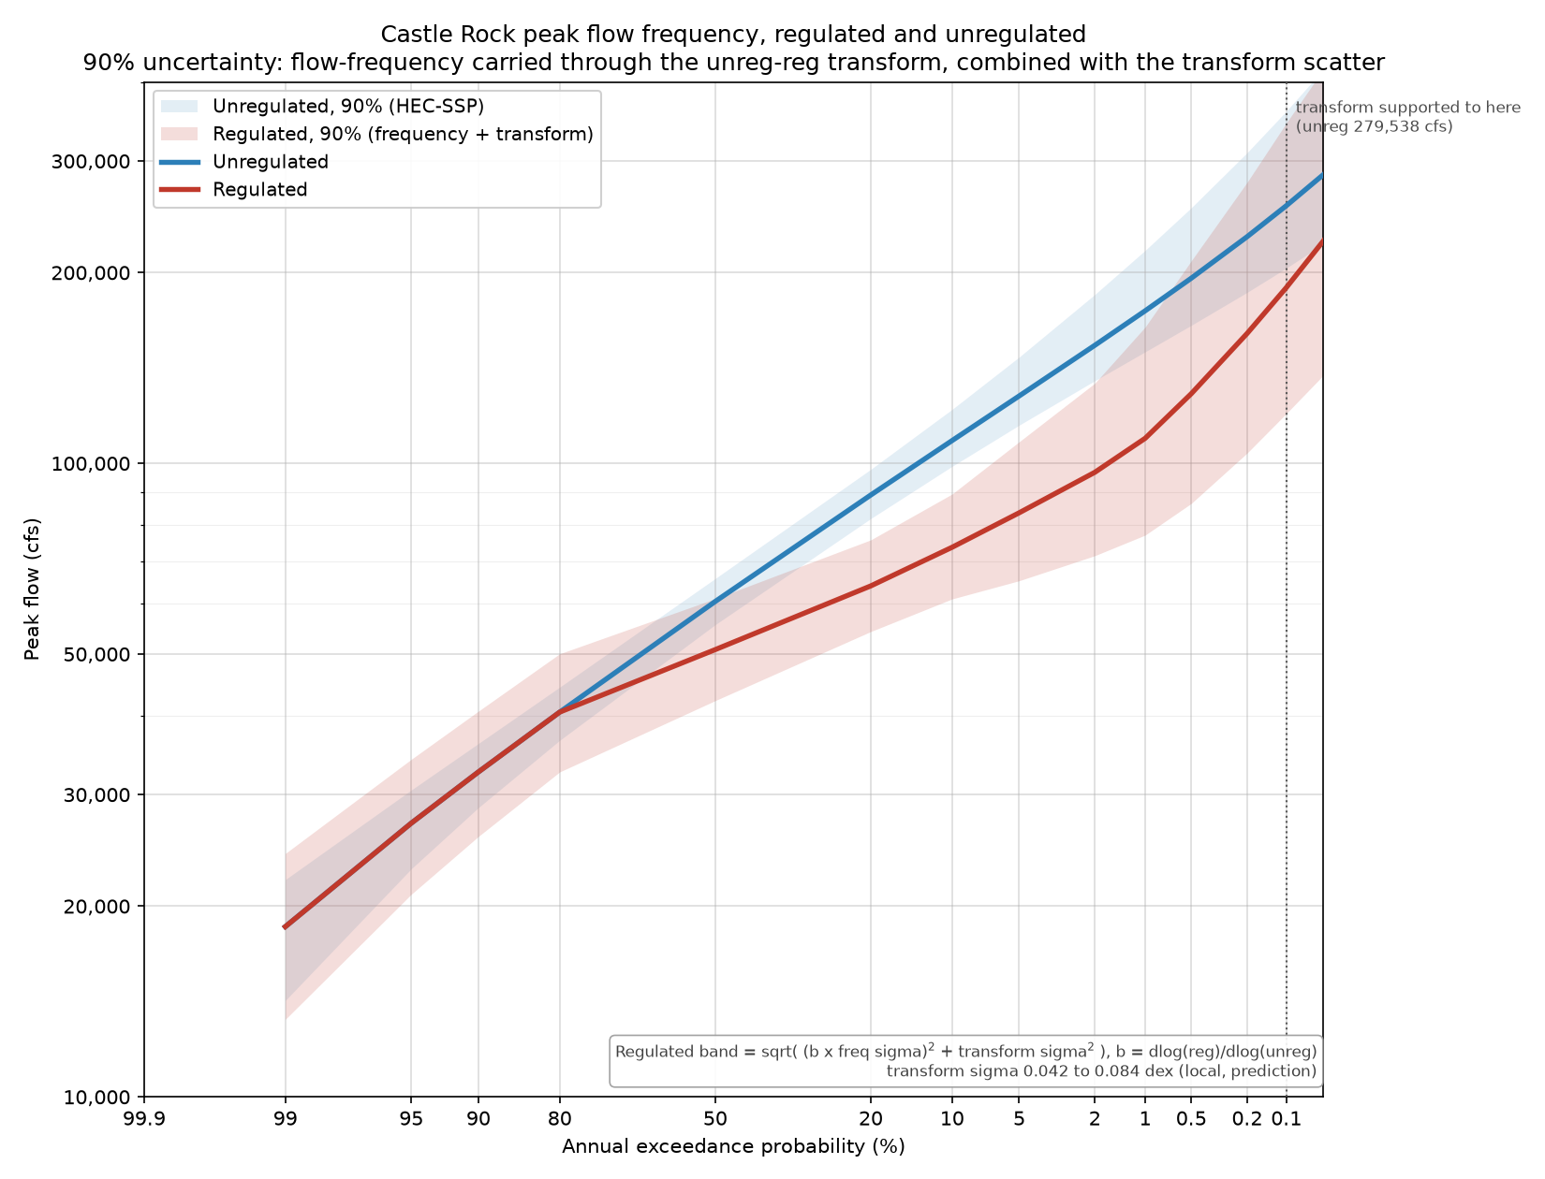
Figure 9-1. Adopted regulated and unregulated frequency curves at Castle Rock, with the 90 percent uncertainty band.

10. Uncertainty
The regulated flow at a given AEP is uncertain for two independent reasons, and the band carries both.
The first is flow frequency. The unregulated quantile being read through the transform is itself an estimate from a roughly 100-year record, and HEC-SSP reports its uncertainty as confidence limits about the computed curve. The second is the transform itself. At one unregulated magnitude the regulated peak still depends on the shape of the flood, which is what the scatter of the pairs about the transform measures.
The two are combined in log space, but the frequency term must be carried through the transform before they are added. A given proportional error in unregulated flow does not produce the same proportional error in regulated flow: it is scaled by the local slope of the transform in log-log space. That slope runs about 0.57 through the middle of the curve, where the projects absorb most of an increase, and rises to about 1.5 at the top, where the transform bends toward pass-through and regulated flow is catching unregulated flow up. Omitting that term would overstate the band through the middle by nearly a factor of two and understate it at the top.
The confidence limits reported by HEC-SSP are asymmetric, being roughly 1.5 times wider on the upper side than the lower at the 500-year. That asymmetry is preserved by combining the two sides separately rather than averaging them, which remains a closed-form calculation. The resulting band is at most 1.4 times more lopsided on one side than the other, which is well within the range a two-piece lognormal represents adequately; no Monte Carlo sampling was required.
The scatter of the transform is not constant along the curve and is not treated as constant. Measured locally it runs about 0.05 in log units below 80,000 cubic feet per second and about 0.08 above 150,000. This is physical: a small flood is simply held, while whether a large one exhausts storage depends on its shape. A single pooled value would be about 25 percent too wide at the median and 15 percent too narrow at the top.
One constraint is imposed on the band. Above 60,000 cubic feet per second the upper bound of the regulated curve is held at or below the upper bound of the unregulated curve, because a regulated flood cannot exceed the unregulated flood it was routed from. Below that threshold the constraint is not applied: minimum release requirements and refill drawdown can legitimately put more water in the river than natural conditions would. The constraint binds only at the three smallest AEPs on the curve.

11. Comparison with the 2009 Restudy
Figure 11-1 places the adopted regulated curve against the 2009 Cowlitz Hydrology Restudy. Through the range supported by observed events the two agree within about 9 percent. At the 1 percent annual chance event the 2026 curve is 13 percent above the 2009 value, and at the 0.2 percent chance event 3 percent above it. Beyond that the 2026 curve falls well below, by 21 percent at the 0.1 percent chance event.
The divergence at the extreme tail is driven by the shape of the 2009 curve, which turns sharply upward above the 0.2 percent annual chance event, rising from 156,000 to 390,000 cubic feet per second between the 0.2 and 0.01 percent chance events. Any comparison in that range is between two extrapolations rather than between two records, and should be read as such.
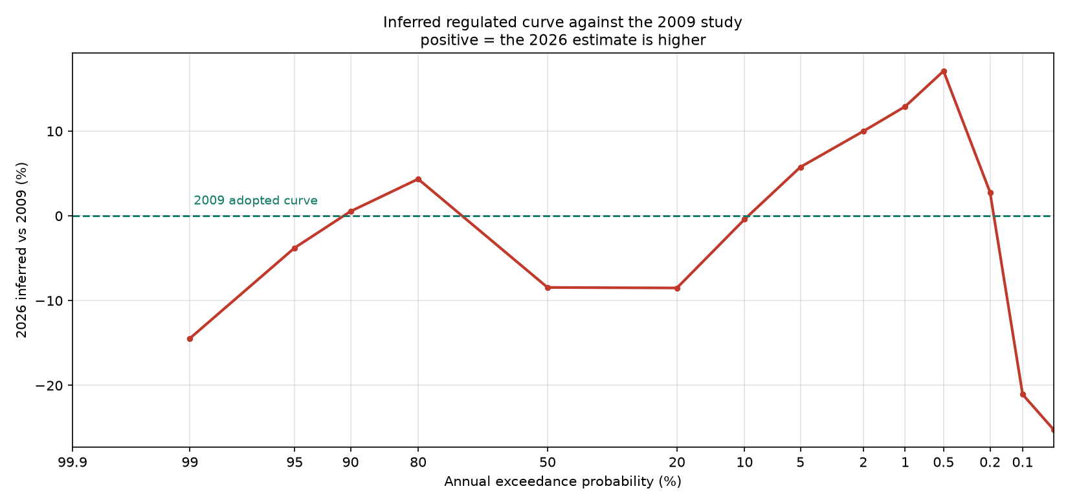
Figure 11-1. Adopted 2026 regulated curve against the 2009 Cowlitz Hydrology Restudy.

12. Limitations
The transform is supported by data over the unregulated range of roughly 23,000 to 280,000 cubic feet per second. The upper part of that range is supported entirely by synthetic events, not by observed floods, and the synthetic events are observed storms scaled up. Hydrograph shape is not independent of size — a large storm is large because it was widespread and sustained — so scaling a moderate storm to a rare magnitude routes a shape that storm never produced. Six of the twelve source storms must be scaled past a factor of two to reach the largest target, and those members should be read as the weaker evidence in the set.
The adjusted record carries its own caveats. Thirteen of the adjustments land within a narrow band near 14,000 cubic feet per second, which is most likely a fixed release constraint binding in one simulation and not the other rather than a pure starting-pool effect. Seven adjustments exceed 40 percent of the observed peak; all are moderate-peak years where a large absolute adjustment is a large fraction, and they influence the lower end of the transform more than the upper.
The adjusted record is deliberately not used for an analytical frequency fit, and should not be. It exists to establish the unregulated-regulated relationship at large events, which is why the screening losses are acceptable: the excluded years are dominated by low peaks that do not influence that relationship.
Finally, the transform is a centre-of-mass line through a scatter, not a physical model of the projects. It reproduces what the simulations did on the events tested. It carries no information about operations outside the current rule set, and it should be redrawn if those rules change.

13. Extension to the Columbia River Confluence
[TO BE COMPLETED]
The regulated frequency curve developed above applies at Castle Rock. Extending it downstream to the Columbia River confluence requires a coincident frequency analysis combining the regulated Cowlitz flow with Columbia River stage, supported by regional flood frequency estimates for the intervening ungaged area. That analysis is in progress and will be documented in this section.
This section is expected to cover the coincident frequency method and the assumed dependence between Cowlitz and Columbia flooding; the regional regression estimates used for the ungaged local area below Castle Rock; the resulting regulated frequency estimates at the downstream locations required for levee analysis; and how the uncertainty developed in Section 10 is carried through that combination.

Appendix A. Adjusted Regulated Peak Record by Water Year
Observed, simulated and adjusted regulated peaks for every shared water year, with the screening result and the reason recorded for each. Flows are in cubic feet per second.
WY | Observed | WCM_RC | Obs_RC | Difference | Adjusted | Screen
1974 | 68,600 | 33,207 | 19,208 | 13,999 | 82,599 | reg_over_unreg
1975 | 58,900 | 57,075 | 56,714 | 361 | 59,261 | ok
1976 | 86,700 | 75,597 | 105,150 | -29,553 | 86,700 | ok
1977 | 15,000 | 14,187 | 12,187 | 2,000 | 17,000 | ok
1978 | 86,400 | 79,778 | 79,778 | 0 | 86,400 | ok
1979 | 39,400 | 42,972 | 40,972 | 2,000 | 41,400 | ok
1980 | 97,000 | — | — | — | 97,000 | both
1981 | 46,900 | 50,909 | 39,206 | 11,703 | 58,603 | ok
1982 | 65,500 | 64,483 | 63,822 | 661 | 66,161 | ok
1983 | 67,300 | 59,457 | 59,457 | 0 | 67,300 | ok
1984 | 49,600 | — | — | — | 49,600 | different_event
1985 | 23,600 | 24,934 | 13,724 | 11,210 | 23,600 | different_event
1986 | 62,700 | 62,206 | 60,657 | 1,549 | 64,249 | ok
1987 | 77,600 | 73,775 | 73,059 | 716 | 78,316 | ok
1988 | 42,100 | 52,818 | 38,880 | 13,938 | 56,038 | ok
1989 | 23,600 | 27,470 | 13,443 | 14,026 | 37,626 | ok
1990 | 89,200 | 84,639 | 83,907 | 732 | 89,932 | ok
1991 | 76,000 | 62,368 | 61,083 | 1,286 | 77,286 | ok
1992 | 27,000 | 35,102 | 21,102 | 14,000 | 41,000 | ok
1993 | 14,700 | 25,147 | 11,148 | 14,000 | 28,700 | ok
1994 | 17,300 | — | — | — | 17,300 | different_event
1995 | 47,500 | — | — | — | 47,500 | different_event
1996 | 112,000 | 132,172 | 108,967 | 23,205 | 135,205 | ok
1997 | 56,700 | 54,439 | 52,636 | 1,803 | 58,503 | ok
1998 | 30,800 | 28,784 | 28,784 | 0 | 30,800 | ok
1999 | 57,600 | 53,768 | 50,442 | 3,326 | 60,926 | ok
2000 | 41,700 | 49,782 | 35,782 | 14,000 | 55,700 | ok
2001 | 11,600 | — | — | — | 11,600 | different_event
2002 | 51,400 | 53,728 | 45,573 | 8,155 | 59,555 | ok
2003 | 69,000 | 62,340 | 62,077 | 263 | 69,263 | ok
2004 | 38,100 | 48,301 | 34,302 | 14,000 | 52,100 | ok
2005 | 29,600 | 40,940 | 26,912 | 14,029 | 43,629 | ok
2006 | 56,200 | — | — | — | 56,200 | different_event
2007 | 77,300 | 94,857 | 70,844 | 24,013 | 101,313 | ok
2008 | 64,300 | 61,129 | 60,053 | 1,076 | 65,376 | ok
2009 | 106,000 | 81,855 | 81,470 | 385 | 106,385 | ok
2010 | 20,900 | 26,302 | 15,335 | 10,966 | 31,866 | ok
2011 | 45,300 | 44,599 | 30,599 | 14,000 | 59,300 | ok
2012 | 36,900 | 38,920 | 24,921 | 13,999 | 50,899 | ok
2013 | 47,000 | 51,961 | 37,704 | 14,257 | 61,257 | reg_over_unreg
2014 | 32,300 | 43,271 | 29,271 | 14,000 | 46,300 | ok
2015 | 38,500 | 45,556 | 31,552 | 14,004 | 52,504 | ok
2016 | 83,700 | 81,000 | 80,324 | 675 | 84,375 | ok
2017 | 40,000 | 51,716 | 39,201 | 12,515 | 52,515 | ok
2018 | 35,100 | 45,514 | 31,518 | 13,996 | 49,096 | ok
2019 | 26,000 | — | — | — | 26,000 | different_event
2020 | 47,400 | 51,580 | 51,580 | 0 | 47,400 | ok
2021 | 45,600 | 50,963 | 42,650 | 8,313 | 53,913 | ok
2022 | 63,900 | 62,387 | 61,747 | 639 | 64,539 | ok
2023 | 34,400 | 44,819 | 30,826 | 13,993 | 48,393 | ok
2024 | 44,800 | 52,638 | 42,979 | 9,659 | 54,459 | ok
Table A-1. Adjusted regulated peak record, water years 1974 through 2024.

Appendix B. Regulated Frequency Curve Ordinates
The adopted regulated curve with its uncertainty band, and the terms that produced the band, for every ordinate. The local slope column is the slope of the transform in log-log space at that ordinate. Flows are in cubic feet per second.
AEP | Unregulated | Regulated | Lower 90% | Upper 90% | Local slope | Reduction % | Extrap.
0.9900 | 18,564 | 18,564 | 13,255 | 24,219 | 1.00 | 0.0 | no
0.9500 | 27,041 | 27,041 | 20,881 | 34,102 | 1.00 | 0.0 | no
0.9000 | 32,573 | 32,573 | 25,768 | 40,626 | 1.00 | 0.0 | no
0.8000 | 40,487 | 40,487 | 32,577 | 50,052 | 1.00 | 0.0 | no
0.5000 | 60,529 | 50,813 | 42,214 | 61,157 | 0.57 | 16.1 | no
0.2000 | 89,126 | 64,047 | 54,260 | 75,716 | 0.61 | 28.1 | no
0.1000 | 108,618 | 73,702 | 61,084 | 89,435 | 0.73 | 32.1 | no
0.0500 | 127,758 | 83,553 | 65,272 | 108,163 | 0.81 | 34.6 | no
0.0200 | 153,556 | 96,784 | 71,482 | 133,786 | 0.86 | 37.0 | no
0.0100 | 174,075 | 109,522 | 77,039 | 164,103 | 1.23 | 37.1 | no
0.0050 | 195,977 | 128,798 | 86,441 | 208,751 | 1.43 | 34.3 | no
0.0020 | 227,900 | 160,342 | 103,814 | 277,782 | 1.47 | 29.6 | no
0.0010 | 255,074 | 189,434 | 119,861 | 344,541 | 1.49 | 25.7 | no
0.0005 | 285,568 | 224,427 | 137,746 | 418,680 | 1.51 | 21.4 | yes
0.0002 | 332,739 | 282,959 | 166,585 | 514,096 | 1.52 | 15.0 | yes
0.0001 | 374,643 | 339,018 | 193,174 | 602,655 | 1.53 | 9.5 | yes
Table B-1. Regulated frequency curve ordinates and uncertainty terms.

References
Lind, G.D., Lamontagne, J.R., and Stonewall, A.J., 2020, Regional skew for selected flood durations for the Columbia River basin: U.S. Geological Survey Scientific Investigations Report.
Mastin, M.C., Konrad, C.P., Veilleux, A.G., and Tecca, A.E., 2016, Magnitude, frequency, and trends of floods at gaged and ungaged sites in Washington, based on data through water year 2014: U.S. Geological Survey Scientific Investigations Report 2016-5118.
Tacoma Power, 2014, Water Control Manual, Cowlitz Hydroelectric Project, Mossyrock and Mayfield Dams.
U.S. Army Corps of Engineers, 2009, Cowlitz River Hydrology Restudy: Portland District.
U.S. Army Corps of Engineers, 2026, Memorandum for Record: Unregulated Flow Frequency, Cowlitz River at Castle Rock, Washington: Portland District.
U.S. Army Corps of Engineers, Hydrologic Engineering Center, HEC-ResSim Reservoir System Simulation, and HEC-SSP Statistical Software Package.
U.S. Geological Survey, National Water Information System: streamflow and peak-flow records for station 14243000, Cowlitz River at Castle Rock, Washington.
England, J.F., Jr., Cohn, T.A., Faber, B.A., Stedinger, J.R., Thomas, W.O., Jr., Veilleux, A.G., Kiang, J.E., and Mason, R.R., Jr., 2018, Guidelines for determining flood flow frequency—Bulletin 17C: U.S. Geological Survey Techniques and Methods, book 4, chap. B5.

