 | Memorandum for File: DQC
 | Date: | 03Aug2026
 | Project: | Mount St Helens Monitoring
 | Subject: | Cowlitz River Flow-Frequency update
 | Prepared By: | Josh Roach, CENWP-ECH-E
 | Reviewer: | Ryan Cahill, CENWP-ECH-E
Review Description
This memo provides the District Quality Control (DQC) the Mount St Helens Monitoring Cowlitz River Flow-Frequency update.

DQC memo: “MEMO_CAS_Unreg_FF_DQC_Comments.docx”, provided on August 3, 2026.

Editorial comments on the complete draft are given in:“MEMO_CAS_Combined_FlowFrequency_26Aug2026_DQC_comments.docx”
Review Charge
Reviewer is charged with reviewing the calculations, data sources and uses, assumptions, and report documentation.

Reviewer Comments with Resolution (Unregulated Flow-Frequency, drafted 24 July 2026)

  - Comment: There is no data point used for the 3-day and 5-day duration for water year 2026, but there is data for the peak and 1-day. Recommend including the peak for WY2026, since data is available and it was a sizeable event.
  - Evaluation: Added 2026
  - Backcheck: Concur with edit

Reviewer Comments with Resolution (Regulated Flow-Frequency, drafted 26 Aug 2026)

  - Comment: The synthetic events simulated in ResSim do not appear appropriate. The guide curve zone is undefined for all simulations, which causes Mossyrock to dump storage in the lead-up to the flood, eventually pushing it below the WCM rule curve in most cases. This ends up creating more space, which decreases the regulated flow estimate. Recommend re-running with the guide curve properly defined in the area circled below. This will affect the unregulated-regulated relationship (including the convergence point, which will likely drop) and regulated curve.
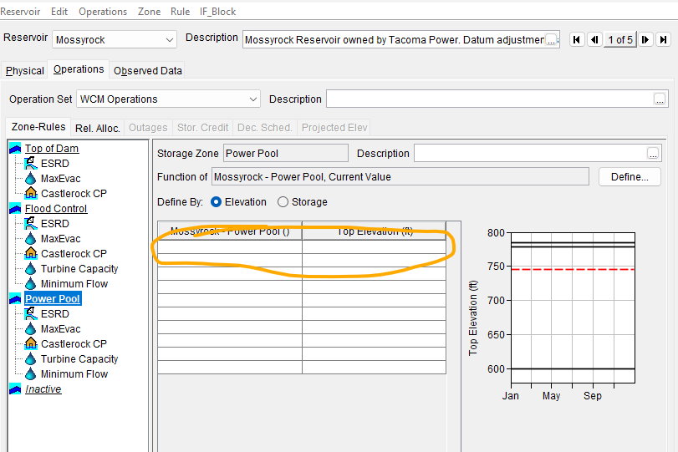
  - Evaluation: Checked box for “use external timeseries” and re-ran. Made a significant difference in the regulated curves.
  - Backcheck: Concur with edit.

  - Comment: The text in section 4.5 states: “A search of USGS qualification codes, the 2009 Restudy, and published USGS/NWS accounts of major southwest Washington floods turned up no pre-1927 event at Castle Rock that could be quantified or reliably bounded so no historical events or Bulletin 17C perception thresholds were used.” This makes it sound like no previous study used any flow estimates before 1927, but the 2009 study did include a historic event for 1906 based on some newspaper clippings. Recommend describing that this was done in 2009 and why it wasn’t deemed appropriate here.
  - Evaluation: Mentioned 2009 study used estimates that were untraceable and that uncovered newspaper reports only offered rough order of magnitude estimates.
  - Backcheck: Concur with edit.

  - Comment: The ResSim model had some development work applied to make it suitable for this study, but the ResSim modifications from the CWMS model are not discussed in the report. Recommend adding a new section (perhaps 5.1) that discusses the basics: rule curve, the minimum flow assumption, the downstream control rule at Castle Rock, max evac rate, and special curves. Discuss how calibration was challenging because of the power operations, which are not really rule-based.
  - Evaluation: Added calibration and validation section.
  - Backcheck: The new section 5.1 is good, but a little more detail would be helpful for posterity so people don’t have to go digging through the ResSim model. Writing down the numbers that were used for the min release, max evac release, and downstream control flow target in a sentence would help. Also, stating that there are no published special curves, but it is likely NWP would regulate Mossyrock to something like special curves in a flood emergency, and state what was used as the time of recession.
  - Evaluation: Added table and a few words about needing special releases

  - Comment: The development of uncertainty bounds in the unregulated-regulated transform are not discussed in the text, though they are applied in Section 5.6. Recommend including text explaining how these 5/95% bounds were drawn and including them in Figure 5-3.
  - Evaluation: Mentioned how the uncertainty in the regulated/unregulated plot operational, antecedent conditions, and storm shape only and referenced section 5.6 where unregulated flow frequency uncertainty is introduced.
  - Backcheck: The uncertainty bounds are now shown, but the upper bound extends beyond the 1:1 line, implying that the reservoir is inducing damages, which is not appropriate. The upper uncertainty bound should be clipped to the 1:1 line.
  - Evaluation: Trimmed upper uncertainty to 1:1 and adjusted lower uncertainty extrapolation to suggest eventual convergence with 1:1.

  - Comment: In Section 8.2, a drainage area ratio is used to estimate contributions from tributaries below Castle Rock. However, no justification is given. If possible, recommend including a scatter plot that shows Coweeman peak flow vs Castle Rock unreg peak flow to bolster the case for using a drainage area ratio.
  - Evaluation: Added using gauge and PRISM data
  - Backcheck: Concur with edit.

  - Comment: In Section 8.4, the below equation is given. Q_{AEP} = AEP_{CAS} * 0.8 * DA_{LOCAL} / DA_{CAS}
However, this does not appear correct. This equation looks like the regulated flows at Castle Rock were used and the drainage area ratio was applied there, when really the drainage area ratio should be applied to the unreg flows at Castle Rock, and then this value should be added to the regulated flows at Castle Rock.
  - Evaluation: I just meant it to be the Local calc, but updated to be Castle Rock calc.
  - Backcheck: Concur with edit.

  - Comment: In Section 5.6 and Appendix F, the uncertainty is described as a 95% interval, but the default for SSP is a 90% interval (5%/95% bounds). Recommend adjusting the description to make it more clear. It invites confusion to call it lower 95% and upper 95%, recommend just saying 5% and 95% like SSP does (and labeling it that way in the table headers), or lower 90% interval and upper 90% interval if desired.
  - Evaluation: Was being calculated as a 95% interval but said it was a 90. I fixed that.
  - Backcheck: Concur with edit.

Conclusions/Recommendations

