# Airborne Avenger

## Physical Setup

* Level Machine, per factory recommendation
* Outlane Posts on Medium settings.
* Ear Plug Tilt Hack
* Verify Tilt Sensitivity – should be sensitive, but only one danger with each hard bump
* Verify no flipper disable when coin door opened.
* Check Flipper Strength, ensure ball can easily go to top of playfield. If not consider Glo Ball
* Clean Playfield if necessary
* Clean Glass

## Switch or Software Setup

* 5-Ball Play for PinGolf, 3-ball for Round E and Rookie

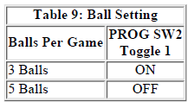

* Disable Extra Balls

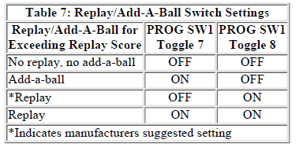 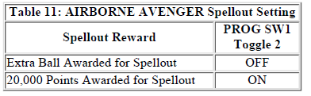

* Special is points

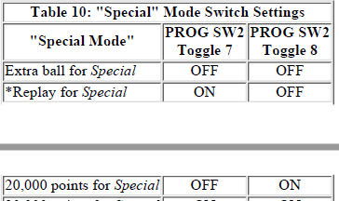

* 50K Replay Score: Rotary Switch to 0, Prog SW1 Toggle 4 OFF.
* Max 20 Credits
* 