# Hotdoggin

## Physical Setup

* Level Machine
* Verify Tilt Sensitivity
* Check Flipper Strength
* Clean Playfield if necessary
* Clean Glass

## Switch or Software Setup

* 3-Ball Play (S16 OFF)



* Disable Extra Balls, Special worth points (S6 ON, S7 OFF)
* Reset multiplier each ball (S14)
* Saucer special once (S24)

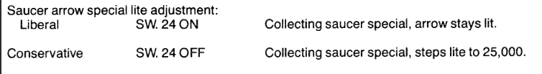

* Spot letter semi-medium

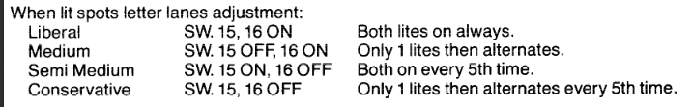

* Inline spot letter – conservative

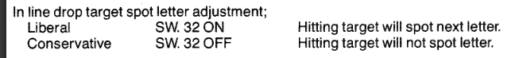

* Free Play if possible, else Max Credits per coin
* 
 