# Monte Carlo

## Physical Setup

* Level Machine, per factory recommendation
* Outlane posts on Medium
* Ear Plug Tilt Hack if it makes sense
* Verify Tilt Sensitivity – should be sensitive, tilt with each hard bump
* Verify no flipper disable when coin door opened.
* Check Flipper Strength, ensure ball can easily go to top of playfield. Consider Glo Balls.
* Clean Playfield if necessary
* Clean Glass
* Verify Volume

## Hardware Setup

* 5-Ball Play.

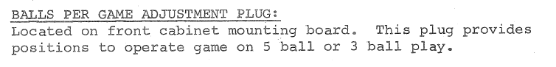

* Leave Extra balls enabled for PinGolf. If lots of EBs are earned, disable them (give a credit) for Round E.

