# Bally Captain Fantastic

* Level Machine
* Verify Tilt Sensitivity
* Check Flipper Strength. Consider Glo-ball if flippers weak or play is too slow.
* Clean Playfield if necessary
* Clean Glass

## Switch or Software Setup

* 5-Ball Play.

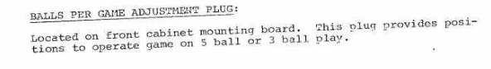

* Extra-ball-Special on Conservative

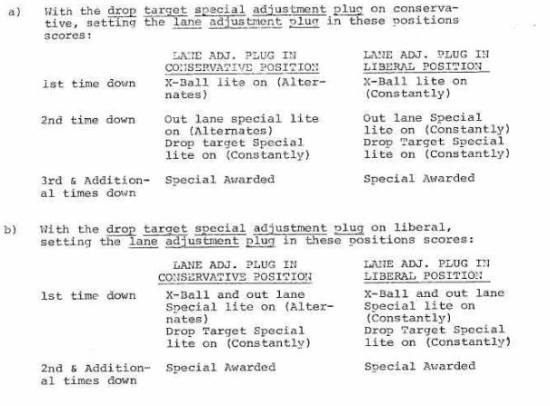

* Not possible to disable Extra ball?
* Free Play if possible, else Max Credits per coin and minimum replay score