# Bally Old Chicago

## Physical Setup

* Level Machine – about 1% steeper than factory recommendation
* Playfield Panel Post Adjustment: HARD
* Ear Plug Tilt Hack
* Verify Tilt Sensitivity – should be sensitive, but only one danger with each hard bump
* Check Flipper Strength, Consider Glo Balls if playing too slow or can’t hit upper playfield
* Ensure center eject is not easily exploitable; needs to be hard kickout. Use glo ball if needed.
* Clean/wax playfield
* Clean glass

## Switch Setup

* 5-Ball Play



* Extra Balls – disable if possible (drop target Adjustment Plug)

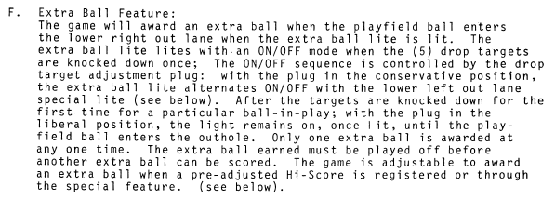

* Hi Score Adjustment Plug: make it lowest score possible, to replenish credits

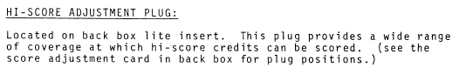

* Double Bonus Feature: 1,3,5 on a 5-ball game
* 