# Bally Eight Ball

* Level Machine
* Verify Tilt Sensitivity
* Verify Volume
* Check Flipper Strength. Consider Glo-ball if flippers weak or play is too slow.
* Clean Playfield if necessary
* Clean Glass

## Switch or Software Setup

* 5-Ball Play (S16 ON)



* Disable EB, Hard Settings (S24 OFF, S23 OFF, S31 OFF, S22 OFF, S30 OFF )  
  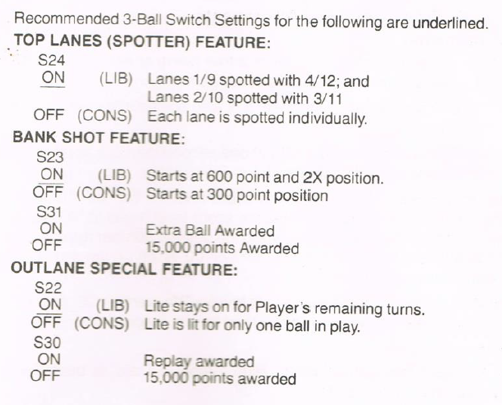
* Max 40 Credits
  + S17-19 ON  
    
* Max Credits per coin (unless free play possible?).
  + S28-S25 ON, S2-5 ON, S1 OFF, S10-13 ON, S9 OFF. S17-S19 ON.
* 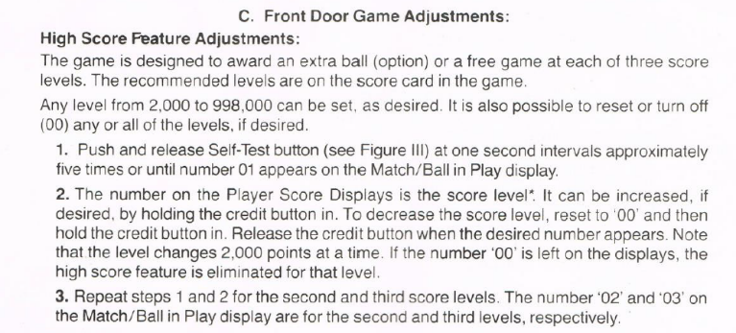Replay at 2K.