# Lost World

## Physical Setup

* Level Machine, per factory recommendation
* Outlane Posts on Medium settings.
* Ear Plug Tilt Hack
* Verify Tilt Sensitivity – should be sensitive, but only one danger with each hard bump
* Verify no flipper disable when coin door opened.
* Check Flipper Strength, ensure ball can easily go to top of playfield.
* Clean Playfield if necessary
* Clean Glass
* Verify Volume

## Switch or Software Setup

* 5-Ball Play for PinGolf, 3-Ball for Round E and Rookie

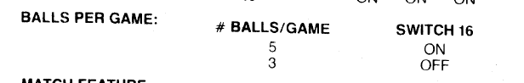

* Novelty Disable Extra Balls, Special worth points

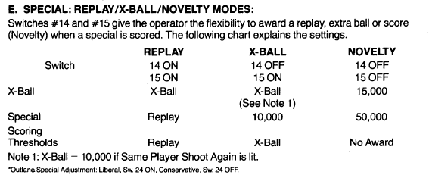

* Max Credits to 40: SW17 ON SW18 ON, SW19 ON
* 15 Credits per Coin, Chutes 1&3: SW5/4/3/2=ON, SW1=OFF SW13/12/11/10=ON, SW9=OFF

