# Mata Hari

## Physical Setup

* Level Machine – about 1% steeper than factory recommendation
* Ear Plug Tilt Hack
* Verify Tilt Sensitivity – should be sensitive, but only one danger with each hard bump
* Check Flipper Strength, Consider Glo Balls if playing too slow or can’t hit upper playfield
* Clean/wax playfield
* Clean glass

## Switch or Software Setup

* 3-Ball Play (S16 ON)



* Disable Extra Balls, Special worth points (S30/S31 OFF)

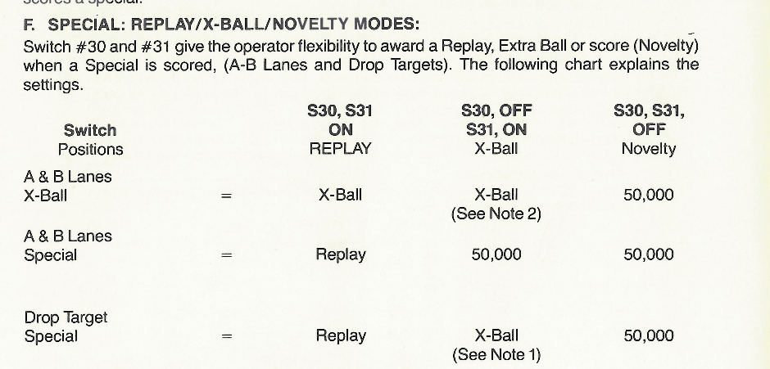

* AB Feature Conservative (S24 OFF)

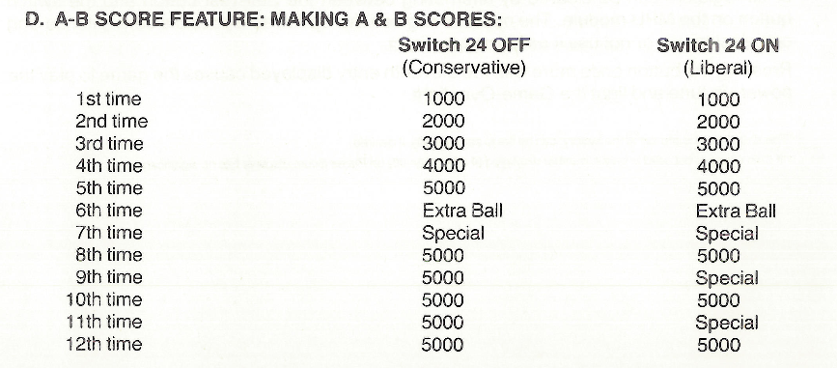

* Free Play if possible, else Max Credits per coin and minimum replay score
  + S28-S25 ON, S2-5 ON, S1 OFF, S10-13 ON, S9 OFF.

